30.10.2023

**USER MANUAL HANDOVER**

VMS MASTER DOCUMENT

Sanika Dewoolkar

Sanika.dewoolkar@techneai.com

WHATSAPP QUERY REPORT

MANALI ASHOK BHADIRAGE

Manali.bhadirage@techneai.com

**CONTENTS**

1. VERSION CONTROL 2

2. INTRODUCTION 2

3. SCOPE 2

4. BUSINESS & SYSTEM RULES 3

5. ABBREVIATIONS & TERMS 3

6. GRAPHICAL REPRESENTATION 3

7. DEVELOPED SYSTEM 4

8. TEST DATA AND BUSINESS SCENARIOS 14

1. **VERSION CONTROL**

|  |  |  |  |  |  |  |
| --- | --- | --- | --- | --- | --- | --- |
| **Sr. No** | **Version no** | **Version Date** | **User name** | **User department** | **Updated By** | **Ticket ID** |
| **1** | **1.0** | **30/10/2023** | **Reshma Sayyad** | **HOBDD** | **Manali bhadirage** | **TT3744** |
|  |  |  |  |  |  |  |
|  |  |  |  |  |  |  |

1. **INTRODUCTION**

Using the Whats-App chat-bot, customers can simply enter a query code, and in response, they will receive the relevant information they are seeking. Customers have the option to input this code for various purposes, such as obtaining their most recent transaction receipt, checking the current rates, receiving a link to download the catalog app, accessing details on ongoing offers, inquiring about available schemes, obtaining a list of store locations, and finding out the toll-free contact number. This streamlined process enables users to efficiently access the information they need at any time.

Furthermore, with the Whats-app query report in connect-us, we can compile data on customer interactions based on the date they reached out and the specific query they had. This valuable data allows us to analyze which types of queries are more frequently asked by customers. By understanding these patterns, we can pinpoint areas that require improvement in our processes, ensuring that we enhance the quality of service we provide to our customers via whats-app chat-bot or any other medium.

1. **SCOPE**

Customers will send the code on Whats-app number 7350250000. They will enter the code of the query provided and send. In return of that customer will receive the expected information as per entered query code. Through Whats-app query report, users will select the date and the query code for which they wish to have data. Once user enters date and query code, the report will be displayed which will have details of the customers who contacted for query code along with date and time. User can also export this report in csv format.

1. **BUSINESS & SYSTEM RULES**

* User should be registered in the system. User should be logged into Connect Us to access whats-app query report.
* System should display error message for incorrect details if entered.
* Customer should enter valid query code in whats-app.
* Report will just display the 1 to 9 query code wise limited data and cannot display other details if customer has asked anything else in whats-app chat-bot.

1. **ABBREVIATIONS & TERMS**

* iOS- iPhone Operating System
* PDF- portable document format
* E catalogue - electronic catalogue that provides information of products sold by CSJ.

1. **GRAPHICAL REPRESENTATION**

**Enter query code**

**Whats-app chat-bot**

**Cus**%3CmxGraphModel%3E%3Croot%3E%3CmxCell%20id%3D%220%22%2F%3E%3CmxCell%20id%3D%221%22%20parent%3D%220%22%2F%3E%3CmxCell%20id%3D%222%22%20value%3D%22Enter%20message%20on%20whats-app%20chat-bot%22%20style%3D%22ellipse%3BwhiteSpace%3Dwrap%3Bhtml%3D1%3B%22%20vertex%3D%221%22%20parent%3D%221%22%3E%3CmxGeometry%20x%3D%22290%22%20y%3D%22100%22%20width%3D%22260%22%20height%3D%2240%22%20as%3D%22geometry%22%2F%3E%3C%2FmxCell%3E%3C%2Froot%3E%3C%2FmxGraphModel%3E**tomer**

**Receive response**

Fig: General Context Diagram for whats-app chat-bot

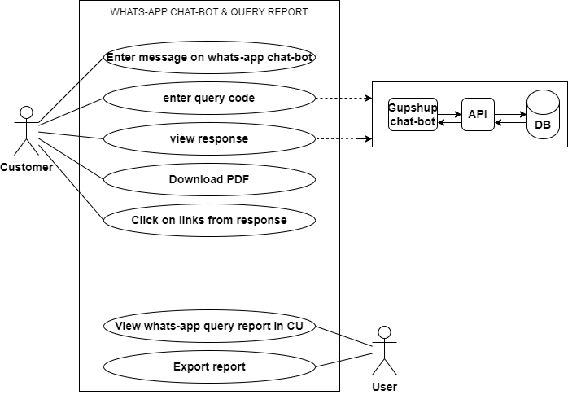

Fig: Use case Diagram

1. **DEVELOPED SYSTEM**

Step1. Cutomer will mention query code in Whats-app chat-bot

Once customer enters any message in whats-app number 7350250000, chat-bot will instantly reply and request customers to enter the query code. Once customer mentions the query code then the response as per query code will be sent to the customer.

Below are the query codes in whats-app chat-bot:

1. Last Transaction
2. Current Rate
3. Latest E-catalogue
4. Download mobile app / online purchase
5. Change Language
6. Theme/Offer
7. Monthly Scheme
8. Store Location
9. Toll Free

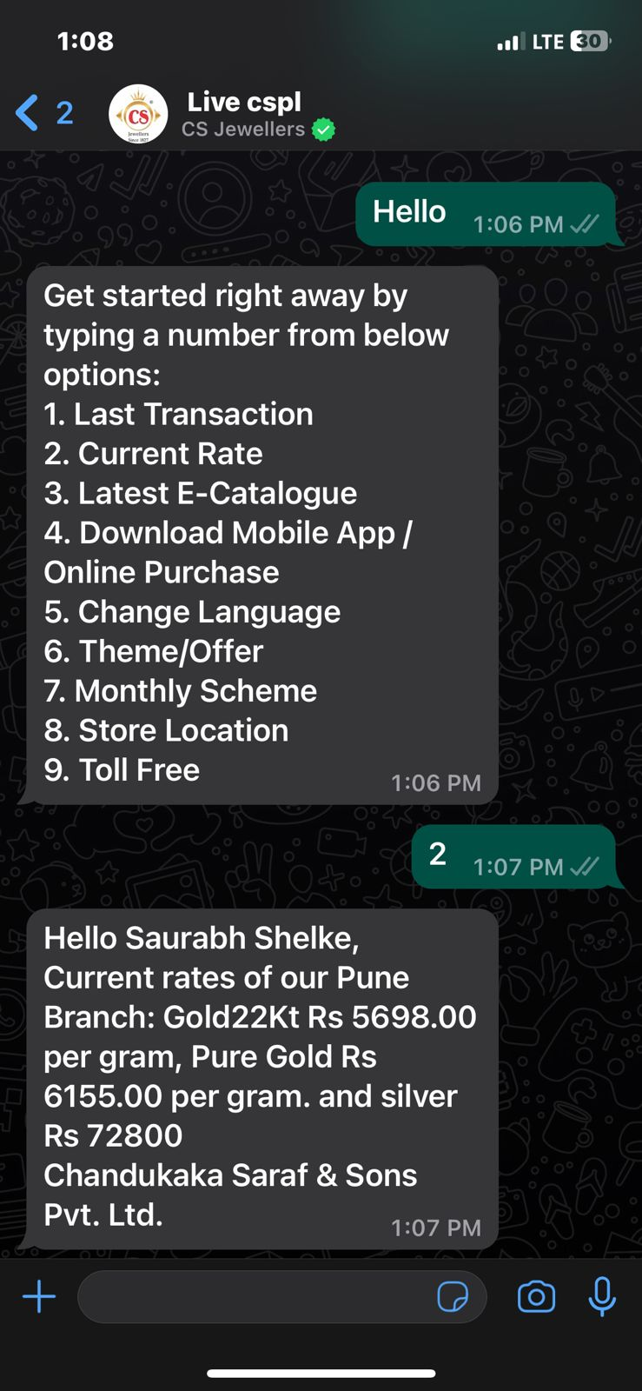

Fig: Main menu

Initially to begin with conversation, customer may enter hi / hello on whats-app number and then the query code list will be sen to him. If customer enters incorrect inputs, then it will display message as ‘ Sorry, we didn’t understand your query and please enter code correctly’.

**Input table**

|  |  |  |  |  |
| --- | --- | --- | --- | --- |
| **FIELDS** | **INPUT TYPE** | **MANDATORY/ OPTIONAL** | **EDITABLE** | **DESCRIPTION** |
| Latest transaction | text | - | - | Once customer enters 1 then user will receive the sales bill of the recently made purchase from any of the CSJ branch.  If customer has not made any purchase till date then it will display message as no result found.  Validation: customer will only have to mention 1 and send. Sales bill receipt will be in PDF extension. Only one recent purchase bill will be sent. |
| Current rate | Text | - | - | User will have to enter 2 to get today’s rate of per gram 24k gold, per gram 22k gold and per kg pure silver.  Rate will be displayed as in padm -> current rate.  Validation: customer will get correct current rate only if user only enters 2 and sends it. |
| Latest e-catalogue | Text | - | - | Customer can get the information of the e-catalogue app if any.  If any e-catalogue are available then PDF file will be sent to the customer having images of the items and its details.  If there are no e-catalogue maintained, it will display message as e-catalogue will be updated soon.  Validation: customer will get correct response only if user only enters 3 and sends it. |
| Download mobile app / online purchase | Text | - | - | Through this customer will directly get the link of mobile app from play store to download and begin shopping from it.  Once customer sends 3, it will confirm whether customer was app link for android or iOS. Once customer confirms, play store or apple store link of mobile app will be sent to the customer. Customer can directly click on the link and install app.  Validation: customer will get correct response only if user only enters 4 and sends it.  Customer will have to enter some message or hello or 10 number to get to main menu i.e. 1 to 9 query codes list and to choose between them.  IMG-20231031-WA0022  Fig: query code 3 and 4 |
| Change language | Text | - | - | Customer can change the language between Marathi, English and Kannada.  Once user enters 5, then user will get option to choose the language as 1 for Marathi, 2 for English and 3 for Kannada. Once user enters the code 1 / 2/ 3 the language will be set accordingly and user will receive messages in set language.  If customer have to change the language them user can change it at any time just y entering 5 first and then choosing the code as per expected language.  Validation: Validation: customer will get correct response only if user only enters 5 and sends it.  User can have only one language at a time.  IMG-20231031-WA0024  Fig: query code 5 |
| Theme / offer | Text | - | - | Customer will get the details of the ongoing or current offers at the shops.  Customer will have to send 6 to get the offers details.  Validation: customer will get correct response only if user only enters 6 and sends it. |
| Monthly scheme | Text | - | - | User will get details of the schemes that are available at the branches for the customers on gold or silver.  Once customer sends 6 then customer will receive the link of CSJ website where terms and conditions for kalpataru scheme and GTS scheme will be mentioned and steps for user to start it. Also, it will have link for payment of the scheme which will be helpful for the customers who already have enrolled for scheme and have to pay the installment.  Validation: customer will get correct response only if user only enters 7 and sends it. |
| Store location | Text | - | - | Customer will get the google map link which will have locations of all the branches of the CSJ in our country.  Once customer send 8, then google map url link will be sent to customer which will have locations of all the branches.  Validation: customer will get correct response only if user only enters 8 and sends it. |
| Toll free | Text | - | - | Once customer enters 9, customer care number will be sent to him.  Validation: customer will get correct response only if user only enters 9 and sends it. |

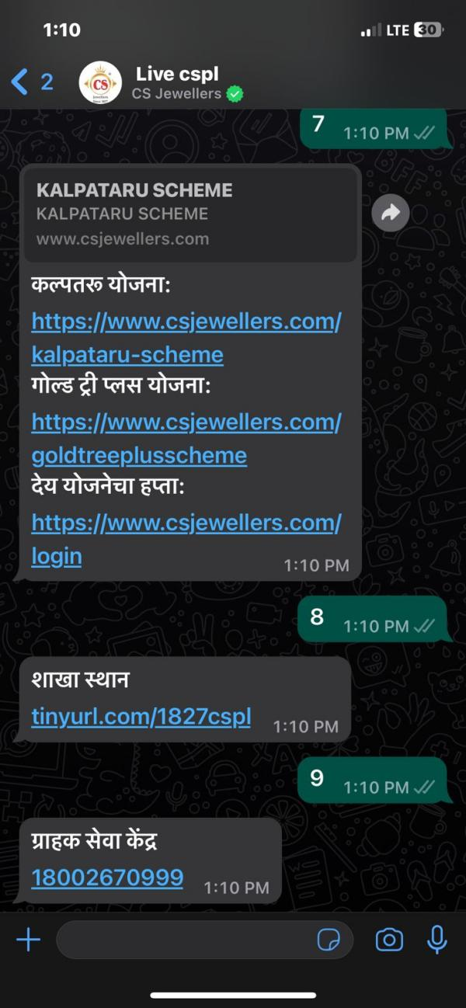

Fig: Query code 7, 8 and 9

Step2. Actual user can view the whats-app chat-bot query report through Connect Us. User will get query wise detailed information about customers who contacted. Whats-app query report menu will have following fields:

* From date
* To date
* Query name
* Filter button
* Export button
* Reset button
* Sr. No.
* Date
* Mobile number
* Customer whats-app name
* Query number

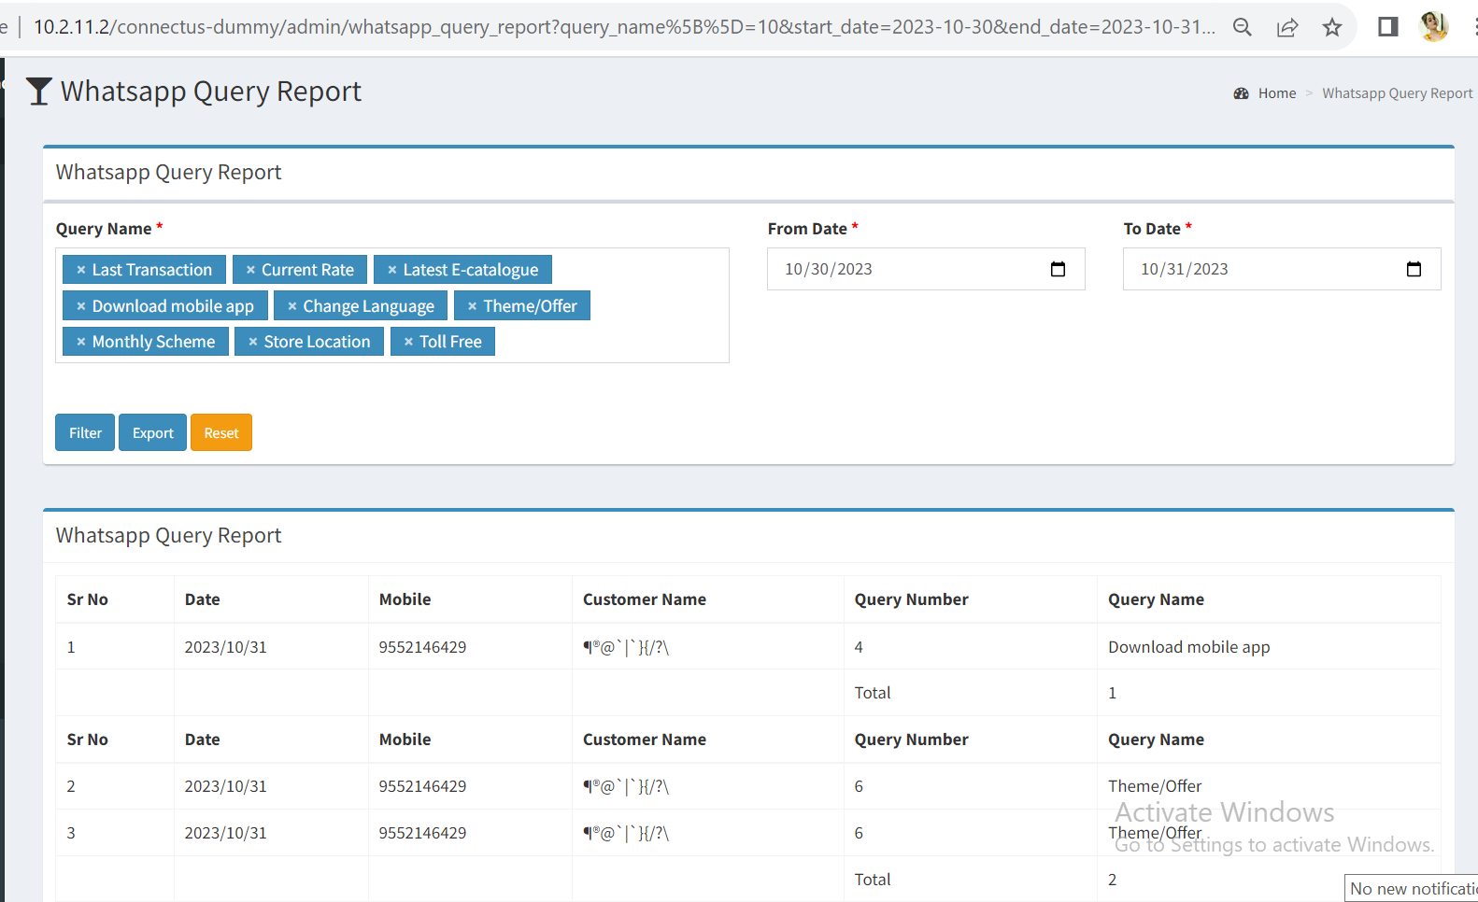

Fig: Whats-app query report

**Input table**

|  |  |  |  |  |
| --- | --- | --- | --- | --- |
| **FIELDS** | **INPUT TYPE** | **MANDATORY/ OPTIONAL** | **EDITABLE** | **DESCRIPTION** |
| From date | Calender date picker | Mandatory | - | User will have to select the date from which customers have contacted on chat-bot.  Validation: single date will be selected at a time. Future dates should be disabled. |
| To date | Calender date picker | Mandatory | - | User will have to select the date till which customers have contacted on chat-bot.  Validation: single date will be selected at a time. Future dates should be disabled. Dates before ‘from date’ should be disabled. |
| Query name | Drop down | Mandatory | - | It will display the list of queries as in main menu of chat-bot namely latest transaction, current rate, e-catalogue, download mobile app / online purchase, change language, theme / offer, monthly scheme, store location, toll free and all.  Also, if user has selected any of the query name along with ‘All’, then it will filter data and display data of all query names.  If any of the option is selected from the drop-down and user clicks on the same selected option again in the list then that option will be deselected.  Validation: It will be multi select. |
| Reset | Click | - | - | Once user clicks on reset button, then page will reload and all pre-filled fields if any will get cleared.  Validation: reset button will be disabled until page gets reloaded completely. |
| Filter | Click | - | - | Once user selects mandatory fields and clicks on filter button, report will be displayed below. It will have following columns:   * Sr no. * Date * Mobile number * Customer whats-app name * Query code * Query name * Total   Validation: filter button will be disabled until page gets reloaded and data gets displayed in grid as a report. |
| Date | Date | - | - | It will display the date on which customer entered that query code on whats-app chat-bot. |
| Mobile number | Text | - | - | It will display the whats-app registered mobile number from which the query code was entered. |
| Customer whats-app name |  |  |  | It will display the whats-app username of the customer number from which query was entered.  Validation: If user has entered any query and then changes the whats-app username, new updated customer whats-app name will not be displayed. It will save and display the earlier name when the code was entered. |
| Query code | Text | - | - | It will display the query code for which the customer contacted on chat-bot. |
| Query name | Text | - | - | It will display the query name as per the queru code which was entered by the customer. |
| Total | Text | - | - | It will display the total count of customers who contacted for that particular query code as per selected dates. |
| Export | Click | - | - | Once user selects mandatory fields and clicks on export button, cv file will get downloaded. It will have following columns:   * Date * Mobile Number * Customer Name * Query Number * Query Name * total of each query is displayed at the bottom. |

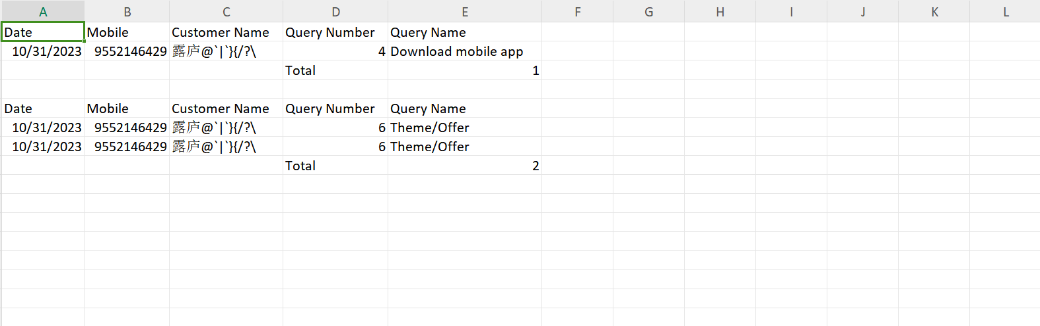

Fig: Whats-app query report -> export

1. **TEST DATA AND BUSINESS SCENARIOS**

