Manali ashok bhadirage

Manali.bhadirage@techneai.com

26.08.2023

BRANCH FEEDBACK REPORT

**Handover Document**

**CONTENTS**

1. TICKET DETAILS 2

2. INTRODUCTION 2

3. BUSINESS REQUIREMENT 2

4. SCOPE 3

5. BUSINESS & SYSTEM RULES 3

6. ABBREVIATIONS & TERMS 3

7. EXISTING SYSTEM 3

8. GRAPHICAL REPRESENTATION 3

9. DEVELOPED SYSTEM 4

10. REFERENCES OF THE USERS 5

1. **TICKET DETAILS**

|  |  |
| --- | --- |
| **Ticket ID** | TT12285 |
| **Ticket description** | Regarding old connectus madhe manager login la all branch cha feedback report show hot ahe tya iavaji single branch cha show zala pahije |
| **Created by** | Sagar gote |
| **Created on** | 17/05/2023 |
| **Priority** | Medium |

1. **INTRODUCTION**

Through PRO tab, users enters the customers number and customers basic details. Further, user sync the data from PRO application and Padm purchase of each branch and gets reflected in Connect Us -> Report -> Feedback. The details displays the list of customers who visited the branches and whether the customer has purchased the items on that day. If customer has purchased on the same day, then all the details of the purchase are being displayed.

This helps CSJ to keep track of the visitors and get report of purchase on each day at each branch. Also, this helps CSJ to analyze the customers who are visiting frequently as each customer’s last purchasing data can be viewed.

1. **BUSINESS REQUIREMENT**

|  |  |  |  |
| --- | --- | --- | --- |
| **Requirement ID** | **Requirement Name** | **Short Description** | **Priority** |
| BR001 | Filter -> Branch field | In branch field, display the list of branches which are assigned to logged in person in users management. | Medium |
| BR002 | Filter -> branch field | In branch field, display all the branches in the list if no branch is assigned in user management for the logged person. | Medium |
| BR003 | Export to excel | Display data to the user as per selected branch.  Do not display data of other branches which is user is not authorized / mapped with. | Medium |

1. **SCOPE**

From Connect Us -> Report -> Feedback, user should be able to view data of customer as per selected branch. In branch field, branches should be displayed as mapped to the logged in user as per user management. Once user selects mandatory fields, select branch and clicks on search then export button should be displayed. Once user clicks on the export file, then excel file should be downloaded which will display the data as per filters applied. User should get data as per selected branch only. The current scope includes testing of feedback report and the downloaded excel file.

The current scope doesn’t include bugs related to users management and/or PRO tab application (except blockers which are affecting Connect Us -> Report -> Feedback report).

1. **BUSINESS & SYSTEM RULES**

* User should be registered in the system and user should be logged in.
* System should display error message for incorrect details if entered.
* If data is not synchronized then blank file will get downloaded in feedback report.

1. **ABBREVIATIONS & TERMS**

NA

1. **EXISTING SYSTEM**

Currently, through Connect Us -> Report -> Feedback all branch managers are able to view data of all the customers from all the branches. Branch manager should be able to view report of the customers out of branch only which are mapped with the branch manager.

1. **GRAPHICAL REPRESENTATION**

Add branch in add / edit action of users management of the employee

Display branch list as per users management of logged in person

Display excel report as per selected branch

Sync data from CU feedback report

Apply filters and select branch

Enter cx details in PRO app

Fig: General Context Diagram

1. **DEVELOPED SYSTEM**

Once user enters customer data on PRO application and after the Padm data gets synchronized, it will get reflected in Connect Us -> Report -> Feedback. It will have following fields:

* From Date and time
* To date and time
* Branch
* Is purchase status
* Today report
* Submit button
* Export to excel button
* Sync Data Date
* Sync data button

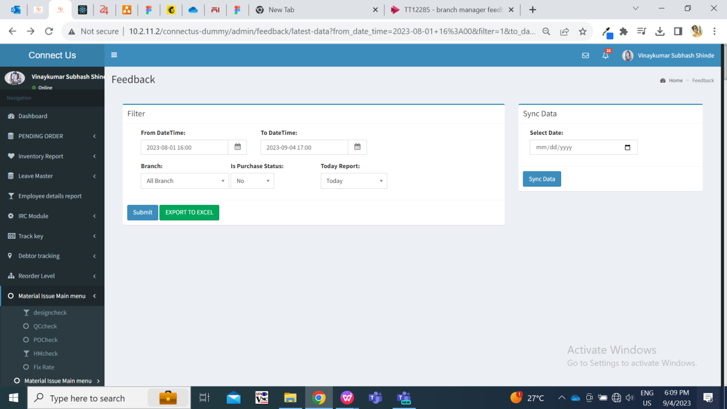

Fig: Feedback report menu

|  |  |  |  |
| --- | --- | --- | --- |
| **FIELDS** | **INPUT TYPE** | **MANDATORY/ OPTIONAL** | **DESCRIPTION** |
| Branch | drop-down | Mandatory | It should display list of branches as set in users management of the logged in person.    Fig: Users management -> list user -> edit  If branches are not set in users management of the logged in person, then all branches should be displayed separately in this field drop-down as well as should display ‘All branches’ option in the list.  Once user selects branch and clicks on submit button, then in exported file it will display the data of customers of the selected branch only.  Validation:- It will be single select. As and when any particular branch(es) are removed from users management of the logged in person, then the mapped branches should be displayed in this field accordingly. |

Once user selects mandatory fields, selects branch and clicks on submit then ‘export to excel’ button gets displayed. The exported excel file displays the data of the customers as selected in filter.

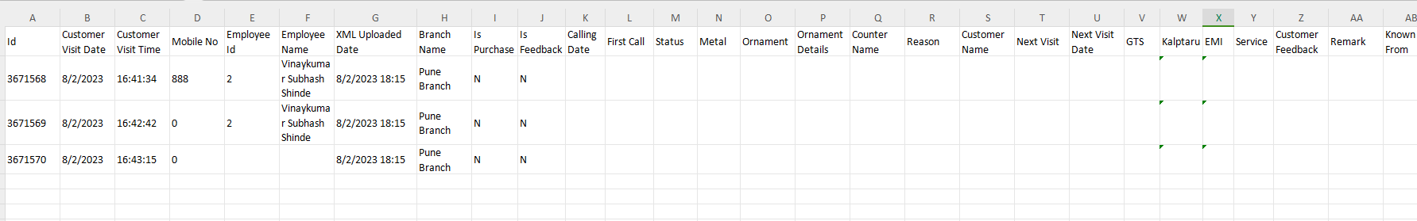

Fig: Exported excel file data

1. **REFERENCES OF THE USERS**

|  |  |  |  |
| --- | --- | --- | --- |
| **User** | **Name** | **Mail** | **Contact number** |
| **Actual user** | Sagar gote | stsupport@techneai.com | 7796617004 |
| **Ticket created by (if any)** | Sagar gote | stsupport@techneai.com | 7796617004 |
| **Assigned business analyst** | Manali bhadirage | Manali.bhadirage@techneai.com |  |
| **Assigned developer** | Punam shinde | Punam.shinde@techneai.com |  |
| **Assigned tester** | Vaishnavi khandwe | Vaishnavi.khandwe@techneai.com |  |