Manali Ashok Bhadirage

Manali.bhadirage@techneai.com

18.12.2023

CU BILL CHECKING - EDIT URL

**Handover Document**

**CONTENTS**

1. TICKET DETAILS 2

2. INTRODUCTION 2

3. BUSINESS REQUIREMENT 2

4. SCOPE 3

5. BUSINESS & SYSTEM RULES 3

6. ABBREVIATIONS & TERMS 3

7. GRAPHICAL REPRESENTATION 3

8. DEVELOPED SYSTEM 3

9. REFERENCES OF THE USERS 5

1. **TICKET DETAILS**

|  |  |
| --- | --- |
| **Ticket ID** | TT12815 |
| **Ticket description** | Enter ticket description |
| **Created by** | Amar Landge |
| **Created on** | 02/06/2023 |
| **Priority** | Very high |

1. **INTRODUCTION**

Introducing "Bill Connect US": a seamless system that simplifies bill management for users. With this innovative platform, users can effortlessly submit vendor bills and facilitate swift payment processing. All payment records are meticulously maintained and audited to ensure transparency. Integrating with Padm, "Bill Connect US" offers an added advantage by displaying the current balance of each vendor. This feature empowers entry users to make informed decisions when submitting bills, as they can analyze the available funds in the Padm account for each vendor. By having visibility into the vendor's balance, users can strategies their bill submissions, avoiding unnecessary work and streamlining the process.

In summary, "Bill Connect US" streamlines bill submissions and payment processing, providing valuable insights into vendor balances through integration with Padm. This empowers entry users to optimize their bill submissions and foster a more efficient workflow.

1. **BUSINESS REQUIREMENT**

Users should be able to edit the bills only which are assigned to them.

|  |  |  |  |
| --- | --- | --- | --- |
| **Requirement ID** | **Requirement Name** | **Short Description** | **Priority** |
| BR001 | Edit bill | User should be able to edit bills only which are assigned to him and are available in his bill checking transaction -> grid. | High |
| BR002 | Restrict edit by copying link | If external users are copying the link of edit action or accessing the edit action link of the bills which are not assigned to them, then it should display message that user doesn’t have authority. | High |
| BR003 | Update all bill special authority | If user has special authority to update all bills, then that user should be able to edit the bills even if they are not assigned to him. | High |

1. **SCOPE**

User shouldn’t be able to access or have access to the edit page if bill is not available in grid and is not assigned to the user. When user enters link of any bill, then system should check whether that bill is assigned to the logged in person or not and then grant access to perform edit actions accordingly. If user has entered edit link of any bill and if that bill is not assigned to user, then it should display error message.

1. **BUSINESS & SYSTEM RULES**

* User should be registered in the system and user should be logged in.
* System should display error message for incorrect details if entered.
* User will have access to edit all bills if user has ‘all update bill’ authority even if that bill is not assigned to the user him.

1. **ABBREVIATIONS & TERMS**

BC ID - Bill checking ID - system generated unique bill number

PO No. - Purchase Order number from Padm bill

GST - Goods Service Tax

TDS - Tax Deducted at Source

TCS - Tax Collection at Source

HOD - Head of Department

UTR - Unique Transaction Reference

1. **GRAPHICAL REPRESENTATION**

Submit

Edit bill only if it is assigned to logged in person or has ‘all update bill’ authority

Display bill in grid of assigned user

Add bill and assign to user

Fig: Context Diagram

1. **DEVELOPED SYSTEM**

When users click on edit action or enters / pastes any browser link of edit action of any bill, it should be verified that if the bill is assigned to the logged in user or not. If assigned to person of the bill is logged in person, then user should be able to edit the bill and submit it. If assigned person of the bill is not logged in person, then it should display error message on page as ‘**You are not authorized to access this bill**’.

Example: Vinaykumar Shinde has created bill E10791 and has assigned it to Divya Danpelli. Then, only Divya Danpelli will be able to edit this bill.

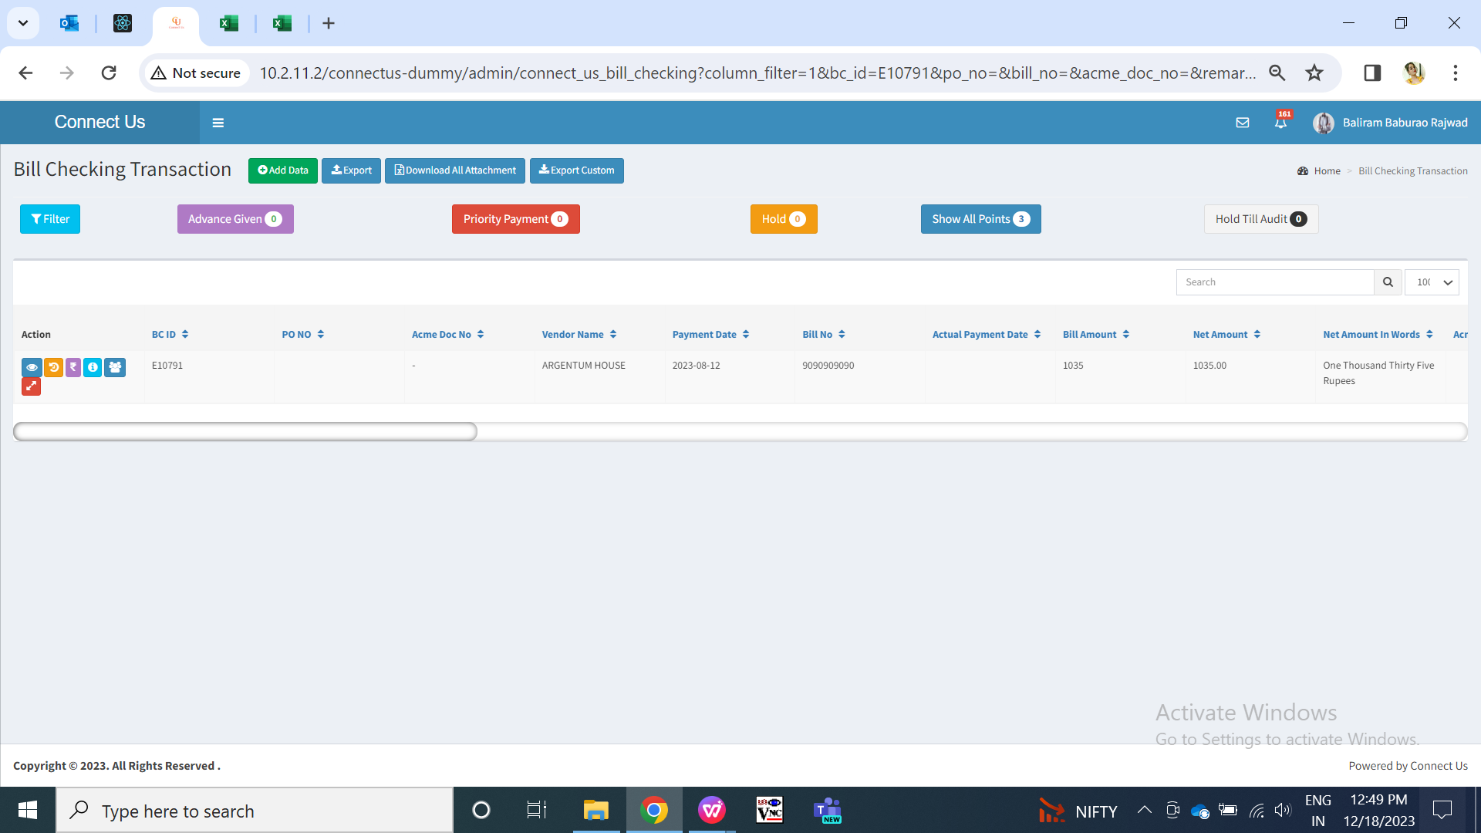

Fig: Baliram Rajwade doesn’t have edit action to E10791

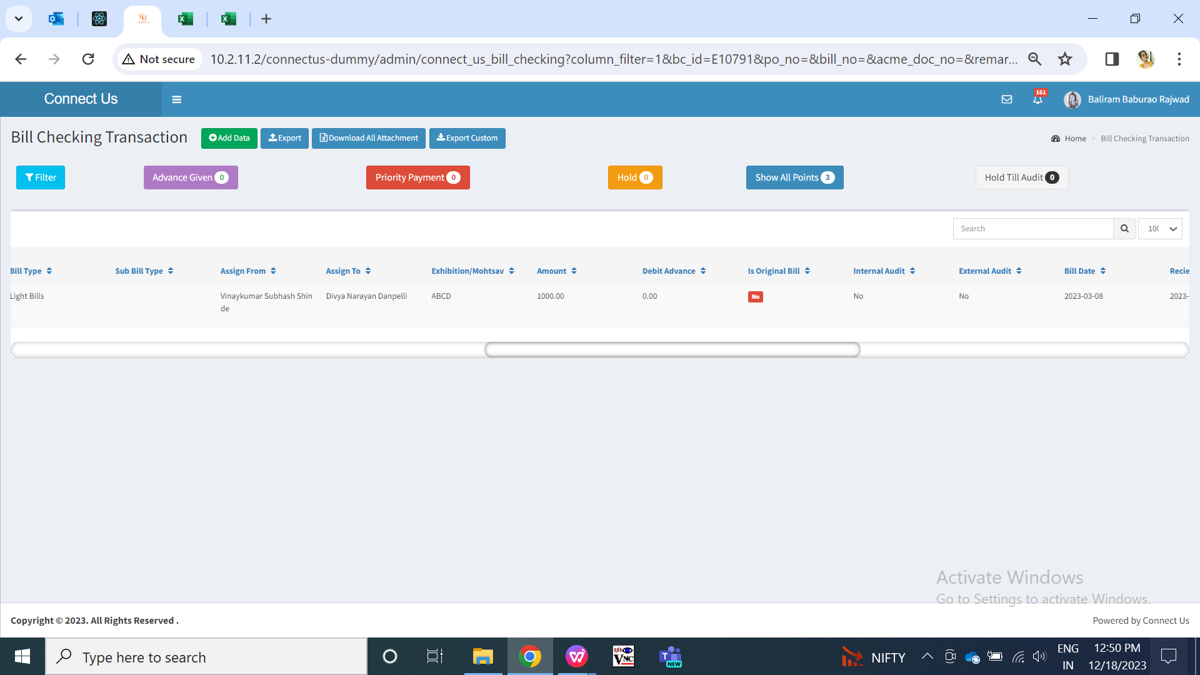

Fig: Vinaykumar Shinde has created E10791 and assigned to Divya

Further, Nilesh Waghmare has special authority of ‘update all bills’, then Nilesh Waghmare will also be able to edit that bill. However, if Baliram Rajwade tries to access link of edit this bill, then it will show him error as bill is not assigned to him neither he have special authority.

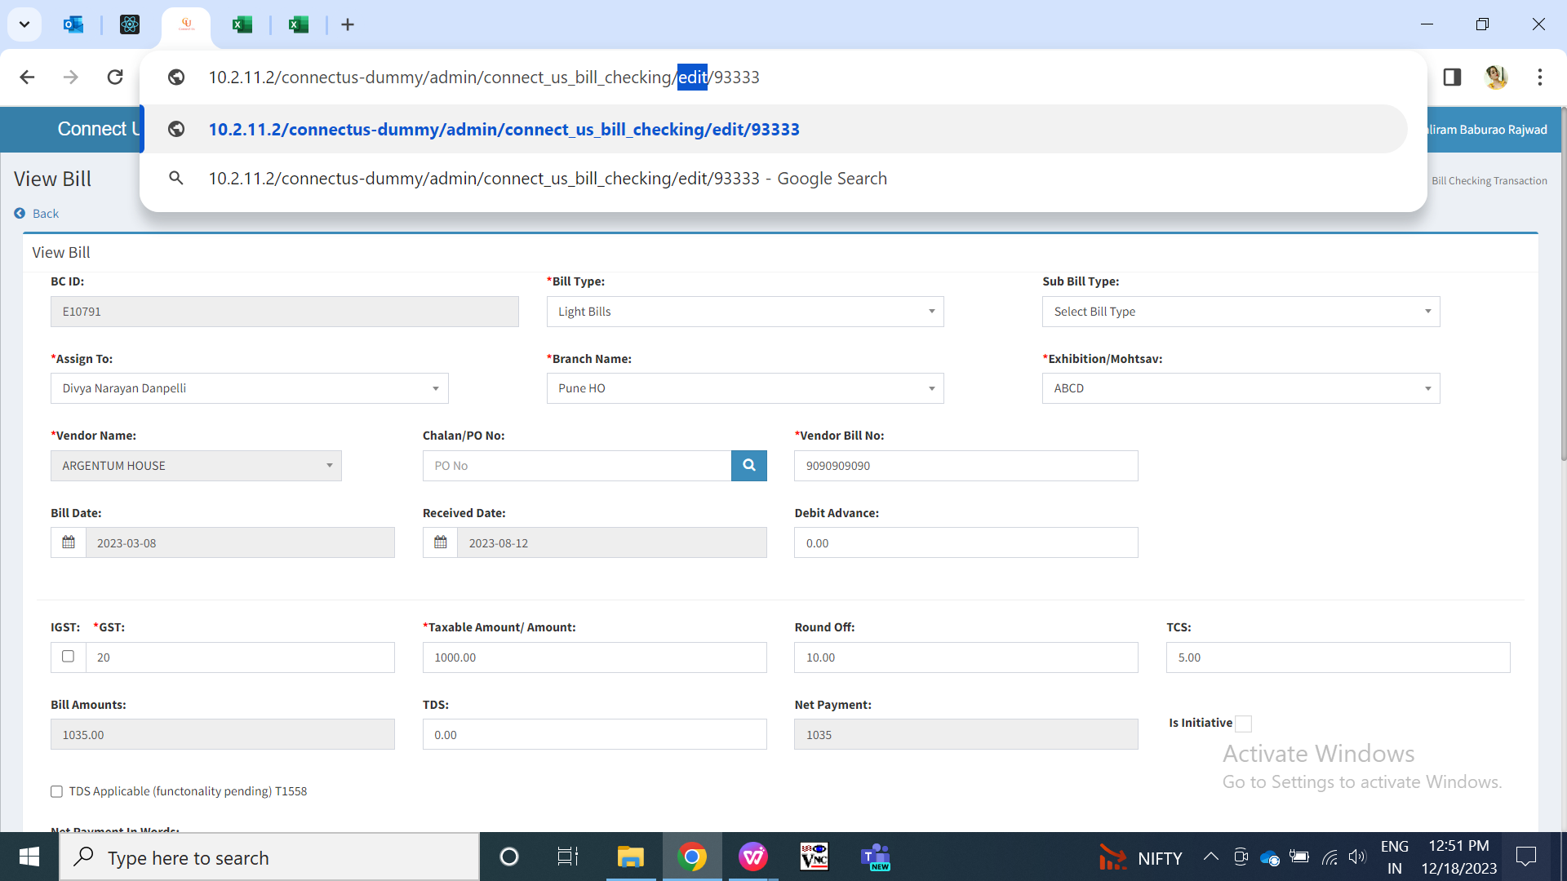

Fig: Baliram Rajwade trying to access edit url of bill E10791

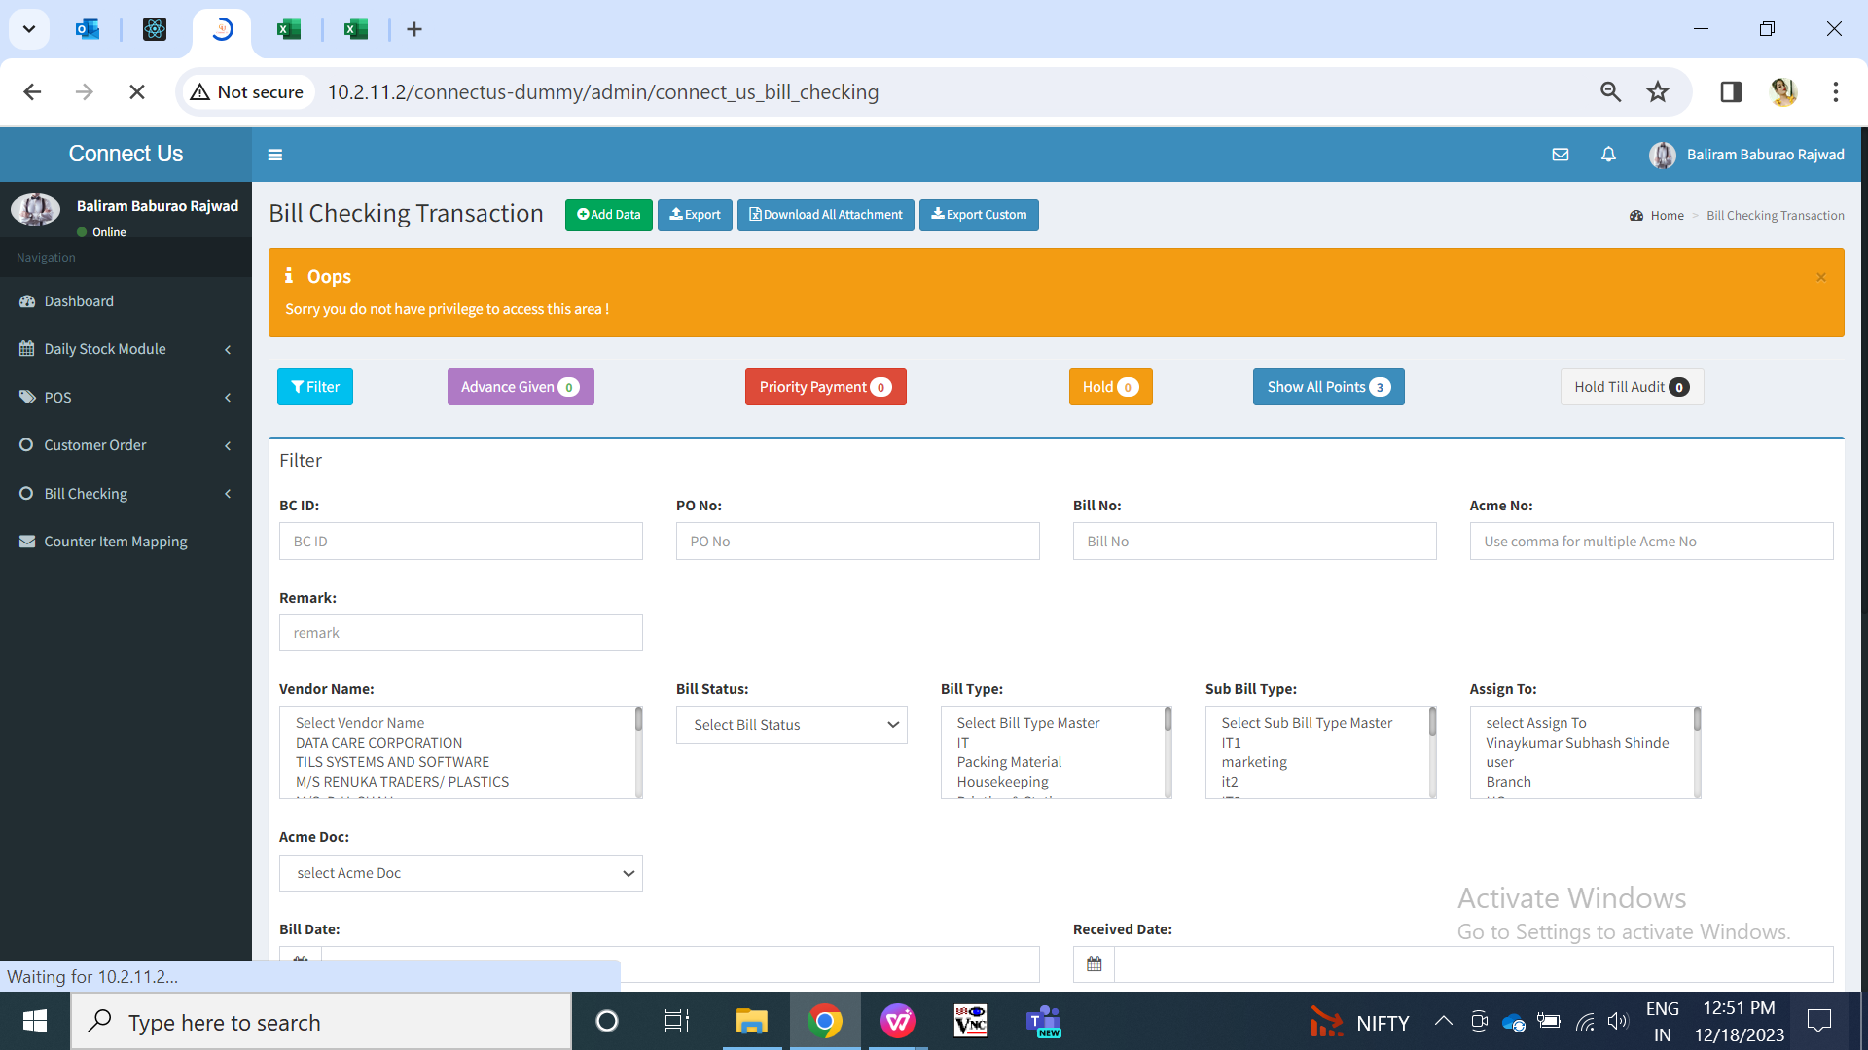

Fig: Error for unauthorized user

1. **REFERENCES OF THE USERS**

|  |  |  |  |
| --- | --- | --- | --- |
| **User** | **Name** | **Mail** | **Contact number** |
| **Actual user** | Amar landge | ia@csjewellers.com |  |
| **Ticket created by (if any)** | Amar landge |  |  |
| **Assigned business analyst** | Manali bhadirage | Manali.bhadirage@techneai.com | 2965 |
| **Assigned developer** | Nikhil bhosale | Nikhil.bhosale@techneai.com |  |
| **Assigned tester** |  |  |  |