Manali Ashok Bhadirage

Manali.bhadirage@techneai.com

07.12.2023

CU BC - INTERNAL AUDIT QUERY REPORT

**Handover Document**

**CONTENTS**

1. TICKET DETAILS 2

2. VERSION CONTROL 2

3. APPROVALS 2

4. ESTIMATION 2

5. INTRODUCTION 3

6. BUSINESS REQUIREMENT 3

7. SCOPE 3

8. BUSINESS & SYSTEM RULES 3

9. ABBREVIATIONS & TERMS 4

10. EXISTING SYSTEM 4

11. GRAPHICAL REPRESENTATION 4

12. PROPOSED SYSTEM 4

13. TEST DATA & SCENARIOS 5

15. REFERENCES OF THE USERS 6

1. **TICKET DETAILS**

|  |  |
| --- | --- |
| **Ticket ID** | TT12839 |
| **Ticket description** | Please find the attachment provide audit team bill checking reports tab under Before record room bill checking point send data report Same discussion with Gaurav sir please find the attachment for reference. |
| **Created by** | Amar Landge |
| **Created on** | 06/06/2023 |
| **Priority** | Medium |

1. **INTRODUCTION**

Introducing "Bill Connect US": a seamless system that simplifies bill management for users. With this innovative platform, users can effortlessly submit vendor bills and facilitate swift payment processing. All payment records are meticulously maintained and audited to ensure transparency.

Entry user adds the bills and assigns it to the another user who works on it. Further when the payment is to be done those bills are sent to the auditors for review. In case any issues are observed in the bill by the auditor, they mention the remark / query in bill -> edit action -> internal audit remark field and then assigns the bill back to the previous user so that they can make necessary changes.

1. **BUSINESS REQUIREMENT**

We need a report through which users can get list of bills under which the auditors have mentioned remark in internal audit remark field of the bill through edit action.

|  |  |  |  |
| --- | --- | --- | --- |
| **Requirement ID** | **Requirement Name** | **Short Description** | **Priority** |
| BR001 | Create new menu | We have to create new menu ‘Internal audit query report’ under bill checking. | Medium |
| BR002 | Filter options | User should be able to apply filters by date, employee name and filter the report. | Medium |
| BR003 | Reset | User should be able to reset the selected filters. | low |
| BR004 | Display report | Once user selects the filters, the expected query report should be displayed below. | High |
| BR005 | Export report | User should be able to export filtered report in excel. | High |

1. **SCOPE**

All the bills which has internal audit remark mentioned in it, should be displayed in the report. User should be able to be able apply filters and view report. Report should be downloadable. If any bill has more than one internal audit remark, then those bills should be displayed those many times in rows where each internal audit remark will be mentioned in each row along with other details.

1. **BUSINESS & SYSTEM RULES**

* User should be registered in the system and User should be logged in.
* System should display error message for incorrect details if entered.
* Bills which doesn’t have any internal audit remark, those bills shouldn’t be displayed in the report.

1. **ABBREVIATIONS & TERMS**

BC ID - bill checking ID

PO No - purchase order number

1. **GRAPHICAL REPRESENTATION**

Enter internal audit remark

Edit

Bill

Assign bill to user

Add bill

Export

Display bills have internal audit remark

Filter Internal audit query report

Fig: General Context Diagram

1. **DEVELOPED SYSTEM**

We have created a new menu in Bill checking as ‘Internal audit query report’.

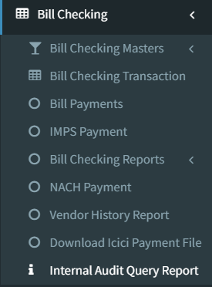

Fig: Internal Audit Query Report (menu)

Once user clicks on internal audit query report ,menu, it will display following fields:

* From Date
* To Date
* Employee
* Filter button
* Reset button
* Export button

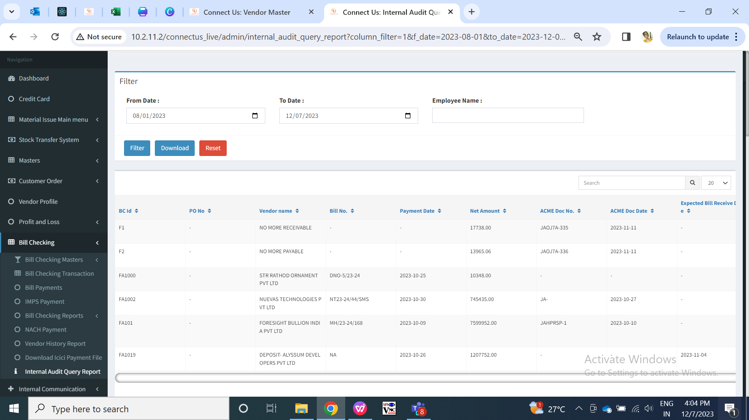

Fig: Internal Audit Query Report (Grid)

|  |  |  |  |
| --- | --- | --- | --- |
| **FIELDS** | **INPUT TYPE** | **MANDATORY/ OPTIONAL** | **DESCRIPTION** |
| From Date | Calender Date Picker | Mandatory | User will select the date from which auditor has written the remark in the bill.  Validation:- Display dates till current date. Future dates will be disabled. |
| To Date | Calender Date Picker | Mandatory | User will select the date till which auditor has written the remark in the bill.  Validation:- Display dates till current date. Future dates will be disabled. Dates before ‘from date’ will be disabled. |
| Employee | Drop-down | Optional | User will select the employees to whom the bill is assigned back to. (we are selecting the employees which will be displayed in “assigned bill from” in the report.)  Validation: - Only active employees from employee master will be displayed. |

Once user clicks on filter, the report will be displayed below with following columns:

* BC ID
* PO NO.
* Vendor name
* bill no.
* Payment date
* Net amount
* Acme doc no.
* Acme doc date
* Expected bill receive date
* Internal audit remark
* Bill type
* Bill sub type
* Assign from
* Assign to
* Amount
* Bill date
* Receive date
* Hold amount
* Actual paid
* Internal audit remark at
* Internal audit remark by

The details will be displayed as per bills details in add / edit / view and payment status action.

Here, if any bill is having more than one internal audit remark then that bill should be displayed in the report for the number of times the internal audit remarks are mentioned. Example: If F1234 bill has three internal audit remark as Query on 10/09/2023, check TDS on 13/09/2023 and bill not proper on 20/09/2023. Then in internal audit query report, this bill should be displayed thrice in a row with all details and specifying each internal audit remark in each row separately.

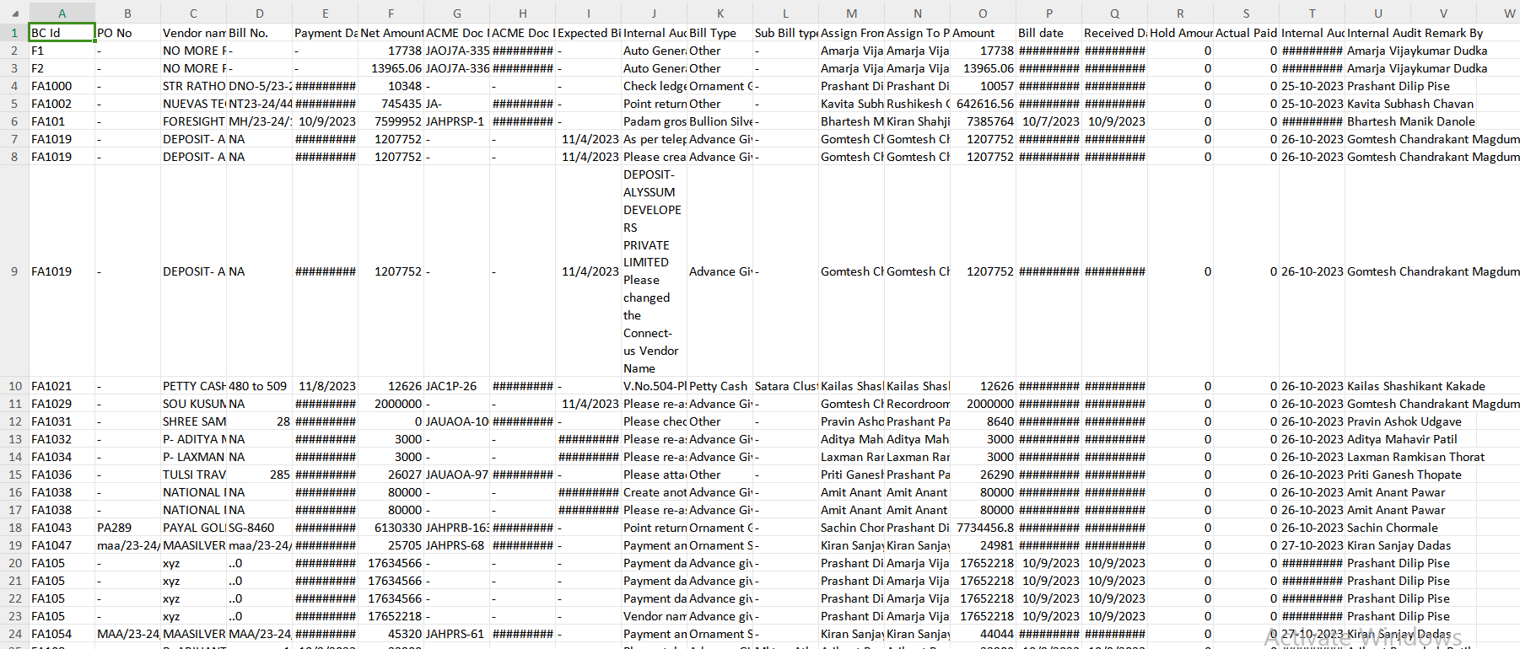

Fig: Inter Audit Query Report (Export)

1. **REFERENCES OF THE USERS**

|  |  |  |  |
| --- | --- | --- | --- |
| **User** | **Name** | **Mail** | **Contact number** |
| **Actual user** | Pritam metha | [ia@csjewellers.com](mailto:ia@csjewellers.com) |  |
| **Ticket created by (if any)** | Amar landge | [ia@csjewellers.com](mailto:ia@csjewellers.com) |  |
| **Assigned business analyst** | Manali bhadirage | Manali.bhadirage@techneai.com |  |
| **Assigned developer** | Punam shinde | Punam.shinde@techneai.com |  |
| **Assigned tester** |  |  |  |