CUSTOMER ORDER - COMPLETE STATUS

Manali Ashok Bhadirage

Manali.bhadirage@techneai.com

07.12.2023

**Handover Document**

**CONTENTS**

1. TICKET DETAILS 2

2. INTRODUCTION 2

3. BUSINESS REQUIREMENT 2

4. SCOPE 3

5. BUSINESS & SYSTEM RULES 3

6. ABBREVIATIONS & TERMS 3

7. GRAPHICAL REPRESENTATION 3

8. PROPOSED SYSTEM 4

9. REFERENCES OF THE USERS 6

1. **TICKET DETAILS**

|  |  |
| --- | --- |
| **Ticket ID** | TT13069 |
| **Ticket description** | Customer ne shop madhe Order deli asel Ani customer te order ghevun gele astil tar Padm Madhe Customer chi Order Completed Dakhavate.Paratu Connect Us Madhe Order Status update Hot nahi.te Order Connect Us Madhe pan Auto Completed zhali Paheje. |
| **Created by** | Reshma Sayyad |
| **Created on** | 10/06/2023 |
| **Priority** | high |

1. **INTRODUCTION**

In the Padm system, order numbers are generated for customer orders, GTS scheme orders, and Kalptaru scheme orders. These orders are then added to the "Customer Order -> Order Detail" menu in Connect Us by branch officials. Subsequently, the Head Office (HO) assigns these orders to Karagirs / Sub-Karagirs. Once the order is ready, HO changes the status so that order could be dispatched to branch. When the orders are ready for pickup, branches update their status from "CU Customer Order -> Order Detail" to indicate readiness.

Once customers arrive at the branch to collect their orders, a sales bill is generated in Padm using the already assigned order number. Generating the sales bill marks the order as completed within the Padm system. Simultaneously, branches are expected to update the order's status to "complete" in the "CU Customer Order -> Order Detail" section.

1. **BUSINESS REQUIREMENT**

Once the order gets marked as completed in Padm, that order should instantly & automatically get displayed as completed in connect us -> customer order as well.

|  |  |  |  |
| --- | --- | --- | --- |
| **Requirement ID** | **Requirement Name** | **Short Description** | **Priority** |
| BR001 | Order detail -> edit | User should be able to change status of order as completed (as per current working) | High |
| BR002 | Order details -> status | Once order gets marked as completed in Padm then it should be displayed as completed in grid, edit, view, history and export action of connect us -> order details. | High |

1. **SCOPE**

Once order note is created in Padm, it should be displayed in order status menu as well. User should be able to add order number in connect us -> customer order - order detail. User should be able to change status as ‘completed’ of the order through edit action. Once sales is generated in Padm, then order status of that order should be displayed as completed in Padm. At the same time, status of that order should be displayed as completed in connect us -> customer order - order detail.

1. **BUSINESS & SYSTEM RULES**

* User should be registered in the system.
* User should be logged in.
* System should display error message for incorrect details if entered.
* As per current working system, users should be able to edit order even when order status is completed.
* User can still manually change the status to ‘completed’ through edit action as per current system. We have to just make an addition of automatically changing the status once it gets displayed as completed in padm. (Padm orders will be synchronized by 12-2am each day and then order status will get updated in Connect Us)

1. **ABBREVIATIONS & TERMS**

NA

1. **GRAPHICAL REPRESENTATION**

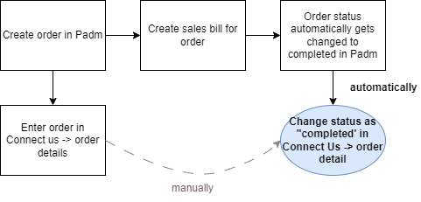

Fig: General Context Diagram

1. **PROPOSED SYSTEM**

Initially, order note is generated for any order at the branches through Padm -> customer order and order number gets displayed for it. Further, these orders are also added in connect us -> customer order -> order detail. In Connect Us order details -> action, it has following fields:

* Order number
* Order date
* Order delivery date
* Estimate pickup date
* Order pick up date
* Customer mobile no.
* Customer name
* Branch name
* Item name
* Category
* Wastage type
* Changed wastage
* Net wt
* Purity
* Salesman name
* Status
* Product group
* Tollfree remark
* Purchased from
* Salesbill no.
* Sales bill date
* Use
* Item details
* Catalog / stone / polish details
* Remarks / assign / receipt details
* Other details

Once order is entered through ‘import data’ button, it gets added in grid and its status is displayed as ‘unprocessed’ initially in grid, view and edit action. Further, branches inform HO about the order so that HO can look into this and change status of the order regularly through edit action of each order.

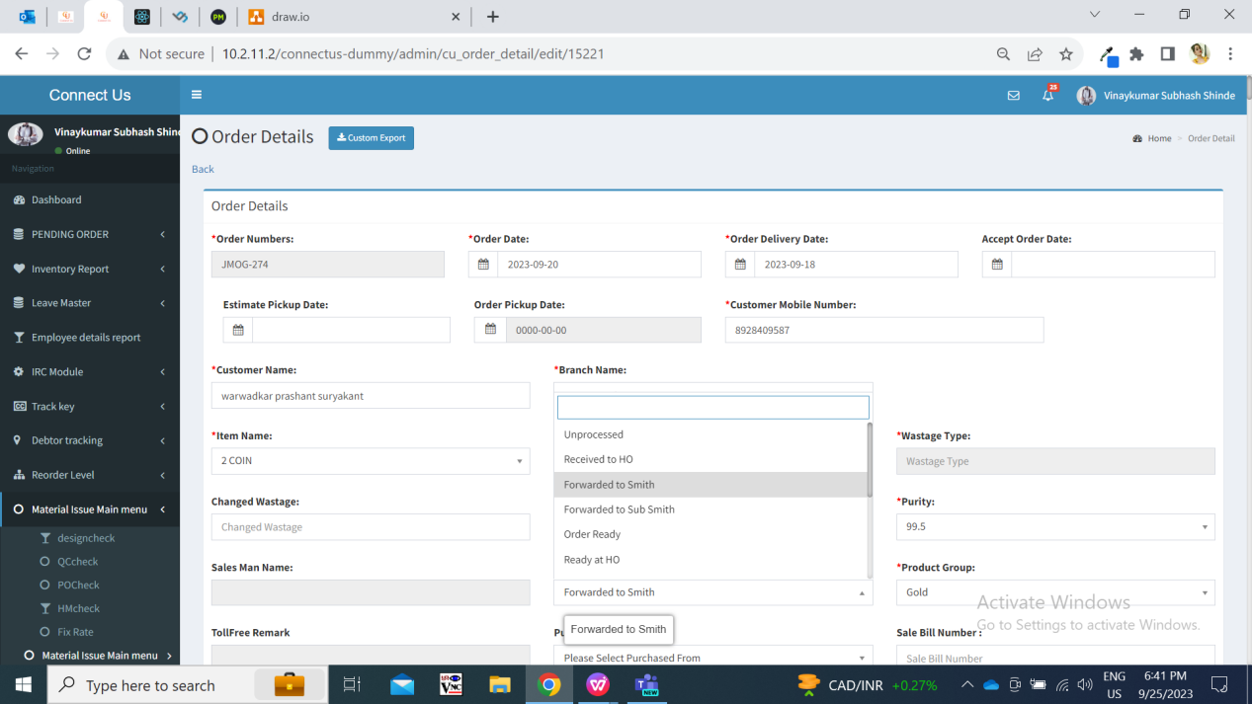

Once order is ready at HO, then further gets assigned to branch. Then branches changes the status of that order to ready at Branch so that customer can collect the order from branch. Once status is displayed as ‘ready at branch’ toll free users contact the customer to give update about collection of the order.

At the same time, the status of the order gets displayed as not completed on Padm -> order status till the time sales bill is not generated against that order number.

Once sales bill is generated for the order number in Padm, then the status of the order number gets automatically displayed as order completed in Padm.

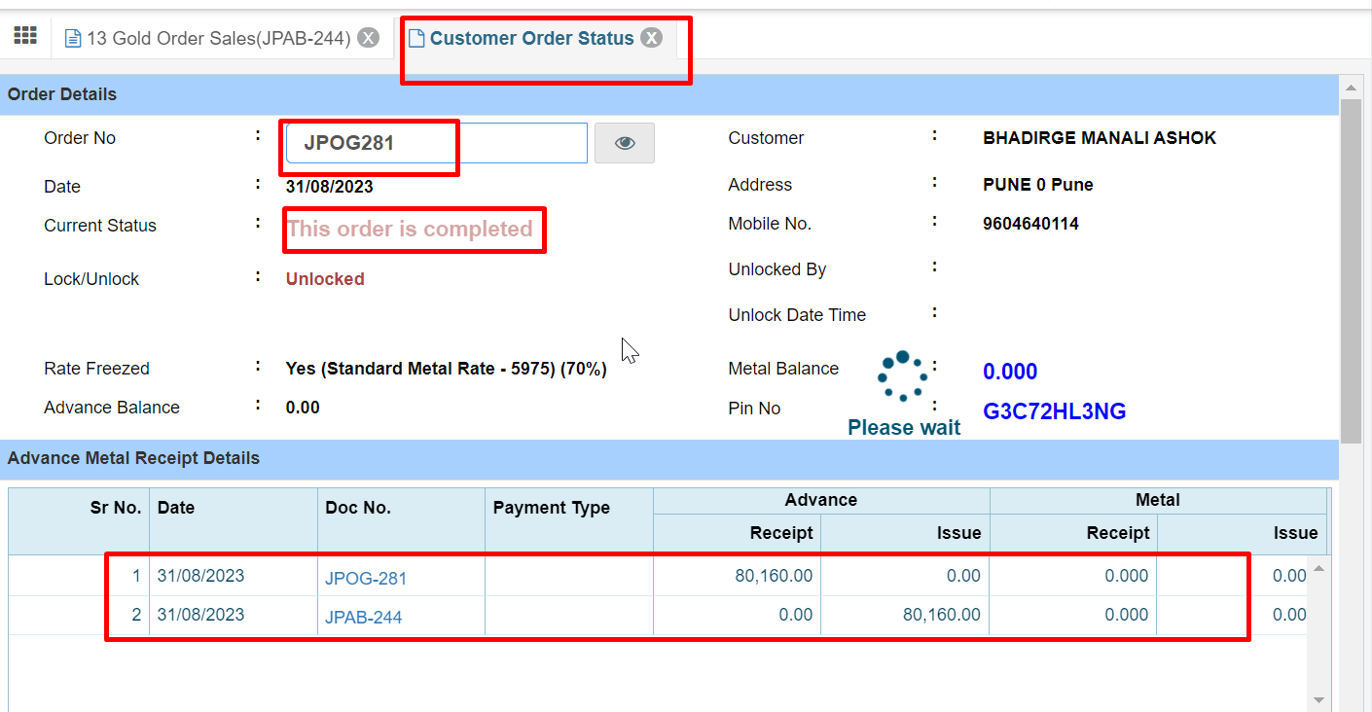

Once the order gets marked as completed in Padm, then all Padm orders should be synchronized with Connect Us each day at 2 am and updated order status should be displayed as completed in Connect Us as well. Status should be displayed in grid, view, edit and export action.

1. **REFERENCES OF THE USERS**

|  |  |  |  |
| --- | --- | --- | --- |
| **User** | **Name** | **Mail** | **Contact number** |
| **Actual user** | Reshma sayyad | hobdd@csjewellers.com |  |
| **Ticket created by (if any)** | Reshma sayyad | hobdd@csjewellers.com |  |
| **Assigned business analyst** | Manali bhadirage | Manali.bhadirage@techneai.com |  |
| **Assigned developer** | Prathmesh shinde | Prathmesh.shinde@techneai.com |  |
| **Assigned tester** | Amreen shaikh | Amreen.shaikh@techneai.com |  |