18.10.2023

**USER MANUAL HANDOVER**

IMPS PAYMENT

Manali ashok bhadirage

Manali.bhadirage@techneai.com

**CONTENTS**

1. VERSION CONTROL 2

2. INTRODUCTION 2

3. SCOPE 2

4. BUSINESS & SYSTEM RULES 2

5. ABBREVIATIONS & TERMS 2

6. GRAPHICAL REPRESENTATION 2

7. DEVELOPED SYSTEM 2

8. TEST DATA AND BUSINESS SCENARIOS 3

1. **VERSION CONTROL**

|  |  |  |  |  |  |  |
| --- | --- | --- | --- | --- | --- | --- |
| **Sr. No.** | **Version no** | **Version Date** | **User name** | **User department** | **Updated By** | **Ticket ID** |
| **1** | **1.0** | **18/10/2023** | **Firoj Shaikh**  **Rohan Shah** | **Treasure** | **Manali Bhadirage** | **TT12838**  **TT12988**  **TT14060 TT14064** |
|  |  |  |  |  |  |  |
|  |  |  |  |  |  |  |

1. **INTRODUCTION**

IMPS payment, a sub-module in Connect US -> Bill Checking, is used during 12 URD purchase transactions done in Padm. The payments of URD purchases are processed through IMPS payment module i.e. we have to pay the mentioned payment amount to the customer. The user enters the document series number from Padm and the data as per document number gets displayed. Further these bills are assigned to another user. The authorized person verifies the bill and then changes the status hold / hold till audit / release / paid. Once payments status is changed to release then that bill gets displayed in list of download payment. Moreover, once user enters the bank file then the successful payments get displayed as paid in imps payment module. IMPS payments are supposed to be done to the customer within 2-4 hours on the same day when series is added in the CU system.

1. **SCOPE**

Once user / cashier enters the Padm document number in IMPS payment -> add action -> series field, then all the details of the customers will be displayed as per entered document number. User will fill other details of the add form, select assigned to user and click on submit. Once bill is submitted, it will be displayed in the top row of the grid. Whereas, the assigned to user will be having authority to edit that bill and other users can only view the bills. Once assigned to user changes the status of the bill to release, then that released bill will be displayed in bill payments. Once the user downloads the text file of the released bills, then its status will get automatically changed as confirmation pending. Further, once the payment is done from bank, then user will have to upload the bank text file in the imps payment -> auto update payment. Once the file is uploaded, status of successful transactions will automatically changed to paid.

All the details which are edited, those will be displayed in view action, payment detail action and grid. Moreover, users can search bills through filter by applying multiple filters and download excel file.

1. **BUSINESS & SYSTEM RULES**

* User should be registered in the system.
* User should be logged in.
* System should pop up a message, if any issues in the system is detected.
* All forms should have on field validations. System should display on field errors in case of incorrect inputs.
* Release / paid statuses will be provided based on authority.
* Download payment and auto-update payment buttons will be displayed based on authority.

1. **ABBREVIATIONS & TERMS**

IMPS - Immediate Payment Service

IFSC code - Indian financial system code

RTGS - Real time gross settlement

NEFT - national electronic fund transfer

1. **GRAPHICAL REPRESENTATION**

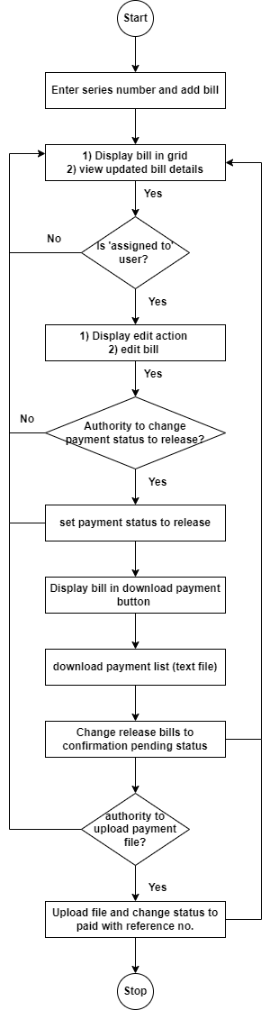

Fig: process flow diagram

1. **DEVELOPED SYSTEM**

Once user clicks on IMPS payment module, it will display following fields:

* Add button
* Export button
* Download payment button
* Auto update payment button
* Filter button
* Reset button
* Edit button
* View detail button
* Payment detail button
* History button
* ID
* IMPS ID
* #
* Series
* Payment status
* Customer name
* Mobile no.
* Address
* Transaction
* Assign to
* Branch name
* Payment date
* Padm credit balance
* Payment amount
* Adjust amount
* IFSC code
* Type
* Bank name
* Bank branch
* Account number
* Confirm account number
* Attachment
* Remark
* Submit button
* Entry user name
* Active
* Created at
* Entry time
* Updated by
* Updated at
* Amount to be paid
* Status
* Actual payment date
* Reference no.
* Till date
* Acme balance
* Total payment amount
* Upload button
* Cancel button
* User agent
* IP address

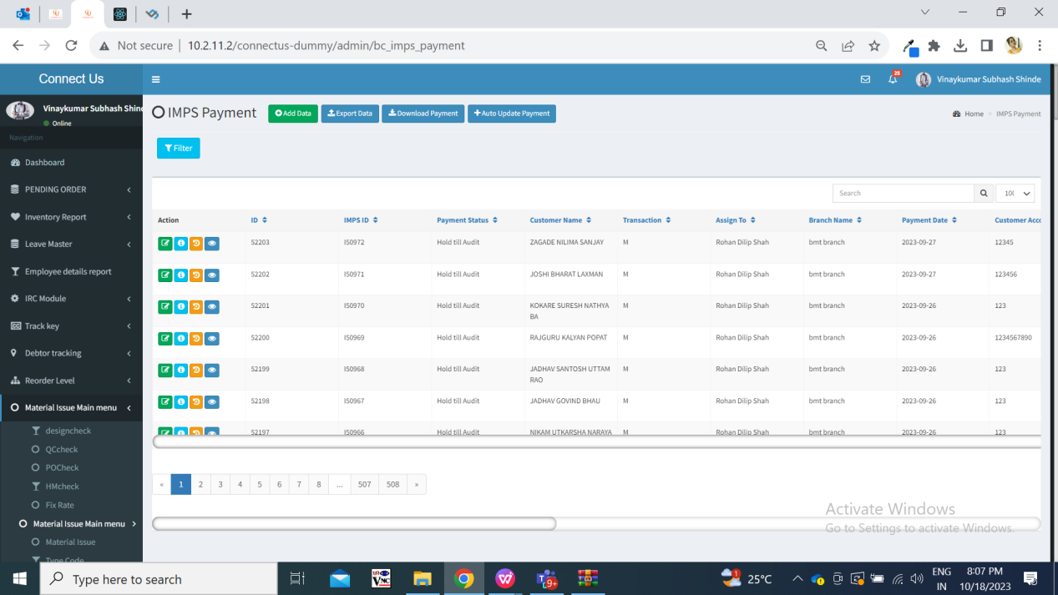

Fig: IMPS Payment grid

Visibility of fields in pages:

|  |  |  |  |  |  |  |  |  |  |
| --- | --- | --- | --- | --- | --- | --- | --- | --- | --- |
| **FIELDS** | **ADD** | **GRID** | **EDIT** | **VIEW** | **PAYMENT DETAIL** | **FILTER** | **DOWNLOAD PAYMENT** | **AUTO UPDATE PAYMENT** | **HISTORY** |
| Add button | **X** | **✓** | **X** | **X** | **✓** | **X** | **X** | **x** | **X** |
| Export button | **X** | **✓** | **X** | **X** | **X** | **X** | **X** | **x** | **X** |
| Download button | **✓**  **Authority based** | **✓**  **Authority based** | **✓**  **Authority based** | **✓**  **Authority based** | **✓**  **Authority based** | **X** | **✓**  **Authority based** | **x** | **X** |
| Auto update payment button | **✓**  **Authority based** | **✓**  **Authority based** | **✓**  **Authority based** | **✓**  **Authority based** | **✓**  **Authority based** | **X** | **X** | **x** | **X** |
| Filter button | **X** | **✓** | **X** | **X** | **X** | **✓** | **X** | **x** | **X** |
| Reset button | **X** | **✓** | **X** | **X** | **X** | **✓** | **X** | **x** | **X** |
| Edit button | **X** | **✓** | **X** | **X** | **X** | **X** | **X** | **x** | **X** |
| View detail button | **X** | **✓** | **X** | **X** | **X** | **X** | **X** | **x** | **X** |
| Payment detail button | **X** | **✓** | **X** | **X** | **X** | **X** | **X** | **x** | **X** |
| History button | **X** | **✓** | **X** | **X** | **X** | **X** | **X** | **X** | **X** |
| ID | **X** | **✓** | **X** | **X** | **✓** | **X** | **X** | **X** | **✓** |
| IMPS ID | **X** | **✓** | **✓** | **✓** | **X** | **✓** | **X** | **X** | **✓** |
| # | **X** | **X** | **X** | **X** | **✓** | **X** | **✓** | **X** | **X** |
| Series | **✓** | **✓** | **✓** | **✓** | **X** | **✓** | **X** | **X** | **✓** |
| Payment status | **X** | **✓** | **✓** | **✓** | **X** | **✓** | **✓** | **X** | **✓** |
| Customer name | **✓** | **✓** | **✓** | **✓** | **X** | **X** | **✓** | **X** | **✓** |
| Mobile no. | **✓** | **X** | **✓** | **✓** | **X** | **X** | **✓** | **X** | **X** |
| Address | **✓** | **X** | **✓** | **✓** | **X** | **X** | **X** | **X** | **X** |
| Transaction / Type | **✓** | **✓** | **✓** | **✓** | **X** | **✓** | **✓** | **X** | **✓** |
| Assign to | **✓** | **✓** | **✓** | **✓** | **X** | **✓** | **X** | **X** | **✓** |
| Branch name | **✓** | **✓** | **✓** | **✓** | **X** | **✓** | **X** | **X** | **✓** |
| Payment date | **X** | **✓** | **X** | **X** | **✓** | **✓** | **✓** | **X** | **✓** |
| Padm credit balance | **X** | **X** | **✓** | **✓** | **X** | **X** | **✓** | **X** | **X** |
| Payment amount | **✓** | **✓** | **✓** | **✓** | **X** | **✓** | **✓** | **X** | **✓** |
| Adjust amount | **✓** | **✓** | **✓** | **✓** | **X** | **X** | **X** | **X** | **✓** |
| IFSC code | **✓** | **✓** | **✓** | **✓** | **X** | **✓** | **✓** | **X** | **✓** |
| Bank name | **✓** | **✓** | **✓** | **✓** | **X** | **✓** | **X** | **X** | **✓** |
| Account number | **✓** | **X** | **✓** | **✓** | **X** | **X** | **✓** | **X** | **✓** |
| Confirm account number | **✓** | **X** | **X** | **✓** | **X** | **X** | **X** | **X** | **X** |
| Attachment | **✓** | **X** | **✓** | **✓** | **X** | **X** | **X** | **✓** | **X** |
| Remark | **✓** | **✓** | **✓** | **✓** | **X** | **X** | **X** | **X** | **✓** |
| Submit button | **✓** | **X** | **✓** | **X** | **X** | **X** | **✓** | **X** | **X** |
| Entry user name | **X** | **✓** | **✓** | **✓** | **X** | **✓**  **(assign from)** | **X** | **X** | **✓** |
| Active | **X** | **✓** | **✓** | **✓** | **X** | **X** | **X** | **X** | **✓** |
| Entry time | **X** | **✓** | **✓** | **✓** | **X** | **✓** | **X** | **X** | **✓** |
| Updated by | **X** | **✓** | **X** | **✓** | **X** | **X** | **X** | **X** | **✓** |
| Updated at | **X** | **✓** | **X** | **✓** | **X** | **X** | **X** | **X** | **✓** |
| Amount to be paid | **X** | **X** | **X** | **✓** | **✓** | **X** | **X** | **X** | **X** |
| Status | **X** | **X** | **X** | **✓** | **✓** | **✓** | **X** | **X** | **X** |
| Actual payment date | **X** | **X** | **X** | **✓** | **✓** | **X** | **X** | **X** | **X** |
| Reference no. | **X** | **X** | **X** | **✓** | **✓** | **X** | **X** | **X** | **X** |
| Till date | **X** | **X** | **X** | **X** | **X** | **X** | **✓** | **X** | **X** |
| Total payment amount | **X** | **X** | **X** | **X** | **X** | **X** | **X** | **X** | **X** |
| Upload button | **X** | **X** | **X** | **X** | **X** | **X** | **X** | **✓** | **X** |
| Cancel button | **X** | **X** | **X** | **X** | **X** | **X** | **X** | **✓** | **X** |
| User agent | **X** | **X** | **X** | **X** | **X** | **X** | **X** | **X** | **✓** |
| IP address | **X** | **X** | **X** | **X** | **X** | **X** | **X** | **X** | **✓** |

**Step 1. Add series number**

|  |  |  |  |  |
| --- | --- | --- | --- | --- |
| **FIELDS** | **INPUT TYPE** | **MANDATORY/ OPTIONAL** | **EDITABLE** | **DESCRIPTION** |
| Series number | text | Mandatory | No | User will enter the document number from Padm -> document -> 12 Gold URD purchase.  Validation: It will be unique. It should not accept space. It should accept hyphen - only as special character. Initial four values should be letters.  Max value = 15  Min value = 9 |
| Branch name | text | Mandatory | No | It displays the branch name of the logged in person who is adding bill. It displays the branch of logged in person as mentioned in employee master against that logged in person.  Validation: It will be read only. |
| Customer name | Text | Mandatory | no | Once user enters the document number, then it will pre-fill and display the customer name from number against entered series number from Padm.  Validation: It will be read only. |
| Mobile number | Text | Mandatory | no | Once user enters the document number, then it displays the mobile number of the customer from number against entered series number from Padm.  Validation: It will be read only. |
| Address | Text | Mandatory | no | Once user enters the document number, then it will pre-fill and display the address of the customer from number against entered series number from Padm.  Validation: It will be read only. |
| Adjust amount | Text | Optional | yes | User manually enters the amount that is not to be considered for payment out of net payment.  Initially when document is scanned, adjust amount is zero. Whereas, user can enter amount in adjust amount that is to be deducted from payment of the customer.  Validation: It will accept only numbers. It will accept decimal point only once. It will not accept special characters or characters. |
| Padm credit balance | Text | Mandatory | no | It displays the net payment value as per entered series number.  This field is named as padm balance in edit action which means same.  Validation: It will be read only. |
| Payment amount | Text | Mandatory | no | Once document number is entered, the net payment amount of that document will be displayed here in payment amount field.  Further, if any value is entered in adjust amount field, then it will calculate and display amount which is to be paid to the customer. Payment amount = Padm credit balance - adjust amount  Validation: It will be read only. It shouldn’t be zero or negative. |
| Assign to | Drop-down | Mandatory | yes | It displays the name of the user to whom the bill is to be assigned. (currently we have only added Rohan shah / Rajesh barse name in the list as only they are handling URD bills)  Validation: It is single select. |
| Type | Drop-dwon | Mandatory | yes | By default it displays M- Imps from the list whereas user can change it from the drop-down.  It has RTGS, NEFT and M IMPS in the list.  Validation: It is single select. |
| Bank name | Drop down | Mandatory | Yes | User will select the customer’s bank name from the list.  Validation: It will be single select. |
| Bank branch | text | Mandatory | Yes | User will enter the customer’s bank branch name.  Validation: Maximum 25 digits / characters should be accepted. |
| IFSC code | text | Mandatory | Yes | User will enter the bank IFSC code.  Validation: Maximum 11 digits will be accepted. User will not be able to enter more than 11 digits. In case user enters less than 11 digits and submits bill, then it will display on field validation error message. It will not accept space. |
| Account number | text | Mandatory | Yes | User will enter the customer’s bank account number.  As and when user enters the account number, each input will be displayed with asterisk. User will not be able to copy it. It will not be encrypted in view, grid, edit action.  Validation: Maximum 25 digits will be accepted. It will not accept space. |
| Confirm account number | text | Mandatory | - | User will enter the customer’s bank account number as same as entered in above account number field.  Validation: Maximum 25 digits will be accepted. It will not accept space. It will display error message if account number is not as same as account number field. |
| Attachments | Attach | Mandatory | Yes | User will attach the images of customer’s account document like passbook, cheque, purchase bill invoice, padm bill, etc.  Validation: It should accept maximum 25 attachments. It should accept png, jpg, jpeg, pdf, doc, heic, webp file extensions only. |
| Remark | text | Optional | yes | User will mention the additional comments in this section.  It is optional in add action whereas it is mandatory to mention remark in edit action.  Validation: Maximum 250 characters / digits. |
| Is Active (if unchecked, bill will be canceled) | Check box | mandatory | Yes (based on authority) | It will be displayed in edit action only after bill is created. It will be displayed based on authority from login special auth.  Validation: By default it will be unchecked that means bill will be active. |
| Submit | Click | - | - | Once bill is submitted, ID for bill will be created and bill will be displayed in the imps payment grid of the assigned person.  Also, it will be displayed in the logged in person’s grid as per branch assigned to him.  Once series is added, successful message will be displayed and user will be directed to grid page.  Once bill is added, then it will be displayed in top of grid. Assigned to person will have edit action for that bill whereas others can only view it. Also, # means serial number of that bill will be displayed.  Validation: It will be disabled until user gets directed to grid page after series gets added successfully. |
| Entry user | Text | - | No | Once series is added, the person who has added the document his/her name will be displayed as entry user name.  Validation: It will be read only. |
| Created at | Text | - | No | It will display the date and time when the document was added.  Validation: It will be read only. |
| Updated at | Text | - | - | It will display the date and time when the document was updated.  Validation: It will be read only. |
| Updated by | Text | - | - | It will display the employee name who updated the document.  Validation: It will be read only. |
| Total attachments | Attach / upload | - | Yes | Once attachments are attached, it will be displayed in view action and edit action. It will display the thumbnail. Once user clicks on thumbnail, image will get zoomed in.  In edit action, each thumbnail will have delete and download action. |
| # | Text | - | - | Once bill is added, then it will be displayed in top of grid to the assigned to person. # means unique serial number of that bill will be displayed. |

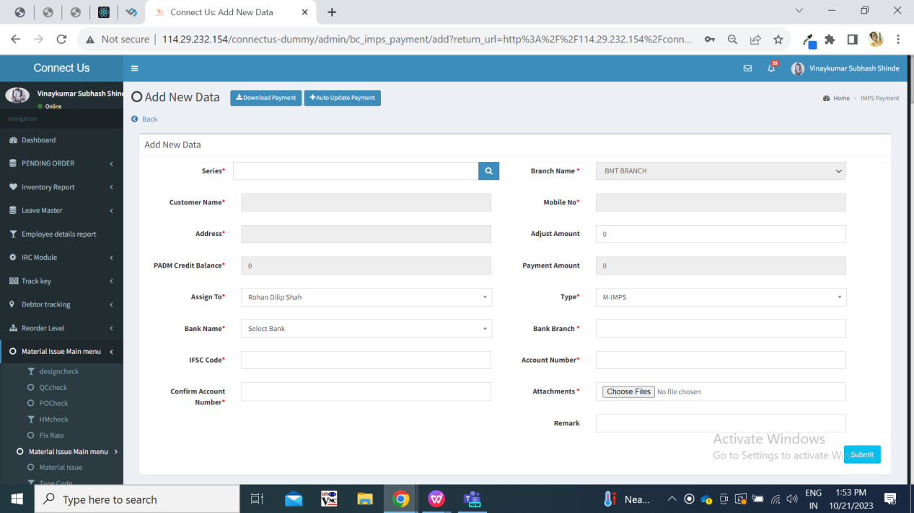

Fig: Add action

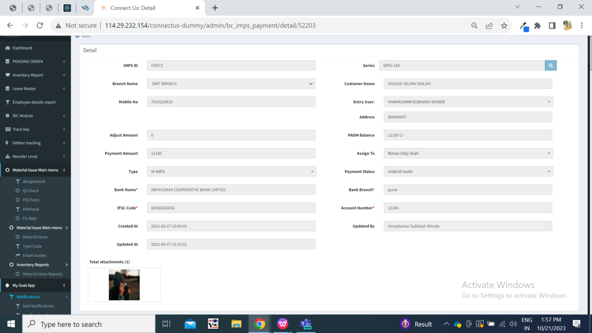

Fig: View action

**Step 2. Edit Document**

All the bills once added will be displayed in grid to all. However, Assigned to user will be able to edit the bills and others will have access to history, payment detail view and edit only. The assigned to person will be able to edit the editable fields of the bill through his grid -> edit action. It will have additional fields as IMPS ID, created at, payment status.

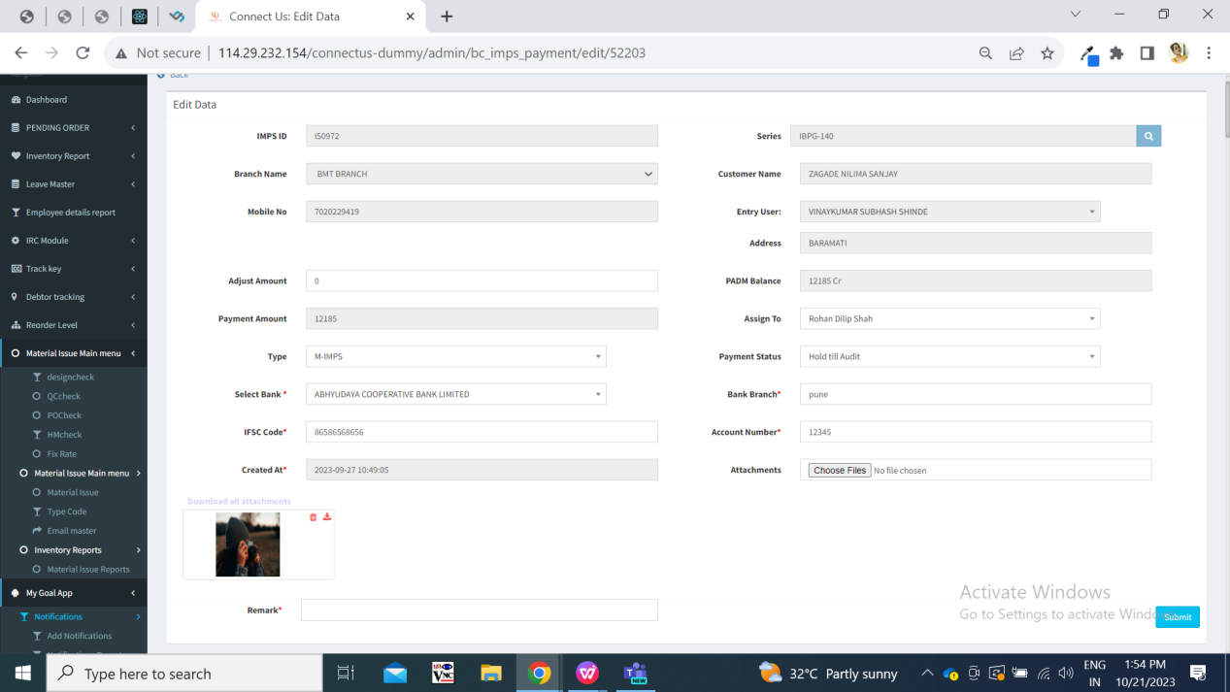

Fig: Edit action

|  |  |  |  |  |
| --- | --- | --- | --- | --- |
| **FIELDS** | **INPUT TYPE** | **MANDATORY/ OPTIONAL** | **EDITABLE** | **DESCRIPTION** |
| IMPS ID | Text | - | No | When bill is added, IMPS ID is incremental unique number for that bill for that financial year. Means currently its initial are I, then in next financial year it will be J. |
| Payment status | Drop down | Mandatory | yes | It will have hold, hold till audit, release and paid.  Release and paid status will be provided in the list based on authority.  Once the bill status is changed to release, then it will be displayed in download payment button list.  Once bill is marked as paid, then its edit action will be removed.  Validation: it will be single select. When new bill is added, then by default status will be hold till audit. |
| Created at | Text | Mandatory | No | It will display the date and time when bill was created.  Validation: it will be read only. |
| Attachments | Attach | Optional | Yes | It will be blank in edit action whereas it will display the already attached documents below it. Once user uploads any attachment here, it will display attachment name in the field.  In edit action, each thumbnail will have delete and download action.  Validation: It should accept maximum 25 attachments including already attached documents. It should accept png, jpg, jpeg, pdf, doc, heic, webp file extensions only. |

**Step 3. Display changes in history action**

Once bill is added then its entry will be displayed as insert in history action. Whereas, once that bill is edited then its entry will be displayed as update in history action. The fields which are changed those will be highlighted.

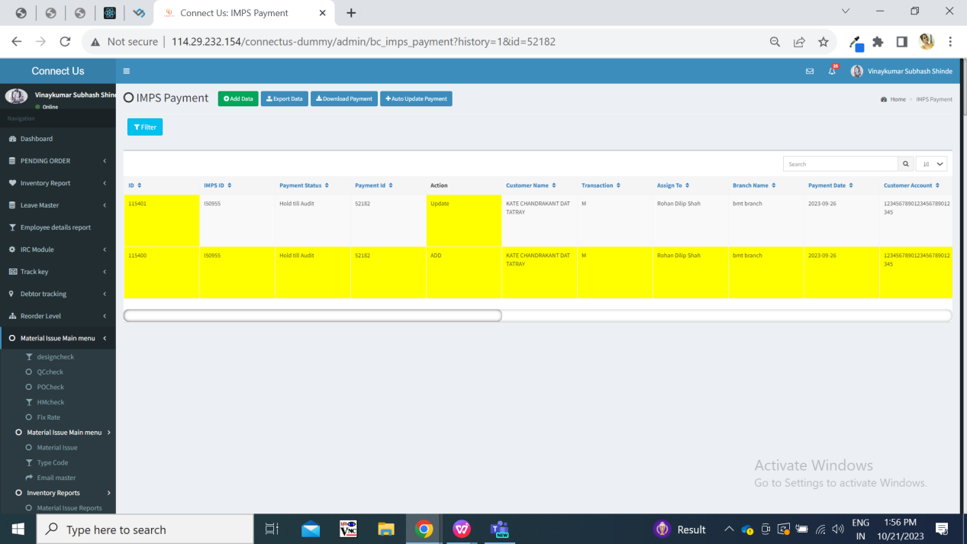

Fig: History

|  |  |  |  |  |
| --- | --- | --- | --- | --- |
| **FIELDS** | **INPUT TYPE** | **MANDATORY/ OPTIONAL** | **EDITABLE** | **DESCRIPTION** |
| Payment ID | Text | - | No | It is id from grid for that series. |
| User agent | Text | - | No | Those are the details of the operating system and browser of user's system who is adding or editing that bill. It will vary. |
| IP address | Text | - | No | It specifies the IP address of the system from which the series was added / updated. |

**Step 4. Payment Detail**

Once series is added in the system, then its entry will be displayed in payment detail.

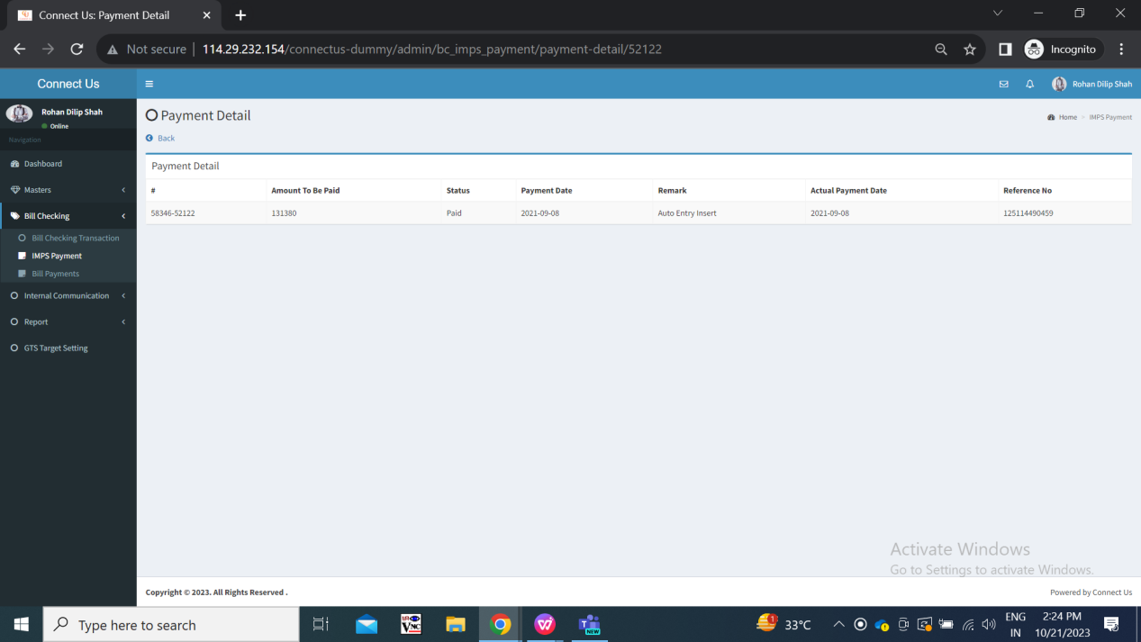

Fig: payment detail

|  |  |  |  |  |
| --- | --- | --- | --- | --- |
| **FIELDS** | **INPUT TYPE** | **MANDATORY/ OPTIONAL** | **EDITABLE** | **DESCRIPTION** |
| # | Text | - | No | When bill is added, IMPS ID is incremental unique number for that bill for that financial year. Means currently its initials are I, then in next financial year it will be J. |
| Amount to be paid | Text | - | No | It will display the payment amount as per series while added. |
| Status | Text | - | No | It will be payment status that has been edited in edit action -> payment status field.  In addition to this, when text file is download through download payment button, then release status will automatically get converted to confirmation pending.  It will also be displayed as paid when bank text file against that payment is uploaded through auto update button.  Validation: it will be read only. |
| Payment date | Text | - | No | It is the same date when bill is added. As these payment of the customers are supposed to be done within 2-4 hours, payment date of the bills are being displayed as the same day. |
| Remark | Text | - | No | Once bill is added then it will display remark automatically as ‘auto entry insert’.  Validation: it will be read only. |
| Actual payment date | Text | - | No | It is the date on which is mentioned on text file of auto update payment. It is the date on which the payment is done successfully for this transaction. |
| Reference no. | Text | - | No | Once the payment is marked as paid when file is uploaded on auto update payment button, then the reference no,. of that payment gets displayed as per bank file.  Validation: it will be read only. It contains only 12 digits. |

**Step 4. Download payment button**

All the payments whose status is release will be displayed in download payment list here.

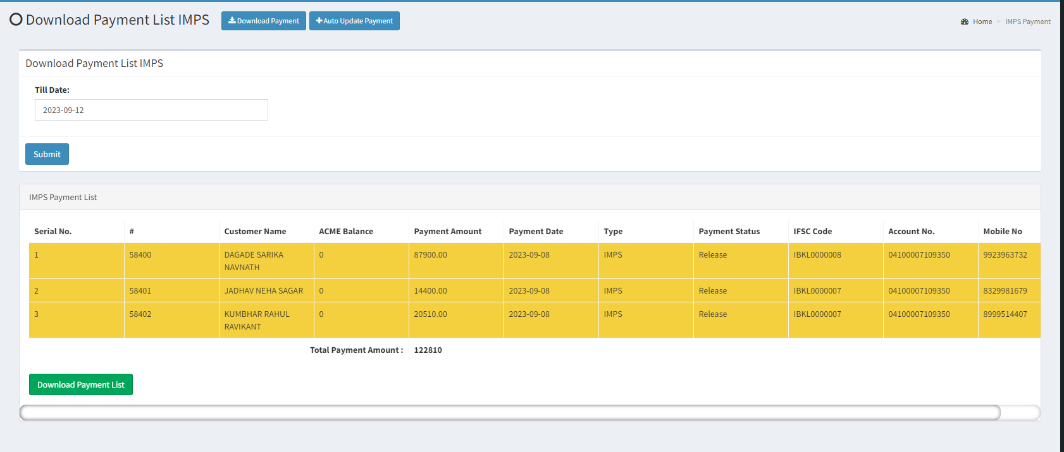

Fig: download payment

Below are the details of the downloaded text file and the uploaded text file:   


|  |  |  |  |  |
| --- | --- | --- | --- | --- |
| **FIELDS** | **INPUT TYPE** | **MANDATORY/ OPTIONAL** | **EDITABLE** | **DESCRIPTION** |
| Till Date | Text | - | No | User will select the date till which the payments has to be done of the customers.  Once user selects the date, then it will display all the list of series which are in release state till the selected date.  Validation: Only one date can be selected. |
| Submit | Click | - | - | Once user selects the date, then it will display all the list of series which are in release state till the selected date.  Validation: it will be disabled until list is displayed below. |
| Sr no. | Text | - | - | It will display the serial no. For each series that are in release state. |
| # | Text | - | - | It will display the # number of that bill as in grid. It is also same as the one displayed in payment detail action of that bill. |
| Customer name | Text | - | - | It will display the name of the customer for that bill. |
| Acme balance | Text | - | - | It will display acme balance from padm. |
| Payment amount | Text | - | - | It will display the payment amount of that bill as in view / edit/ payment detail action. |
| Type | Text | - | - | It will display the type of the payment as in view / edit action for that series. |
| Payment status | Text | - | - | It will display release status for all the bills as here only released bills will be displayed. |
| IFSC code | Text | - | - | It will display IFSC code of that customer which was mentioned in add / edit action for that series. |
| Account no. | Text | - | - | It will display account number of that customer which was mentioned in add / edit action for that series. |
| Mobile no. | Text | - | - | It will display mobile number of that customer which was mentioned in add / edit action for that series. |
| Total payment amount | Text | - | - | At bottom of the bills, it will display the sum of all payment amounts in the list. |
| Download payment list | Click | - | - | Once user clicks on download payment list button, then all the bills which were mentioned in list those status get automatically changed to confirmation pending.  Also, the text file will get downloaded which will have details of all the bills as in the list.  The bills which are included in the downloaded text file,will not get downloaded again another time in text file. |

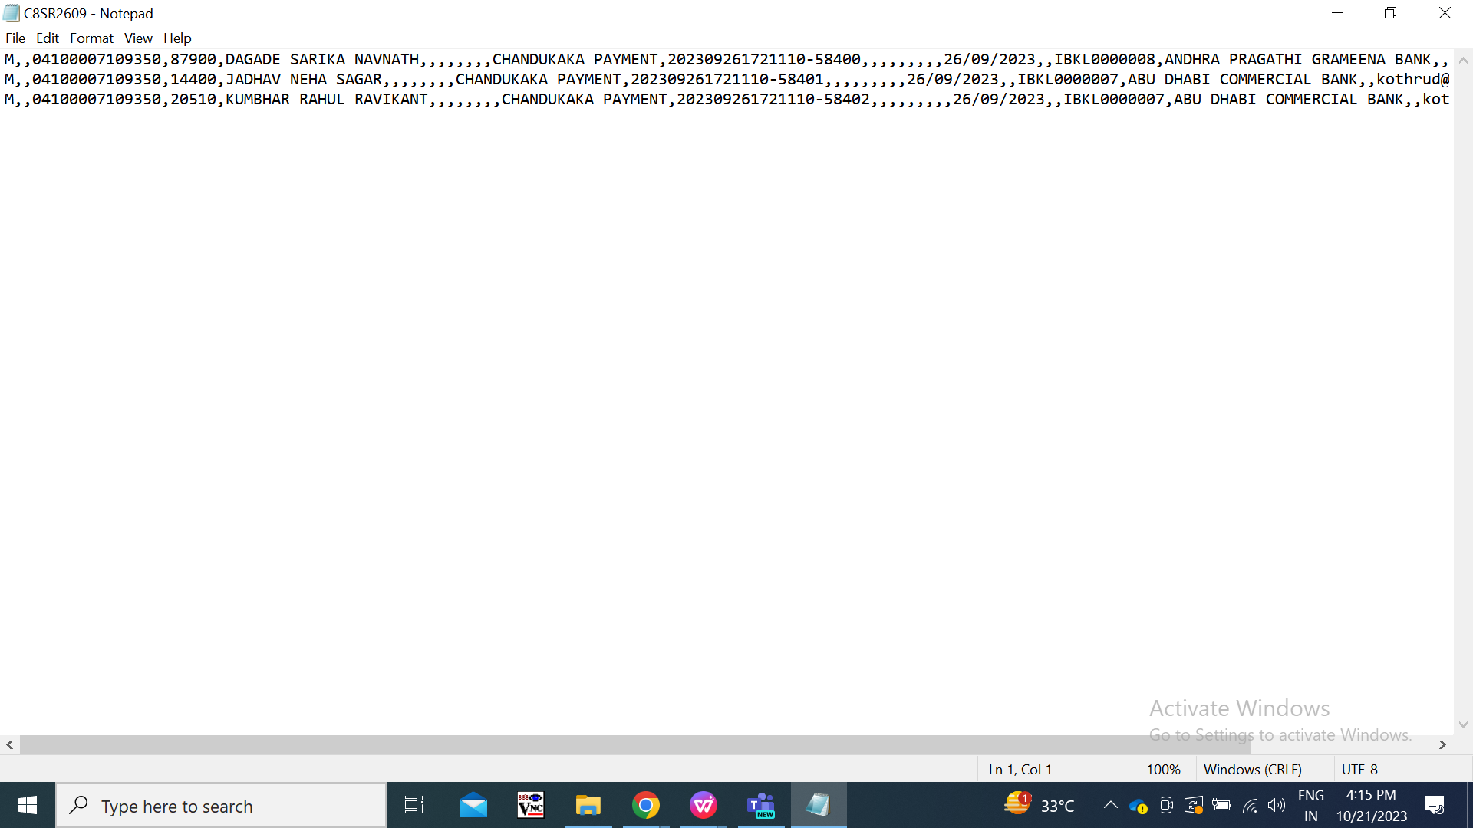

Fig: Download payment list -> text file





**Step 5. Auto update payment**

Once the payment is done successfully by the bank, then the authorized user will have to upload the bank text file so that confirmation pending status of the bills will get changed to paid. Also, these paid bills will be added in padm -> document -> bank payment HO.

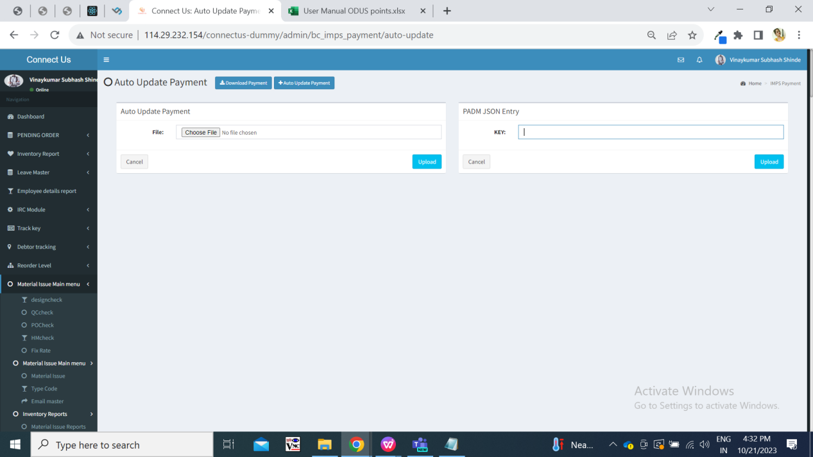

Fig: Auto update payment

|  |  |  |  |  |
| --- | --- | --- | --- | --- |
| **FIELDS** | **INPUT TYPE** | **MANDATORY/ OPTIONAL** | **EDITABLE** | **DESCRIPTION** |
| File | Attach | Mandatory | No | User have to upload the bank text file here through which the status of confirmation pending bills will get changed to paid automatically for successful transactions from bank.  Once bills status changes as paid , it will be displayed in payment detail, view, grid and history action for that series.  Validation: Single text file can be uploaded. |
| Cancel | Click | - | - | Once user clicks on cancel button, then file if attached or json key if mentioned, it will get reset.  Validation: it will be disabled until pre-filled field gets reset. |
| Submit | Click |  |  | Once user attached file and clicks on submit button, then bill status gets changed to paid successfully and successful message will be displayed. Also, these paid bills will be added in padm -> document -> bank payment HO.  Else if file attached was incorrect, then it will display error message.  Validation: It will be disabled until file gets uploaded successfully or until error message gets displayed in case of invalid upload. |

**Step 6. Filter**

User can search the series which are added in the system and view its details. User can search bill by applying one or multiple filters. If user applies multiple filters at a time, then it will display the filtered series in grid as per selected filters.

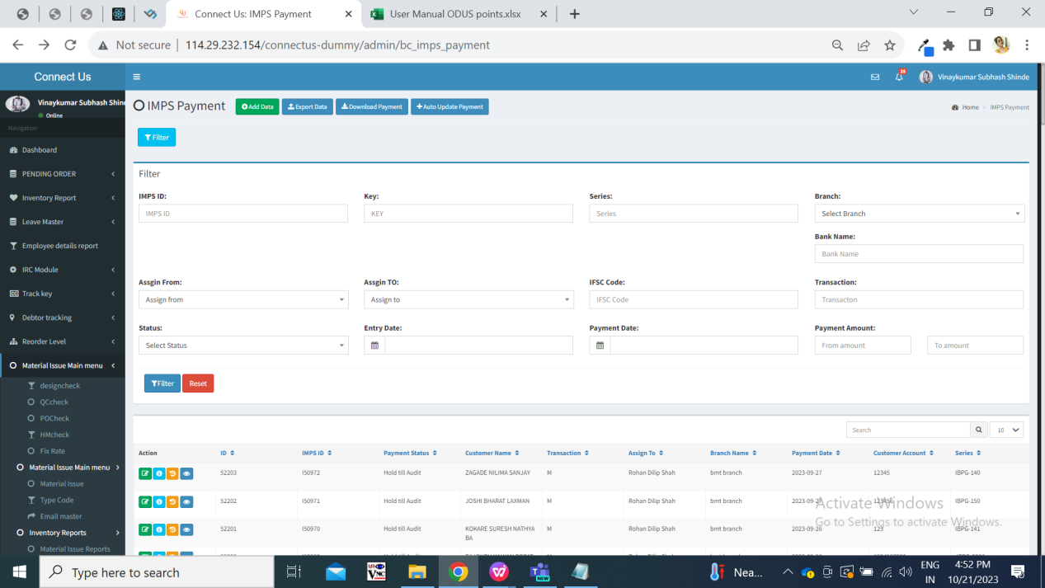

Fig: Filter

|  |  |  |  |  |
| --- | --- | --- | --- | --- |
| **FIELDS** | **INPUT TYPE** | **MANDATORY/ OPTIONAL** | **EDITABLE** | **DESCRIPTION** |
| IMPS ID | Text | - | - | User will enter the valid imps id here to search that series.  If user enters incorrect imps id and clicks on filter, then blank record will be displayed in grid.  Validation: Only one imps id can be searched at a time. It shouldn’t accept special character or space. |
| Series | Text | - | - | User will enter the series number that users wants to search and will click on filter button. If the enter series number is correct then it will be displayed in the grid.  Validation: Only one series can be searched at a time. It shouldn’t accept special character or space. |
| Branch | Drop down | - | - | It will display the list of branches from branch master. User can search by entry branch means branch which is displayed whe entry user adds the series.  Validation: it will be single select. |
| Bank name | Text | - | - | User will have to manually enter the bank name of the customer and then it will display the searched result in grid after clicking on filter button. (User will have to enter the exact bank name as per bill)  Validation: Maximum 25 digits / characters should be accepted. It shouldn’t be case sensitive. |
| Assign from | Drop down | - | - | It will display the active employees from employee master. User can search by the entry user by selecting this filter.  Validation: it will be single select. |
| Assign to | Drop down | - | - | It will display the list of employees to whom the bills are assigned till the date. It will display the employees who are mentioned as ‘assigned to’ in the grid.  Validation: it will be single select. |
| Ifsc code | text | - | - | User will have to manually enter the ifsc code of the customer’s bank and then it will display the searched result in grid after clicking on filter button if that any bill was added with that ifsc code.  Validation: Maximum 11 digits should be accepted. It shouldn’t be case sensitive. It should not accept space or special characters. |
| Transaction | text | - | - | User can search series in grid by transaction type. User will have to enter either R / M / N.  Validation: user search by single transaction type at time. It should accept only one letter. It shouldn’t accept space or special characters. |
| Status | Drop down | - | - | It will display payment status as paid, release, hold , hold till audit and confirmation pending in the list.  Validation: It will be single select. |
| Entry date | Calender date picker | - | - | User can search the bills from the entry date means when series was added in the system by the entry user.  Validation: Only one date can be selected at time. |
| Payment date | Calender date picker | - | - | User can search the bills by the payment date means when payment for the bill is to be done on selected payment date.  Validation: Only one date can be selected at time. |
| Payment amount | Text | - | - | User can search by the payment amount of the bill. All the bills in range as entered ‘from amount’ and ‘to amount’ will be displayed.  Validation: it should accept numbers only. It should not accept space. It should accept decimal point only once. |
| Filter | click | - | - | Once user selects filters and clicks on search then the bills as per selected filters will be displayed. If there is no bill in the system as per applied single or multiple filters then grid will be displayed blank. |
| Reset | Click | - | - | Once user clicks on reset button then page will reload and all the pre-filled fields in filter will get reset. |

1. **TEST DATA AND BUSINESS SCENARIOS**

