28.11.2023

**USER MANUAL HANDOVER**

LASER MARKING

Manali Ashok Bhadirage

manali.bhadirage@techneai.com

**CONTENTS**

1. VERSION CONTROL 2

2. INTRODUCTION 2

3. SCOPE 2

4. BUSINESS & SYSTEM RULES 2

5. ABBREVIATIONS & TERMS 2

6. GRAPHICAL REPRESENTATION 2

7. DEVELOPED SYSTEM 3

8. TEST DATA AND BUSINESS SCENARIOS 21

1. **VERSION CONTROL**

|  |  |  |  |  |  |  |
| --- | --- | --- | --- | --- | --- | --- |
| **Sr. No.** | **Version no** | **Version Date** | **User name** | **User department** | **Updated By** | **Ticket ID** |
| **1** | **1.0** | **28/11/2023** | **Tushar Nikam** | **Inventory** | **Manali Bhadirage** | **TT3492** |
|  |  |  |  |  |  |  |
|  |  |  |  |  |  |  |

1. **INTRODUCTION**

Laser marking is a module through which user can laser mark few items out of document. Few lot numbers needs to be laser marked for the customer. Lot number consists of one or more items in it. Given that lot numbers are distributed among various employees for laser marking, users can specify the employee name responsible for each laser marking. Additionally, users can generate a comprehensive report that displaying list of items laser marked by each employee within a defined time-frame. Report will help user to analyze the total laser-marked items till date and assess the performance of individual employees.

1. **SCOPE**

IN SCOPE:- As per authority, user should be able to add the lot number through add form. Once user enters the lot number, list of items in that lot number along with its details will be fetched from padm -> document -> labeling voucher. Further, entry user will select the employee name against the item name and clicks on submit button. Added entry will be displayed in the grid on top. Lot number will be displayed in different rows as per different employee name selected. User should be able to add only new lot number and not the existing one. In addition to this, user should be able to add lot number by bulk upload option. Moreover, authorized user should be able to edit the employee name of already added record. Authorized user should be able to cancel or restore the records. User can search the record in grid by applying filters. History of the records should be displayed for each operation.

User should be able to view the collective laser marking report. User should be able to download reports.

OUT SCOPE:- As user will enter the lot number from Padm, the addition and edition of records under lot number are not in our scope.

1. **BUSINESS & SYSTEM RULES**

* User should be registered in the system. User should be logged in.
* System should display error message for incorrect details if entered.
* Authority to cancel, restore and edit record will be provided through login special auth mapping.

1. **ABBREVIATIONS & TERMS**

Lot number: Doc number-Series number

1. **GRAPHICAL REPRESENTATION**

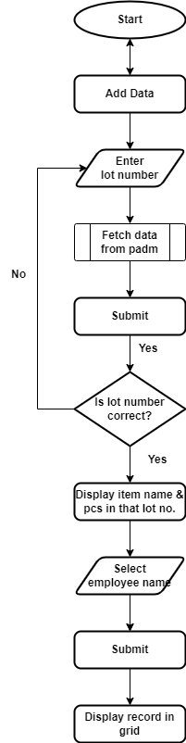

Fig: Process Flow Diagram

1. **DEVELOPED SYSTEM**

Laser marking has two sub-modules in it: add laser marking and laser marking report.

Through add laser marking sub-module, user can add document numbers which will consist of item name and specify the employee name who has laser marked it. Further, user can also edit, cancel and restore documents. Whereas, user can view report of the items that has been laser marked by employee.

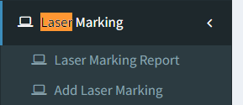

Add laser marking will have following fields:

* Add button
* Bulk format button
* Bulk upload button
* Filter button
* View button
* Edit button
* Cancel button
* Restore button
* History button
* Date
* Lot number
* Pcs
* Employee name
* Is cancel
* Created by
* Created at
* Updated by
* Updated at
* Sr. No.
* Doc no.
* Series no.
* Item name
* Submit button
* Reset button
* Action
* IP address
* From date
* To date

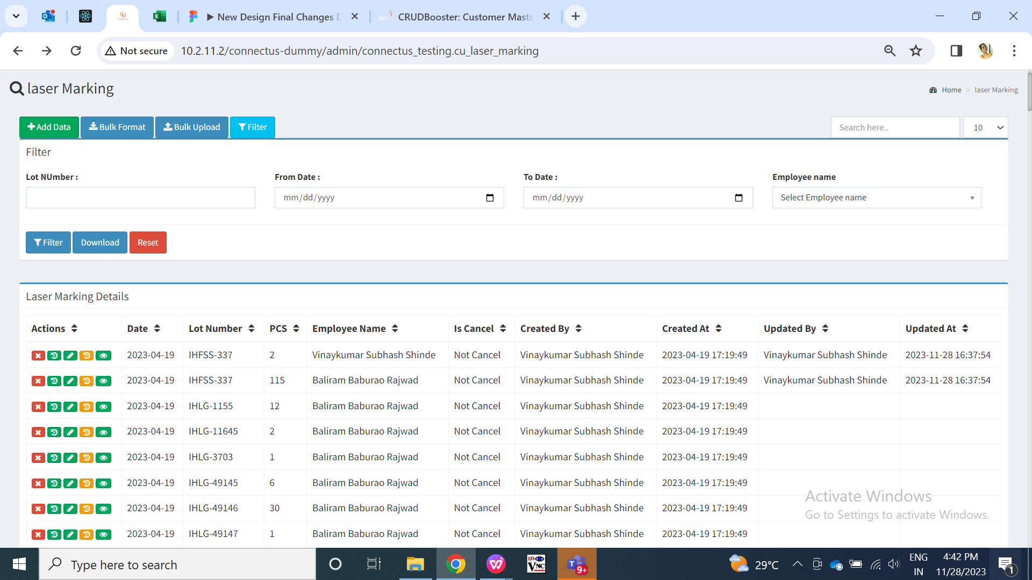

Fig: Add Laser marking -> grid page

Visibility of fields:

|  |  |  |  |  |  |  |  |
| --- | --- | --- | --- | --- | --- | --- | --- |
| **FIELDS** | **GRID** | **ADD** | **EDIT** | **HISTORY** | **FILTER** | **BULK FORMAT** | **VIEW** |
| Add button |  | X | X | X | X | X | X |
| Bulk format button |  | X | X | X | X | X | X |
| Bulk upload button |  | X | X | X | X | X | X |
| Filter button |  | X | X | X | X | X | X |
| View button |  | X | X | X | X | X | X |
| Edit button |  | X | X | X | X | X | X |
| Cancel button |  | X | X | X | X | X | X |
| Restore button |  | X | X | X | X | X | X |
| History button |  | X | X | X | X | X | X |
| Date |  |  |  |  | X | X |  |
| Lot number |  |  |  |  |  |  |  |
| Pcs |  |  |  |  | X | X |  |
| Employee name |  |  |  |  |  |  |  |
| Is cancel |  | X | X |  | X | X |  |
| Created by |  | X | X |  | X | X |  |
| Created at |  | X | X |  | X | X |  |
| Updated by |  | X | X |  | X | X |  |
| Updated at |  | X | X |  | X | X |  |
| Sr. No. | X |  |  |  | X | X |  |
| Doc no. | X |  | X | X | X | X | X |
| Series no. | X |  | X | X | X | X | X |
| Item name | X |  |  |  | X |  |  |
| Submit button | X |  |  | X | X | X | X |
| Reset button | X |  | X | X | X | X | X |
| Action | X | X | X |  | X | X | X |
| IP address | X | X | X |  | X | X | X |
| From date | X | X | X | X |  | X | X |
| To date | X | X | X | X |  | X | X |

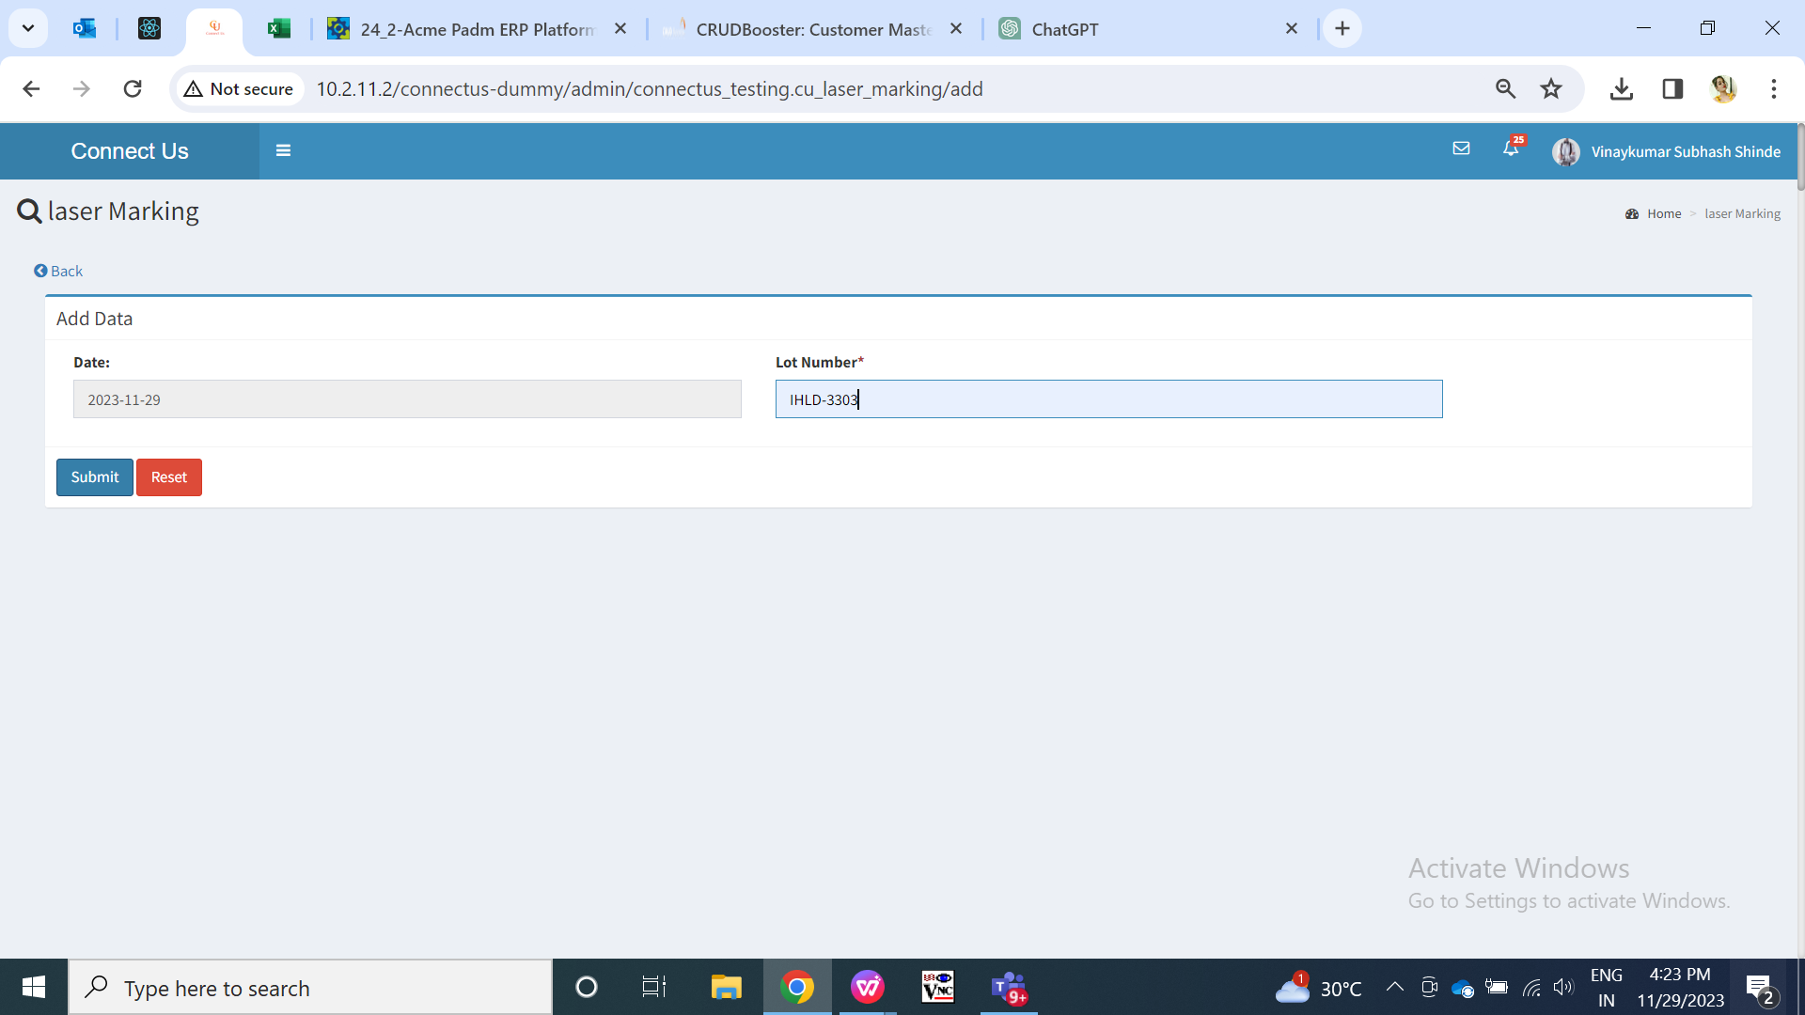

Fig: Add (before submitting lot number)

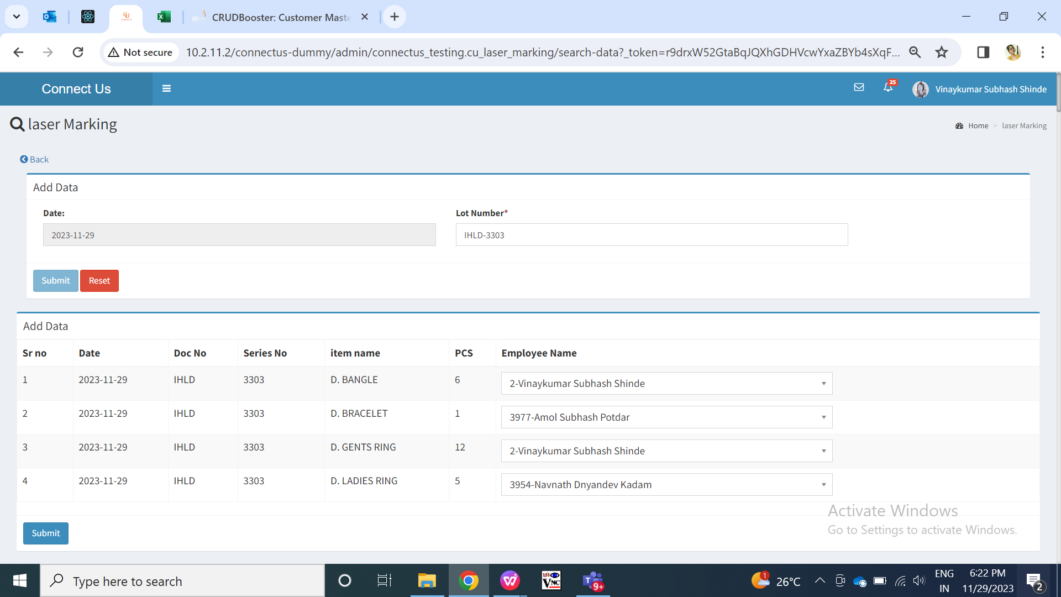

Fig: Add (after entering lot number)

|  |  |  |  |  |
| --- | --- | --- | --- | --- |
| **FIELDS** | **INPUT TYPE** | **MANDATORY/ OPTIONAL** | **EDITABLE** | **DESCRIPTION** |
| Date | Calender date picker | Mandatory | No | It will be the date on which the lot number is laser marked.  It will display today’s date by default as the employee is adding lot number today. It will display today’s date for each item against that lot number in the list below while adding.  Whereas, for edit action, it will display the date on which the lot number was added / edited.  Validation: It will be read only. |
| Lot number | Text | Mandatory | No | User will enter the lot number from Padm -> documents -> labeling voucher gold / silver / diamond / MRP / forming. It will be combination of doc no. and series number.  Same lot number which is active in grid that cannot be entered again.  Lot number field will be disabled will be disabled once user clicks on submit and details against it gets displayed below.  Validation:- Only one document can be entered. It should accept alphanumeric value. It should accept only hyphen as special character. It shouldn’t accept space.  Min length = 6  Max length = 12 |
| Submit | click | - | - | Once user enters valid lot number and clicks on submit button, all the details of the items against that document will be displayed below.  In case user has entered invalid lot number format, it will display on field error message once user clicks on submit button. If entered lot number doesn’t exist in Padm, then it should display error message as ‘record not found’ after clicking on submit button.  Moreover, if user has entered already existing lot number and if it not canceled then same lot number shouldn’t get entered again. It should display error message as ‘record already exist’ after clicking on submit button.  Validation: It will be disabled once clicked until details against that lot number gets displayed below. |
| Reset | Click | - | - | Once user clicks on reset button, page will get reloaded and pre-filled lot number will get cleared.  Validation: Reset button should be disabled until page gets reloaded. |
| Sr. No. | Text | Mandatory | No | Once lot number is entered and submitted, it will display the list of items and its details which are available in that lot number. It will display serial no. For each item in the list. |
| Doc no. | Text | Mandatory | No | Once user enters the lot number and submit, it will display the doc number and series number of that number.  Example: In lot number IHLD-3303, IHLD is doc no. and 3303 is series.  Validation: It will be read only and displayed same for each of the item in the list. |
| Series | Text | Mandatory | No | Once user enters the lot number and submit, it will display the doc number and series number of that number.  Example: In lot number IHLD-3303, IHLD is doc no. and 3303 is series.  Validation: It will be read only and displayed same for each of the item in the list. |
| Item name | Text | Mandatory | No | As per entered lot number, it will display the list of all items in it from Padm while adding  Validation: it will be read only. |
| Pcs | Text | Mandatory | No | It will display total pcs of that item name in that lot number. number of pcs of each item will be displayed as per the line item entry of that item name in Padm lot number.  Example: Line item of ashtapailu in lot number IHLG-21477 is 3. So, when we add lot number IHLG-21477 in laser marking module, it will display pcs count as 3 for ashtpailu.  Validation: It will be read only.  Screenshot (20) |
| Employee name | Drop down | Mandatory | Yes | Edit action will be authority based. Authority to edit the data in this module needs to be given from masters -> general master -> login special auth.  User will select the ID and name of the employee who has laser marked that item name of that lot number. Employee will have to laser mark all the pieces of that item name in that lot number.  Initially, it will display the name of the logged in person in the drop-down while adding.  If user selects one or more employee name under the same lot number, then it will display entry in grid for each employee separately with the pcs count laser marked by that employee. Example: In lot number IHFSS-337, 21 pcs of ac payal sil and 9 pcs of payal (wt) sil are been marked by sachin and remaining have been marked by vinaykumar. So, in grid, it will display one row as lot number IHFSS-337 with total 30 pcs by Sachin. In another row, it will display as lot number IHFS-337 with total 87 pcs by vinaykumar. Further, when user clicks on edit action of that one of the row then it will display list of items that were laser marked by that employee only in that lot number.  Validation: It will display active employees in the list from employee master. It will be single select.    Fig: Grid (multiple entries if one lot number is laser marked by multiple employees) |
| Add : Submit 2 | Click | - | - | Once user clicks on submit button , record will get added and displayed on top row of grid. Successful message will be displayed. Moreover, if items of that lot number were laser marked by more than one employee, then those many rows will be displayed in grid for same lot number.  Validation: It will be disabled once user clicks on it until record gets added on grid. |
| Created at | Text | Mandatory | No | The name of the person who has added that lot number will be displayed in view, grid and history.  Validation: It will be read only. |
| Created at | Text | Mandatory | No | It will display the date and time when the lot number was added by the user.  Validation: It will be read only. |
| Updated at | Text | Mandatory | - | It will display the name of the user who edited and saved the record. |
| Updated by | Text | Mandatory | - | It will display the date and time when that record was modified. |

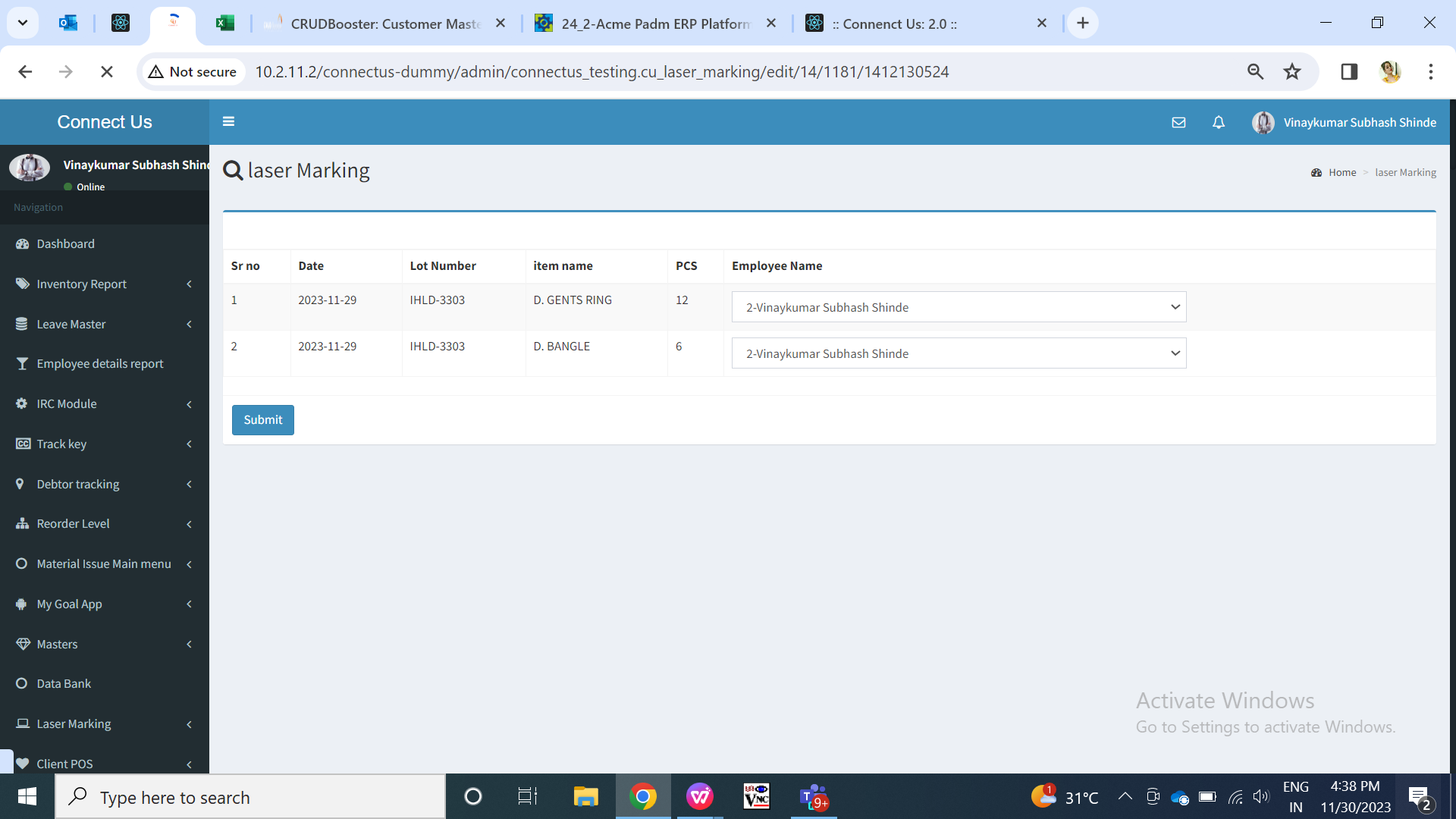

Fig: Edit

**Step 2. View**

Once user clicks on view action, it will display details of that particular record.If any item in that record is canceled, it will be highlighted.

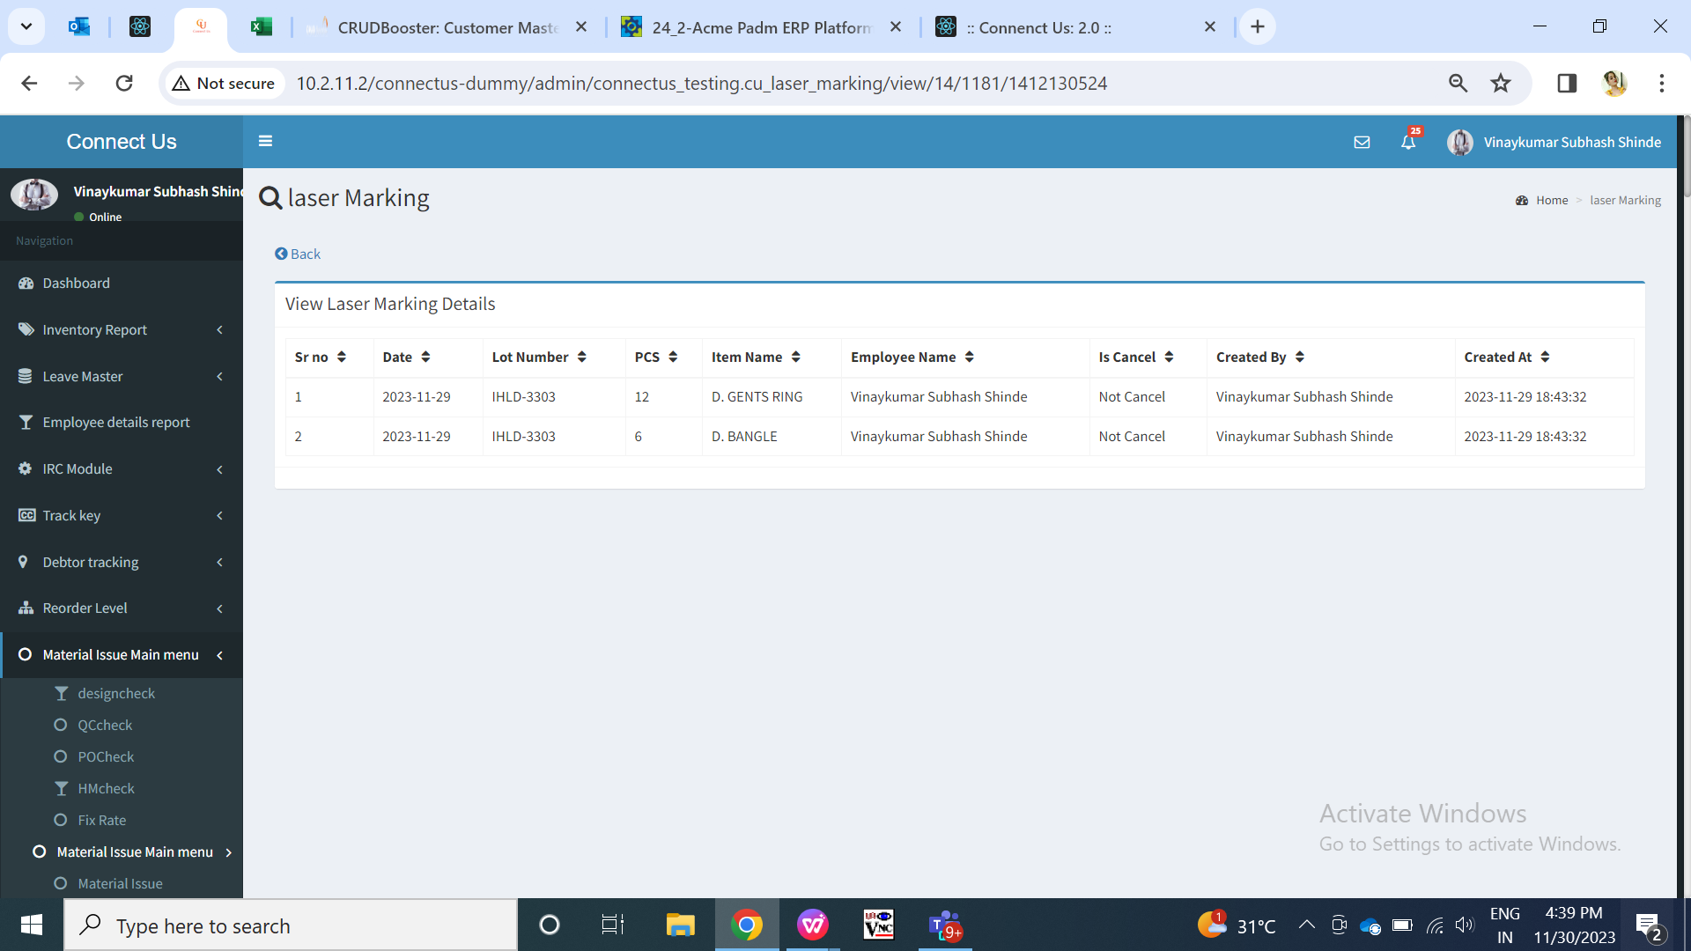

Fig: View

**Step 2. Cancel**

Cancel action will be authority based. Authority to cancel the data in this module needs to be given from masters -> general master -> login special auth.

Once user clicks on cancel button of active record, then it will cancel that record only. Successful message will be displayed and the status of that record will be displayed as canceled in history, grid and view action. Also, edit action for the canceled record will be disabled.

User can add the canceled lot number again. Moreover, if user wants to add that canceled lot number again then all records against that lot number should be canceled.

In case, user clicks on cancel button of already canceled record then it will display message as ‘Record already canceled’.

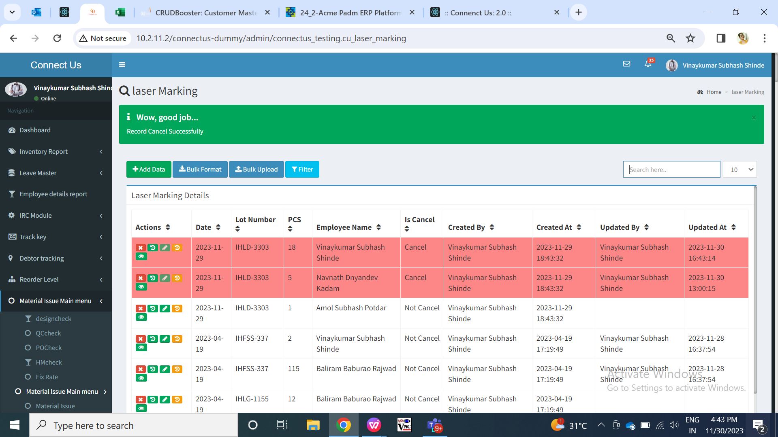

Fig: Cancel

**Step 3. Restore**

Restore action will be authority based. Authority to restore the data in this module needs to be given from masters -> general master -> login special auth.

Only canceled data can be restored. Once data is restored, it will display the message of successful restoration at the top.

In case, user clicks on restore button of already active record then it will display message as ‘Record already restored.

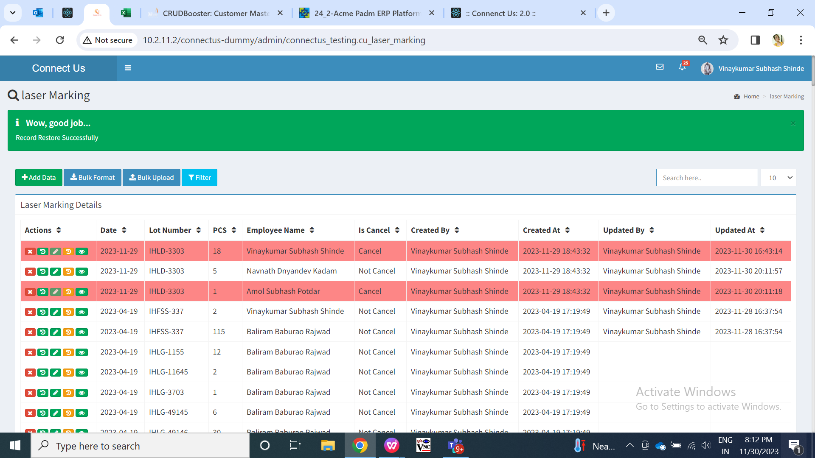

Fig: Restore

**Step 4. History**

Once the record is added, its record will be displayed as ‘add’ in history action. In case one lot number is laser marked by one or more employees, then its entry will be displayed in history with ‘add’ action for each employee.

Further, when the record is edited, canceled or restored, its entry will be displayed in history action. Here, history for that entire lot number will be common / same even if that lot number is laser marked by different employees.

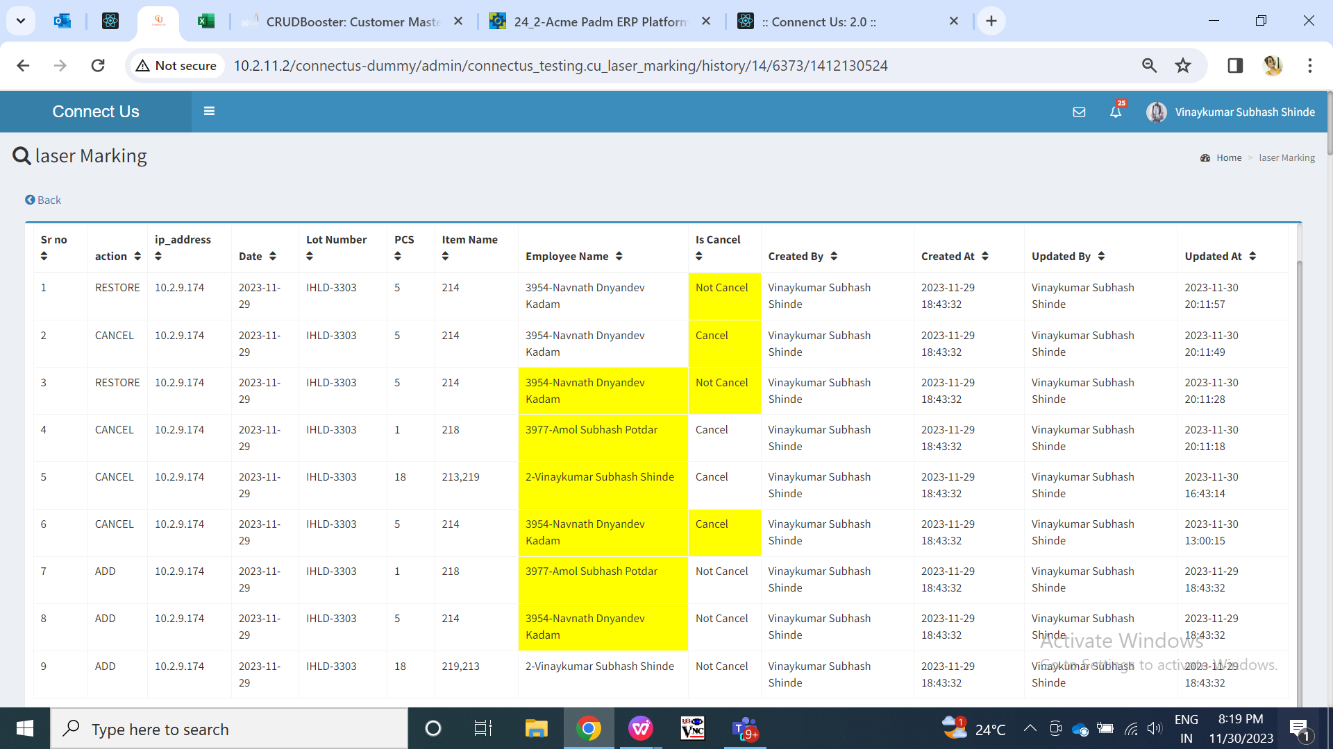

Fig: History

**Step 5. Bulk Format**

Through add action, user can add one lot number at a time. Whereas, user can multiple lot numbers and its data through bulk upload option at a time.

Initially, user will have to download the bulk format through ‘bulk format’ button. Further, user will fill the details in the bulk file and then will upload it through ‘bulk upload’ button. User will mention the lot number, employee ID and item name for each if items in that lot number are laser marked by more then one employee.

If the details in the files are valid, then successful message will be displayed and all details will gets added and displayed in grid. However, if any of the data in the file is incorrect, error message will be displayed and error file will get downloaded displaying which data is invalid.

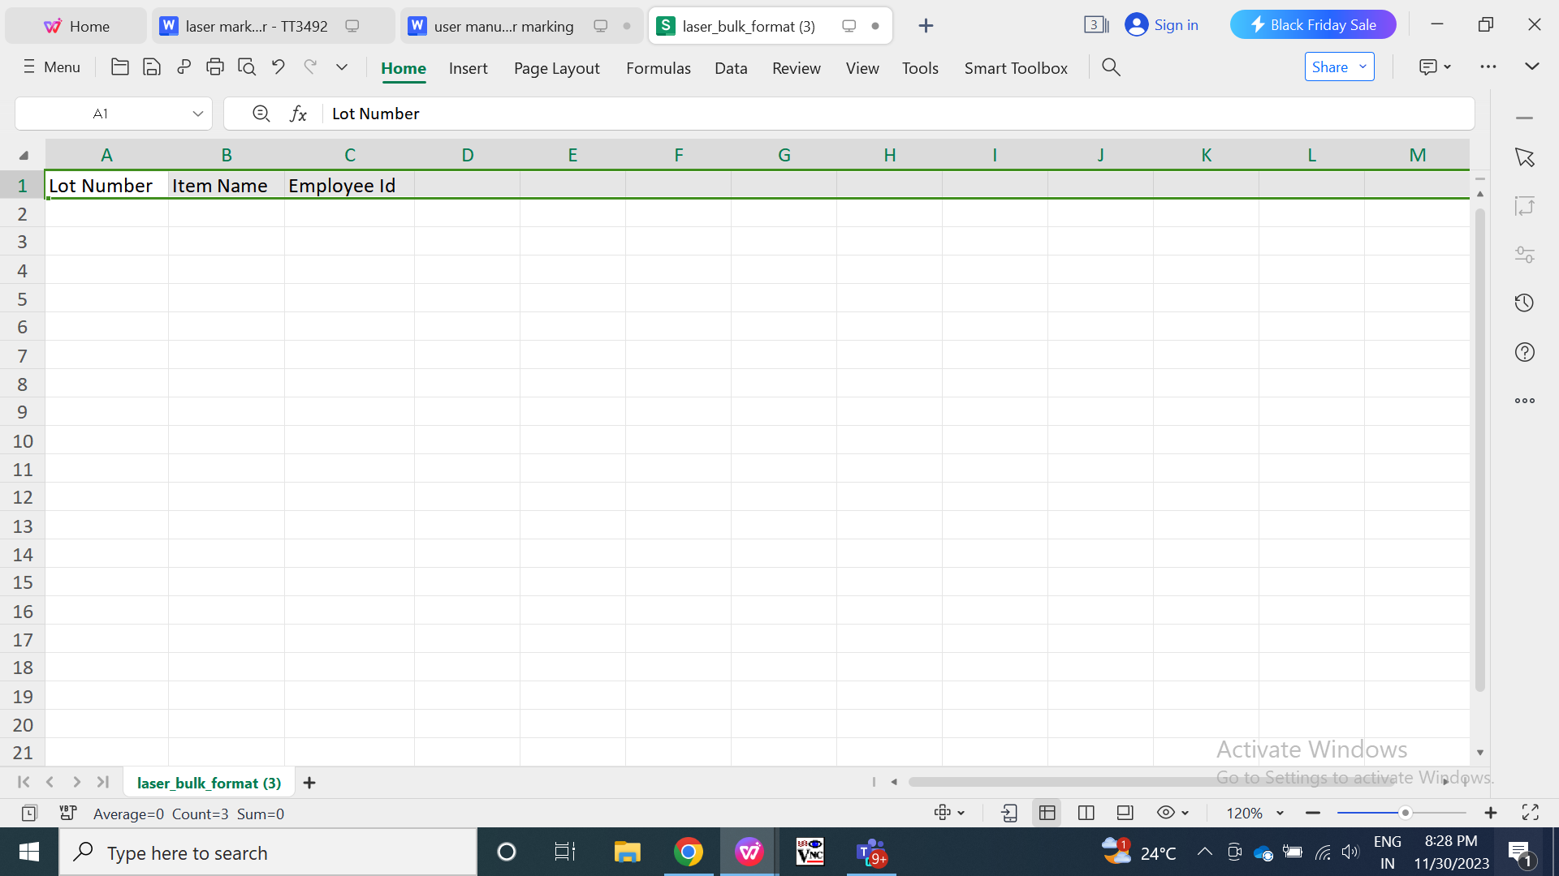

Fig: Bulk format

**Step 6. Bulk Upload**

|  |  |  |  |  |
| --- | --- | --- | --- | --- |
| **FIELDS** | **INPUT TYPE** | **MANDATORY/ OPTIONAL** | **EDITABLE** | **DESCRIPTION** |
| Upload csv | attach | Mandatory | No | User will upload the csv file in which user has mentioned the lot numbers, item name and employee ID. User will have to enter the fields in file with validations as per add and edit for lot number, item name and employee name fields.  Validation: Only one file can be attached. It should accept only csv extension. |
| Upload | Click | - | - | Once user clicks on upload button after attaching file and If the details in the files are valid, then successful message will be displayed and all details will gets added and displayed in grid. However, if any of the data in the file is incorrect, error message will be displayed and error file will get downloaded displaying which data is invalid.  In case users enter incorrect file extension and user clicks on upload button, then it should display error message as ‘invalid file format’.  If user clicks on upload button without attaching file, then on field error message should be displayed in ‘upload csv’ field.  Validation: Upload button will be disabled until successful message of record gets displayed or until error file gets displayed in case of invalid data / file. |
| Back | Click | - | - | Once user clicks on back button, page will get reloaded and user should be directed to grid page. Record should not get inserted if user has attached any file and clicked on back button.  Validation: Back button will be disabled until user gets directed to grid page. |

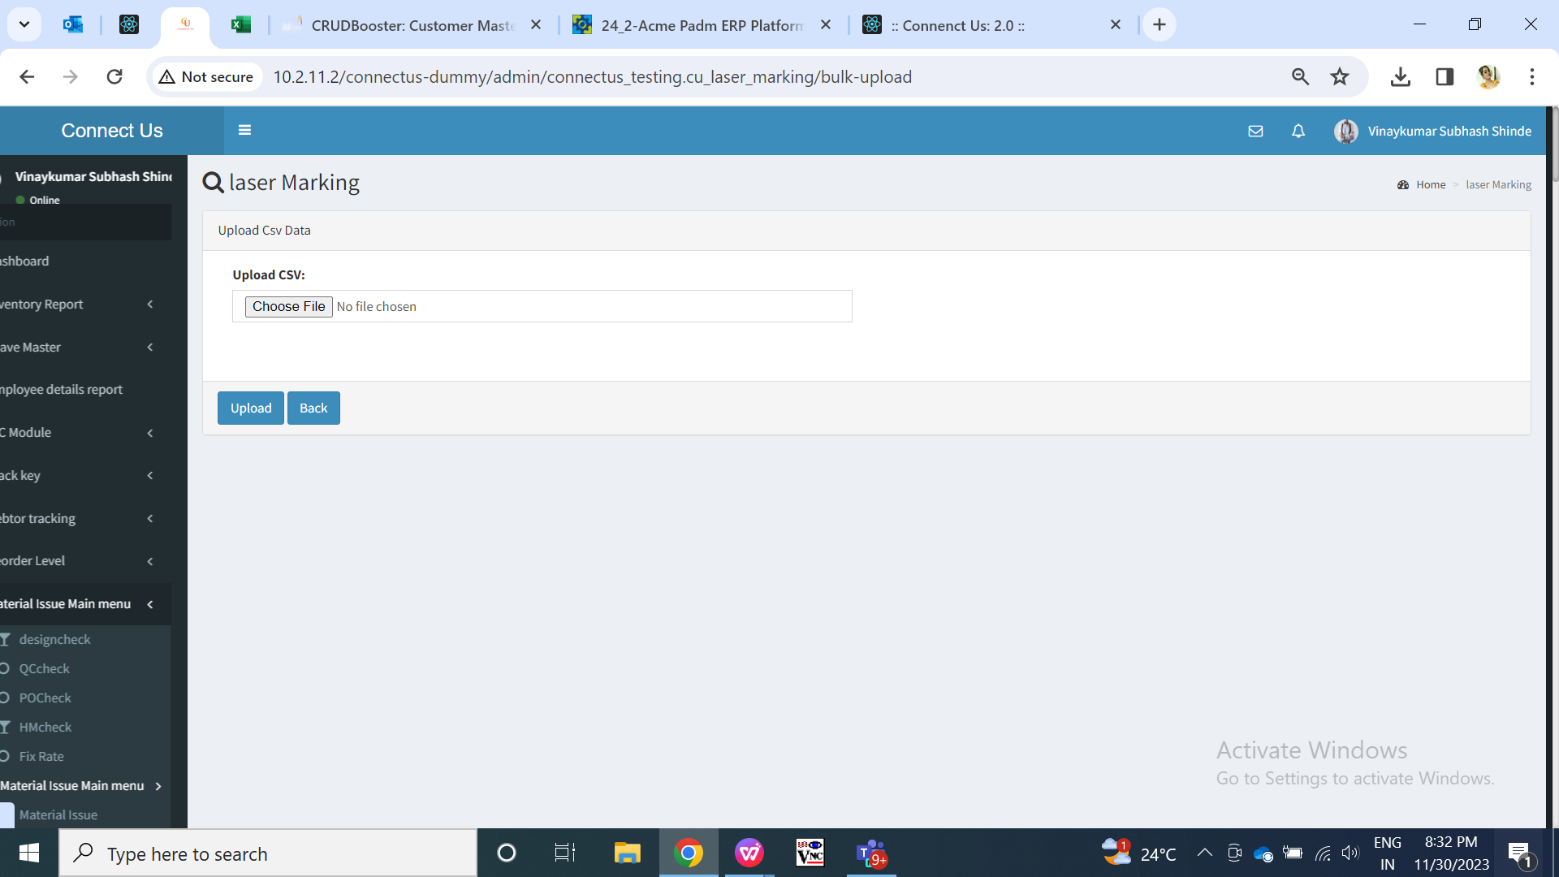

Fig: Bulk upload

**Step 7. Filter**

|  |  |  |  |  |
| --- | --- | --- | --- | --- |
| **FIELDS** | **INPUT TYPE** | **MANDATORY/ OPTIONAL** | **EDITABLE** | **DESCRIPTION** |
| From Date | Calender date picker | Optional | Yes | User will select the date from which the lot numbers were added.  Validation: Only one date can be selected. Future dates will be disabled. |
| To Date | Calender date picker | Optional | Yes | User will select the date till which lot numbers were added.  Validation: Only one date can be selected. Future dates will be disabled. Dates before ‘from date’ will be disabled. |
| Lot number | Text | Optional | Yes | User can search the records from grid by lot number.  Validation: Only one document can be entered. It should accept alphanumeric value. It should accept only hyphen as special character. It shouldn’t accept space.  Min length = 6  Max length = 12 |
| Employee name | Drop down | Optional | Yes | User can search the records that added by specifi employee.  User will enter select the name of the employee who has added the record in grid.  Validation: It will display active employees from employee master. It will be single select. |
| Filter | Click | Optional | No | Once user selects dates, employee name and clicks on submit button, then all the records as per filter applied options will be displayed in grid.  Initially, it will display all data in grid by default. Further, it will display searched data in grid after applying filter.  Validation: It will be disabled once clicked until data appears in grid. |
| Download | Click | Optional | No | Once user clicks on download button, then CSV file will get downloaded which will have columns as grid.  Validation: Only one file will get downloaded after clicking on it. |
| Reset | Click | Optional | No | Once user clicks on reset button,page will get reloaded and all pre-filled fields in filter will get cleared. Also, if any data was displayed in grid as filter option, it will get reset and entire data will get displayed in grid.  Validation: It will be disabled once clicked until page gets reloaded and entire data gets displayed in grid. |

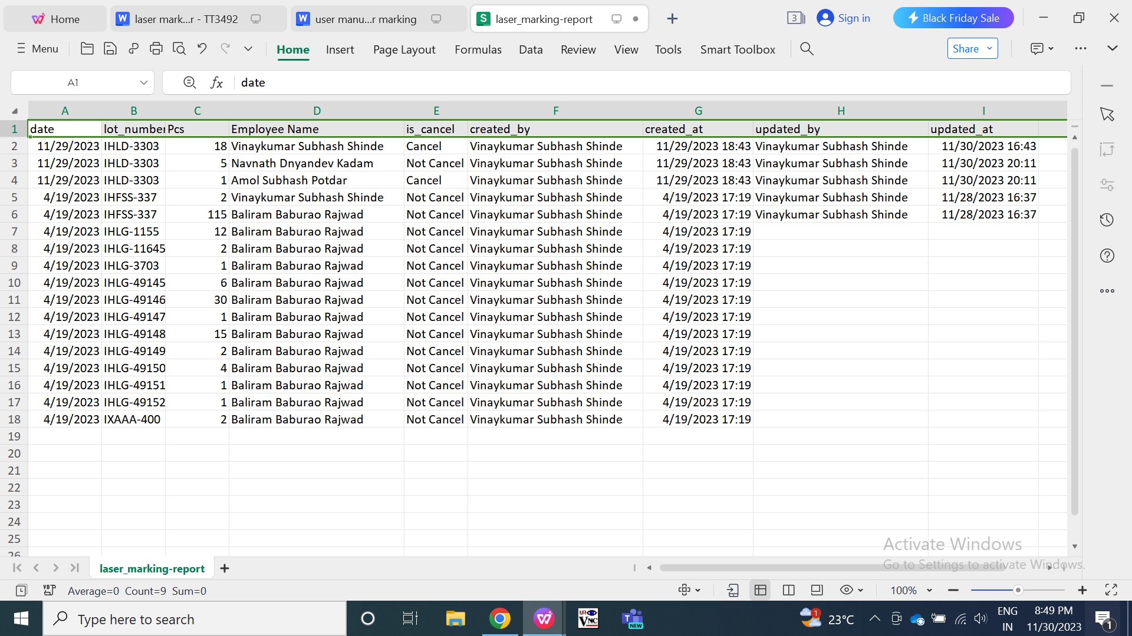

Fig: Filter

**Step 8. Laser Marking Report**

Through laser marking report,we will get user wise product group wise report marked by each specific employee of selected duration. This report will be useful for improving process by evaluating the performance of the employee and understand the laser marking frequency of product group.

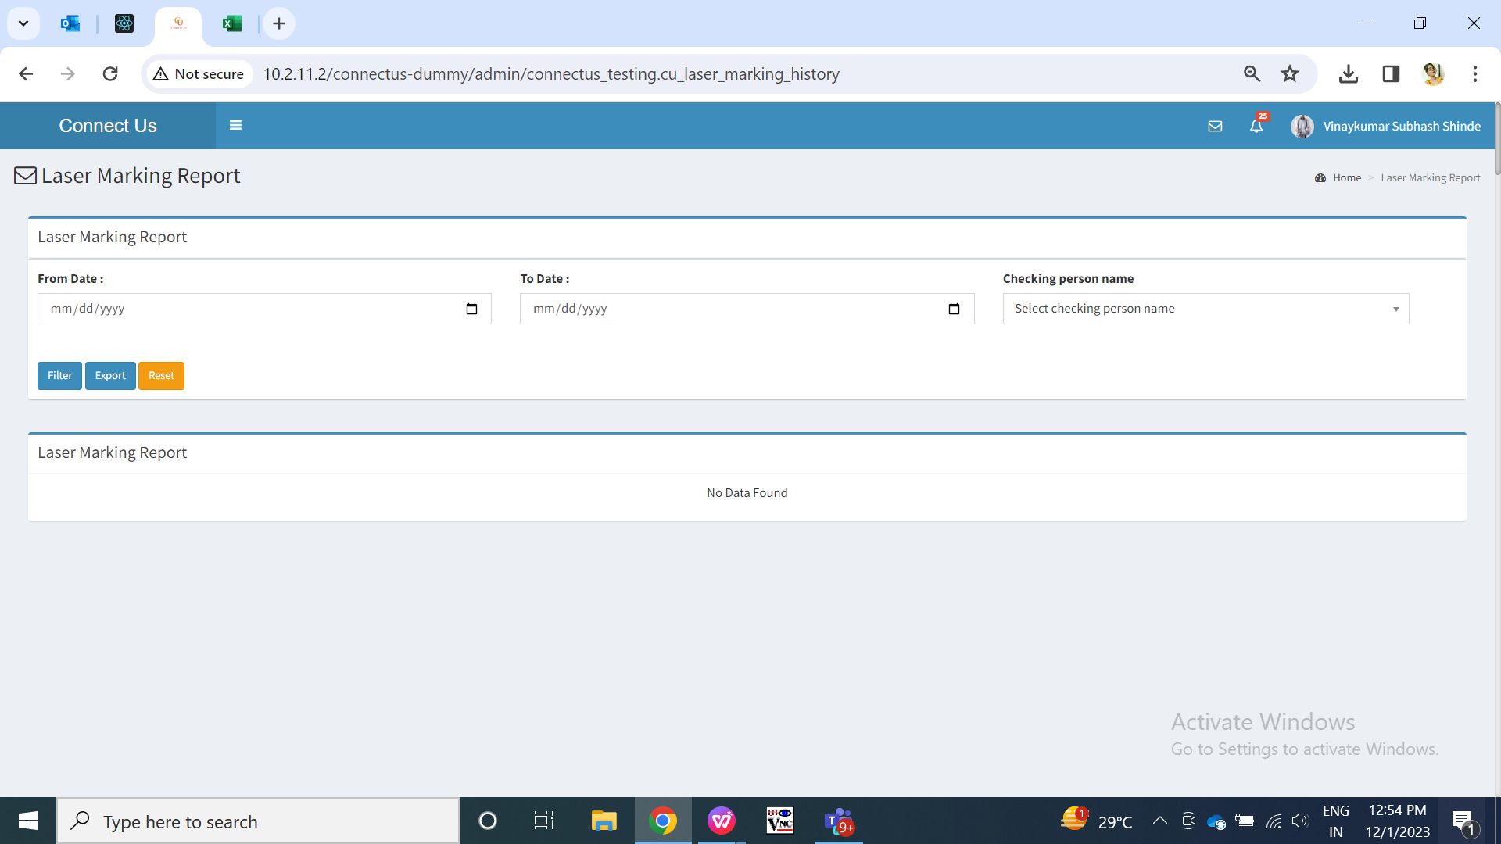

Fig:: Laser Marking Report

|  |  |  |  |  |
| --- | --- | --- | --- | --- |
| **FIELDS** | **INPUT TYPE** | **MANDATORY/ OPTIONAL** | **EDITABLE** | **DESCRIPTION** |
| From Date | Calender date picker | Mandatory | Yes | User will select the date from which the records were added by the employees.  Validation: Only one date can be selected. Future dates will be disabled. |
| To Date | Calender date picker | Mandatory | Yes | User will select the date till which the records were added by the employees.  Validation: Only one date can be selected. Future dates will be disabled. |
| Checking person name | Drop down | Optional | Yes | User will select the name of the employee who has done laser marking.  Validation: It will be single select. It will display active employees from employee master. |
| Filter | Click | - | - | Once user selects dates and / or employee name and clicks on filter button, it will display the expected data in grid. It will display the product group and total pcs that are laser marked by particular employee.  Validation: Filter button will be disabled until data gets displayed in grid. |
| Export | Click | - | - | Once user clicks on export button, csv file will get downloaded which will display data as in grid having product group, total and employee columns in it.  In case, there is no data in grid then blank csv file will get downloaded having only column names in it.  Validation: Only one csv file will get downloaded. |
| Reset | Click | - | - | Once user clicks on reset button,page will get reloaded and all pre-filled fields in filter will get cleared. Also, if any data was displayed in grid as filter option, it will get reset and will be displayed blank in grid.  Validation: It will be disabled once clicked until page gets reloaded and entire data gets displayed in grid. |

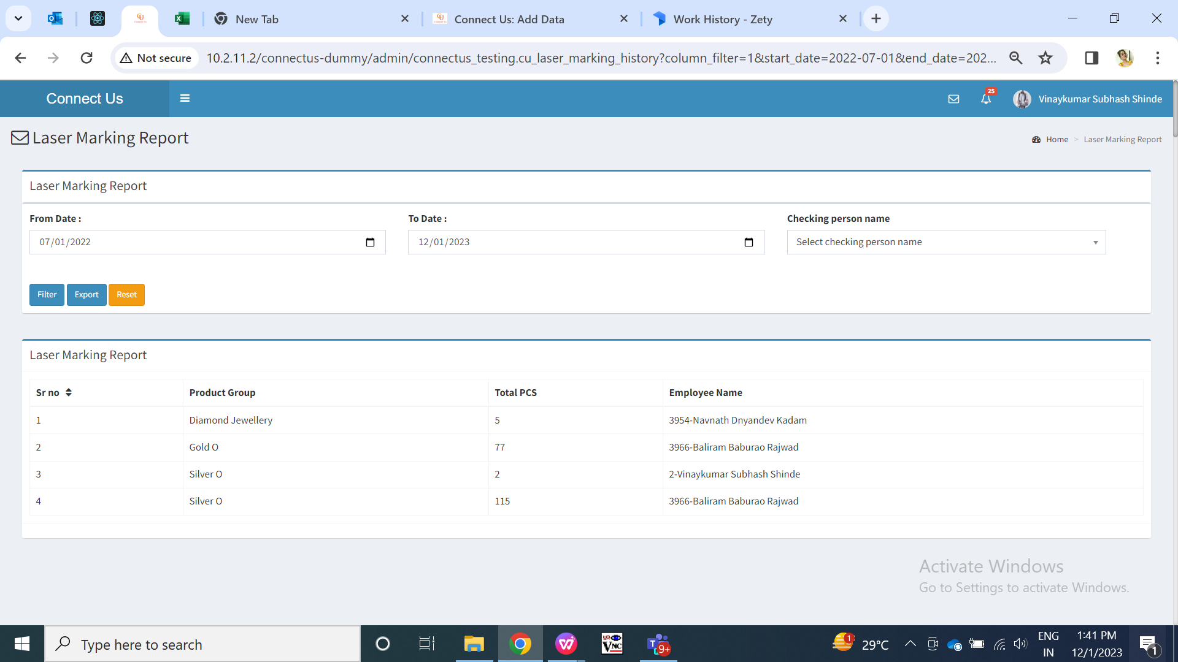

Fig: Laser Marking Report (after applying filter)

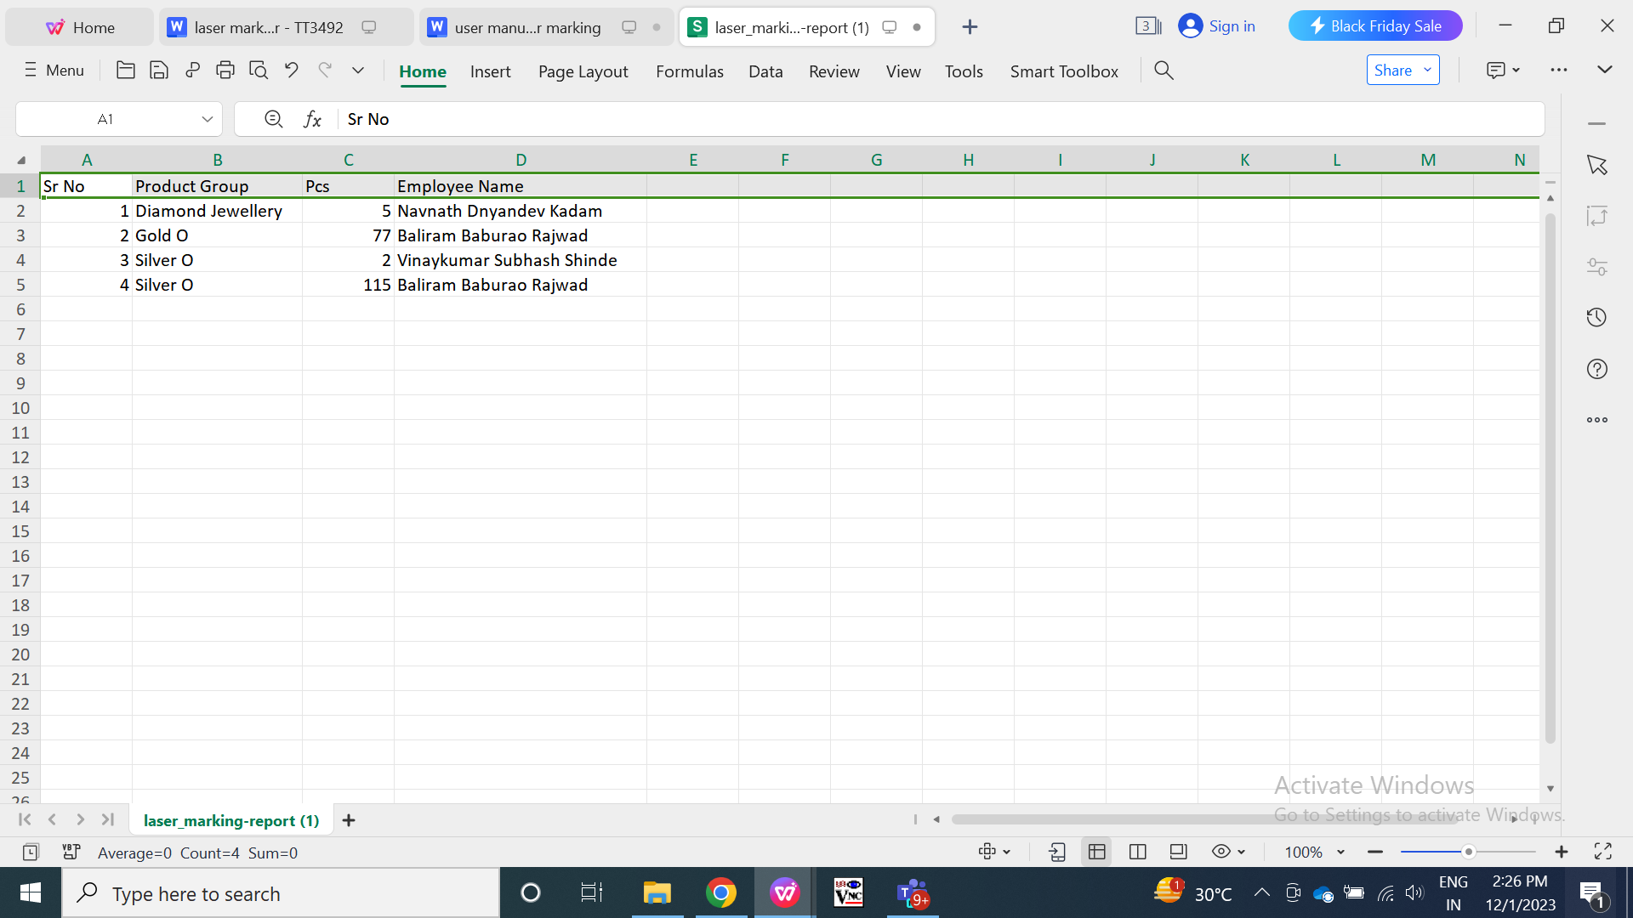

Fig: Laser Marking Report (Export)

1. **TEST DATA AND BUSINESS SCENARIOS**

