Manali Ashok Bhadirage

Manali.bhadirage@techneai.com

26.01.2024

Bill checking transaction - Ledger Balance

**Handover Document**

**CONTENTS**

1. TICKET DETAILS 2

2. INTRODUCTION 2

3. BUSINESS REQUIREMENT 2

4. SCOPE 3

5. BUSINESS & SYSTEM RULES 4

6. ABBREVIATIONS & TERMS 4

7. GRAPHICAL REPRESENTATION 4

8. DEVELOPED SYSTEM 5

9. REFERENCES OF THE USERS 8

1. **TICKET DETAILS**

|  |  |
| --- | --- |
| **Ticket ID** | TT14040 |
| **Ticket description** | Bill Checking Transaction madhe bill payment la detana padm madhil ledger cha balance connect us la show zala pahije & jevd payment deyil tevda balance less zala pahije . |
| **Created by** | Tushar Koratkar |
| **Created on** | 12/07/2023 |
| **Priority** | Very high |

1. **INTRODUCTION**

Introducing "Bill Connect US": a seamless system that simplifies bill management for users. With this innovative platform, users can effortlessly submit vendor bills and facilitate swift payment processing. All payment records are meticulously maintained and audited to ensure transparency.

Integrating with Padm, "Bill Connect US" offers an added advantage by displaying the current balance of each vendor. This feature empowers entry users to make informed decisions when submitting bills, as they can analyze the available funds in the Padm account for each vendor. By having visibility into the vendor's balance, users can strategize their bill submissions, avoiding unnecessary work and streamlining the process.

In summary, "Bill Connect US" streamlines bill submissions and payment processing, providing valuable insights into vendor balances through integration with Padm. This empowers entry users to optimize their bill submissions and foster a more efficient workflow.

1. **BUSINESS REQUIREMENT**

For few specific bill types, user needs provision to check the ledger balance of that vendor in Padm so that they could do the necessary corrections in their bill submission as per ledger balance.

|  |  |  |  |
| --- | --- | --- | --- |
| **Requirement ID** | **Requirement Name** | **Short Description** | **Priority** |
| BR001 | Bill type master | In bill type master -> add, edit, view action we have to add one checkbox field as ‘Do not consider if less ledger balance’. | High |
| BR002 | Bill Payments | If ledger balance < total payment of that particular bill type which is checked in bill type master, then such payments shouldn’t be forwarded for payment.  If ledger balance < total payment of that particular bill type which is not checked in bill type master, then such payments can be or cannot be passed for payment once user chooses it.  If ledger balance > total payment, then consider this payment that means this amount should get forwarded in text file. | High |
| BR003 | Bill payments -> download payment text file | Entries for which we do not have to consider the payment, those entries shouldn’t be considered or included in text files. | High |
| BR004 | Bill payments | We need to provide check-box for each bill where it will be disabled based on conditions. | High |
| BR005 | Bill payments | Display pop up message that ‘These particular bills are not considered for payments as ledger balance of vendor is less for this bill type’ after text file gets downloaded. | Medium |
| BR006 | Bill checking transaction -> payment details | The payments which are not considered for payment, those payments shouldn’t be displayed in downloaded text file and also the status of these payments should remain as it is. (Do not change the status of these payments to confirmation pending as these are not supposed to included in text files) | High |

1. **SCOPE**

In bill type master, we have to add checkbox field in add, edit and view action as ‘Do not consider if less ledger balance’. The bills / payments whose status is release in bill checking transaction, those bills / payments will be reflected in bill payments as per bill types. Further, the acme balance I.e. ledger balance of the each vendor and each bill type will be compared with the (payment amount + previous confirmation pending bills) in bill payments. Based on conditions, it should include / exclude the payments in text files.

1. **BUSINESS & SYSTEM RULES**

* User should be registered and logged in to the system.
* When user downloads text files at that time, it will display pop up message as “Bill IDs --- are not considered for payment due to less ledger balance currently.” when few of the bills in the list are not included in the downloaded text file.

1. **ABBREVIATIONS & TERMS**

Dr - Debit (we have to take from vendor)

Cr - Credit (we have to pay to vendor)

BC ID - Bill Checking ID

IFSC code - Indian financial system code

UTR number - Unique Transaction Reference

Acme - Padm ERP

1. **GRAPHICAL REPRESENTATION**

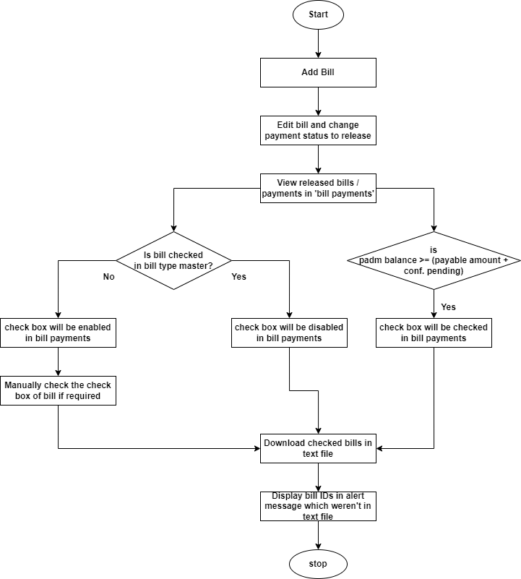

Fig: Process flowchart

1. **DEVELOPED SYSTEM**

In earlier system, the bills were getting submitted even if the ledger balance is less than the payment amount. For few bill types, user needed a provision such that bills shouldn’t be forwarded for payment if ledger balance is less than payment amount.

In Connect Us -> bill checking -> bill type master, in grid / add / edit / view form it will have following fields:

* Company
* bill type
* Sort Order
* Do not consider if less ledger balance
* Remark
* Save button
* Back button
* Save and add more button

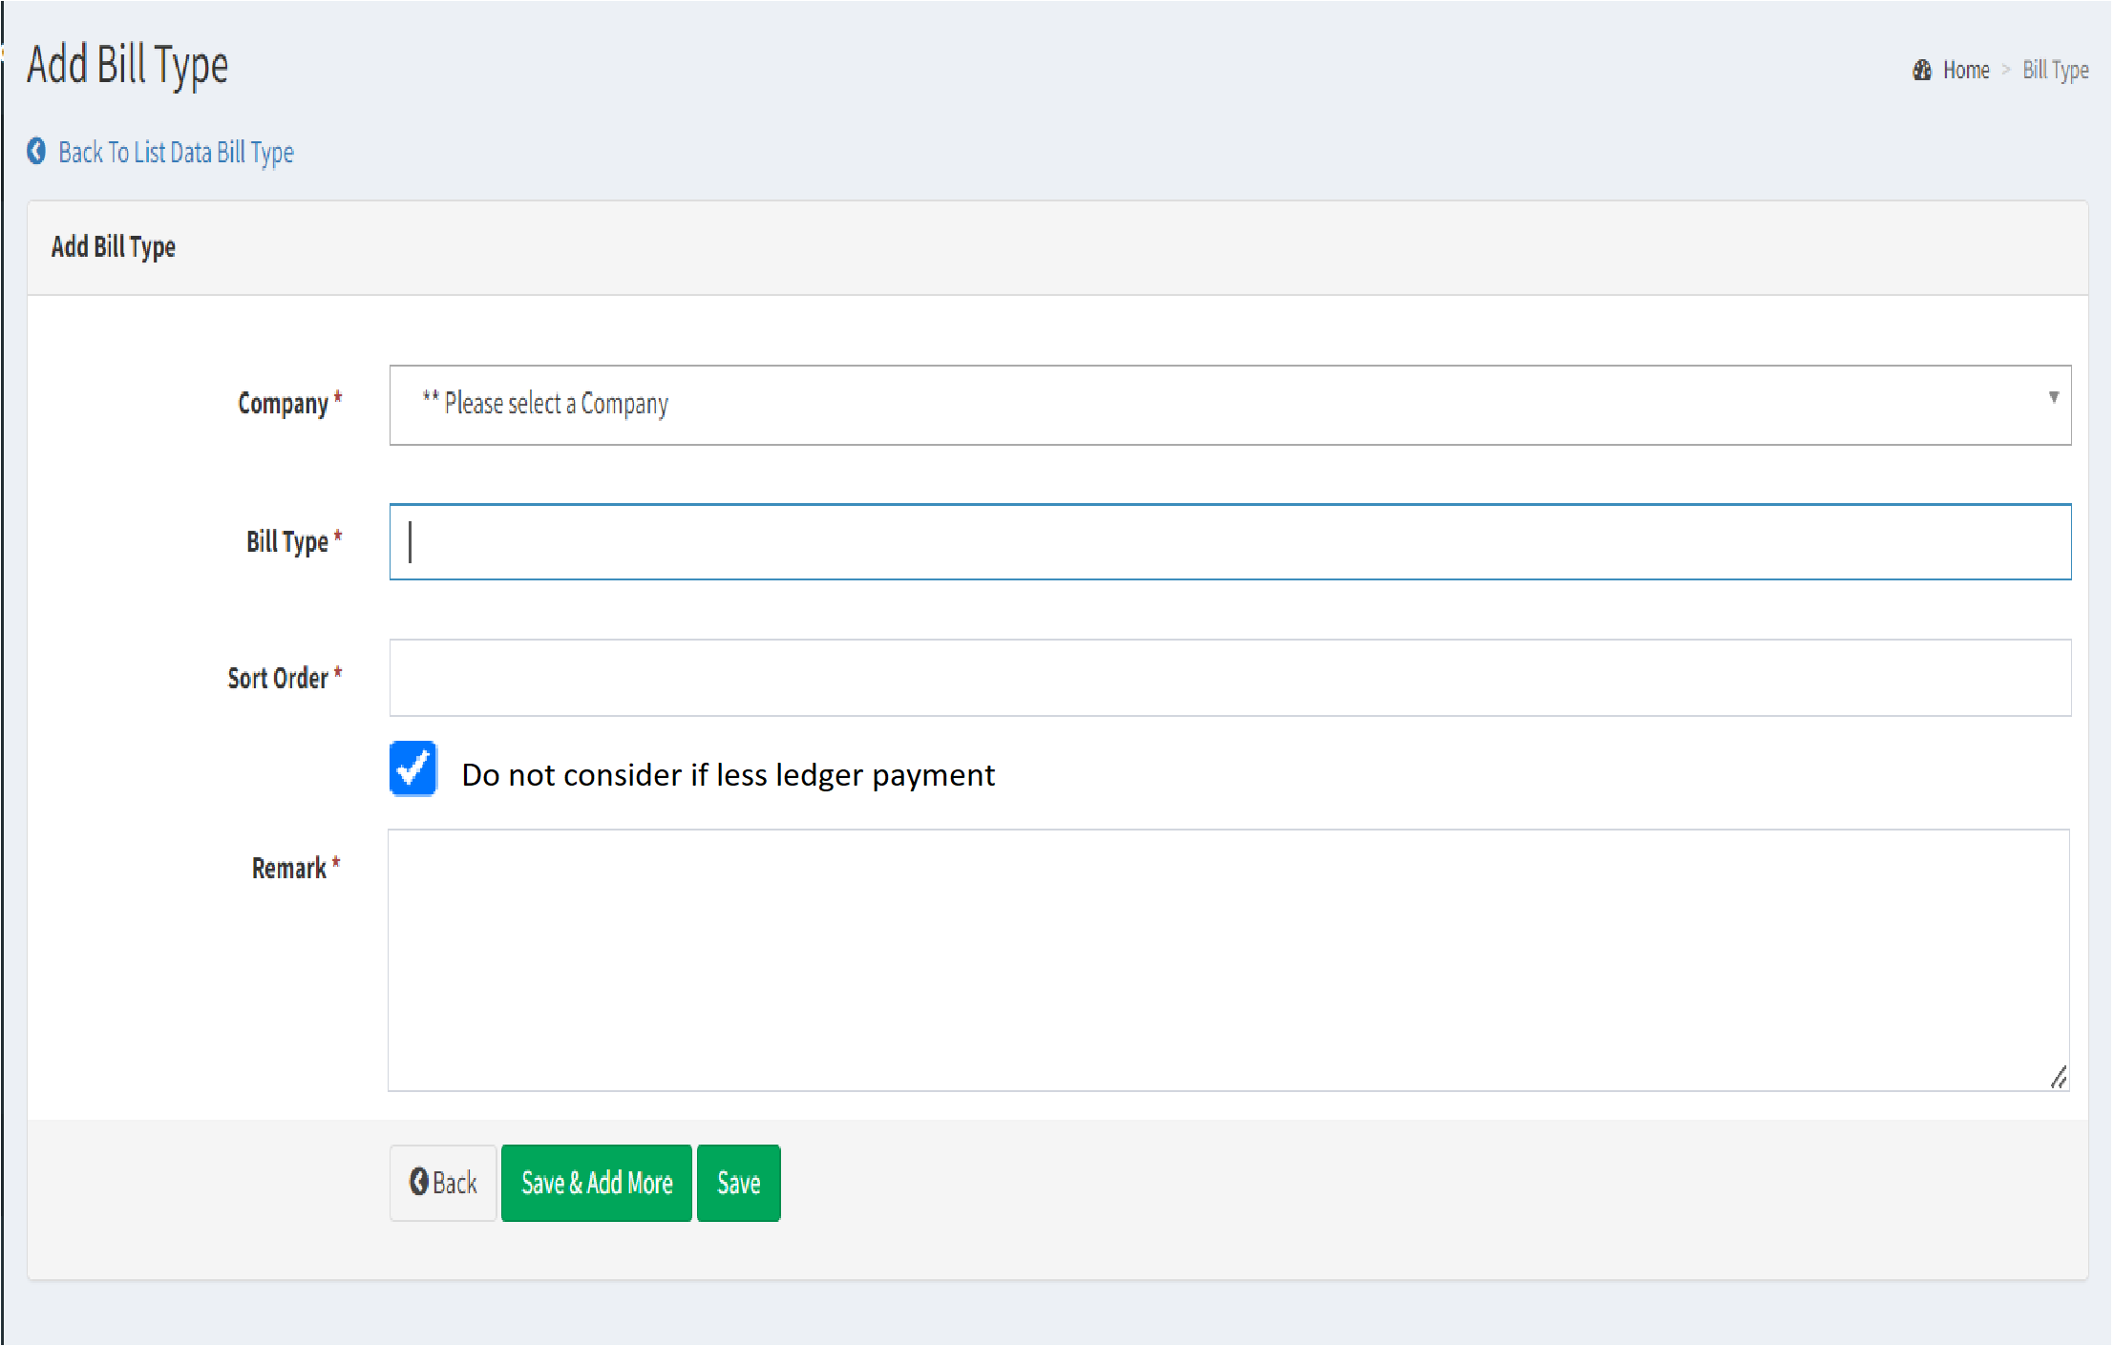

Fig: Bill type master -> add / edit form

**Input table**

|  |  |  |  |
| --- | --- | --- | --- |
| **FIELDS** | **INPUT TYPE** | **MANDATORY/ OPTIONAL** | **DESCRIPTION** |
| Do not consider if less ledger balance | Check box | Optional | User will check the bills for which the ledger balance will be checked with payment amount in bill payments menu.  If this checked box is checked, then ledger balance will be compared with the payment amount for that bill type. Further, if ledger balance < payment amount then that bill should not be considered for payment and should not be included in downloaded text file. |

Further, once bills are added in bill checking transaction and the status of the amount is changes to release, those bills gets reflected in bill payments menu. User can fetch bills and amounts by bill types in bill payments which are to be paid to the vendors in the list.

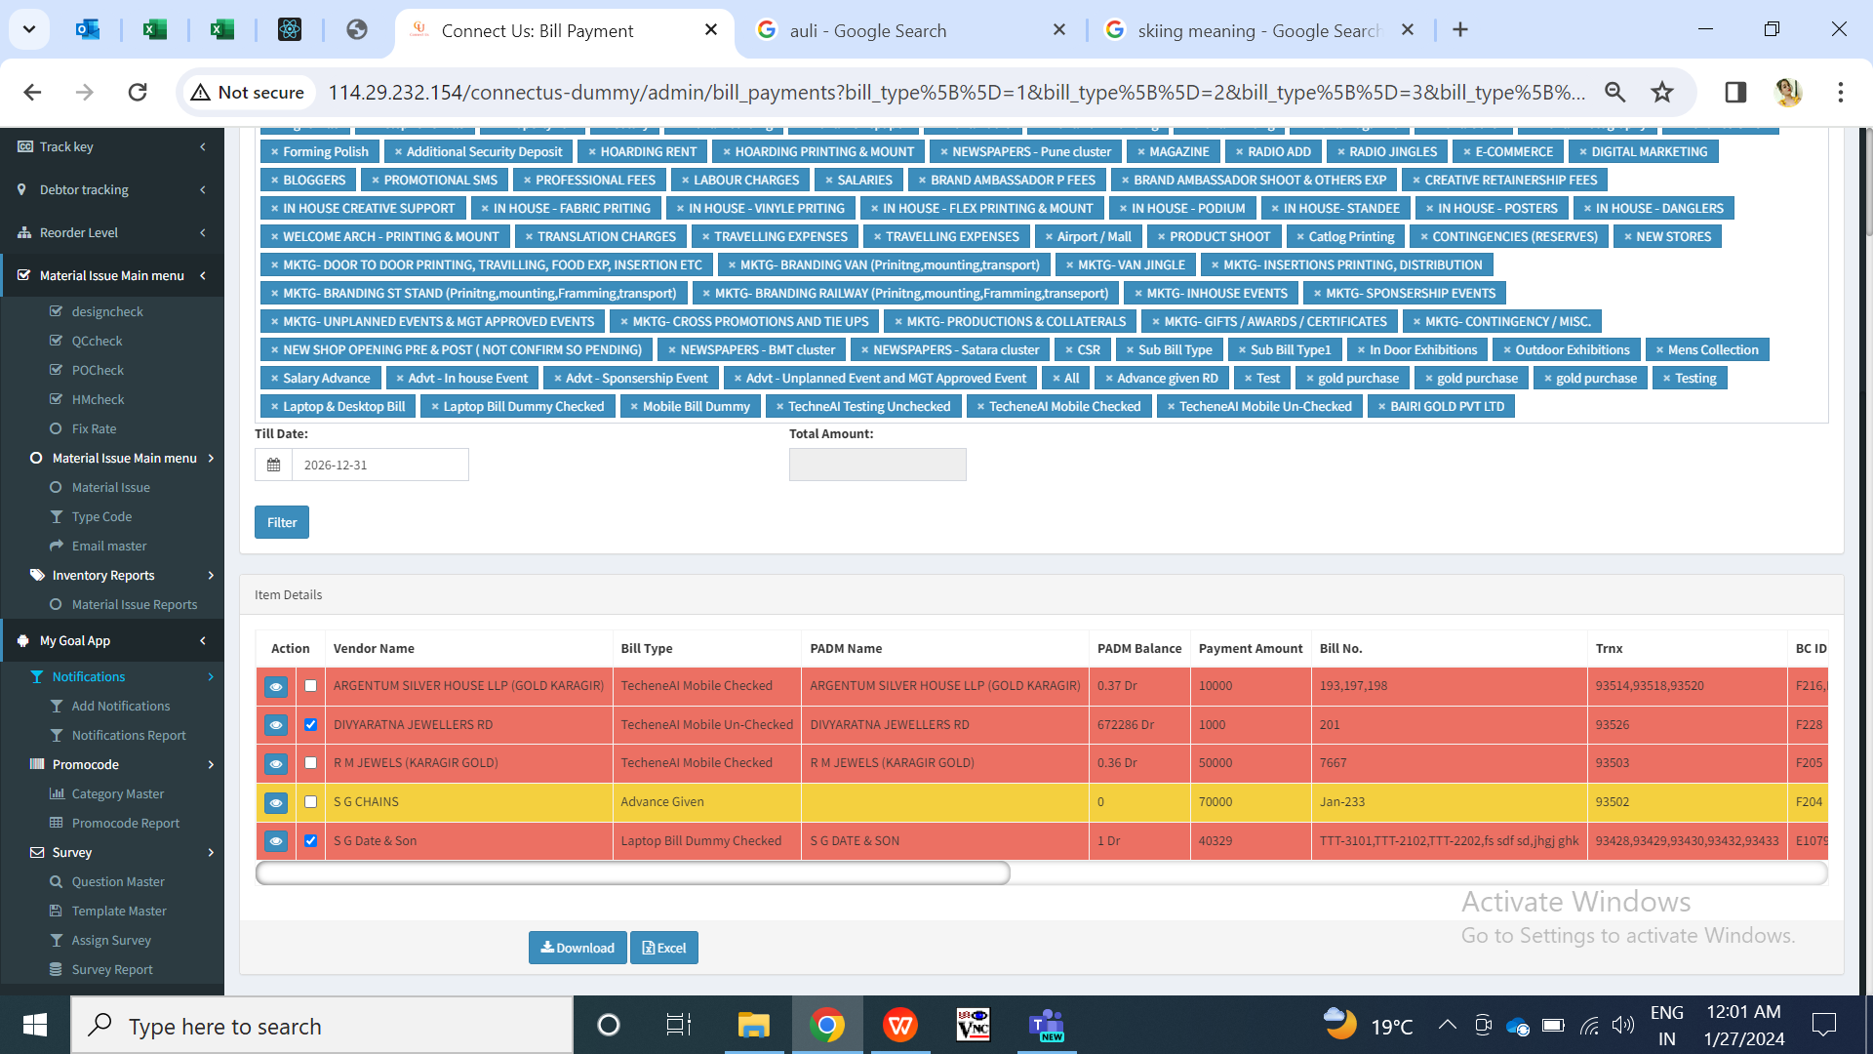

Fig: Bill payments

In bill payments, once user selects the bill types and the payment date and clicks on submit, it will display the list of vendors whose bills are in release status. It displays following fields:

* Check-box
* View action
* Vendor name
* Bill type
* Padm name
* Padm balance
* Payment amount
* Bill no.
* Transaction
* BC ID
* Acme no.
* Paid
* Sbi amount
* Remark
* Download text button
* Excel button

Once user clicks on download text file button, it downloads text files of the payments. Once the text files gets downloaded, the payments which were displayed, those status gets changed to confirmation pending in payment status action of that bill.

Here, it should include the payments based on bill type, consider for payment if less balance or not and then compare acme balance with payment amount.

Case 1) If bill type is checked in bill type master and if ledger balance < (payment amount + previous confirmation pending amount of that vendor) then, check box of that bill will be disabled and unchecked. Moreover, that bill should not be considered for payment and should not be included in downloaded text file.

Case 2) If bill is un-checked in bill type master and if ledger balance < (payment amount + previous confirmation pending amount of that vendor) then, check box of that bill will be unchecked and checkbox will be enabled. User can check this bill and proceed for payment. If user doesn’t check on this bill then it should not be displayed in text file.

Case 3) If bill is checked in bill type master and if ledger balance >= (payment amount + previous confirmation pending amount of that vendor) then, checkbox will be checked and disabled for that bill. By default bill will be considered for payment and then will be reflected in downloaded text file.

Case 4) If bill is un-checked in bill type master and if ledger balance >= (payment amount + previous confirmation pending amount of that vendor) then, checkbox for that bill will be checked by default and check box will be enabled. Bill will be considered for payment as usual and then will be reflected in downloaded text file. Whereas, if user doesn’t want to proceed to this bill, then user can uncheck it.

For un-checked bill types, there is not need to compare ledger balance with payment amount and bill will still be proceeded for payment. For bill types whose check box is checked, conditions will be checked for those bill like checkbox enable / disabled as well as whether to consider or not for payment.

Moreover, when user downloads text files, then bills which are not considered for payments, the payment status of those bills should remain as it is and should not get changed to confirmation pending. In addition to this, when user downloads text files at that time, it should display pop up message as “Bill IDs --- are not considered for payment”.

Example:

|  |  |  |
| --- | --- | --- |
| Padma Balance | Payment Amount (Net Payable) | Match / Mismatch |
| 100000 Cr | 100000 | Match |
| 100000 Cr | 70000 | Match |
| 100000 Cr | 110000 | Mismatch |
| 500 Dr | 110000 | Mismatch |
| 100000 Dr | 100000 | Mismatch |

1. **REFERENCES OF THE USERS**

|  |  |  |  |
| --- | --- | --- | --- |
| **User** | **Name** | **Mail** | **Contact number** |
| **Actual user** | Tushar Koratkar | gold@csjewellers.com |  |
| **Ticket created by (if any)** | Tushar Koratkar | gold@csjewellers.com |  |
| **Assigned business analyst** | Manali Bhadirage | Manali.bhadirage@techneai.com |  |
| **Assigned developer** | Yogita Jagtap | Yogita.jagtap@techneai.com |  |
| **Assigned tester** | Amreen Shaikh  Kiran | [Amreen.shaikh@techneai.com](mailto:Amreen.shaikh@techneai.com)  intern@techneai.com |  |