Manali Ashok Bhadirage

Manali.bhadirage@techneai.com

30.12.2023

MATERIAL ISSUE - JANGAD / ON APPROVAL OUT CHALLAN

**Handover Document**

**CONTENTS**

1. TICKET DETAILS 2

2. INTRODUCTION 2

3. BUSINESS REQUIREMENT 2

4. SCOPE 3

5. BUSINESS & SYSTEM RULES 3

6. ABBREVIATIONS & TERMS 3

7. GRAPHICAL REPRESENTATION 3

8. DEVELOPED SYSTEM 4

9. REFERENCES OF THE USERS 12

1. **TICKET DETAILS**

|  |  |
| --- | --- |
| **Ticket ID** | TT14739 |
| **Ticket description** | Connect-Us Madhe Material Issue La New Outword che Document Add karaun Dene. |
| **Created by** | Somnath Magar |
| **Created on** | 05/08/2023 |
| **Priority** | high |

1. **INTRODUCTION**

Within the material issue menu, inventory users input details of materials received from vendors. This input triggers the generation of a document number, which must then be approved by an authorized individual before progressing to four checking stages (design check, QC check, PO check, HM check). During these inspection stages, some pieces may be rejected and will be sent back to the vendor, while the accepted pieces will lead to the creation of a RD purchase bill within the Padm system for the vendor. Purchase return bill is generated for the rejected pcs and then returned to the vendor.

In inventory we do receive orders from vendors for which the Padm bill need not be created. Inventory team can accept the slot if they like and/or return the entire lot to vendor or disliked items. This is termed as Jangad process. We have to create challan when such materials are returned to vendor.

1. **BUSINESS REQUIREMENT**

|  |  |  |  |
| --- | --- | --- | --- |
| **Requirement ID** | **Requirement Name** | **Short Description** | **Priority** |
| BR001 | Material issue -> On Approval Out challan | We have to provide On approval out action in grid of material issue for each document once they complete HMcheck process. | High |
| BR002 | Print on approval out challan | Once user clicks on ‘on approval out action’, PDF should get downloaded displaying vendor details and the rejected item details in it. | High |

1. **SCOPE**

Once data is added in material issue, then it should get received by the authorized user. Once document is received by the authorized user, then that document should be displayed in design check process. Once user rejects the items from that document through issued action, then the accepted pcs of that document will be passed to QC check process. Further, accepted pcs of QC check process will be passed to PO check process. Once user rejects pcs in PO check, the accepted pcs of that document will be passed to HM check process. After accepting and rejecting the pcs in HM check process, ‘on approval out challa’ action will be displayed in material issue menu grid.

Once user clicks on ‘on approval out’ action then receipt should get downloaded. It will display the vendor name and details as per added document and vendor address from vendor master.

1. **BUSINESS & SYSTEM RULES**

* User should be registered in the system.
* User should be logged in.
* System should pop up a message, if any issues in the system is detected.
* If all pcs of document gets rejected in earlier checking process, then ‘on approval out challan’ action should not be provided to that document in material issue menu grid.

1. **ABBREVIATIONS & TERMS**

Wt - Weight

Gm - grams

KT - karat

MK - making

Pcs - pieces

PDF - Portable Document Format

BB - Black Bits

1. **GRAPHICAL REPRESENTATION**

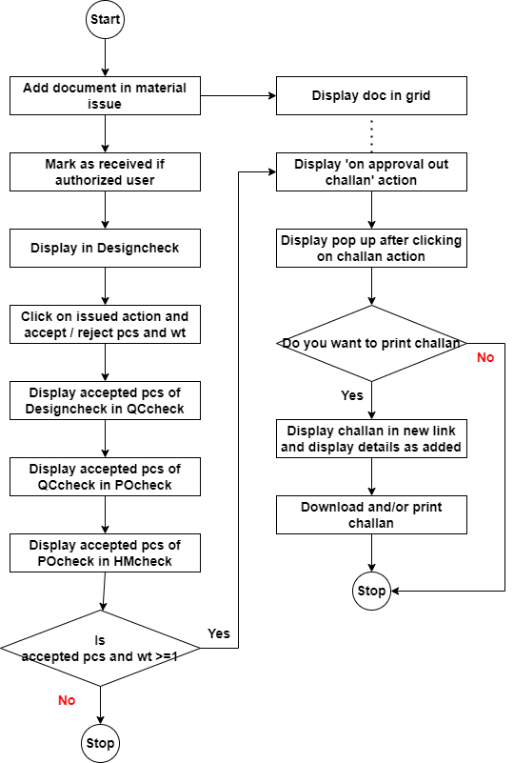

Fig: Flowchart

1. **DEVELOPED SYSTEM**

Earlier, there was no provision available to download challans for returning jangad documents to the vendor. Users were managing jangad document records through Excel spreadsheets and manually generating challans for their return. As a result, there was no systematic record of these within the system. So we have developed the ‘on approval out’ action in material issue.

Once user clicks on material issue menu, it will display following fields:

* Add button
* View action
* History action
* Edit action
* Take print action
* Received action
* Edit data action
* Get attachment action
* On approval out challan action
* Doc no.
* Date
* Challan no.
* Net wt (gm)
* Location
* Issued type
* Vendor
* Sub supplier
* Narration
* Received status
* Time difference

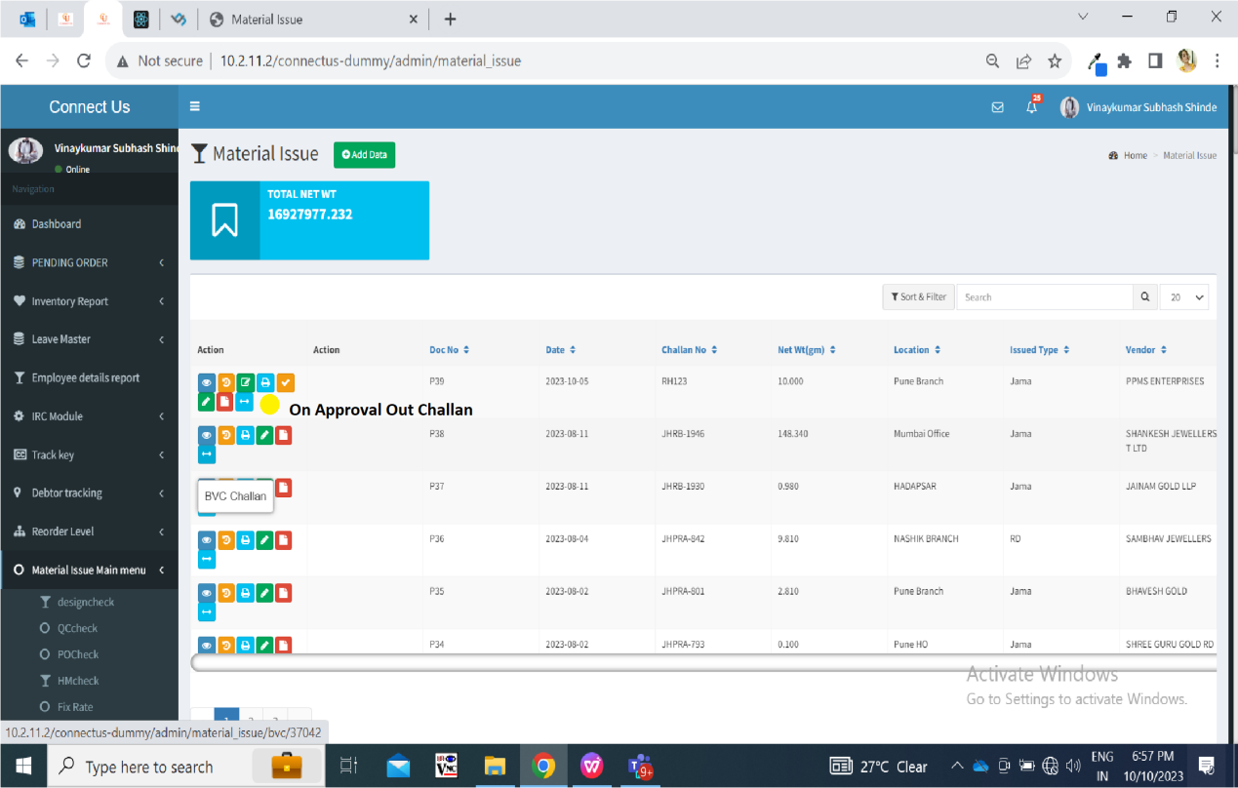

Fig: Material issue grid

Once data is added, then doc number gets generated to it and it will be displayed in grid displaying received action against it to the authorized user. Once authorized user marks the doc as received, then its received action will be removed whereas this doc will be displayed in design check process menu.

In **design check** phase, from Issue data action, user enters the details of accepted and rejected pcs and submits the challan to further process.

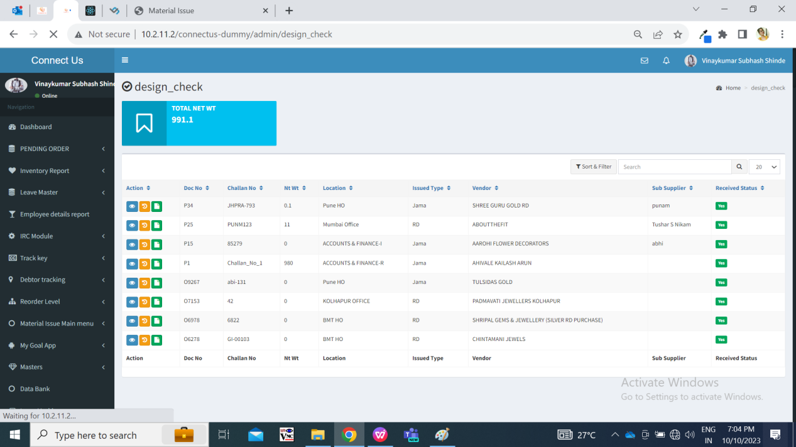

Fig: Design check

Once design check is done, the accepted pcs and all details in the document will be forwarded to **QC check** process. The documents received from design check process should be first displayed to QC incharge in QC check menu. Here, QC incharge will first split the document into present employees.

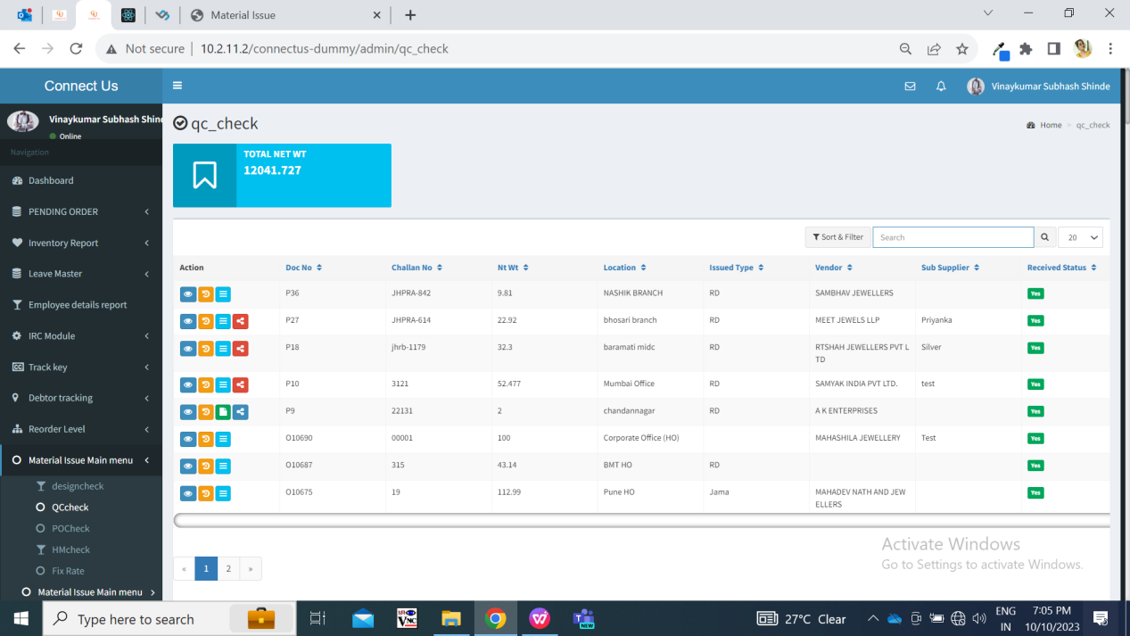

Fig: QC check

Once all the QC incharge has submitted details of accepted / rejected in QCcheck -> issued action, then total accepted gross wt, total accepted net wt, total accepted pcs should be displayed to **POcheck** process for the respective doc.

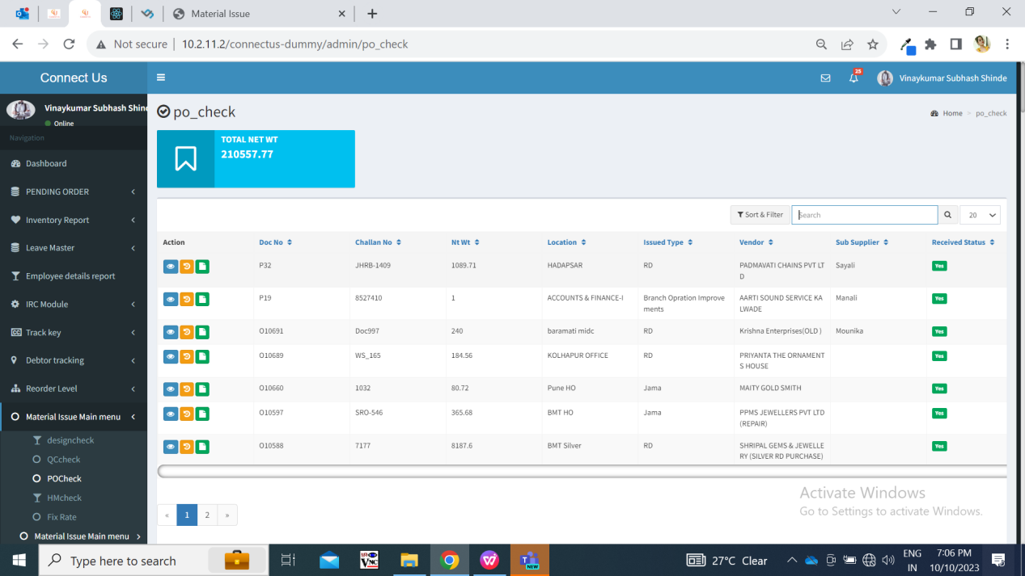

Fig: PO check

Further, the accepted pcs from PO check process are forwarded to **HM check** process. And in generate slip, the total details of rejected and accepted pcs, wt will be displayed.

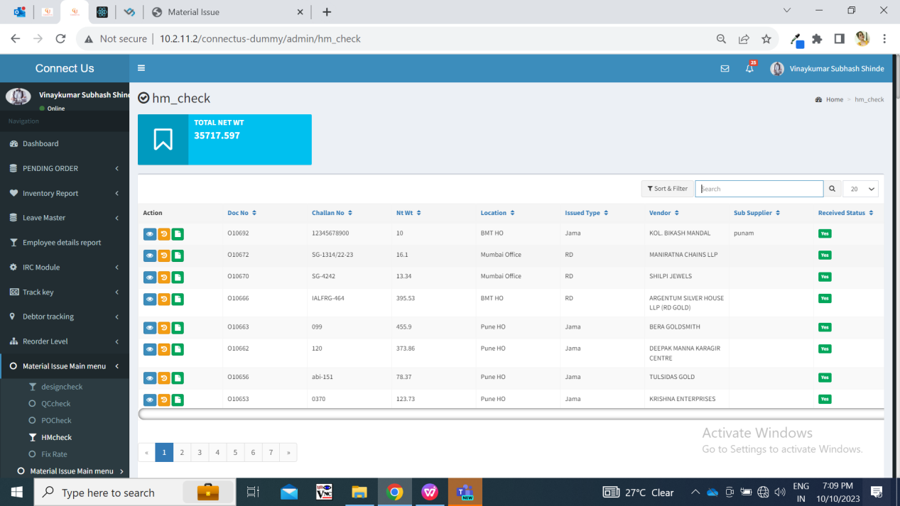

Fig: HM check

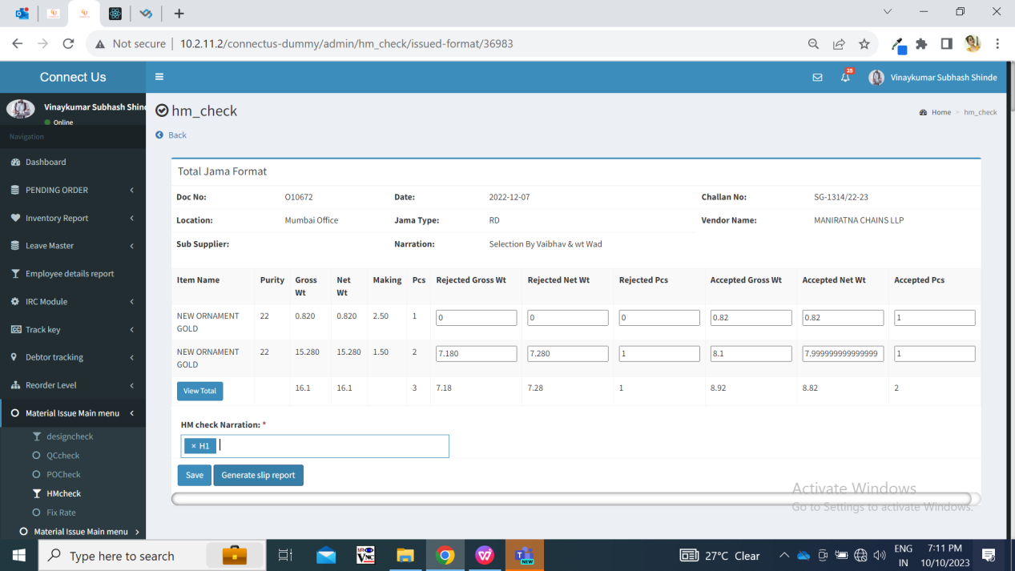

Fig: HM check issued

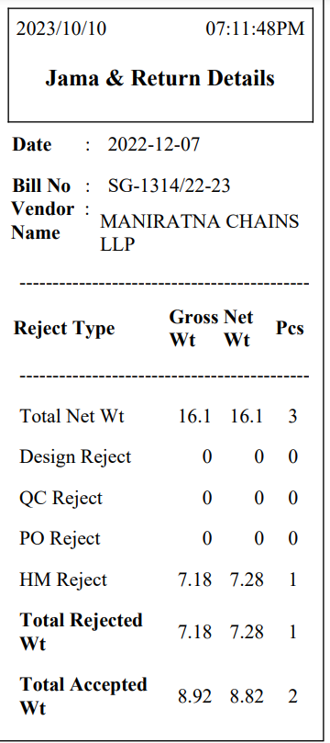

Fig: Receipt after HM check

Whenever pcs are rejected in each checking process, it will be displayed in view action of documents in material issue as well.

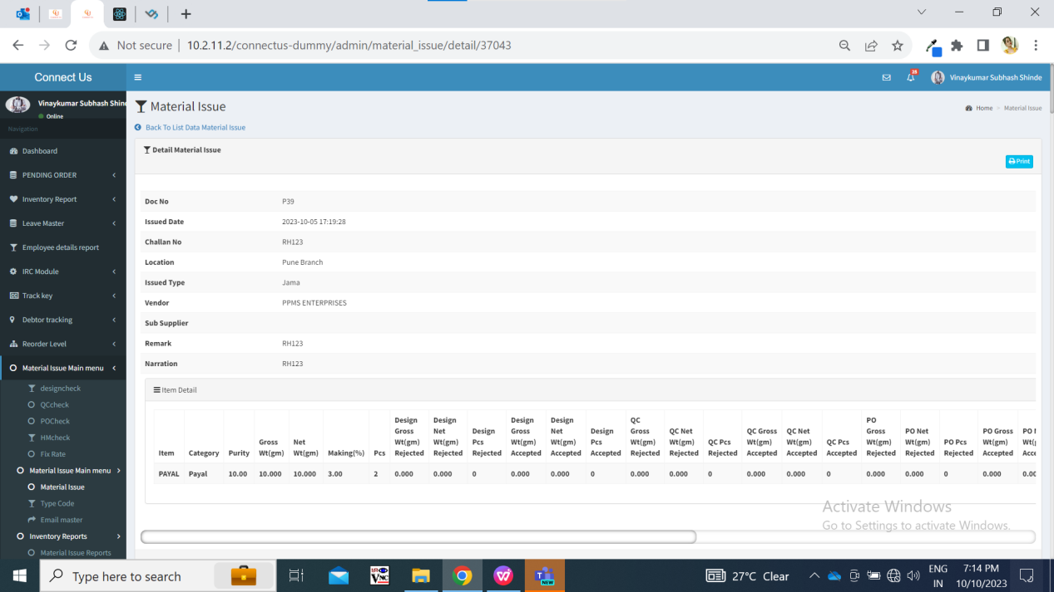

Fig: material issue view action

Once the HM check process for the document is completed, then only ‘on approval out challan’ action will be displayed in material issue menu for that document. (This action will not be displayed until all checking processes for that document are done.)

If all pcs are rejected from the document, then ‘on approval out’ action will display all details as 0 in the table.

Once user clicks on this action, it will display pop up message as ‘Do you you want to print receipt? Yes/ No’. Once user clicks on yes, then challan will open in new link. It will display following fields:

* From:

Chandukaka Company name   
 Address

Gst no.

Phone no.

Pan no.

* To:

Vendor Name   
 Vendor Address

Vendor GST no.

Vendor pan no.

Vendor phone no.

* Doc No.
* Issued Date
* Challan no. / bill no.
* Jama type
* Narration
* Sr. No.
* Item name
* KT
* W/MK
* Rejected pcs
* Rejected gross wt
* Rejected net wt

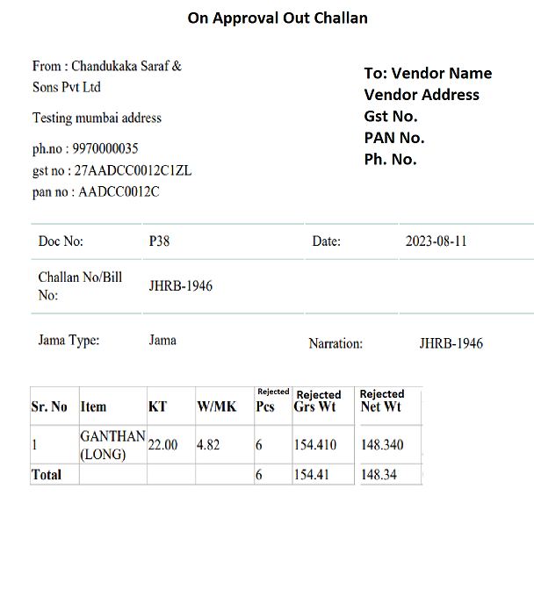

|  |  |  |  |
| --- | --- | --- | --- |
| **FIELDS** | **INPUT TYPE** | **MANDATORY/ OPTIONAL** | **DESCRIPTION** |
| From details | Text | Mandatory | It represents the details of the company from which the stock is being dispatched.  It will display company name, address, gst no., pan no. and ph no. From cu_master_setting table.  Setting number 43 (here 43 is company name), setting no. 44 for address 1, setting no. 45 for address 2, setting no. 46 for pan no. and setting no. 67 for GST no. |
| To details | Text | Mandatory | It will display the vendor details from vendor master.  Vendor will be the one which was selected while adding the document in material issue menu. |
| Doc no. | Text | Mandatory | It will display the doc. No. Which was generated after adding the document in material issue menu. |
| Issued date | Text | Mandatory | It will display the date on which the doc. Number was added in the material issue menu. |
| Challan no. / bill no. | Text | Mandatory | It will display the challan no. Which was mentioned while adding the document. |
| Jama type | Text | Mandatory | It will display rd / jama as mentioned while adding the document. |
| Narration | Text | Mandatory | It will display narration as mentioned while adding the document. |
| Sr. no | Text | Mandatory | It will display the no. of items added in the document. |
| Item name | Text | Mandatory | It will display the names of item added in the document. |
| KT | Text | Mandatory | It will display the KT of each item added in the document. |
| W/MK | Text | Mandatory | It will display the W/MK of each item added in the document. |
| Rejected pcs | Text | Mandatory | It will display the rejected pcs of each item in that document as per rejeced pcs in HM check process. |
| Rejected gross wt | Text | Mandatory | It will display the rejected gross wt of each item in that document as per rejeced gross wt until HM check process. |
| Rejected net wt | Text | Mandatory | It will display the rejected net wt of each item in that document as per rejeced net wt in HM check process. |

User will be able to download and print on approval out challan multiple times.

1. **REFERENCES OF THE USERS**

|  |  |  |  |
| --- | --- | --- | --- |
| **User** | **Name** | **Mail** | **Contact number** |
| **Actual user** | Somnath magar |  |  |
| **Ticket created by (if any)** | Somnath magar |  |  |
| **Assigned business analyst** | Manali bhadirage | Manali.bhadirage@techneai.com |  |
| **Assigned developer** | Yogita jagtap | Yogita.jagtap@techneai.com |  |
| **Assigned tester** | Amruta kore | intern@techneai.com |  |