REORDER LEVEL - SCM MASTER

Manali Ashok Bhadirage

Manali.bhadirage@techneai.com

11.01.2024

**Functional Requirement Document**

**CONTENTS**

1. TICKET DETAILS 2

2. VERSION CONTROL 2

3. APPROVALS 2

4. ESTIMATION 2

5. INTRODUCTION 3

6. BUSINESS REQUIREMENT 3

7. SCOPE 3

8. BUSINESS & SYSTEM RULES 4

9. ABBREVIATIONS & TERMS 4

10. EXISTING SYSTEM 4

11. GRAPHICAL REPRESENTATION 4

12. PROPOSED SYSTEM 5

13. TEST DATA & SCENARIOS 14

15. REFERENCES OF THE USERS 14

1. **TICKET DETAILS**

|  |  |
| --- | --- |
| **Ticket ID** | TT17825 |
| **Ticket description** | In Connect Us Reorder Level Report Pls Create Process to find which Size Range & Wt Range is Overlapped |
| **Created by** | Rohit Shete |
| **Created on** | 15/11/2023 |
| **Priority** | Medium |

1. **VERSION CONTROL**

|  |  |  |  |  |
| --- | --- | --- | --- | --- |
| **Sr. No** | **Version no** | **Version Date** | **User name** | **User department** |
| **1** | **1.0** | **09/01/2024** | **Rohit Shete** | **Inventory Gold HO** |
|  |  |  |  |  |

1. **APPROVALS**

|  |  |  |
| --- | --- | --- |
| **Field** | **Name of the User** | **Approved date by the user** |
| **Actual User Name Actual User Department Organization Name** | Rohit Shete  Inventory Gold HO  CSJ |  |
| **Assigned BA** | Manali Bhadirage |  |
| **Assigned Developer** |  |  |
| **Assigned Tester** |  |  |

1. **ESTIMATION**

|  |  |  |  |  |
| --- | --- | --- | --- | --- |
| **Department name** | **Estimated Time (In hr)** | **Scheduled Date (Starting date)** | **Estimated date** | **Actual delivery date** |
| **BA** |  |  |  |  |
| **Development** |  |  |  |  |
| **Testing** |  |  |  |  |

1. **INTRODUCTION**

Inventory Reorder Level Report provides information about the stock levels of items in inventory and specifies when it's time to reorder more supplies. The report is crucial for inventory management, helping to maintain balance between having enough stock to meet demand and avoiding overstock situations. Through SCM master, users mention the reorder level count of each SCM code for each branch. Further, user can view count of current quantity at each branch for each SCM code. User can view branch wise reorder level count for each SCM code through reorder level.

Reorder level count specifies the minimum count of each specific SCM code needed at each branch so that new order can be given to the vendor accordingly.

1. **BUSINESS REQUIREMENT**

|  |  |  |  |
| --- | --- | --- | --- |
| **Requirement ID** | **Requirement Name** | **Short Description** | **Priority** |
| BR001 | SCM Master | If user uploads file having overlapping weight range, size range and purity range, then it should display error file and those records should not get added in scm master. (New scm code shouldn’t be considered for overlapping ranges.) | High |
| BR002 | SCM Master | Purity Range should accept and consider single purity or its range with 0 as same. (Like 18, 18.00 and 18.00-18.00 are same) | Medium |
| BR003 | SCM Master | Display reorder level count of each branch in view action of each specific SCM code with updated at and updated by details. | Medium |
| BR004 | Reorder level report | Remove following columns from downloaded reorder level report csv file - SCM code, item code, category code, from size, to size, from weight, to weight. | Medium |

1. **SCOPE**

Once user downloads bulk format from scm master, user will enter the details of item, catgeory, wt range, size range, purity range, exact wt, reorder level and branch name in it. Once user uploads the bulk file having all correct details, it will update the reorder level count of the existing SCM code against that branch. However, it will display error file when user enters incorrect details in the bulk format file. Further, once the reorder level count of each SCM code gets updated, it will also be displayed in reorder level report once generated. Once user clicks on add button, record gets generated in grid displaying action to download stock level report and reorder level report. Reorder level report will display the list of branches vertically and reorder level count of each SCM code in that branch.

1. **BUSINESS & SYSTEM RULES**

* User should be registered & logge in the system.
* User should be logged in.
* System should pop up a message, if any issues in the system is detected.

1. **ABBREVIATIONS & TERMS**

SCM code - item, category, wt range, size range, purity range

Wt - weight

KT - karat

1. **EXISTING SYSTEM**

Currently, it is accepting all entered adat in uploaded bulk file. Even if user enters incorrect data or overlapping weight range / size range / purity range, it is considering the overlapped as new SCM code and record is getting displayed in scm master. Also, user is unable to view reorder level of each branch of SCM codes in SCM master.

1. **GRAPHICAL REPRESENTATION**

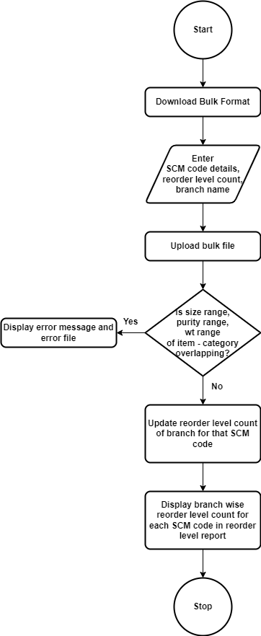

Fig: Process Flow diagram

1. **PROPOSED SYSTEM**
2. **SCM MASTER**

Once user clicks on SCM master menu, it will display following fields:

* Bulk format
* Upload file
* Export data
* View button
* Delete button
* ID
* Item
* Category
* From size
* To size
* From weight
* To weight
* Exact wt
* Purity Range
* Created at
* Created by

Once user downloads bulk format, it will have following columns:

* Item
* Category
* Size range
* Weight range
* Exact wt
* Purity Range
* Reorder level
* Padm branch name

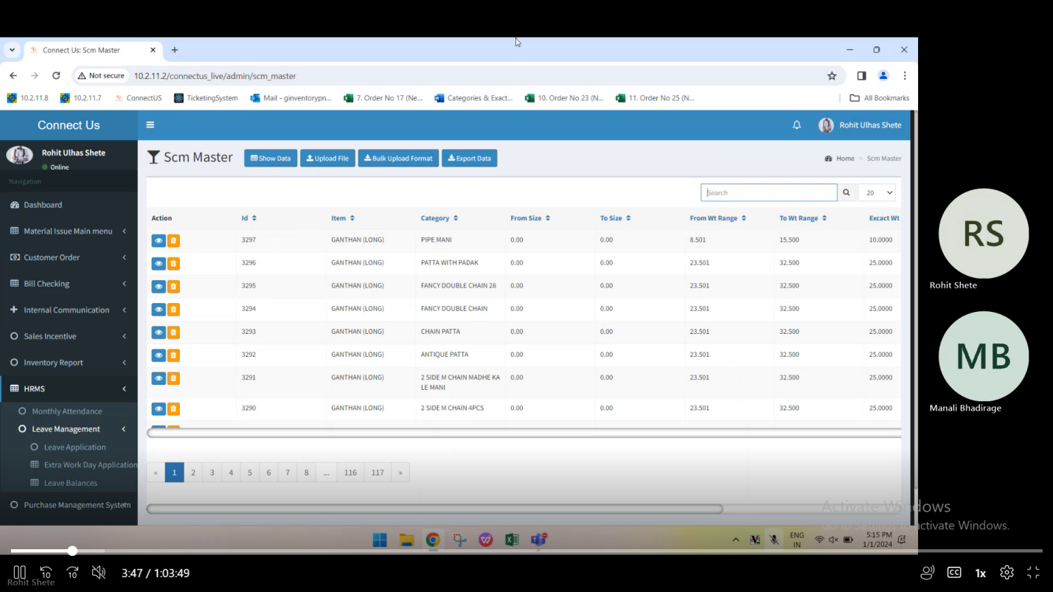

Fig: SCM Master -> grid

Once user fills the data in above columns and uploads the file, reorder level count of each branch will get updated for each entered SCM code. However, in case user enters incorrect data and uploads the file through upload file button, then error message should be displayed along with error file. Error file should specify the invalid details of the record.

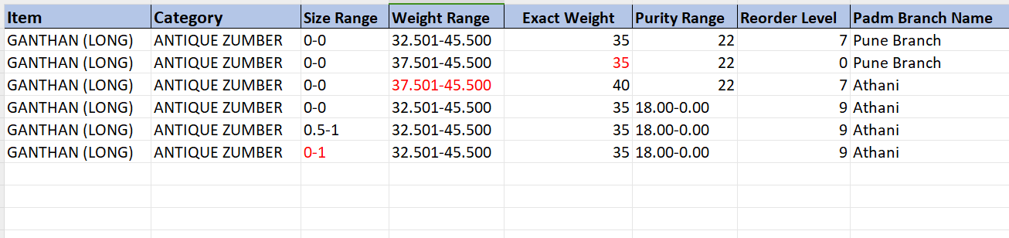

Fig: SCM Master -> Bulk upload file

**Input table**

|  |  |  |  |  |
| --- | --- | --- | --- | --- |
| **FIELDS** | **INPUT TYPE** | **MANDATORY/ OPTIONAL** | **EDITABLE** | **DESCRIPTION** |
| Item | Text | Mandatory | Editable in bulk file only | User will mention the name of the item for which the reorder level of branch is to be mentioned.  Validation: It will accept alphanumeric value. It should accept - and / only as special character. It should accept space.  Min length = 3 Max length = 50 |
| Category | Text | Mandatory | Editable in bulk file only | User will mention the name of the category name of the item for which the reorder level of branch is to be mentioned.  Validation: It will accept alphanumeric value. It should accept - and / only as special character. It should accept space.  Min length = 3 Max length = 50 |
| Size Range | Text | Mandatory | Editable in bulk file only | User will enter the from size and to size of the mentioned item - category.  In case user enters overlapping size range from the existing SCM code, then it should display error for that record in bulk file.  Each time when user enters record, then it should check it SCM code (item - category - size range - weight range - purity range). And, if entered size range of bulk upload file gets overlapped with its existing SCM code entry, then it should display error file and that record should not get added as new SCM code in master or grid. Example: If user already enters BANGDI - CSB - size range 2-4, weight range 10.000-15.000, then it will get added initially. However If user enters another SCM code as BANGDI - CSB - size range 3-5, weight range 10.000-15.000 then it should not get added as size is overlapping.  Validation: It should accept one hyphen only. It should accept numbers only. It accept only max two numbers after decimal point. It should consider number and its number with 00 after decimal point as same (I.e. 1 and 1.00 are same). |
| Weight range | Text | Mandatory | Editable in bulk file only | User will enter the from weight and to weight of the entered item - category.  In case, user enters overlapping weight range of existing SCM code, then it should display error file and that record should not get added in SCM master grid. Example: If user already enters BANGDI - CSB - size range 2-4, weight range 10.000-15.000, then it will get added initially. However If user enters another SCM code as BANGDI - CSB - size range 2-4, weight range 10.000-13.000 then it should not get added as weight is overlapping.  Validation: It should accept one hyphen only. It should accept numbers only. It accept only max three numbers after decimal point. It should consider number & its number with 00 after decimal point as same (I.e. 14 and 14.00 are same). |
| Purity range | Text | Mandatory | Editable in bulk file only | User will enter the from purity and to purity of the item - category.  In case, user enters overlapping purity range of existing SCM code, then it should display error file and that record should not get added in SCM master grid. Example: If user already enters BANGDI - CSB - size range 2-4, weight range 10.000-15.000, purity range 18.00-22.00 then it will get added initially. However If user enters another SCM code as BANGDI - CSB - size range 2-4, weight range 10.000-13.000, purity 23.5 then it should not get added as weight is overlapping.  Validation: It should accept one hyphen only. It should accept numbers only. It accept only max two numbers after decimal point. It should consider number & its number with 00 after decimal point as same (I.e. 14, 14.00 and 14.00-14.00 are same). |
| Exact wt | Text | Mandatory | Editable in bulk file only | User will enter the exact wright of the item - category.  Validation - It should be between the entered weight range. It should accept numbers only. It should accept decimal point only as special character. It should accept only one decimal point. It accept max three digits after decimal point. |
| Reorder level | Text | Mandatory | Editable in bulk file only | User will enter the reorder level count for that SCM code at the branch. Once user enters the SCM code along with reorder level of the specified branch, then if record of that branc for same SCM os existing then it will update / replace the reorder level count. If the record doesn’t exist for that branch for that SCM code, then it will get added.  Reorder level count is the count of that product required at the branch.  Validation: It should accept numbers only. |
| Padm branch name | Text | Mandatory | Editable in bulk file only | User will enter the branch name for which reorder level count has to be updated for that SCM code.  Validation: It should accept branch name as in padm masters -> branch information table only. |

Further, once user uploads the file and submits it, the SCM code will be displayed in the grid if it is new along with its reorder level count of mentioned branches or it will update the branchwise reorder level count of existing SCM code.

Once user clicks on view action of SCM master record, it will display following fields:

* Item
* Category
* From size
* To size
* From wt
* To wt
* From purity
* To purity
* Created at
* Created by
* Reorder level details: Branch name, Reorder level count, Updated at, Updated by

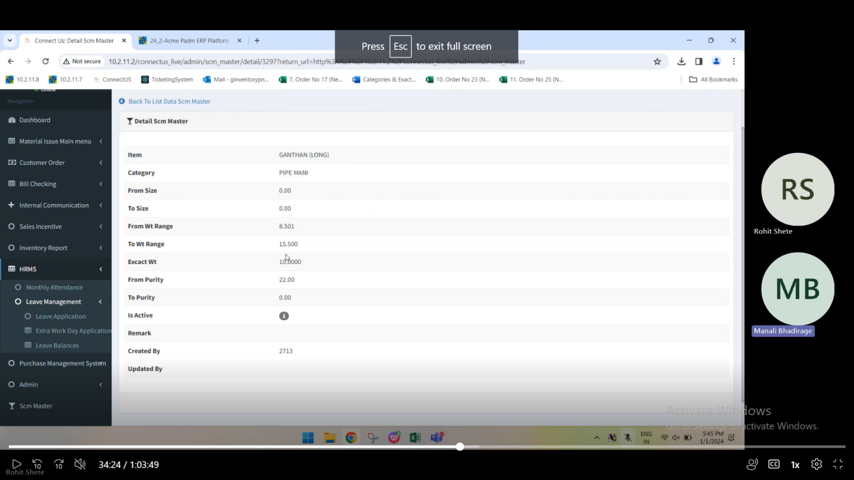

Fig: SCM Master -> view action

|  |  |  |  |  |
| --- | --- | --- | --- | --- |
| **FIELDS** | **INPUT TYPE** | **MANDATORY/ OPTIONAL** | **EDITABLE** | **DESCRIPTION** |
| Created at | Text | Mandatory | No | It will display the date and time when the SCM code was created by the user that means added in grid through bulk upload file. |
| Branch name | Text | Mandatory | No | It will display the branch name in the tables which were entered in uploaded bulk file for that SCM code. |
| Reorder level count | Text | Mandatory | No | Each time when bulk file is uploaded with new reorder level count for the branch of specified SCM code, then reorder level count of that SCM code should be updated and displayed here. |
| Updated at | Text | Mandatory | No | It will display the date and time when the reorder level count of that branch for that SCM master was updated. |
| Updated by | Text | Mandatory | No | It will display the Employee ID and employee name when the reorder level count of that branch for that SCM master was updated through bulk upload file. |

1. **REORDER LEVEL REPORT**

Furthermore, once the file is uploaded in the SCM master, its details gets updated in recently generated report through Reorder level report menu. It has following fields:

* Generate report
* Stock level report
* Requisition Report
* Reorder level report
* Report ID
* Start at
* Completed at
* Status
* Created by

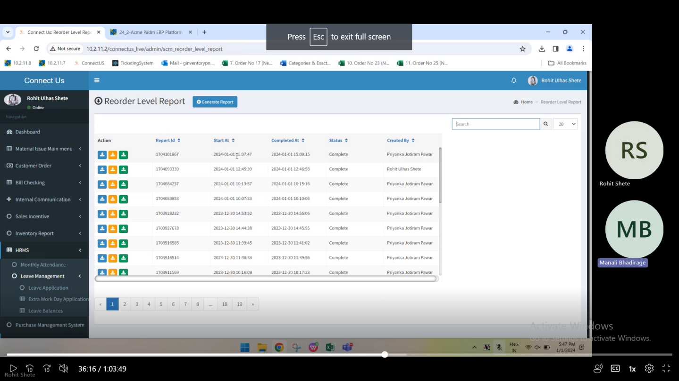

Fig: Reorder level report -> Grid

Once user clicks on generate report button, a record will be created and displayed in the grid.

Through reorder level report button, user can download recently generated reorder level report. This report displays the total count of pcs each branch has for each SCM code. It will have following columns in generated csv report:

* ID
* Unique key
* Branch name
* Item
* Category
* Size range
* Weight range
* Exact wt
* Reorder level
* Current stock
* Hallmarking pcs
* Created at
* Created by

(Remove SCM code, item code, category code, from size, to size, from weight, to weight)

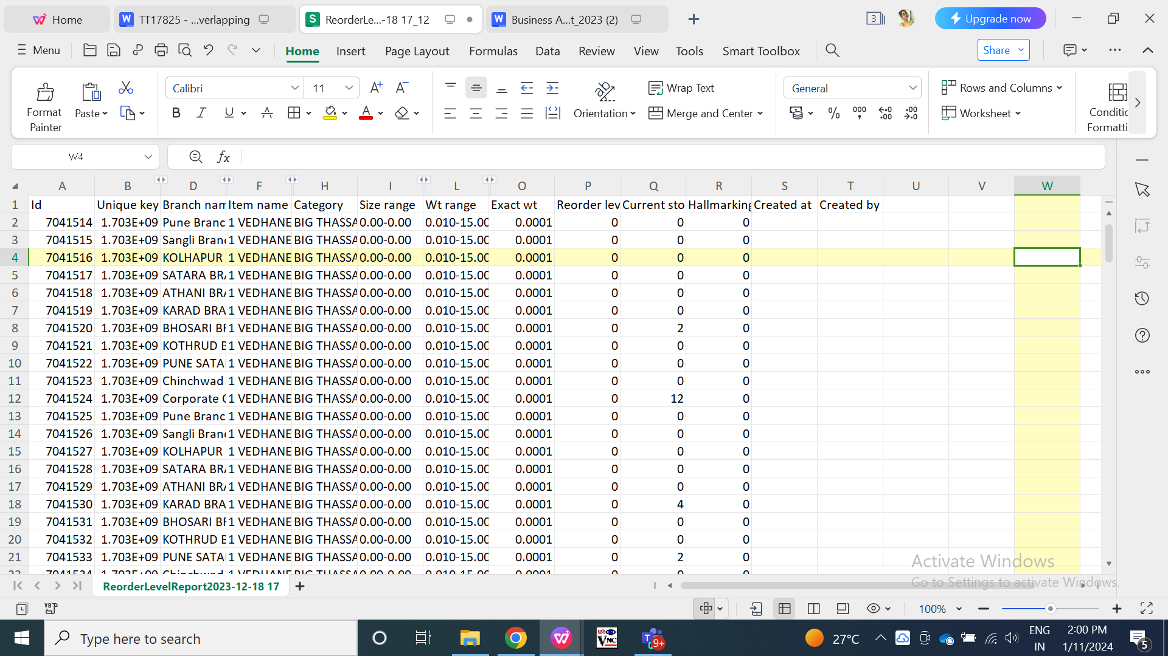

Fig: Reorder level report -> CSV

Here, in branch name it will display list of branches for whom the reorder level count was entered / updated for that SCM code.

In reorder level count, it will display the pcs count for that branch for that SCM code as entered while uploading bulk file in SCM master. If the reorder level count for the branch for that SCM master was not updated then it will display the old count in reorder level report.

In current stock level, it will display the count of pcs available in branch for that SCM code. It can be verified from padm -> label / batch wise stock report.

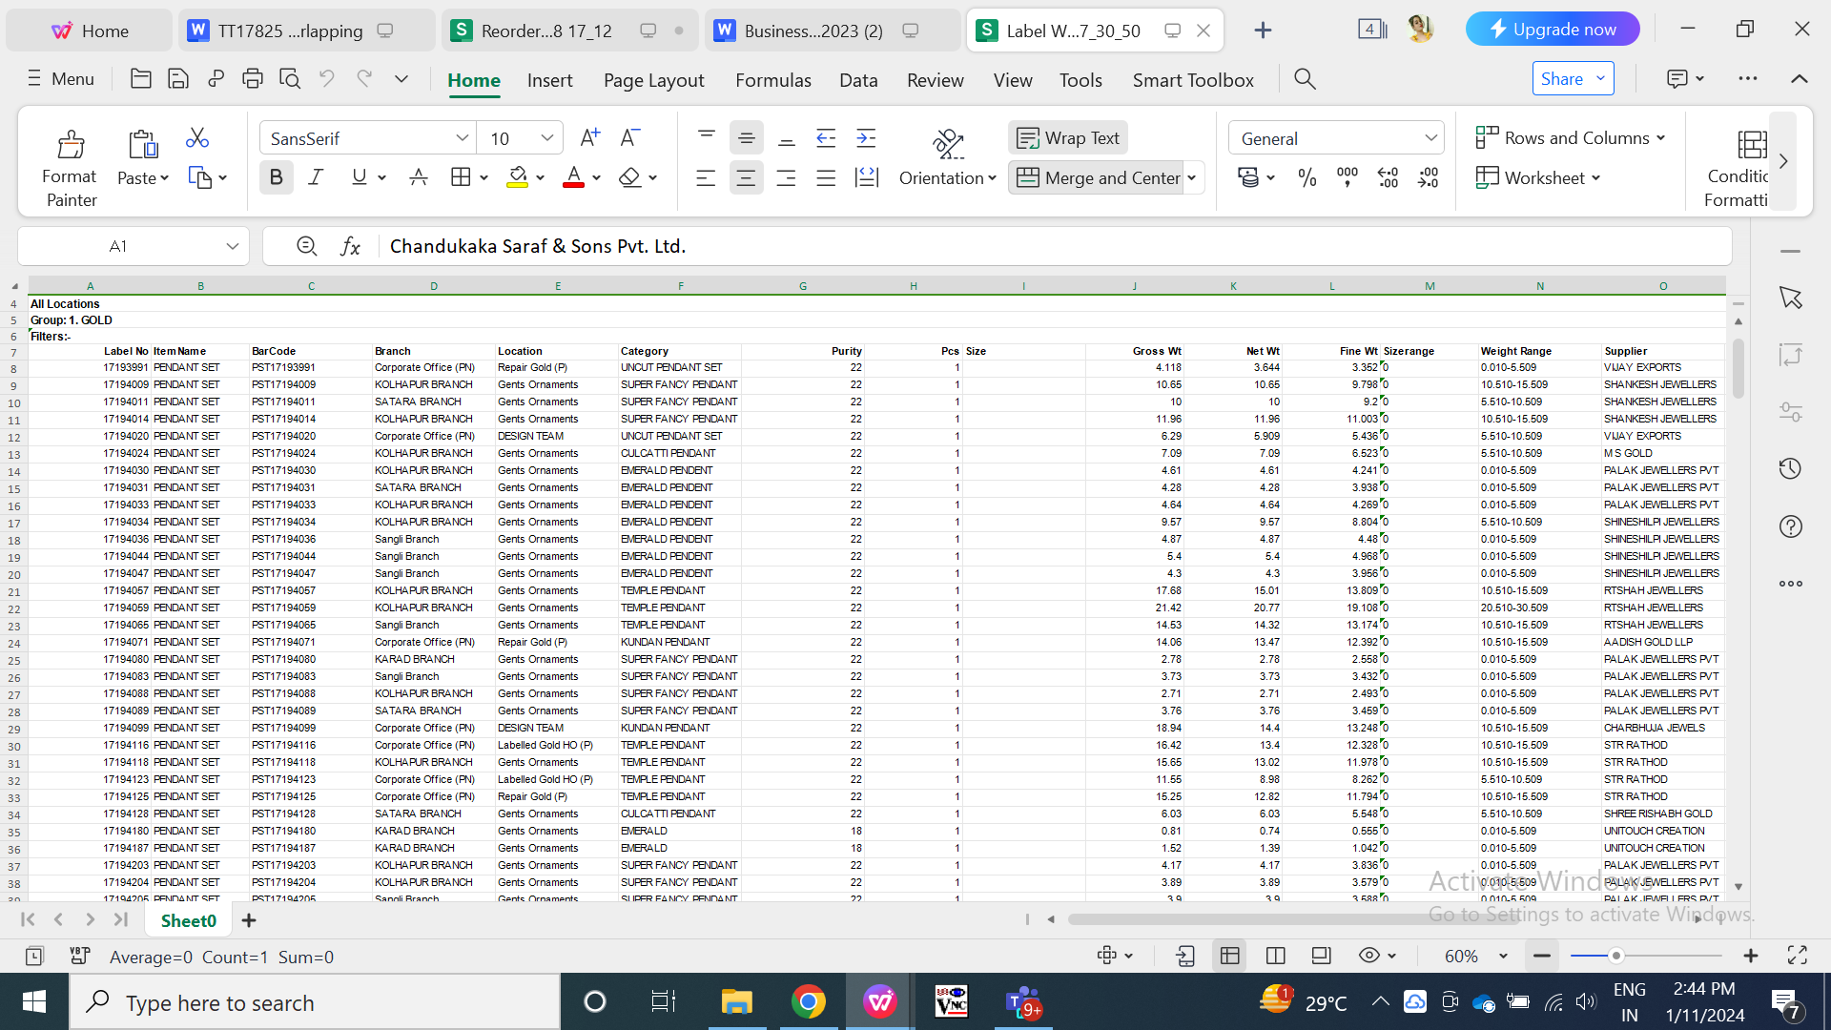

Fig: Padm label / batch wise stock report

1. **TEST DATA & SCENARIOS**



1. **ODUS (Open Discussion Unhandled Scenarios)**

|  |  |  |  |  |
| --- | --- | --- | --- | --- |
| **Sr. No.** | **Topic** | **Priority**  **(High / medium / low)** | **Remark** | **Status**  **(Open/**  **Closed)** |
| 1 |  |  |  |  |
| 2 |  |  |  |  |
| 3 |  |  |  |  |

1. **REFERENCES OF THE USERS**

|  |  |  |  |
| --- | --- | --- | --- |
| **User** | **Name** | **Mail** | **Contact number** |
| **Actual user** | Rohit shete | ginventorypn1@csjewellers.com |  |
| **Ticket created by (if any)** | Rohit shete | ginventorypn1@csjewellers.com |  |
| **Assigned business analyst** | Manali bhadirage | Manali.bhadirage@techneai.com |  |
| **Assigned developer** |  |  |  |
| **Assigned tester** |  |  |  |