16.01.2024

IMPS - EDIT URL

Manali.bhadirage@techneai.com

Manali.bhadirage@techneai.com

**Handover Document**

**CONTENTS**

1. TICKET DETAILS 2

2. INTRODUCTION 2

3. BUSINESS REQUIREMENT 2

4. SCOPE 3

5. BUSINESS & SYSTEM RULES 3

6. ABBREVIATIONS & TERMS 3

7. GRAPHICAL REPRESENTATION 3

8. DEVELOPED SYSTEM 4

9. REFERENCES OF THE USERS 6

1. **TICKET DETAILS**

|  |  |
| --- | --- |
| **Ticket ID** | TT18510 |
| **Ticket description** | Restrict edit url to users who do not have authority to edit imps bills. Only 'assigned to user' and special authority users should be able to edit bills. |
| **Created by** | Manali ashok bhadirage |
| **Created on** | 18/12/2023 |
| **Priority** | high |

1. **INTRODUCTION**

IMPS payment, a sub-module in Connect US -> Bill Checking, is used during 12 URD purchase transactions done in Padm. The payments of URD purchases are processed through IMPS payment module i.e. we have to pay the mentioned payment amount to the customer. The user enters the document series number from Padm and the data as per document number gets displayed. Further these bills are assigned to another user. The authorized person verifies the bill and then changes the status hold / hold till audit / release / paid. Once payments status is changed to release then that bill gets displayed in list of download payment. Moreover, once user enters the bank file then the successful payments get displayed as paid in imps payment module.

1. **BUSINESS REQUIREMENT**

Restrict edit option or by url to unathorised user.

|  |  |  |  |
| --- | --- | --- | --- |
| **Requirement ID** | **Requirement Name** | **Short Description** | **Priority** |
| BR001 | Edit action | Only ‘assigned to’, super admin and/or user having special authority should have edit action of the bill. | High |
| BR002 | Edit URL | If user tries to access the bill by editing url which is not assigned to logged in person, then it should display alert message. | High |

1. **SCOPE**

Once entry user adds the bills and sub,its, then bill should be displayed in the grid where assigned user can edit it whereas all other users can only view it. Other users shouldn’t be able to edit or have access to the edit page if bill is not available in grid and is not assigned to the logged in user. When user enters link of any bill, then system should check whether that bill is assigned to the logged in person or not and then grant access to perform edit actions accordingly. If user has entered edit link of any bill and if that bill is not assigned to user, then it should display error message stating ‘you do not have privilege to access this bill.

1. **BUSINESS & SYSTEM RULES**

* User should be registered in the system.
* User should be logged in.
* System should pop up a message, if any issues in the system is detected.

1. **ABBREVIATIONS & TERMS**

IMPS - Immediate Payment Service

IFSC code - Indian financial system code

RTGS - Real Time gross settlement

1. **GRAPHICAL REPRESENTATION**

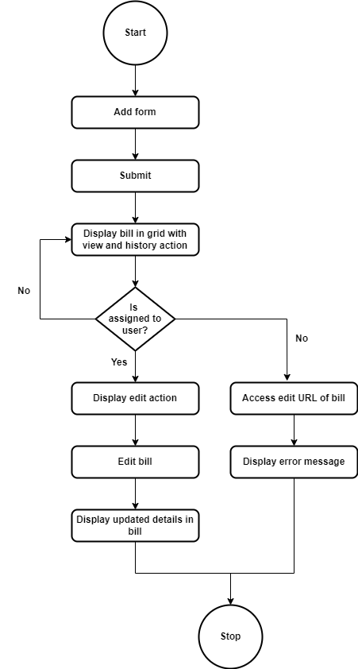

Fig: Process flow diagram

1. **DEVELOPED SYSTEM**

Previously, when entry user created bill and assigned to ‘assigned to’ user, assigned to user gets provision of edit action to the bill which is assigned to him. Whereas all other users only have access to view action and history action as bill is not assigned to them. However, other users were clicking on view action and editing URL to have access to edit it. Hence, all users were able to access edit action to all the bills even when it is not assigned to them. Thus, it was leading to malfunctioning of the system.

Once entry user clicks on **add** bill, it will display following fields:

* Series no. And search button
* Branch name
* Customer name
* Mobile no.
* Address
* Adjust amount
* Padm credit balance
* Payment amount
* Assign to
* Type
* Bank name
* Bank branch
* Ifsc code
* Account number
* Confirm account number
* Attachments
* Remark
* Submit button

Once user fill the form with mandatory details and submits it, bill will be generated and displayed in the top row of grid. The bill will get assigned to the selected user and ‘assigned to’ user will have dit action for that bill. Example: Vinaykumar shinde is the entry user and has assigned bill to Rohan Shah. Once vinaykumar shinde submits the bill, then it will be displayed in grid of all users where only rohan shah will have edit action to that assigned bill.

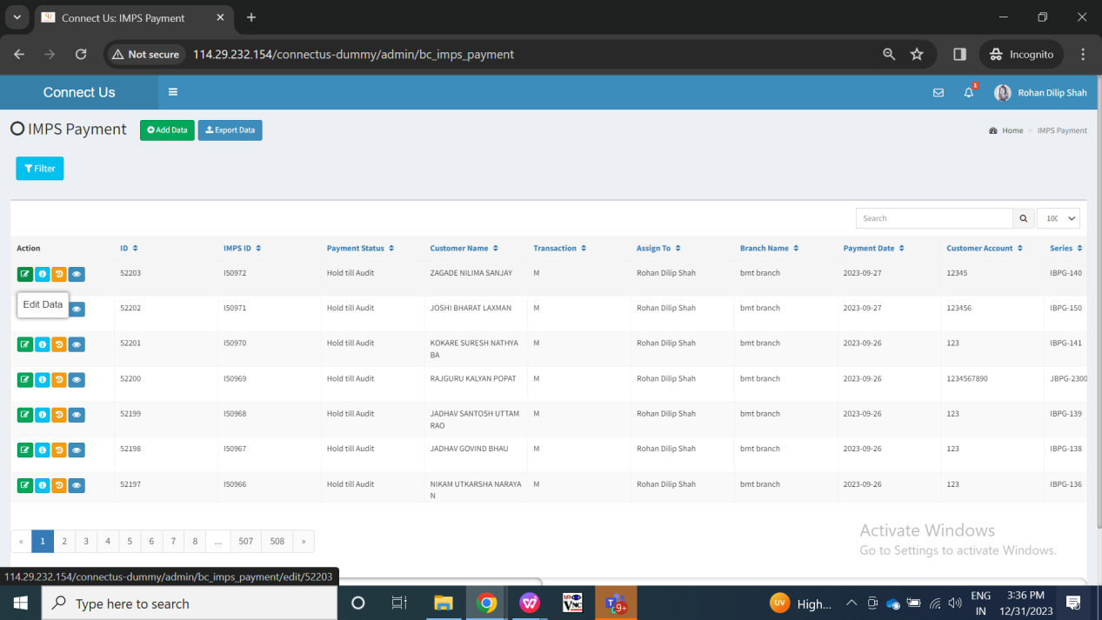

Fig: Vinaykumar shinde assigned bills to Rohan Shah

Only the ‘assigned to’ user should be able to click on edit action of the bill and edit it. Only Rohan Shah will have edit action for the bill whereas other users will only have access to view and history action of that bill.

So, now when Divya Danpelli logs in, that user should be able to only view it and view its history but shouldn’t be able to edit it through url.

When Divya tries to edit the url and access edit url, then it should display error message as ‘ you do not have privilege to access this bill’ because bill is not assigned to divya.

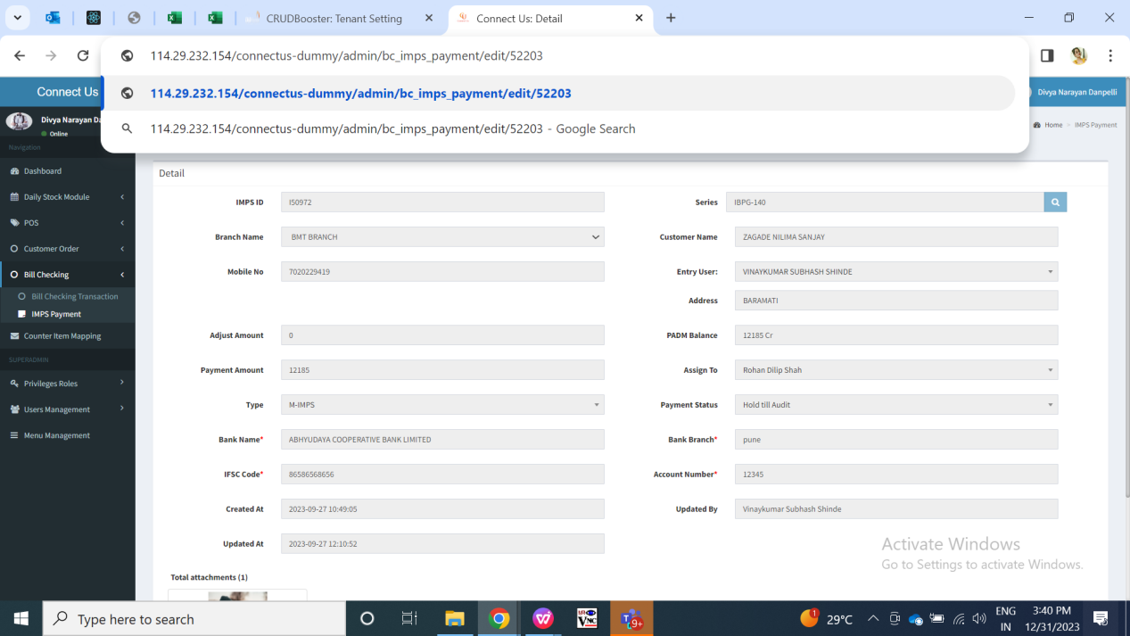

Fig: Unauthorized user editing edit URL to access bill

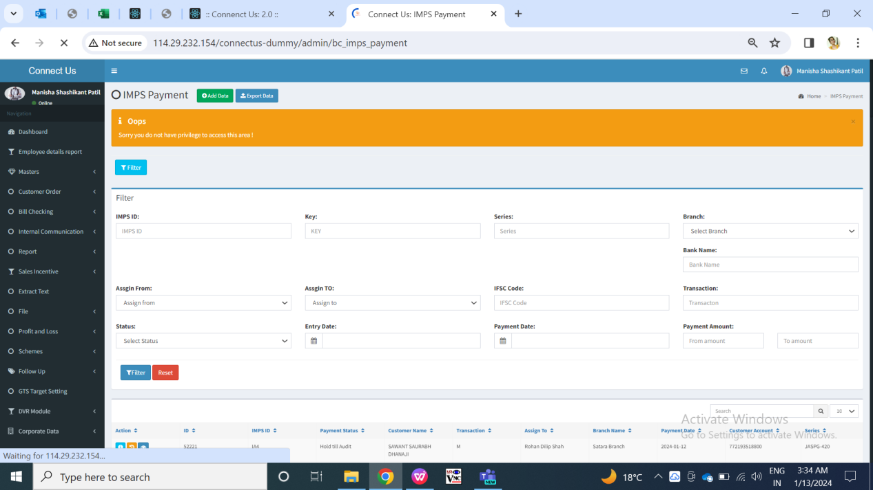

Fig: Expected error message when unauthorized user edits bill

1. **REFERENCES OF THE USERS**

|  |  |  |  |
| --- | --- | --- | --- |
| **User** | **Name** | **Mail** | **Contact number** |
| **Actual user** | Rajesh Barse |  |  |
| **Ticket created by (if any)** | Manali bhadirage | Manali.bhadirage@techneai.com |  |
| **Assigned business analyst** | Manali bhadirage | Manali.bhadirage@techneai.com |  |
| **Assigned developer** | Jaydeep Patil | Jaydeep.patil@techneai.com |  |
| **Assigned tester** | Amruta Kore | intern@techneai.com |  |