**MATERIAL ISSUE PDF - ITEM CATEGORY**

Manali Ashok Bhadirage

Manali.bhadirage@techneai.com

28.12.2023

**Handover Document**

**CONTENTS**

1. TICKET DETAILS 2

2. INTRODUCTION 2

3. BUSINESS REQUIREMENT 2

4. SCOPE 3

5. BUSINESS & SYSTEM RULES 3

6. ABBREVIATIONS & TERMS 3

7. GRAPHICAL REPRESENTATION 3

8. DEVELOPED SYSTEM 4

9. REFERENCES OF THE USERS 9

1. **TICKET DETAILS**

|  |  |
| --- | --- |
| **Ticket ID** | TT18593 |
| **Ticket description** | Add Category Column in Material Isuue Print Format Current Format Print Attached |
| **Created by** | Sunil Khuspe |
| **Created on** | 22/12/2023 |
| **Priority** | High |

1. **INTRODUCTION**

Within the material issue menu, inventory users input details of materials received from vendors.As per input details in add form and once user submits it, record get displayed in grid and unqiue document number gets genarated for it. Further, this document gets approved by an authorized individual before progressing to four checking stages (design check, QC check, PO check, HM check). During these inspection stages, some pieces may be rejected and will be sent back to the vendor, while the accepted pieces will lead to the creation of a RD purchase bill within the Padm system for the vendor. Purchase return bill is generated for the rejected pcs and then returned to the vendor.

When document is generated, PDF file gets generated to it which is displayed in ‘take print’ action of that document. PDF file displays all the details of the document like from details, to details, detailed information of items and its total count.

1. **BUSINESS REQUIREMENT**

|  |  |  |  |
| --- | --- | --- | --- |
| **Requirement ID** | **Requirement Name** | **Short Description** | **Priority** |
| BR001 | Material issue -> Take print -> PDF | We need to add category column in item details of document’s PDF file. | Medium |
| BR002 | Material issue -> Take print -> PDF | We need to display category wise items in the PDF table format of document. | Medium |
| BR003 | Material issue -> Take print -> PDF | We need to display all the details and pcs count of item and category accordingly. | Medium |

1. **SCOPE**

In scope: Once user adds the details of each item it will be displayed in the table below. Further, added record will be displayed on top of grid once user submits the form. Once the record is added, document number will be generated and displayed in grid. It will have actions namely view, edit, history, take print and get attachment data. Once user clicks on ‘take print’ action, then pdf file displaying all details of that document will be displayed on new tab. The PDF file should display all the details namely to details, from details, document information, category wise item information and their total. Currently, PDF displays only the item wise details. It doesn’t display catgeories included in that item. PDF should display all the details in PDF format as entered by the entry user while adding or editing it.

Out scope: Once document is marked as received, it gets forwarded to first Design check process of material issue. However, checking of items will not be considered as part of this scope. Moreover, matching the data with Padm will not be included in this point as it will dependent on the entry user.

1. **BUSINESS & SYSTEM RULES**

* User should be registered in the system and user should be logged in.
* System should display on field errors in case of incorrect inputs.

1. **ABBREVIATIONS & TERMS**

Wt - Weight

Gm - grams

KT - karat

MK - making

Pcs - pieces

PDF - Portable Document Format

BB - Black Bits

1. **GRAPHICAL REPRESENTATION**

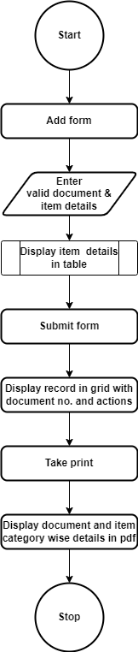

Fig: Process Flow Diagram

1. **DEVELOPED SYSTEM**

In previous system, PDF displayed only the item wise details. It wasn’t displaying catgeories included in that item.

Once user clicks on material issue menu, it should display following fields:

* Add button
* View action
* History action
* Edit action
* Take print action
* Received action
* Edit data action
* Get attachment action
* Doc no.
* Date
* Challan no.
* Net wt (gm)
* Location
* Issued type
* Vendor
* Sub supplier
* Narration
* Received status
* Time difference

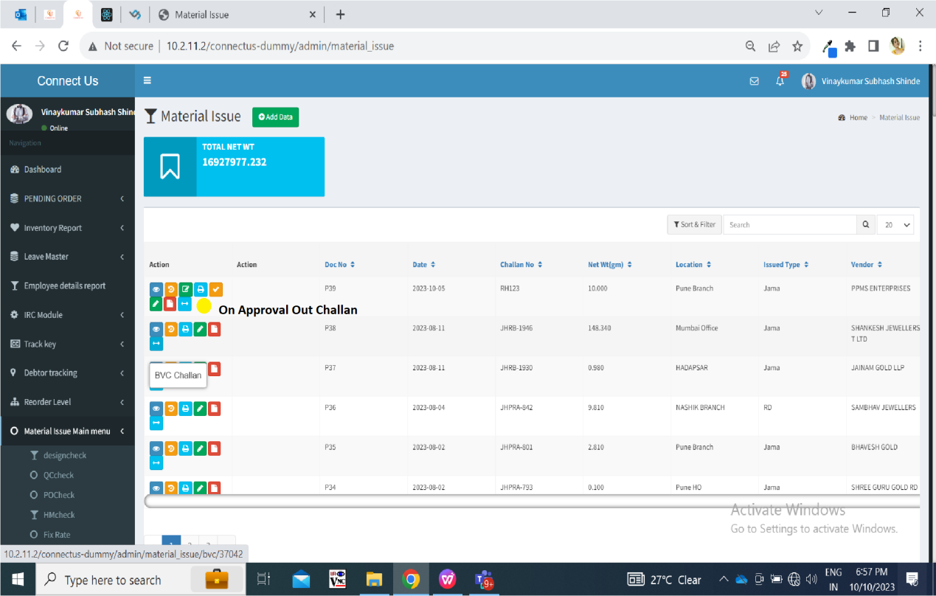

Fig: Material issue grid

Once user clicks on add action, it will display following fields:

* Issued date
* Challan no.
* Location
* Issued Type
* Vendor
* Sub supplier
* Narration
* Remark
* Item detail form:
* Item
* Category
* KT
* Gross wt
* Net wt
* Black bits
* Stone wt
* Stone amt
* Other charges
* Other wt
* Making
* Wastage
* Pcs
* Add to table button
* Reset button
* Table detail
* Total
* Save button
* Save & add more button
* Back button

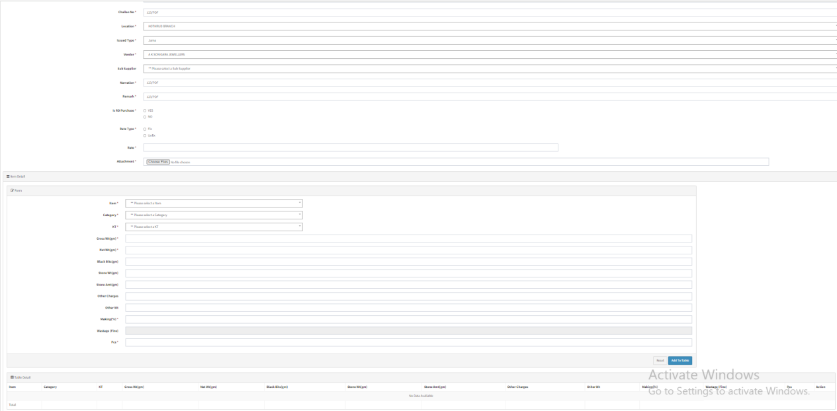

Fig: Material issue -> add

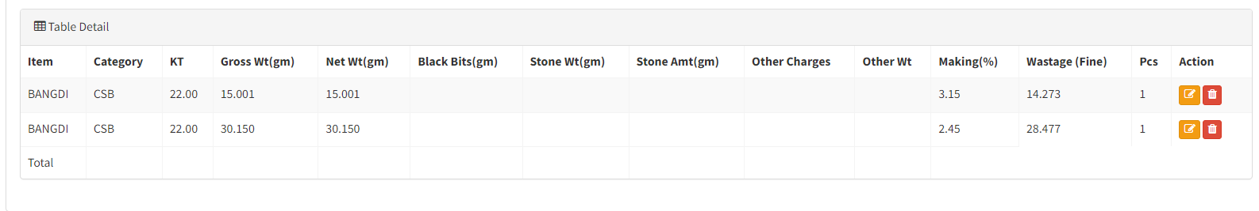

Fig: Added item details

Once data is added, then doc number gets generated to it and it will be displayed in grid displaying view, edit, history, take print, received and get attachment action against it.

Further, it will display a pop when user will click on take print action. If user clicks on yes, then pdf file will be displayed in new tab. PDF file should display following fields:

* From - Name, Address, ph no, GST no., PAN no
* To - Name, Address, ph no, GST no., PAN no
* Doc no.
* Date
* Challan no.
* Location
* Jama type
* Vendor name
* Address
* GST no.
* Narration
* Item details Table
* Sr. No.
* Item
* Category
* KT
* W/MK
* Pcs
* Gross wt
* BB wt
* Stone wt
* Other wt
* Net wt
* Wastage
* Total
* Issud signature
* Receiver signature

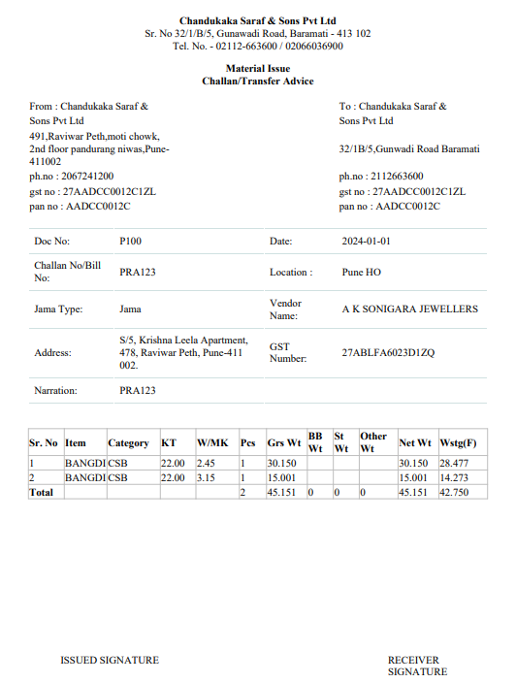

Fig: Material issue -> PDF

|  |  |  |  |  |
| --- | --- | --- | --- | --- |
| **FIELDS** | **INPUT TYPE** | **MANDATORY/ OPTIONAL** | **EDITABLE** | **DESCRIPTION** |
| Category | text | Mandatory | No | When user has added the item in the table while creating the document, category of that item should be displayed here. If user edits document and updates category, then updated category name should be displayed in view action, edit action as well in print.  It should display all the other details of the item in pdf as it was menioned in add / edit.  If user adds new organament gold item of new ornament category with 1 pcs and adds same item category with 1 pcs in material issues, then on print it should display only one row of new ornament gold - new ornament, then iIt should display two rows as user has added two item details in the table of material issue. Just ensure that we display category against each item.  Validation: If more than one item of different category were added, then it should be displayed in the pdf along with its respective different category. |

1. **REFERENCES OF THE USERS**

|  |  |  |  |
| --- | --- | --- | --- |
| **User** | **Name** | **Mail** | **Contact number** |
| **Actual user** | Sunil Khuspe  Rohit shete | [ginventorypn@csjewellers.com](mailto:ginventorypn@csjwellers.com)  Ginventorypn1@csjewellers.com |  |
| **Ticket created by (if any)** | Sunil Khuspe | ginventorypn@csjewellers.com |  |
| **Assigned business analyst** | Manali Bhadirage | Manali.bhadirage@techneai.com |  |
| **Assigned developer** |  |  |  |
| **Assigned tester** |  |  |  |