17.01.2024

UNFIX / FIX RATE

Manali Ashok Bhadirage

Manali.bhadirage@techneai.com

**Handover Document**

**CONTENTS**

1. TICKET DETAILS 2

2. INTRODUCTION 2

3. BUSINESS REQUIREMENT 2

4. SCOPE 3

5. BUSINESS & SYSTEM RULES 3

6. ABBREVIATIONS & TERMS 4

7. GRAPHICAL REPRESENTATION 4

8. PROPOSED SYSTEM 6

9. REFERENCES OF THE USERS 25

1. **TICKET DETAILS**

|  |  |
| --- | --- |
| **Ticket ID** | TT11135 |
| **Ticket description** | Unfix process development in inventory |
| **Created by** | Manali Ashok Bhadirage |
| **Created on** | 10/04/2023 |
| **Priority** | Very high |

1. **INTRODUCTION**

Generally, following the material issue inspection by the HM check process, users assess the daily rates in accordance with the vendor. This evaluation will be done through the fix rate menu, containing documents related to RD purchases with an unfixed rate type. Subsequently, credit or debit notes will be created depending on whether the fixed rate is greater or unfixed rate is greater.

1. **BUSINESS REQUIREMENT**

|  |  |  |  |
| --- | --- | --- | --- |
| **Requirement ID** | **Requirement Name** | **Short Description** | **Priority** |
| BR001 | Material issue -> add, edit and view action | We have to add following fields: Is RD purchase, rate type, fix rate, attachments. | Medium |
| BR002 | Material issue -> edit | Fix rate and rate type fields will be read only once that particular document has completed HM check process. | Medium |
| BR003 | Fix rate | We have to create new menu and display documents which are saved in HM check process, are RD purchase, whose rate type is unfix. | High |
| BR004 | Fix rate - edit action | We have to provide edit action based on authority.  In edit action, user will enter the document number of purchase return and RD purchase. | High |
| BR005 | Fix rate - fix rate action | Once documents are entered, then fix rate action will be displayed and edit action will be removed for that record.  Fix rate action will be provided based on authority.  Through fix rate action, user will break and fix the rate and further net amount will be calculated.  User will enter the credit and debit note numbers. | High |
| BR006 | Fix rate - view action | It will display the details of the documents scanned. It will display the details of the break rate till now. It will display the net payable amount of that document.  Submit button will be enabled once fine wt for that document is 0.00 | Medium |

1. **SCOPE**

Once user enters the challan and item details in material issue and submits it, document no. will be generated and it will be displayed in first row of material issue -> grid. Once authorised user marks its as received, that document will be displayed in Design check process. User will accept / reject few pcs, gross wt and net wt and submit it. Then, accepted pcs of document will be displayed to QC check process. Then, accpted pcs of QC check will be displayed to PO check process and then accepted pcs of POcheck will be displayed in HM check. Once user saves the document, email will be sent to the vendor displaying all the details of rejected and accepted pcs in each checking stage.

Now, only the accepted pcs of document which are saved from HM check process, document which is marked as RD purchase yes and whose rate type is unfix, that document will be displayed in Fix rate menu. Initially, each record will have edit action based on authority. Through edit action, user will enter the document number from padm about RD purchase and Purchase return. Once user submits it, then edit action will be removed and that record will have view action and fix rate action. Through fix rate action, user will enter the fix rate and the quantity. Based on greater rate type, credit or debit note message will be displayed for that record in the table along with gross amount. Also, user can enter the debit note or credit note number. Moreover, all the details of scanned documents and the break rate will be displayed in view action along with net payable amount.

1. **BUSINESS & SYSTEM RULES**

* User should be registered in the system.
* User should be logged in.
* System should display error message for incorrect details if entered.
* Only purchase return documents will be scanned in purchase return od edit action. And, only accepted details document will be entered in RD purchase.
* One document can be scanned only once in the entire menu.

1. **ABBREVIATIONS & TERMS**

Wt - weight

Pcs - pieces

RD - registered dealer

1. **GRAPHICAL REPRESENTATION**

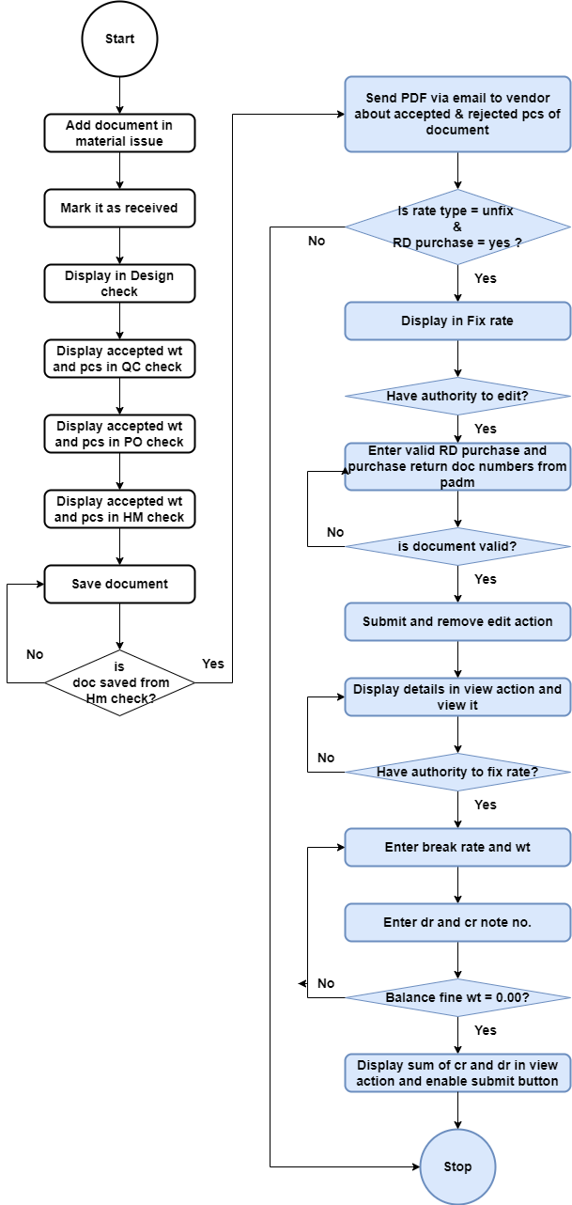

Fig: Process flow diagram

1. **DEVELOPED SYSTEM**

Previously, there was no system to break the rate as it was done manually through excel by the user.

Step 1. In Connect us -> material issue main menu -> material issue, once user clicks on add data, it will display following fields:

* Issued Date
* Challan No.
* Location
* Issued Type
* Vendor
* Sub supplier
* Narration
* Remark
* **Is RD purchase?**
* **Type of Rate**
* **Rate (per gram for 99.50%)**
* **Unfix fine rate**
* **Attachment**
* Item Detail table
* Save button
* Back button
* Save and add more button

The additional fields will be displayed in add, edit and view action of each record in material issue.

|  |  |  |  |  |
| --- | --- | --- | --- | --- |
| **FIELDS** | **INPUT TYPE** | **MANDATORY/ OPTIONAL** | **EDITABLE** | **DESCRIPTION** |
| Is RD purchase? | Radio button | Mandatory | Yes | This specifies whether this document is purchased from registered dealer or not.  It will display yes or no in the list. Only rd purchase - yes documents will be displayed in the fix rate menu.  Validation: It will be single select. Initially none of the type will be selected. |
| Type of rate | Radio button | Mandatory | Yes | It will display Fix or Unfix. While adding the data in material issue, the user will specify whether the rate for the particular vendor is fixed or not. Only unfix rate type documents will be displayed in fix rate menu.  Validation: It will be single select. Initially, none of the type will be selected. |
| Fix Rate | text | Mandatory | yes | Rate which is decided by the vendor for the day during purchase, it will be mentioned here. User will mention the rate of per gram.  This field will be disabled once this document has completed HM check process. This field will be editable only till the document hasn’t reached fix rate menu.  Validation: In add and both edit actions, it will accept only 4 digits before decimal point and after decimal point. It will accept numbers only. It will accept only one decimal point as a special character.  Min length = 1  Max length = 9 |
| Unfix fine rate | Text | Mandatory | No | It will be rate of 100% purity. It will get auto calculated and displayed once user enters unfix rate in above field.  Unfix fine rate = Unfix rate / 99.50%  Validation: It will be read only. It will round upto 3 decimals after decimal point when fourth digit will be greater than equal to 5. |
| Attachments | Upload | Mandatory | Yes | User will attach the bill of the total items received from vendor.  Validation: It will be multi-select. It will accept jpeg / jpg / png / pdf extensions only. |

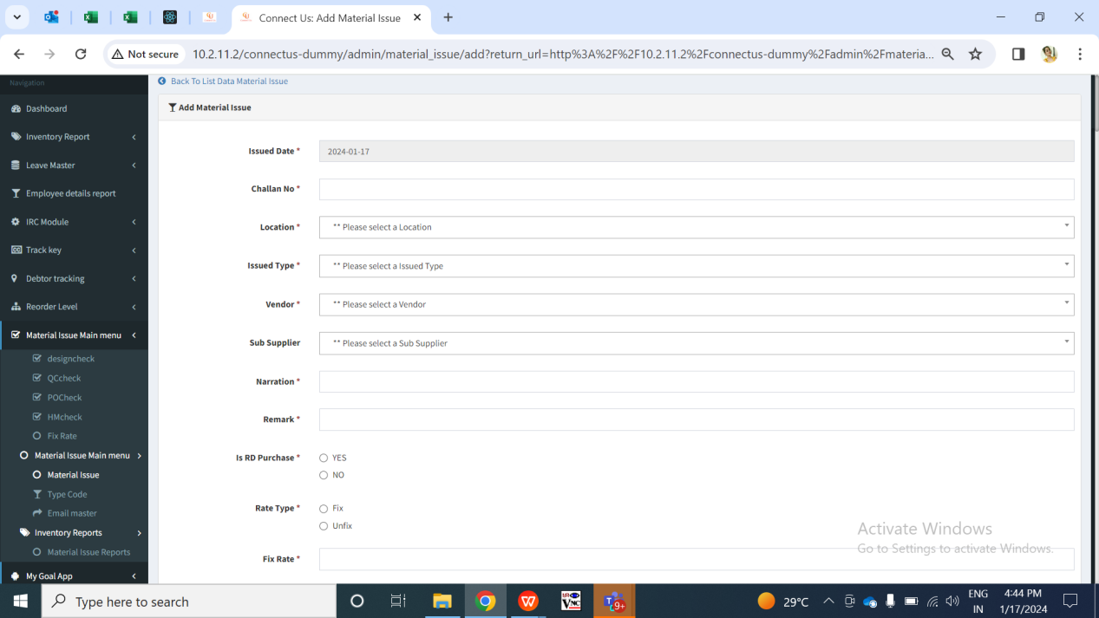

Fig: Material issue -> Add data

Once user enters items details, adds to table and clicks on submit, the doc. no. will be generated to it. It will be displayed in material issue grid.

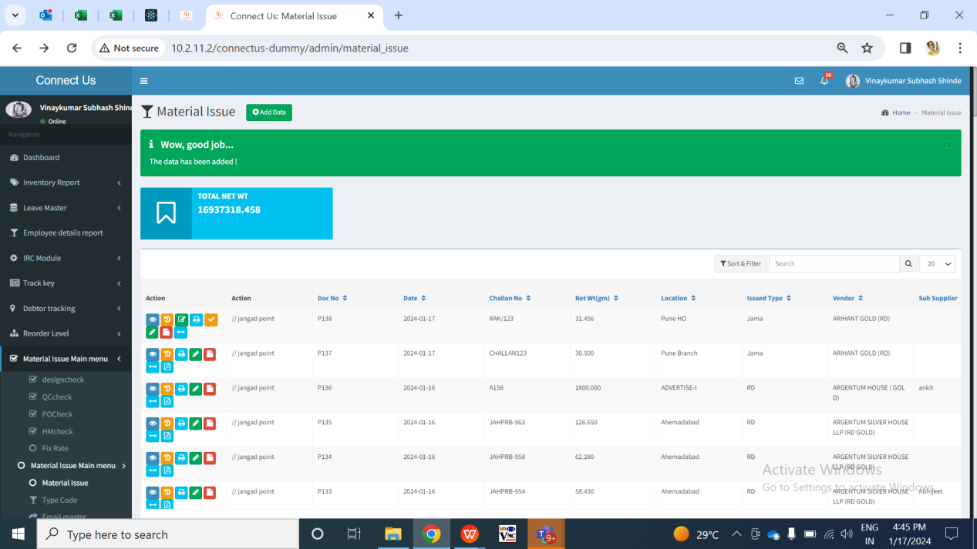

Fig: Material issue -> grid

Step 2. Once the data is marked as received by authority from material issue, it will be displayed in design check module.

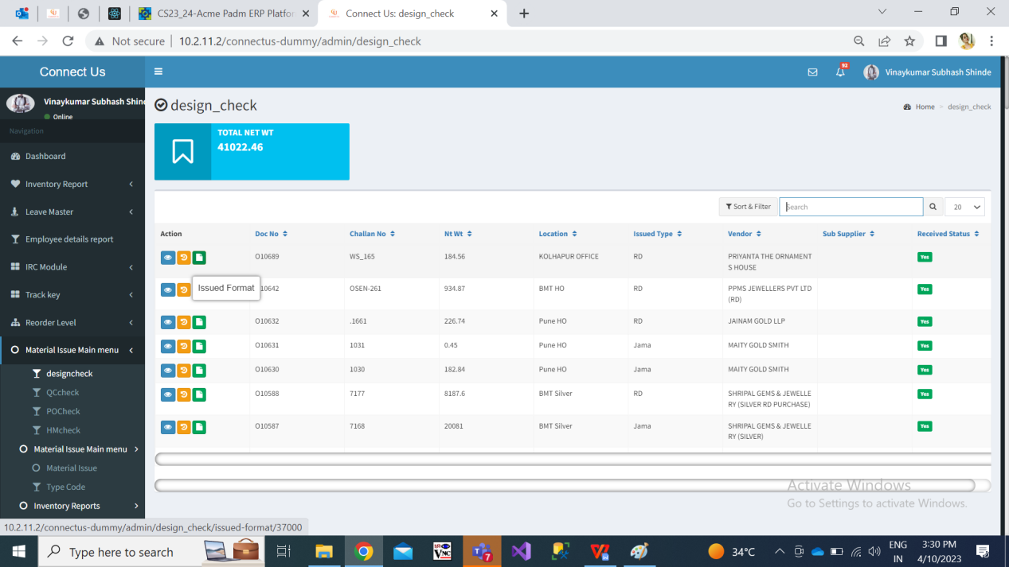

Fig: design check -> grid

Once user checks the items and enters details of rejected gross wt, rejected net wt and rejected pcs , then the remaining accepted gross wt, accepted net wt, accepted pcs will be auto calculated and displayed. Only the accepted details of the items will be forwarded to quality check process.

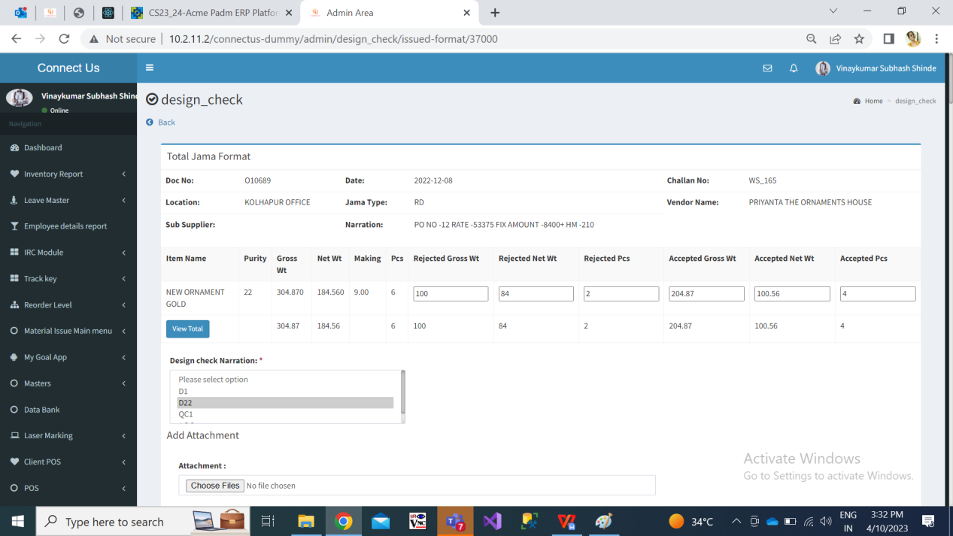

Step 3. Only the accepted gross wt, accepted net wt and accepted pcs from design check will be forwarded to quality check.

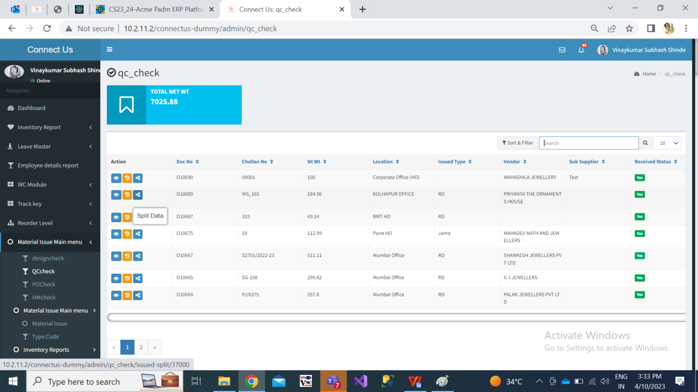

Fig: quality check -> grid

Qc incharge will split the accepted pcs into employees. The split data / pcs will be displayed to the employees and will be able to perform quality checking of the items.

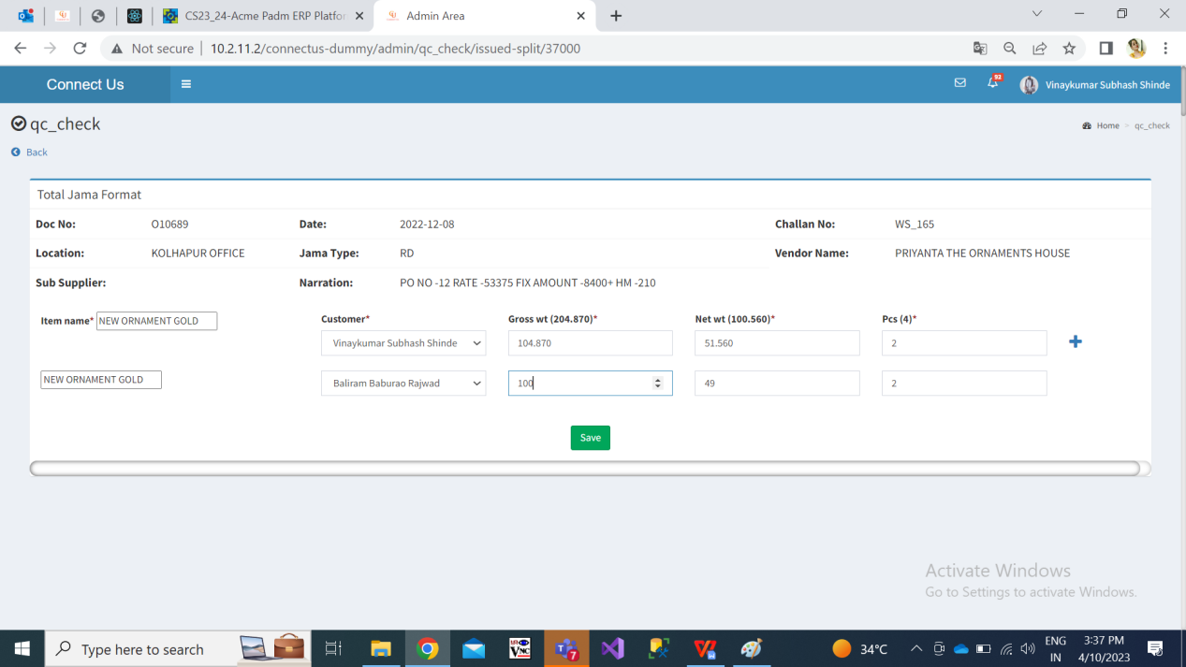

Fig: QC check -> split

Once QC employees checks the items and enters details of rejected gross wt, rejected net wt and rejected pcs , then the remaining accepted gross wt, accepted net wt, accepted pcs will be auto calculated and displayed.

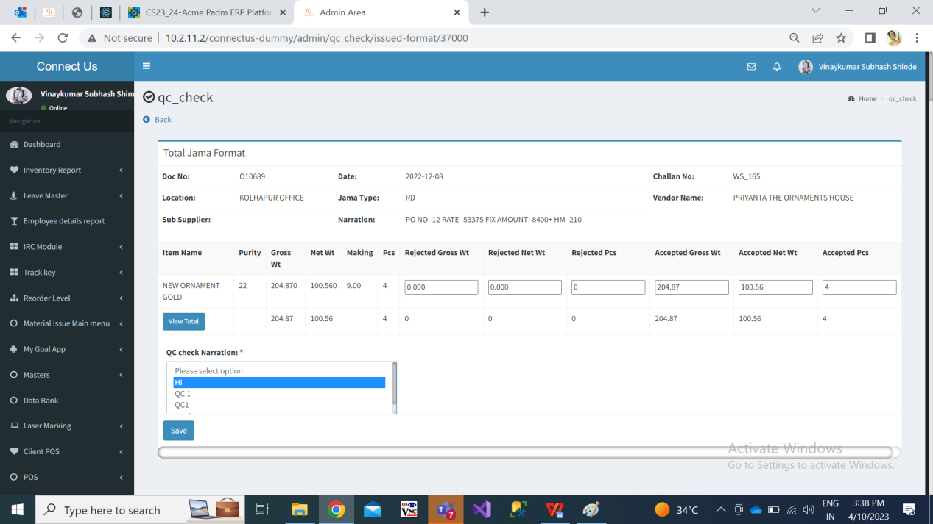

Step 4. Only the accepted details of the items from qc check document will be computed together and will be forwarded to POcheck process.

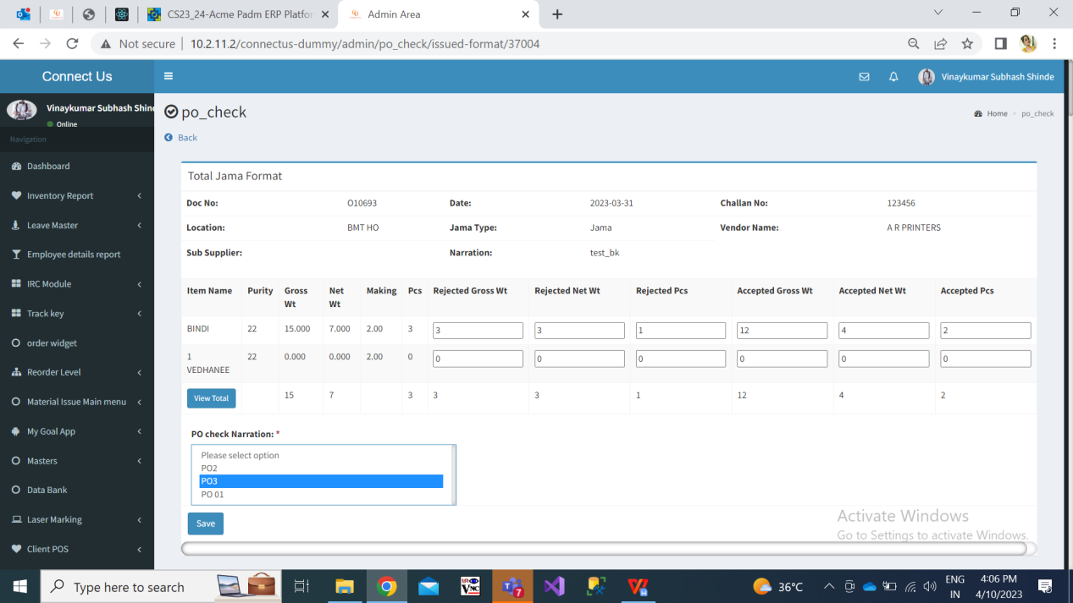

Step 5. Only the accepted details of the items in from PO check document will be computed together and will be forwarded to HMcheck process.

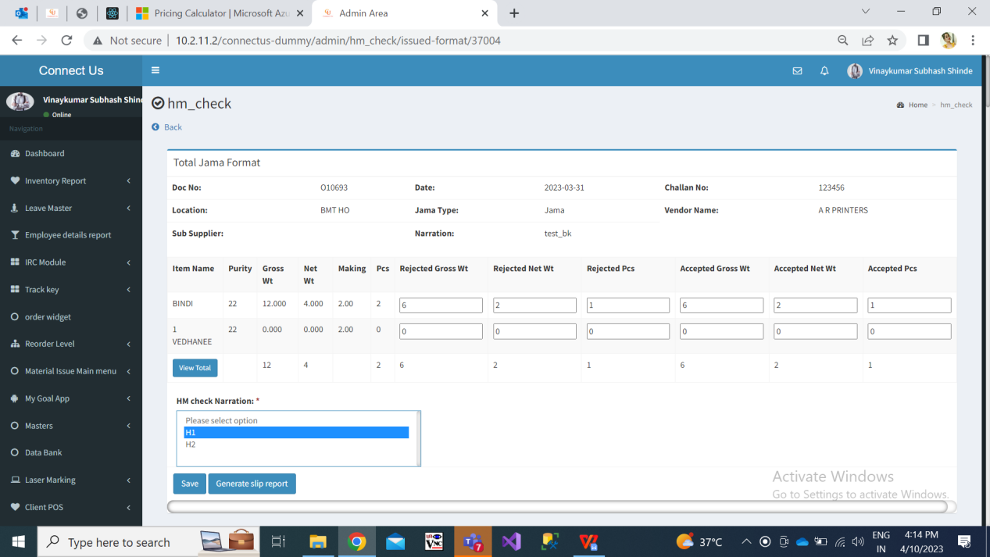

Once user enters of rejected gross wt, net wt and pcs, it will displayed accepted gross wt, net wt and pcs. Once user clicks on view total button, it will display all the collated details of accepted & rejected gross wt, net wt and pcs in each process.

Step 6. All the collated details of accepted & rejected gross wt, net wt and pcs in each process should be sent to the vendor via Email after it is saved in HM check process.

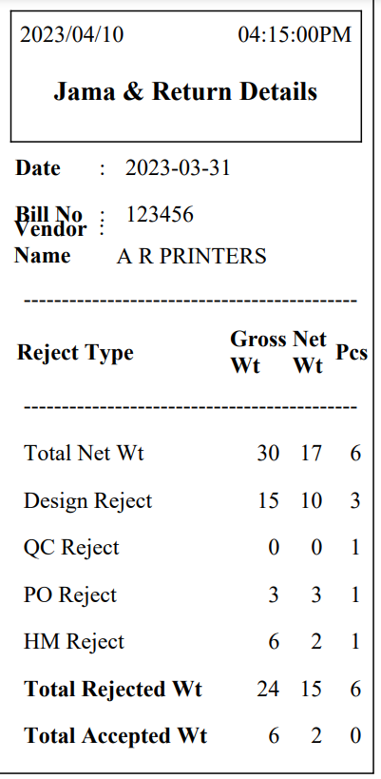

Fig: HM check -> generated slip

Step 7. FIx Rate

User will break the rate for the documents -? wt of the vendor through fix rate menu. All the documents which were marked as ‘yes’ for “Is RD purchase” field and rate type is “unfix” in material issue menu and have cleared HMcheck process will be dispayed in fix rate menu. It has following fields in grid:

* Action - view, edit, fix rate
* Doc no.
* Challan no.
* Vendor name
* Rate type - Fix / Unfix
* Rate

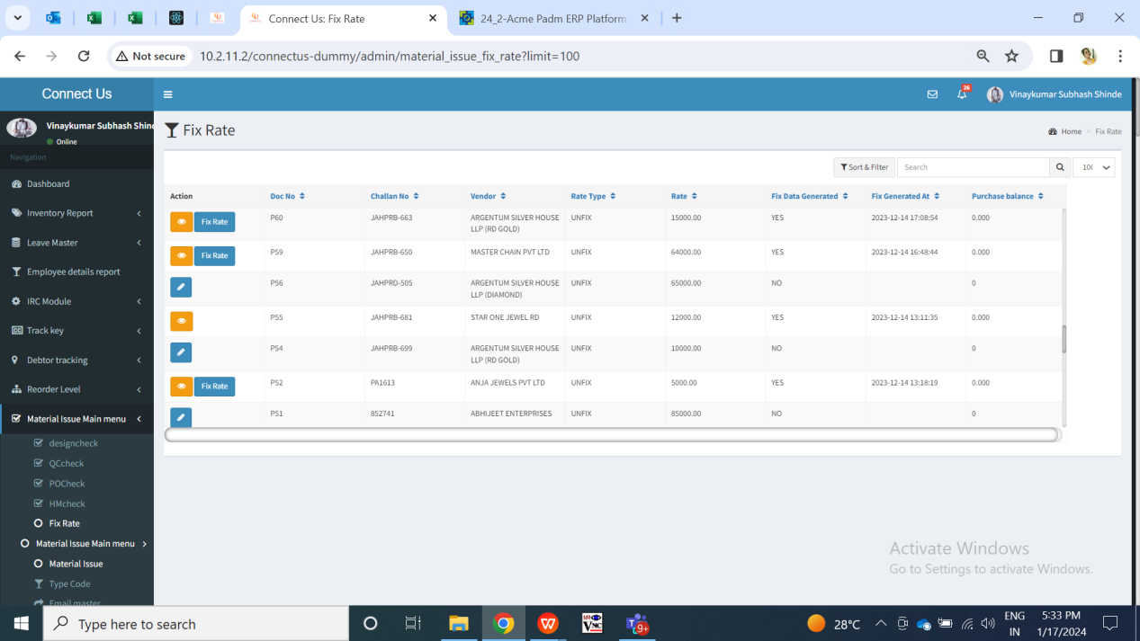

Fig: Fix rate -> grid

**Edit Action:**

Initially, each action will have edit action where user will enter the RD purchase and purchase retruns documents from padm for that record documet. As per scanned documents, values will be matched with the doc. no. From material issue -> accepted and rejected till HM check process. Edit button will be displayed based on authority. (Authority from masters -> general master -> login special authority -> edit_action_in_fix_rate_module).

Once user clicks on edit action it will display following fields in form:

* Doc no.
* Challan no.
* Vendor name
* Total accepted - gross wt, net wt, pcs
* Total rejected - gross wt, net wt, pcs
* RD purchase doc no. - search and check button
* Doc no.
* Doc date
* Gross wt
* Net wt
* Pcs
* Stone amount
* HM charges
* Other charges
* TDS
* GST
* Gross amount
* Net amount
* Fine wt
* Purchase return doc no. - search and check button
* Doc no.
* Doc date
* Gross wt
* Net wt
* Pcs
* Stone amount
* HM charges
* Other charges
* TDS
* GST
* Gross amount
* Net amount
* Fine wt
* Save (button)
* Cancel (button)

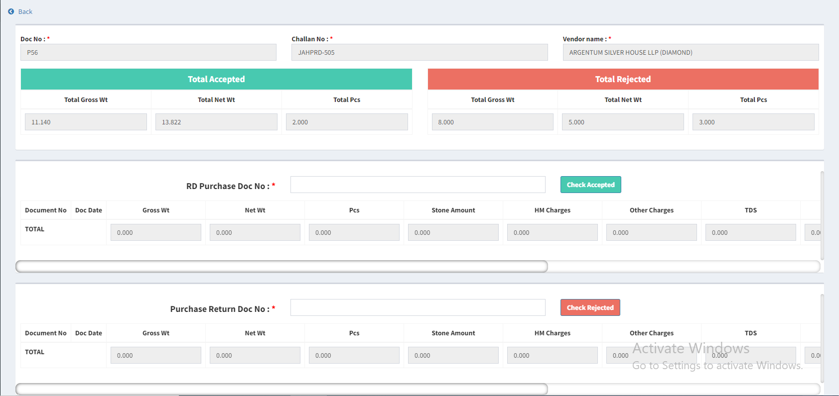

Fig: Fix rate -> edit action

|  |  |  |  |  |
| --- | --- | --- | --- | --- |
| **FIELDS** | **INPUT TYPE** | **MANDATORY/ OPTIONAL** | **EDITABLE** | **DESCRIPTION** |
| Doc no. | Text | Mandatory | No | It will display the doc no. From the material issue which got generated when doc. was created. |
| Challan no. | Text | Mandatory | No | It will display the challan no. which was mentioned for this document in add / edit action of material issue. |
| Vendor name | Text | Mandatory | No | It will display the vendor name. which was mentioned for this document in add / edit action of material issue. |
| Total accepted | Text | Mandatory | No | It will display the total accepted gross wt, total accepted net wt and total accepted pcs which was displayed till saving this document in HM check. |
| Total rejected | Text | Mandatory | No | It will display the total rejected gross wt, total rejected net wt and total rejected pcs which was displayed till saving this document in HM check. |
| Rd purchase doc no. | Text | Mandatory | yes | User will enter the rd puchase doc number from padm -> documents -> rd purchase.  Entered document no. will be unique from entire system.  User can scan multiple document no. from padm.  This field will not accept purchase return document numbers.  Validation: It will accept alphanumeric value. It should accept one hyphen as special character before numbers. It should not accept space.  Min length = 5  Max length = 15 |
| Check accepted button | Click | - | - | Once user enters doc no and clicks on check accepted button, it will display following details of that document from padm:   * Gross wt * Net wt * Pcs * Stone amount * HM charges * Other charges * TDS * GST * Gross amount * Net amount * Fine wt   Once details of scanned documents are displayed, it will be displayed in row and have cancel action against it so that user can remove the scanned document from the table.  If the entered document already exists in the system and user clicks on this button, it will display alert message as document already scanned.  Validation: Once user clicks on this button, it will be disabled until all details against that document are displayed in the table row. Also, once valid record of the scanned document gets displayed in the table row, then button will get enabled again so that user will enter another doc number. |
| Total | Text | Mandatory | No | It will display the sum of values of all scanned documents in rd purchase. The total fine wt from this will be displayed in fix rate -> balance fine wt field.  The total of net amount from here will be displayed in view action -> bill amount field of net payable amount table. |
| Purchase return doc no. | Text | Optional | yes | User will enter the rd puchase doc number from padm -> documents -> purchase return.  Entered document no. will be unique from entire system.  User can scan multiple document no. from padm. This field will not accept rd purchase document numbers.  Validation: It will accept alphanumeric value. It should accept one hyphen as special character before numbers. It should not accept space.  Min length = 5  Max length = 15 |
| Check rejected button | Click | - | - | Once user enters doc no and clicks on check rejected button, it will display following details of that document from padm:   * Gross wt * Net wt * Pcs * Stone amount * HM charges * Other charges * TDS * GST * Gross amount * Net amount * Fine wt   Once details of scanned documents are displayed, it will be displayed in row and have cancel action against it so that user can remove the scanned document from the table.  If the entered document already exists in the system and user clicks on this button, it will display alert message as document already scanned.  Validation: Once user clicks on this button, it will be disabled until all details against that document are displayed in the table row. Also, once valid record of the scanned document gets displayed in the table row, then button will get enabled again so that user will enter another doc number. |
| Total | Text | Mandatory | No | It will display the sum of values of all scanned documents in purchase return.  The total of net amount from here will be displayed in view action -> purchase return field of net payable amount table. |
| Submit button | Click | - | - | Once user enters documents and clicks on submit, it will display alert message as record doesn’t match if the accepted & rejected values of the padm documents doesn’t match with the accepted and rejected values from HM check. If user still wants to proceed, user will click on ok and record will get submitted.  Once the user clicks on submit, then edit action will be removed for that record in the grid and fix rate & view action will be displayed for that record. Moreover, documents that were scanned in edit action those will be displayed in view action for that record. |
| Cancel button | Click | - | - | If user clicks on cancel button, details will rmain unaffacted and user will be directed to grid page of fix rate menu.  Validation: cancel button will be disabled until user is directed to grid page. |

**Fix rate action:**

Through fix rate action, user will enter the breaking rate that has been finalized for that day for the vendor. It will be displayed based on special authority (Fixing_rate_action_in_fix_rate_module). It will have following fields:

* Doc no.
* Balance fine wt
* Unfix rate
* Unfix fine rate
* Vendor name
* Fix rate
* Quantity
* Add button
* Break rate table
* Sr. No.
* Balance fine w
* Unfix rate
* Unfix fine rate
* Fix Rate
* Fix fine rate
* Difference amount
* Quantity
* Gross amount
* GST Amount
* Net amount
* Remark
* Created by & at
* Note no.
* Update button

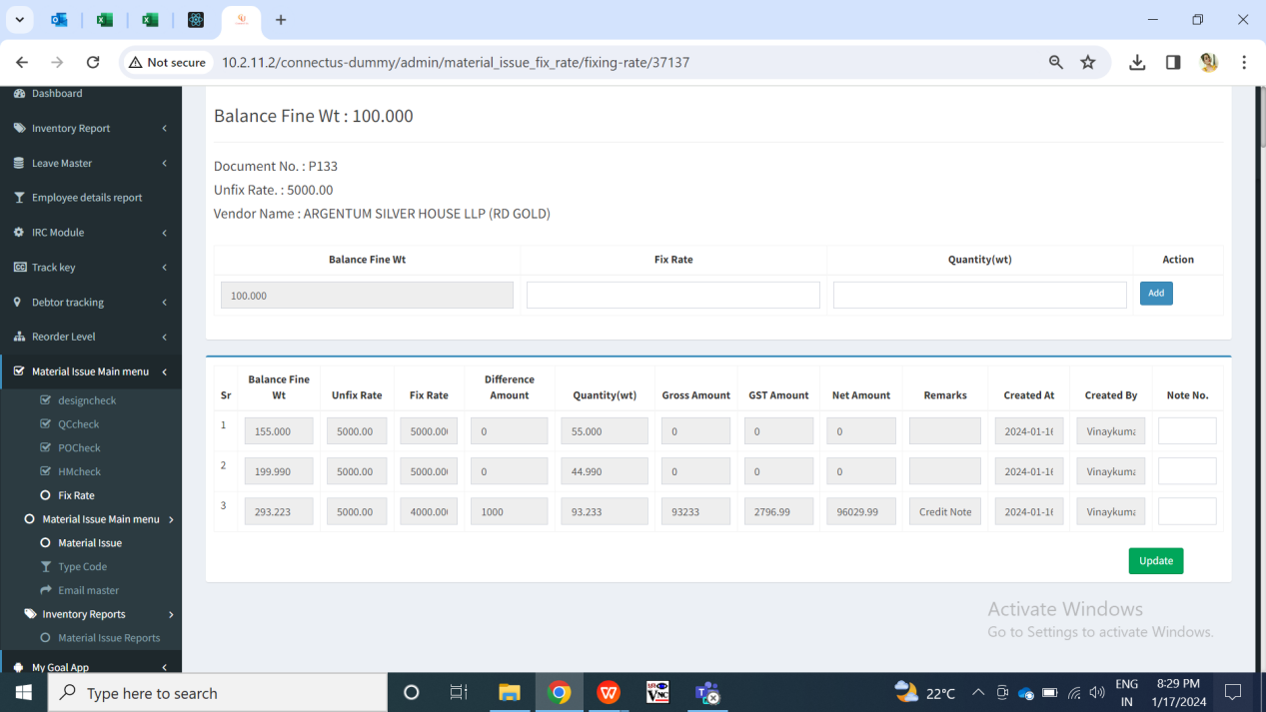

Fig: Fix rate -> fix rate action

|  |  |  |  |  |
| --- | --- | --- | --- | --- |
| **FIELDS** | **INPUT TYPE** | **MANDATORY/ OPTIONAL** | **EDITABLE** | **DESCRIPTION** |
| Doc no. | Text | Mandatory | No | It will display the doc no. From the material issue which got generated when doc. was created. |
| Balance fine wt | Text | Mandatory | No | It will display the balance fine wt for which the rate is not fixed yet. Initially, it will display the total fine wt which is displayed from total of rd purchase documents. |
| Vendor name | Text | Mandatory | No | It will display the vendor name. which was mentioned for this document in add / edit action of material issue. |
| Unfix rate | Text | Mandatory | No | It will display the rate which was entered in material issue -> fix rate text field of add / edit action for that document. It will be for per gram. |
| Unfix fine rate | Text | Mandatory | No | It will display the unfix fine rate from material issue -> add / edit / view action of that document.  Unfix fine rate = Unfix rate / 99.50%. |
| Breaking fix rate | Text | Mandatory | No | User will enter the rate of per gram which has to be break for the vendor for that day.  Validation: It will accept only numbers. It will accept single decimal point as special character. It should accept 3 digits only after decimal point.  Min length = 3  Max length = 15 |
| Breaking fix fine rate | Text | Mandatory | No | It will auto-calculate and display the fix fine rate once user enters the value in breaking fix rate text field. It represents the fix rate for 100% purity.  fix fine rate = breaking fix rate / 99.50%.  Validation: It will be read only. It will round upto 3 decimals after decimal point when fourth didgit will be greater than equal to 5. |
| Breaking quantity wt | Text | Mandatory | No | User will enter the wt for which the rate is finalized.  Validation: It should less than or equal to balance fine wt. It will accept only numbers. It will accept single decimal point as special character. It should accept 3 digits only after decimal point.  Min length = 1  Max length = 15 |
| Add button | Click | - | - | Once user enters valid quantity, fix rate and user clicks on add button then it will display that record in the table below as well as it will be displayed in view action. Moreover, each time when record is added, email will be sent to the vendor of that table.  In case user fills incorrect values in fix rate and quantity field and clicks on add button, then on field error message will be displayed.  Validation: Add button will be disabled until record of break rate gets displayed in the table below. |
| Break rate table - balance fine wt | Text | Mandatory | No | It will display the balance fine wt which was available while breaking rate for that particular record.  Previous balance fine wt - quanity of that record will be displayed here. Initially, it will display total balance fine wt of that document for the fist record in the table. |
| Break rate table - Unfix rate | Text | Mandatory | No | It will display the rate which was entered in material issue -> fix rate text field of add / edit action for that document. It will be for per gram. It will be same for all the records. |
| Unfix fine rate | Text | Mandatory | No | It will display the unfix fine rate from material issue -> add / edit / view action of that document. It will be same in all record of the table as this unfix fine rate is calculated only once in material issue. |
| Break rate table - fix rate | Text | Mandatory | No | It will display the rate which was entered by the user while breaking the rate I.e. rate mentioned in fix rate column of add button table. |
| Breaking fix fine rate | Text | Mandatory | No | It will display the fix fine rate for that record which got calculated when user entered the value in breaking fix rate text field.  Validation: It will be read only. |
| Break rate table - Difference amount | Text | Mandatory | No | Difference amount will display the difference between unfix rate and fix rate of each entry in the table.  Difference amount = Unfix rate - Fix rate of the table. |
| Break rate table - Gross amount | Text | Mandatory | No | Gross amount = Difference amount * Qty |
| Break rate table - GST amount | Text | Mandatory | No | It will display 3 % of gross amount in each row of the table. |
| Break rate table - net amount | Text | Mandatory | No | Net amlount = gross amount + gst amount |
| Break rate table - remark | Text | Mandatory | No | It will display here whether credit note will be generated or debit note will be generated for that breaking rate record each time when it is added.  As per greater rate amount it will display whether credit note or debit will be generated.  If **fix fine rate > unfix fine rate**, then **debit note** should be generated.  If **fix fine rate < unfix fine rate**, then **credit note** should be generated.  If **fix fine rate = unfix fine rate**, then it will display as no note or blank. |
| Break rate table - created at | Text | Mandatory | No | It will display the date and time when that row got added in the table I.e. when break rate along with quantity was entered. |
| Break rate table - created by | Text | Mandatory | No | It will display the name of the employee name who added the record of break rate in that table. |
| Break rate table - note no. | Text | Optional | No | User will enter the credit or debit note no. here from Padm.  Initially, it will be blank whereas once user enters the note no. Clicks on update button, then this field will be read only displaying entered note no. in it.  Once all note no. in all rows of break rate table are entered and all fine wt is break, then update button will be disabled.  Validation: It will accept alphanumeric value. It should accept space and - . / only as special character.  Min length = 1  Max length = 15 |
| Update button | Click | - | - | Once user enters note number and clicks on update button, note number will be saved for that row whereas it will be read only further. Moreover, user will be directed to grid page of fix rate.  Validation: It will be disabled until note number gets saved and user gets directed to update button. |

**View action:**

Through view action, user will all the details of the documents scanned and the break rate table. In addition to this, user will be able to submit the net payable amount here. It has following fields:

* Doc no.
* Challan No.
* Vendor Name:
* Rate type:
* Unfix Rate
* Net payable
* Submit button
* RD purchase documents:
* Total gross wt
* Total net wt
* Total pcs
* Total Stone amount
* Total HM charges
* Total Other charges
* Total TDS
* Total GST
* Total Gross amount
* Total Net amount
* Total Fine wt
* Purchase return documents:
* Total gross wt
* Total net wt
* Total pcs
* Total Stone amount
* Total HM charges
* Total Other charges
* Total TDS
* Total GST
* Total Gross amount
* Total Net amount
* Total Fine wt
* Break rate table

1. Balance fine wt
2. Unfix rate
3. Unfix fine rate
4. Fix Rate
5. Fix fine rate
6. Quantity (I.e wt)
7. Net
8. Created at & by
9. Remark
10. Note no.

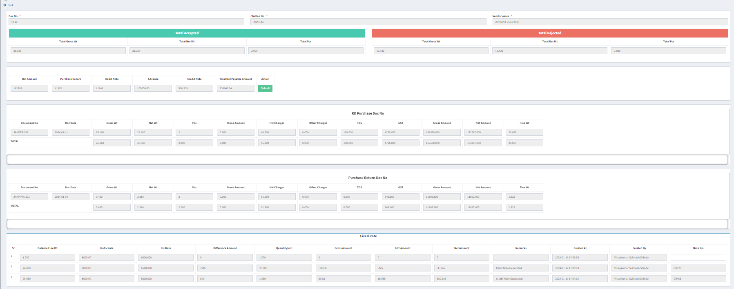

Fig: Fix rate -> view action

|  |  |  |  |  |
| --- | --- | --- | --- | --- |
| **FIELDS** | **INPUT TYPE** | **MANDATORY/ OPTIONAL** | **EDITABLE** | **DESCRIPTION** |
| Bill amount | Text | Mandatory | No | It will display the total net amount of accepted documents I.e. RD purchase documents. |
| Purchase return | Text | Mandatory | No | It will display the total net amount of rejected documents I.e. purchase return documents. |
| Debit note | Text | Mandatory | No | It will display the sum of gross amounts of the debit notes rows in fix rate -> break rate table. Do not consider its negative sign. |
| Credit note | Text | Mandatory | No | It will display the sum of gross amounts of the credit notes rows in fix rate -> break rate table. Do not consider its negative sign. |
| Advance | Text | Mandatory | No | User will manually enter the advance amount given to the vendor here.  Validation: It will accept numbers only. It will accept single decimal point as special character. It will accept three digits only after decimal point.  Min length = 1  Max length = 25 |
| Net payable amount | Text | Mandatory | No | Net payable = Rd purchase net Bill amt - Purchase return net amount - sum of DR note gross amount - Advance + sum of CR note gros amount |
| Submit button | Click | - | - | This button will be disabled until balance fine wt in that document is 0.00 I.e. until rate is break for entire fine wt.  Once user enters advance amount and clicks on submit button, net payable amount will get calculated and displayed whereas submit button will be disabled. Also, advance amount field will be disabled and display entered value once submitted. |

1. **REFERENCES OF THE USERS**

|  |  |  |  |
| --- | --- | --- | --- |
| **User** | **Name** | **Mail** | **Contact number** |
| **Actual user** | Prashan Pise  Sachin Humne  Rakesh Thikane | isa@csjewellers.com |  |
| **Ticket created by (if any)** | Manali Bhadirage | Manali.bhadirage@techneai.com |  |
| **Assigned business analyst** | Manali Bhadirage | Manali.bhadirage@techneai.com |  |
| **Assigned developer** | Prathmesh shinde  Punam shinde | [Prathmesh.shinde@techneai.com](mailto:Parthmesh.shinde@techneai.com)  Punam.shinde@techneai.com |  |
| **Assigned tester** | Priyanka Dupargude  Amruta Kore | [Priyanka.dupargude@techneai.com](mailto:Priyanka.dupargude@techneai.com)  intern@techneai.com |  |