Manali Ashok Bhadirage

Manali.bhadirage@techneai.com

07.02.2024

URD CRM REPORT - PREVIOUS TRANSACTION

**Handover Document**

**CONTENTS**

1. TICKET DETAILS 2

2. INTRODUCTION 2

3. BUSINESS REQUIREMENT 2

4. SCOPE 3

5. BUSINESS & SYSTEM RULES 3

6. ABBREVIATIONS & TERMS 3

7. GRAPHICAL REPRESENTATION 3

8. DEVELOPED SYSTEM 4

9. REFERENCES OF THE USERS 9

1. **TICKET DETAILS**

|  |  |
| --- | --- |
| **Ticket ID** | TT18309 |
| **Ticket description** | While doing URD purchase of diamond ornaments in the shop we check bill of customer. The URD executive enters the bill number of the customer in the narration column. Our requirement is that this bill number will be entered somewhere and we will be able to pull the corresponding barcodes of the bill along with the Design code and IGI number of the product. |
| **Created by** | Shrikant Girigosavi |
| **Created on** | 09/12/2023 |
| **Priority** | Very high |

1. **INTRODUCTION**

Through URD CRM report - previous transaction menu, users enter the customer’s registered mobile number and gets the detailed information of the purchases done by the customer till current date. This report is generally used during URD transactions to know the items purchased by the customer and know exact item of URD when it is purchased through CSJ.

1. **BUSINESS REQUIREMENT**

|  |  |  |  |
| --- | --- | --- | --- |
| **Requirement ID** | **Requirement Name** | **Short Description** | **Priority** |
| BR001 | Design no. | Add design no. Field in the URD report which will display design no for the item diamon items from padm -> documents -> 41 diamond jewels sales bill, 43 Diamond Order Sales Bill, GTS Order Sales bill, Kalpataru Order Sales Bill, Loan Diamond Jewel Sales Bill.  If item is not diamond then design no. field will be blank in report. | Medium |
| BR002 | Diamond Certificate no. | Add diamon certificate no. field in the URD report which will display certificate no for the item diamon items from padm -> documents -> 41 diamond jewels sales bill, 43 Diamond Order Sales Bill, GTS Order Sales bill, Kalpataru Order Sales Bill, Loan Diamond Jewel Sales Bill.  If item is not diamond then certificate no. field will be blank in report. | Medium |

1. **SCOPE**

Once user enters the registered mobile number of the customer in URD CRM report and clicks on submit button, list of all the purchases done by the customer will be displayed along with customers details. Whereas, it will display branch name, document number, purchase date, no. of pcs, gross wt, net wt, diamond design no. and diamond certificate no. will be displayed for each record. In case entered mobile number doesn’t have any purchases then it will display error message. Moreover, if any purchase document number doesn’t have any diamond item in it then it will display design no. and certificate no field as blank. Diamond design no. And diamond certificate no. will be diplayed from padm -> documents -> 41 Diamond Jewels Sales bill. lIn addition to this, if any doument has more than one item in it then it will display each item in each row with same document number in the record. Each time when purchase is done by the customer, thise records will be displayed correctly in our report.

1. **BUSINESS & SYSTEM RULES**

* User will be registered in the system.
* User will be logged in.
* User will have privilege to access URD CRM report menu.
* System will pop up a message, if any issues in the system is detected.

1. **ABBREVIATIONS & TERMS**

WT - weight

PCS - pieces

URD - Unregistered dealer

CRM - customer relationship management

1. **GRAPHICAL REPRESENTATION**

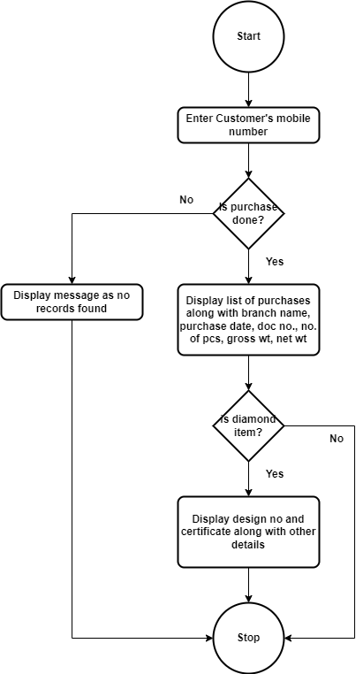

Fig: Flow chart

1. **DEVELOPED SYSTEM**

Earlier, the report lacks details regarding diamond items, making it challenging for users to analyze customer diamond purchases. This leads to a manual cross-check of customer transactions involving diamonds, resulting in a time-consuming process.

Furthermore, in URD cases, we need to provide the diamond certificate number to vendors. It becomes inconvenient for the vendors to know the item when design no and certificate number are not provided. To streamline URD customer interactions and enhance vendor convenience, it is imperative to incorporate these two fields in the report.

Once user clciks on URD CRM report, it will dispay customer mobile number field and search button.

|  |  |  |  |  |
| --- | --- | --- | --- | --- |
| **FIELDS** | **INPUT TYPE** | **MANDATORY/ OPTIONAL** | **EDITABLE** | **DESCRIPTION** |
| Customer mobile no. | Text | Mandatory | Yes | User will enter the mobile number of the customer whose purchases is to be viewd in the report.  Validation: It will accept only numbers. It will only accept 7 or 8 or 9 as first digit.  Min & Max length =10 |
| Search | click | - | - | Once user enters valid customer mobile no. and clicks on search button, it will display purchases record in grid. Whereas, it will display alert message as record doesn’t exist when there are sales bill against entered mobile number.  Validation: Search button will be disabled until data gets found or error message gets displayed. |

Once user enters mobile no. which is not registered or doesn’t have any purchase record, then it will display error message nce user clicks on submit button.

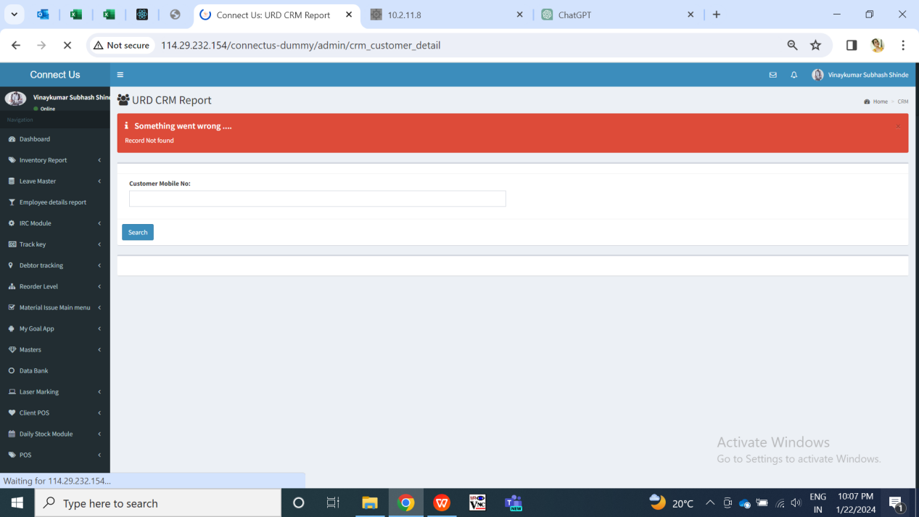

Fig: URD CRM Report -> alert message

Secondly, once user enters the registered mobile which has more than one account registered to that mobile number, then it will display the list of customer names so that user can select on the desired customer name and get the list of purchases.

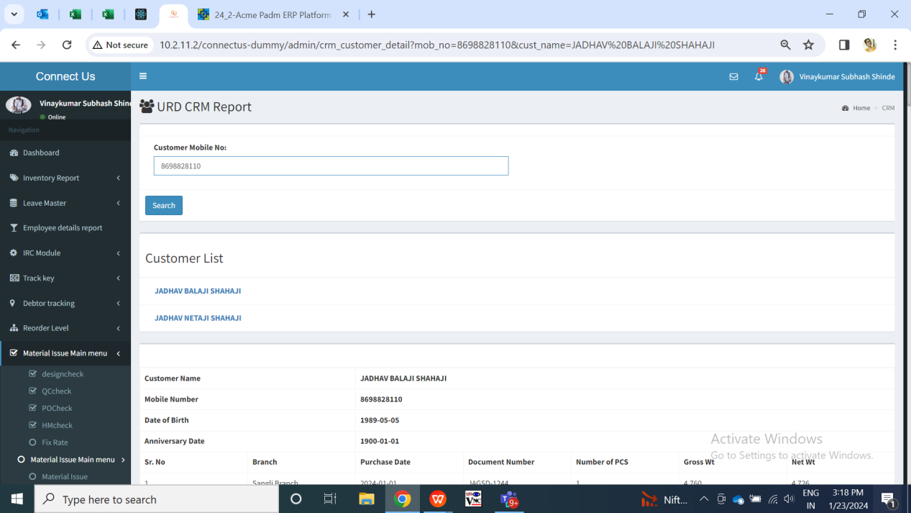

Once user enetrs the registered mobile number and clicks on submit button when only one account is registered to that number, then it will display following fields in the grid report:

* Customer name
* Mobile no.
* Date of birth
* Date of anniversary
* Sr. No.
* Branch name
* Purchase date
* Doc no.
* No. Of pcs
* Gross wt
* Net wt
* Diamond design no.
* Diamond certificate no.

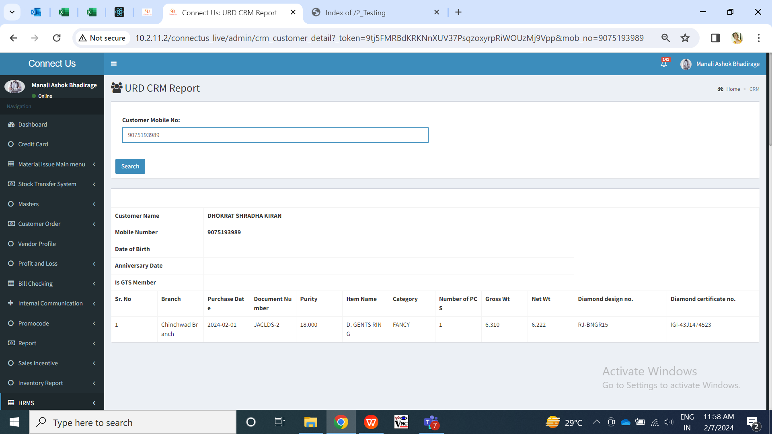

Fig: URD CRM report -> grid

|  |  |  |  |  |
| --- | --- | --- | --- | --- |
| **FIELDS** | **INPUT TYPE** | **MANDATORY/ OPTIONAL** | **EDITABLE** | **DESCRIPTION** |
| Customer name | Text | Yes | No | It will display the customer name as per entered mobile number from padm -> masters -> customer. |
| Mobile no. | Text | Yes | No | It will display the entered customer’s mobile number here for which the purchases record is being displayed. |
| DOB | Text | Yes | No | It will displaythe date of birth of the specified customer from padm -> masters -> customers. In case, there is no details of DOB for the customer then it will be displayed blank. Whereas, in case any user adds / edits DOB of the customer in Padm then it will display added / updated DOB for the specified customer here. |
| DOA | Text | Yes | No | It will displaythe date of anniversary of the specified customer from padm -> masters -> customers. In case, there is no details of DOA for the customer then it will be displayed blank. Whereas, in case any user adds / edits DOB of the customer in Padm then it will display added / updated DOB for the specified customer here. |
| Branch name | Text | Yes | No | It will display the list of purchases done by the registered customer. It will display the branch name from where the purchase of specified document no. was done.  It will displayed from sales bill of that document no. |
| Purchase date | Text | Yes | No | It will display the sales bill date I.e date on which the transaction of that document number was done. |
| Document no. | Text | Yes | No | It will display the document no. which is purchased by the customer. If any document has more than one items in it, then that same document no. will be displayed in row as per count of items. |
| No. Of pcs | Text | Yes | No | It will display the count of pcs that customer has purchased for that item in the document. |
| Gross wt | Text | Yes | No | It will display the gross wt for that item in the document. |
| Net wt | Text | Yes | No | It will display the net wt for that item in the document as per sales bill. |
| Diamond design no. | Text | Yes | No | In case diamond is included in the document, then it will display the certificate no. of that diamond for that document from bill -> attributes -> certificate no. from Padm documents 41 diamond jewels sales bill, 43 Diamond Order Sales Bill, GTS Order Sales bill, Kalpataru Order Sales Bill, Loan Diamond Jewel Sales Bill.  If the item is not diamond, then it will be blank on the report. |
| Diamond certificate no. | Text | Yes | No | In case diamond is included in the document, then it will display the design no. of that diamond for that document from bill -> attributes -> certificate no. from Padm documents 41 diamond jewels sales bill, 43 Diamond Order Sales Bill, GTS Order Sales bill, Kalpataru Order Sales Bill, Loan Diamond Jewel Sales Bill.  If the item is not diamond, then it will be blank on the report. |

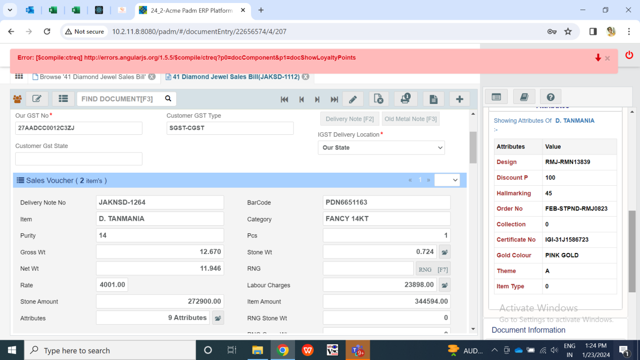

Fig: Padm -> Diamond jewels sales bill atrributes

1. **REFERENCES OF THE USERS**

|  |  |  |  |
| --- | --- | --- | --- |
| **User** | **Name** | **Mail** | **Contact number** |
| **Actual user** | Shrikant Girigosavi | orderdiamondpn@csjewellers.com |  |
| **Ticket created by (if any)** | Shrikant Girigosavi | orderdiamondpn@csjewellers.com |  |
| **Assigned business analyst** | Manali Bhadirage | Manali.bhadirage@techneai.com |  |
| **Assigned developer** | Yogita Jagtap | Yogita.jagtap@techneai.com |  |
| **Assigned tester** | Vaishnavi Khandwe | Vaishnavi.khandwe@techneai.com |  |