19.02.2024

Employee Details Report

Manali Ashok Bhadirage

Manali.bhadirage@techneai.com

**Handover Document**

**CONTENTS**

1. TICKET DETAILS 2

2. INTRODUCTION 2

3. BUSINESS REQUIREMENT 2

4. SCOPE 3

5. BUSINESS & SYSTEM RULES 3

6. ABBREVIATIONS & TERMS 3

7. GRAPHICAL REPRESENTATION 3

8. DEVELOPED SYSTEM 4

9. REFERENCES OF THE USERS 8

1. **TICKET DETAILS**

|  |  |
| --- | --- |
| **Ticket ID** | TT19051 |
| **Ticket description** | Kindly provide employee report access which will have only Employee ID, Employee Name, Designation, Department, Current Branch, Role, Mobile Number, DOJ. Please make provision for Export Data field with above fields only. Previous Refer ticket ID TT17257. |
| **Created by** | Amrut Ghadage |
| **Created on** | 15/01/2024 |
| **Priority** | Very high |

1. **INTRODUCTION**

Record of each employee is registered in employee master which serves as a central repository for comprehensive and organized information about each employee within an organization. It plays a crucial role in streamlining HR processes and ensuring efficient management of workforce data. Employee Details Report report typically provides a snapshot of key information about the current workforce. It provides valuable insights for strategic planning, compliance, talent management, and overall organizational effectiveness.

1. **BUSINESS REQUIREMENT**

|  |  |  |  |
| --- | --- | --- | --- |
| **Requirement ID** | **Requirement Name** | **Short Description** | **Priority** |
| BR001 | Filter -> branch | It will be multi-select. If user doesn’t select it, then it will consider all branches. | Medium |
| BR002 | Filter -> role | It will be multi-select. If user doesn’t select it, then it will consider it as all roles. | Medium |
| BR003 | Filter -> designation | It will be multi-select. If user doesn’t select it, then it will consider all designations. | Medium |
| BR004 | Employee name | Remove this field from filter. | Low |
| BR005 | DOJ | It will display from DOJ and To DOJ in filter so that user can search employees by the DOJ of specific duration. | Medium |
| BR006 | Report columns | Once user clicks on search button, following columns will be displayed in grid report : Sr. No., Employee ID, Employee Name, Designation, Department, Current Branch, Role, Mobile Number, DOJ, DOB and gender. | High |
| BR007 | Export columns | Once user clicks on search button, following columns will be displayed in grid report : Sr. No., Employee ID, Employee Name, Designation, Department, Current Branch, Role, Mobile Number, DOJ and DOB. | High |

1. **SCOPE**

Once employee is added in employee master, it will be displayed in employee details report. Once user selects filter options in employee details report and clicks on search, then details of active employees will be displayed in report. If details of employee are edited in employee master, updated details of employee will be displayed in employee details report as well. User will be able to export the report.

1. **BUSINESS & SYSTEM RULES**

* User will be registered in the system.
* User will be logged in.
* System will display error message for incorrect details if entered.
* Only active employees will be displayed in grid.

1. **ABBREVIATIONS & TERMS**

DOB - Date of birth

DOJ - Date of joining

1. **GRAPHICAL REPRESENTATION**

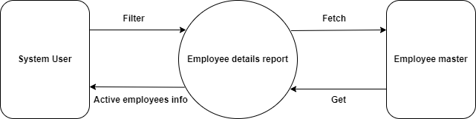

Fig: Data Flow Diagram - Level 0

1. **DEVELOPED SYSTEM**

In existing system, there is no option for user to multi-select in filter fields and hence causing user to select single filter at a time. Also, the current report displays data of all employees even if they are inactive. Thus, leading user to incorrect data of employees. Moreover, all details of the employees are not being displayed in report leading to limited information of employees.

Once user clicks on employee details report menu, it will display following fields:

* Branch
* Role
* Designation
* From DOJ
* To DOJ
* Search button
* Reset button
* Export button

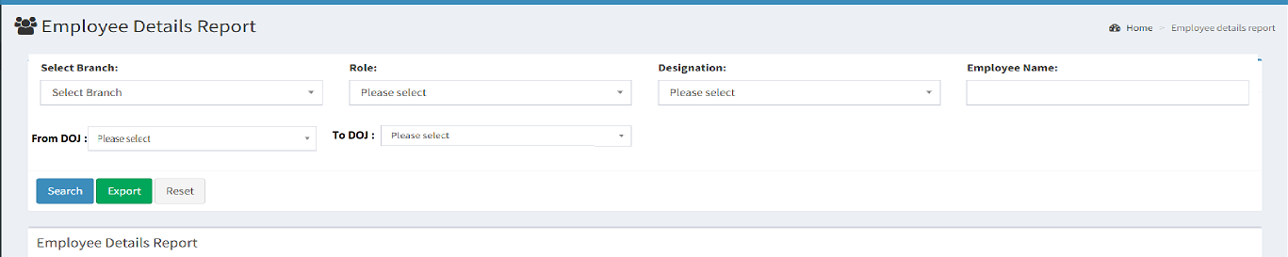

Fig: Employee details report -> filter options

|  |  |  |  |  |
| --- | --- | --- | --- | --- |
| **FIELDS** | **INPUT TYPE** | **MANDATORY/ OPTIONAL** | **EDITABLE** | **DESCRIPTION** |
| Branch | Drop down | Optional | - | User will select the branch from which the list of employees will be displayed in the report. If user doesn’t select any branch, then employees of all branches will be considered.  Validations: It will display active branches from branch master. It will be multi-select. Already selected branch will be excluded from the list. User will also be able to remove already selected branch. |
| Role | Drop down | Optional | - | User will select the role from which the list of employees will be displayed in the report. If user doesn’t select any role, then employees of all roles will be considered for displaying in the report.  Validations: It will display active branches from role master. It will be multi-select. Already selected role will be excluded from the list. User will also be able to remove already selected role. |
| Designation | Drop down | Optional | - | User will select the designation from which the list of employees will be displayed in the report. If user doesn’t select any role, then employees of all roles will be considered for displaying in the report.  Validations: It will display active designations from designation master. It will be multi-select. Already selected designation will be excluded from the list. User will also be able to remove already selected designation. |
| From DOJ | Calender date picker | Optional | - | User will select the date from which the employees have joined. Report will display the employees who have joined between the selected ‘from DOJ’ and ‘to DOJ’. If user doesn’t select any of the DOJ, then it will consider all employees.  Validations: Future dates will be disabled. Only one date can be selected. |
| To DOJ | Calender date picker | Optional | - | User will select the date till which the employees have joined. Report will display the employees who have joined between the selected ‘from DOJ’ and ‘to DOJ’. If user doesn’t select any of the DOJ, then it will consider all employees.  Validations: Only one date can be selected. Future dates will be disabled. Dates before ‘from DOJ’ will be disabled. |
| Search | Click | - | - | Once user clicks on the search button without selecting any of the filter options, then all actives employees will be displayed in the report with their other details.  If user selects any of the filter options and clicks on search button, then report will display the list of active employees as per selected filter. Report will display following columns:   * Sr. No. * Employee ID * Employee name * Designation * Department * Current Branch * Role * Mobile Number * DOJ * DOB * Gender   (Removed employee photo column)  Once user clicks on search button, report gets displayed in grid and export button gets displayed besides search button.  Validations: Search button will be disabled once clicked until report gets displayed in the grid. |
| Reset | Click | - | - | User will click on reset button to reset all the filter fields if selected any.  Validation: Reset button will be disabled until page gets reloaded and all fields get cleared if selected any. |
| Export | Click | - | - | Once reports gets displayed in the grid, export button will be displayed besides search button.  Once user clicks export button, CSV file will get downloaded displaying data of employees in as in grid. CSV file will have following columns:   * Sr. No. * Employee ID * Employee name * Designation * Department * Current Branch * Role * Mobile Number * DOJ * DOB * Gender   (Removed employee photo column) |

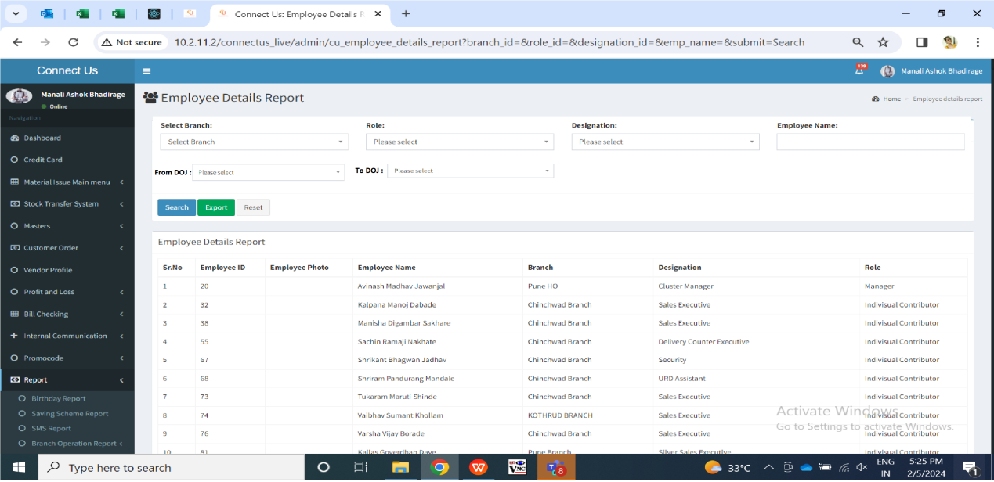

Fig: Employee details report -> grid

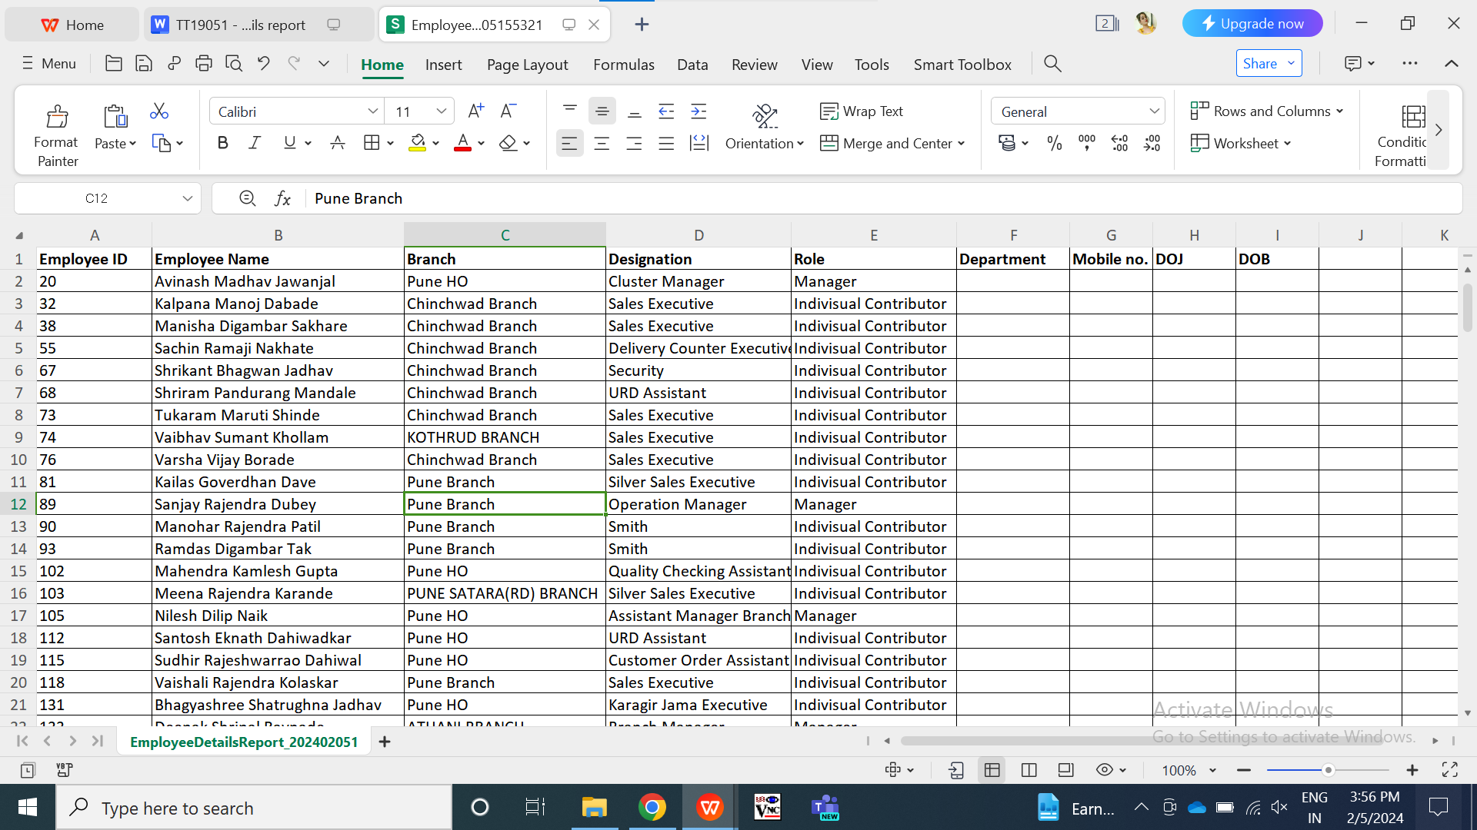

Fig: Employee details report -> export

1. **REFERENCES OF THE USERS**

|  |  |  |  |
| --- | --- | --- | --- |
| **User** | **Name** | **Mail** | **Contact number** |
| **Actual user** | Amrut Ghadage | Training1@csjewellers.com |  |
| **Ticket created by (if any)** | Amrut Ghadage | Training1@csjewellers.com |  |
| **Assigned business analyst** | Manali bhadirage | Manali.bhadirage@techneai.com |  |
| **Assigned developer** | Yogita jagtap | Yogita.jagtap@techneai.com |  |
| **Assigned tester** | Vaishnavi khandwe | Vaishnavi.khandwe@techneai.com |  |