04.02.2024

Employee Details Report

Manali Ashok Bhadirage

Manali.bhadirage@techneai.com

**Functional Requirement Document**

**CONTENTS**

1. TICKET DETAILS 2

2. VERSION CONTROL 2

3. APPROVALS 2

4. ESTIMATION 2

5. INTRODUCTION 3

6. BUSINESS REQUIREMENT 3

7. SCOPE 4

8. BUSINESS & SYSTEM RULES 4

9. ABBREVIATIONS & TERMS 4

10. EXISTING SYSTEM 4

11. GRAPHICAL REPRESENTATION 4

12. PROPOSED SYSTEM 4

13. TEST DATA 8

14. ODUS 9

15. REFERENCES OF THE USERS 9

1. **TICKET DETAILS**

|  |  |
| --- | --- |
| **Ticket ID** | TT19051 |
| **Ticket description** | Kindly provide employee report access which will have only Employee ID, Employee Name, Designation, Department, Current Branch, Role, Mobile Number, DOJ. Please make provision for Export Data field with above fields only. Previous Refer ticket ID TT17257. |
| **Created by** | Amrut Ghadage |
| **Created on** | 15/01/2024 |
| **Priority** | Very high |

1. **VERSION CONTROL**

|  |  |  |  |  |
| --- | --- | --- | --- | --- |
| **Sr. No** | **Version no** | **Version Date** | **User name** | **User department** |
| **1** | **1.0** | **04/02/2024** | **Amrut Ghadage** | **Training Team** |
| **2** | **1.1** | **07/02/2024** | **Amrut Ghadage** | **Training team** |

1. **APPROVALS**

|  |  |  |
| --- | --- | --- |
| **Field** | **Name of the User** | **Approved date by the user** |
| **Actual User Name Actual User Department Organization Name** | Amrut Ghadage  Training team  CSJ |  |
| **Assigned BA** | Manali Bhadirage |  |
| **Assigned Developer** | Yogita Jagtap |  |
| **Assigned Tester** | Vaishnavi Khandwe |  |

1. **ESTIMATION**

|  |  |  |  |  |
| --- | --- | --- | --- | --- |
| **Department name** | **Estimated Time (In hr)** | **Scheduled Date (Starting date)** | **Estimated date** | **Actual delivery** |
| **BA** |  |  |  |  |
| **Develop** | 2.30 hour development  1.30 hour bug solving | 12/02/2024 | 16/02/2024 |  |
| **Test** | 7 hour testing  4.5 hour retesting | 12/02/2024 | 16/02/2024 |  |

1. **INTRODUCTION**

Record of each employee is registered in employee master which serves as a central repository for comprehensive and organized information about each employee within an organization. It plays a crucial role in streamlining HR processes and ensuring efficient management of workforce data. Employee Details Report report typically provides a snapshot of key information about the current workforce. It provides valuable insights for strategic planning, compliance, talent management, and overall organizational effectiveness.

1. **BUSINESS REQUIREMENT**

|  |  |  |  |
| --- | --- | --- | --- |
| **Requirement ID** | **Requirement Name** | **Short Description** | **Priority** |
| BR001 | Filter -> branch | It should be multi-select. If user doesn’t select it, then it should consider all branches. | Medium |
| BR002 | Filter -> role | It should be multi-select. If user doesn’t select it, then it should consider it as all roles. | Medium |
| BR003 | Filter -> designation | It should be multi-select. If user doesn’t select it, then it should consider all designations. | Medium |
| BR004 | Employee name | Remove this field from filter. | Low |
| BR005 | DOJ | It should display from DOJ and To DOJ in filter so that user can search employees by the DOJ of specific duration. | Medium |
| BR006 | Report columns | Once user clicks on search button, following columns should be displayed in grid report : Sr. No., Employee ID, Employee Name, Designation, Department, Current Branch, Role, Mobile Number, DOJ, DOB and gender. | High |
| BR007 | Export columns | Once user clicks on search button, following columns should be displayed in grid report : sr. No., Employee ID, Employee Name, Designation, Department, Current Branch, Role, Mobile Number, DOJ and DOB. | High |

1. **SCOPE**

Once employee is added in employee master, it should be displayed in employee details report. Once user selects filter options in employee details report and clicks on search, then details of active employees should be displayed in report. If details of employee are edited in employee master, updated details of employee should be displayed in employee details report as well. User should be able to export the report.

1. **BUSINESS & SYSTEM RULES**

* User should be registered in the system.
* User should be logged in.
* System should display error message for incorrect details if entered.

1. **ABBREVIATIONS & TERMS**

DOB - Date of birth

DOJ - Date of joining

1. **EXISTING SYSTEM**

In existing system, there is no option for user to multi-select in filter fields and hence causing user to select single filter at a time. Also, the current report displays data of all employees even if they are inactive. Thus, leading user to incorrect data of employees. Moreover, all details of the employees are not being displayed in report leading to limited information of employees.

1. **GRAPHICAL REPRESENTATION**

Edit details of existing active employee

Add new employee is employee master

**Employee details report**

Fig: Context Diagram

1. **PROPOSED SYSTEM**

Once user clicks on employee details report menu, it will display following fields:

* Branch
* Role
* Designation
* From DOJ
* To DOJ
* Search button
* Reset button
* Export button

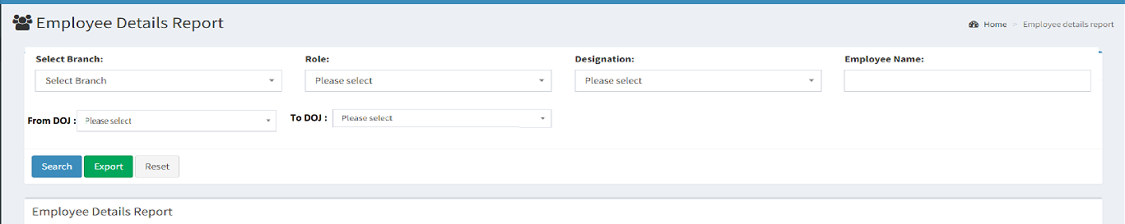

Fig: Employee details report -> filter options

**Input table**

|  |  |  |  |  |
| --- | --- | --- | --- | --- |
| **FIELDS** | **INPUT TYPE** | **MANDATORY/ OPTIONAL** | **EDITABLE** | **DESCRIPTION** |
| Branch | Drop down | Optional | - | User will select the branch from which the list of employees should be displayed in the report. If user doesn’t select any branch, then employees of all branches should be considered.  Validations: It should display active branches from branch master. It should be multi-select. Already selected branch should be excluded from the list. User should also be able to remove already selected branch. |
| Role | Drop down | Optional | - | User will select the role from which the list of employees should be displayed in the report. If user doesn’t select any role, then employees of all roles should be considered for displaying in the report.  Validations: It should display active branches from role master. It should be multi-select. Already selected role should be excluded from the list. User should also be able to remove already selected role. |
| Designation | Drop down | Optional | - | User will select the designation from which the list of employees should be displayed in the report. If user doesn’t select any role, then employees of all roles should be considered for displaying in the report.  Validations: It should display active designations from designation master. It should be multi-select. Already selected designation should be excluded from the list. User should also be able to remove already selected designation. |
| From DOJ | Calender date picker | Optional | - | User will select the date from which the employees have joined. Report will display the employees who have joined between the selected ‘from DOJ’ and ‘to DOJ’. If user doesn’t select any of the DOJ, then it should consider all employees.  Validations: Future dates should be disabled. Only one date can be selected. |
| To DOJ | Calender date picker | Optional | - | User will select the date till which the employees have joined. Report will display the employees who have joined between the selected ‘from DOJ’ and ‘to DOJ’. If user doesn’t select any of the DOJ, then it should consider all employees.  Validations: Only one date can be selected. Future dates should be disabled. Dates before ‘from DOJ’ should be disabled. |
| Search | Click | - | - | Once user clicks on the search button without selecting any of the filter options, then all actives employees should be displayed in the report with their other details.  If user selects any of the filter options and clicks on search button, then report should display the list of active employees as per selected filter. Report will display following columns:   * Sr. No. * Employee ID * Employee name * Designation * Department * Current Branch * Role * Mobile Number * DOJ * DOB * Gender   (Remove employee photo column)  Once user clicks on search button, report gets displayed in grid and export button gets displayed besides search button.  Validations: Search button will be disabled once clicked until report gets displayed in the grid. |
| Reset | Click | - | - | User will click on reset button to reset all the filter fields if selected any.  Validation: Reset button will be disabled until page gets reloaded and all fields get cleared if selected any. |
| Export | Click | - | - | Once reports gets displayed in the grid, export button will be displayed besides search button.  Once user clicks export button, CSV file will get downloaded displaying data of employees in as in grid. CSV file will have following columns:   * Sr. No. * Employee ID * Employee name * Designation * Department * Current Branch * Role * Mobile Number * DOJ * DOB * Gender   (Remove employee photo column) |

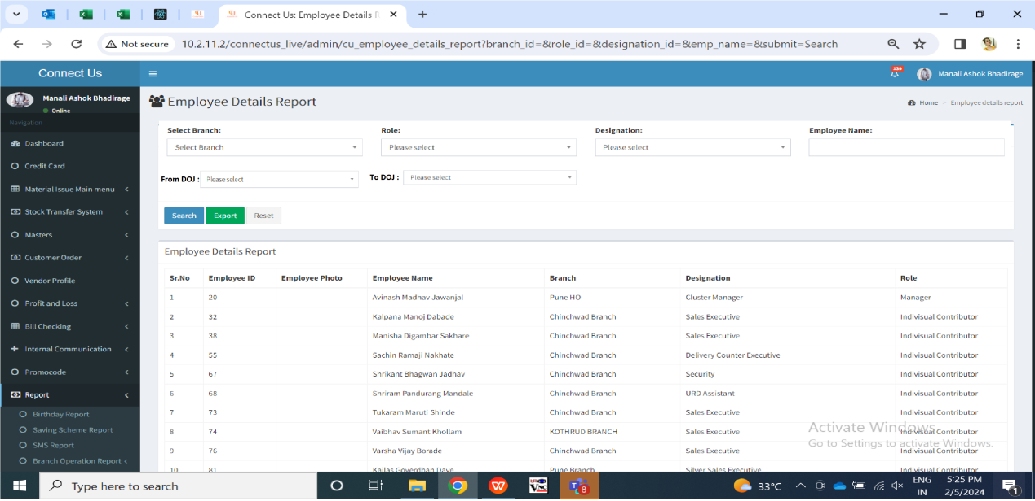

Fig: Employee details report -> grid

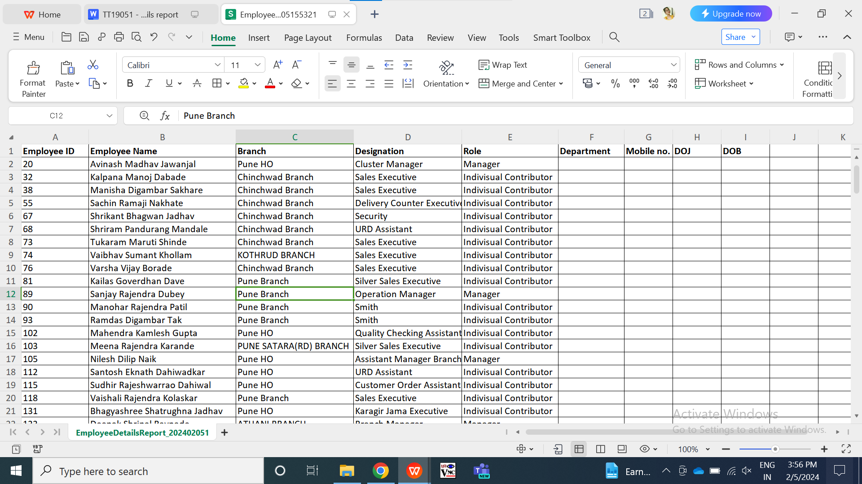

Fig: Employee details report -> export

1. **TEST DATA & SCENARIOS**



1. **ODUS (Open Discussion Unhanded Scenarios)**

|  |  |  |  |  |
| --- | --- | --- | --- | --- |
| **Sr. No.** | **Topic** | **Priority** | **Remark** | **Status** |
| 1 | Amrut: Need gender field as well in report. | Medium |  | Closed |
| 2 |  |  |  |  |
| 3 |  |  |  |  |

1. **REFERENCES OF THE USERS**

|  |  |  |  |
| --- | --- | --- | --- |
| **User** | **Name** | **Mail** | **Contact number** |
| **Actual user** | Amrut Ghadage | Training1@csjewellers.com |  |
| **Ticket created by (if any)** | Amrut Ghadage | Training1@csjewellers.com |  |
| **Assigned business analyst** | Manali bhadirage | Manali.bhadirage@techneai.com |  |
| **Assigned developer** | Yogita jagtap | Yogita.jagtap@techneai.com |  |
| **Assigned tester** | Vaishnavi khandwe | Vaishnavi.khandwe@techneai.com |  |