07.02.2024

Manali Ashok Bhadirage

Manali.bhadirage@techneai.com

Ticketing System Web - Solved Date & By

**Haondover Document**

**CONTENTS**

1. TICKET DETAILS 2

2. INTRODUCTION 2

3. BUSINESS REQUIREMENT 2

4. SCOPE 3

5. BUSINESS & SYSTEM RULES 3

6. ABBREVIATIONS & TERMS 3

7. GRAPHICAL REPRESENTATION 3

8. DEVELOPED SYSTEM 5

9. REFERENCES OF THE USERS 8

1. **TICKET DETAILS**

|  |  |
| --- | --- |
| **Ticket ID** | TT19186 |
| **Ticket description** | We need solved date field in my tickets -> export & grid when tickets are marked as solved. If ticket is not marked as solved then it should be blank whereas it should display date and time when tickets are marked as solved. |
| **Created by** | Manali Bhadirage |
| **Created on** | 22/01/2024 |
| **Priority** | Medium |

1. **INTRODUCTION**

Tech Ticket is tool designed for planning & managing your projects by creating tickets. It is easy to use IT software for scheduling tasks of team under each ticket and thus further increasing productivity of each member.

Ticket management software provides a centralized, structured and efficient way to handle tasks, issues, or requests, offering numerous benefits for organizations seeking streamlined workflows.With the ability to conveniently pause and resume tasks at any point, users can have greater control over their workflow. Tickets can be categorized and prioritized, allowing for organized task management and ensuring that critical issues are addressed promptly. Each ticket can be assigned to a specific individual or team, promoting accountability and clear ownership of tasks. By efficiently managing tasks and resolving issues in a timely manner, businesses can optimize their resources. Users can receive real-time updates on the status of their tickets, facilitating quick issue resolution and preventing delays. The reports collectively provide a comprehensive view of the performance and history of a ticket, enabling organization to make data-driven decisions.

1. **BUSINESS REQUIREMENT**

|  |  |  |  |
| --- | --- | --- | --- |
| **Requirement ID** | **Requirement Name** | **Short Description** | **Priority** |
| BR001 | Solved Date | Display solved date for solved tickets in grid of ‘search result tab’ when searched through filter.  Display solved date column in exported file of my tickets from all tabs.  Solved date field should be blank for the tickets whose status is not solved. | Medium |
| BR002 | Solved By | Display solved by for solved tickets in grid of ‘search result tab’ when searched through filter.  Display solved by column in exported file of my tickets from all tabs.  Solved by field should be blank for the tickets whose status is not solved. | Medium |

1. **SCOPE**

Once assigned to user changes the status of the ticket as solved or when ticket creator confirms ticket as solved, then the solved date should be displayed for that ticket in grid, view action and exported file. When user searches any solved ticket through filter option or using the search tab, then its solved date should be displayed in the grid. For rest of the ticket status, solved ticket column shouldn’t be displayed in any of the tabs above. Moreover, when user clicks on export button of any of the tab, then excel file should get downloaded displaying ticket details along with the solved date column in it.

1. **BUSINESS & SYSTEM RULES**

* User should be registered in the system.
* User should be logged in.
* System should display error message for incorrect details if entered.

1. **ABBREVIATIONS & TERMS**

ID - Identification number

1. **GRAPHICAL REPRESENTATION**

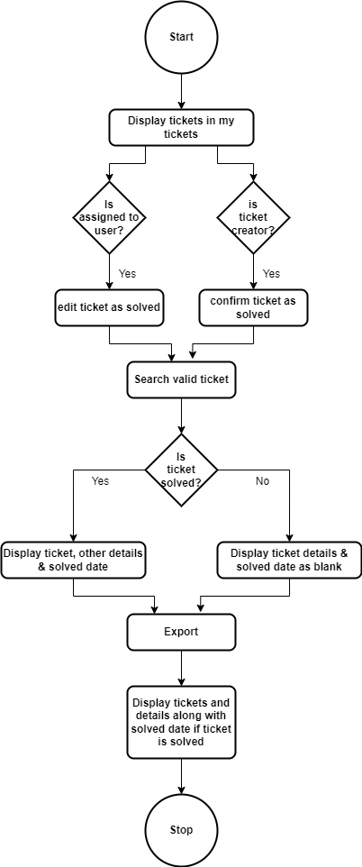

Fig: process flow diagram

1. **DEVELOPED SYSTEM**

Earlier, we didn’t had solved date an solved by for the tickets in the system and thus couldn’t analyze the data of tickets solved by the users during specific period.

Assigned to user can click on assigned to me tab -> edit action of ticket-> status -> solved and click on submit button to mark the tickets as solved which are assigned to them. Moreover, the ticket creator can mark the ticket as solved from their end through created by me -> confirm action of ticket -> mention comment and click on yes.

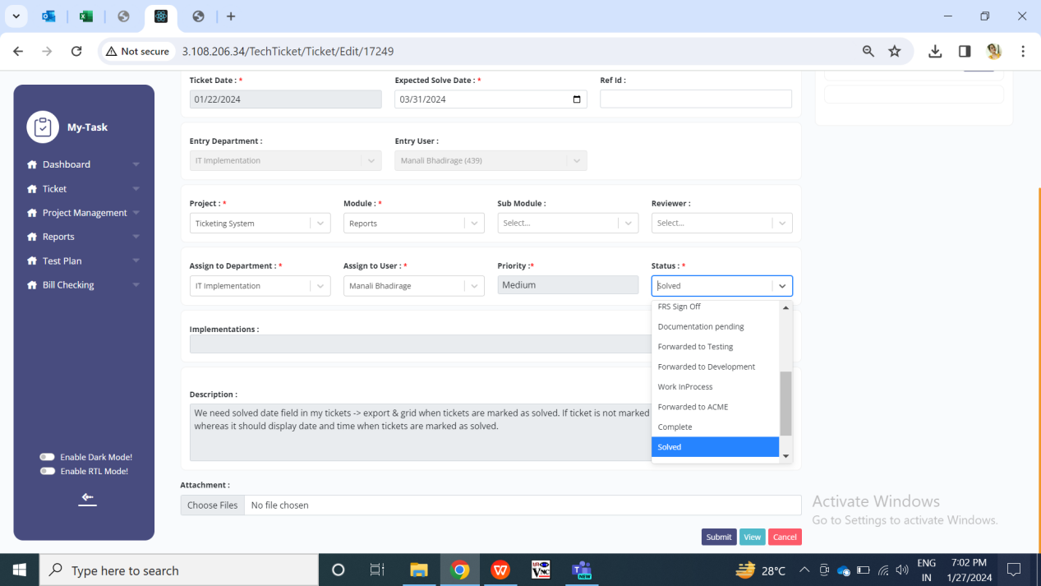

Fig: Assigned to user’s edit action to mark ticket as solved

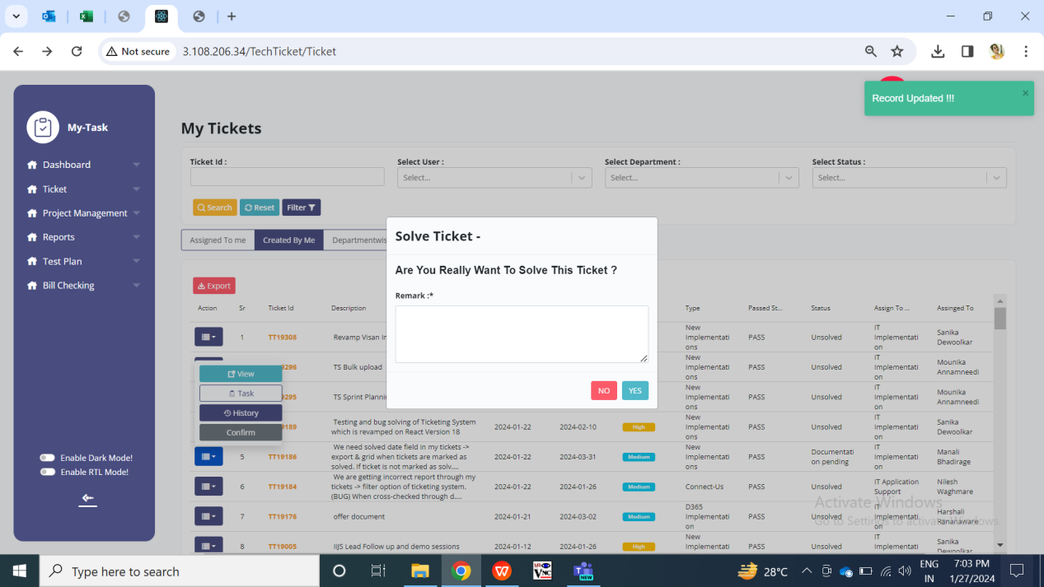

Fig: Ticket creator’s confirm action to mark ticket as solved

Further, when the user enters any valid ticket number in the search tab or selects status as solved in filter options and clicks on search button, expected ticket details will be displayed in the ‘search by me’ tab. It should have following columns:

* Action
* Sr. No.
* Ticket ID
* Description
* Ticket Date
* Expected Date
* Priority
* Type
* Passed status
* Status
* Assigned to dept.
* Assigned user
* Created by
* Solved date
* Solved by

|  |  |  |  |  |
| --- | --- | --- | --- | --- |
| **FIELDS** | **INPUT TYPE** | **MANDATORY/ OPTIONAL** | **EDITABLE** | **DESCRIPTION** |
| Solved Date | Text | - | No | It will display the date on which the ticket was marked as solved by the assigned to user / confirmed by the ticket creator. It will be displayed in YYYY/MM/DD format.  If ticket status is not solved, then solved date will be blank in the grid. |
| Solved by | Text | - | No | It will display the name of the user who solved the ticket. It will be displayed from the user master.  If ticket status is not as solved, then solved y field will be blank. |

Moreover, when user clicks on export button of any of the tab, excel file will get downloaded displaying list of tickets as in the grid. It should have following columns:

* Sr. No.
* Ticket ID
* Ticket created date
* Expected date
* Assign to dept
* Assign to user
* Query type
* Priority
* Ticket Status
* Description
* Created by
* Basket configured
* Confirmation
* Reference ID
* From dept
* Passing status
* Passing status at
* Passed by
* Passed remark
* Project name
* Module name
* Sub module name
* Template ID
* Tenant ID
* Solved date
* Solved by

Change sequence as mentioned above. Remove ID and status which is in P and Q column respectively.

|  |  |  |  |  |
| --- | --- | --- | --- | --- |
| **FIELDS** | **INPUT TYPE** | **MANDATORY/ OPTIONAL** | **EDITABLE** | **DESCRIPTION** |
| Solved Date | Text | - | No | It will display the date on which the ticket was marked as solved. It will be displayed in YYYY/MM/DD format.  If ticket status is not solved, then solved date will be blank in the cell. |
| Solved by | Text | - | No | It will display the name of the user who solved the ticket. It will be displayed from the user master.  If ticket status is not as solved, then solved y field will be blank. |

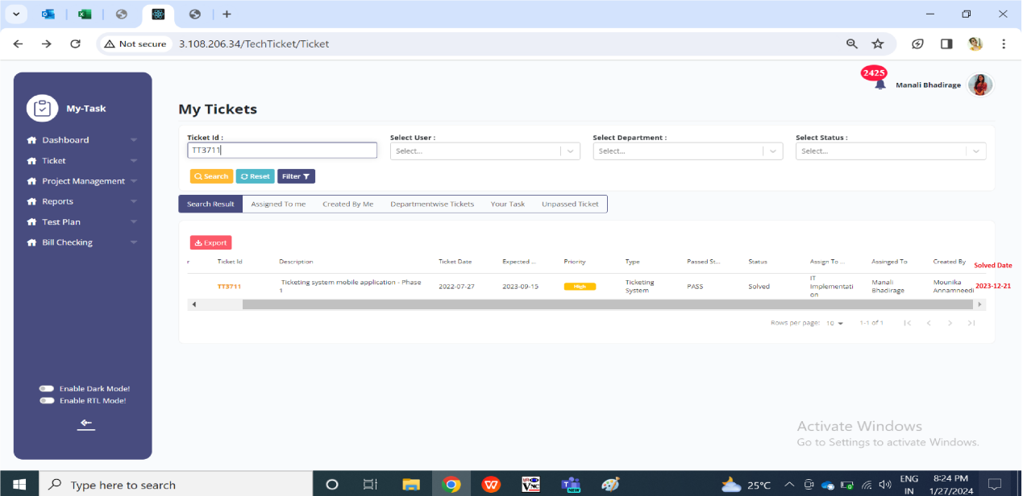

Fig: Solved Date in grid of search tab

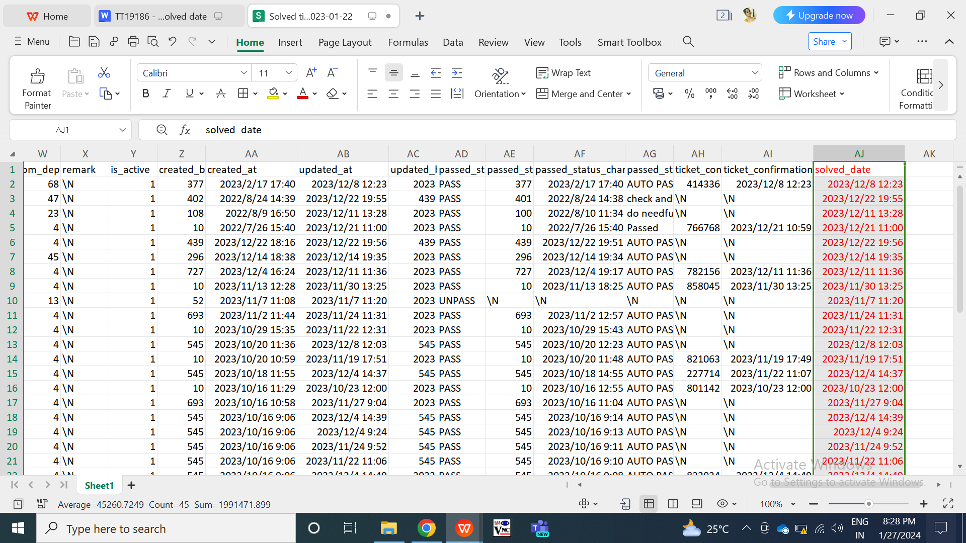

Fig: solved date in exported file

1. **REFERENCES OF THE USERS**

|  |  |  |  |
| --- | --- | --- | --- |
| **User** | **Name** | **Mail** | **Contact Number** |
| **Actual user** | Manali Bhadirage | Manali.bhadirage@techneai.com |  |
| **Ticket created by (if any)** | Manali Bhadirage | Manali.bhadirage@techneai.com |  |
| **Assigned business analyst** | Manali Bhadirage | Manali.bhadirage@techneai.com |  |
| **Assigned developer** | Priyanka Satpute  Prathmesh shinde | [priyanka.satpute@techneai.com](mailto:Amit.solanki@techneai.com)  Prathmesh.shinde@techneai.com |  |
| **Assigned tester** | Preeti bokade | Preeti.bokade@techneai.com |  |