Manali Ashok Bhadirage

Manali.bhadirage@techneai.com

07.02.2024

MATERIAL ISSUE REPORTS - IS RD PURCHASE COLUMN

**Handover Document**

**CONTENTS**

1. TICKET DETAILS 2

2. INTRODUCTION 2

3. BUSINESS REQUIREMENT 2

4. SCOPE 2

5. BUSINESS & SYSTEM RULES 3

6. ABBREVIATIONS & TERMS 3

7. GRAPHICAL REPRESENTATION 3

8. DEVELOPED SYSTEM 3

9. REFERENCES OF THE USERS 12

1. **TICKET DETAILS**

|  |  |
| --- | --- |
| **Ticket ID** | TT19299 |
| **Ticket description** | Material Issued Report Madhe Is RD Purchase Ya Column Che Filed Ale Pahije .Plz Check Attachment |
| **Created by** | Rakesh Thikane |
| **Created on** | 26/01/2024 |
| **Priority** | Very high |

1. **INTRODUCTION**

When lot is added in material issue, it is marked as received by the authority. Further, the lost is sent for checking in four stages. Here, based on parameters, the items are accepted and rejected. The rejected items are returned to the vendor whereas the purchase document is created in Padm for accepted items. Users use the material issue reports to recheck the documents and its details after completing four checking stages. Through material issue reports, analysis of documents is verified again finally the inventory and audit team. Each document is crossed checked and thus gives better understanding of inventory materials, accuracy and completeness. Reports give understanding on the time required for each process while passing the document along with accepted and rejected details in it.

1. **BUSINESS REQUIREMENT**

|  |  |  |  |
| --- | --- | --- | --- |
| **Requirement ID** | **Requirement Name** | **Short Description** | **Priority** |
| BR001 | Material issue reports -> grid | Display Is RD purchase column in the report and yes / no as per material issue add / edit against that document. | Medium |
| BR002 | Material issue reports -> export | Display Is RD purchase field in the downloaded file displaying yes / no against document as per material issue add / edit. | Medium |

1. **SCOPE**

After an item is added to the material issue and marked as received, it undergoes a sequential progression through Design check, further QC check, additional PO check, and finally, an HM check. Details of accepted and rejected documents are forwarded to the subsequent stage for checking here. Meanwhile, the material issue reports displays all accepted and rejected details from each document in every stage. Users can select a specific date range, vendor-wise or according to the checking stage or all reports. The report grid presents comprehensive information for each document, as in the add/edit/view actions in material issue of that document along with other details. Additionally, users have the option to export the report in grid format.

1. **BUSINESS & SYSTEM RULES**

* User will be registered in the system.
* User will be logged in.
* System should display error message for incorrect details if entered.
* Is RD purchase columns will be displayed in all the filter reports of material issue reports.

1. **ABBREVIATIONS & TERMS**

RD - Registered Dealer

WT - weight

1. **GRAPHICAL REPRESENTATION**

Add form in material issue (Is RD purchase field)

Mark as received

Display in Design check first and Forward accepted to QC -> PO -> HM sequentially

Display ‘Is RD purchase’ field in grid and export along with other columns

Material issue reports: apply filter and select report type

Fig: Context Diagram

1. **DEVELOPED SYSTEM**

Earlier, Id RD purchase column in the material issue report wasn’t provided and thus user are not able to analyze the exact data accordingly.

In Connect us -> material issue main menu -> material issue, once user clicks on add data, it will display following fields:

* Issued Date
* Challan No.
* Location
* Issued Type
* Vendor
* Sub supplier
* Narration
* Remark
* **Is RD purchase?**
* **Type of Rate**
* **Rate**
* **Attachment**
* Item Detail table
* Save button
* Back button
* Save and add more button

Once user clicks on save button, the record gets created and displayed in the top row of grid of material issue along with document number for it. As soon as the document gets created, it also gets displayed in material issue report.

|  |  |  |  |  |
| --- | --- | --- | --- | --- |
| **FIELDS** | **INPUT TYPE** | **MANDATORY/ OPTIONAL** | **EDITABLE** | **DESCRIPTION** |
| Is RD purchase? | Radio button | Mandatory | Yes | This specifies whether this document is purchased from registered dealer or not.  It will display yes or no in the list. Only rd purchase - yes documents will be displayed in the fix rate menu.  This field and value will be displayed in material issued report in grid as well as in exported file.  Validation: It will be single select. Initially, by default it will be no. |

Further once the document is marked as received, it gets displayed in Design check process -> QC check -> PO check and HM check process.

Once user clicks on Material issue reports, it displays following fields:

* From Date
* To date
* Type wise reports
* User wise reports
* Type wsie and user wise reports
* All reports
* Submit button
* Reset button

|  |  |  |  |  |
| --- | --- | --- | --- | --- |
| **FIELDS** | **INPUT TYPE** | **MANDATORY/ OPTIONAL** | **EDITABLE** | **DESCRIPTION** |
| From Date | Calender date picker | Mandatory | Yes | User will select the date from which the document was added in the material issue. (I.e. from issued date)  Validation: It will be single select and future dates are disabled. |
| To date | Calender date picker | Mandatory | Yes | User will select the date till which the document was added in the material issue. (I.e. till issued date)  Validation: It will be single select and future dates are disabled. |
| Type wise reports | Check box | Mandatory to select one report type | - | User can view the report by the checking type (Design check / qc check / po check / hm check). The report will display the fields of the selected type only.  Once user clicks on type wise report check-box, then report type drop-down will be displayed below which will be mandatory. It will be single select.  If user selects type wise report and any one type (design check / qc check / hm check / po check) and clicks on submit button, it will display the documents which are issued I.e. added between the selected filters dates and the details of that document related to design process. Report will display following fields in the grid and export:   * Sr. No. * Issued date * User name * Doc no. * Karagir name * Sub supplier name * Is RD purchase? * Location * Narration * Received status * Current status * Issued date and time * Received date and timing * Time difference * Item * Category * Purity * Making * Pcs * Gross wt * Net wt * Gross wt Rejected * Net wt rejected * Pcs rejected * Gross wt accepted * Net wt accepted * Pcs accepted * Total pcs * Total gross wt * Total net wt * Add to received status   It will display the accepted and rejected details here based on the type selected. |
| User wise reports | Check box | Mandatory to select one report type | - | User can view the documents in the report of specific vendor only by clicking here to know which user has done checking in which stage.  Once user click on ‘user wise report’ then users drop-down will be displayed where user will select the vendor for which the data is to be displayed. It will be single select.  As per selected vendor name, it will display the documents in the grid of the selected vendor only.  If user checks user wise report check-box and selects one of the vendor name in the users field, it will display following columns in the report:   * Sr. No. * Issued date * User name * Doc no. * Karagir name * Sub supplier name * Is RD purchase? * Location * Narration * Received status * Current status * Issued date and time * Received date and timing * Time difference * Item * Category * Purity * Making * Pcs * Gross wt * Net wt * Design user * QC user * PO user * HM user * Add to received status * Received status to design check update * Design check update to QC check update * QC check update to PO check update * PO check update to print * Print to HM check update * Time difference start to end process |
| Type wise User wise report | Check box | Mandatory to select one report type | - | User can view documents by specific checking type and vendor.  Once user clicks on type wise user report then report type and user drop-down will be displayed. Both will be single select each. It will display following columns in grid:   * Sr. No. * Issued date * User name * Doc no. * Karagir name * Sub supplier name * Is RD purchase? * Location * Narration * Received status * Current status * Issued date and time * Received date and timing * Time difference * Item * Category * Purity * Making * Pcs * Gross wt * Net wt * Gross wt Rejected * Net wt rejected * Pcs rejected * Gross wt accepted * Net wt accepted * Pcs accepted * Narration * Add to received status * Received status to design check , etc. - Here it will display the columns based on the checking type selected. |
| All reports | Check box | Mandatory to select one report type | - | Once user selects all reports, all details of each document will be displayed which were issued within selected dates in filter.  It will display following columns in the grid:   * Sr. No. * Date * Doc no. * Material created by * Material accepted by * Karagir name * Sub supplier name * Is rd purchase * Location * Narration * Received status * Current status * Issued date and time * Received date and timing * Time difference * Item * Category * Purity * Making * Pcs * Gross wt * Net wt * Design Gross wt Rejected * Design Net wt rejected * Design Pcs rejected * Design Gross wt accepted * Design Net wt accepted * Design Pcs accepted * Design narration * QC Gross wt Rejected * QC Net wt rejected * QC Pcs rejected * QC Gross wt accepted * QC Net wt accepted * QC Pcs accepted * Qc narration * PO Gross wt Rejected * PO Net wt rejected * PO Pcs rejected * PO Gross wt accepted * PO Net wt accepted * PO Pcs accepted * PO narration * HM Gross wt Rejected * HM Net wt rejected * HM Pcs rejected * HM Gross wt accepted * HM Net wt accepted * HM Pcs accepted * HM narration * Black bits * Stone wt * Stone amt * Other charges * Extra stone wt * Hallmark tunch * Hallmark pcs * Add to received status * Received status to design check update * Design check update to QC check update * QC check update to PO check update * PO check update to print * Print to HM check update * Time difference start to end process |
| Submit | Click | - | - | Once user selects dates, report type and clicks on submit button, expected report will be displayed in the gird.  In case, user doesn’t select mandatory fields in filter and clicks on submit button, then error message will be displayed. |

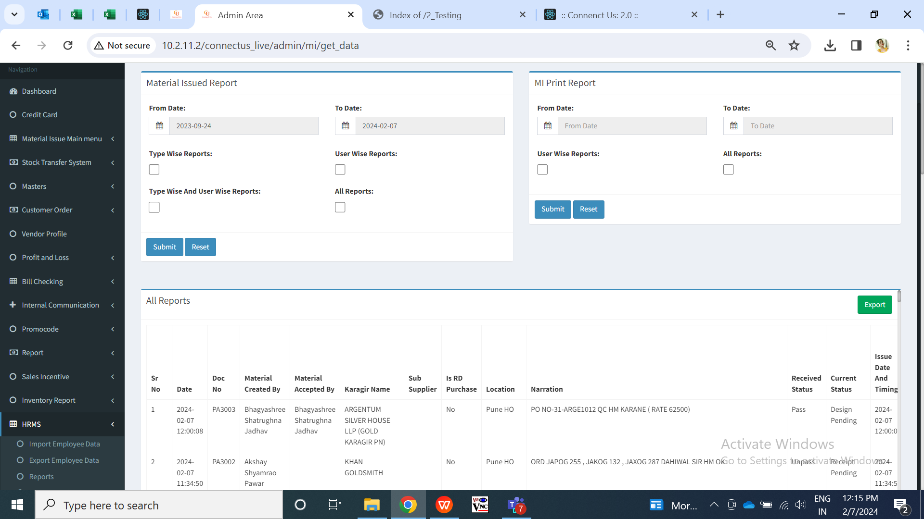

Fig: All reports

Once user clicks on export button, csv file will get downloaded displaying all the columns in it as in grid with the documents.

|  |  |  |  |  |
| --- | --- | --- | --- | --- |
| **FIELDS** | **INPUT TYPE** | **MANDATORY/ OPTIONAL** | **EDITABLE** | **DESCRIPTION** |
| Is RD purchase | Text | Mandatory | Yes | It will display the rd purchase type column in the grid as well as in exported csv file and will display as yes or no in it as per material issue -> add / edit of that document number. |

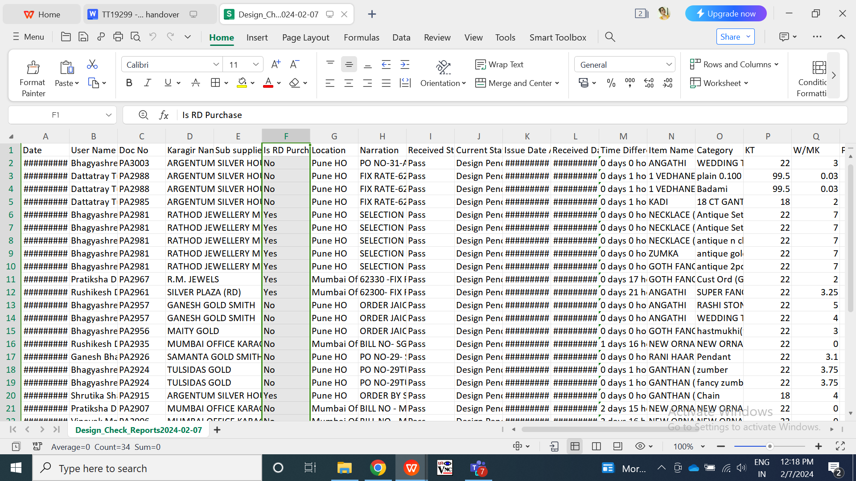

Fig: Export

1. **REFERENCES OF THE USERS**

|  |  |  |  |
| --- | --- | --- | --- |
| **User** | **Name** | **Mail** | **Contact number** |
| **Actual user** | Rakesh Thikane | isa@csjewellers.com |  |
| **Ticket created by (if any)** | Rakesh Thikane | isa@csjewellers.com |  |
| **Assigned business analyst** | Manali Bhadirage | Manali.bhadirage@techneai.com |  |
| **Assigned developer** | Prathmesh shinde | Prathmesh.shinde@techneai.com |  |
| **Assigned tester** | Manali bhadirage | Manali.bhadirage@techneai.com |  |