14.12.2023

**USER MANUAL HANDOVER**

Connect US 1.0 Bill Checking

Manali Ashok Bhadirage

Manali.bhadirage@techneai.com

**CONTENTS**

1. VERSION CONTROL 2

2. INTRODUCTION 2

3. SCOPE 2

4. BUSINESS & SYSTEM RULES 2

5. ABBREVIATIONS & TERMS 2

6. GRAPHICAL REPRESENTATION 2

7. DEVELOPED SYSTEM 2

8. TEST DATA AND BUSINESS SCENARIOS 3

1. **VERSION CONTROL**

|  |  |  |  |  |  |  |
| --- | --- | --- | --- | --- | --- | --- |
| **Sr. No.** | **Version no** | **Version Date** | **User Name** | **User department** | **Updated By** | **Ticket ID** |
| **1** | **1.0** | **14/12/2023** |  |  |  |  |
|  |  |  |  |  |  |  |
|  |  |  |  |  |  |  |

1. **INTRODUCTION**
2. **SCOPE**
3. **BUSINESS & SYSTEM RULES**

* User should be registered in the system and should be logged in.
* System should pop up a message, if any issues in the system is detected.
* All forms should have on field validations. System should display on field errors in case of incorrect inputs.

1. **ABBREVIATIONS & TERMS**
2. **GRAPHICAL REPRESENTATION**

Fig:

1. **DEVELOPED SYSTEM**

Bill Checking system contain following modules in it:

1. BILL CHECKING MASTERS
2. Acme Doc series
3. Vendor master
4. Payment template
5. Bill Type
6. Bill Type mapping user
7. BILL CHECKING TRANSACTION
8. BILL CHECKING TRANSACTION REPORTS
9. BILL PAYMENTS
10. BILL TO BILL REFERENCE REPORT
11. NACH PAYMENT
12. INTERNAL AUDIT QUERY REPORT

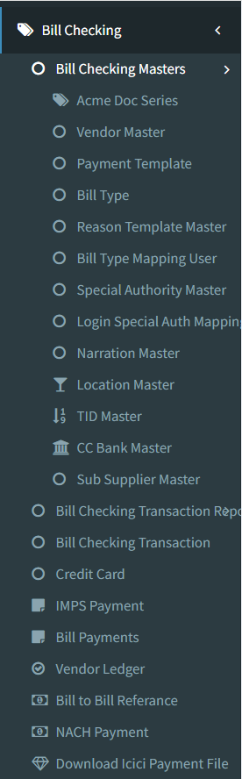

1. **BILL CHECKING MASTERS**
2. **Bill type**

While entering the bill through bill checking transaction -> add form, the entry user will select the type of bill that they are adding in the system like light bill, laptop bill, etc. Those types of bill will be displayed in bill checking transaction -> add and edit form from bill type master.

Bill type master menu has following fields:

* Add button
* Edit button
* History button
* View button
* Bill Type
* Sort Order
* Remark
* Is Active
* Save button
* Save & add more button
* Back button
* Created at
* Created by
* Updated at
* Updated by
* IP address
* User agent

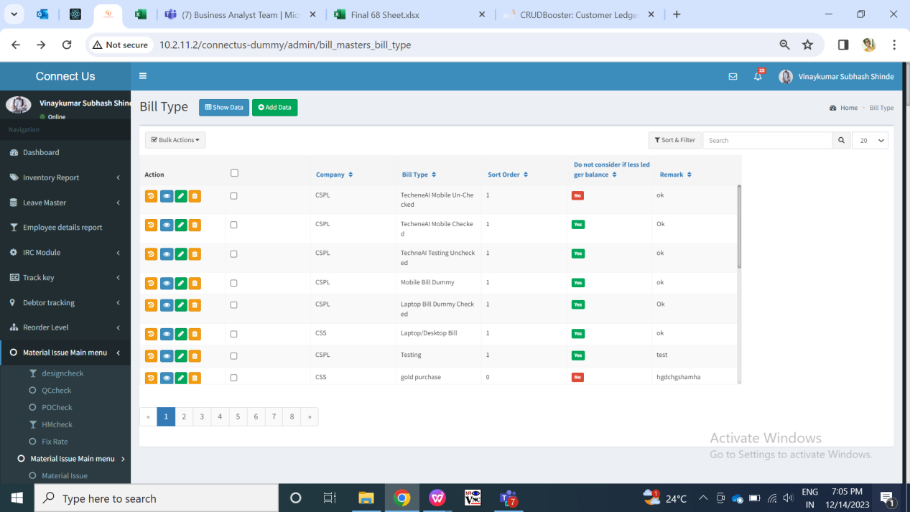

Fig: Bill type master (Grid)

Visibility of fields on pages:

|  |  |  |  |  |
| --- | --- | --- | --- | --- |
| **FIELDS** | **GRID** | **ADD** | **EDIT** | **HISTORY** |
| Add button |  | X | X | X |
| Edit button |  | X | X | X |
| History button |  | X | X | X |
| View button |  | X | X | X |
| Bill Type |  |  |  |  |
| Sort Order |  |  |  |  |
| Remark |  |  |  |  |
| Is Active |  |  |  |  |
| Save button | X |  |  | X |
| Save & add more button | X |  | X | X |
| Back button | X |  |  | X |
| Created at |  | X | X |  |
| Created by |  | X | X |  |
| Updated at |  | X | X |  |
| Updated by |  | X | X |  |
| IP address | X | X | X |  |
| User agent | X | X | X |  |
| Action / operation | X | X | X |  |

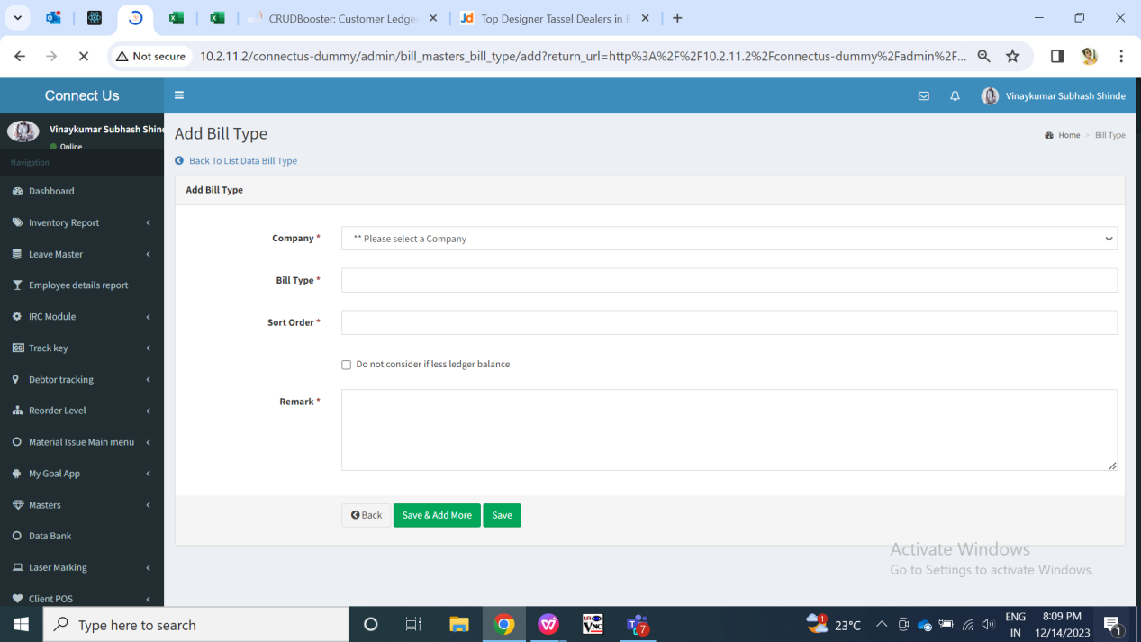

Fig: Bill type master (Add)

|  |  |  |  |  |
| --- | --- | --- | --- | --- |
| **FIELDS** | **INPUT TYPE** | **MANDATORY/ OPTIONAL** | **EDITABLE** | **DESCRIPTION** |
| Bill type | Text | Mandatory | Yes | User will enter name for the Bill Type in this field.  Validation: It should be unique. It should accept characters, special characters, numbers and space.  Min length = 8  Max length = 50 |
| Sort order | Text | Optional | Yes | User will enter the number for the bill type which will be displayed in the bill checking transaction -> add and edit -> bill type field drop-down list.  Validation: Same number cannot be used again. It should accept only numbers. It should not accept space, characters, special characters.  Min length = 1 digit  Max length = 4 digits |
| Remark | Text | Optional | Yes | User will enter additional notes in this field.  Validation: It should accept characters, numbers and space. It should accept English / Marathi script.  Min length = 8  Max length = 250 |
| Is active | Radio button | Mandatory | Yes | It will display status as active / inactive. Only the active bills will be displayed in bill checking transaction -> add and edit -> bill type drop-down list.  Validation: It should keep “active” status by default. It will be single select. |
| Save button | Click | - | - | Once user enters valid details in mandatory fields and clicks on save button, bill type should get added. Successful message should be displayed. User should be directed to grid page of bill type where recently added bill type will be displayed at top.  Validation: Button should be displayed until bill type gets added successfully or until error message is displayed in case of invalid fields. |
| Save & add more | Click | - | - | Once user enters valid details in mandatory fields and clicks on save button, bill type should get added. Successful message should be displayed. Recently added bill type will be displayed at top whereas user will remain on the same page to add another new bill type.  Validation: Button should be displayed until bill type gets added successfully or until error message is displayed in case of invalid fields. |
| Back button | Click | - | - | Once user clicks on back button, user will be directed to grid page and the record will not get added if details are filled any in add form of bill type.  Validation: Once back button is clicked, then it will be disabled until user is redirected to grid page. |
| Created at | Text | - | No | It will display the date and time when the bill type details were added.  Validation: It will be read only. |
| Created by | Text | - | No | It will display the employee name who added the bill type details.  Validation: It will be read only. |
| Updated at | Text | - | - | Once the user edits the bill type details, then it will display the date and time when the bill type details were modified.  Validation: It will be read only. |
| Updated by | Text | - | - | Once the user edits the already created bill type, then it will display the employee name who modified the details.  Validation: It will be read only. |
| IP address | Text | - | No | It specifies the IP address of the system from which user added or edited the bill type.  Validation: It is read only. |
| User agent | Text | - | No | User-Agent is a string of characters sent by HTTP clients (browsers, bots, calendar applications, etc.) for each individual HTTP request to a server.  Thus, in history action we will view the user agent which is nothing but the details of the operating system and browser of user's system who is adding or editing that bill type. It will vary.  Validation: It is read only. |

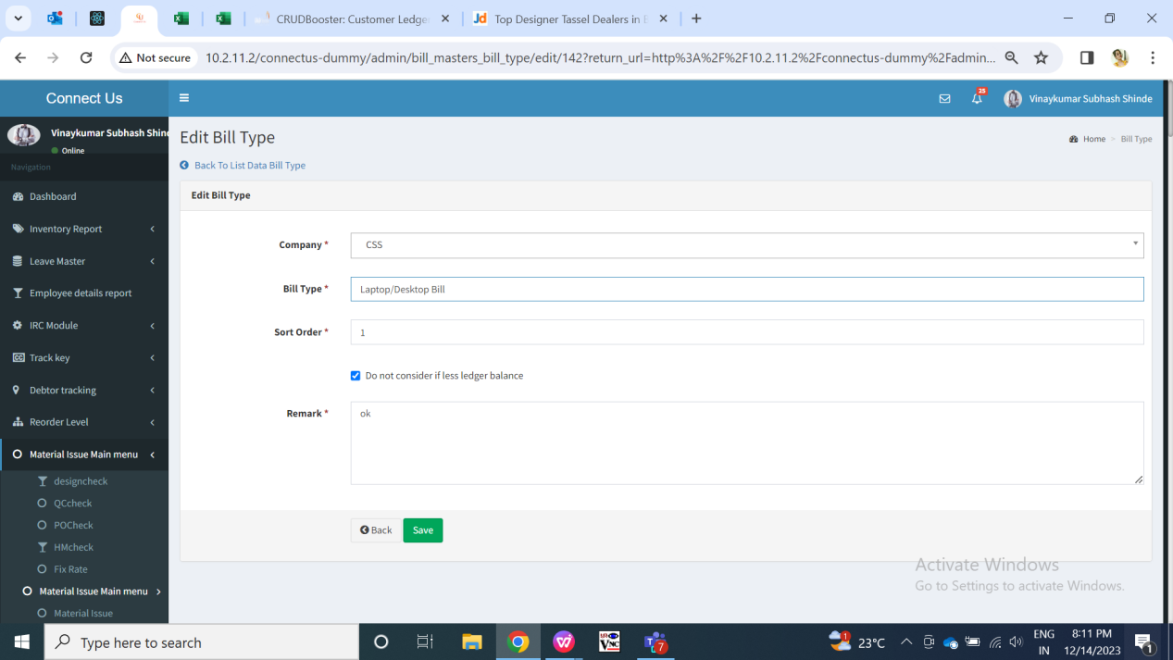

Fig: Bill type master (edit)

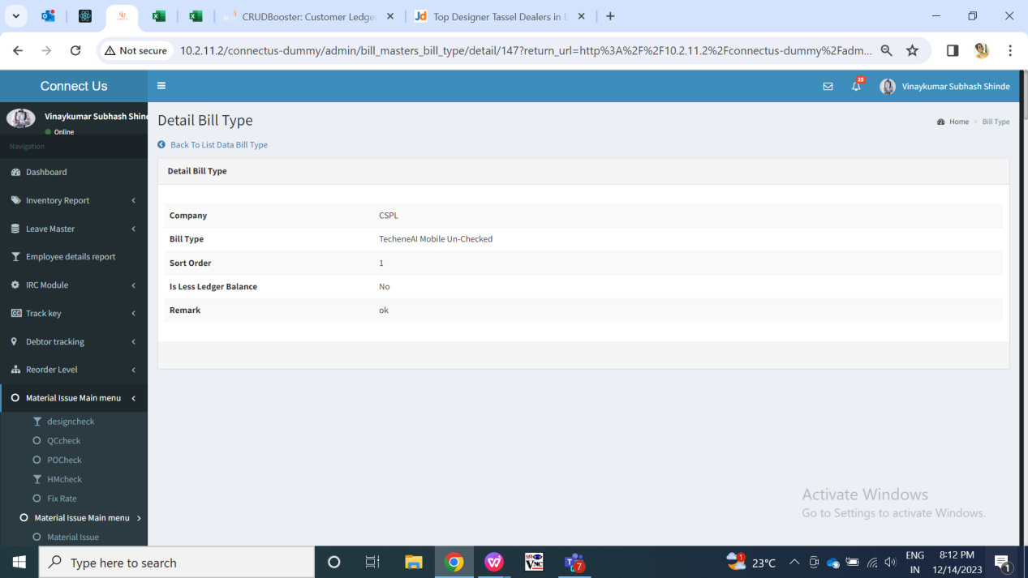

Fig: Bill type master (view)

1. **Bill type mapping user**

Through bill type mapping user, we can map the created bill type with users in the employee master. Thus, users will be able to add the bills for the bill types only which are mapped to them. Once the bill type is mapped with the user, then in bill checking transaction -> add and edit form, the list of ‘assigned to users’ will be displayed as per selected bill type.

Bill type mapping user has following fields:

* Add button
* Edit button
* View button
* Bill type
* User name
* Remark
* Is active
* Save button
* Save & add more button
* Back button
* Created at
* Created by
* Updated at
* Updated by

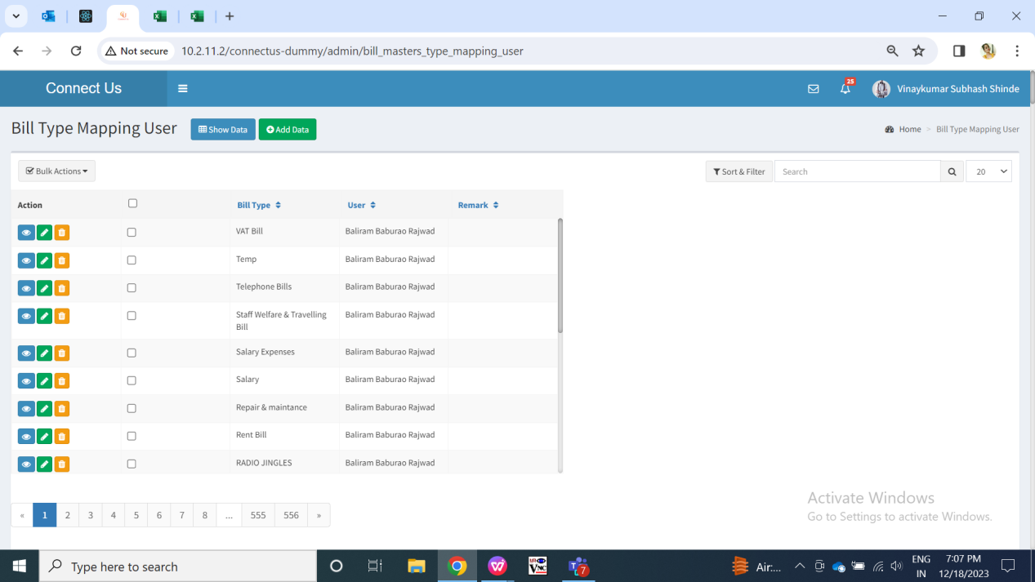

Fig: Bill type mapping user (grid)

Visibility of fields on pages:

|  |  |  |  |  |
| --- | --- | --- | --- | --- |
| **FIELDS** | **GRID** | **ADD** | **EDIT** | **VIEW** |
| Add button |  | X | X | X |
| Edit button |  | X | X | X |
| View button |  | X | X | X |
| Bill type |  |  |  |  |
| User name |  |  |  |  |
| Remark |  |  |  |  |
| Is active |  |  |  |  |
| Save button | X |  |  | X |
| Save & add more button | X |  | X | X |
| Back button | X |  |  | X |
| Created at |  | X | X |  |
| Created by |  | X | X |  |
| Updated at |  | X | X |  |
| Updated by |  | X | X |  |

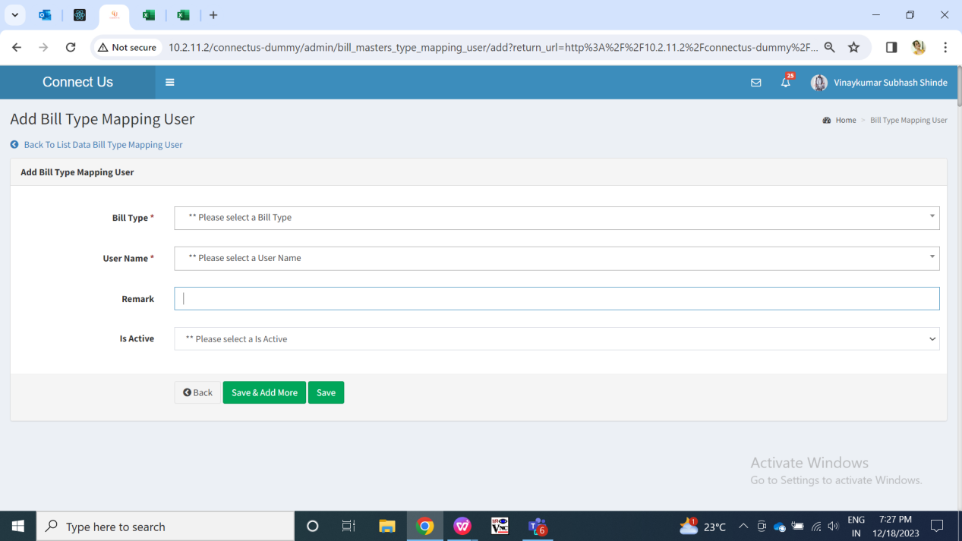

Fig: Bill type mapping user (add)

|  |  |  |  |  |
| --- | --- | --- | --- | --- |
| **FIELDS** | **INPUT TYPE** | **MANDATORY/ OPTIONAL** | **EDITABLE** | **DESCRIPTION** |
| Bill type | Drop down | Mandatory | Yes | User will select the bill type against which they have to map assigned to user.  Validation: It will be single select. It will display active bill types in the list from bill type master. |
| User name | Drop down |  |  | User will select the name of the user from the drop down to which that bill type is to be mapped. Once the bill type is mapped with the user, then in bill checking transaction -> add and edit form, the list of ‘assigned to users’ will be displayed as per selected bill type.  Same bill type can be mapped to the same user only once. So, user names will be disabled from the drop down list as per bill type selected and already mapped.  Validation: It will be single select. It will display active employees from employee master. |
| Remark | Text | Optional | Yes | User will enter additional notes in this field.  Validation: It should accept characters, numbers and space. It should accept English / Marathi script.  Min length = 3  Max length = 250 |
| Is active | Radio button | Mandatory | Yes | It will display status as active / inactive. If mapping is inactive then the particular bill cannot be assigned to that user through add and edit of bill checking transaction.  If the mapping is active then only the name of the user will be displayed in assigned to user field of bill checking transaction after selecting the particular bill type.  Validation: It should keep “active” status by default. It will be single select. |
| Save button | Click | - | - | Once user enters valid details in mandatory fields and clicks on save button, bill type mapping with the user should get added. Successful message should be displayed. User should be directed to grid page of bill type mapping user master where recently added bill type mapping user record will be displayed at top.  Validation: Button should be displayed until bill type mapping user gets added successfully or until error message is displayed in case of invalid fields. |
| Save & add more | Click | - | - | Once user enters valid details in mandatory fields and clicks on save button, bill type should get added. Successful message should be displayed. Recently added bill type will be displayed at top whereas user will remain on the same page to add another new bill type.  Validation: Button should be displayed until bill type gets added successfully or until error message is displayed in case of invalid fields. |
| Back button | Click | - | - | Once user clicks on back button, user will be directed to grid page and the record will not get added if details are filled any in add form of bill type.  Validation: Once back button is clicked, then it will be disabled until user is redirected to grid page. |
| Created at | Text | - | No | It will display the date and time when the bill type details were added.  Validation: It will be read only. |
| Created by | Text | - | No | It will display the employee name who added the bill type details.  Validation: It will be read only. |
| Updated at | Text | - | - | Once the user edits the bill type details, then it will display the date and time when the bill type details were modified.  Validation: It will be read only. |
| Updated by | Text | - | - | Once the user edits the already created bill type, then it will display the employee name who modified the details.  Validation: It will be read only. |

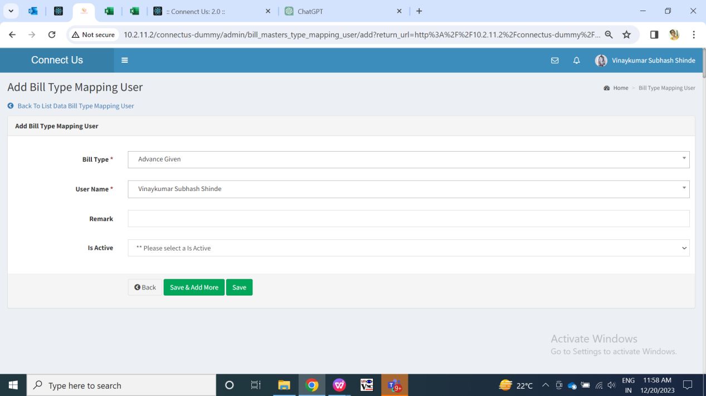

Fig: Bill type mapping user (edit)

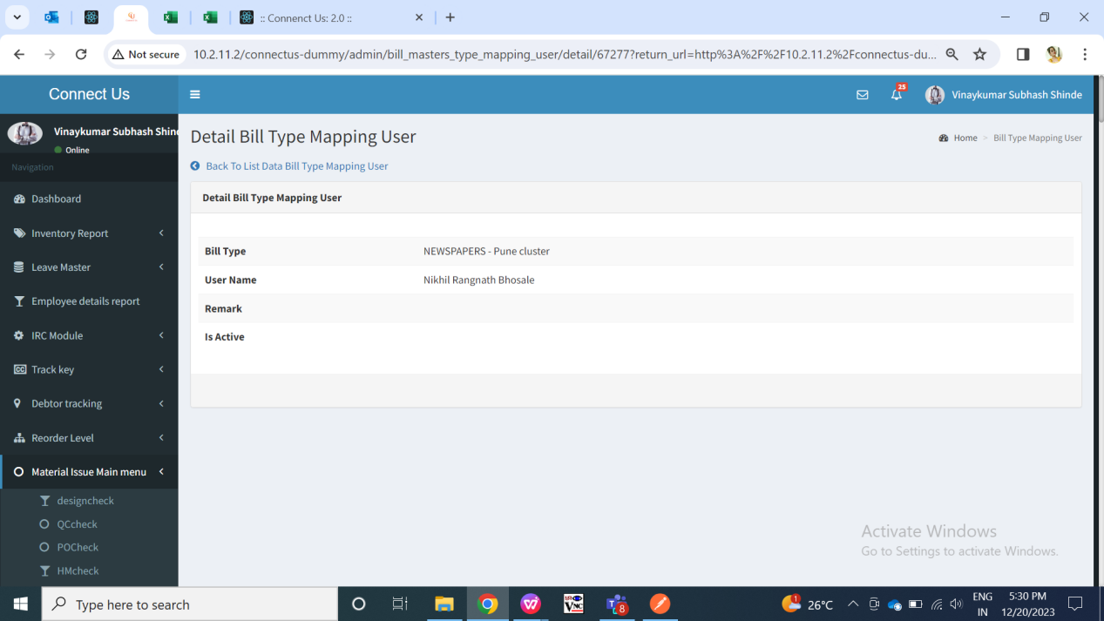

Fig: Bill type mapping user (view)

1. **Payment Template Master**

Whenever a bill for vendor is added through bill checking transaction, its payment date gets displayed as per payment tempolate set against that vendor. This payment template is made in payment template master and then mapped against vendor in vendor master. It has following fields:

* Add button
* View button
* Edit button
* Template name
* Payment type
* Type of bill
* Min days
* Payment weekly days
* Bill dates
* Remark
* Terms and conditions
* Save button
* Save & add more button
* Back button
* Created at
* Created by
* Updated at
* Updated by

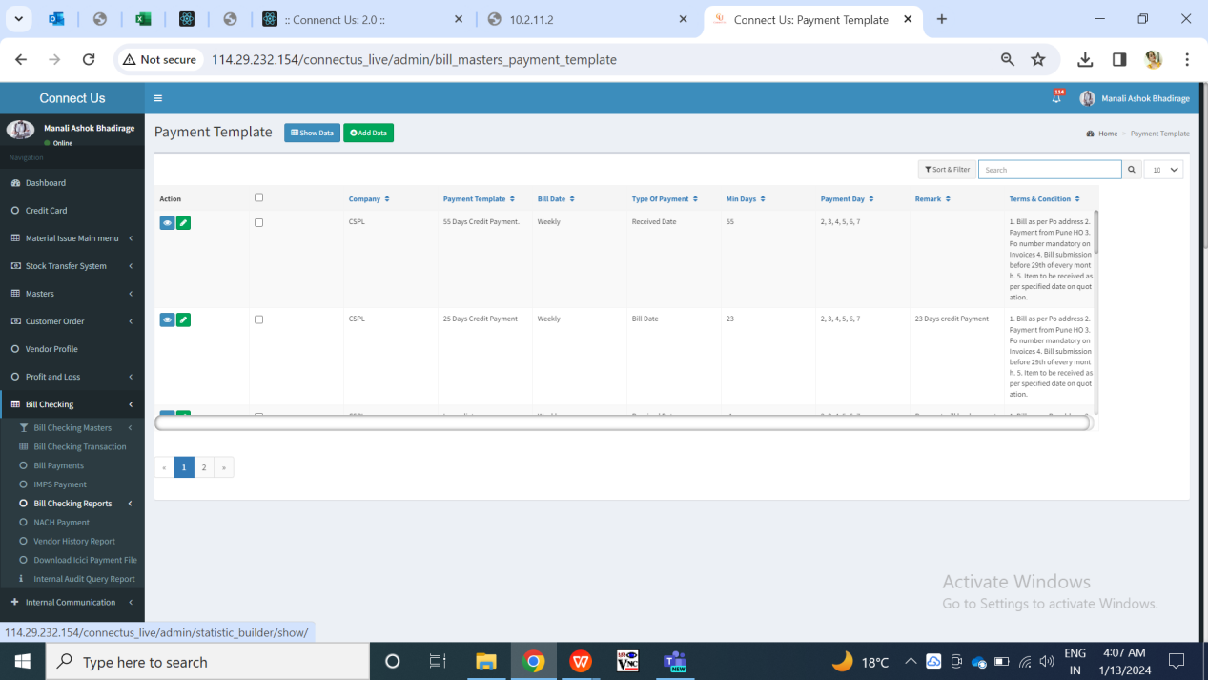

Fig: Payment template master (Grid)

Visibility of fields:

|  |  |  |  |  |
| --- | --- | --- | --- | --- |
| **FIELDS** | **GRID** | **ADD** | **EDIT** | **VIEW** |
| Add button |  | X | X | X |
| Edit button |  | X | X | X |
| View button |  | X | X | X |
| Template name |  |  |  |  |
| Payment type |  |  |  |  |
| Type of bill |  |  |  |  |
| Min days |  |  |  |  |
| Payment weekly days |  |  |  |  |
| Bill dates |  |  |  |  |
| Remark |  |  |  |  |
| Terms and conditions |  |  |  |  |
| Save button | X |  |  | X |
| Save & add more button | X |  | X | X |
| Back button | X |  |  | X |
| Created at |  | X | X |  |
| Created by |  | X | X |  |
| Updated at |  | X | X |  |
| Updated by |  | X | X |  |

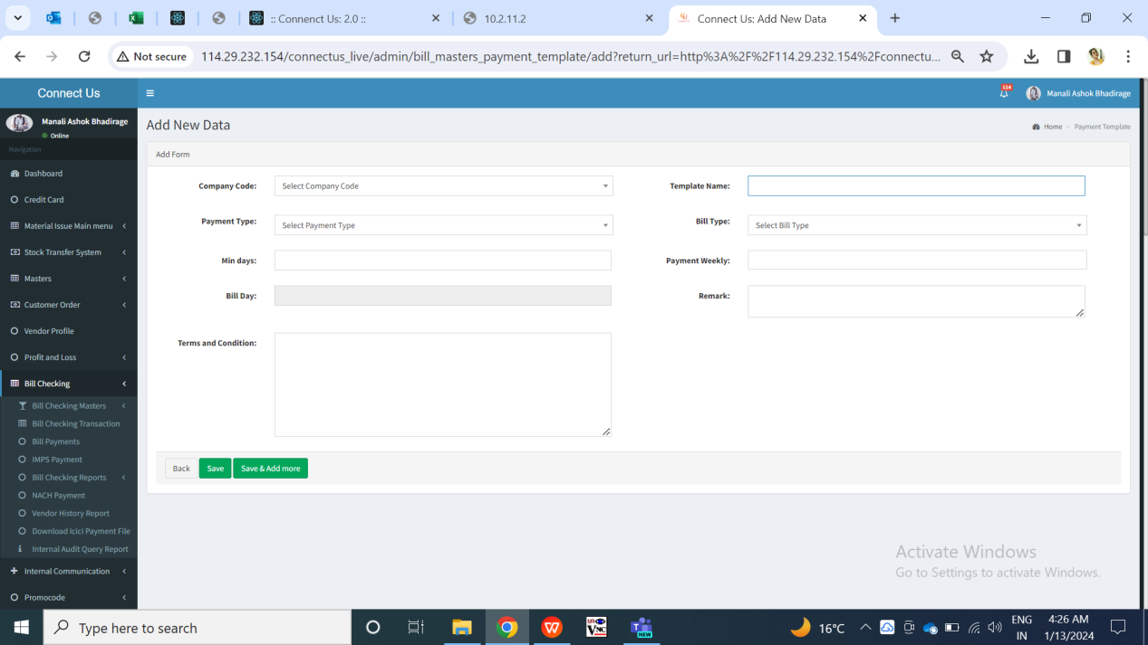

Fig: Payment template master (Add)

|  |  |  |  |  |
| --- | --- | --- | --- | --- |
| **FIELDS** | **INPUT TYPE** | **MANDATORY/ OPTIONAL** | **EDITABLE** | **DESCRIPTION** |
| Template name | Text | Mandatory | Yes | User will enter name for the template in this field. It will be displayed in vendor master -> payment template field.  Validation: It should accept characters, special characters, numbers and space.  Template name will be unique.  Min length = 3  Max length =25 |
| Payment type | Drop down | Mandatory | Yes | It consists of drop-down consisting “monthly” and “weekly” in the list.  User will select the payment type I.e. whether that payement should be done weekly or monthly.  If user selects “monthly” from this drop-down, then “Payment weekly days” field will be disabled. If user selects “weekly” from this drop-down, then “Bill Dates” field will be disabled.  Validation: It will be single select. |
| Type of bill | Drop down | Mandatory | Yes | It will display bill date and received date in the list. The payment date will get caculated from the selected type of bill.  Validation: It will be single select. |
| Min days | Text | Mandatory | Yes | User will manually enter the number of minimum days in this field. The entered minimum days count will be calculated from the selected type of bill I.e. bill date or from received day.  Valodation: It should accept only numbers. |
| Payment weekly days | Srop down | Mandatory | Yes | It will be enabled if user selects payment type as weekly. User will select the days on which the payment of that vendor needs to be done after calculating minumum days count from type of bill.  Payment weekly field will display drop-down consisting Sunday, Monday, Tuesday, Wednesday, Thursday, Friday and Saturday in the list.  Validation: It will be multi select. Selected day will be removed from the drop down list so that user can select another remaining days if needed from the list. |
| Bill Dates | Text | Mandatory | Yes | User will mention the dates of the calender on which the payment date is to be displayed for the vendor after calculating minimum days from type of bill.  If user selects “monthly” from Payment type drop-down, then user will manually enter number in Bill Dates column.  Validation: It should accept numbers only. User can enter multiple dates from the calender 1 to 31 only. It should accept comma only as special character. |
| Remark | Text | Optional | Yes | User will enter additional notes in this field.  Validation: It should accept characters, numbers and space. It should accept English / Marathi script.  Min length = 3  Max length = 250 |
| Terms and condition | Text | Optional | Yes | User will enter the terms for the created template if any.  Validation: It should accept characters, numbers and space. It should accept English / Marathi script.  Min length = 3  Max length = 250 |
| Save button | Click | - | - | Once user enters valid details in mandatory fields and clicks on save button, payment template will get added. Successful message should be displayed. User should be directed to grid page of payment template master where recently added payment template will be displayed at top.  Validation: Button should be displayed until payment template user gets added successfully or until error message is displayed in case of invalid fields. |
| Save & add more | Click | - | - | Once user enters valid details in mandatory fields and clicks on save button, payment template should get added. Successful message should be displayed. Recently added payment template will be displayed at top whereas user will remain on the same page to add another new bill type.  Validation: Button should be displayed until payment template gets added successfully or until error message is displayed in case of invalid fields. |
| Back button | Click | - | - | Once user clicks on back button, user will be directed to grid page and the record will not get added if details are filled any in add form of payment template.  Validation: Once back button is clicked, then it will be disabled until user is redirected to grid page. |
| Created at | Text | - | No | It will display the date and time when the payment template details were added.  Validation: It will be read only. |
| Created by | Text | - | No | It will display the employee name who added the payment template details.  Validation: It will be read only. |
| Updated at | Text | - | - | Once the user edits the bill type details, then it will display the date and time when the payment template details were modified.  Validation: It will be read only. |
| Updated by | Text | - | - | Once the user edits the already created bill type, then it will display the employee name who modified the details.  Validation: It will be read only. |

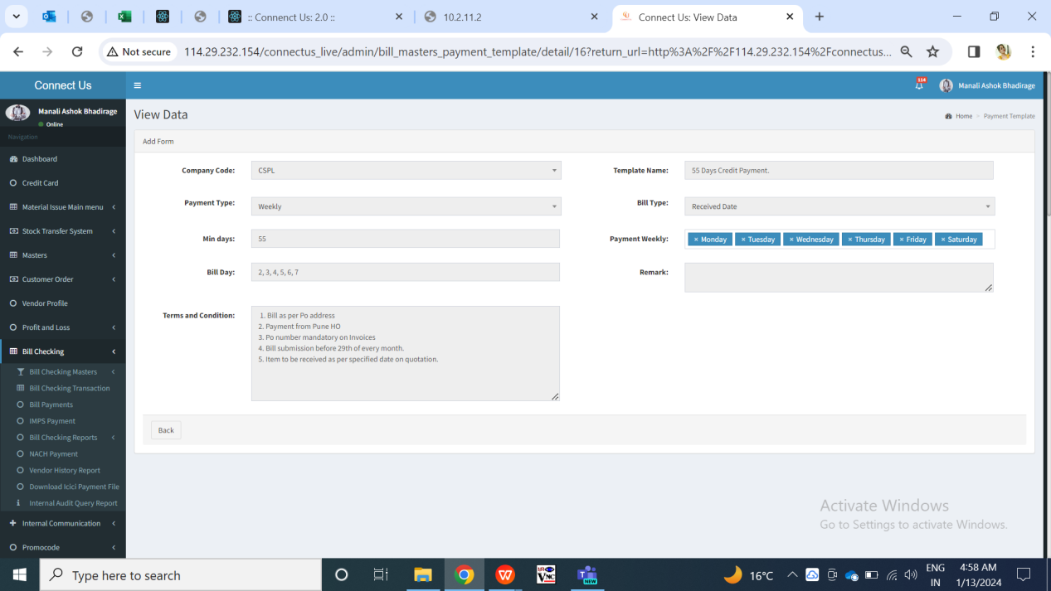

Fig: Payment template master (View)

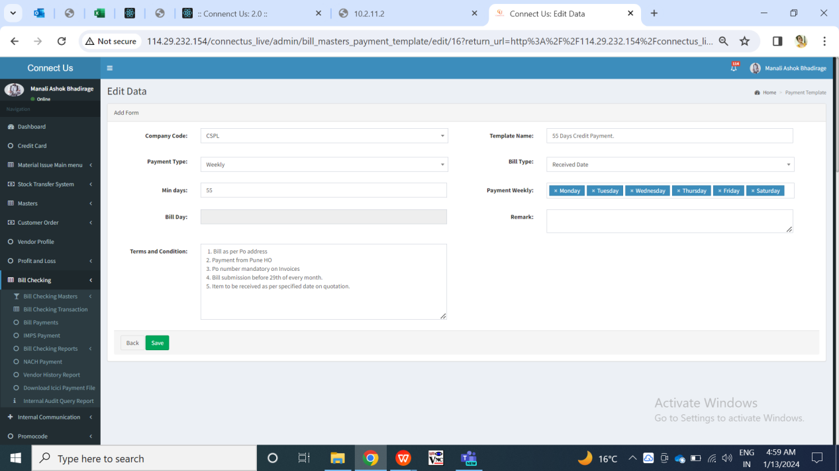

Fig: Payment template master (Edit)

1. **Vendor Master**

User will add the vendor in vendor master which will get displayed in bill checking transaction while adding the bill. While submitting the bill, entry user selects the vendor for the bill payment is to be done. Vendor master has following fields:

* Add data button
* Edit button
* View button
* History button
* Export data button
* Vendor name
* Vendor type
* Address
* Remark
* Contact person name
* Contact no.
* Alternate no.
* Landline no.
* Email
* Pan no.
* Referred by
* Referred department
* Udyog Aadhaar/MSME No.
* Legal status
* Acme account name
* GST no.
* GSTR1
* Consider in payment
* Beneficiary name
* Template
* Attachments
* Save button
* Save & add more button
* Back button
* Created at
* Created by
* Updated at

Updated by

1. **TEST DATA AND BUSINESS SCENARIOS**