Manali Ashok Bhadirage

Manali.bhadirage@techenai.com

07.03.2024

MATERIAL ISSUE - CANCEL DOCUMENT

**Functional Requirement Document**

**CONTENTS**

1. TICKET DETAILS 2

2. VERSION CONTROL 2

3. APPROVALS 2

4. ESTIMATION 2

5. INTRODUCTION 3

6. BUSINESS REQUIREMENT 3

7. SCOPE 4

8. BUSINESS & SYSTEM RULES 4

9. ABBREVIATIONS & TERMS 4

10. EXISTING SYSTEM 4

11. GRAPHICAL REPRESENTATION 5

12. PROPOSED SYSTEM 5

13. TEST DATA 9

14. ODUS 9

15. REFERENCES OF THE USERS 10

1. **TICKET DETAILS**

|  |  |
| --- | --- |
| **Ticket ID** | TT9952 |
| **Ticket description** | Material Issue Che Document Cancel Karata Ale Pahije. |
| **Created by** | Rakesh Thikane |
| **Created on** | 28/02/2024 |
| **Priority** | High |

1. **VERSION CONTROL**

|  |  |  |  |  |
| --- | --- | --- | --- | --- |
| **Sr. No** | **Version no** | **Version Date** | **User name** | **User department** |
| **1** | **1.0** | **07/03/2024** | **Rakesh Thikane** | **Stock Audit Team** |
|  |  |  |  |  |

1. **APPROVALS**

|  |  |  |
| --- | --- | --- |
| **Field** | **Name of the User** | **Approved date by the user** |
| **Actual User Name Actual User Department Organization Name** | Rakesh Thikane  Stock Audit Team  CSJ |  |
| **Assigned BA** | Manali Bhadirage |  |
| **Assigned Developer** | Punam Shinde |  |
| **Assigned Tester** | Amruta Kore |  |

1. **ESTIMATION**

|  |  |  |  |  |
| --- | --- | --- | --- | --- |
| **Department name** | **Estimated Time (In hr)** | **Scheduled Date (Starting date)** | **Estimated date** | **Actual delivery date** |
| **BA** |  |  |  |  |
| **Development** |  |  |  |  |
| **Testing** |  |  |  |  |

1. **INTRODUCTION**

When lot is added in material issue, it is marked as received by the authority. Further, the lot is sent for checking in four stages. Here, based on parameters, the items are accepted and rejected. The rejected items are returned to the vendor whereas the purchase document is created in Padm for accepted items. Users use the material issue reports to recheck the documents and its details after completing four checking stages. Through material issue reports, analysis of documents is verified again finally the inventory and audit team. Each document is crossed checked and thus gives better understanding of inventory materials, accuracy and completeness. Reports give understanding on the time required for each process while passing the document along with accepted and rejected details in it.

1. **BUSINESS REQUIREMENT**

Cancel documents which are added in material issue.

|  |  |  |  |
| --- | --- | --- | --- |
| **Requirement ID** | **Requirement Name** | **Short Description** | **Priority** |
| BR001 | Cancel Authority | We need to create ‘cancel document authority’ in maters -> special authority. | High |
| BR002 | Material issue -> cancel action | Authorized user should be able to cancel already added documents. | High |
| BR003 | Material issue -> cancel | Cancel documents should be displayed in material issue -> grid in red colour and remove edit action against it. | High |
| BR004 | Material issue -> ‘is canceled’ | We need to add ‘Is canceled’ field in grid and view action of all documents where it will display yes / no accordingly. | Medium |
| BR005 | Material issue -> DC / QC / PO / HM | If any document is displayed in any of the checking stage and authorized user cancels it, it should be removed from that stage. | High |
| BR006 | Material issue -> cancel history | When document is cancel, its record of ‘cancel’ action done should be displayed in history action of that document. | Medium |
| BR007 | Restore authority | We need to create ‘cancel document authority’ in maters -> special authority. | High |
| BR008 | Material issue -> restore action | Authorized user should be able to cancel already canceled documents. | High |
| BR009 | Material issue -> restore | Restored documents should be displayed in material issue -> grid along with edit action for it and red colour should be removed. | High |
| BR010 | Material issue -> DC / QC / PO / HM | If any document is restored, then it should be displayed back to that stage till which the checking was done. | High |
| BR011 | Material issue -> restore history | When document is restored, its record of ‘cancel’ action done should be displayed in history action of that document. | Medium |

1. **SCOPE**

Once user adds the lot details and clicks on submit button, data gets added and document number gets generated for that record. Data with document numbers gets displayed in grid. In grid, cancel button should be displayed against added document based on authority. Once user clicks on cancel button, that document should get canceled. Canceled documents should be displayed in red colour in grid. Moreover, if any of the document is marked as received and is displayed in any of the checking stage - DC / QC/ PO / HM then it should get removed from that stage. Additionally, each time whenever any document is canceled then its cancellation record should be displayed in history action for that document. Furthermore, user can restore the canceled documents based on authority. Once any record is restored, then record of cancel or restore action should be displayed in history of that document.

1. **BUSINESS & SYSTEM RULES**

* User should be registered in the system.
* User should be logged in.
* System should display error message for incorrect details if entered.
* Edit action should be removed against canceled documents.
* Once document is canceled then restore action should be displayed against it and vice versa. (Based on authority)
* Once document cannot have both cancel and restore actions at the same time. It will be alternative.

1. **ABBREVIATIONS & TERMS**

Wt - weight

Pcs - pieces

RD - registered dealer

1. **EXISTING SYSTEM**

Currently, users are not able to cancel the documents even which are entered twice or wrong.

1. **GRAPHICAL REPRESENTATION**

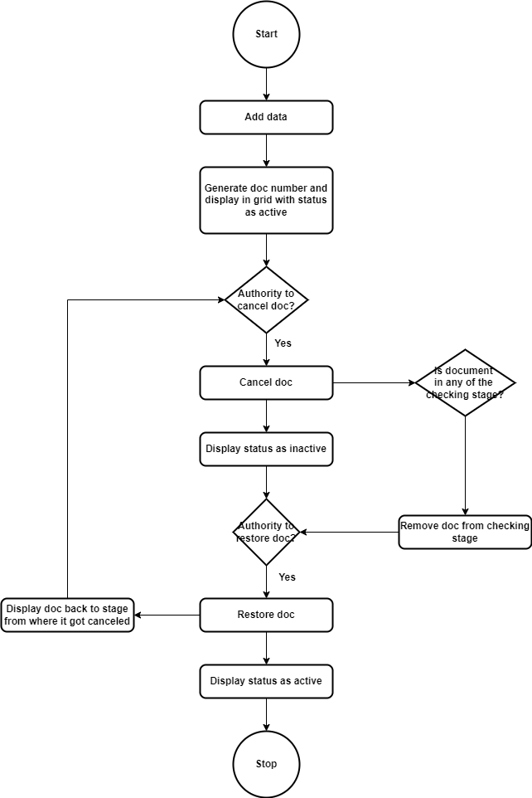

Fig: Process flow diagram

1. **PROPOSED SYSTEM**

Step 1. We have to create special authority to cancel (Material_issue_cancel_document) and restore (Material_issue_restore_document) material issue document in masters -> general -> special authority.

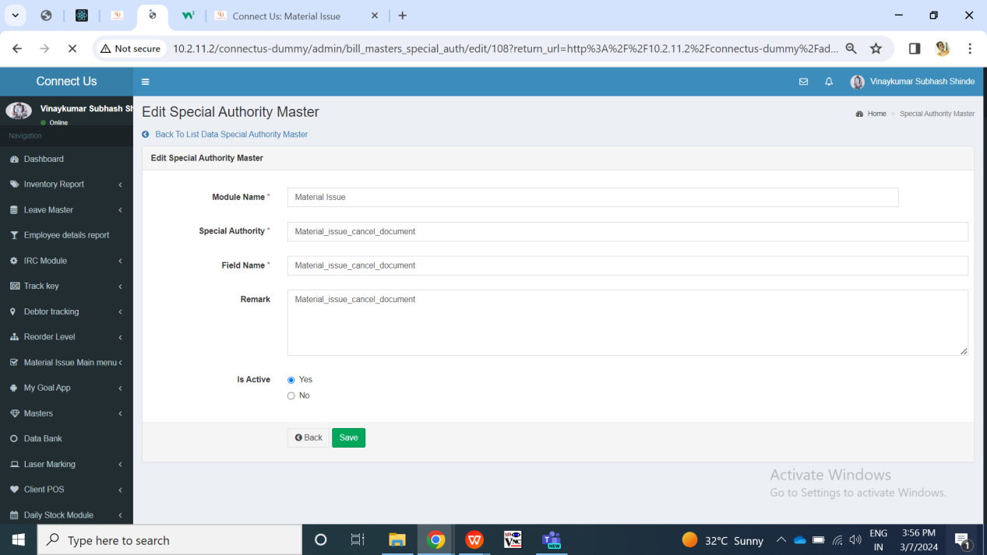

Fig: Special authority -> cancel document  
  
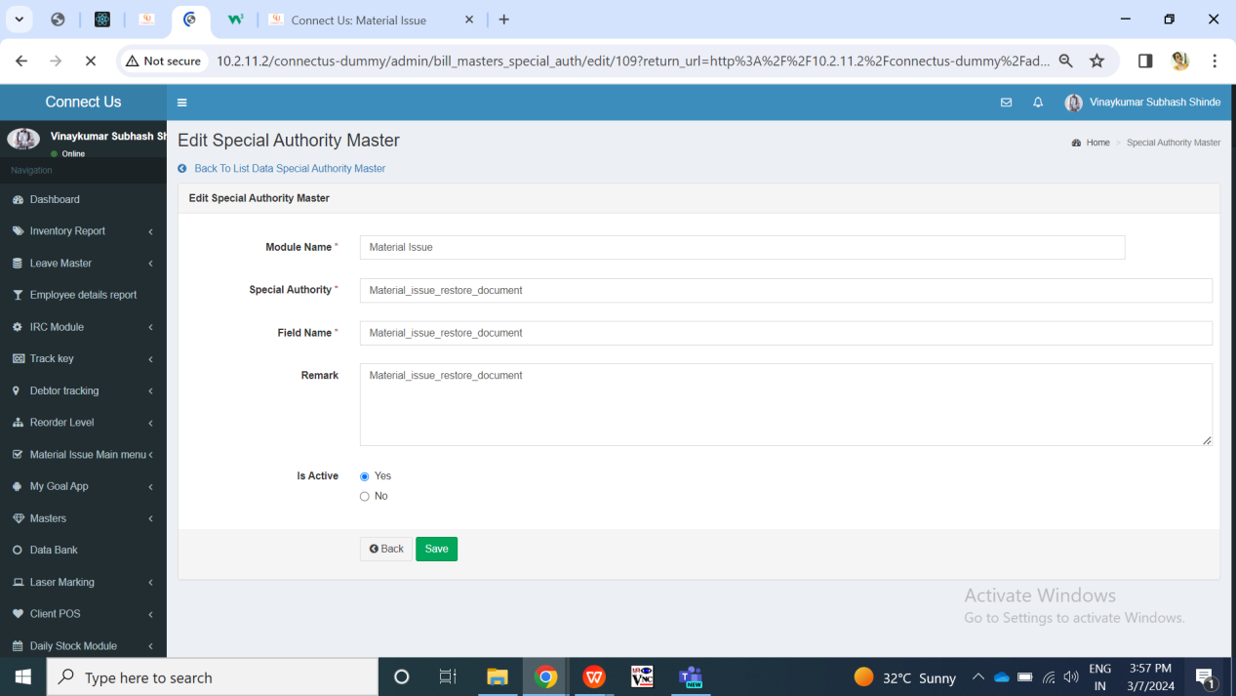

Fig: special authority -> restore document  
  
Step 2. In Connect us -> material issue main menu -> material issue, once user clicks on add data, it will display following fields:

* Issued Date
* Challan No.
* Location
* Issued Type
* Vendor
* Sub supplier
* Narration
* Remark
* Is RD purchase?
* Type of Rate
* Rate (per gram for 99.50%)
* Unfix fine rate
* Attachment
* Item Detail table
* Save button
* Back button
* Save and add more button

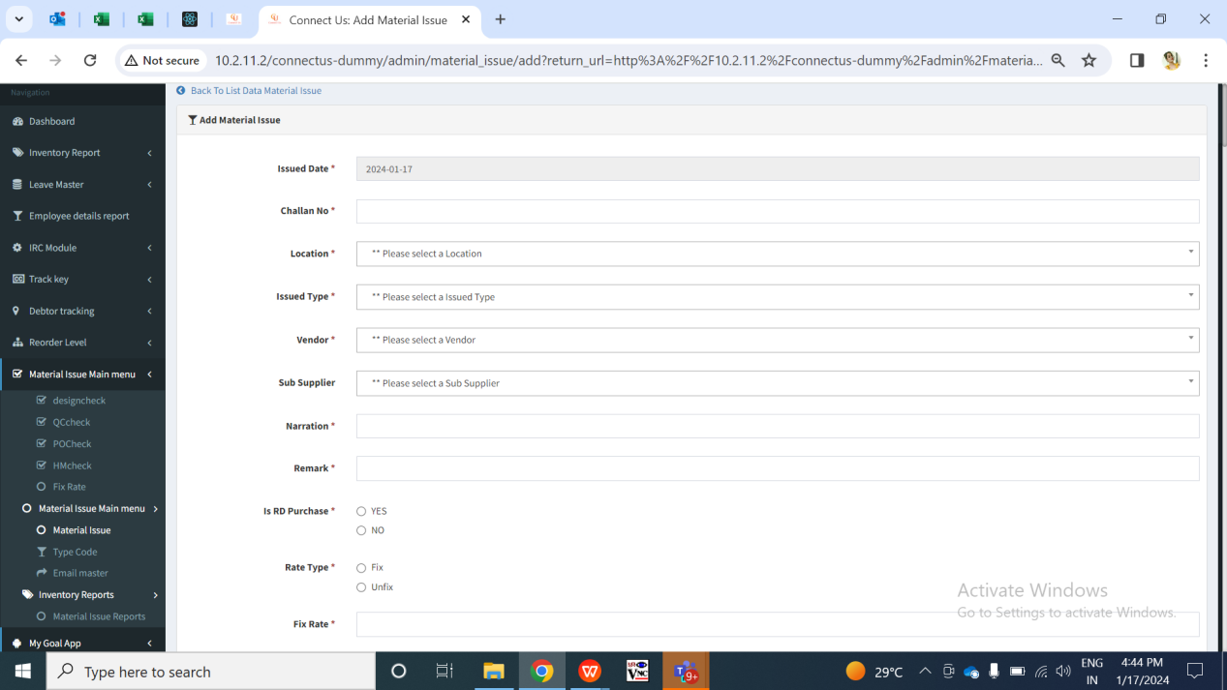

Fig: Material issue -> Add data

Once user enters items details, adds to table and clicks on submit, the doc. no. will be generated to it. It will be displayed in material issue grid. It will display following columns for each record in grid:

* Edit action
* View action
* History action
* Take print action
* Received action
* Cancel action / restore action
* Doc. no.
* Date
* Bill date
* Challan no.
* Net wt
* Location
* Vendor
* Sub supplier
* Narration
* Is rd purchase
* Rate type
* Rate for 99.50%
* Received status
* Is canceled
* Time difference

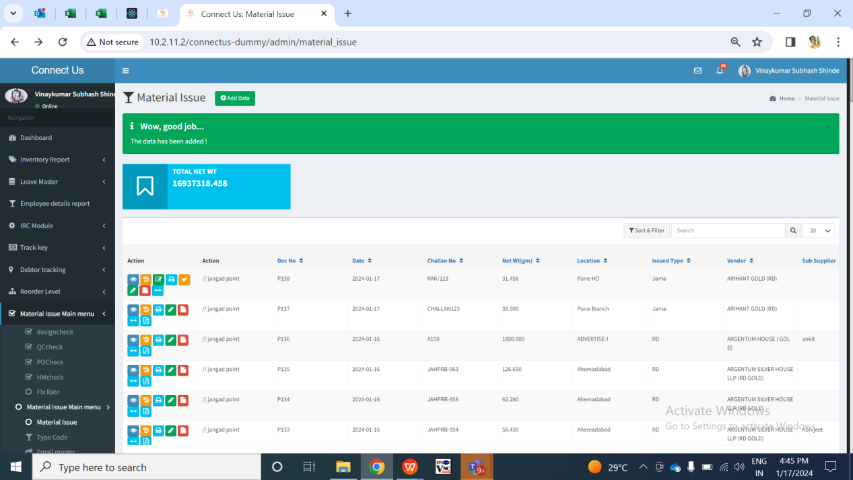

Fig: Material issue -> grid

|  |  |  |  |
| --- | --- | --- | --- |
| **FIELDS** | **INPUT TYPE** | **MANDATORY/ OPTIONAL** | **DESCRIPTION** |
| Cancel action | Click | - | Cancel button will be displayed in grid against each document only to the user having special authority.  Initially, when document is added then it will have cancel action against it. Its ‘is canceled’ status in view action and grid against that document will be no as document is active.  Further, when authorized user clicks on cancel button, the document will get canceled. Its ‘is canceled’ status will be displayed as yes in view and edit action against that document. Moreover, canceled document will be displayed in red colour in grid and it will have restore against that canceled action.  Additionally, once any document is marked as received and is in any of the checking stage, then it will be removed from that stage if authorized user cancels that document from material issue.  Further, the record of cancel will be displayed in history action of that document.  Validation: Once user clicks on cancel button, then cancel button will be removed and restore button will be displayed. |
| Restore action | Click | - | Authorized user can restore the canceled document.  Restore action will be displayed only against canceled documents. Once user clicks on restore action, its ‘is canceled’ status will be displayed as no in view action and grid. Moreover, the red colour of that document will be removed. Additionally, the restore record of that document will be displayed in history action.  Also, if any document was restored which was already into any of the stage then that document will be displayed in that stage again once restored.  Validation: Once user clicks on cancel button, then cancel button will be removed and restore button will be displayed. |

1. **TEST DATA & SCENARIOS**



1. **ODUS (Open Discussion Unhanded Scenarios)**

|  |  |  |  |  |
| --- | --- | --- | --- | --- |
| **Sr. No.** | **Topic** | **Priority** | **Remark** | **Status** |
| 1 | Gaurav Shaha: Is requirement much needed as users has to be precise while entering data. If frequency to cancel documents is more, then we can develop. Else, we need to take document numbers from user and get it canceled from database as of now. | High |  | Open |
| 2 |  |  |  |  |
| 3 |  |  |  |  |

1. **REFERENCES OF THE USERS**

|  |  |  |  |
| --- | --- | --- | --- |
| **User** | **Name** | **Mail** | **Contact number** |
| **Actual user** | Rakesh Thikane | is@csjewellers.com |  |
| **Ticket created by (if any)** | Rakesh Thikane | is@csjewellers.com |  |
| **Assigned business analyst** | Manali bhadirage | Manali.bhadirage@techneai.com |  |
| **Assigned developer** | Punam shinde | Punam.shinde@techneai.com |  |
| **Assigned tester** | Amruta kore | intern@techneai.com |  |