05.03.2023

Pending Order

Manali Ashok Bhadirage

Manali.bhadirage@techneai.com

**Handover Document**

**CONTENTS**

1. TICKET DETAILS 2

2. INTRODUCTION 2

3. BUSINESS REQUIREMENT 2

4. SCOPE 4

5. BUSINESS & SYSTEM RULES 5

6. ABBREVIATIONS & TERMS 5

7. GRAPHICAL REPRESENTATION 5

8. DEVELOPED SYSTEM 5

9. REFERENCES OF THE USERS 35

1. **TICKET DETAILS**

|  |  |
| --- | --- |
| **Ticket ID** | TT4393 & TT19541 |
| **Ticket description** | Inventory Silver Department Sathi ConnectUS Madhe New Report Create Karne Report Name :- Pending Order Check Ref By :- Vinaykumar Shinde Sir (Attachment Send In Mail)  PO phase 2 CR |
| **Created by** | Tushar Nikam  Manali Bhadirage |
| **Created on** | 22/08/2023  06/02/2024ss |
| **Priority** | Medium |

1. **INTRODUCTION**

In connect us -> inventory report user needs to create a Pending Order checking report through which user can understand the count of pcs which are given for labeling and which are pending from the Karagir side. Through reorder level report, user gets to know the count of pcs / order that is to be given to Karagir for particular SCM (item - category - weight range - size). The order of one particular SCM is divided and given to one or more karagirs. So, order number is generated for each Karagir. This is called as purchase order. Further, out of total pcs in one order given to Karagir is again divided as per delivery dates.

Example: Angathi- Fancy - 2.760-3.759 - 0 has total requirement of 40 pcs. Then this order of 40 pcs is divided and given to multiple karagirs. Like, 12 pcs order is given to Karagir A (PO1), 18 pcs order is given to Karagir B (PO2) and 10 pcs order is given to Karagir C (PO3). Further, PO1 of 12pcs can be sub-divided as per delivery date. Delivery date for 5 pcs can be set 18/05/2023 and delivery date for 7 pcs can be set 21/05/2023.

1. **BUSINESS REQUIREMENT**

|  |  |  |  |
| --- | --- | --- | --- |
| **Requirement ID** | **Requirement Name** | **Short Description** | **Priority** |
| BR001 | Upload bulk file of new order | User will upload an excel file with details as delivery date, order date, Karagir, item, category, size range, weight range, new order, Karagir weight range, knock off weight range, karagir size range. | High |
| BR002 | Bulk upload - Grid | Once excel file is uploaded with valid details, record will be displayed in grid with PO no. To it. | Medium |
| BR003 | Bulk upload - view | It will display the details which were inserted displaying the total order details which were inserted in file, count of pcs got mapped after uploading labeling file and count of canceled items. | High |
| BR004 | Bulk upload - cancel action | User will be able to cancel the items of that order by specifying reason from the drop-down list through remark master. | High |
| BR005 | Authority based actions | Uploading excel bulk file will be based on authority.  Canceling order pcs action will be based on authority.  Authority to upload labeling file. | High |
| BR006 | Upload labeling file from Padm | User will upload Padm -> labeling file. Once valid labeling file is uploaded, it will display the count of accepted pcs for that SCM and vendor in bulk upload -> view action as well as in PO report. | High |
| BR007 | Upload labeling - grid | Once valid labeling file is uploaded, it will display the record in grid as per actual jama date, invert jama date and Karagir name. | Medium |
| BR008 | PO report | As per uploaded excel file and labeling report, it will display all the orders which were given to vendor (by uploading bulk file) and the count which we have received at inventory (by uploading labeling file) and the remaining pcs count. | High |
| BR009 | Labeling report | Through labeling report, user can view list of accepted, rejected, knockoff and extra pcs. | Medium |
| BR010 | Vendor pending order | Vendor will view his own orders given by the jeweller to him with details of total pending quantity of each order number. | High |
| BR011 | Vendor pending order -> Challan | Once vendor enters the new delivery count, Challan will get generated. | High |
| BR012 | Padm vendor mapping | We have multiple vendors created with different names in vendor master as per ornament. However, it is only one vendor in Padm. Thus through vendor mapping, user will select vendor name from drop-down and mention all its possible names. This file will be when user will upload the labeling file. | High |

1. **SCOPE**

Using the PO Bulk File Order Upload menu, users can upload an Excel file containing order details to be provided to the vendor. Upon successful upload of a file with valid data, an order number will be generated, and the record will be displayed in the grid. Detailed information for each order can be viewed through the view action, and users have the option to cancel or reject specific units from the given order.

For managing the labeling process, the PO Labeling File menu allows users to upload details of units received for labeling from the vendor, indicating acceptance. Once the labeling file is uploaded, the corresponding record will be displayed in the grid. Accepted units will be marked in the view action of the PO Bulk File menu against the respective order.

To track orders given to vendors and the labeling process, details are accessible through the PO Report. This report provides information for each SCM code, including the total order given, the count of units received, the count of units accepted, and the count of canceled units. This allows users to understand the pending units for each order from the vendor.

In situations where extra units are received from the vendor, users can manage them by accepting or returning them through the PO Adjust Report menu. This provides a comprehensive system for handling various aspects of order management and ensures effective communication with vendors.

Another part of this includes Vendor Pending order. When bulk upload order is uploaded then given orders will be displayed to that vendor. Vendor will log into the system, view the received orders, enter the quantity which vendor is delivering, generate challan for it and accordingly qty of each order will get displayed in PO report as well.

1. **BUSINESS & SYSTEM RULES**

* User will be registered in the system.
* User will be logged in.
* System will pop up a message, if any issues in the system is detected.
* Updated details in PO report and adjust report will be displayed once user uploads order and/or labeling file and then it will be removed from grid.

1. **ABBREVIATIONS & TERMS**

PO - Pending Order

SCM code- item, category, weight range, size range, purity range

Wt - weight

Qty - quantity

1. **GRAPHICAL REPRESENTATION**

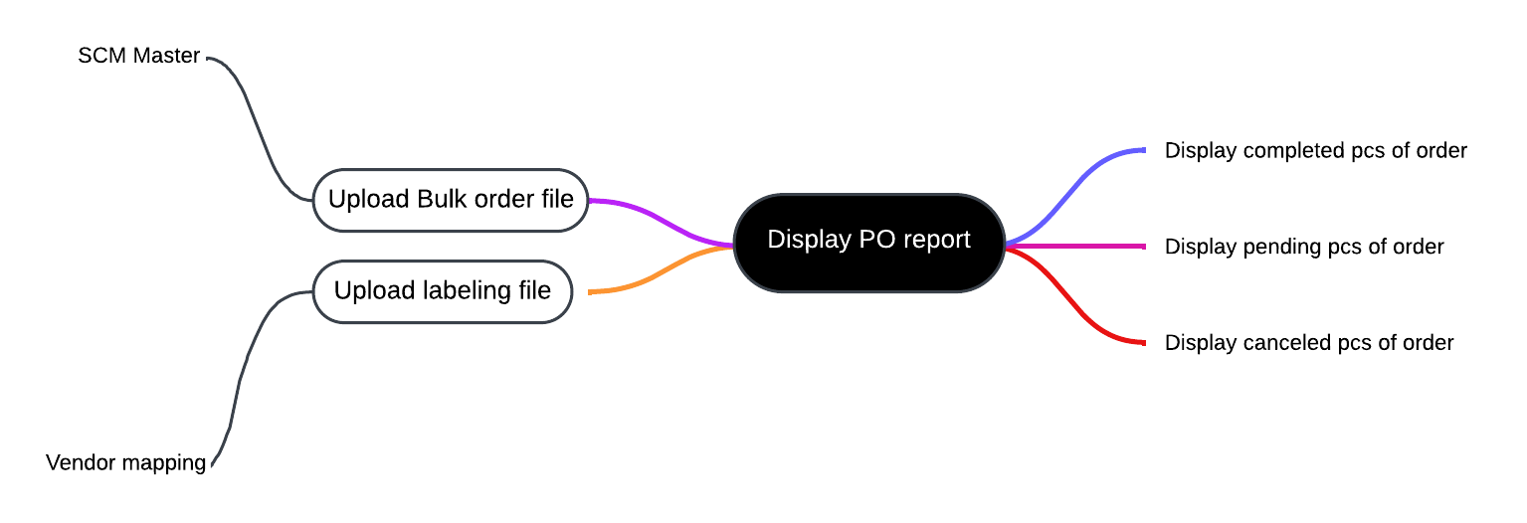

Fig: Mind map

1. **DEVELOPED SYSTEM**

Previously, all work of labeling pcs and new order is done on excel manually and using Vlookup formulas they get the count of pending pcs.

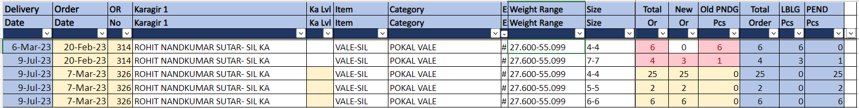

Fig: PO report (manual excel)

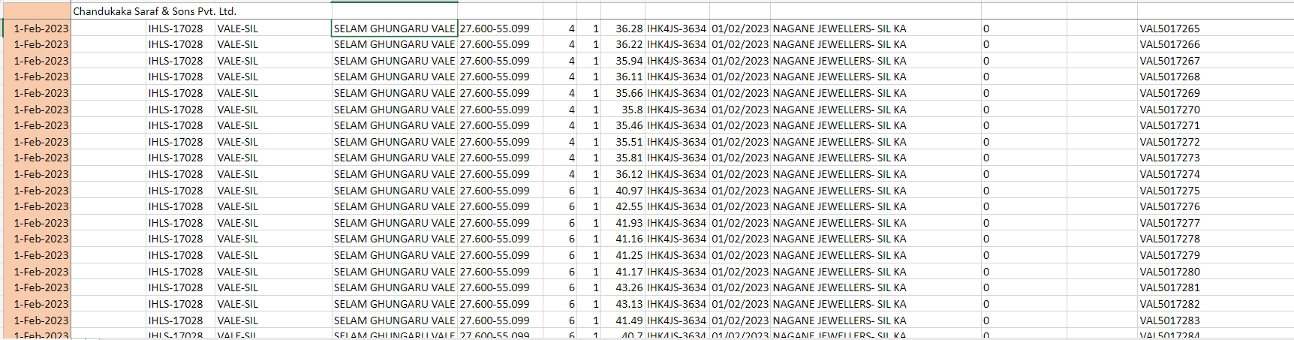

Fig: labeling pcs sheet

In Connect us, we have created pending order as main menu which will have bulk upload, labeling file upload, PO report, labeling report and vendor PO modules in it.

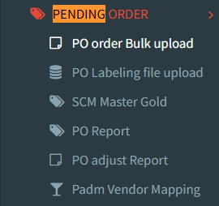

**Step 1. PO BULK FILE UPLOAD**

Through pending order user will upload the excel file which contains the details of orders that is given for Karagirs as per SCM code. It will have following fields:

* Download bulk format
* Upload bulk file
* View action
* History action
* PO date
* PO no.
* Karagir
* Total order pcs
* Created at
* Created by
* Updated at
* Updated by

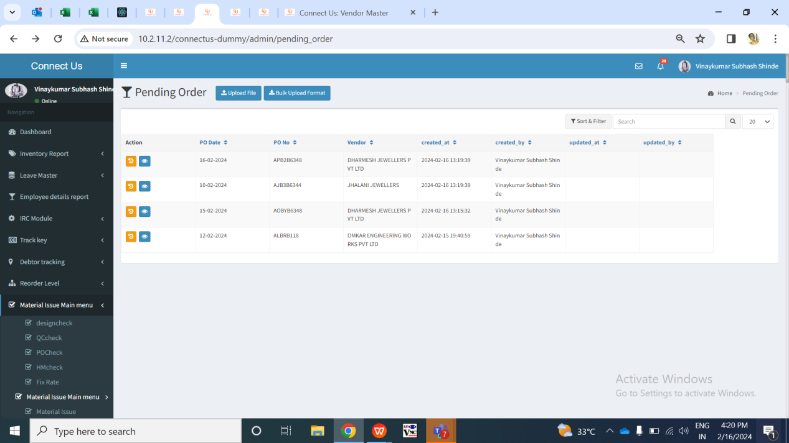

Fig: PO Bulk upload menu -> grid

User will have to first download the bulk format file. Once user clicks on bulk upload format, excel file will get downloaded which will have following columns:

* Delivery date
* Order date
* Karagir
* Item
* Category
* Size range
* Weight range
* Exact wt
* Purity range
* New order
* Karagir weight range
* Knockoff weight range
* Karagir size range

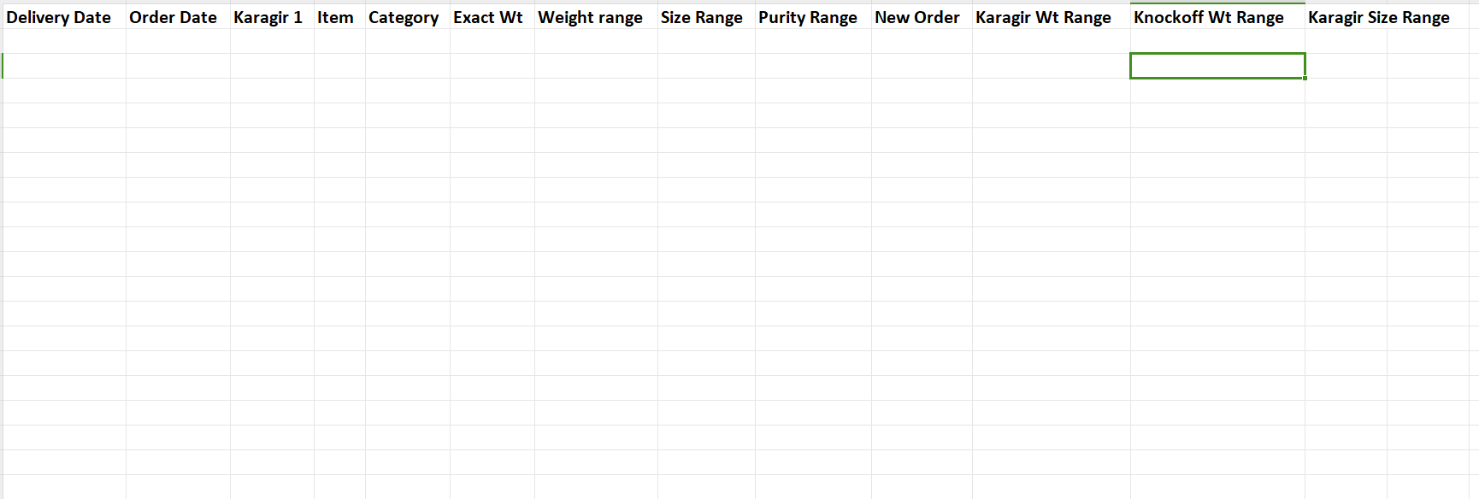

Fig: PO Bulk upload menu -> Download bulk format

|  |  |  |  |  |
| --- | --- | --- | --- | --- |
| **FIELDS** | **INPUT TYPE** | **MANDATORY/ OPTIONAL** | **EDITABLE** | **DESCRIPTION** |
| Delivery Date | Text | Yes | No | User will enter the delivery date on which the order is expected to be delivered by the vendor at inventory.  Validation: Delivery date will and order date can be same. Its format in excel file will be MM/DD/YYYY or DD-first three letters of month-YY. Its format should be as ‘Date’ in excel and not text. |
| Order date | Text | Mandatory | No | User will enter the date on which the order is given to the vendor for that SCM code.  Validations: Delivery date will and order date can be same. Its format in excel file will be MM/DD/YYYY or DD-first three letters of month-YY. Its format should be as ‘Date’ in excel and not text. |
| Karagir | Text | Mandatory | No | User will enter the name of the vendor to whom this order is given.  Validation: It will accept exact name from connect us -> bill checking -> vendor master which are active only. |
| Item | Text | Mandatory | No | User will mention item name from the SCM master gold. |
| Category | Text | Mandatory | No | User will mention category name from the SCM master gold for that item. |
| Exact wt | Text | Mandatory | No | User will mention the exact wt of the item - category which will be between mentioned weight range only. |
| Weight range | Text | Mandatory | No | User will mention weight range from the SCM master gold for that item -category. |
| Size range | Text | Mandatory | No | User will mention size range from the SCM master gold for that item -category. |
| Purity range | Text | Mandatory | No | User will mention purity range from the SCM master gold for that item - category. As SCM code is combination of item-category-weight range - size range - purity rnage, if user enters any of these values and there is not SCM code then it will display error for that record. |
| New order | Text | Mandatory | No | User will mention the pcs count for which are to be ordered from the vendor for that SCM code. |
| Karagir wt range | Text | Mandatory | No | User will enter the Karagir wt range that that means weight range as per karagir’s record.  Validation: Karagir wt range can be different from weight range column but Karagir wt range has to be between or equal to mentioned weight range only. |
| Knockoff wt range | Text | Mandatory | No | User will mention the weight range against which we have to map the pcs with net wt field of labeling file once uploaded.  Validation: Knockoff wt range can be different from weight range column but knock off wt range has to be between or equal to mentioned weight range only. |
| Karagir size range | Text | Mandatory | No | User will enter the karagir size range for that item - category.  Validation: karagir size wt range can be different from SCM size range column but karagir size range has to be between or equal to mentioned SCM size range only. |

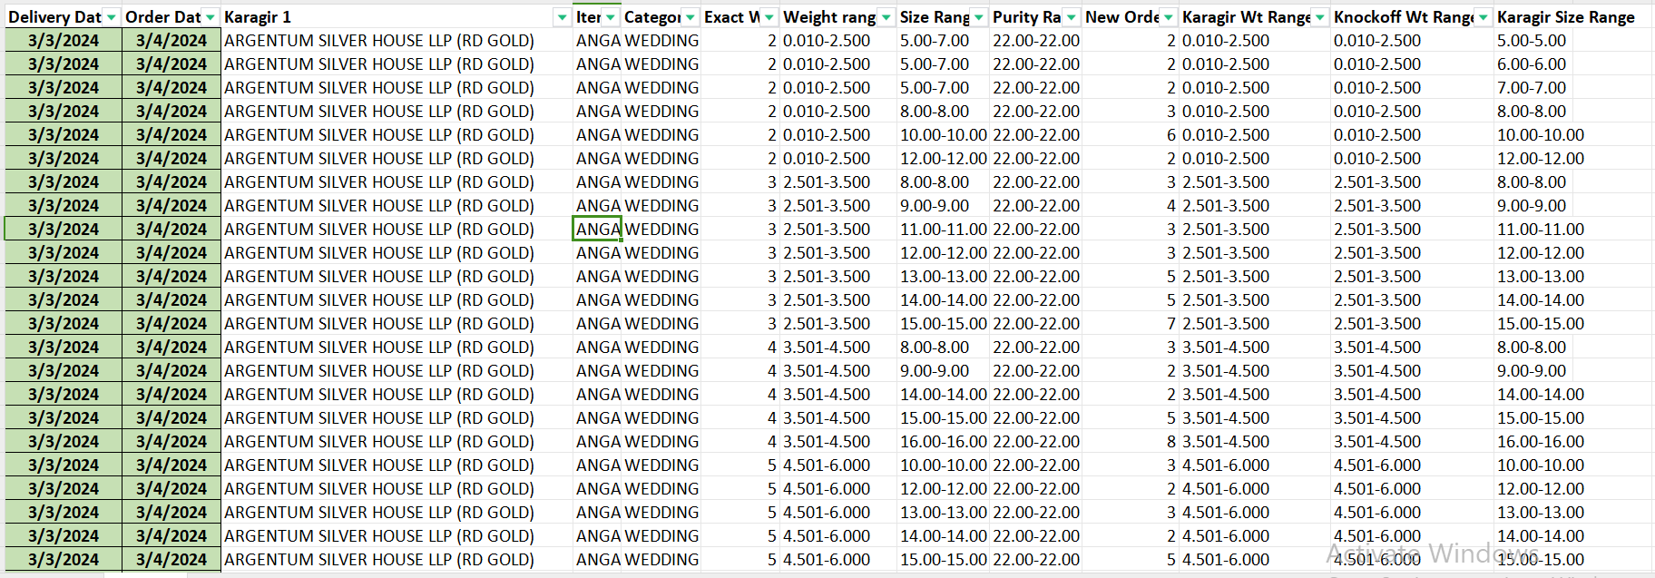

Fig: PO Bulk Upload file

Once user uploads the bulk order file through upload button and clicks on submit button, submit button will be disabled until successful or error message gets displayed.

In case any of the data in uploaded bulk file is incorrect, error will be displayed. User can download the error file in which error message will be displayed against each incorrect record. None of the data will get uploaded if any single data is invalid in bulk file. Duplicate record of entire same same cannot be added. Bulk will upload data only if it has all correct details in it.

Once file is uploaded, then the collated data will be displayed as per Order date, order no and Karagir name in the grid. The record of that uploaded file I.e. that upload activity only will be displayed in grid whereas will be removed when user explores to another men. PO Bulk upload menu will have following columns on grid:

* PO date
* Delivery date
* Order number
* Vendor name
* Total Order pcs
* Created at
* Created by
* Updated at
* Updated by

|  |  |  |  |  |
| --- | --- | --- | --- | --- |
| **FIELDS** | **INPUT TYPE** | **MANDATORY/ OPTIONAL** | **EDITABLE** | **DESCRIPTION** |
| PO Date | Text | Mandatory | No | It will display the order date from the bulk file.  Validation: It will be displayed in MM/DD/YYYY format. |
| Delivery date | Text | Mandatory | No | It will display the delivery date of that order from the bulk file.  Validation: It will be displayed in MM/DD/YYYY format. |
| Order number | text | Mandatory | no | Once bulk file is uploaded, order no. will be generated by the system.   * First letter for financial year code (A for 2023-24 and there onwards) * Second character stands for order date (A to Z for dates 1 to 26 and then numbers 1 to 5 for dates from 27 to 31) * Third character stands for order date -> month ( A to L means from jan to dec) * Fourth character stands for delivery date (A to Z for dates 1 to 26 and then numbers 1 to 5 for dates from 27 to 31) * Fifth character stands for delivery date -> month ( A to L means from jan to dec) * Sixth onwards will be vendor code from database |
| Vendor name | Text | Mandatory | No | It will display the Karagir name which was mentioned in the uploaded bulk file for that record. |
| Total order pcs | Text | Mandatory | No | It will display the count of total pcs under that order once user uploads the bulk upload file. |
| Created by | Text | Mandatory | No | It will display the name of the employee who created this record by uploading the bulk file. |
| Created at | Text | Mandatory | No | It will display the date and time on which the record was created in the grid by uploading bulk file. |
| Updated by | Text | Mandatory | No | It will display the employee name once user updates the record either by canceling the pcs of that order through view and by uploading new order under it. |
| Updated at | Text | Mandatory | No | It will display the date and time on which the record was updated by uploading bulk file. |

For each new order, if scm code and Karagir name is same, then the new order pcs will get added in the same existing order if delivery date is not different.

Once data is uploaded, successful message will be displayed and data will be displayed in the grid for one time. If user re-uploads new data, then newly uploaded data will be displayed in grid and previous one will not be displayed. If user visits on another menu, then the grid data of PO bulk upload will be removed as it is one time activity.

As header includes PO order number, PO date and vendor number, view action will display order details of each SCM code in that order. Through **view action** of each PO, details of that order will be displayed as below:

* PO date
* PO no.
* Vendor name
* PO Order details Table
* Item
* Category
* Weight range
* Size range
* Purity range
* Delivery Date
* Total Order
* Accepted Quantity
* Canceled quantity
* Canceled pcs count
* Cancel action
* Table of canceled details

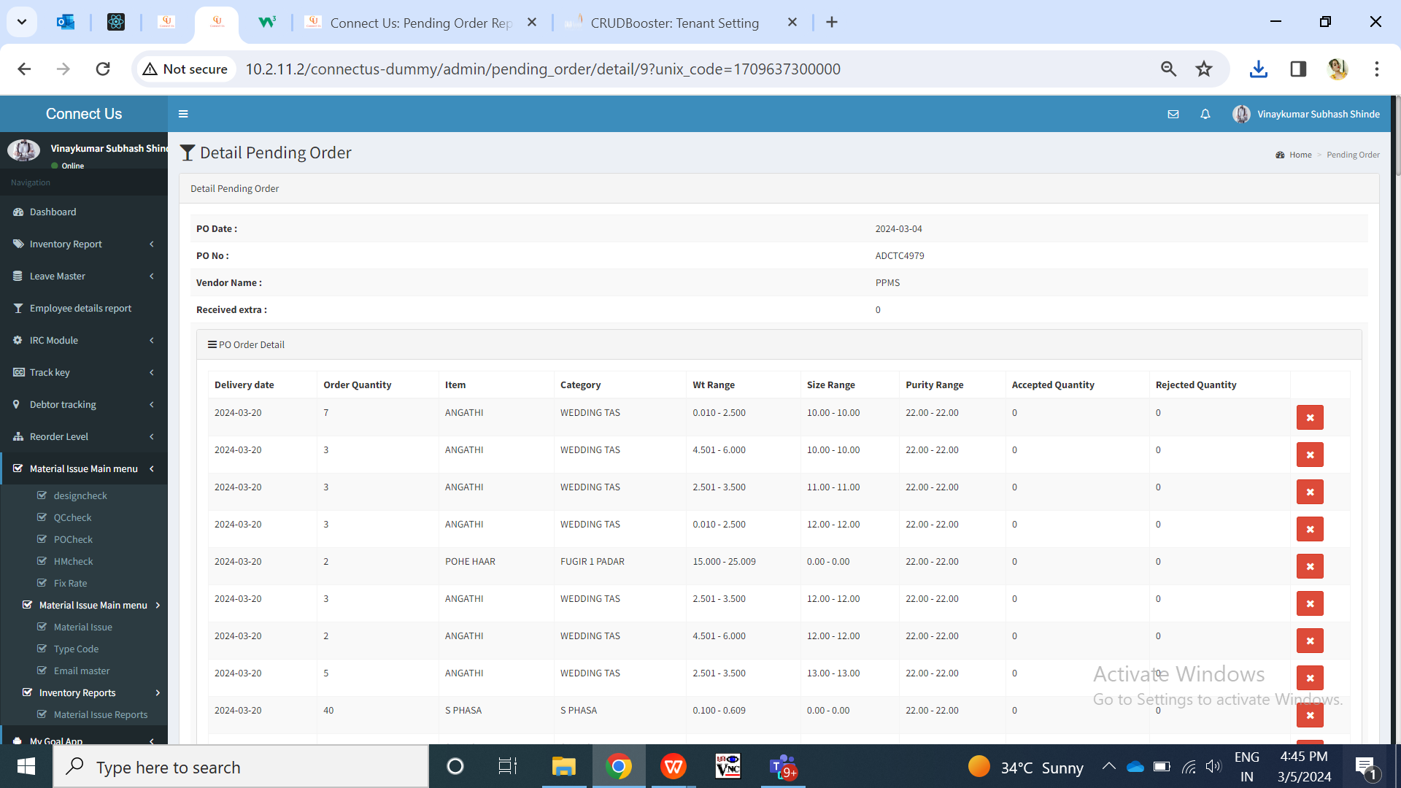

Fig: PO Bulk upload file menu -> view action

|  |  |  |  |  |
| --- | --- | --- | --- | --- |
| **FIELD** | **INPUT TYPE** | **MANDATORY** | **EDITABLE** | **DESCRIPTION** |
| PO Date | Text | Yes | No | It will display the order date of that order which will as same as in grid as per uploaded bulk order file. |
| PO number | Text | Yes | No | It will display the order number for that record as same as in grid. |
| Vendor name | Text | Yes | No | It will display the karagir name of that order as per grid and uploaded bulk order file. |
| PO Order details table | Text | Yes | No | It will display the order details of each SCM code under that order. It will display following columns and details as per uploaded order file in each row:   * Item * Category * Weight range * Size range * Purity range * Delivery Date * Total Order * Accepted Quantity * Canceled quantity * Canceled pcs count * Cancel action |
| Delivery Date | Text | Yes | No | It will display the delivery date of the order given to vendor for that particular SCM code(item-category-size range-weight range-purity range). It will displayed as per uploaded bulk order file.  Validation; Its format will be MM/DD/YYYY. |
| Count of total pcs ordered | Text | Yes | No | It will display the count of total pcs of order that has been given to Karagir for that SCM code and delivery date. It will be displayed as per uploaded bulk order excel file. |
| Accepted pcs | Text | Yes | No | Once pcs are being received from the Karagir and labeling is done, then it will be considered as accepted for that SCM code from vendor. As and when the labeling file is uploaded (step 3) for SCM code and Karagir, the accepted pcs count will get updated here. |
| Canceled pcs | Text | Yes | No | It will display the total pcs of order that have been canceled by the authorized user through cancel action. |
| Cancel action button | Click | - | - | This button will be provided based on authority.  Through cancel action, authorized user can cancel the entire order or few pcs from the order that has already been given to vendor. Once authorized user clicks on cancel button, it will display below fields:   * Cancel pcs count * Cancel reason * Confirm button       Cancel count will be text field where user will mention the number of pcs that has to be canceled. If total order count = total accepted count, that means all pcs have been received and labeled. Then in such case, “cancel action button” will be disabled. Also, user will be able to cancel pcs out of total pcs ordered only.  Cancel reason - Reasons on drop-down list of ‘cancellation reason’ will be specified from daily stock remark master-> active reasons. It will be mandatory and single select.  Once user clicks on submit button, dialogue box will be displayed as “Are you sure you want to cancel?” Once user clicks yes, then the count of canceled pcs will be displayed in ‘canceled pcs’ field.  Canceled pcs count will get deducted from the total pcs orders and accordingly pending pcs count will be displayed in PO report. User can cancel the item pcs out of total order pcs only. However, if user has canceled any pcs and still those are being received and uploaded in PO labeling I.e user definable report then those canceled pcs will be considered as extra and will be displayed in labeling report. |
| Table of canceled details | Text | - | No | It will display details of canceled pcs in table having following columns:   * Delivery date * Order quantity * Canceled quantity * Reason * Canceled by * Canceled date and time |

**Step 2. Padm Vendor Mapping**

As there are multiple vendor names in vendor master for the same vendor name. We need to map the different vendor names with Padm vendor name. When user will upload the labeling file, it will check the supplier name of the labeling file with vendor name in this master and then updated the pcs accordingly in PO report and PO bulk file menu -> view against against that order.

Padm Vendor mapping will have following fields:

* Add button
* View button
* Edit button
* Vendor name
* Padm vendor name
* Is active
* Remark
* Created at
* Created by
* Updated at
* Updated by

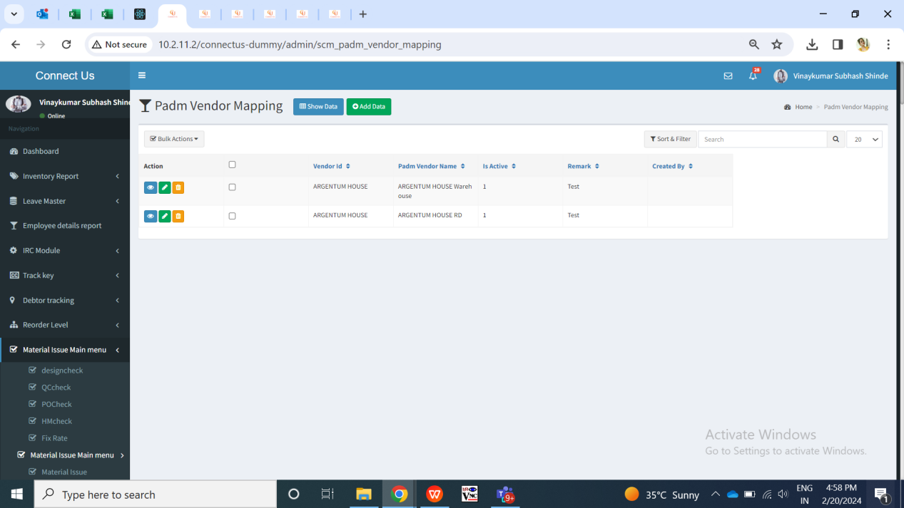

Fig: Padm vendor mapping -> grid

|  |  |  |  |  |
| --- | --- | --- | --- | --- |
| **FIELD** | **INPUT TYPE** | **MANDATORY** | **EDITABLE** | **DESCRIPTION** |
| Vendor name | Drop down | Yes | Yes | User will select the vendor against which the Padm name is to e mentioned which will get checked when labeling file is uploaded. It will display the list of vendors from bill checking -> vendor master.  Validation: It will be single select. |
| Padm vendor name | Text | Yes | Yes | User will mention the Padm names for that vendor here.  Validation: It has to be unique for same vendor else it will display error message as ‘record already exists’.  Min length = 5  Max length = 50 |
| Is active | Radio button | Yes | Yes | If the user selects it as active, then it will consider and map the order correctly with the Padm vendor name mentioned. If this is inactive, then labeling file will display error when user will upload the data of inactive Padm vendor name.  Validation: it will be single select. Default value will be yes. |
| Remark | Text | Optional | Yes | User will mention the additional comments here if required.  Validation: It will accept characters, numbers, space and special characters.  Min length = 0  Max length = 250 |
| Save | Click | - | - | Once user enters data in mandatory fields and clicks on save button, Padm vendor name will get saved for that vendor. |

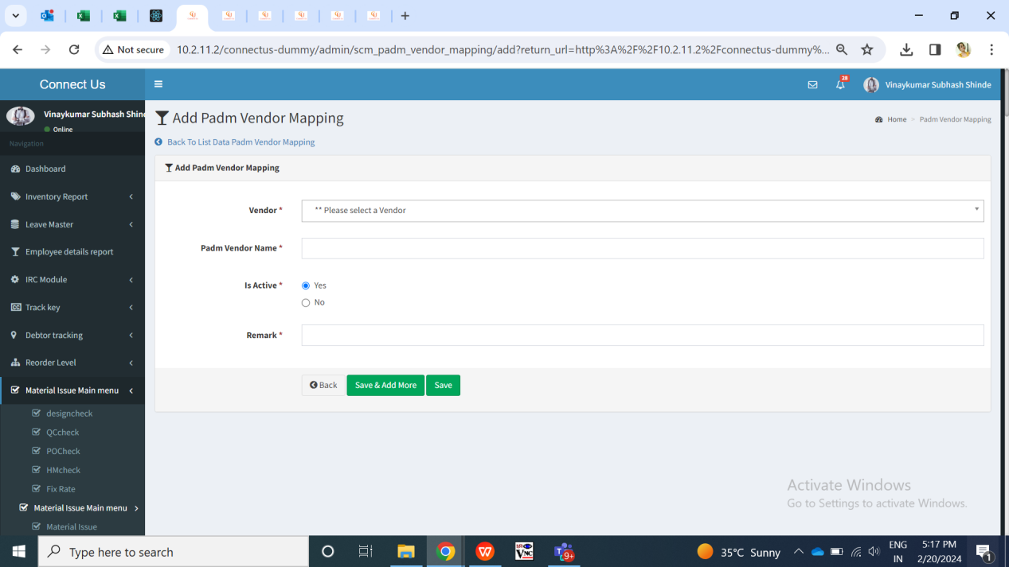

Fig: Padm vendor name menu -> add

View action of Padm vendor mapping menu will have following fields:

* Vendor name
* Padm vendor name
* Is active
* Remark
* Created at
* Created by
* Updated at
* Updated by

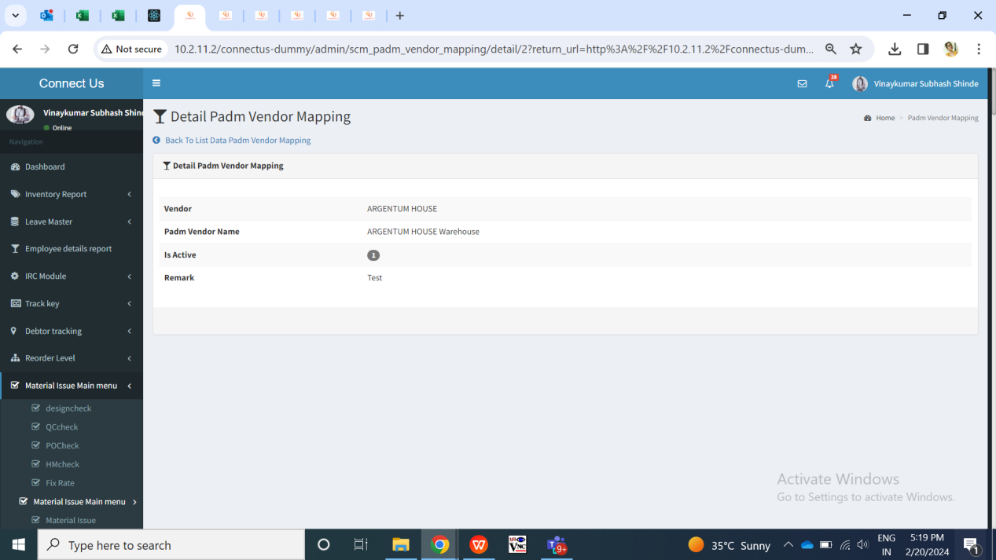

Fig: Padm vendor mapping -> view action

**Step 3. PO LABELING FILE UPLOAD**

Note: This is not deployed on live yet and will be done soon.

User will upload the labeling file from Padm which means the stock which has been received from vendor and has been labeled at our inventory. Once user uploads labeling file through ‘upload’ action and clicks on submit button, submit button will be disabled until file gets uploaded successfully or until error message is displayed. Once the file is uploaded, then it will check the labeling pcs code and vendor details by considering net wt of labeling file with knockoff wt range of bulk uploaded file and then display accepted pcs in PO report and bulk upload menu -> view action of that order.

**Step 4. PO REPORT**

In PO report, it will display following fields:

* From Order date
* To Order date
* From delivery date
* To delivery date
* Vendor name
* Item
* Category
* Size range
* Weight range
* Filter button
* Reset button
* Export button

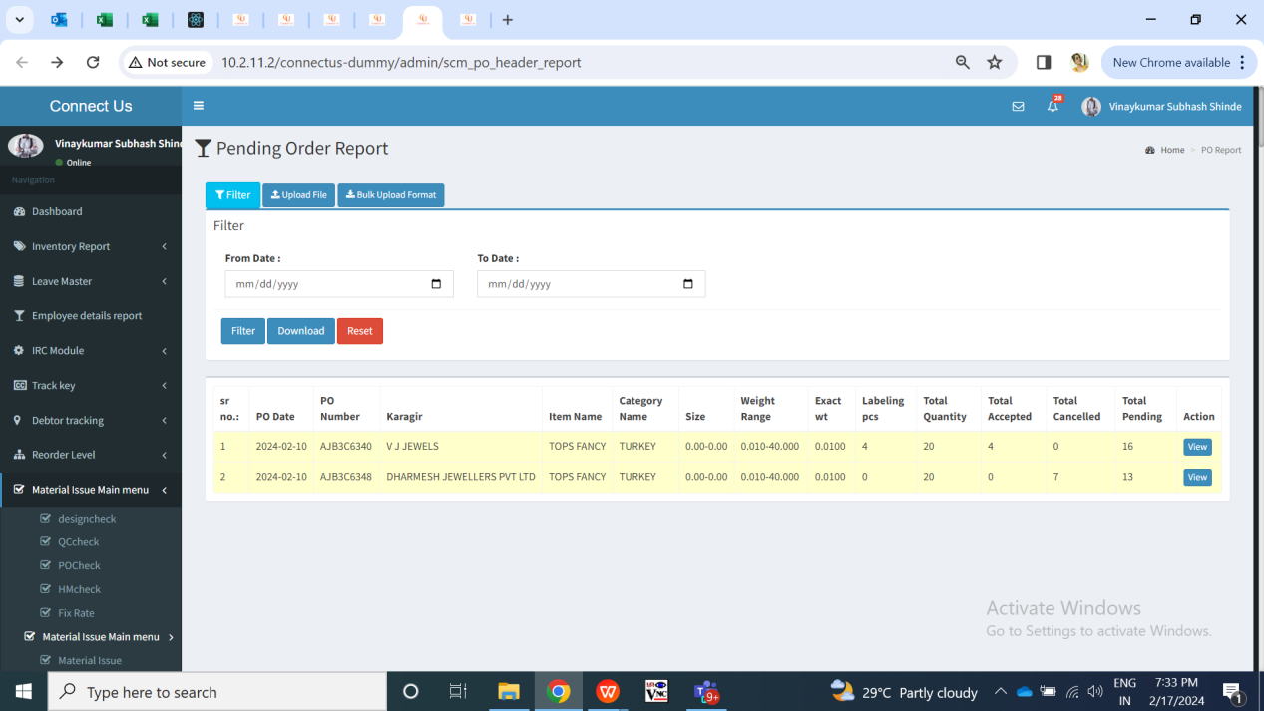

Fig: PO report menu

|  |  |  |  |
| --- | --- | --- | --- |
| **FIELDS** | **INPUT TYPE** | **MANDATORY/ OPTIONAL** | **DESCRIPTION** |
| From Order Date | Calender picker | Optional | User will select the order date from which the report is to be extracted.  Validation: It will be single select. It will accept back dates as well as future dates. |
| To Order Date | Calender picker | Optional | User will select the order date till which the report is to be extracted.  Validation: It will be single select. It will accept back dates as well as future dates. It will disable the dates before selected ‘from order date’. |
| From Delivery date | Calender picker | Optional | User will select the delivery date from which the orders will be displayed in report.  Validation: It will be single select. It will accept back dates as well as future dates. |
| To Delivery date | Calender picker | Optional | User will select the delivery date till which the orders will be displayed in report.  Validation: It will be single select. It will accept back dates as well as future dates. It will disable the dates before selected ‘from order date’. |
| Vendor name | Drop-down | Optional | User can search the orders by selecting specific vendor here.  Validation: It will display vendors in the list from Bill checking -> vendor master. It will be multi-select. It will disable already selected vendor from the drop-down list. |
| Item | Drop-down | Optional | It will display the list of items in the drop-down list which are active and updated through scm master gold.  Validation: It will be single select. |
| Category | Drop-down | Optional | It will display the list of categories in the drop-down list which are active and updated through scm master gold.  Validation: It will be single select. |
| Size range | Drop-down | Optional | It will display the list of size ranges in the drop-down list which are active and updated through scm master gold.  Validation: It will be single select. |
| Weight range | Drop-down | Optional | It will display the list of weight range in the drop-down list which are updated through scm master gold.  Validation: It will be single select. |
| Filter | Click | - | Once user clicks on filter button, the report will be displayed in grid and export button will be displayed.  Report will display the details of each vendor, order and SCM code. It will have following columns:   * Sr no. * Order no. * Order date * Delivery date * Karagir * Item * Category * Wt range * Size range * Purity range * Total order * Accepted pcs * Canceled pcs * WIP Pcs * Pending pcs   Order number can be same in the rows with different SCM code in each individual row and its order pcs details.  Through view action, user will be directed to view page of bulk file upload menu of that order. |
| Export | Click |  | Export button will be display after user clicks on filter and data will be displayed.  Once user clicks on export button, excel file will be downloaded displaying data in following columns:   * Sr no. * Order no. * Order date * Delivery date * Karagir * Item * Category * Wt range * Size range * Purity range * Total order * Accepted pcs * Canceled pcs * Pending pcs   Downloaded excel file name will be PO report followed by date. |

Each time when labeling file is uploaded, the PO report will display updated data. It will display all the list of orders which are given to vendors with SCM code, total pcs count of order, total accepted means received pcs count, total pending pcs count means which are not received to labeling yet.

|  |  |
| --- | --- |
| **FIELDS** | **DESCRIPTION** |
| Order no. | It will display the order as mentioned in excel file. |
| Order date | It will display the order no. From PO bulk upload menu when bulk file of order was uploaded. |
| Karagir | It will be displayed as mentioned in uploaded excel file for order. |
| Item - category - wt range - size range - purity range | It will be displayed as mentioned in uploaded excel file for order of that order no. |
| Total order | It will display the total order for that order no. Which was uploaded through bulk file. It will also be displayed same in view action of bulk file menu of that order no. |
| accepted pcs | It will display labeling pcs count as per labeling file uploaded in PO labeling menu. |
| Canceled pcs | As and when pcs are canceled by the user through cancel action on bulk upload file menu, it will display cancel pcs count here for that order. |
| WIP pcs | It will display the pcs which are sent by the vendor but have not received for labeling yet. It will be displayed from Vendor Challan. |
| **Pending pcs** | **Total Order - Labeling Order - Canceled Pcs - (WIP - Accepted) = Pending pcs**  **From these pending pcs, the inventory team and authorized person can analyse pending order of scm code with its karagir and can further assign new orders to another karagir, take follow ups of pending pcs from karagir, etc.** |

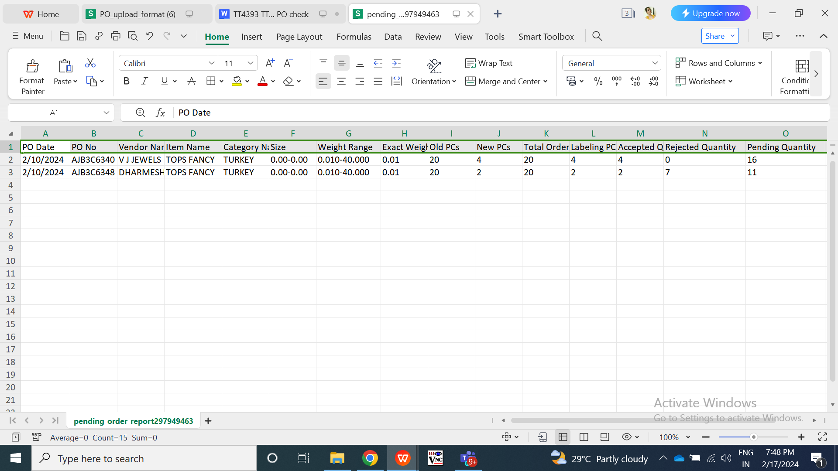

Fig: PO report -> download

**Step 5. PO ADJUST REPORT**

Note: This is not deployed on live yet and will be done during labeling phase.

PO Adjust report will display the count of pcs that are extra, that are accepted means mapped / knocked off with order by uploading labeling file and pcs that are returned to vendor in case of extra.

**Step 6. VENDOR PO**

Vendor can log into the system and view the total orders and its quantities they have received from the jeweller. Vendor can also enter the quantity of each order which they are delivering and thus generate Challan for it.

We are creating user in user management for vendor, link with credentials will be sent to the vendor via email and privilege of that user (vendor) will be displayed as Purchase System Vendor in user management. For Purchase system vendor privilege, employee name field will be super-admin as we have created credentials for the vendor.

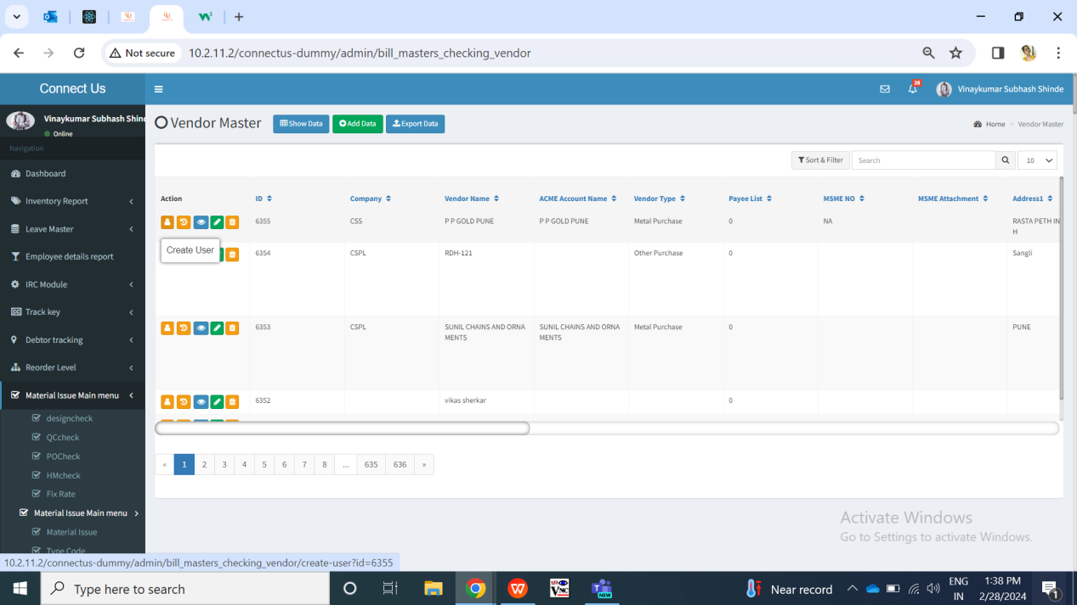

Fig: Vendor master

Orders of recent delivery date will be displayed on top. Once vendor logs in and clicks on Vendor PO menu, it will display following fields:

* Search bar
* Export button
* Challan History button
* Order details
* Sr. No.
* PO number
* Delivery Date
* Item
* Category
* Karagir weight range
* Karagir size range
* Size range
* Purity range
* New Delivery
* Balance quantity
* Submit button

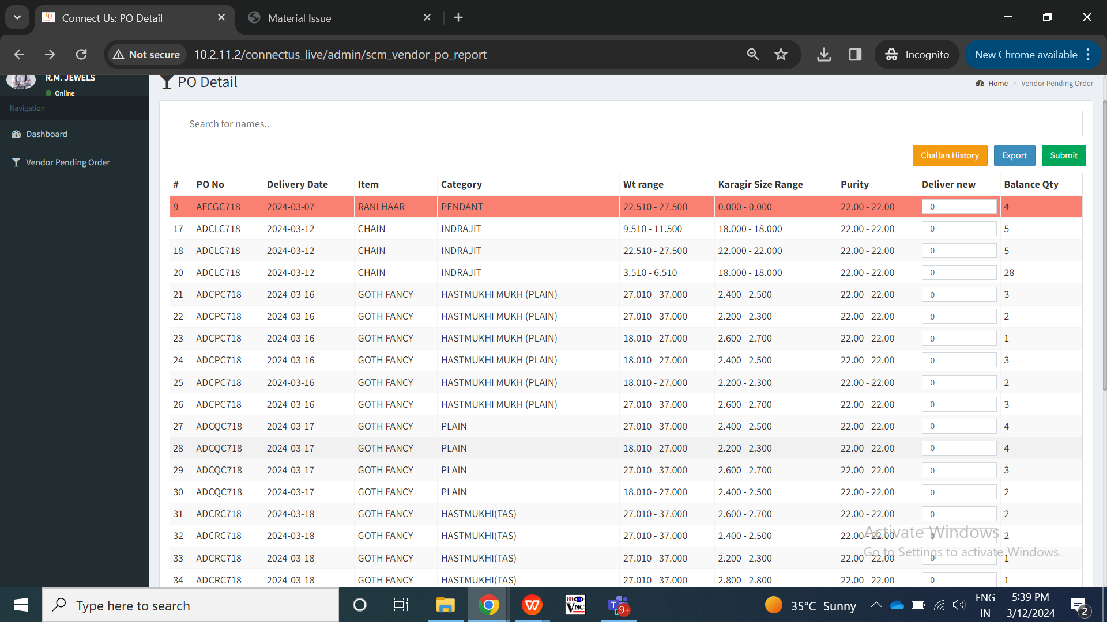

Fig: Vendor PO -> grid

Here, it will display the list of orders given by the jeweller to this vendor. It will display the order number and its SCM code details along with total pcs which are to be delivered to jeweller by the vendor.

|  |  |  |  |
| --- | --- | --- | --- |
| **FIELDS** | **INPUT TYPE** | **MANDATORY/ OPTIONAL** | **DESCRIPTION** |
| Search bar | text | Optional | Vendor can search the order by PO number, delivery date, item, category, wt range, size range, purity range, balance qty.  Once vendor enters any details, it will display the exact match records in the grid.  Validation: By default search field will be blank and will display all orders in the grid.  Min length = 0  Max length = 100 |
| Export button | Click | - | Vendor can download the orders details which are available in grid I.e. the orders given to that vendor.  Once vendor clicks on export button, csv file will get downloaded which will have following columns displaying the data as in grid:   * Sr. No. * Po no. * Delivery date * Item * Category * Karagir wt range * Karagir size range * Purity range * Delivery qty   Validation: It will be disabled until exported file gets downloaded. |
| Challan History | Click | - | Vendor can view the Challan which they have generated till now. Vendor can download the Challan again in new tab.  As and when vendor generates new Challan, it will be displayed in top row of Challan history as well.  It will have following fields of generated columns in grid:   * Challan no. * Download button * Created at     Challan no - It will display the Challan no. Which is displayed in generated Challan.  Download button - Vendor can download the Challan multiple times anytime by clicking on it. Once vendor clicks on download button, Challan will get generated in new tab which will be the same which was generated when vendor entered the new delivery count and clicked on submit.  Created at - It will display the date and time when that Challan was generated. |
| Delivery Date | Text | Mandatory | It will display the delivery date of that order for that particular SCM code mentioned by the jeweller in uploaded bulk order file through their own end.  Records for which the delivery date has passed, those orders will be displayed in red colour in grid.  Validation: It will be read only. |
| Item | Text | Mandatory | It will display the item name of that order number as uploaded by the jeweller from their own end through bulk order upload menu. If there are multiple different items under that order number, then it will display all those items in each row with order number as same against it.  Validation: It will be read only. |
| Category | Text | Mandatory | It will display the category name of that order number and item as uploaded by the jeweller from their own end through bulk order upload menu. If there are multiple different items under that order number, then it will display all those categories in each row with same order number against it.  Validation: It will be read only. |
| Karagir weight range | Text | Mandatory | It will display the Karagir weight range of that order number and SCM which was mentioned by the jeweller while uploading the bulk order file from their end.  Validation: It will be read only. |
| Karagir size range | Text | Mandatory | It will display the karagir size range of that order number and SCM which was mentioned by the jeweller while uploading the bulk order file from their end.  Validation: It will be read only. |
| Size range | Text | Mandatory | It will display the size range of that order number and SCM which was mentioned by the jeweller while uploading the bulk order file from their end.  Validation: It will be read only. |
| Purity range | Text | Mandatory | It will display the purity range of that order number and SCM which was mentioned by the jeweller while uploading the bulk order file from their end.  Validation: It will be read only. |
| Deliver new | Text | Mandatory | Vendor will enter the pcs of that particular order which vendor is delivering to the jeweller. This will be also be considered as WIP qty.  Once user enters deliver new qty for rows and clicks on submit button, Challan will get generated displaying order details.  Validation: Default value will be 0. It will accept digits only. It will not be more than Balance qty. |
| Balance qty | Text | Mandatory | It will display the total qty of that order and SCM which is pending and to be delivered by the vendor to jeweller.  Balance Qty = Order quantity - (accepted + Rejected) - WIP  Order details will be removed from the grid once balance qty = 0.  Validation: It will be read only. |
| Submit | Click | - | User will enter the deliver new qty and click on submit button to generate Challan.  If user enters incorrect delivery new qty then relevant error message will be displayed after clicking on submit button.  Challan will get generated in new tab. Challan will display following fields:   * Jeweller Name * Challan No. * Challan Date * Vendor Name * Order details table for which Challan is being generated: * Sr. No. * PO Date * Delivery Date * Item * Category * Karagir Wt range * Karagir size range * Size range * Purity range * Delivery Qty   Once Challan is generated for the delivery new qty, then those delivery qty will be deducted from the balance qty of that order from grid. Once Challan is generated for delivery new qty = balance qty, then that record will be removed from the grid.  Validation: Button will be disabled once clicked until Challan is generated or error message is displayed in case of incorrect inputs. |

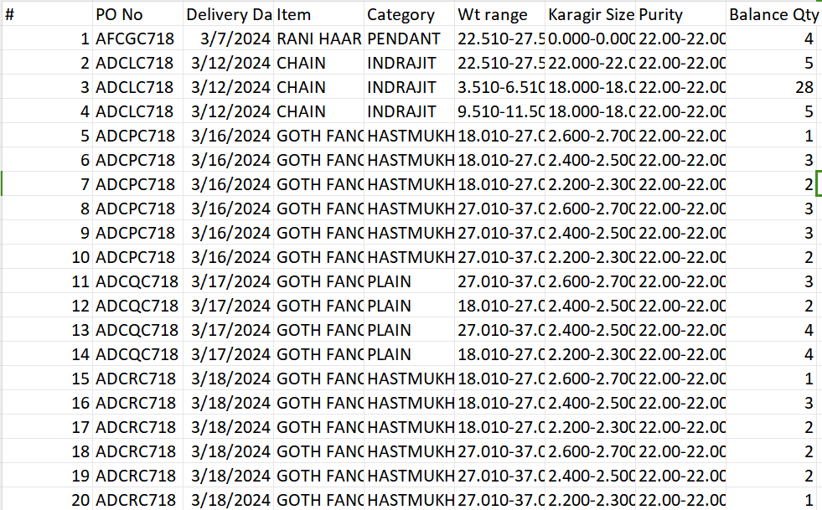

Fig: Vendor PO -> export grid

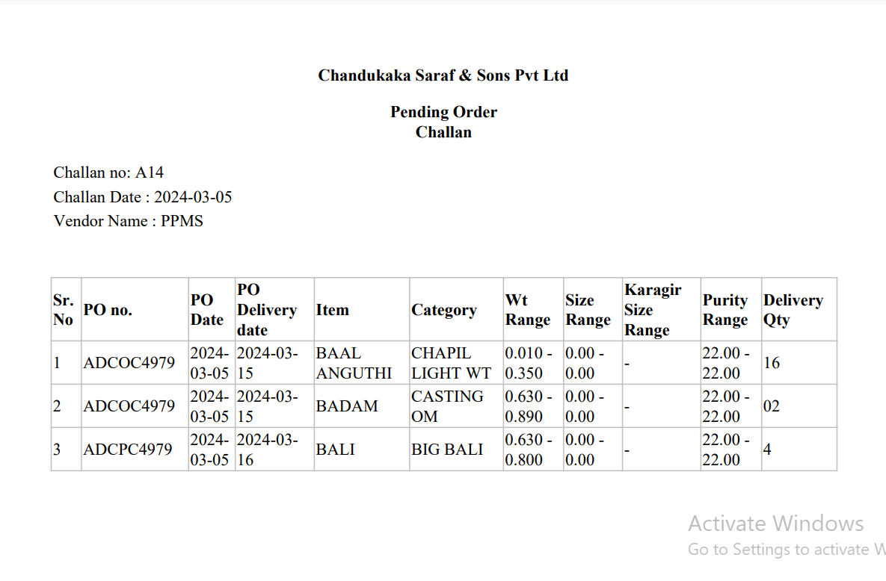

Fig: Vendor Challan

1. **REFERENCES OF THE USERS**

|  |  |  |  |
| --- | --- | --- | --- |
| **User** | **Name** | **Mail** | **Contact number** |
| **Actual user** | Rohit Shete  Sunil khuspe | ginventorypn1@csjewellers.com |  |
| **Ticket created by (if any)** | Tushar nikam | itinv@csjewellers.com |  |
| **Assigned business analyst** | Manali bhadirage | [Manali.bhadirage@techneai.com](mailto:Manali.bhadirage@techneai.com) |  |
| **Assigned developer** | Prathmesh shinde | Prathmesh.shinde@techneai.com |  |
| **Assigned tester** |  |  |  |