28.01.2024

EGOLD

Manali Ashok Bhadirage

Manali.bhadirage@techneai.com

**Functional Requirement Document**

**CONTENTS**

1. TICKET DETAILS 2

2. VERSION CONTROL 2

3. APPROVALS 2

4. ESTIMATION 2

5. INTRODUCTION 3

6. BUSINESS REQUIREMENT 3

7. SCOPE 3

8. BUSINESS & SYSTEM RULES 3

9. ABBREVIATIONS & TERMS 3

10. EXISTING SYSTEM 3

11. GRAPHICAL REPRESENTATION 3

12. PROPOSED SYSTEM 3

13. TEST DATA 4

14. ODUS 4

15. REFERENCES OF THE USERS 5

1. **TICKET DETAILS**

|  |  |
| --- | --- |
| **Ticket ID** | TT13173 |
| **Ticket description** | Kindly check attached eGold Requirements for Aadhar card authentication document. |
| **Created by** | Sayali Kasture |
| **Created on** | 14/06/2023 |
| **Priority** | Very high |

1. **VERSION CONTROL**

|  |  |  |  |  |
| --- | --- | --- | --- | --- |
| **Sr. No** | **Version no** | **Version Date** | **User name** | **User department** |
| **1** | **1.0** | **28/01/2023** | **Yogesh Shah** |  |
|  |  |  |  |  |

1. **APPROVALS**

|  |  |  |
| --- | --- | --- |
| **Field** | **Name of the User** | **Approved date by the user** |
| **Actual User Name Actual User Department Organization Name** | Yogesh Shah  CSJ |  |
| **Assigned BA** | Manali bhadirage |  |
| **Assigned Developer** | Jaydeep Patil |  |
| **Assigned Tester** | Uttareshwar Bhusari |  |

1. **ESTIMATION**

|  |  |  |  |  |
| --- | --- | --- | --- | --- |
| **Department name** | **Estimated Time (In hr)** | **Scheduled Date (Starting date)** | **Estimated date** | **Actual delivery date** |
| **BA** |  |  |  |  |
| **Development** |  |  |  |  |
| **Testing** |  |  |  |  |

1. **INTRODUCTION**

We have introduced the E-gold mobile application. This innovative platform enables customers to seamlessly register, engage in online buying and selling of precious metals such as gold and silver, and stay informed about live market rates. Additionally, customers have the convenience of choosing to have their purchased metals delivered to their doorstep. Our application guarantees reliable quality, providing a 100% assurance and ensuring the utmost security on all transactions. In addition to this, customers can buy gold & silver by setting monthly EMIs and also can send e-gifts to their closed ones.

1. **BUSINESS REQUIREMENT**

|  |  |  |  |
| --- | --- | --- | --- |
| **Requirement ID** | **Requirement Name** | **Short Description** | **Priority** |
| BR001 | Registration & KYC | Cx should be able to register via aadhar number and linked mobile number. Further, OTP verification should be done for mobile number. | High |
| BR002 | Login | User should be able to login using registered mobile number once registered. | High |
| BR003 | Dashboard | Cx should have features, banners, functionalities as set by tenant on dashboard. | High |
| BR004 | Live rates | Cx should be able to view live rates of per gram metal of 99.99% purity. The live rate should get refreshed by time set by the tenant. | High |
| BR005 | Buy | Cx should be able to buy metal by entering grams or amount and thus should be able to proceed with transaction. Whereas, purchased metal should be displayed in your trades. | High |
| BR006 | Sell | Cx should be able to sell the metal out of purchased metal. Cx should proceed to transaction and balance should be credited in cx bank account. Weight balance should be updated on each successful trade. | High |
| BR007 | Delivery | Cx should be able to get purchased metal delivered at address and proceed with transaction of delivery charges. Weight balance should be updated on each successful trade. | Medium |
| BR008 | SIP | Cx should be able to start investment of specific amount of metal in each month. SIP transaction should be deducted from cx account and purchased metal should be displayed in weight balance. Cx should be able to cancel the SIP at any time. | Medium |
| BR009 | Bank settings | Cx should be able to add max 3 bank accounts which cx will select while sell transaction in which amount should be credited. | Medium |
| BR010 | Preference settings | Cx will set his communication preferences for the help desk beneficial of tenant. | Medium |
| BR011 | Nominee settings | Cx will add the nominee for the account for legal purpose. | Medium |
| BR012 | Tenant settings | Tenant will edit customization settings from web which will be displayed to all their cx on application. | High |
| BR013 | Help Desk | Cx can contact support team of tenant via call or email in case of any issues. | Medium |
| BR014 | Profile | Cx will e able to view and edit his profile. | Medium |
| BR015 | Notifications | Cx should be able to receive and view notifications of each transaction, changes done in account and rate triggers if set any. |  |
| BR016 | Transaction report | Tenant should be able to view transaction report of all and / or individual cx for buy, sell, sip, delivery and their updated weight balance. | High |
| BR017 | Customer master | Each time when cx registers themselves , they will be added and displayed in cx master to tenant. Also, when profile changes are done by cx, updated details will be displayed in cx master. | High |
| BR018 | Tenant master | Super-admin will add the tenant from tenant master where further cx will get registered under the added tenant. | High |
| BR019 | Customer liability report | Through liability report, tenant admin can view the summary of opening and closing weight of gold and silver on each date of each customer. | Medium |
| BR020 | Customer ledger report | Through customer ledger report, tenant admin will view all the detailed transactions done by the specific customer in selected dates. | Medium |
| BR021 | Rate alert | Customer will get notifications on chosen medium when rate of the metal matches the set amount. | Medium |

1. **SCOPE**

Customer will be able to register himself using the aadhar number and linked mobile number. Customer will further be able to log into app using mobile number after successful registration. Further, customer will be able to view sell rate of gold and silver on dashboard along with banners, features and functionality buttons of bug, sell, rate trigger as per tenant’s settings. Custromer will view details in profile as per aadhar number. Further, customer will be able to buy or sell metal. Weight balance will be displayed in your trades. Customer can set the rate at which they want to receive the message through rate alert option. Customer has provision to add bank and nominee through settings. Moreover, customer can contact tenant via email or call through help desk option.

Tenant has customization settings through web which will be reflected on mobile app to customers. Tenant can view customer details through customer master and have access to transaction reports, liability report and customer ledger report.

1. **BUSINESS & SYSTEM RULES**

* User should be registered in the system.
* User should be logged in.
* System should display error message for incorrect details if entered.
* Customer can register for multiple tenants using same mobile and aadhar number.

1. **ABBREVIATIONS & TERMS**

Cx - Customer

OTP - One time password

KT - Karat

Wt - Weight

Gm - Grams

SIP - Systematic investment plan

KYC - Know Your Customer

PAN - Permanent Account Number

GST - Goods and Services Tax

TCS - Tax collected at source

1. **EXISTING SYSTEM**

There was no such application for trading having SIP functionality.

1. **GRAPHICAL REPRESENTATION**

Refer below figma link for reference:

<https://www.figma.com/proto/zoLllak3WHQ6OTncJm5Ac5/Egold-App?type=design&node-id=957-12077&scaling=contain&page-id=927%3A8353&starting-point-node-id=1358%3A17119&show-proto-sidebar=1>

1. **PROPOSED SYSTEM**
2. **Register**

User will have to first register himself using mobile no. and aadhar no.to further log into mobile app. It will have following fields:

* Aadhar number
* Mobile number
* Continue button

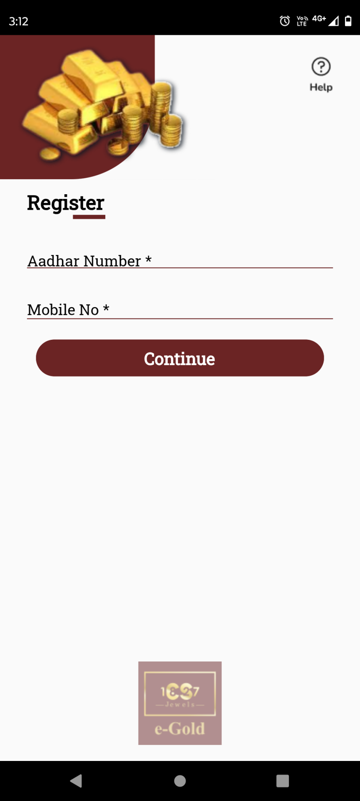

Fig: Register

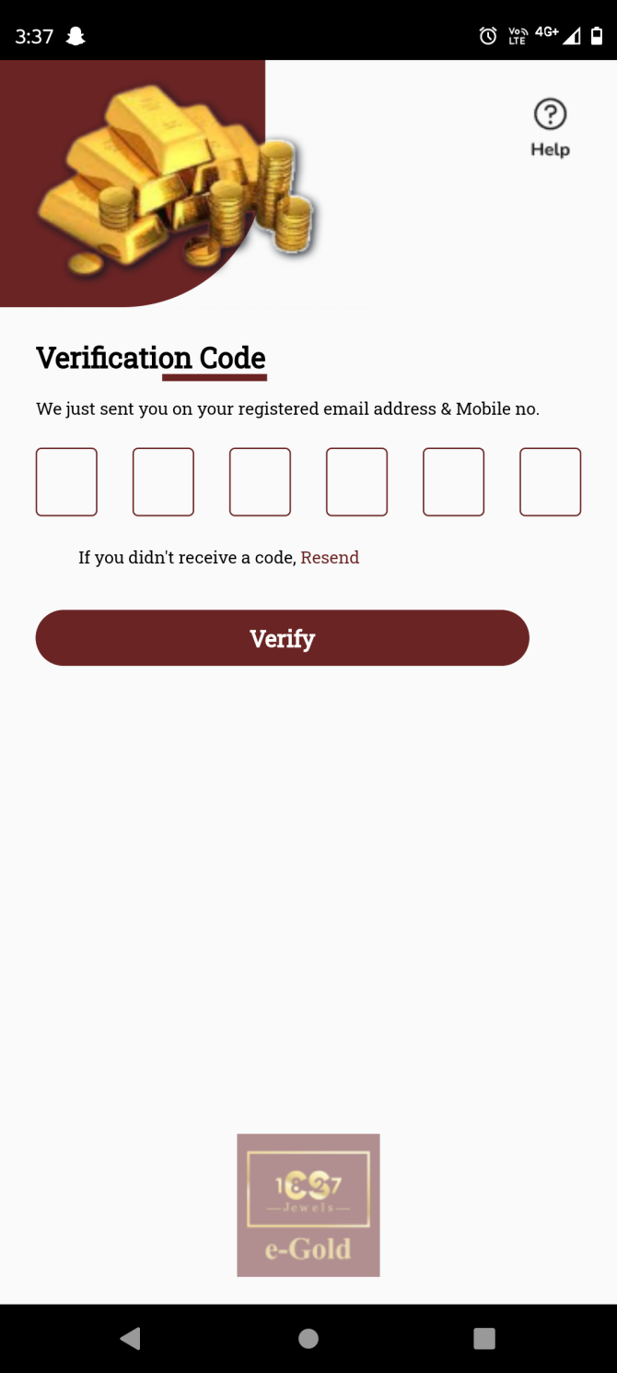

Fig: Verify OTP

**Input table**

|  |  |  |  |  |
| --- | --- | --- | --- | --- |
| **FIELDS** | **INPUT TYPE** | **MANDATORY/ OPTIONAL** | **EDITABLE** | **DESCRIPTION** |
| Aadhar number | Text | Mandatory | Yes | Customer will enter the registered aadhar number against which account is to be created.  Once customer enters aadhar number and clicks on submit, it will display on field error message if the entered aadhar number doesn’t exist or if user has not entered all digits.  Validation: It will accept only numbers. It will accept compulsorily 12 digits. |
| Mobile number | Text | Mandatory | Yes | Customer will enter the mobile number which is registered against the entered aadhar number.  If customer enters aadhar number and enters another mobile number which is not linked, then it will display alert message as ‘mobile number not linked with this aadhar number’.  Validation: It will accept numbers only. It should not accept all zeros. It should only accept 7/8/9 at the beginning.  Min & max length = 10. |
| Submit | Click | - | - | Once customer enters valid aadhar number and mobile number and clicks on submit button, OTP will get sent to entered mobile number via SMS and user will be directed to verification code page.  If customer enters incorrect aadhar / mobile number and clicks on submit, it will display on field validation error message.  If the minor cx tried to register, then its details will be stored in db but cx won’t get registered. Whereas, once cx completes min age, then reminder SMS will get sent to the cx for registering again.  Validation: Once customer clicks on submit button, it should be disabled until user is directed to further page or until error message is displayed in case of invalid details. |
| Verification code | Text | Mandatory | - | Customer will enter the OTP code here which is sent on the registered number via SMS.  If customer enters incorrect OTP and clicks on verify button, then it will display on field error message as incorrect OTP.  Already sent OTP gets active for 45 seconds by sure pass, hence it displays rate limit alert message when cx tries to regenerate OTP within 45 seconds.  Validation: It will accept numbers only. Max & min length = 6 digits. |
| Resend OTP | Click | - | - | Once cx enters aadhar number, mobile number and clicks on submit button, OTP gets sent to the cx’s aadhar registered mobile number and cx gets directed to verification code page. Here, the timer gets displayed of 45 seconds. Further resend OTP button gets enabled only once the timer gets down to 00:00.  Once cx clicks on resend OTP button, new otp will get sent to the cx and again the resend otp button will be disabled until further 45 seconds. |
| Verify | Click | - | - | Once user enters valid OTP and clicks on verify button, successful message will be displayed and customer will get registered under the tenant. Customer’s details will be displayed in customer master of web for that tenant as well as will be displayed in profile once customer logs in. As per successful registration, user can log in by using the registered mobile number.  If customer enters incorrect OTP and clicks on verify button, then it will display on field error message as incorrect OTP. |

As customer registers using aadhar card number, it is considered as KYC done and thus his KYC status is being displayed as accepted in customer master of that tenant.

1. **Sign in**

User can sign in using registered mobile number on which an OTP will be sent. Sign in page has following fields:

* Mobile no.
* Send OTP button
* Register button
* Help icon

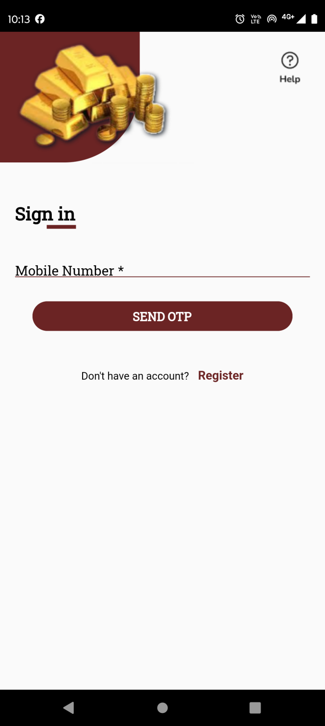

Fig: Sign In

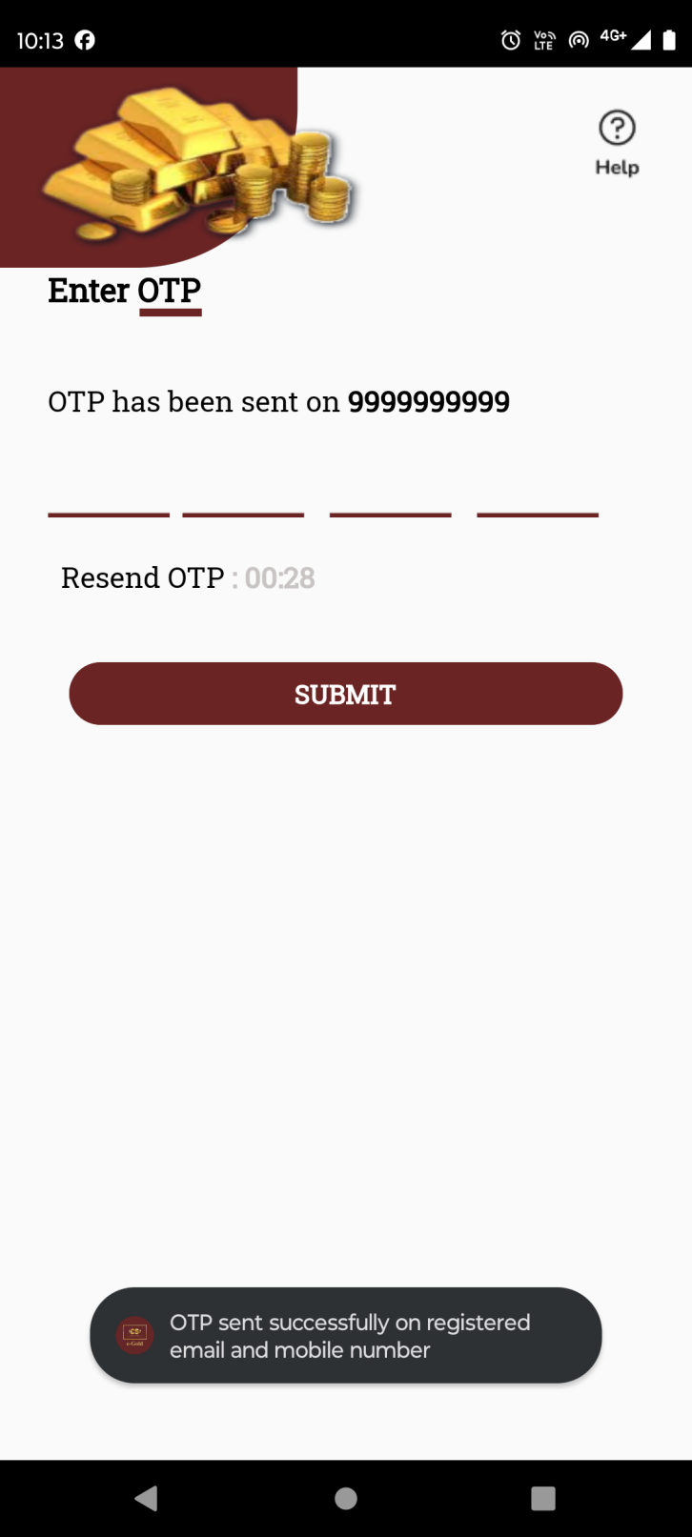

Fig: Enter OTP

|  |  |  |  |  |
| --- | --- | --- | --- | --- |
| **FIELDS** | **INPUT TYPE** | **MANDATORY/ OPTIONAL** | **EDITABLE** | **DESCRIPTION** |
| Mobile number | Text | Mandatory | Yes | Customer will enter the mobile number by which he has registered.  Once customer enters valid registered number and clicks on send button, OTP will be sent on that number via SMS and user will be directed to the page to enter the sent OTP.  If customer enters mobile number by which any customer is not registered yet and clicks on send OTP button, then it will display pop up error message as ‘mobile number not registered. If customer enters less than 10 digits and clicks on send button, it will display on field validation error message.  Validation: It will accept numbers only. It should not accept all zeros. It should only accept 7/8/9 at the beginning.  Min & max length = 10. |
| Send OTP button | Click | - | - | Once customer enters valid registered number and clicks on send button, OTP will be sent on that number via SMS and user will be directed to the page to enter the sent OTP. |
| Enter OTP | Text | Mandatory | No | Once cx enters valid registered mobile number and clicks on send button, OTP will get sent to the customer’s mobile number and cx will be directed to enter OTP page. Customer will have to enter 4 digit correct OTP within 30 seconds and click on submit button to log into the app.  If cx enters invalid OTP and clicks on submit button, it will display pop up error message as invalid OTP. |
| Resent OTP button | Click | - | - | Once cx enters valid registered mobile number and clicks on send button, OTP will get sent to the customer’s mobile number and cx will be directed to enter OTP page where timer of 45 seconds will run in descending order.  Timer will be reset to 00:00 if cx doesn’t enter valid OTP and click on submit button. To create new OTP, cx will have to click on resend OTP button. Once cx clicks on resend OTP button, new OTP will be sent to cx via SMS and timer will restart again in decrement order from 45.  Validation: Resend OTP button will be enabled only when time is 00:00. |
| Submit button | click | - | - | Once user enters valid OTP number and clicks on submit button, successful message will be displayed and cx will be directed to dashboard of the application.  Validation: Submit button will be disabled until user is directed to dashboard or until error message is displayed in case of incorrect OTP number. |
| Help icon | Click | Optional | - | Cx can contact the help desk / support team of the tenant via email or call through this option.  Once user clicks on help button, it will display following fields:   * Email Address * Mobile Number * Query type * Query text field * Submit button |

1. **Help Desk**

Once user clicks on help button, it will display following fields:

* Email Address
* Mobile Number
* Query type
* Query text field
* Submit button

|  |  |  |  |  |
| --- | --- | --- | --- | --- |
| **FIELDS** | **INPUT TYPE** | **MANDATORY/ OPTIONAL** | **EDITABLE** | **DESCRIPTION** |
| Mobile number | Text | Mandatory | Yes | Customer will enter the mobile number.  If customer is not logged in yet, then this field will be blank. If user has logged in into the app and clicks on help desk button, then mobile number will get pre-filled as per mobile number in the profile and it will be editable here.  Validation: It will accept numbers only. It should not accept all zeros. It should only accept 7/8/9 at the beginning.  Min & max length = 10. |
| Email address | Text | Optional | yes | Customer will enter his own email address.  If cx is not logged in yet, then it will be blank. If user has logged in into the app and clicks on help desk button, then email address will get pre-filled as per email address in the profile and it will be editable here.  Validation: This field should accept “ @ - . “ only as special characters. In case of invalid format, it should display on field error message as “Invalid email address”. It shouldn’t accept space. Maximum length of input field should be 100 characters. |
| Query type | Drop-down | mandatory | yes | Cx will select the type of help they need related to. It will display Concern, transaction issue, application issue, feedback and others in the list.  Validation: it will be single select. |
| Query | Text | Mandatory | Yes | Customer will write his concerns / feedback in the text field.  Validation: It should accept characters, numbers, special characters and space.  Min length = 1  Max length = 250 |
| Submit | Click | - | - | Once customer clicks on submit, it will display message as “Your response has been sent to support team. You will receive an update within 24-48 hours”. And, email will get sent to application support team of tenant. Email will have details of cx mobile no, cx email address, query type, query description, cx preference timing, cx communication language and cx communication mode. Here, email will have preference timing, cx communication language and cx communication mode only if cx has set it.  If user doesn’t enter mandatory fields and clicks on submit button, it will display on field error message.  Validation: Button will be disabled until successful message or error message is displayed. |

1. **Dashboard**

Once cx logs into the app, he will be directed to the dashboard page. It will consist of following menus:

* Live rate of gold and/or silver
* Banners
* Buy and/or Sell and/ or SIP button
* Rate alert button
* Features
* Tenant logo

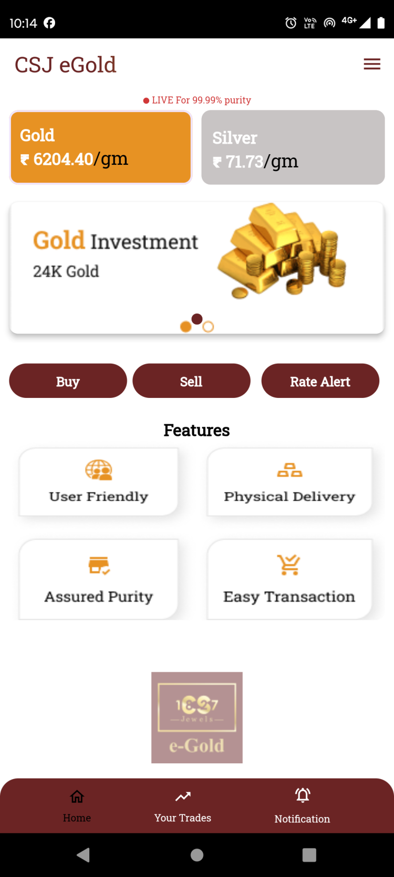

Fig: Dashboard

|  |  |  |  |  |
| --- | --- | --- | --- | --- |
| **FIELDS** | **INPUT TYPE** | **MANDATORY/ OPTIONAL** | **EDITABLE** | **DESCRIPTION** |
| Live rate of gold and/or silver | Text | - | By tenant through customer type setting | It will display live purchase rates of gold and silver per gram with 99.99% purity.  Gold and/ or silver cards will be displayed as per tenant’s commodity settings. If tenant only sets Gold as active commodity, then only card for Gold live rate will be displayed on dashboard to all customers of that tenant.  Rates displayed will be different for each tenant as per settings done by tenant in back-end web app through tenant’s customer type setting. |
| Banners / sliders | Image | Mandatory (min 1 image) | By tenant through banner setting | Sliders will be different for each tenant where tenant will display images related to their offers / new features / etc.  It will be changed from tenant’s web -> settings -> dashboard -> banner.  Validation: It will be view only. Min = 1 image  Max = 4 images. |
| Buy button | Click | - | - | Customer can purchase metal during the timing set by the tenant just by entering either amount or metal weight and book gold or silver in his account after completing transaction.  The button will be displayed as set active by the tenant in functionality setting. |
| Sell button | Click | - | - | Customer can sell the metal out of the purchased metal just by entering either amount or metal weight. Whereas, amount will be credited during set business days in cx account as selected during transaction.  The button will be displayed as set active by the tenant in functionality setting. |
| SIP button | Click | - | - | Once customer clicks on SIP button, customer can select date, tenure and amount for auto purchasing the metal each month.  The button will be displayed as set active by the tenant in functionality setting. |
| Rate alert | Click | - | No | Customer can set the rate triggers for which wants to receive as notification so that it will be useful for customer to analyze uy and sell.  Customer can set multiple alerts for silver and gold individually each. Once the rate matches as per set trigger, then notification will be sent to customer only one time and then the set trigger will get disabled and also will be saved in rate trigger history. |
| Features | Image | - | By tenant through feature setting | Tenant will add the images displaying the features of the application which are read only.  It will be changed by tenant through feature settings. |

1. **Profile**

Cx can view and update its details through profile. The updated details of the customer will be reflected in tenant’s customer master once saved. Profile page has following fields:

* Profile image
* Cx name
* Aadhar number
* Pan number
* KYC status
* Address
* Pin code
* Country
* State
* City
* Mobile no.
* Whatsapp no.
* DOB
* DOA
* Gender
* PAN no.
* Email
* Occupation
* Save button

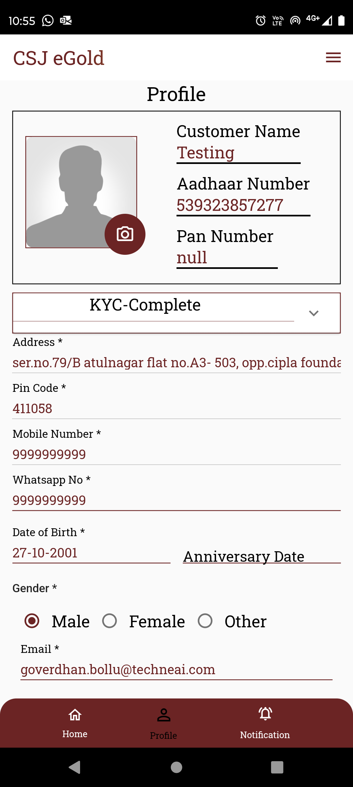

Fig: Profile

|  |  |  |  |  |
| --- | --- | --- | --- | --- |
| **FIELDS** | **INPUT TYPE** | **MANDATORY/ OPTIONAL** | **EDITABLE** | **DESCRIPTION** |
| Profile image | Upload | Optional | Yes | Cx will attach his profile image through here.  Initially when cx registers himself, the profile image field is displayed blank by default when cx gets created.  Once cx clicks on camera icon on profile image, it will display options to either attach image from camera or through gallery. Once user selects image or clicks image and clicks on OK, it will be displayed on profile page. The added image in profile image will also be saved as user image in cx master for that customer.  Validation: Only one image can be set at a time. It will accept only jpg, png, heic, heif, webp and jpeg extensions only. |
| Cx name | Text | Mandatory | No | It will display the cx name as per aadhar number entered while registering.  Validation: It will be read only to customer as well as tenant. |
| Aadhar number |  |  |  | It will display the aadhar number entered by cx while registering.  Validation: It will be read only to customer as well as tenant. |
| Pan number |  |  |  | PAN number will be entered by the cx in the profile. It will be null initially. Whereas, once user enters valid PAN number in the form ans saves it, it will be displayed here. Once PAN number is saved, it will also be displayed in tenant’s customer master against that cx details.  Validation: It will be read only in header table above whereas it can be edited through field in the profile form below. |
| KYC status | Text | Mandatory | No | It will display that status whether the cx verification is done using documents or not. As cx registers using aadhar number and further details are being displayed in profile as per aadhar number, KYC status is being displayed as completed.  Validation: It will be read only. |
| Address | Text | Mandatory | No | It will display the address as per aadhar number.  Validation: It will be read only. |
| Pin code | Text | Mandatory | No | It will display the pin code number as registered on the aadhar.  Validation: It will be read only. |
| Country | Text | Mandatory | No | It will display the country name from pin code as mentioned in the aadhar number.  Validation: It will be read only. |
| State | Text | Mandatory | No | It will display the state name from pin code as mentioned in the aadhar number.  Validation: It will be read only. |
| City | Text | Mandatory | No | It will display the city name from pin code as mentioned in the aadhar number.  Validation: It will be read only. |
| Mobile no. | Text | Mandatory | No | It will display the mobile number entered in mobile number field while registration.  Validation: It will be unique. It will accept only numbers. It should only accept 7 / 8/ 9 as first digit.  Min & Max length = 10 |
| Whats-app no. | Text | Mandatory | Yes | Initially it will be blank whereas cx will enter the Whats-app no. here.  It will display on field validation error message in case user doesn’t enter this number before saving or in case user has not 10 digits.  Validation: It can be same. It will accept only numbers. It should only accept 7 / 8/ 9 as first digit.  Min & Max length = 10 |
| DOB | Date calender picker | Mandatory | No | It will display customer’s date of birth as per aadhar number.  Validation: Its format will be DD/MM/YYYY. It will be read only. |
| DOA | Date calender picker | Optional | Yes | Cx can enter the Date of anniversary if applicable. Its format will be DD/MM/YYYY.  Validation: Only one date can be selected. Future dates will be disabled. Dates before DOB will be disabled. |
| Gender | Radio button | Mandatory | No | It will display gender as male / female / other from aadhar number.  Validation: It will be read only. It will be single select. |
| PAN no. | Text | Mandatory | Yes | Cx will enter PAN number as it is needed for verifying transactions above 2 lakh.  In case of invalid pan card number format, it should display error message as “Invalid pan number”. If user enters same pan number which is already added in another cx account, then it should display on field error message as PAN number already exists.  Validation: Customer will enter 10 digit alphanumeric PAN No. of nominee. PAN number should be unique in cx master. It includes first five letters, followed by 4 numbers and last character. |
| Email | Text | Optional | Yes | Cx will enter valid email address so as to receive notifications on it.  The entered email address will also be displayed in help desk -> email field after login.  Validation: It should be unique in cx master. This field should accept “ @ - . “ only as special characters. In case of invalid format, it should display on field error message as “Invalid email address”. It shouldn’t accept space anywhere. It should be unique. Maximum length of input field should be 50 characters. |
| Occupation | Drop down | Optional | Yes | Cx will mention his occupation for the tenant’s reference.  Validation: It will display active occupations from occupation master. It will be single select. |
| Save button | Click | - | - | Once cx enters valid mandatory details and clicks on save button, successful message will be displayed and updated details will be displayed in profile as well as in cx master.  Validation: Save button will be disabled until successful message is displayed or error message is displayed in case of invalid details if entered. |

1. **About Us**

It will display information about the application, tenant, description of features, terms and conditions and will include sliders, images & videos. It will have social media links at the bottom, contact details and application share button.

The details / information in about us will be displayed as per tenant’s settings from web.It should have following contents:

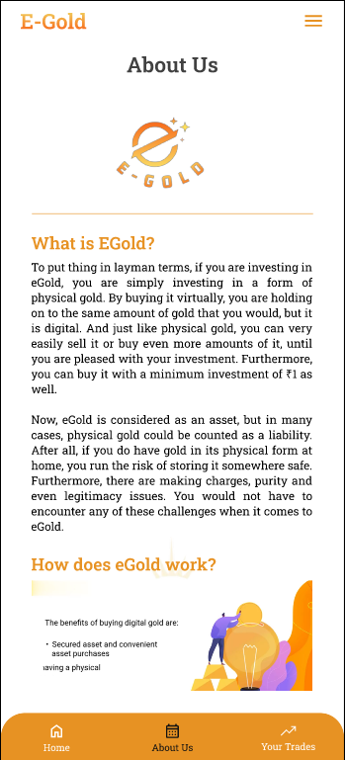

Fig: About us

1. **Settings - Nominee settings**

Customer can add only one nominee under his account. Initially, none of the nominee will be added. Once customer clicks on add button, it will display following fields:

* Nominee name
* Full address
* Date of Birth
* Relation with nominee
* Aadhar number of nominee
* PAN number of nominee
* Mobile number
* Email ID
* Add button
* Cancel button

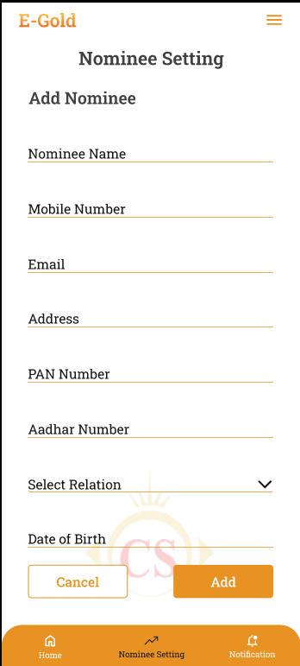

Fig: Nominee settings

|  |  |  |  |
| --- | --- | --- | --- |
| **FIELDS** | **INPUT TYPE** | **MANDATORY / OPTIONAL** | **DESCRIPTION** |
| Nominee name | Text | Mandatory | Customer will enter the name of the nominee he wants to add.  Validations: It should accept characters and space only. It should not accept space initially.  Min length = 2  Max length = 100 |
| Full Address | text | mandatory | Customer will enter the full address of the nominee.  It will accept maximum 250 characters / numbers. It should accept single space only after each word. It should accept . / - , special characters only. |
| Date of Birth | Calendar picker | Mandatory | customer will enter the date of birth of the nominee.  Validation: Future dates should be disabled. It should display dates from 01-01-1924 to current date. |
| Relation with nominee | Text | Mandatory | Customer will choose his relation with the nominee from the drop-down as mother / father / sister / brother / daughter / wife / husband / son/ other.  Validation: It will be single select. |
| PAN number | text | Optional | Customer will enter 10 digit alphanumeric PAN No. of nominee.  Validation: One nominee’s pan number can same as nominee of another person. It includes first five letters, followed by 4 numbers and last character. In case of invalid pan card number format, it should display error message as “Invalid pan number”. |
| Aadhar card number of nominee | Text | Mandatory | customer will enter 12 digit Aadhar number of the nominee.  One Aadhar no. should be entered only once. customer will have to enter unique Aadhar no. Customer cannot mention same already entered aadhar number for another nominee. Also, it cannot be as same as registered user’s aadhar number.  In case of invalid aadhar card number format, it should display error message as “Invalid aadhar number”. |
| Nominee mobile no. | text | mandatory | Customer will enter nominee’s mobile number. It can be same as customer’s number from profile.   Validation: It can be same. It should accept 7/8/9 only at the beginning. It should not accept space or characters or special characters. Min & Max length = 10 |
| Nominee’s Email ID | text | Optional | Customer will enter nominee’s email ID. It can be same as customer’s number from profile.  Validation: Min length = 11  Max length = 100 |
| Save | Click | Mandatory | Once customer enters one or more nominee details and clicks on save, it will save data and display the added details on ‘Nominee settings’ page. |

Once customer adds nominee, added nominee details will be displayed whereas user can edit it.

1. **Settings - Bank account settings**

Customer will add the list of bank accounts into the application. The added bank accounts will be displayed while making payments. Cx will select the added bank in which he want amount credited while performing sell transaction. It will display list of bank accounts if added any and add more button. Maximum 3 banks accounts can be added for one customer. Once customer clicks on add more button, it will display following fields:

* Credit / Debit card number
* Card holder name
* Bank name
* IFSC code
* Save button

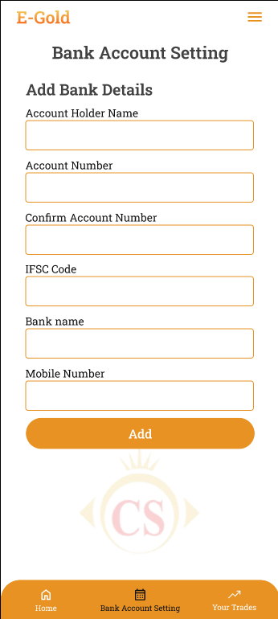

Fig: Bank account settings

|  |  |  |  |
| --- | --- | --- | --- |
| **FIELDS** | **INPUT TYPE** | **MANDATORY / OPTIONAL** | **DESCRIPTION** |
| Card number / account number | Text | Mandatory | Customer will enter the alphanumeric or only numeric bank account number.  Validation: It shouldn’t accept space. It should accept 19 digits. |
| Card holder name | Text | Mandatory | customer will enter the account holder name as on bank passbook or on card.  Validation: It should accept characters and space only. Maximum length of input field should be 50 characters. |
| Bank Name | Drop-down | Mandatory | customer will select the bank name for the list.  Validation: It will be single select. |
| IFSC number | Text | Mandatory | customer will enter 11 digit alphanumeric IFSC number. As per selected bank name and IFSC number, it should validate whether the IFSC number is correct or not and display error message in case it is incorrect.  Validation: Min & max length = 11 |
| Save | click | mandatory | Once customer enters one or more bank details and clicks on save, it will save data and display the added details on ‘Bank account settings’ page. |

1. **Settings - Preference settings**

Customer will set communication preferences. The set preferences will be heloful for the tenant’s support team. It will display following fields:

* Communication mode
* Call timings
* Communication language
* Notification permissions
* App unlock recognition

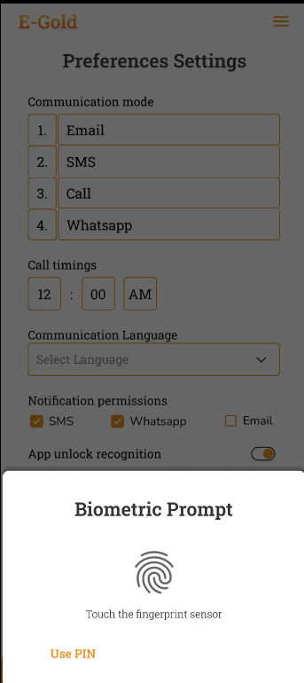

Fig: Preference settings

|  |  |  |  |
| --- | --- | --- | --- |
| **FIELDS** | **INPUT TYPE** | **MANDATORY / OPTIONAL** | **DESCRIPTION** |
| Communication mode | Drag & drop | Optional | customer will drag and drop his preferred communication mode in sequence. It will display following options email, SMS, call, Whats-app. |
| Call timings | Time | Optional | Customer will mention his available ‘from and to’ timing so that tenant’s support team can contact customer as per his preferred time.  Validation: It should accept numbers only. It will display 24 hours clock. By default it will display it as 00:00. |
| Communication language | Drop-down | Optional | customer will select the language that he prefers to get call and messages.  Validation: It will be single select. |
| Notification permissions | Permissions | Optional | customer will enable / disable communication preference by toggle. It will have options as SMS, email and whats-app.  If customer disables any mode, then notification should get sent to customer on that medium and should get sent by the enabled medium only.  However, within application notification will be sent to all by default. Whereas rate trigger notifications will get sent on selected primary medium and its second medium will be the one selected from here.  Validation: it will be multi-select. |
| App unlock recognition | Radio button | Optional | Customer will select the option which he prefers while visiting the app each time and unlocking it.  After setting unlock code, once customer clicks on save button, then later when customer visits / opens app each time, customer will have to enter the pass-code and unlock the app.  Validation: Min & Max length = 4 |
| Save | click | - | Once user sets the preferences and clicks on save button, it will be displayed in web -> preference settings against that |

1. **Buy**

Once customer clicks on **BUY button**, it will display following fields on next page:

* Buy live rate of gold and silver
* Purchase by rupees (button)
* Purchase in grams (button)
* Text box to enter weight or amount
* Calculated value of amount / grams
* Continue (button)

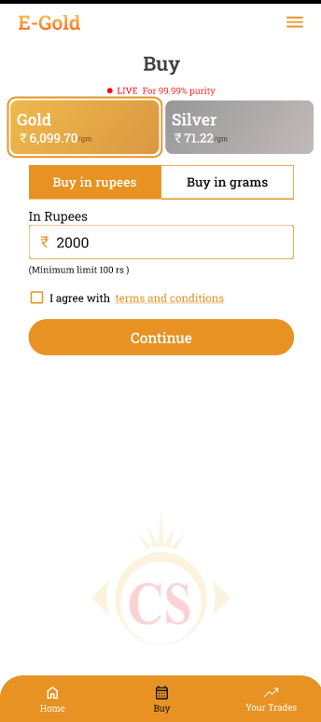

|  |  |  |  |
| --- | --- | --- | --- |
| **FIELDS** | **INPUT TYPE** | **MANDATORY / OPTIONAL** | **DESCRIPTION** |
| Live rates | Click | Mandatory | It will display live rates.  By default, it will click Gold live rate card.  If user clicks on silver card, then user will proceed to buy silver. |
| Purchase by rupees | Click | Mandatory | Customer can purchase metal by entering amount. And then as per entered amount and current rate, weight of the metal that can be purchased will get calculated.  It should accept max 3 digits after decimal point.  Below this text field, it will display the minimum and maximum grams / limit that customer can buy at a time as set by tenant settings.  One time transaction limit will be set as 5,00,000 by default whereas max limit will vary foe each tenant as per their settings from web. |
| Purchase in grams | Click | Mandatory | Customer can purchase metal by entering weight of metal. Then as per current rate and metal, the amount of purchase will get calculated and displayed.  Below this text field, it will display the minimum and maximum grams / limit that customer can buy at a time as set by tenant settings.  It should accept max 3 digits after decimal point. |
| Text box | Text | Mandatory | Once customer clicks on purchase by metal, then in text box customer will enter the amount in rupees.  If customer clicks on purchase in grams, then in text box customer will have to enter the weight of the metal in grams. |
| Calculated value | Display |  | As per entered amount, it will display the weight of metal that can be booked. Booked metal = purchasing amount / (current rate per gram + 3% Gst).  If customer has entered grams, then it will display calculated amount as per current rate and GST for the entered grams. Purchasing amount = (current rate of per gram + 3% GST) * value entered in purchasing gram field.  It should accept max 3 digits after decimal point. |
| Continue | Click | Mandatory | If customer clicks on continue button, it will display the billing information of the purchase and proceed to pay button.  Here, it will display metal amount, GST amount and (tcs amount if applicable) for the customer and then total of the transaction at end. |
| Pan number | Text |  | If customer is doing transaction of 2,00,000 or more than 2,00,000 then pan number field will be displayed.  (The limit will for which pan is required will be 2 lakh by default, else it will vary as per tenant’s setting in web.) |
| Proceed to pay | click |  | Once customer clicks on proceed to pay button, then rounded off total billing amount will be displayed and customer will be directed to bank payment gateway. Here, it will display the list of banks that customer has added to online payments on his mobile. If customer hasn't added any bank, then it will direct customer to add bank account details.  Once customer selects bank account, enters password and completes payment, then it will display successful message as “Metal booked for you” and it will be displayed in ‘Your Trades’ menu. Each time when purchase is done, then unique ID should be generated for that transaction and it will be displayed in ‘your trades’. |

1. **SIP**

Customer will set the date, amount and period till which customer wants to book the metal automatically and add in his account. Once customer clicks on SIP button, it will display following fields:

* Live rates of gold and silver
* Set Start Date
* Set Duration in months
* Period
* Monthly amount
* Continue button

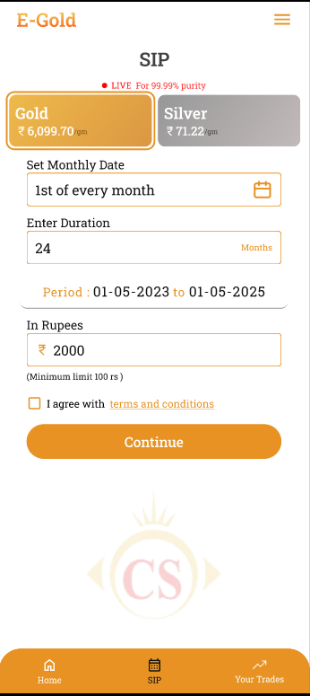

Fig: SIP

|  |  |  |  |
| --- | --- | --- | --- |
| **FIELDS** | **INPUT TYPE** | **MANDATORY / OPTIONAL** | **DESCRIPTION** |
| Live rates | Marquee tag | Mandatory | It will display live rates.  By default, it will click Gold live rate card.  If user clicks on silver card, then user will proceed to buy silver. |
| Set start date | Calendar picker | Mandatory | customer will select the date on which customer wants to get amount auto-deducted each month and book the metal.  Validation:- It will display dates of current month. Back dated dates will be disabled from calendar. It should select only one date a time. |
| Set Duration | Year | Mandatory | customer will select the year until which he wish to continue monthly auto-purchase.  Validation:- It should accept numbers only. |
| Period | Date | Mandatory | As per selected date and duration, it will display period of SIP.  Example: If customer selects Start date as 17/05/2023 and sets duration as 2025. Then in period it will display as : 17/05/2023 to 17/05/2025.  Validation:- It will be read only. It should display updated period as per changing date and duration entered by customer. |
| Monthly Amount | Text | Mandatory | Customer will enter the amount that will be deducted each month and metal will be booked as per current rate. As SIP monthly amount is fixed by customer, then from second installment, metal will get booked as as per SIP amount and current rate in that particular month.  Below this text field, it will display the minimum and maximum amount / limit that customer can create SIP of as set by tenant settings.  Validation:- It should accept only numeric value. It should accept max 3 digits after decimal point. |
| Continue | Click | Mandatory | Once customer clicks on continue button, it will display the billing information of the purchase and have ‘proceed to pay’ button.  While starting the SIP for first time, customer will have to make one payment of the current month even if the date selected hasn’t passed yet in the current month.  Once customer clicks on proceed to pay button, customer will be directed to bank payment gateway. Here, it will display the list of banks that customer has added through his settings -> add bank. If customer hasn't added any bank, then it will direct customer to add credit/debit card or UPI account details.    Fig: Bank settings -> add  Post condition:- Once customer selects bank account, enters password and completes payment, then it will display successful message as “Payment successful and your SIP has started.”  SIP number will be generated and the created SIP will be displayed in hamburger menu -> manage SIP.  Also, it will display the transaction of each monthly auto-purchase in ‘your trades’ menu. Moreover, each time when transaction is done for monthly auto-purchase, notification should be sent to customer within app, sms and Whats-app.  Further, as current rate of each day keeps on changing, then the monthly grams to be booked should get calculated as per current rate of that particular day and the monthly amount chosen by user.  Example: If customer has chosen 17th date of each month and 5000/- amount as each month transaction. Then, 5000/- will be deducted on 17th of each month however the metal booked for each time will vary as per current rate.  Each month when transaction is done about purchase, then unique ID should be generated and it should be displayed in ‘your trades’. |

**Manage SIP**

All created SIP of gold and silver will be displayed in manage SIP. Customer can view details of his created SIP, change the SIP date or can cancel the SIP. Once customer clicks on ‘manage sip’ menu, it will display following details of each SIP where gold / silver will be displayed with respective colour:

* SIP number
* Start date
* Booked metal
* Amount
* Total paid SIP
* Upcoming SIP date
* View action
* Edit action

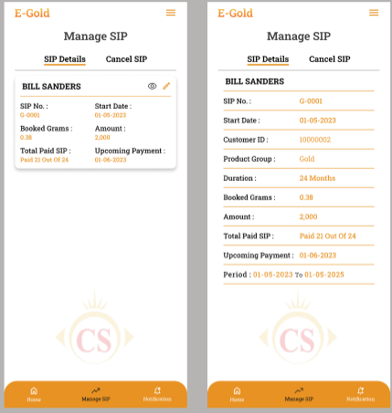

Fig: Manage SIP

Once customer clicks on view action, it will display all details of SIP as customer entered while creating it. It will display following read only fields:

* SIP Number
* Start date
* Customer ID
* Product group
* Duration in months
* Booked metal in grams
* Amount
* Total paid SIP
* Upcoming sip date
* Period
* Transaction History : It will display all transactions done for each particular SIP. It will display field s as Sr. No., Date & time, Amount, Status (successful / unsuccessful).

Once clicks on edit action of the SIP, it will display following fields:

* SIP Number
* Start date
* Customer ID
* Product group
* Duration in months
* Booked metal in grams
* Amount
* Total paid SIP
* Change date
* Cancel checkbox

If customer changes date and clicks on save button, then a dialogue box will open where it will specify the changed date and customer will have to confirm as yes / no. Once changes are saved then the edited details should be reflected in SIP details of manage SIP. Also, the payment of the customer should be done as per updated date of the SIP.

If user clicks on cancel SIP, then user will have to specify the reason for cancellation. Once reason is mentioned and customer clicks on save button, it will cancel the SIP and display the canceled SIPs in ‘canceled SIP’ menu.

1. **Sell**

Customer can sell the metal out of his total booked metal till the date. It will display following fields:

* Live rates of gold and silver
* Weight Balance in account
* Sell weight in grams
* Remaining weight
* Calculated amount
* Continue button

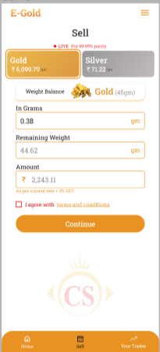

Fig: Sell

|  |  |  |  |
| --- | --- | --- | --- |
| **FIELDS** | **INPUT TYPE** | **MANDATORY / OPTIONAL** | **DESCRIPTION** |
| Live rates | Marquee tag | Mandatory | It will display live rates.  It will display gold and silver sell rate only. |
| Weight Balance in account | Text | Mandatory | It will be read only field.  It will display the total grams purchased / available in user’s account for gold & silver. |
| Sell weight in grams | Text | Mandatory | customer will enter the weight in grams which customer wants to sell. It should NOT accept value more than the weight balance in user’s account.  Below this text field, it will display the minimum and maximum grams / limit that customer can sell as set by tenant settings. (If customer has purchased 5 grams on 01/09 and 3 grams on 02/09. Suppose tenant has set setting that customer should sell weight after 48 hours of purchase. Then on 03/09 when customer is selling the grams then it should display the value that customer can sell only out of 5 grams (as 3 grams purchased haven’t passed 48 hours yet).  Validations:- It should accept value or weight more than the weight in customer’s weight balance. It should accept numbers only. It should accept single decimal point. It should accept only three digits after decimal point. |
| Remaining weight | Text | Mandatory | It will display weight that will remain in customer’s account after entering weight in selling field.  Remaining weight = weight balance - sell weight.  Validation:- It will be read only. It will display updated value as and when user enters different values in sell weight text field. |
| Calculated amount | Text | Mandatory | It will display calculated amount that customer will get into his account after selling the entered grams.  Sell amount = sell weight in grams * current sell rate.  Validation:- It will be read only. It will display updated amount as and when customer enters different values in sell weight text field. |
| Continue | Click | Mandatory | Once customer clicks on continue button, it will display the billing information of the sell and will have ‘proceed to sell’ button.  Once customer clicks on proceed to sell button, then rounded off total billing amount will be displayed and it will display the list of bank accounts that customer has added in application. customer will select the bank in which customer wants the payment to be done and will click on continue button.  Once customer clicks on continue button, customer will enter the pin and on clicking confirm, it will display the message as “Metal sold successfully. Amount will be transferred to your account soon!”.  As per sold metal, the weight balance in account should get updated and the transaction of sell should be displayed in ‘your trades’ menu. Each time when transaction is done about sell, then unique transaction ID should be generated and displayed in your trades along with receipt no.  Notification of sell should get sent to customer on SMS, whats-app and within app.  Notification should get sent to customer via SMS and within app once amount is credited in customer’s bank account. |

1. **Delivery**

Through delivery option, customer can get the gold / silver physically delivered at his address. Customer can get egold delivered only out of the total weight balance in his account. It will have following fields:

* Grams
* Full name
* Mobile number
* Alternate mobile number
* Address
* Landmark
* Pin code
* State
* City
* ID proof
* Address type - residential / home
* Continue

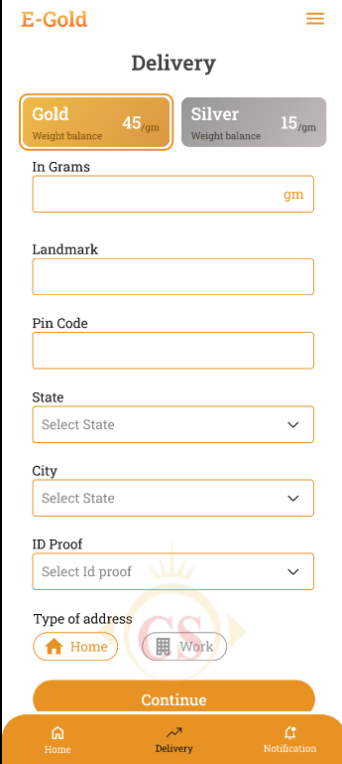

|  |  |  |  |
| --- | --- | --- | --- |
| **FIELDS** | **INPUT TYPE** | **MANDATORY / OPTIONAL** | **DESCRIPTION** |
| Product Group | Cards | Mandatory | It will display current buy rate.  Validation:- By default it will be clicked on Gold. |
| Grams | text | mandatory | Customer will enter the grams that he/she wants to get physically delivered at his address.  Validation:- it should accept value more than weight balance in account for particular product group. |
| Mobile number | text | mandatory | Customer will enter his mobile number.  Validation:- Only numbers should be accepted. Maximum 10 digits should be accepted. It should accept 6 /7 /8 / 9 only at the beginning. |
| Address | text | Mandatory | Customer will enter the address at which the e-gold will be delivered.  Validation:- It should accept max 250 characters. It should accept / - . , special character only. |
| Landmark | text | mandatory | Customer will enter landmark of the address.  Validation:- It should accept max 50 characters. It should accept / - . , special character only. |
| Pin code | text | mandatory | Customer will enter the pin code of the address.  Validation:- It should accept max 6 digits. It should accept only numbers. |
| state | Drop-down | mandatory | Customer will select state of the address.  Validation:- it will display active states from state master. It will be single select. |
| city | text | mandatory | Customer will select city of the address.  Validation:- it will display active cities from state master. It will be single select. |
| Id proof | Drop-down | mandatory | Customer will select the ID proof that will be checked by delivery person while delivery. (Pan card / aadhar card / driving license)  Validation- It will be single select. |
| Type of address | checkbox | optional | It will be either residential or official address. This will help delivery person during delivery.  Validation:- It will be single select. |
| Save | click |  | Once user clicks on save button, then billing information of the delivery will be displayed where delivery charges will be applied to the customer as per tenant’s setting. |
| Proceed to pay | Click |  | Once customer clicks on save button, it will display the details of the delivery. Delivery date will be displayed as per tenant’s settings.  Further, once user clicks on ‘proceed to pay’, list of banks will be displayed and payment gateway will open. Once payment is successful, message will be displayed and this transaction will be displayed in ‘your trades’.  Moreover, notification will be sent to customer within app and other medium (sms / email / whats-app) as per preference settings. |

Further, the status as delivered / not delivered will be updated by tenant through web app for keeping updates about delivery.

1. **Your trades**

On app, it will display the list of all successful trades i.e. transactions done by the customer till the date about buy, sell and delivery. It has following fields:

* Gold Weight Balance
* Silver weight balance
* Filter
* Export
* List of trades

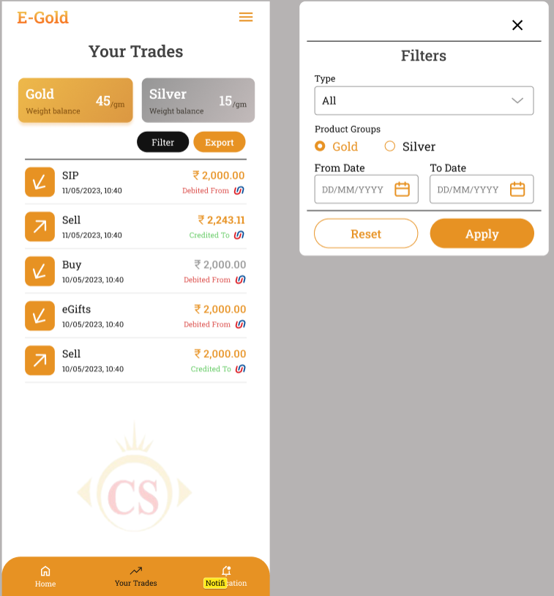

Fig: Your trades

|  |  |  |  |
| --- | --- | --- | --- |
| **FIELDS** | **INPUT TYPE** | **MANDATORY / OPTIONAL** | **DESCRIPTION** |
| Weight Balance | Text | - | It will be read only field.  It will display the total weight in grams for gold and silver that customer has available in his account after making buy / sell / delivery / SIP transactions. |
| Filter | Drop-down | Optional | Customer can filter specific transactions any time.  Once user clicks on filter button, it will display following fields:   * Transaction type * Product Group * From date * To date * Apply button * Reset button   As per selected filter options, once customer clicks on apply button then it should display list of trades accordingly. If customer has selected. Initially all successful transactions will be displayed in the list until users applies filter.  Further, cx will have to click reset button to view all transactions in the list again.  Validation: Once clicked it will be disabled until pop-up to select filter option appears. |
| Filter -> transaction type | Drop down | Mandatory | Customer can view by the type of transactions. It will be display below list:   * All * Buy * SIP * Sell * Delivery * Egifts   It will display the transactions of selected type only once user selects it and clicks on apply button.  Validations : It will be single select. ‘All’ option will be selected by default. |
| Filter -> product group | Radio button |  | Customer can search transactions by product group - gold / silver.  It will display the transactions of selected metal only once user selects it and clicks on apply button.  Validation: It will be single select. |
| Filter -> from date | Calender date picker |  | It should display calender picker from which customer will select the date from which customer wants to view the trades. In ‘from date’ it will display the date from which customer registered into the application.  Validation: Future dates will be disabled. |
| Filter -> to date | Calender date picker | Mandatory | It should display calender picker from which customer will select the date till which customer wants to view the trades.  Validation: Future dates will be disabled. Dates before selected ‘from date’ should be disabled. |
| Apply button | Click | - | As per selected filter options, once customer clicks on apply button then it should display list of trades accordingly. If customer has selected. Initially all successful transactions will be displayed in the list until users applies filter.  Validation: It will be disabled until list of transactions appears as per applied filter. |
| Export | click | Optional | Once customer clicks on export button, it will download the excel file. If customer directly clicks on export, then it will display data of all transactions till the date. If customer applies filter and then clicks on export button, then in excel sheet, it will display data of transactions as per applied filter.  It will display data in following columns in downloaded file:   * Sr No. * Receipt no. * Transaction no. * Transaction date * Transaction time * Transaction type * Product group * Amount * Grams / metal weight in account * Payment mode * Payment ref no / UTR no. * Bank name * Credited / Debited |
| List of trades | View | Mandatory | It will display the list of successful transactions done by the cx through this account.  If there are not transactions, then list will be blank.  For each trade, it should display following details on first view:   * Trade Id I.e receipt ID * Date & time * Trade type (Buy /sell / SIP) * Amount of trade * Credited / debited * Bank name / symbol   Once customer clicks on each trade, it should display the detailed billing information of the trade done.   * Trade ID * Date & time * Trade type * Amount * Grams (grams purchased or grams sold in that trade) * Bank name * Payment reference number * Customer name * Customer ID * Download button * Share button |
| Download button |  |  | Through download button, customer should be able to download bill in pdf format.  Once user clicks on download button, pdf file will get downloaded for that transaction. Cx can download the same transaction receipt multiple times.  Validation: It will be disabled until file gets downloaded. |
| Share button |  |  | Through share button, customer should be able to share bill in pdf format via any share mode available in mobile.  Once user clicks on share button, list of apps through which cx can share the pdf will appear. Cx will select the app through which he/she wants to share the pdf and then cx will be directed to that application.  Cx can share the same transaction receipt multiple times via any sharing app. |
| Email invoice click |  |  | Customer can get the receipt of that transaction sent over email which is registered in his profile.  Once user clicks on email invoice button, pdf will get emailed to the email address mentioned in profile and successful message will be displayed as ‘Invoice sent via email sent successfully’.  Cx can get pdf emailed multiple times. |

1. **Customer master**

Once customer registers through their mobile against particular tenant, it will be displayed in customer master as well with generated customer ID. It will display following fields:

* Export button
* View action
* Edit action
* Preferences action
* Nominee action
* Customer ID
* Tenant name
* Customer name
* Mobile number
* Email
* KYC
* Status
* Account Balance
* Created at
* Updated at & by

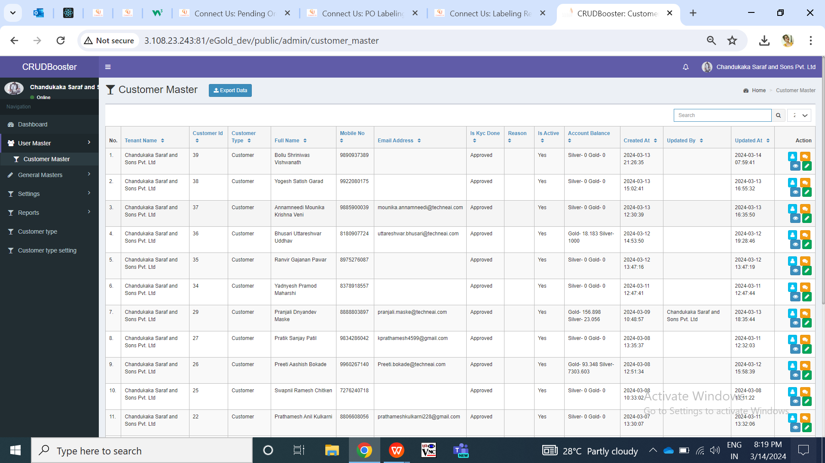

Fig: Customer master

|  |  |  |  |
| --- | --- | --- | --- |
| **FIELDS** | **INPUT TYPE** | **MANDATORY / OPTIONAL** | **DESCRIPTION** |
| Export button | Click | Optional | Tenant admin can download the customer data as in grid.  Once user clicks on export button, user can select the columns needed in exported file and click on submit button so that file will get downloaded. Downloaded file will have the customers details in it as in grid I.e. when cx registered himself.  It will have following columns:   * Customer ID * Tenant name * Customer name * Mobile number * Email * KYC * Status * Account Balance * Created at & by * Updated & by   Validation: Once user clicks on export button, dialogue box will appear to select columns in downloaded file. Once user clicks on export button again, the opened dialogue box will get closed. Submit button will be disabled until file gets downloaded.    Fig: Customer master -> export |
| View action | Click | - | Tenant admin can view the details of each added customer individually through view action. It will display following details:   * Customer ID * Tenant Name * Customer Name * Address * Pin code * Country * State * City * Mobile number * Date of birth * Gender * Email * Occupation * Date of anniversary * Referral Code * Aadhar card number * Pan card number * Password * KYC status * Profile photo * Status * Created at & by * Updated at & by   Validation: All field in view page will be read only.    Fig: Customer master -> view action |
| Edit action | Click | - | Tenant admin can edit the details of the already created customer through edit action here. It will have following fields:    Fig: Customer master -> edit action  Validation: Once tenant admin clicks on edit action, he will be directed to edit page where all fields will be displayed from profile of customer and few fields will be editable. |
| Preferences action | Click | - | Through preferences action, tenant admin can make changes related to communication mode as per customers wish.  Initially, when customer registers himself, then preferences will be blank in web here as well as on app until customer or tenant admin sets his preferences. |
| Nominee action | Click | - | Through nominee action, tenant admin can make changes related to nominee details.  Initially, when customer registers himself, then nominee will be blank in web here as well as on app until customer or tenant admin adds it. |
| Tenant name | Text | Mandatory | It will display the tenant name here against which that customer is registered.  Validation: It will be read only. |
| Customer name | Text | Mandatory | It will display the full name of the customer as per aadhar card when customer registered himself for that tenet.  Validation: It will be read only. |
| Customer ID | Text | Mandatory | It will display the Customer ID when customer registered himself for that tenet.  Validation: It will be read only. It will unique for all. |
| Mobile no. | Text | Mandatory | It will display the mobile number customer entered while registering.  Validation: It will be read only in grid. |
| Email | Text | - | If customer has added email address through profile, then it will be displayed here. Else, if tenant admin has added email address through customer master -> edit -> email, it will be mentioned here.  Validation: It will be read only in grid. |
| Kyc | Text | Mandatory | It will display KYC status as completed as cx are registering themselves using aadhar number.  Validation: It will be read only. |
| Status | Text | Mandatory | It will display whether cx is active or inactive under this tenant. Tenant can edit it from cx master -> edit -> status.  Validation: it will be read only in grid. |
| Created at | Text | Mandatory | It will display the date and time when customer registered himself I.e. when cx data got added and displayed in cx master.  Validation: It will be read only. |
| Updated at | Text | - | It will display the date and time when the tenant admin updated the customer details through cx master -> edit.  Validation: It will be read only. |
| Updated by | Text | - | It will display the name of the user who edited the cx details.  Validation: It will be read only. |

**Customer master -> Edit action**

Through edit action, tenant admin can update the details of the customer. It will have following fields:

* Customer ID
* Tenant Name
* Customer Name
* Address
* Pin code
* Country
* State
* City
* Mobile number
* Date of birth
* Gender
* Email
* Occupation
* Date of anniversary
* Referral Code
* Aadhar card number
* Pan card number
* Profile photo
* Status
* Remark
* Save button
* Back button

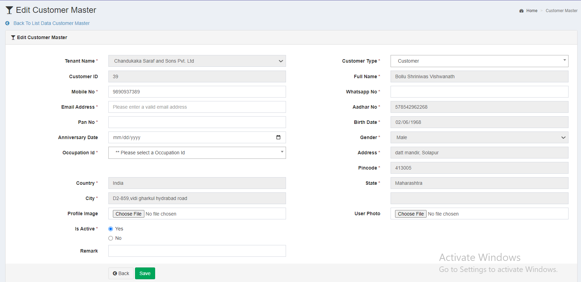

Fig: Customer master -> edit action

|  |  |  |  |
| --- | --- | --- | --- |
| **FIELDS** | **INPUT TYPE** | **MANDATORY / OPTIONAL** | **DESCRIPTION** |
| Cx Id | Text | Mandatory | Once cx is registered, Cx ID gets generated to it by the system and it will be displayed here.  Validation: It will be read only. |
| Tenant name | Text | Mandatory | Once cx registers itself, the tenant name under which cx is registered, it will be displayed here.  Validation: It will be read only. |
| Address | Text | Mandatory | It will display the address of the cx from aadhar number mentioned while registration.  Validation: It will be read only. |
| Pin code | Text | Mandatory | It will display the pin code of the cx from aadhar number mentioned while registration.  Validation: It will be read only. |
| Country | Text | Mandatory | It will display the pin code of the cx from aadhar number mentioned while registration.  Validation: It will be read only. |
| State | Text | Mandatory | It will display the state of the cx from aadhar number mentioned while registration.  Validation: It will be read only. |
| City | Text | Mandatory | It will display the city I.e. vtc or loc of the cx from aadhar number mentioned while registration.  Validation: It will be read only. |
| Mobile number | Text | Mandatory | It will display the mobile number which cx entered while registration. It will be editable from mobile app -> profile as well as from web -> cx master -> edit -> mobile no.  Validation: It will accept numbers only. It should not accept all zeros. It should only accept 7/8/9 at the beginning.  Min & max length = 10. |
| DOB | Calender date picker | Mandatory | It will display the date of birth of the cx as per aadhar number.  Validation: It will be read only. Its format will be DD/MM/YYYY. |
| Gender | Text | Mandatory | It will display the gender of the cx as per aadhar number.  Validation: It will be read only. |
| Email | Text | Mandatory | It will display the email address mentioned by the cx in mobile app -> profile. It will be blank if cx has not added any email address yet. It will be editable in cx master -> edit and through mobile app.  Notifications via email will be sent to the cx on this registered email address.  Validation: This field should accept “ @ - . “ only as special characters. In case of invalid format, it should display on field error message as “Invalid email address”. It shouldn’t accept space.  Min = 6  maximum length = 150. |
| Occupation | Drop down | Mandatory | Tenant admin will mention his occupation. It will be blank if cx has not added any occupation yet. It will be editable in cx master -> edit and through mobile app.  It will display occupations in list from occupation master.  Validation: It will be single select. It will display active occupation names only in the list. |
| DOA | Calender date picker | Optional | Tenant admin will select the date of anniversary if required. It will be blank if cx has not selected any DOA yet. It will be editable in cx master -> edit and through mobile app.  Validation: Only one date can be selected. Future dates will be disabled. Dates before DOB will be disabled. |
| Aadhar card number | Text | Mandatory | It will display the aadhar number mentioned by the cx while registering.  Validation: It is read only. Max length = 12 |
| PAN number | Text | Mandatory | It will be the PAN card number of the cx. It will be blank if cx has not mentioned any PAN number yet. It will be editable in cx master -> edit and through mobile app.  In case of invalid pan card number format, it should display error message as “Invalid pan number”. If user enters same pan number which is already added in another cx account, then it should display on field error message as PAN number already exists.  Validation: Customer will enter 10 digit alphanumeric PAN No. of nominee. PAN number should be unique in cx master. It includes first five letters, followed by 4 numbers and last character. |
| Profile photo | Attach / upload | Optional | It will display the profile image attached by Cx in mobile app -> profile.  Initially when cx registers himself, the profile image field is displayed blank in mobile app and web. Further tenant admin can add image from cx master -> edit or cx can add from profile.  If cx has added profile image, then hyperlink pf profile image will be displayed here through which can view and download it.  Validation: Only one image can be set at a time. It will accept only jpg, png, heic, heif, webp and jpeg extensions only.  Max image size = 2MB |
| Status | Radio button | mandatory | It will display whether cx is active or inactive under this tenant. Only tenant admin can change the status of the cx.  Inactive cx won’t be able to log into the mobile app. It will display alert message to cx as ‘account deactivated’. |
| Remark | Text | Optional | Tenant admin can mention the additional comments here if required.  Validation: It will accept alphanumeric value with space and special characters.  Min length = 0  Max length = 250 |
| Save | Click | - | Once tenant admin enters valid details and clicks on save button, cx details will be saved and displayed in mobile app -> profile, cx master -> edit, grid and view page.  If invalid details are entered in any single field and tenant admin clicks on save button, on field error message will be displayed where data is incorrect. |
| Back | Click | - | Once user clicks on back, tenant admin will be redirected to cx master -> grid without saving any data. |

**Customer master -> Nominee action**

Tenant admin can view and update the nominee details of the customer through nominee action here. It will have following fields:

* Nominee name
* Nominee email
* Nominee mobile no.
* Nominee DOB
* Nominee relation
* Nominee aadhar
* Nominee PAN number
* Nominee address
* Save button

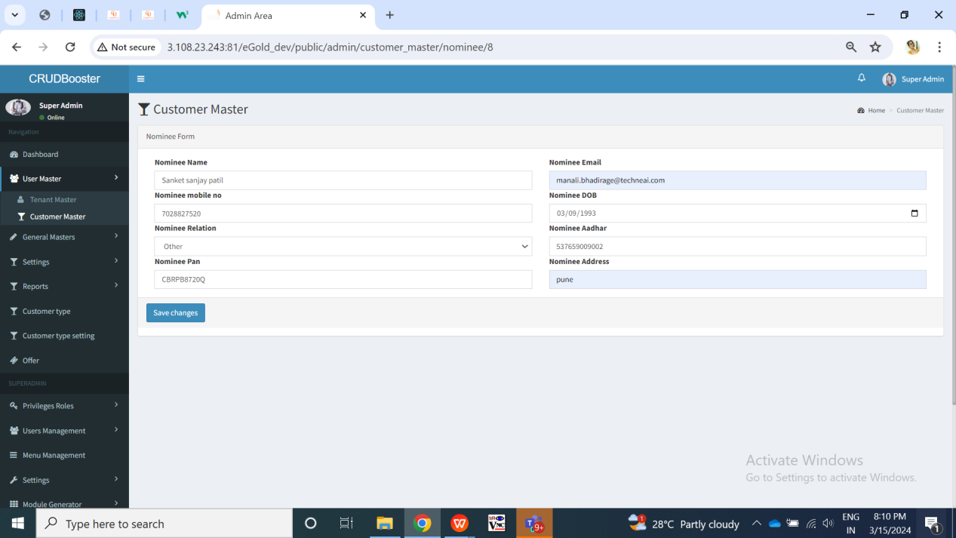

Fig: Customer master -> nominee action

|  |  |  |  |
| --- | --- | --- | --- |
| **FIELDS** | **INPUT TYPE** | **MANDATORY / OPTIONAL** | **DESCRIPTION** |
| Nominee name | Text | Mandatory | Customer will enter the name of the nominee he wants to add through mobile app or else tenant admin can enter nominee name through cx master -> nominee. It will be blank if cx has not mentioned any nominee name through mobile app. It will be editable in cx master -> nominee and through mobile app.  Validations: It should accept characters and space only. It should not accept space initially.  Min length = 2  Max length = 100 |
| Full Address | text | mandatory | Customer will enter the address of the nominee he wants to add through mobile app or else tenant admin can enter nominee name through cx master -> nominee. It will be blank if cx has not mentioned any nominee address through mobile app. It will be editable in cx master -> nominee and through mobile app.  Validation: It will accept maximum 250 characters / numbers. It should accept single space only after each word. It should accept . / - , special characters only. |
| Date of Birth | Calendar picker | Mandatory | Customer will enter the DOB of the nominee he wants to add through mobile app or else tenant admin can enter nominee DOB through cx master -> nominee. It will be blank if cx has not mentioned any nominee name through mobile app. It will be editable in cx master -> nominee and through mobile app.    Validation: Future dates should be disabled. It should display dates from 01-01-1924 to current date. |
| Relation with nominee | Text | Mandatory | Customer will choose his relation with the nominee from the drop-down as mother / father / sister / brother / daughter / spouse / son/ other. Customer will enter the relation of the nominee he wants to add through mobile app or else tenant admin can enter nominee DOB through cx master -> nominee. It will be blank if cx has not mentioned any nominee relation through mobile app. It will be editable in cx master -> nominee and through mobile app.  Validation: It will be single select. |
| PAN number | text | Optional | Customer will enter the pan number of the nominee he wants to add through mobile app or else tenant admin can enter nominee pan number through cx master -> nominee. It will be blank if cx has not mentioned any nominee name through mobile app. It will be editable in cx master -> nominee and through mobile app.  Validation: One nominee’s pan number can same as nominee of another person. It includes first five letters, followed by 4 numbers and last character. In case of invalid pan card number format, it should display error message as “Invalid pan number”. |
| Aadhar card number of nominee | Text | Mandatory | Customer will enter the aadhar number of the nominee he wants to add through mobile app or else tenant admin can enter nominee aadhar number through cx master -> nominee. It will be blank if cx has not mentioned any nominee name through mobile app. It will be editable in cx master -> nominee and through mobile app.  One Aadhar no. should be entered only once. customer will have to enter unique Aadhar no. Customer cannot mention same already entered aadhar number for another nominee. Also, it cannot be as same as registered user’s aadhar number.  In case of invalid aadhar card number format, it should display error message as “Invalid aadhar number”. |
| Nominee mobile no. | text | mandatory | Customer will enter nominee’s mobile number through mobile app or tenant admin can enter it through web -> cx master -> nominee settings. It can be same as customer’s number from profile.   Validation: It can be same. It should accept 7/8/9 only at the beginning. It should not accept space or characters or special characters. Min & Max length = 10 |
| Nominee’s Email ID | text | Optional | Customer will enter nominee’s email ID or tenant admin will enter through cx master -> nominee settings. It can be same as customer’s number from profile.  Validation: It can be same. It should not accept space. It should accept special characters -_@. only. Min length = 11  Max length = 100 |
| Save | Click | - | Once tenant admin clicks on save, nominee settings will get saved / updated and displayed in mobile app -> nominee settings to the cx and on web -> cx master -> nominee.  Validation: Tenant admin will get directed to save grid page once user clicks on save button and successful message is displayed. It will display on field error message if invalid details are entered. Save button will be disabled until details are saved or error message is displayed. |

**Customer master -> Preferences action**

Customer can add preference settings through mobile app from his own end which will be displayed to tenant admin through web cx master -> preference settings. It will have following fields:

* Communication mode
* Call timings
* Communication language
* Notification permissions

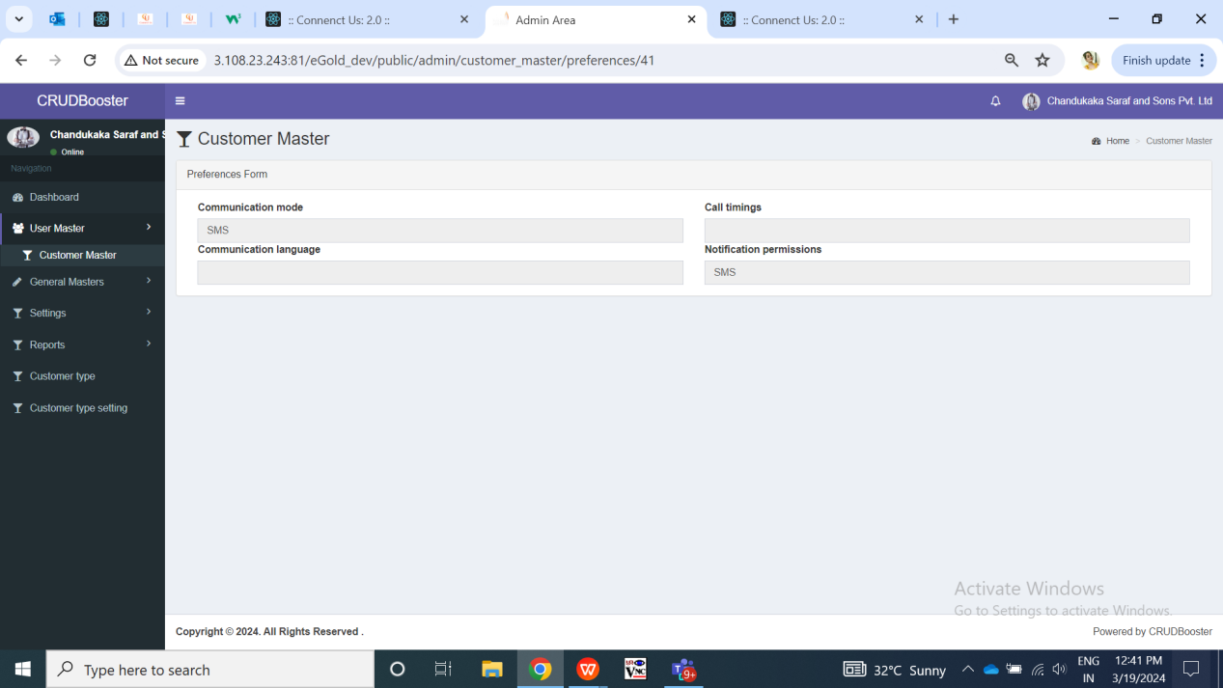

Fig: Customer master -> preferences

|  |  |  |  |
| --- | --- | --- | --- |
| **FIELDS** | **INPUT TYPE** | **MANDATORY / OPTIONAL** | **DESCRIPTION** |
| Communication mode | Text | - | Initially when cx has registered, its default communication mode will be displayed as SMS. Further, when cx sets his communication modes, it will be displayed in the same sequence in web.  Validation: It will be read only in web. |
| Call timings | Text | - | It will display the timings set by the customer for call. It will be displayed in 24 hours clock.  Validation: It will be read only in web. |
| Communication language | Text | - | It will display the languages set by the customer for call. Once cx updates it through mobile app, it will be displayed accordingly on web.  Validation: It will be read only in web. It will be single value. |
| Notification permissions | Text | - | Initially when cx has registered, its default notifications permission will be displayed as SMS. Further, when cx add another mediums, it will be displayed in the same sequence in web.  Validation: It will be read only in web. |

1. **Default settings**

Default settings will be accessible to super-admin only. Super admin will add default settings. Once tenant is created, tenant settings for that tenant gets created whereas it will display value for all the settings from default settings initially. Tenant will either keep value for settings from default or else can edit it from their own end. If tenant removes any tenant setting value, then it will display default value settings to their customers if tenant admin has selected option to take value from default value.

Default settings will have following fields:

* Module name
* Sub module name
* Setting name
* Setting data type
* Default value
* Possible values
* Sort order
* User can change
* Use encryption
* Remark
* Is active
* Save & add more button
* Save button

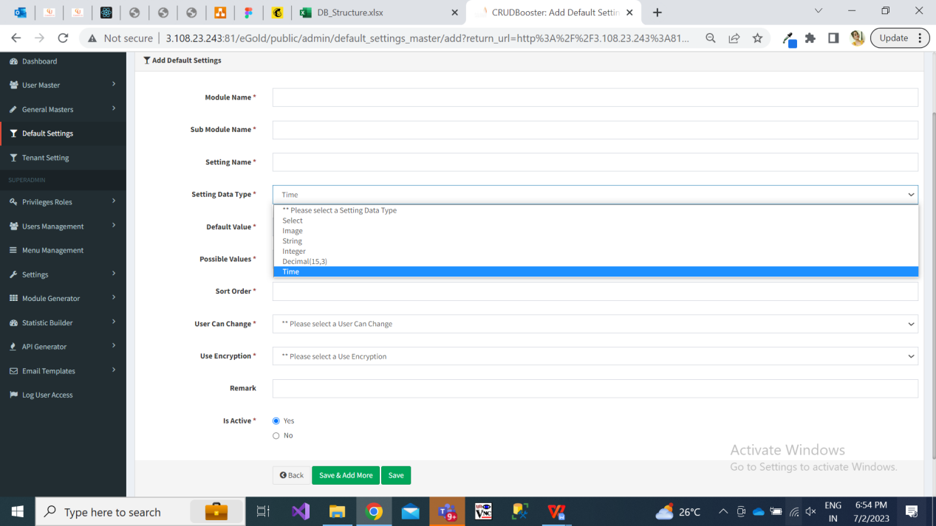

Fig: Add default settings

|  |  |  |  |
| --- | --- | --- | --- |
| **FIELDS** | **INPUT TYPE** | **MANDATORY / OPTIONAL** | **DESCRIPTION** |
| Module name | text | Mandatory | Super admin will enter the module name referring to which the setting is about.  Validation:  Min length = 5  Max length = 50 |
| Sub module name | text | Mandatory | Super admin will enter the sub-module name referring to which the setting is about. |
| Setting name | text | Mandatory | Super admin will enter the setting name referring to which the setting is about.  Validation: It should be unique.  Min length = 5  Max length = 50 |
| Setting data type | Drop-down | mandatory | It will be the data type of setting we are reffing to.   * Image * Select * String * Int * Decimal * Time   Example: If setting is about image like displaying logo, then super admin will select data type as image.  If setting is about text field, then super admin will select string.  If setting is about timing, then super admin will select time. Example: If tenant wants to set start time and end time during which customers can make transactions, then tenant will select data type as time for such setting.  Validation: It will be single select. |
| Default value | text | Mandatory | Super admin will enter the default value as per data type.  Means, by default which image / text should be displayed in the selected setting.  Validation:  Min length = 1  Max length = 50 |
| Possible values | text |  | This field will be displayed only if super admin selects data type as ‘select’. |
| User can change | Drop down | Mandatory | It will display yes / no. Means, whether tenant can change it or not through tenant settings -> edit action. |
| Use encryption | Drop down | Mandatory | It will display yes / no to display encrypted data for selected field on customer’s page. |
| remark | text | Optional | Super admin will mention additional comments in this text field.  Validation: It should accept alphanumeric value, space and special characters.  Max length =250 |
| Is active | Radio button | mandatory | By default it will display as active.  Once the particular default setting is deactivated then this field won’t be editable to tenant.  Further, if any default setting is deactivated by super admin, then that setting will be disabled in tenant setting as well. Whereas, that deactivated setting will be reflected as blank to new customers as well as already existing customers.  Validation: It will be single select. |
| Save button | click |  | Once super admin clicks on save button, then as per settings & development in database, the default setting will get added and the same will get reflected against each active tenant in tenant settings.   Also, default settings will be displayed to customers until their tenant hasn’t changed the particular setting from tenant settings.  Validation: save button should be disabled once clicked until record gets added or error message is displayed. |

1. **Tenant settings**

Initially, tenant will get all default settings further which tenant can edit them. If any changes are not made in settings by tenant, then respective customers of that tenant will get view on application as per default settings.

Once tenant log into web application by their credentials, tenant admin will have access to tenant settings menu. It will have following fields in grid for each available setting:

* Tenant id
* Setting name
* Setting value
* Remark
* Is active
* Created at & by
* Updated at & by
* Edit action
* View action

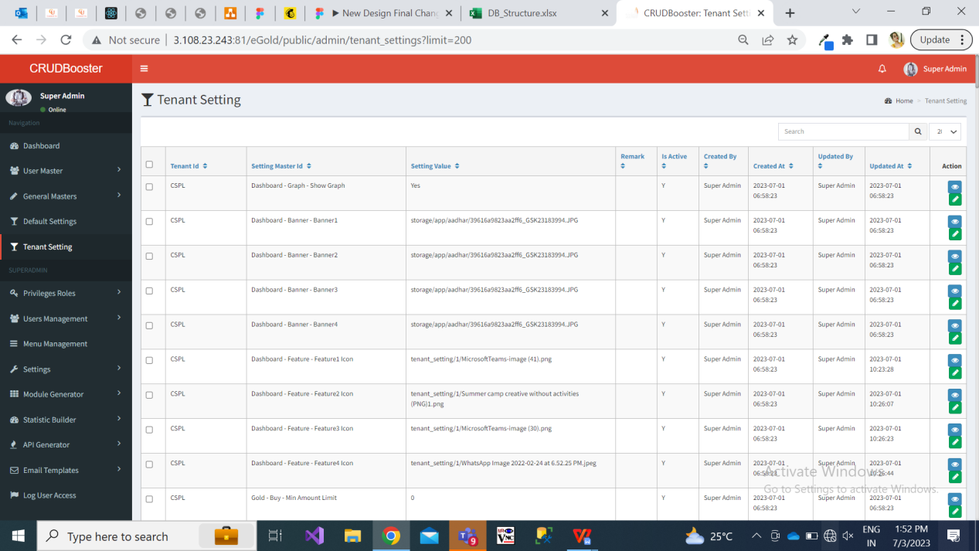

Fig: Tenant setting

Once user clicks on edit action of tenant setting, it will display following pre-filled fields:

* Setting name
* Setting value
* Remark
* Is active

|  |  |  |  |
| --- | --- | --- | --- |
| **FIELDS** | **INPUT TYPE** | **MANDATORY / OPTIONAL** | **DESCRIPTION** |
| Setting name | Text | Mandatory | It will display the setting name as mentioned by the super admin.  Validation: It will be read only. |
| Setting value | Text / Attach | Mandatory | Initially it will display the default setting value for that selected setting name as set by the super admin. Whereas, tenant admin can edit it.  If the setting is attachment, then user will upload the image. The attached image will be displayed to the customers of that tenant.  If the setting name is text, then it will display the limits and amount as here.  If user removes the value from here then if the check-box for that  Validation: It should accept numbers only in case of limits, age, time settings. It should accept single image only in case of attachment settings with extensions png, jpeg, jpg, heic, webp formats only. |
| Remark | Text | Optional | Tenant admin will mention the additional comments here if required.  Validation: It should accept characters, space, numbers and special characters.  Min length = 0  Max length = 250 |
| Save | Click | - | Once user clicks on save button, then it will display the set value to the customers on application. |

Currently, below settings will be configurable as per tenant:

* Tenant Config--Logo
* Tenant Config--Backgroup_image
* UI-Dark Mode-fore_color (font color)
* UI-Dark Mode-back_color (buttons, footer, hamburger)
* UI-Light Mode-fore_color (font color)
* UI-Light Mode-back_color (buttons, footer, hamburger)
* Tenant Config-Commodity-Gold
* Tenant Config-Commodity-Silver
* Dashboard--Show Graph
* Dashboard-Banner-Banner1
* Dashboard-Banner-Banner2
* Dashboard-Banner-Banner3
* Dashboard-Banner-Banner4
* Mobile App-Funcationality-SIP
* Mobile App-Funcationality-Buy
* Mobile App-Funcationality-Sell
* Mobile App-Funcationality-Rate Trigger
* Dashboard-Feature-Feature1 Icon
* Dashboard-Feature-Feature2 Icon
* Dashboard-Feature-Feature3 Icon
* Dashboard-Feature-Feature4 Icon
* Timing-Booking-Start Time
* Timing-Booking-End Time
* Gold-Buy-Min Amount Limit
* Gold-Buy-Min Grams Limit
* Gold-Sell-Min Amount Limit
* Gold-Sell-Min Grams Limit
* Silver-Buy-Min Amount Limit
* Silver-Buy-Min Grams Limit
* Silver-Sell-Min Amount Limit
* Silver-Sell-Min Grams Limit
* Gold-Delivery-Min Grams Limit
* Gold-Delivery-Delivery Multiple of
* Silver-Delivery-Min Grams Limit
* Silver-Delivery-Delivery Multiple of
* Gold-Delivery-Delivery Charges
* Silver-Delivery-Delivery Charges
* Security-Transaction-Delay between buy and sell
* Tenant Config-WhatsApp-Provider
* Tenant Config-WhatsApp-Number
* Tenant Config-WhatsApp-Key
* Tenant Config-WhatsApp-Key1
* Tenant Config-SMS-Sender ID
* Tenant Config-SMS-Provider
* Tenant Config-SMS-User Name
* Tenant Config-SMS-Password
* Security-Transaction-Max Amount in one transaction
* Statutory-Pan Card required-Limit
* Statutory-TCS-TCS %
* Statutory-TCS-Limit
* Mobile App-Contact-Mobile No
* Mobile App-Contact-Email ID
* Tenant Config-Rate-Refresh Time in seconds
* Security-KYC-Mandatory for transaction
* Tenant Config-Payment Gateway-Provider
* Tenant Config-Payment Gateway-User Name
* Tenant Config-Payment Gateway-Salt Key
* Tenant Config-KYC-Min Age of Customer
* Tenant Config-Monthly SIP-Min Amount
* Tenant Config-Monthly SIP-Multiple Amount
* Tenant Config-Monthly SIP-Min Month
* Tenant Config-Monthly SIP-Max Month
* Delivery functionality
* Buy terms and conditions
* Sell terms and conditions

In banners, at-least one banner will be mandatory.

In features, at-least two features will be mandatory.

Through help desk, customers emails will get sent on email address mentioned in email ID setting by tenant.

1. **Buy report**

It will display the buy transactions done by the customers under that tenant. Once customer initiates the transactions from mobile app, its record will be displayed here and once the transactions is successful by the payment gateway its status gets updated. It will display following fields:

* Export data
* Tenant ID
* Tenant name
* Customer ID
* Cx name
* Transaction type
* Product group
* Transaction ID
* Transaction status
* Purchased grams
* Final bill amount
* Transaction date
* Payment mode
* Receipt
* View action

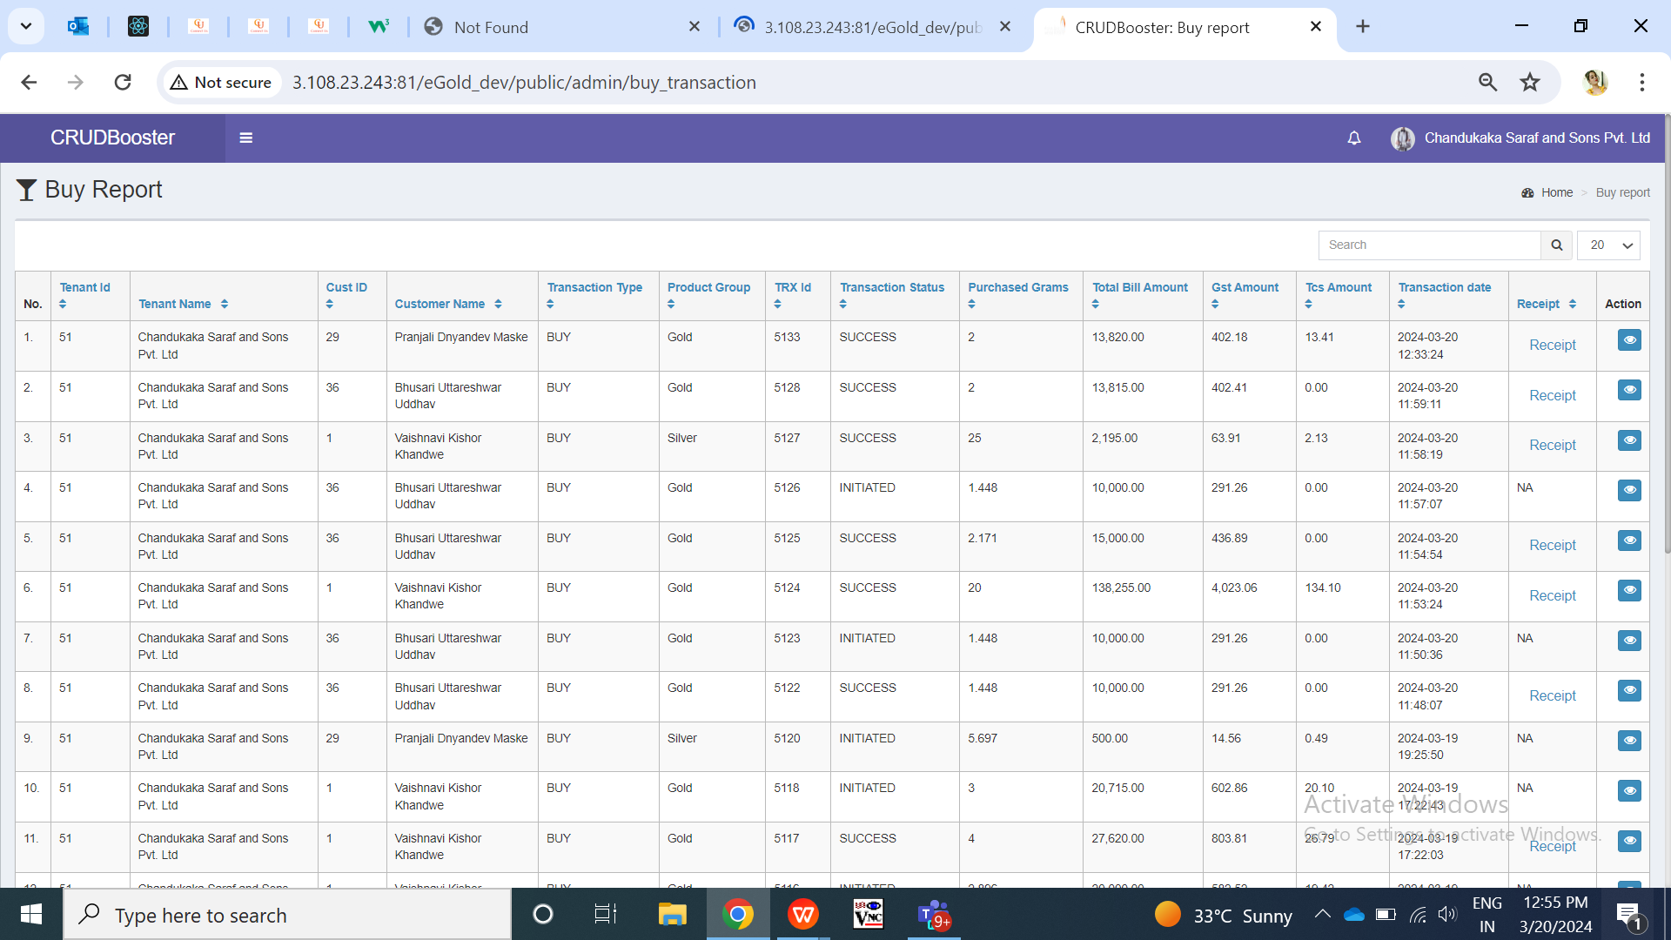

Fig: Buy Report

It will display following fields once cx clicks on view action:

* Tenant ID
* Tenant name
* Customer ID
* Cx name
* Transaction type
* Product group
* Transaction ID
* Transaction status
* Purchased grams
* Current Metal rate
* Metal amount
* GST amount
* Total amount
* Round up amount
* TCS %
* TCS amount
* Final bill amount
* Transaction date
* Transaction time
* Payment mode
* Receipt

|  |  |  |  |
| --- | --- | --- | --- |
| **FIELDS** | **INPUT TYPE** | **MANDATORY / OPTIONAL** | **DESCRIPTION** |
| Export data | Click | - | Once user clicks on export data button, then list of all the records will get displayed in downloaded csv file as in grid. It will have following columns:   * Tenant ID * Tenant name * Customer ID * Cx name * Transaction type * Product group * Transaction ID * Transaction status * Purchased grams * Current Metal rate * Metal amount * GST amount * Total amount * Round up amount * TCS % * TCS amount * Final bill amount * Transaction date * Transaction time * Payment mode |
| Tenant ID | Text | Mandatory | It will display the tenant ID of the logged in tenant as per tenant master as the transactions are being displayed for the logged in tenant itself.    Validation: It will be read only. |
| Tenant name | Text | Mandatory | It will display the tenant name of the logged in tenant as per tenant master as the transactions are being displayed for the logged in tenant itself.  Validation: It will be read only. |
| Customer ID | Text | Mandatory | It will display the Customer ID from customer master who has done that transaction.  Validation: It will be read only. |
| Customer name | Text | Mandatory | It will display the Customer name from customer master who has done that transaction.  Validation: It will be read only. |
| Transaction type | Text | Mandatory | It will display type as buy here in all records as only buy transactions will be displayed in this report.  Validation: It will be read only. |
| Product group | Text | Mandatory | It will display the metal type of the transaction I.e either gold or silver when cx processed it.  Validation: It will be read only. |
| Transaction ID | Text | Mandatory | It will display the transaction ID when cx processed the transaction from his end. It will display the order ID when the transaction is initiated whereas it will display the transaction ID when transaction is successful by the payment gateway.  Validation: It will be read only. |
| Transaction status | Text | Mandatory | Initially when cx performs transaction of buy, its record gets displayed here with initiated transaction status. Further, the transaction gets successful through the payment gateway then its status gets updated as success. Else, its gets displayed as delayed or failure as per payment gateway response.  Once transaction status is successful, grams of the buy transaction will get added and displayed in customer’s weight balance. Successful Transaction will be displayed in your trades to customer and notification will be sent to the cx.  Validation: It will be read only. |
| Purchased grams | Text | Mandatory | It will display the metal weight entered / got calculated while performing that buy transaction. It will display in grams.  Validation: It will be read only. |
| Current metal rate | Text | Mandatory | It will display the per gram current rate of metal when that transaction was performed. It will display in grams.  Validation: It will be read only. |
| Metal amount | Text | Mandatory | It will display the metal amount of that transaction where metal amount = metal weight * current rate per gram. It will display in grams.  Validation: It will be read only. |
| GST amount | Text | Mandatory | It will display the GST amount of that transaction where GST amount = metal amount * 3%.  Validation: It will be read only. |
| Total amount | Text | Mandatory | It will display the total amount of that transaction where total taxable amount = metal amount + GST amount.  Validation: It will be read only. |
| Round up amount | Text | - | It will display the total round up which has to be deducted for final bill amount.  Validation: It will be read only. |
| TCS % | Text | - | TCS will get applicable only of the amount of that cx has reached more then the TCS limit set in tenant settings. It will display the TCS % set by the tenant from tenant settings.  If TCS is not applicable than, it will display 0. |
| TCS amount | Text | - | Once the total transaction amount of current financial year exceeds TCS limit amount, then TCS limit will be applicable on the amount which is above the limit.  TCS amount = Extra amount * TCS%  Example: Transactions done till the date by cx is 460000. TCS limit set by tenant is 500000. Cx is making transaction of 1,80,000.  Then, as per his current transaction his purchase amount if going to 460000 + 1,80,000 = 540000. TCS will get applicable for extra 1,40,000 amount. Thus, 0.1% of 1,40,000 = 140/-. Further onwards, TCS will get considered for that particular transaction. |
| Final bill amount | Text | Mandatory | It will display the final bill amount of that transaction where final bill amount = Total amount - Round Up + TCS amount. It will display in grams.  Validation: It will be read only. |
| Transaction date | Text | Mandatory | It will display the date when that transaction was processed by the cx.  Validation: It will be read only. It will be displayed in DD/MM/YYYY format. |
| Transaction time | Text | Mandatory | It will display the time when that transaction was processed by the cx.  Validation: It will be read only. It will be displayed in HH:MM:SS format. |
| Payment mode | Text | Mandatory | It will display the payment mode by which that transaction was processed. It will display either wallet / UPI / Net banking / Card.  Validation: It will be read only. |
| Receipt | Hyperlink | Mandatory | It will display the hyperlink of the receipt which gets generated when cx processes the transaction and gets displayed in your trade. It will have download button to it. Once user clicks on download button, PDF format of the receipt will get downloaded which will have all the details of the transaction.   * Customer name * Transaction type * Product group * Transaction ID * Transaction status * Purchased grams * Current Metal rate * Metal amount * GST amount * Total amount * Round up amount * TCS % (if applicable) * TCS amount (if applicable) * Final bill amount * Transaction date * Transaction time * Payment mode   Validation: Downloaded file will have PDF extension. |

1. **Sell report**

Once the customers initiates sell transactions through mobile, its records will be displayed in sell report for that tenant. It will have following fields:

* Upload file
* Export data
* Tenant ID
* Tenant name
* Customer ID
* Cx name
* Transaction type
* Product group
* Transaction ID
* Transaction status
* Sold grams
* Final bill amount
* Transaction date
* View action
* Edit action

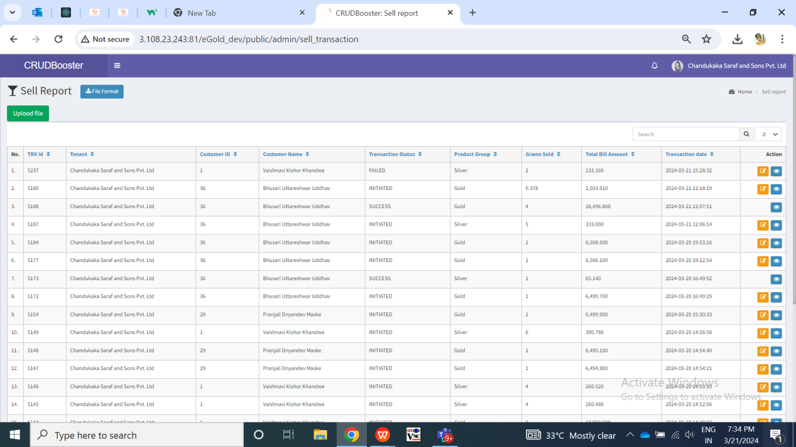

Fig: Sell report

Once tenant admin clicks on view action, it will display following fields:

* Tenant ID
* Tenant name
* Customer ID
* Cx name
* Transaction type
* Product group
* Transaction ID
* Transaction status
* Sold grams
* Current selling rate (per gram)
* Final bill amount
* Transaction date
* Credited to bank
* Receipt
* Payment date
* ERP reference no.
* ERP reference date
* Updated at
* Updated by

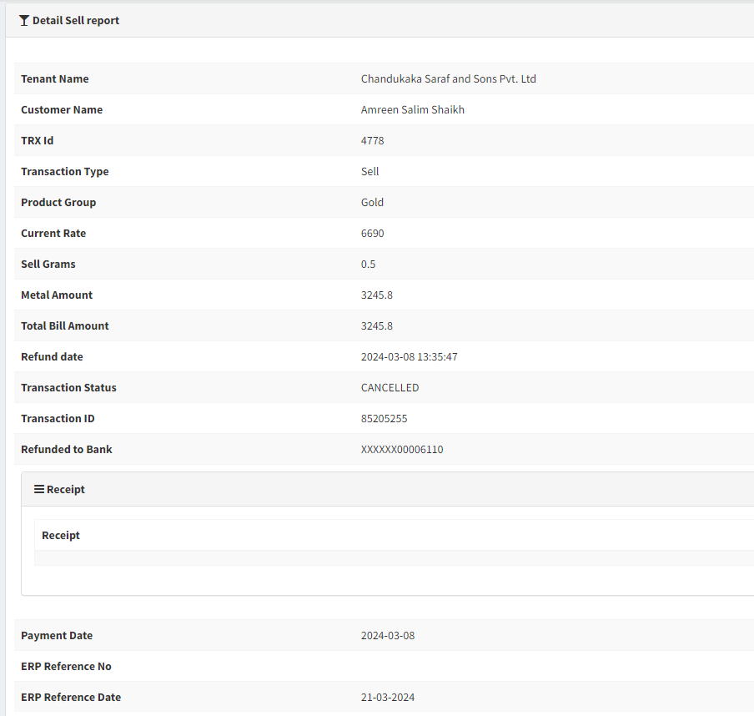

Fig: Sell report -> view action

Once tenant admin clicks on edit action, it will display following fields:

* Tenant ID
* Tenant name
* Customer ID
* Cx name
* Transaction type
* Product group
* Transaction ID
* Sold grams
* Current selling rate (per gram)
* Final bill amount
* Transaction date
* Credited to bank
* Transaction status
* Payment date
* ERP reference no.
* ERP reference date
* Save button
* Back button

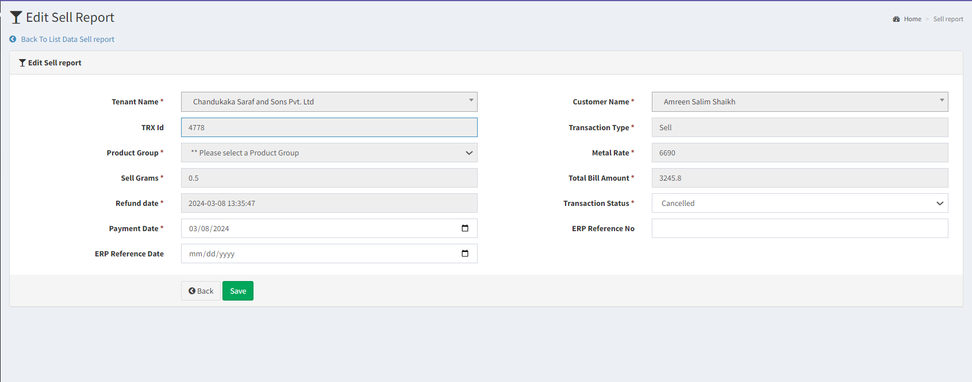

Fig: Sell report -> edit action

|  |  |  |  |
| --- | --- | --- | --- |
| **FIELDS** | **INPUT TYPE** | **MANDATORY / OPTIONAL** | **DESCRIPTION** |
| Export data | Click | - | Once user clicks on export data button, then list of all the records will get displayed in downloaded csv file as in grid. It will have following columns:   * Tenant ID * Tenant name * Customer ID * Cx name * Transaction type * Product group * Transaction ID * Transaction status * Sold grams * Final bill amount * Transaction date * Credited to bank * Receipt * Payment date * ERP reference no. * ERP reference date * Updated at * Updated by |
| Upload file | Attach | - | When tenant admin want to update the transaction details of the customers in bulk, transaction file will be uploaded here. Once user uploads the file, then payment status, payment date, ERP ref number, ERP payment date of the mentioned customers will get updated in bulk. It will have following details:   * Cx name * DOB * Amount * Cx bank name * Cx bank account number * Payment date * ERP reference no. * ERP reference date * Transaction status   Validation: It will accept text, excel, csv and doc file only. It will accept single file only. |
| Edit action | Click | - | Tenant admin can enter the payment details and change the status through edit action. Once the transaction status is successful, then edit action against that record will be removed from grid.  Validation: Once user clicks on edit action of any particular record, button will be disabled and user will be directed to edit page of it. |
| Tenant ID | Text | Mandatory | It will display the tenant ID of the logged in tenant as per tenant master as the transactions are being displayed for the logged in tenant itself.  Validation: It will be read only. |
| Tenant name | Text | Mandatory | It will display the tenant name of the logged in tenant as per tenant master as the transactions are being displayed for the logged in tenant itself.  Validation: It will be read only. |
| Customer ID | Text | Mandatory | It will display the Customer ID from customer master who has done that transaction.  Validation: It will be read only. |
| Customer name | Text | Mandatory | It will display the Customer name from customer master who has done that transaction.  Validation: It will be read only. |
| Transaction type | Text | Mandatory | It will display type as sell here in all records as only sell transactions will be displayed in this report.  Validation: It will be read only. |
| Product group | Text | Mandatory | It will display the metal type of the transaction I.e either gold or silver when cx processed it.  Validation: It will be read only. |
| Transaction ID | Text | Mandatory | It will display the transaction ID when cx processed the transaction from his end.  Validation: It will be read only. |
| Sold grams | Text | Mandatory | It will display the grams of metal that was entered by the cx for sell transaction. It will be displayed in grams.  Validation: It will be read only. |
| Current selling rate (per gram) | Text | Mandatory | It will display the selling rate of per gram for that metal when cx processed that sell transaction.  Validation: It will be read only. |
| Final bill amount | Text | Mandatory | It will display the total final bill amount of that transaction where final bill amount = current metal rate * sold grams.  Validation: It will be read only. |
| Transaction date | Text | Mandatory | It will display the date on which that transaction was initiated by cx.  Validation: It will be read only. It will display in format of DD/MM/YYYY. |
| Credited to bank | Text | Mandatory | It will display the bank account which cx selected for credit to be received.  Validation: It will be read only. |
| Transaction status | Drop down | Mandatory | Initially, when transaction is initiated by cx its status will be displayed as ‘initiated’. Further, it will display status as per payment gateway. Once the transaction status is marked as successful manually or through uploaded file, then edit action will be removed against it.  Once transaction is successful, weight balance of that metal will get displayed in cx’s account. Transaction will be displayed in your trades to customer and notification will be sent to the cx.  Validation: It will be single select. |
| Payment date | Calender date picker | Mandatory | It refers to the payment date when the transaction was successful and cx received the amount in bank account.  Tenant admin can manually select it or it will updated through uploaded bulk file.  Validation: Future dates will be disabled. Dates before transaction date will be disabled. It will be displayed in format of DD/MM/YYYY. |
| ERP reference no. | Text | Optional | As this for CSPL reference, they will enter the Padm reference no. Of the cx for that transaction.  Tenant admin can manually enter it or it will get updated through uploaded bulk file.  Validation: It will be alphanumeric value and should not accept space or special characters.  Min length = 1  Max length = 50 |
| ERP payment date | Text | Optional | As this for CSPL reference, they will enter the ERP payment date. Of the cx for that transaction means when the record of this transaction was added in ERP.  Tenant admin can manually enter it or it will get updated through uploaded bulk file.  Validation: Future dates will be disabled. Dates before transaction date will be disabled. It will be displayed in format of DD/MM/YYYY. |
| Save button | Click | - | Once user enters mandatory fields and clicks on save, the data will be saved and successful message will be displayed. Tenant admin will be directed to grid page of sell report. |
| Receipt | hyperlink | - | It will display the hyperlink of the receipt which gets generated when cx processes the transaction and it gets displayed in your trade after being successful. It will have download button to it. Once user clicks on download button, PDF format of the receipt will get downloaded which will have all the details of the transaction.   * Customer name * Transaction type * Product group * Transaction ID * Transaction status * Transaction initiated date & time * Sold grams * Selling Metal rate (per gram) * Final bill amount * Payment date & time   Validation: Downloaded file will have PDF extension. |
| Updated by | Text | - | It will display the name who updated the transaction details.  Validation: It will be read only. |
| Updated at | Text | - | It will display the date and time when the transaction details were updated either manually or through bulk file.  Validation: It will be read only. It will be displayed in format DD/MM/YYYY HH:MM:SS. |

1. **Delivery report**

All delivery transactions initiated by the cx through app will be displayed in delivery report to that tenant. Tenant admin can view the delivery transaction details and change the delivery status. It will have following fields:

* Export data
* Tenant ID
* Tenant name
* Customer ID
* Cx name
* Transaction type
* Product group
* Transaction ID
* Delivery grams
* Transaction date
* Transaction status
* Delivery status
* Delivery date
* View action
* Edit action

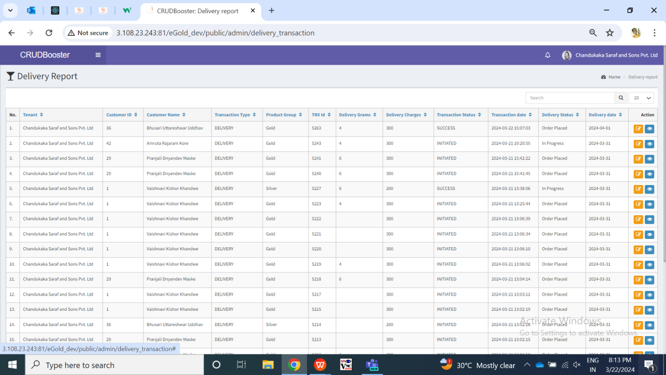

Fig: Delivery report -> grid

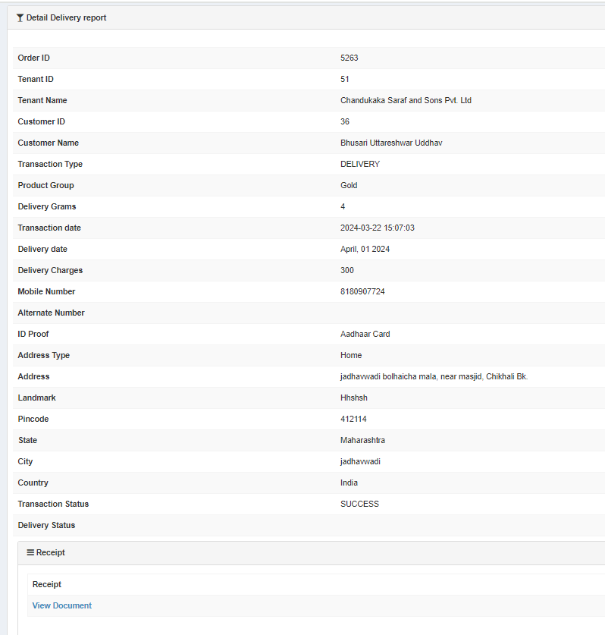

Fig: Delivery report -> view action

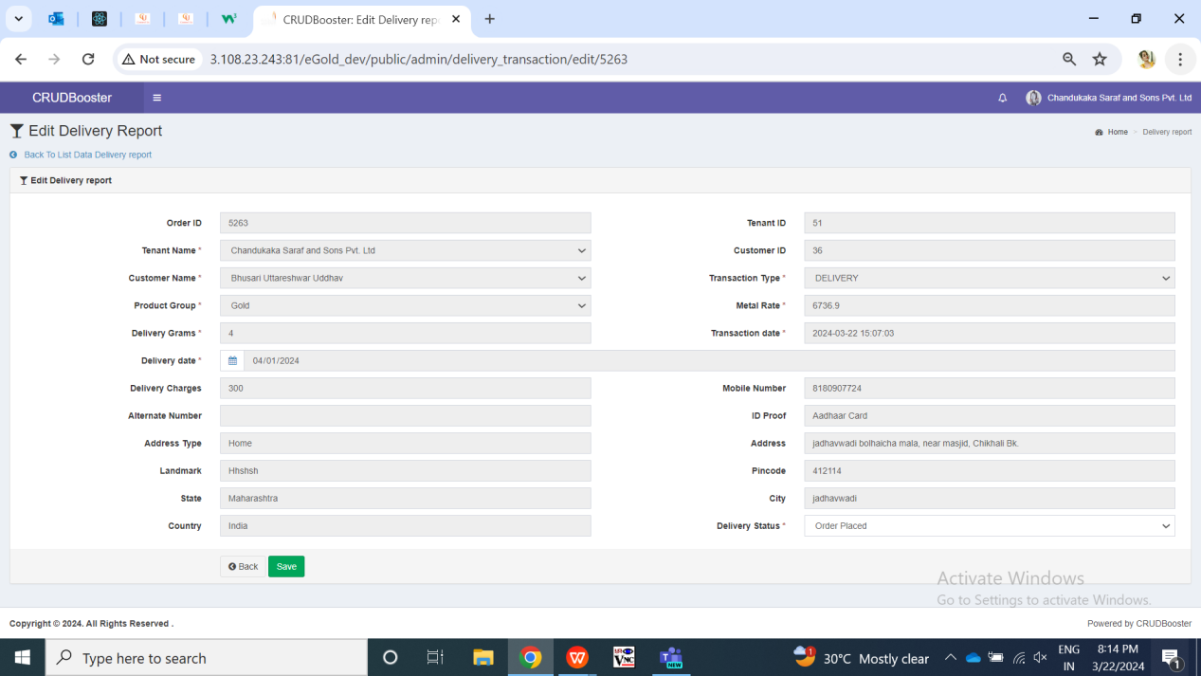

Fig: Delivery report -> edit action

1. **SIP report**
2. **Customer ledger report**

Through customer ledger report, tenant admin will view all the detailed transactions done by the specific customer in selected dates. It will help tenant admin to analyze the transactions customer wise and know opening and closing balance for each cx as per selected dates. It will have following fields:

* From Date
* To Date
* Metal type
* Customer name
* Filter button
* Reset button
* Export button
* Sr. No.
* Transaction Date
* Metal type
* Transaction type
* Metal weight
* Weight balance

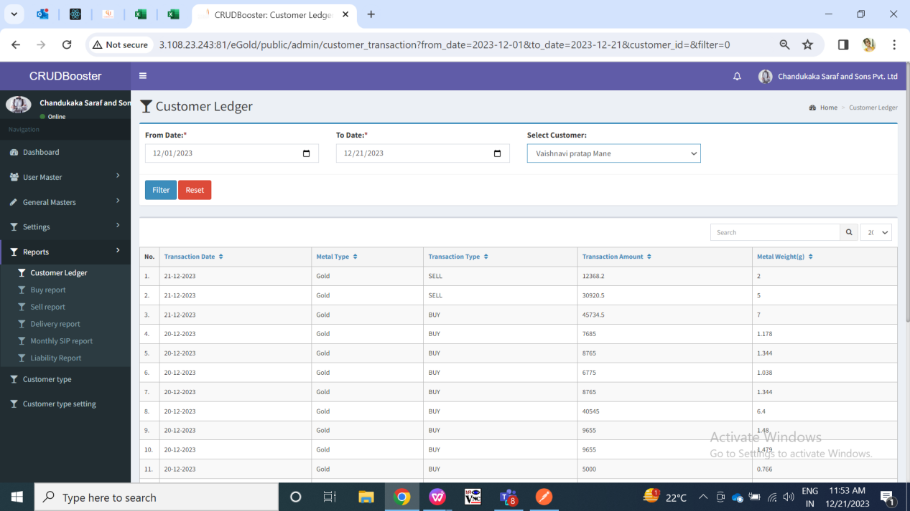

Fig: Customer ledger report

|  |  |  |  |
| --- | --- | --- | --- |
| **FIELDS** | **INPUT TYPE** | **MANDATORY / OPTIONAL** | **DESCRIPTION** |
| From Date | Calender date picker | Optional | Tenant admin will select the date from which they wants to view report from.  Validation: Future dates will be disabled. It will be single select. |
| To date | Calender date picker | Optional | Tenant admin will select the date till which they wants to view report.  Validation: Future dates will be disabled. It will be single select. |
| Metal type | Drop down | Mandatory | User can view report by specific metal gold / silver or both. It will display the transactions in the report as per selected.  If user keeps this field blank, then it will display transactions of both metal types.  Validation: It will be single select. |
| Customer name | Drop down | Optional | It will display the ID and customer name from customer master of that tenant admin only.  Tenant admin will select the customer for which he wants to view the report.  Tenant admin should be able to search the customer by entering name.  Validation: It will be single select. It will display the list of customers registered under that tenant. |
| Filter button | Click | - | Once user clicks on filter button, all the details of the transactions done by the selected user will be displayed below in grid.   * Sr. No. * Customer ID * Customer Name * Transaction Date * Metal type * Transaction type * Transaction amount * Metal weight * Weight balance   Here first row will display the opening balance of that cx on the selected from date for selected metal type. Last row will display the closing balance as per selected ‘till date’ for specific metal type. Transactions records will be displayed in between opening balance top row and closing balance bottom row.  Validation: If user clicks on filter button then it will display transactions of each customer in the grid, else report will be blank initially. |
| Reset button | Click | - | Once user clicks on reset button, page will get reloaded and all the data in grid will be cleared so that user can select fields.  Validation: It will be disable until page gets reloaded and all pre-filled fields gets cleared. |
| Export button | Click | - | Once user applies filter and data appears in grid, export button will be displayed.  User can export the csv file displaying the customer’s all transactions report as in grid. It will have following columns:   * Sr. No. * Customer ID * Customer Name * Transaction Date * Metal type * Transaction type * Transaction amount * Metal weight * Weight balance   Opening and closing balance row at the top and bottom displaying transactions records in between. |
| Transaction Date | Text | - | The date on which the transaction was successful, it will be displayed in the report. |
| Metal type | Text | - | It will display the metal type I.e gold or silver for which the transaction was made. |
| Transaction type | Text | - | It will display the type of transaction I.e buy, sell, sip, delivery when successful. |
| Opening | Text | - | It will display the closing balance by the end of day before ‘from date’ I.e. at the beginning of selected from date. |
| Metal weight | Text | - | It will display the metal weight I.e. grams of the metal that has been either purchased / sold / proceeded for delivery while making the transaction.  Buy transactions will be displayed in positive whereas sell and delivery metal weights will be displayed in negative. |
| Weight balance | Text | - | It will display the weight balance of metal that has got updated & displayed in customer’s account after making that particular transaction. Means it will display the total weight balance in customer’s account after making that particular transaction.  It will display the total of buy transactions done till the previous date and subtract buy and delivery transaction record from it. |
| Closing | Text | - | It will display the closing balance by the end of selected ‘till date’. |

1. **Customer liability report**

Through liability report, tenant admin can view the summary of opening and closing weight of gold and silver on selected dates of each customer. Also, tenant admin can view the details of each customer. It will have following fields:

* From Date
* To date
* Customer
* Metal type
* Filter button
* Reset button
* Export button

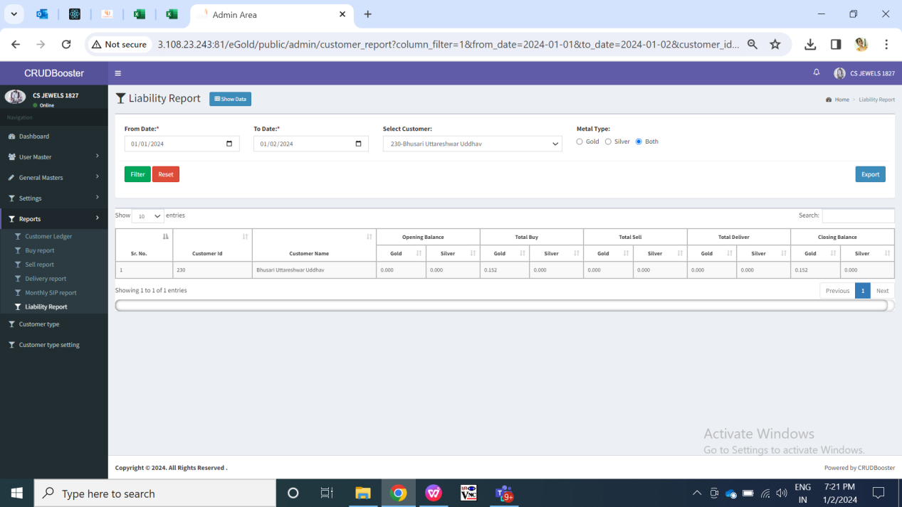

Fig: Liability Report

|  |  |  |  |
| --- | --- | --- | --- |
| **FIELDS** | **INPUT TYPE** | **MANDATORY / OPTIONAL** | **DESCRIPTION** |
| From Date | Calender date picker | optional | Tenant admin will select the date from which they wants to view report from.  Validation: Future dates will be disabled. It will be single select. |
| To date | Calender date picker | optional | Tenant admin will select the date till which they wants to view report.  Validation: Future dates will be disabled. It will be single select. Dates before selected ‘from date’ will be disabled. |
| Customer name | Drop down | Optional | It will display the ID and customer name from customer master of that tenant admin only.  Tenant admin will select the customer for which he wants to view the report.  Tenant admin should be able to search the customer by entering name.  Validation: It will be single select. If user keeps it blank then report for all customers will be displayed once admin clicks on filter button. |
| Metal Type | Drop-down | Mandatory | Admin will select the metal type for which they wants to view the report against customer.  By default, it will be clicked both. Whereas once user selects either gold or silver, then it will display opening balance, closing balance and total for the selected metal type only for customer. |
| Filter button | Click | - | Once user clicks on filter button, all the details of the transactions done by the user will be displayed below in grid. It will display the opening and closing balance of the customer as per selected from and to date whereas it will display the gold / silver accumulated by total buy, sell and delivery.  Validation: Once user selects mandatory fields and clicks on filter button, it should be disabled until data gets displayed below in grid. |
| Summary report | Check box | Optional | Through summary report, tenant can view the opening balance of metal on the selected start date and closing balance of metal on the selected end date. It will display the overall balance means of all the customers together. It will display following columns metal wise:   * Opening balance * Total buy * Total sell * Total delivery * Closing balance   Validation: By default it will be unchecked. |
| Reset button | Click | - | Once user clicks on reset button, page will get reloaded and all the data in grid will be cleared so that user can select fields.  Validation: It will be disable until page gets reloaded and all pre-filled fields gets cleared. |
| Export button | Click | - | Once user clicks on filter button, data should be displayed in grid and export button should be displayed to download csv report.  If user clicks on summary report then exported file should display summarized report in csv file as in grid. Else, it should display customer wise record in grid as in grid.  User can export the csv file displaying the customer’s all transactions report as in grid. It will have following columns:   * Sr. No. * Customer ID * Customer name * Opening balance * Total buy * Total sell * Total delivery * Closing balance |
| Customer ID | Text | Mandatory | It will display the customer id from customer master for that customer. |
| Customer Name | Text | - | It will display the name of the customers in the list along with their trading details who has any opening or closing balance in selected dates. |
| Opening Balance | Text | - | It will display the weight balance in customer’s account available at beginning of selected from date for gold and silver specifically.  Opening balance of selected ‘from date’ will be displayed. |
| Closing balance | Text | - | It will display the weight balance of in customer’s account available till end of selected from date.  Closing balance = Opening + (Buy - sell - delivery) |
| Total Buy | Text | - | It will display the total gram of gold and silver purchased during the selected period (from date and to date). |
| Total sell | Text | - | It will display the total gram of gold and silver sold during the selected period (from date and to date). |
| Total delivery | Text | - | It will display the total gram of gold and silver delivery transactions done during the selected period (from date and to date). |
| Closing balance | Text | - | It will display the weight balance in customer’s account available at end of selected till date for gold and silver specifically. |

1. **TEST DATA & SCENARIOS**
2. **ODUS (Open Discussion Unhanded Scenarios)**

|  |  |  |  |  |
| --- | --- | --- | --- | --- |
| **Sr. No.** | **Topic** | **Priority** | **Remark** | **Status** |
| 1 | About Us settings based or CSS | Medium |  | Open |
| 2 |  |  |  |  |
| 3 |  |  |  |  |

1. **REFERENCES OF THE USERS**

|  |  |  |  |
| --- | --- | --- | --- |
| **User** | **Name** | **Mail** | **Contact number** |
| **Actual user** |  |  |  |
| **Ticket created by (if any)** | Manali Bhadirage | Manali.bhadirage@techneai.com |  |
| **Assigned business analyst** | Manali Bhadirage | Manali.bhadirage@techneai.com |  |
| **Assigned developer** | Goverdhan Bollu  Pranjali Maske  Jaydeep Patil | [Goverdhan.bollu@techneai.com](mailto:Goverdhan.bollu@techneai.com)  [Pranjali.maske@techneai.com](mailto:Pranjali.maske@techneai.com)  Jaydeep.patil@techneai.com |  |
| **Assigned tester** | Preeti Bokade  Vaishnavi Khandwe  Amreen Shaikh  Uttareshwar Bhusari |  |  |