MANALI ASHOK BHADIRAGE

Manali.bhadirage@techneai.com

03.04.2024

CUSTOMER ORDER DETAILS - READY AT BRANCH

**Functional Requirement Document**

**CONTENTS**

1. TICKET DETAILS 2

2. VERSION CONTROL 2

3. APPROVALS 2

4. ESTIMATION 2

5. INTRODUCTION 3

6. BUSINESS REQUIREMENT 3

7. SCOPE 4

8. BUSINESS & SYSTEM RULES 4

9. ABBREVIATIONS & TERMS 4

10. EXISTING SYSTEM 4

11. GRAPHICAL REPRESENTATION 4

12. PROPOSED SYSTEM 5

13. TEST DATA 13

14. ODUS **15.**

15. REFERENCES OF THE USERS 15

1. **TICKET DETAILS**

|  |  |
| --- | --- |
| **Ticket ID** | TT19813 |
| **Ticket description** | connect us > order detail chi order shop madhye transfer zali ki order che status auto update "Ready at Branch" zal pahije |
| **Created by** | Jotiram Pawar |
| **Created on** | 21/02/2024 |
| **Priority** | Very high |

1. **VERSION CONTROL**

|  |  |  |  |  |
| --- | --- | --- | --- | --- |
| **Sr. No** | **Version no** | **Version Date** | **User name** | **User department** |
| **1** | **1.0** | **03/04/2024** | **Jotiram Pawar** | **Stock Audit Team** |
|  |  |  |  |  |

1. **APPROVALS**

|  |  |  |
| --- | --- | --- |
| **Field** | **Name of the User** | **Approved date by the user** |
| **Actual User Name Actual User Department Organization Name** | Jotiram Pawar  Stock Audit Team  CSJ |  |
| **Assigned BA** | Manali Bhadirage |  |
| **Assigned Developer** |  |  |
| **Assigned Tester** |  |  |

1. **ESTIMATION**

|  |  |  |  |  |
| --- | --- | --- | --- | --- |
| **Department name** | **Estimated Time (In hr)** | **Scheduled Date (Starting date)** | **Estimated date** | **Actual delivery date** |
| **BA** |  |  |  |  |
| **Development** |  |  |  |  |
| **Testing** |  |  |  |  |

1. **INTRODUCTION**

In the Padm system, order numbers are generated for customer orders, GTS scheme orders, and Kalptaru scheme orders. These orders are then imported to the "Customer Order -> Order Detail" menu in Connect Us by branch officials. Subsequently, the Head Office (HO) assigns these orders to Karagirs / Sub-Karagirs. Once the order is ready, HO changes the status so that order could be dispatched to branch. When the orders are ready for pickup, branches update their status from "CU Customer Order -> Order Detail" to indicate readiness.

Once customers arrive at the branch to collect their orders, a sales bill is generated in Padm using the already assigned order number. Generating the sales bill marks the order as completed within the Padm system. Simultaneously, branches are expected to update the order's status to "complete" in the "CU Customer Order -> Order Detail" section.

1. **BUSINESS REQUIREMENT**

Once bar-code is generated in Padm and entered against imported order in cx order -> order details, then status of the order should get auto updated and displayed as ‘ready at branch’ as per the location against that bar-code in Padm.

|  |  |  |  |
| --- | --- | --- | --- |
| **Requirement ID** | **Requirement Name** | **Short Description** | **Priority** |
| BR001 | Order location mapping -> add | We have to created menu where user will map the branch against the order location. User will select the branch from active branch master and enter the order location against it. | High |
| BR002 | Order location mapping -> edit | User will map the branch against the order location where branch with location name mapping will be unique record. | High |
| BR003 | Order location mapping -> view | Mapped branch with entered order location name will be displayed in view action. | Medium |
| BR004 | Order details -> status | Status of the order should be displayed as ‘ready at branch’ if the bar-code against order is displayed at branch in Padm as per order location mapping. | High |

Note: Bar-code entered against order should be available in Padm.

1. **SCOPE**

Once order note is created in Padm, it will be displayed in order status menu as well. User will be able to import order number in connect us -> customer order - order detail. Once order is imported, it will be displayed in the grid with default initial status as ‘Unprocessed’. Simultaneously, when the item is processed and bar-code gets generated for it, user will enter the bar-code number in order details -> edit against that order. Further, whenever the status of the order gets changed to branch location as mentioned in branch order location mapping then, on the next day, the status of the order will be displayed as ready at branch in order details -> grid, view, edit, export data, history and custom export.

1. **BUSINESS & SYSTEM RULES**

* User should be registered in the system.
* User should be logged in.
* System should display error message for incorrect details if entered.

1. **ABBREVIATIONS & TERMS**

Cx - Customer

CU - Connect Us

1. **EXISTING SYSTEM**

Currently, user has to manually change the status of each order whenever its gets ready at branch. User needs the system to track the bar-code location and based on that branch it should display the status of the order in connect us.

1. **GRAPHICAL REPRESENTATION**

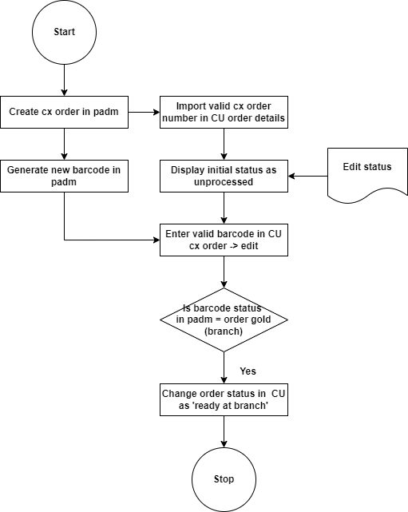

Fig: Process flow

1. **PROPOSED SYSTEM**

* **Branch - order location mapping**

Through branch - order location mapping master, user will select the branch and enter the order location against it. This entered location will be checked against the bar-code in Padm. User will have to enter the order location which should be checked against the bar-code and then order status should get updated as ‘ready at branch’ accordingly. Through this master, user will add the order locations from his end whenever there is addition in the location.

It will have following fields on data grid:

* Export button
* Add button
* Edit button
* View button
* Sr. No.
* Branch name
* Order location
* Remark
* Is active
* Created at
* Created by
* Updated at
* Updated by

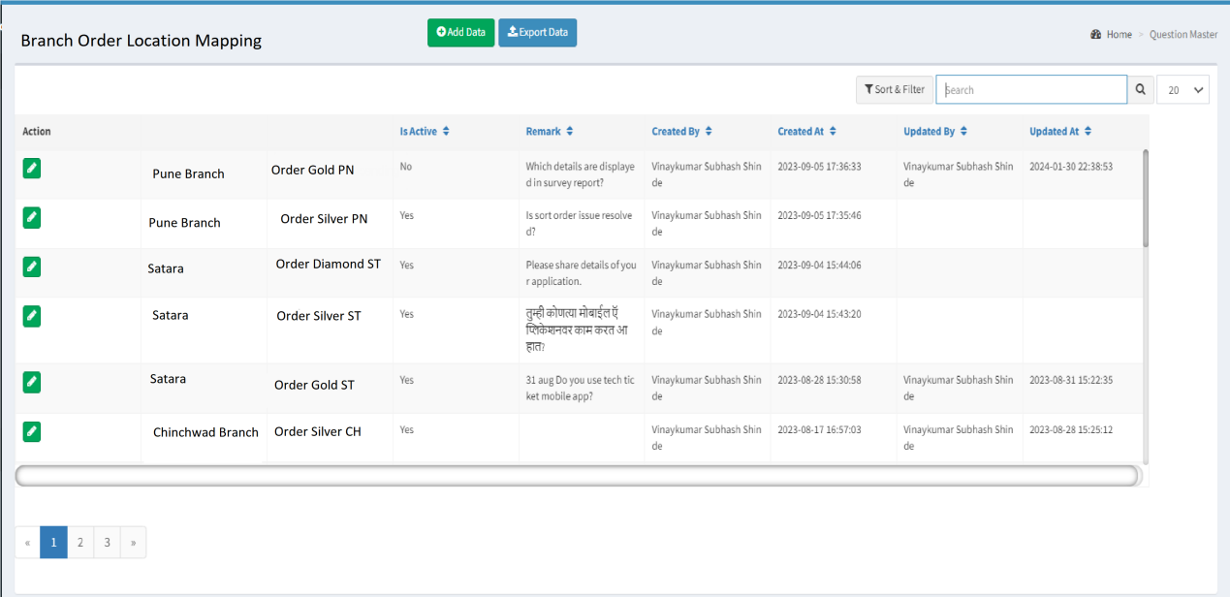

Fig: Branch Order location mapping -> data grid

Once user clicks on add button, it will display following fields:

* Branch
* Order location name
* Remark
* Is active
* Save button
* Save & add more button
* Cancel button

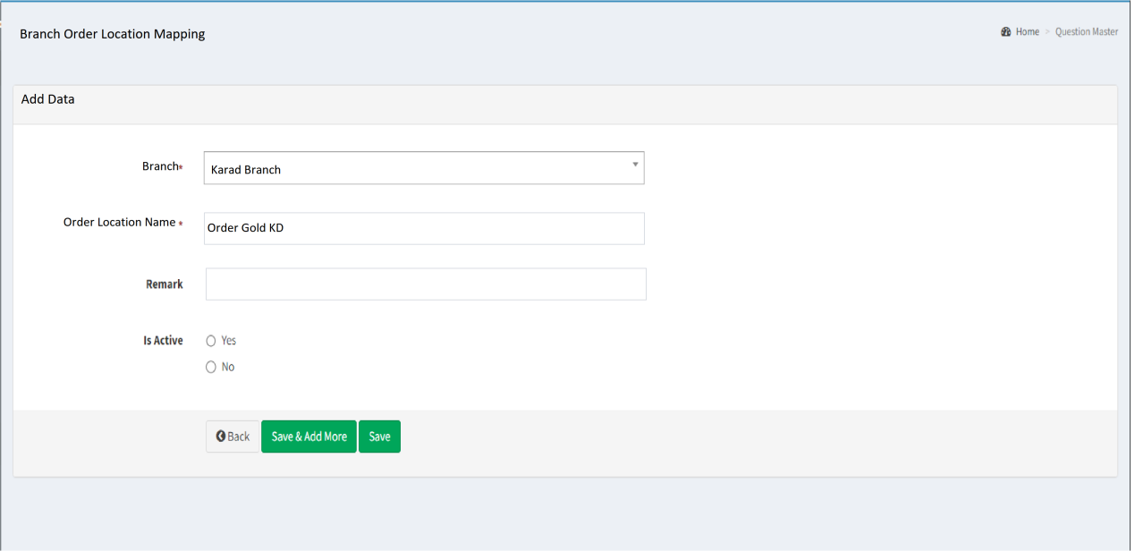

Fig: Branch Order location mapping -> add

|  |  |  |  |  |
| --- | --- | --- | --- | --- |
| **FIELDS** | **INPUT TYPE** | **MANDATORY/ OPTIONAL** | **EDITABLE** | **DESCRIPTION** |
| Branch | Drop down | Mandatory | Yes | User will select the branch against which he wants to enter the order location of bar-code.  Validation: It will be single select. It will display active branches only in list from branch master. |
| Order location | Text | Mandatory | Yes | User will enter the order location name against that branch which should be considered / checked against bar-code whether it is ready as branch or not. Example: Order Gold KL, Order Gold SR, order silver AN, order silver SR, order diamond BH, Order diamond ST, etc.  Order location name with mapped branch should be unique else it should display error message as record already exists.  Validation: It should accept characters and space only.  Min = 5  Max = 25 |
| Is active | Radio button | Mandatory | Yes | User can activate / decativate the mapping of branch with order location.  If user decativates it then even when the status of the bar-code gets changes as order gold / silver / diamon then status of that order won’t get updated in cx order -> order details.  Validation: It will be single select. Default value will be yes. |
| Save | Click | - | - | Once user enters valid mandatory data and clicks on submit, succesful message will be displayed and record will be displayed at top in data grid. Further, as per entered order location, the location of the bar-code will get checked by cron and status of order will get updated if its matches.  Validation: button will be disabled once clicked until on field error message is displayed in case of invalid data or until user gets directed to data grid in case of valid data being saved. |
| Created at | Text | Mandatory | No | It will display the employee name who added the record. |
| Created by | Text | Mandatory | No | It will display the date and time when user created the record.  Validation: It will display in DD/MM/YYYY HH:MM:SS format. |
| Updated at | Text | Mandatory | No | It will display the employee name who added the record. |
| Updated by | Text | Mandatory | No | It will display the date and time when user updated the record.  Validation: It will display in DD/MM/YYYY HH:MM:SS format. |

**View** action will display following fields as in add/ edit of that record:

* Branch name
* Order location
* Remark
* Is active
* Created at
* Created by
* Updated at
* Updated by

Once user clicks on **export** data button, csv file will get downloaded displaying data as in grid with following columns:

* Sr. No.
* Branch name
* Order location
* Remark
* Is active
* Created at
* Created by
* Updated at
* Updated by
* **Order details**

Initially, order note is generated for any order at the branches through Padm -> customer order and order number gets displayed for it. Further, these orders are also imported in connect us -> customer order -> order detail.

Once user clicks on import data button, it will display following fields:

* Filter
* Date
* Order number
* Submit button

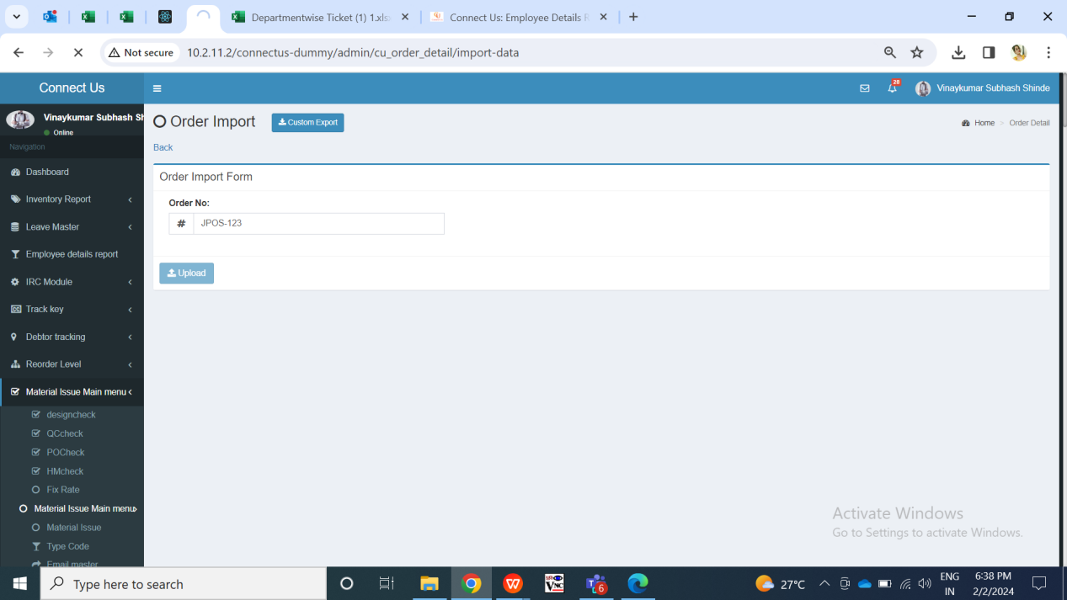

Fig: Import order no.

|  |  |  |  |  |
| --- | --- | --- | --- | --- |
| **FIELDS** | **INPUT TYPE** | **MANDATORY/ OPTIONAL** | **EDITABLE** | **DESCRIPTION** |
| Order no. | Text | Mandatory | - | User will enter the order number from Padm -> documents -> customer order which is to be entered here. Further once order is added, then it will be forwarded further and its status will be changed accordingly.  Validation: It will accept alphanumeric value. It will accept hyphen only as special character.  Min length = 4 Max length = 15 |
| Submit button | Click | - | - | Once user enters valid order no. and clicks on submit button, successful message gets displayed and order gets added in order details menu. The recently added order gets displayed on top of the grid with its initial status as ‘unprocessed’. |

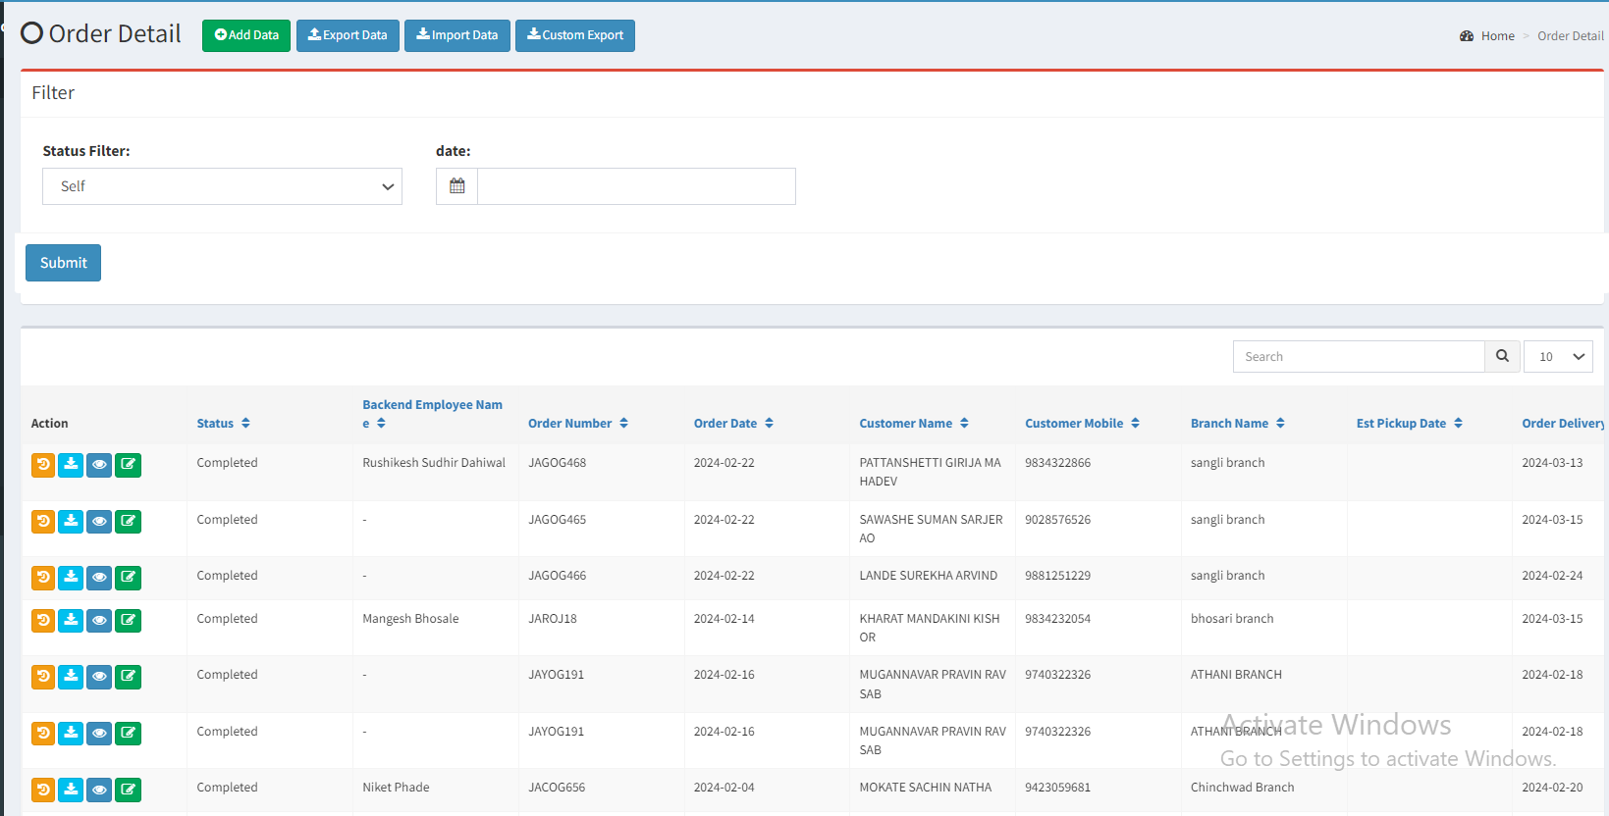

Fig: Order details -> data grid

Once order is entered through ‘import data’ button, it gets added in grid and its status is displayed as ‘unprocessed’ initially in grid, view and edit action. Further, branches inform HO about the order so that HO can look into this and change status of the order regularly through edit action of each order.

In Connect Us order details -> edit action, it has following fields:

* Order number
* Order date
* Order delivery date
* Estimate pickup date
* Order pick up date
* Customer mobile no.
* Customer name
* Branch name
* Item name
* Category
* Wastage type
* Changed wastage
* Net wt
* Purity
* Salesman name
* Status
* Back-end employee name
* Product group
* Toll-free remark
* Purchased from
* Sales bill no.
* Sales bill date
* Use
* Item details
* Catalog / stone / polish details
* Remarks / assign / receipt details
* Other details

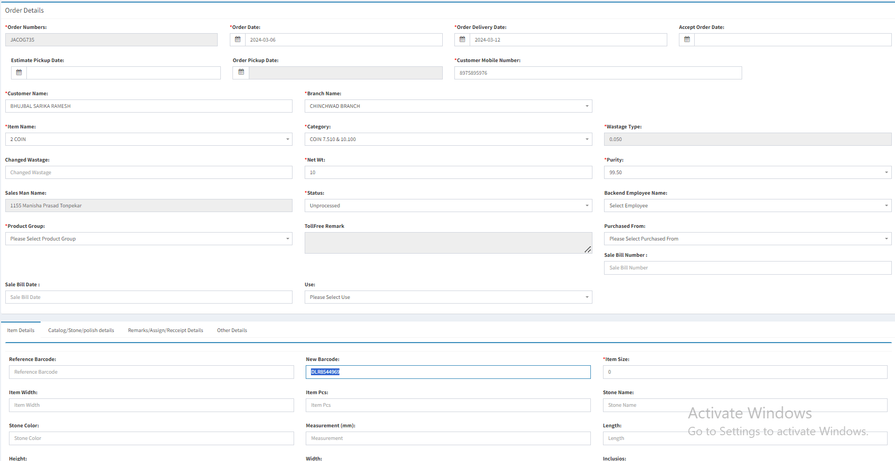

Fig: Order details -> edit

Once user creates the bar-code number in Padm -> labeling voucher, user will enter the generated bar-code number in cx order -> order details -> edit against that order.

Simultaneously, inventory users changes the location of the bar-code by generating document in Padm -> locationwise transfer -> enter in location.

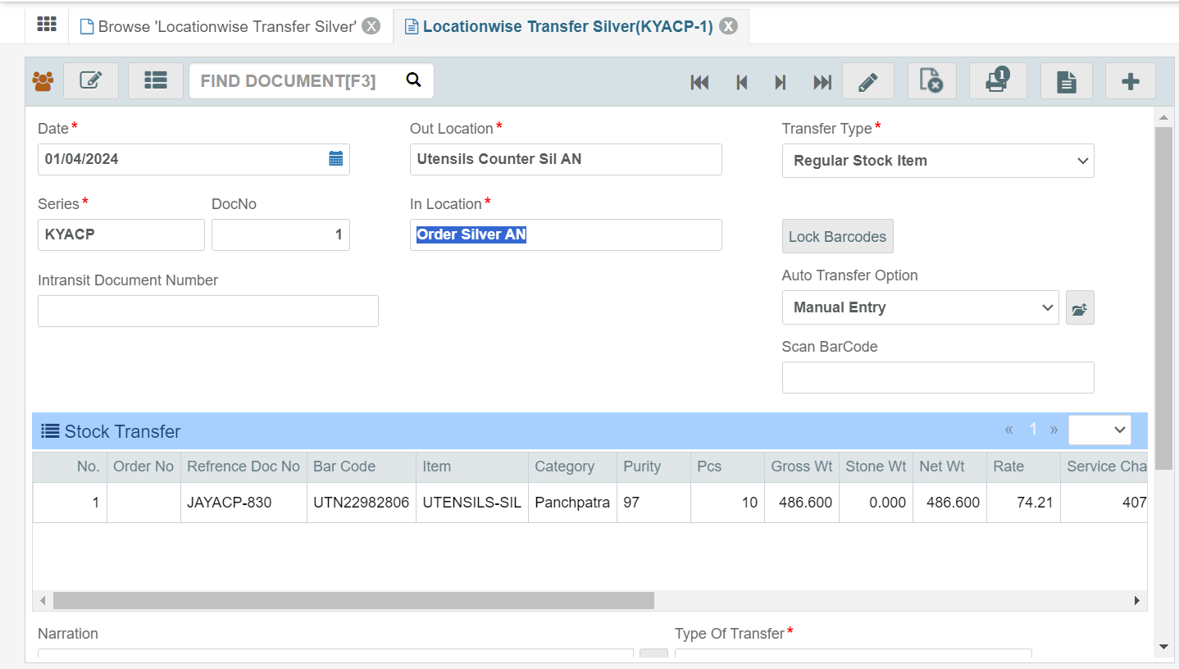

Fig: Padm -> locationwise transfer

Further, the status and location of this bar-code can be tracked through Padm -> label status -> enter bar-code number.

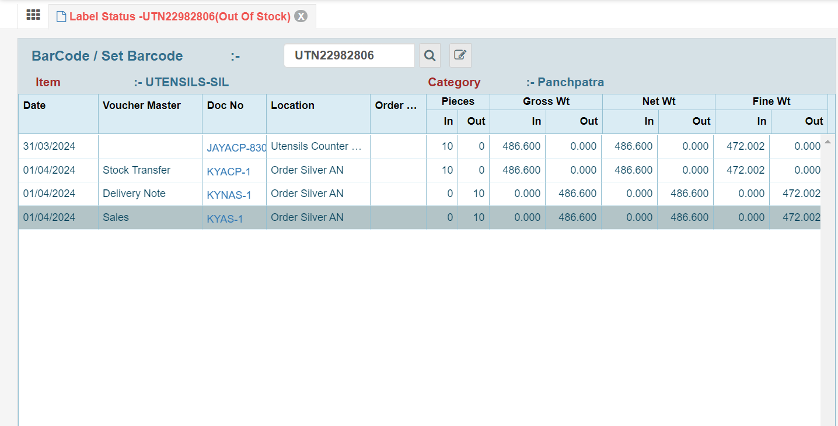

Fig: Padm -> label status

Once the ‘in location’ of the bar-code gets displayed as Order Gold / Silver / Diamond as mentioned in bar-code, it will be considered that order is ready at branch. These ‘in locations’ should be mentioned in branch order location mapping.

Once the status of the bar-code gets changed to the one as mentioned in branch order location mapping, then the status of that order in CU should get updated on the next day and displayed as ‘ready at branch’ in order details -> grid, edit, view, export data, custom export.

Note: User can manually edit the status of the order however cron will update the order details of previous one day only.

1. **TEST DATA & SCENARIOS**



1. **ODUS (Open Discussion Unhanded Scenarios)**

|  |  |  |  |  |
| --- | --- | --- | --- | --- |
| Sr. No. | Topic | Priority | Remark | Status |
| 1 | Steps for creating bar-code and change its location in Padm | Medium | 1. **Documents -> 14 gold rd purchase :-**  * Click + Add. * Select location unlabelled gold (p). * Enter rate. * Enter challan no. * Select supplier and sub smith * order type cx order. * Click +for item details. * Save item details to get displayed in row. * Click save. * Select credit payment detail. * Click submit. * Click print. * Series doc number will generated to it.  1. **Documents -> Labelling Voucher Gold:-**  * Click + Add. * Select out location unlabelled gold (P) and in location packing process (p). * Enter series doc number which we generated in above steps (12 gold rd purchase). * Click find. * click select. * Details will be displayed (enter gross wt net wt rate). * Click save. * Bar-code gets generated.     (Then, firstly Check bar-code in location through label status before locationwise transfer).   1. **Locationwise Transfer**  * Add record. * Enter its previous doc number from label status -> bar-code's doc no. Column. * Enter out location and in location and generate document. The record will be displayed in label status -> bar-code's doc no. Column with it in location. | closed |
| 2 | One order can have multiple bar-code in it. | Medium | It won’t get considered as ‘new bar-code’ ia free text field. Status will get updated on exact match only. |  |

1. **REFERENCES OF THE USERS**

|  |  |  |  |
| --- | --- | --- | --- |
| **User** | **Name** | **Mail** | **Contact number** |
| **Actual user** |  |  |  |
| **Ticket created by (if any)** | Jotiram Pawar | isa@techneai.com |  |
| **Assigned business analyst** | Manali Bhadirage | Manali.bhadirage@techneai.com |  |
| **Assigned developer** |  |  |  |
| **Assigned tester** |  |  |  |