26.04.2024

BILL CHECKING - MSME VENDORS

Manali Ashok Bhadirage

Manali.bhadirage@techneai.com

**Functional Requirement Document**

**CONTENTS**

1. TICKET DETAILS 2

2. VERSION CONTROL 2

3. APPROVALS 2

4. ESTIMATION 2

5. INTRODUCTION 3

6. BUSINESS REQUIREMENT 3

7. SCOPE 4

8. BUSINESS & SYSTEM RULES 4

9. ABBREVIATIONS & TERMS 4

10. EXISTING SYSTEM 4

11. GRAPHICAL REPRESENTATION 4

12. PROPOSED SYSTEM 5

13. TEST DATA 13

14. ODUS 13

15. REFERENCES OF THE USERS 13

1. **TICKET DETAILS**

|  |  |
| --- | --- |
| **Ticket ID** | TT20473 |
| **Ticket description** | Require one different colour to CU BC Points which indicates MSME vendors only. You can confirm MSME Number of Vendor from CU as well as PADM Master too.Its implement is very urgent due to new clause 43B amended in MSME Sector from 1st April 2024. |
| **Created by** | Amarja Dudka |
| **Created on** | 25/03/2024 |
| **Priority** | Very high |

1. **VERSION CONTROL**

|  |  |  |  |  |
| --- | --- | --- | --- | --- |
| **Sr. No** | **Version no** | **Version Date** | **User name** | **User department** |
| **1** | **1.0** | **04/04/2024** | **Amarja Dudka** | **Accounts** |
|  |  |  |  |  |

1. **APPROVALS**

|  |  |  |
| --- | --- | --- |
| **Field** | **Name of the User** | **Approved date by the user** |
| **Actual User Name Actual User Department Organization Name** | Amarja Dudka  Accounts  CSJ |  |
| **Assigned BA** | Manali bhadirage |  |
| **Assigned Developer** | Jaydeep Patil |  |
| **Assigned Tester** |  |  |

1. **ESTIMATION**

|  |  |  |  |  |
| --- | --- | --- | --- | --- |
| **Department name** | **Estimated Time (In hr)** | **Scheduled Date (Starting date)** | **Estimated date** | **Actual delivery date** |
| **BA** |  |  |  |  |
| **Development** |  |  |  |  |
| **Testing** |  |  |  |  |

1. **INTRODUCTION**

Introducing "Bill Connect US": a seamless system that simplifies bill management for users. With this innovative platform, users can effortlessly submit vendor bills and facilitate swift payment processing. All payment records are meticulously maintained and audited to ensure transparency.

Integrating with Padm, "Bill Connect US" offers an added advantage by displaying the current balance of each vendor. This feature empowers entry users to make informed decisions when submitting bills, as they can analyze the available funds in the Padm account for each vendor. By having visibility into the vendor's balance, users can strategize their bill submissions, avoiding unnecessary work and streamlining the process.

In summary, "Bill Connect US" streamlines bill submissions and payment processing, providing valuable insights into vendor balances through integration with Padm. This empowers entry users to optimize their bill submissions and foster a more efficient workflow.

1. **BUSINESS REQUIREMENT**

Through vendor master, we can mark the vendors as MSME or not. Thus when entry users submits the bill of MSME vendor in bill checking transaction, that bill should be highlighted in grid.

|  |  |  |  |
| --- | --- | --- | --- |
| **Requirement ID** | **Requirement Name** | **Short Description** | **Priority** |
| BR001 | Vendor master -> add | Add ‘Is MSME’ check-box field in vendor master-> add form which will be considered as yes if user checks it against that vendor. | High |
| BR002 | Vendor master -> view and history | Add ‘Is MSME’ field in vendor master which will be displayed as yes if user checks it against that vendor. | Medium |
| BR003 | Vendor master -> edit | Add ‘Is MSME’ field in vendor master -> edit form which will be displayed as yes if user checks it against that vendor. | Medium |
| BR004 | Vendor master -> export data | Add ‘Is MSME’ field in vendor master -> edit form which will be displayed as yes if user checks it against that vendor. | Medium |
| BR005 | Bill checking transaction -> grid | When entry user adds bill of MSME vendor and submits it, bill should be highlighted in grid. | High |

1. **SCOPE**

Through bill checking -> vendor master, user should be able to mention whether the vendor is MSME or not. The set details of vendor should be displayed in edit, view and export action. If user edits the MSME details of that vendor in the vendor master, then updated details of the vendor should be displayed accordingly in edit, view and export. Further, when entry user adds the bill, selects the vendor, enters amount and submits it then the bill ID should get generated to it. Whereas, if the selected vendor of that Bill was MSME in vendor master then that bill should be highlighted in grid.

1. **BUSINESS & SYSTEM RULES**

* User should be registered in the system.
* User should be logged in.
* System should display error message for incorrect details if entered.

1. **ABBREVIATIONS & TERMS**

MSME - Micro, Small & Medium Enterprises

PAN - Permanent Account Number

GST No. - Goods and Services Tax

BC ID - Bill Checking ID

IFSC code - Indian financial system code

UTR number - Unique Transaction Reference

Acme - Padm ERP

1. **EXISTING SYSTEM**

Presently, the system lacks visibility for MSME vendors specially. Users needs to prioritize clearing bills from MSME vendors promptly and ensure their visibility within the system. By highlighting these vendors, entry users can easily access and process their bills efficiently without any delay and providing support to MSME vendors.

1. **GRAPHICAL REPRESENTATION**

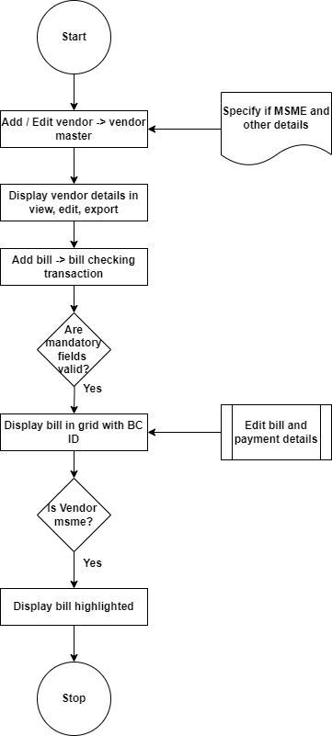

Fig: Process workflow

1. **PROPOSED SYSTEM**

* **VENDOR MASTER**

Vendor master menu will have following fields on **grid**:

* Create user
* Create PO user
* Edit
* View
* History
* ID
* Company name
* Vendor name
* Acme account name
* Vendor type
* Payee list
* Is MSME?
* Msme no.
* Address 1
* Address 2
* Gst default supplier status
* Contact person
* Email
* Contact no.
* Consider in payment
* Payment template
* Gst no.
* Gstr1
* Pan no.
* Referred by
* Dept

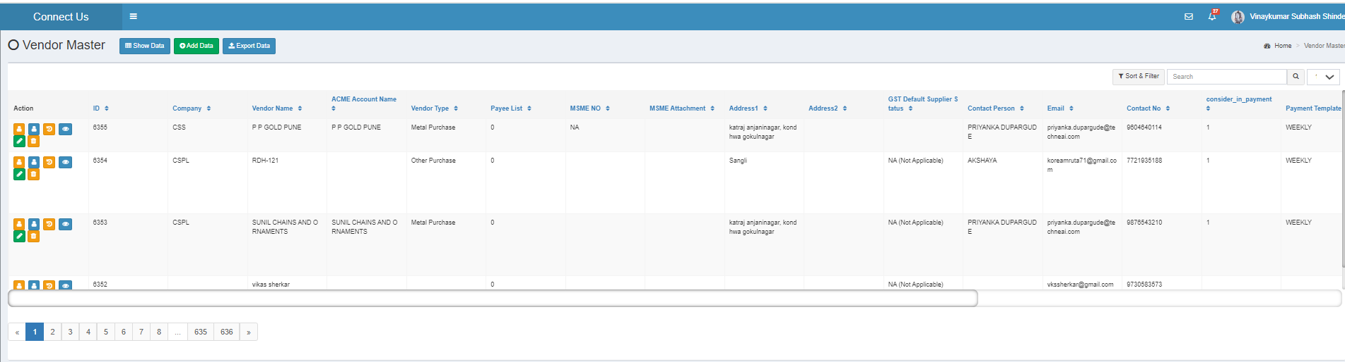

Fig: Vendor master -> grid

Once user clicks on **add button** for creating new vendor, it will display following fields:

* Company
* Vendor Name
* Vendor type
* Address 1
* GST default supplier status
* Remark
* Contact person
* Contact no.
* Alternate no.
* Landline no.
* Email
* Pan no.
* Referred by
* Dept
* Is MSME?
* MSME No.
* Legal status.
* GST No.
* Acme account name
* Gstr1
* Consider in payment (yes/no/petty cash)
* Beneficiary Name
* Payment Template
* Attachments
* Save (button)
* Save & add more button
* Back (button)

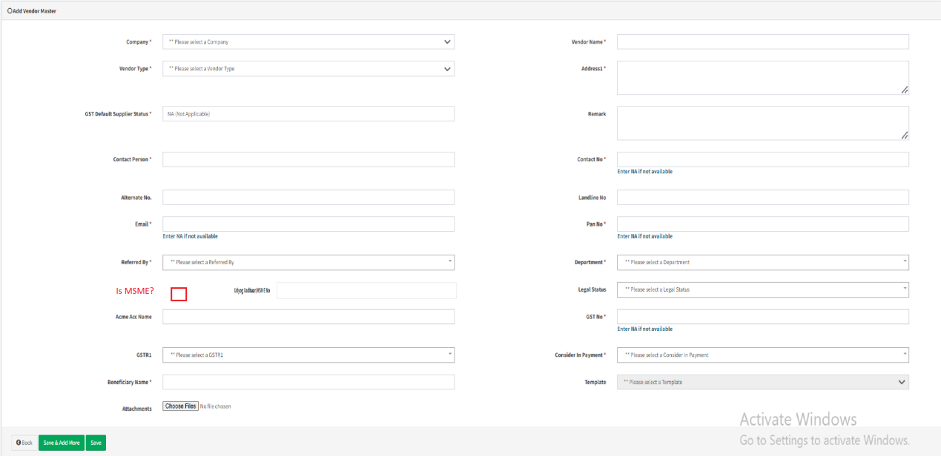

Fig: vendor master -> add

**Input table**

|  |  |  |  |  |
| --- | --- | --- | --- | --- |
| **FIELDS** | **INPUT TYPE** | **MANDATORY/ OPTIONAL** | **EDITABLE** | **DESCRIPTION** |
| Is MSME? | check-box | Optional | Yes | User will check the check-box if the vendor is MSME. User will keep it unchecked if vendor is not MSME.  It will be displayed as yes or no in view, edit, history action and exported file accordingly. It will display updated MSME details if user has checked or unchecked it through edit action.  Validation: By default, it will be unchecked. |

Once user clicks on **view action** of vendor master, it will display following fields:

* Company
* Vendor Name
* Vendor type
* Address 1
* GST default supplier status
* Remark
* Contact person
* Contact no.
* Alternate no.
* Landline no.
* Email
* Pan no.
* Referred by
* Dept
* Is MSME?
* MSME No.
* Legal status.
* GST No.
* Acme account name
* Gstr1
* Consider in payment (yes/no/petty cash)
* Beneficiary Name
* Payment Template
* Attachments
* Narration

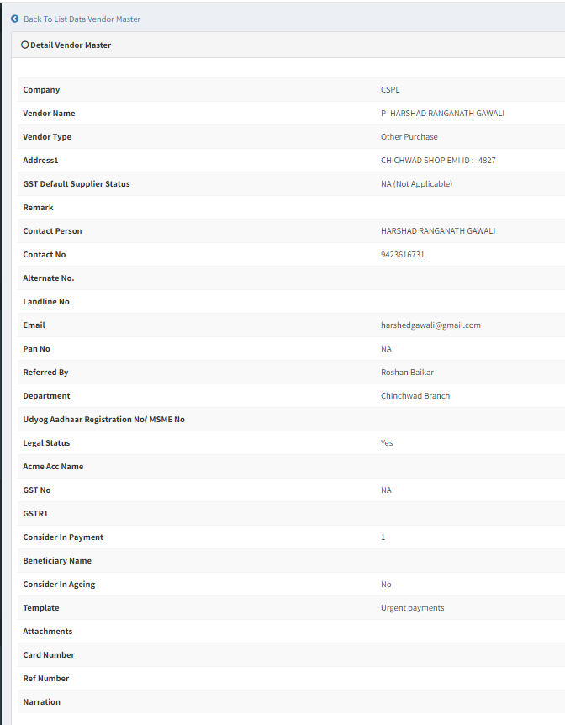

Fig: Vendor master -> view

|  |  |  |  |  |
| --- | --- | --- | --- | --- |
| **FIELDS** | **INPUT TYPE** | **MANDATORY/ OPTIONAL** | **EDITABLE** | **DESCRIPTION** |
| Is MSME? | Text | Optional | Yes | User will check the check-box if the vendor is MSME. User will keep it unchecked if vendor is not MSME.  It will be displayed as yes or no in view action if it is checked. It will display updated MSME details if user has checked or unchecked it through edit action.  Validation: It will be read only in view action. |

Once user clicks on **export data button**, it will display following options to select the columns names in exported file:

* ID
* Company
* Vendor name
* Acme account number
* Vendor type
* Payee list
* Is msme?
* Msme no.
* Address1
* Address2
* GST default supplier status
* Contact person
* Email
* Contact no.
* Consider in payment
* Payment template
* GST no.
* GSTR1
* Pan no.
* Bank name
* Branch name
* Account no.
* IFSC code
* Referred by
* Departments

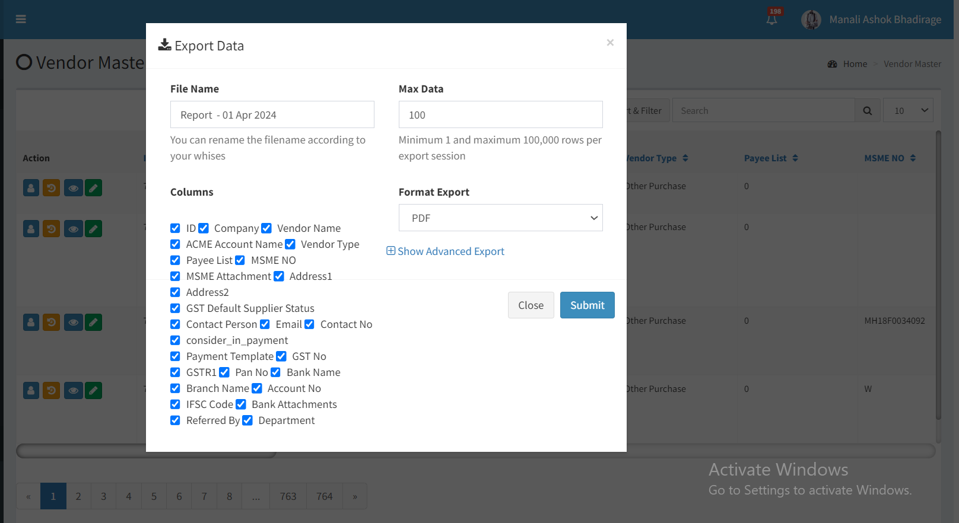

Fig: Vendor master -> export data

Exported file will have same columns as users selects before exporting data where details of each vendor will be displayed per details in its edit/view action. Whereas, it will display yes or no in ‘is msme’ column if msme check box is checked against that vendor.

* **BILL CHECKING TRANSACTION**

Once user clicks on add button of bill checking transaction to add the bill of any vendor and submit it, it will have following fields:

* Bill type
* Sub bill type
* Assign to
* Vendor name
* Branch name
* Exhibition
* Vendor bill no.
* Challan po no.
* Bill date
* Received date
* Debit advance
* Taxable amount
* IGST / GST
* Round off
* Tcs
* Bill amount
* Tds%
* Net payment
* Is initiative
* TDS applicable
* Tds section
* Tds constitution
* Tds amount
* Net amount in words
* Remark
* Padm doc date
* Padm doc name
* Add data
* Acc effect
* Audit remark
* External remark
* Attachment
* Submit button

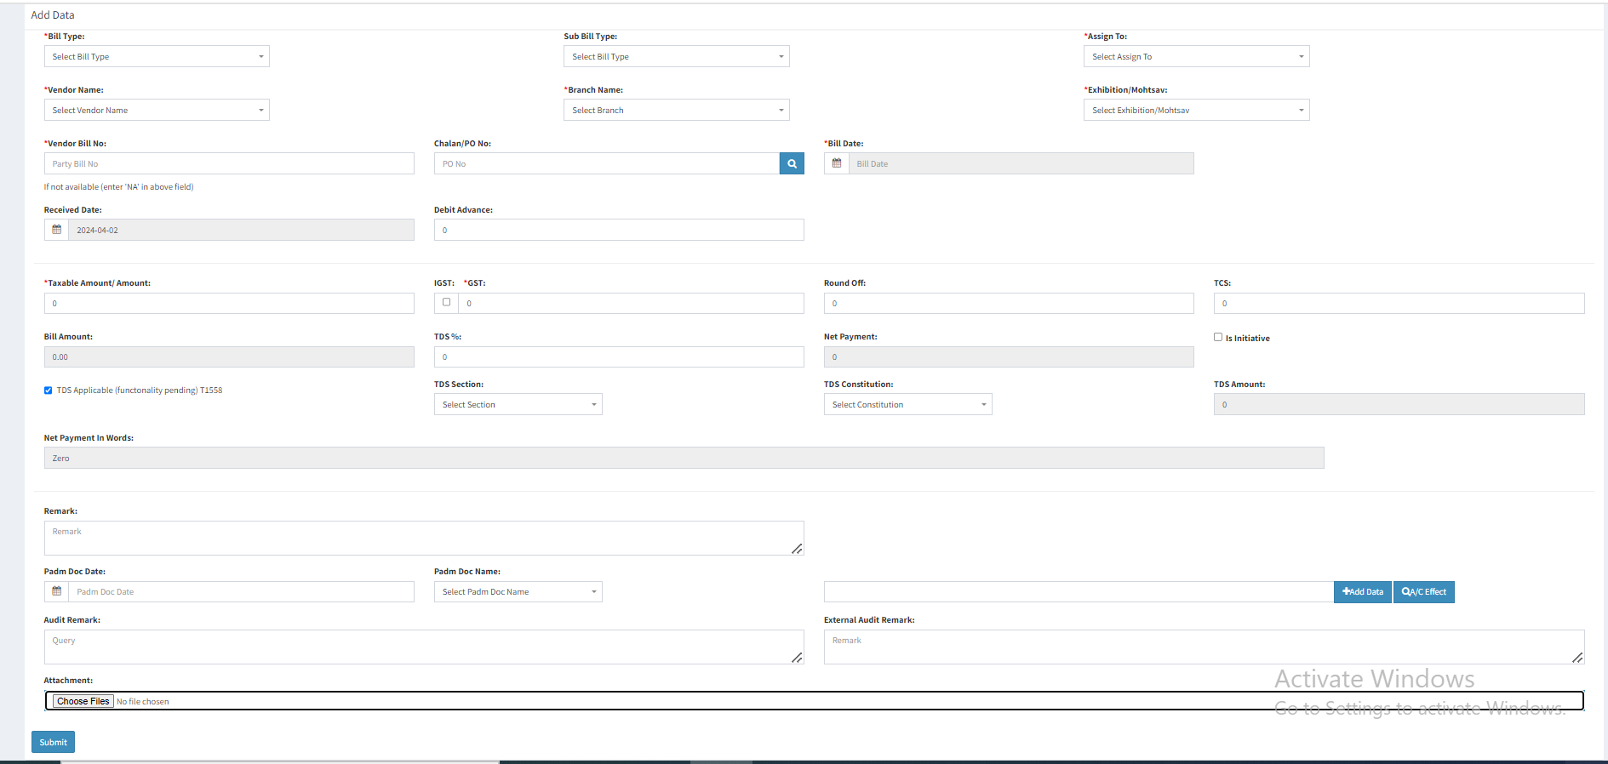

Fig: Bill checking transaction -> add

Here, once entry user selects the vendor name and fills other mandatory fields and clicks on submit button, Bill get submitted successfully. BC ID gets displayed against generated bill and bill get displayed on top in grid of assigned to user.

Here, if vendor of submitted bill is ‘yes’ in vendor master -> MSME, then those bills should be highlighted with different colour in grid. If user edits the msme vendor as no’, then that bill should not be highlighted.

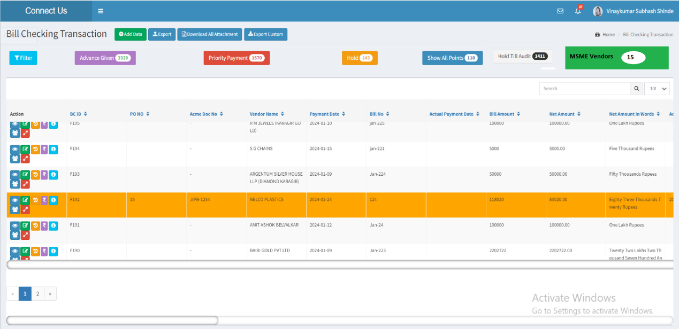

Fig: Bill checking transaction -> grid

1. **TEST DATA & SCENARIOS**



1. **ODUS (Open Discussion Unhanded Scenarios)**

|  |  |  |  |  |
| --- | --- | --- | --- | --- |
| **Sr. No.** | **Topic** | **Priority**  **(High / medium / low)** | **Remark** | **Status**  **(Open/**  **Closed)** |
| 1 | Manali: In bill checking transaction, do we need to display the colour representation and its count on grid? If yes then we will have to also display that filter page displaying list of msme vendors bills. | Low | Gaurav shaha: Not now. Consider that as CR later on whereas deliver only vendor master -> msme field and bill checking colour highlight if development is to be done now. | Open |
| 2 |  |  |  |  |
| 3 |  |  |  |  |

1. **REFERENCES OF THE USERS**

|  |  |  |  |
| --- | --- | --- | --- |
| **User** | **Name** | **Mail** | **Contact number** |
| **Actual user** | Amarja Dudka | account@csjewellers.com |  |
| **Ticket created by (if any)** | Amarjadudka | account@csjewellers.com |  |
| **Assigned business analyst** | Manali Bhadirage | Manali.bhadirage@techneai.com |  |
| **Assigned developer** | Jaydeep Patil | Jaydeep.patil@techneai.com |  |
| **Assigned tester** |  |  |  |