Manali Ashok Bhadirage

Manali.bhadirage@techneai.com

28.03.2024

MATERIAL ISSUE -

ON APPROVAL OUT RECEIPT & RD PURCHASE RECEIPT

**Functional Requirement Document**

**CONTENTS**

1. TICKET DETAILS 2

2. VERSION CONTROL 2

3. APPROVALS 2

4. ESTIMATION 2

5. INTRODUCTION 3

6. BUSINESS REQUIREMENT 3

7. SCOPE 3

8. BUSINESS & SYSTEM RULES 4

9. ABBREVIATIONS & TERMS 4

10. EXISTING SYSTEM 4

11. GRAPHICAL REPRESENTATION 4

12. PROPOSED SYSTEM 5

13. TEST DATA 26

14. ODUS 26

15. REFERENCES OF THE USERS 26

1. **TICKET DETAILS**

|  |  |
| --- | --- |
| **Ticket ID** | TT20190 |
| **Ticket description** | CONNECT US MADHE APPROVAL CHI PRINT SATHI POP-UP MSG CH OPTION DENE - LOCATION SELECT SATHI RATE FIX/UNFIX SELECT KELA ASEL TAR TYACHA VEGALA COLOMN ALA PAHIJE UNFIX RATE - 6500.000 FIX RATE - 6500.000 ASA |
| **Created by** | Prashant Pise |
| **Created on** | 11/03/2024 |
| **Priority** | Very high |

1. **VERSION CONTROL**

|  |  |  |  |  |
| --- | --- | --- | --- | --- |
| **Sr. No** | **Version no** | **Version Date** | **User name** | **User department** |
| **1** | **1.0** | **28/03/2024** | **Prashant Pise** | **Inventory Gold HO** |
| **2** | **1.1** | **03/05/2024** | **Prashant Pise** | **Inventory Gold HO** |
| **3** | **2.0** | **03/05/2024** | **Rakesh Thikane** | **Internal Auditor** |

1. **APPROVALS**

|  |  |  |
| --- | --- | --- |
| **Field** | **Name of the User** | **Approved date by the user** |
| **Actual User Name Actual User Department Organization Name** | Prashant Pise  Inventory Gold HO  CSJ |  |
| **Assigned BA** | Manali Bhadirage |  |
| **Assigned Developer** | Jaydeep Patil |  |
| **Assigned Tester** | Amruta Kore |  |

1. **ESTIMATION**

|  |  |  |  |  |
| --- | --- | --- | --- | --- |
| **Department name** | **Estimated Time (In hr)** | **Scheduled Date (Starting date)** | **Estimated date** | **Actual delivery date** |
| **BA** |  |  |  |  |
| **Development** | 5.5 hours |  |  |  |
| **Testing** | 7 + 4 hours |  |  |  |

1. **INTRODUCTION**

Within the material issue menu, inventory users input details of materials received from vendors. This input triggers the generation of a document number, which must then be approved by an authorized individual before progressing to four checking stages (design check, QC check, PO check, HM check). During these inspection stages, some pieces may be rejected and will be sent back to the vendor, while the accepted pieces will lead to the creation of a RD purchase bill within the Padm system for the vendor. Purchase return bill is generated for the rejected pcs and then returned to the vendor.

In inventory we do receive orders from vendors for which the Padm bill need not be created. Inventory team can accept the slot if they like and/or return the entire lot to vendor or disliked items. This is termed as Jangad process. Challan gets generated for rejected items details which are to be returned to vendor. When items are added from one location (example added at Mumbai office), we can return it to vendor from our another location (Pune HO).

1. **BUSINESS REQUIREMENT**

User needs to provision to select ‘from location’ while generating on approval out challan I.e. receipt of returning rejected items to vendor.

|  |  |  |  |
| --- | --- | --- | --- |
| **Requirement ID** | **Requirement Name** | **Short Description** | **Priority** |
| BR001 | On approval out | User should have option to select ‘from location’ before generating challan. | Medium |
| BR002 | On approval out | Selected ‘from location’ details should be displayed in generated challan as per branch master. | Medium |
| BR003 | Material issue all reports , user wise report and type wise report - grid and export | Need vendor system challan number, rate type and rate(for 99.50%) fields in material issue -> all reports, user wise report & type wise reports -> data grid and exported file. | Medium |

1. **SCOPE**

Once data is added in material issue, then it should get received by the authorized user. Once document is received by the authorized user, then that document should be displayed in design check process. Once user rejects the items from that document through issued action, then the accepted pcs of that document will be passed to QC check process. Further, accepted pcs of QC check process will be passed to PO check process. Once user rejects pcs in PO check, the accepted pcs of that document will be passed to HM check process. After accepting and rejecting the pcs in HM check process, ‘on approval out challan’ action will be displayed in material issue menu grid.

Once user clicks on ‘on approval out’ action then user should be able to select from location from drop-down. Once user clicks on yes, receipt should get downloaded in new tab. It will display the vendor name and details as per added document and vendor address from vendor master. It will display the from address from branch master.

1. **BUSINESS & SYSTEM RULES**

* User should be registered in the system.
* User should be logged in.
* System should display error message for incorrect details if entered.

1. **ABBREVIATIONS & TERMS**

Wt - Weight

Gm - grams

KT - karat

MK - making

Pcs - pieces

PDF - Portable Document Format

BB - Black Bits

1. **EXISTING SYSTEM**

In existing system, ‘from location’ is displayed from location selected in material issue -> add / edit. However, user needs provision to select the from location manually before generating challan.

1. **GRAPHICAL REPRESENTATION**

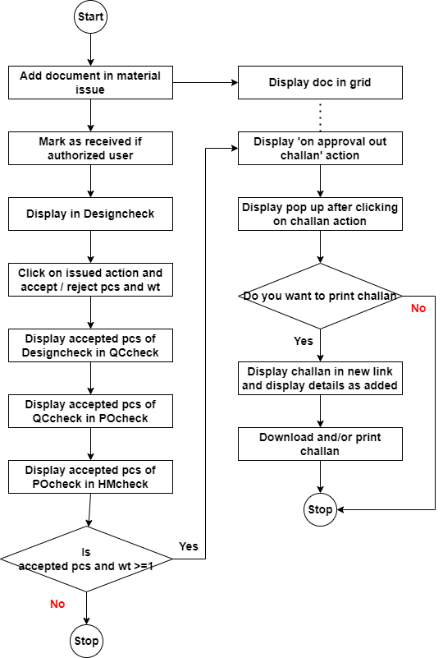

Fig: Flowchart

1. **PROPOSED SYSTEM**

In Connect us -> material issue main menu -> material issue, once user clicks on add data, it will display following fields:

* Issued Date
* Challan No.
* Location
* Issued Type
* Vendor
* Sub supplier
* Narration
* Remark
* **Is RD purchase?**
* **Type of Rate**
* **Rate**
* **Attachment**
* Item Detail table
* Save button
* Back button
* Save and add more button

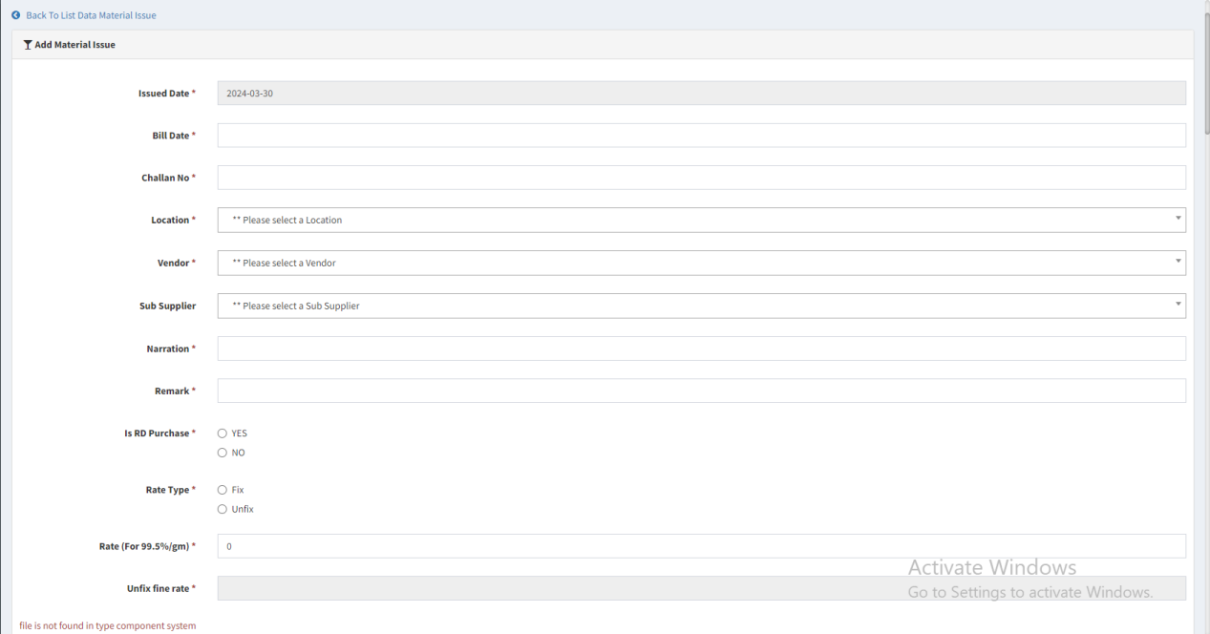

Fig: material issue -> add

|  |  |  |  |  |
| --- | --- | --- | --- | --- |
| **FIELDS** | **INPUT TYPE** | **MANDATORY/ OPTIONAL** | **EDITABLE** | **DESCRIPTION** |
| Location | drop-down | Mandatory | Yes | Users selects the location at which this lot is being added.  Validation: It will be single select. Active branches from branch master will be displayed in the list. |

Once user clicks on material issue menu, it will display following fields:

* Add button
* View action
* History action
* Edit action
* Take print action
* Received action
* Edit data action
* Get attachment action
* On approval out challan action
* Doc no.
* Date
* Challan no.
* Net wt (gm)
* Location
* Issued type
* Vendor
* Sub supplier
* Narration
* Received status
* Time difference

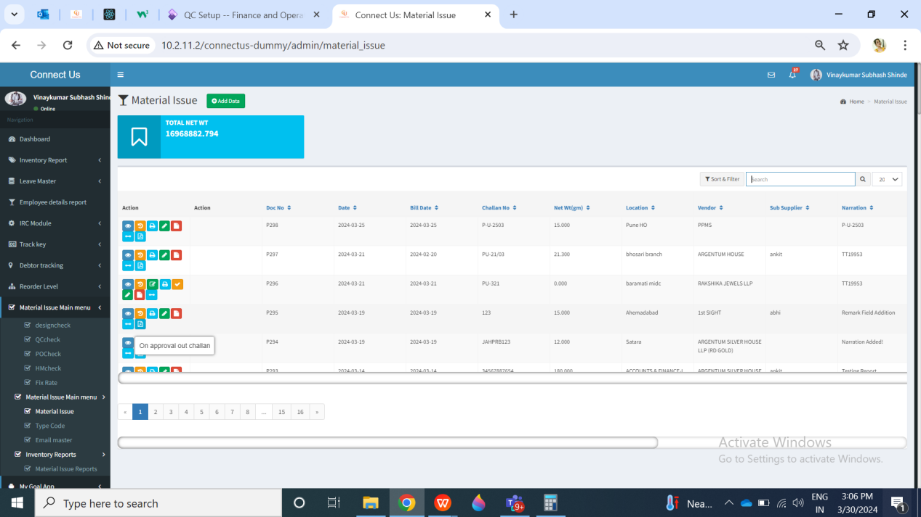

Fig: Material issue -> grid

Once data is added, then doc number gets generated to it and it will be displayed in grid displaying received action against it to the authorized user.

Once user clicks on **print action**, it will display following fields on PDF:

* From details
* Address
* Ph. no.
* GST no.
* PAN no.
* To details
* Address
* Ph no.
* GST no.
* PAN no.
* Doc no.
* Date
* Challan no.
* Location
* Vendor name
* Address
* GST Number
* Narration
* Rate type
* Rate (for 99.50%)
* Fine rate
* Item details table
* Sr no.
* Item
* Category
* KT
* W/MK
* Pcs
* Gross wt
* BB wt
* Stone wt
* Other wt
* Net wt
* Wastage

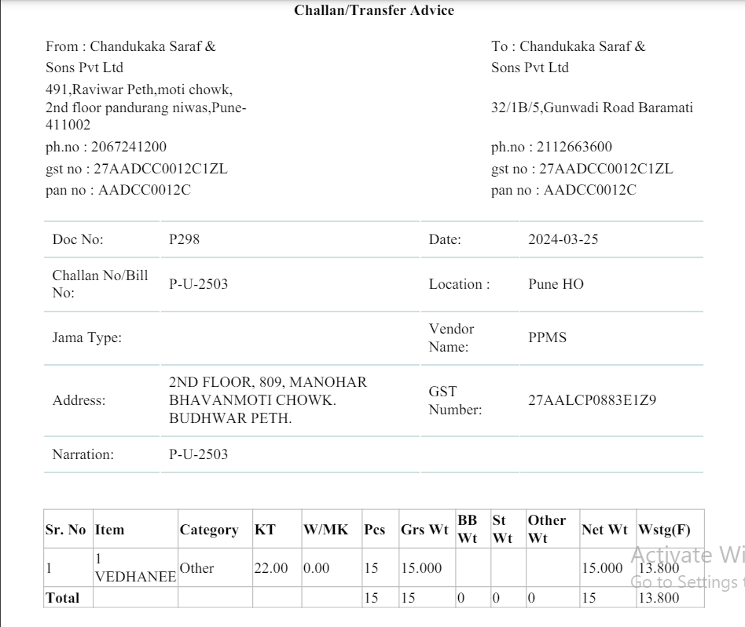

Fig: material issue -> print

|  |  |  |  |
| --- | --- | --- | --- |
| **FIELDS** | **INPUT TYPE** | **MANDATORY/ OPTIONAL** | **DESCRIPTION** |
| From - Address | Text | Mandatory | It will display the address of the location selected against that document while adding / through edit. It will display address of that selected location from branch master. |
| From - Ph. No. | Text | Mandatory | It will display the phone no. of the selected branch from branch master. |
| From - GST No. | Text | Mandatory | It will display the GST no. from cu setting master table. Setting no. 46 for pan no. |
| From - PAN No. | Text | Mandatory | It will display the PAN no. from cu setting master table. Setting no. 67 for GST no. |
| TO - Address | Text | Mandatory |  |
| From - Ph. No. | Text | Mandatory |  |
| TO - GST No. | Text | Mandatory | It will display the GST no. from cu setting master table. Setting no. 46 for pan no. |
| TO - PAN No. | Text | Mandatory | It will display the PAN no. from cu setting master table. Setting no. 67 for GST no. |
| Doc no. | Text | Mandatory | It will display the doc number generated when user submitted & this record got added on grid. |
| Date | Text | Mandatory | It will display the date on which the document was created in material issue. |
| Challan no. | Text | Mandatory | It will display the challan no. Which user entered in add / edit against this document. |
| Location | Text | Mandatory | It will display the location selected by the user in add /edit for this document. |
| Vendor name | Text | Mandatory | It will display the name of vendor which was selected by the user against that document while add / edit.  It will be displayed as in vendor master.  Validation: It will be read only. It will display updated name on new print if users edits vendor name in vendor master. |
| Vendor Address | Text | Mandatory | It will display the address of vendor as per vendor master which was selected by the user against that document while add / edit.  Validation: It will be read only. It will display updated address on new print if users edits vendor address of that vendor in vendor master. |
| Vendor GST number | Text | Mandatory | It will display the GST number of vendor as per vendor master which was selected by the user against that document while add / edit.  Validation: It will be read only. It will display updated GST on new print if users edits vendor GST of that vendor in vendor master. |
| Narration | Text | Mandatory | It will display the narration mentioned by the user against that document as in add / edit.  Validation: It will be read only. |
| Rate type | Text | Mandatory | It will display rate type as either fix or unfix which is selected by the user for that document as in add / edit. |
| Rate (for 99.50) | Text | Mandatory | It will display rate (for 99.50%) which is mentioned by the user for that document as in add / edit. |
| Fine rate | Text | Mandatory | It will display rate (for 99.50%) which is mentioned by the user for that document as in add / edit. |
| Item details table - sr no. | Text | Mandatory | It will display the Sr. No. for each row in the table. |
| Item details table - item | Text | Mandatory | It will display the list of items in each row which was elected by the user in add. |
| Item details table - category | Text | Mandatory | It will display the list of categories in each row which was elected by the user in add. |
| Item details table - KT | Text | Mandatory | It will display the KT of each item row which was elected by the user in add. |
| Item details table - W/MK | Text | Mandatory | It will display the W/MK of each item row which was elected by the user in add. |
| Item details table - pcs | Text | Mandatory | It will display the pcs of each item row which was elected by the user in add. |
| Item details table - gross wt | Text | Mandatory | It will display the gross wt of each item row which was elected by the user in add. |
| Item details table - BB wt | Text | Mandatory | It will display the BB wt of each item row which was elected by the user in add. |
| Item details table - stone wt | Text | Mandatory | It will display the stone wt of each item row which was elected by the user in add. |
| Item details table - other wt | Text | Mandatory | It will display the other of each item row which was elected by the user in add. |
| Item details table - net wt | Text | Mandatory | It will display the net wt of each item row which was elected by the user in add. |
| Item details table - wastage | Text | Mandatory | It will display the wastage of each item row which was elected by the user in add. |

Once authorized user marks the doc as received, then its received action will be removed whereas this doc will be displayed in design check process menu.

In **design check** phase, from Issue data action, user enters the details of accepted and rejected pcs and submits the challan to further process.

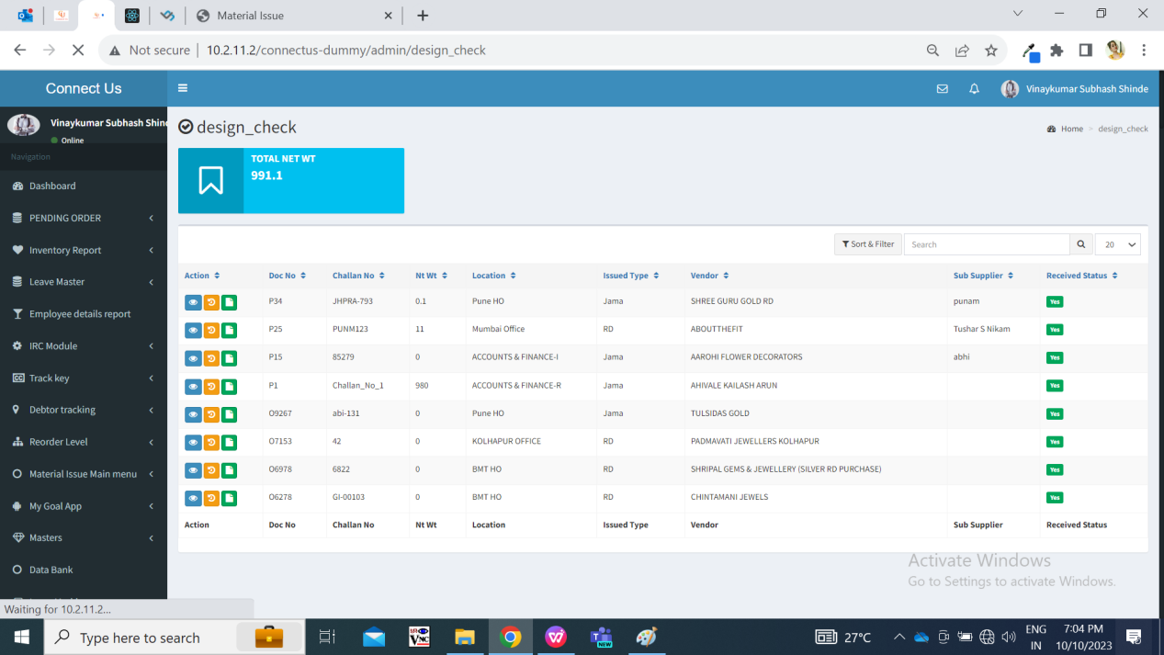

Fig: Design check

Once design check is done, the accepted pcs and all details in the document will be forwarded to **QC check** process. The documents received from design check process should be first displayed to QC incharge in QC check menu. Here, QC incharge will first split the document into present employees.

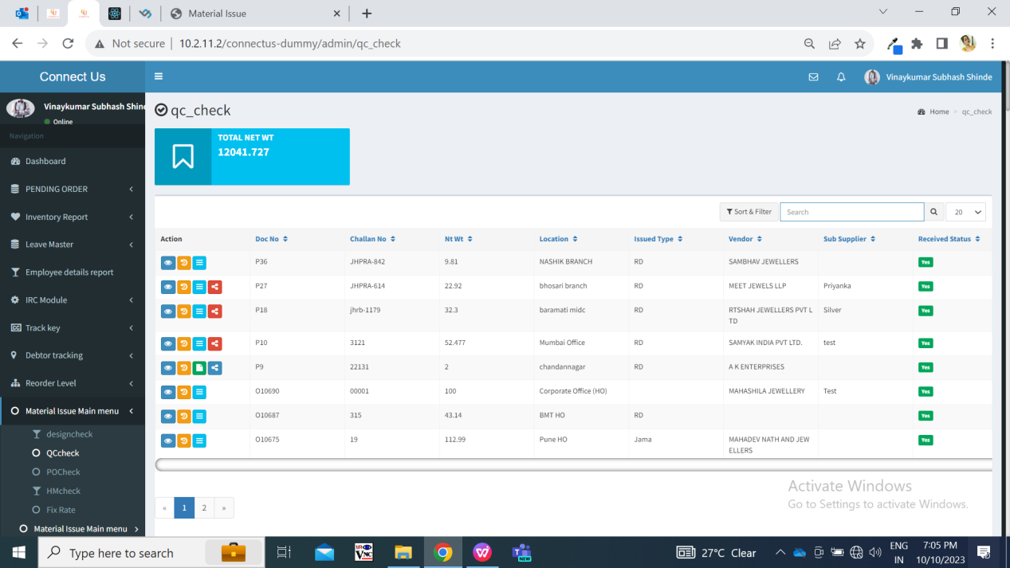

Fig: QC check

Once all the QC incharge has submitted details of accepted / rejected in QCcheck -> issued action, then total accepted gross wt, total accepted net wt, total accepted pcs should be displayed to **POcheck** process for the respective doc.

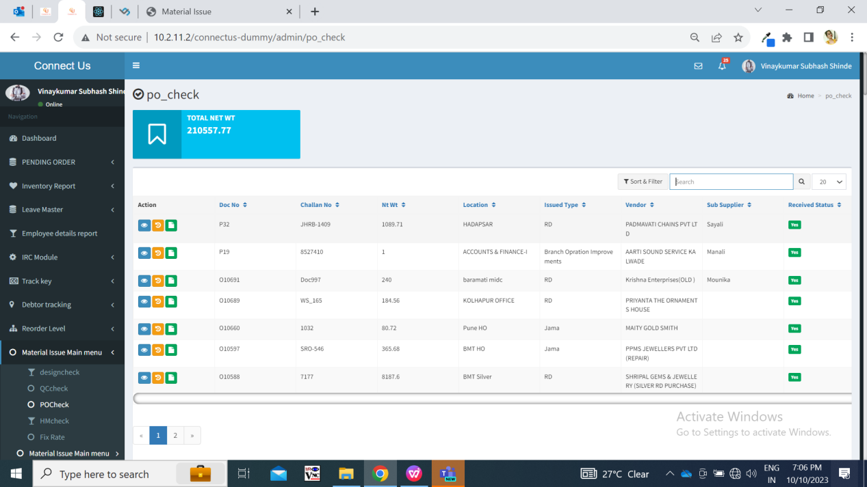

Fig: PO check

Further, the accepted pcs from PO check process are forwarded to **HM check** process. And in generate slip, the total details of rejected and accepted pcs, wt will be displayed.

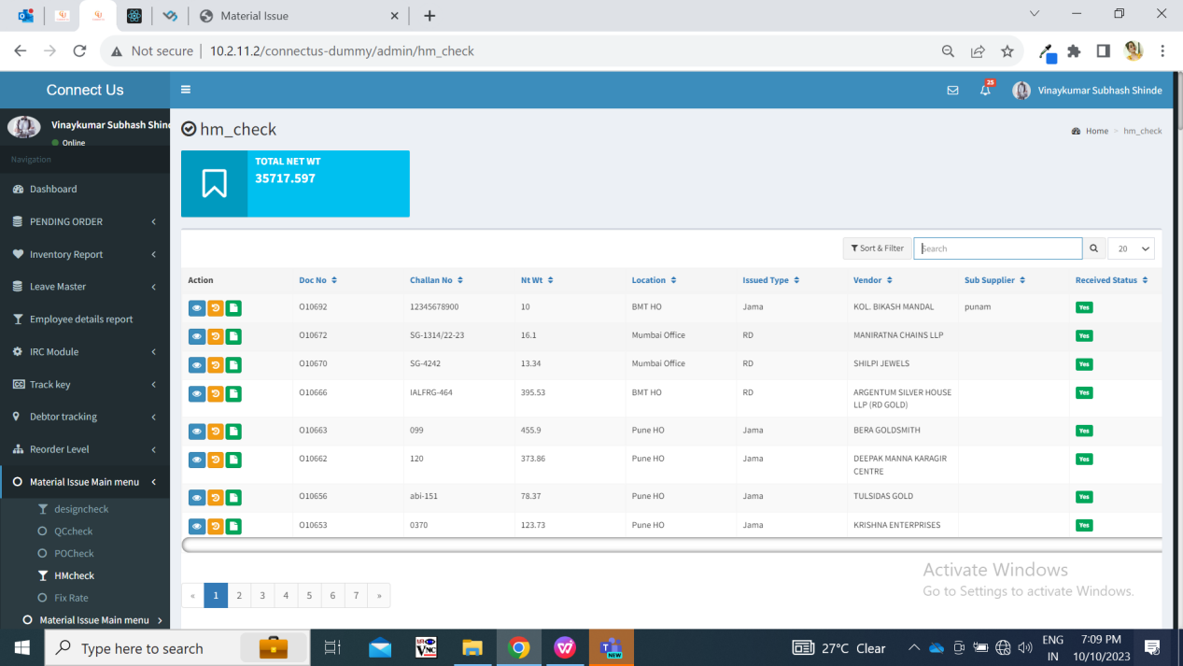

Fig: HM check

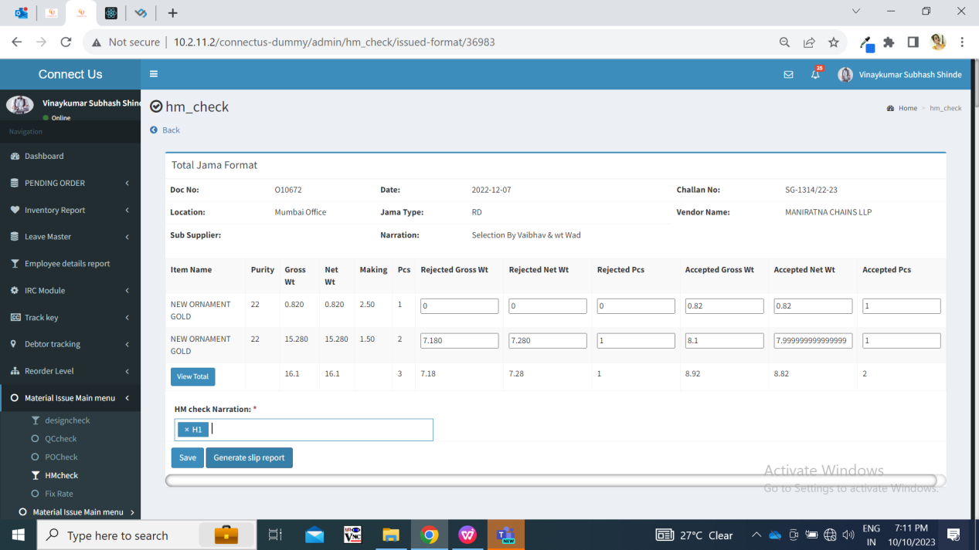

Fig: HM check issued

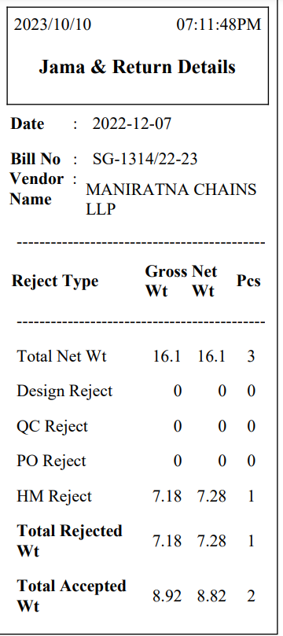

Fig: Receipt after HM check

Whenever pcs are rejected in each checking process, it will be displayed in view action of documents in material issue as well.

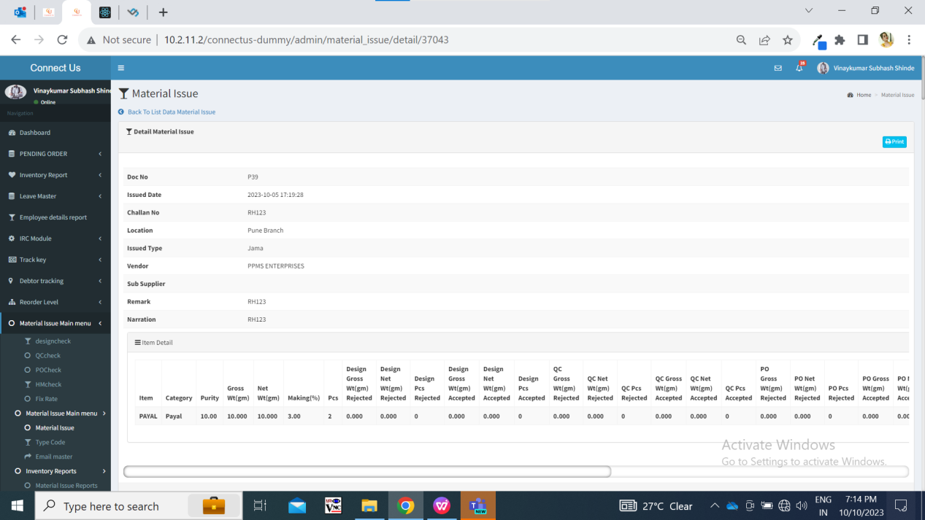

Fig: material issue -> view action

Once the HM check process for the document is completed, then only ‘on approval out challan’ action will be displayed in material issue menu for that document. (This action will not be displayed until all checking processes for that document are completed.) If all pcs are rejected from the document, then ‘on approval out’ action will display all details as 0 in the table.

Once user clicks on ‘on approval out’ action, pop up message should be displayed where user should be able to select ‘from location’. It should display list of active branches from branch master. It will be single select. This selected location and its details will be displayed on challan.

Further, user shoul be able to download print multiple times with address as per selected from location, however selecting ‘from location’ will be one time action I.e. user should be able to select ‘from location’ only once.

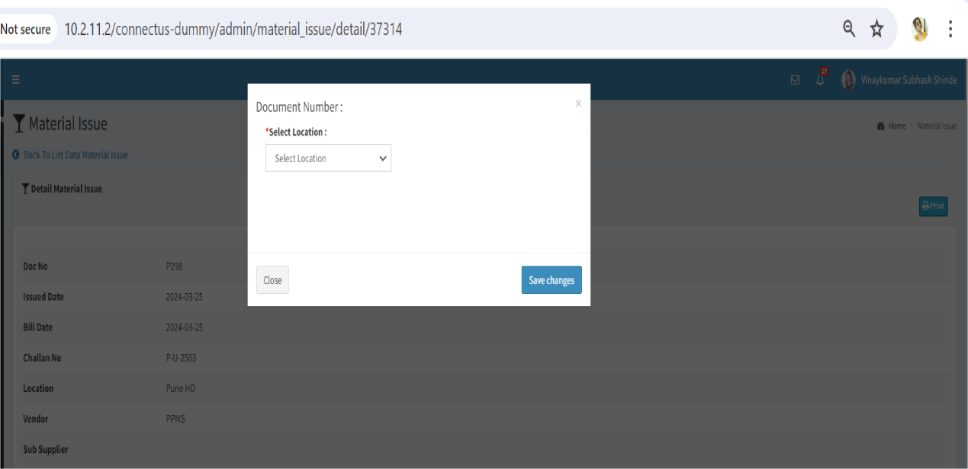

Fig: On approval out -> from location

Once user clicks on confirm button, then challan will be displayed in new tab. It will display following fields:

* From:
* Chandukaka Company name
* Address
* Gst no.
* Phone no.
* Pan no.
* To:
* Vendor Name
* Vendor Address
* Vendor GST no.
* Vendor pan no.
* Vendor phone no.
* Doc No.
* Issued Date
* Challan no. / bill no.
* Narration
* Sr. No.
* Item name
* KT
* W/MK
* Rejected pcs
* Rejected gross wt
* Rejected net wt

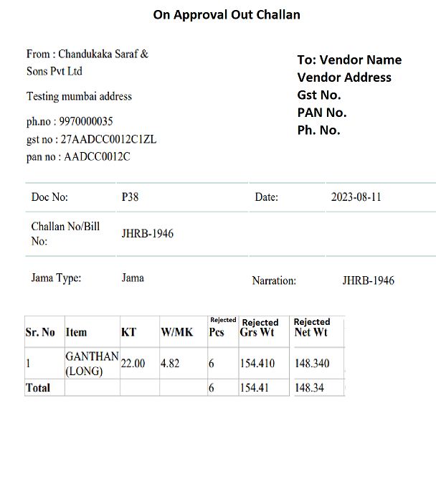

Fig: On approval out challan

|  |  |  |  |
| --- | --- | --- | --- |
| **FIELDS** | **INPUT TYPE** | **MANDATORY/ OPTIONAL** | **DESCRIPTION** |
| From details | Text | Mandatory | It represents the details of the location from which the stock is being dispatched.  It will display company name, gst no., pan no. and ph no. From cu_master_setting table. Whereas, it will display the address from branch master against that selected branch.  Setting number 43 (here 43 is company name), setting no. 46 for pan no. and setting no. 67 for GST no. |
| To details | Text | Mandatory | It will display the vendor details from vendor master.  Vendor will be the one which was selected while adding the document in material issue menu. |
| Doc no. | Text | Mandatory | It will display the doc. No. Which was generated after adding the document in material issue menu. |
| Issued date | Text | Mandatory | It will display the date on which the doc. Number was added in the material issue menu. |
| Challan no. / bill no. | Text | Mandatory | It will display the challan no. Which was mentioned while adding the document. |
| Narration | Text | Mandatory | It will display narration as mentioned while adding the document. |
| Sr. no | Text | Mandatory | It will display the no. of items added in the document. |
| Item name | Text | Mandatory | It will display the names of item added in the document. |
| KT | Text | Mandatory | It will display the KT of each item added in the document. |
| W/MK | Text | Mandatory | It will display the W/MK of each item added in the document. |
| Rejected pcs | Text | Mandatory | It will display the rejected pcs of each item in that document as per rejected pcs in HM check process. |
| Rejected gross wt | Text | Mandatory | It will display the rejected gross wt of each item in that document as per rejected gross wt until HM check process. |
| Rejected net wt | Text | Mandatory | It will display the rejected net wt of each item in that document as per rejected net wt in HM check process. |

User will be able to download and print on approval out challan multiple times.

Once user clicks on **Material issue reports**, it displays following fields:

* From Date
* To date
* Type wise reports
* User wise reports
* Type wise and user wise reports
* All reports
* Submit button
* Reset button

|  |  |  |  |  |
| --- | --- | --- | --- | --- |
| **FIELDS** | **INPUT TYPE** | **MANDATORY/ OPTIONAL** | **EDITABLE** | **DESCRIPTION** |
| From Date | Calender date picker | Mandatory | Yes | User will select the date from which the document was added in the material issue. (I.e. from issued date)  Validation: It will be single select and future dates are disabled. |
| To date | Calender date picker | Mandatory | Yes | User will select the date till which the document was added in the material issue. (I.e. till issued date)  Validation: It will be single select and future dates are disabled. |
| Type wise reports | Check box | Mandatory to select one report type | - | User can view the report by the checking type (Design check / qc check / po check / hm check). The report will display the fields of the selected type only.  Once user clicks on type wise report check-box, then report type drop-down will be displayed below which will be mandatory. It will be single select.  If user selects type wise report and any one type (design check / qc check / hm check / po check) and clicks on submit button, it will display the documents which are issued I.e. added between the selected filters dates and the details of that document related to design process. Report will display following fields in the grid and export:   * Sr. No. * Issued date * User name * Doc no. * Karagir name * Sub supplier name * Challan no. * Vendor system challan no. * Rate type * Rate for 99.50% * Fine rate * Location * Narration * Received status * Current status * Issued date and time * Received date and timing * Time difference * Item * Category * Purity * Making * Pcs * Gross wt * Net wt * Gross wt Rejected * Net wt rejected * Pcs rejected * Gross wt accepted * Net wt accepted * Pcs accepted * Total pcs * Total gross wt * Total net wt * Add to received status   It will display the accepted and rejected details here based on the type selected. |
| User wise reports | Check box | Mandatory to select one report type | - | User can view the documents in the report of specific vendor only by clicking here to know which user has done checking in which stage.  Once user click on ‘user wise report’ then users drop-down will be displayed where user will select the vendor for which the data is to be displayed. It will be single select.  As per selected vendor name, it will display the documents in the grid of the selected vendor only.  If user checks user wise report check-box and selects one of the vendor name in the users field, it will display following columns in the report:   * Sr. No. * Issued date * User name * Doc no. * Karagir name * Sub supplier name * Challan no. * Vendor system challan no. * Rate type * Rate for 99.50% * Fine rate * Location * Narration * Received status * Current status * Issued date and time * Received date and timing * Time difference * Item * Category * Purity * Making * Pcs * Gross wt * Net wt * Design user * QC user * PO user * HM user * Add to received status * Received status to design check update * Design check update to QC check update * QC check update to PO check update * PO check update to print * Print to HM check update * Time difference start to end process |
| Type wise User wise report | Check box | Mandatory to select one report type | - | User can view documents by specific checking type and vendor.  Once user clicks on type wise user report then report type and user drop-down will be displayed. Both will be single select each. It will display following columns in grid:   * Sr. No. * Issued date * User name * Doc no. * Karagir name * Sub supplier name * Challan no. * Vendor system challan no. * Rate type * Rate for 99.50% * Fine rate * Location * Narration * Received status * Current status * Issued date and time * Received date and timing * Time difference * Item * Category * Purity * Making * Pcs * Gross wt * Net wt * Gross wt Rejected * Net wt rejected * Pcs rejected * Gross wt accepted * Net wt accepted * Pcs accepted * Narration * Add to received status * Received status to design check , etc. - Here it will display the columns based on the checking type selected. |
| All reports | Check box | Mandatory to select one report type | - | Once user selects all reports, all details of each document will be displayed which were issued within selected dates in filter.  It will display following columns in the grid:   * Sr. No. * Date * Doc no. * Material created by * Material accepted by * Karagir name * Sub supplier name * Challan no. * Vendor system challan no. * Rate type * Rate for 99.50% * Fine rate * Is rd purchase * Location * Narration * Received status * Current status * Issued date and time * Received date and timing * Time difference * Item * Category * Purity * Making * Pcs * Gross wt * Net wt * Design Gross wt Rejected * Design Net wt rejected * Design Pcs rejected * Design Gross wt accepted * Design Net wt accepted * Design Pcs accepted * Design narration * QC Gross wt Rejected * QC Net wt rejected * QC Pcs rejected * QC Gross wt accepted * QC Net wt accepted * QC Pcs accepted * Qc narration * PO Gross wt Rejected * PO Net wt rejected * PO Pcs rejected * PO Gross wt accepted * PO Net wt accepted * PO Pcs accepted * PO narration * HM Gross wt Rejected * HM Net wt rejected * HM Pcs rejected * HM Gross wt accepted * HM Net wt accepted * HM Pcs accepted * HM narration * Black bits * Stone wt * Stone amt * Other charges * Extra stone wt * Hallmark tunch * Hallmark pcs * Add to received status * Received status to design check update * Design check update to QC check update * QC check update to PO check update * PO check update to print * Print to HM check update * Time difference start to end process |
| Submit | Click | - | - | Once user selects dates, report type and clicks on submit button, expected report will be displayed in the gird.  In case, user doesn’t select mandatory fields in filter and clicks on submit button, then error message will be displayed. |

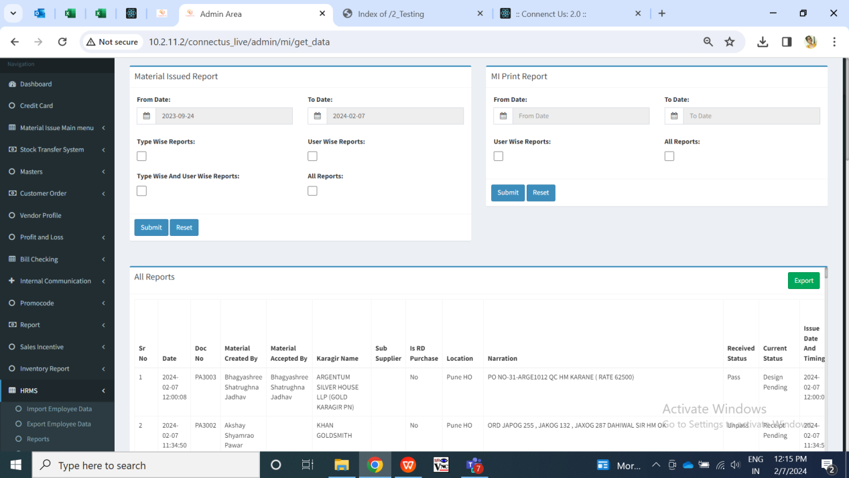

Fig: All reports

Once user clicks on export button, csv file will get downloaded displaying all the columns in it as in grid with the documents. Exported file will have all the fields as in grid along with additional fields : challan no, vendor system challan no, rate type, rate for 99.50% and fine frate.

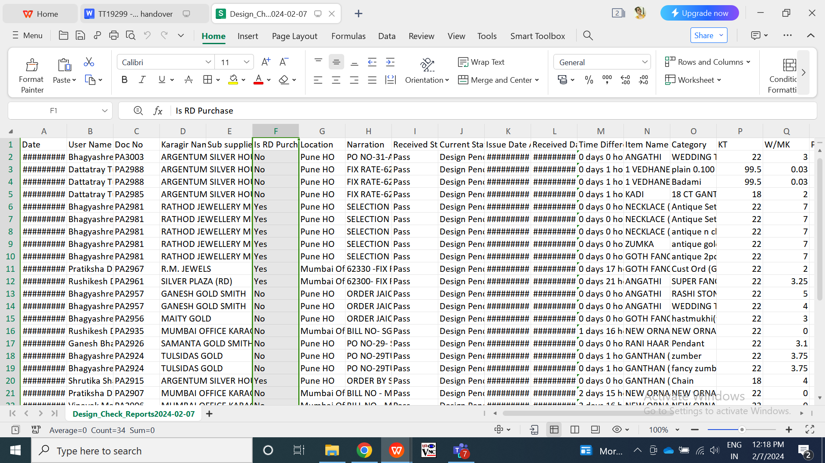

Fig: Export

1. **TEST DATA & SCENARIOS**



1. **ODUS (Open Discussion Unhanded Scenarios)**

|  |  |  |  |  |
| --- | --- | --- | --- | --- |
| **Sr. No.** | **Topic** | **Priority** | **Remark** | **Status** |
| 1 | Rate type and rate needed in rd purchase print | medium | Required | Open |
| 2 | From location to selected only once? | medium | Prashant Pise: User should be able to select from location only once. Further when user clicks on on approval out print, address of selected ‘from location’ should be displayed each time when user downloads print. Print should be downloaded multiple times. In case of any issues or change in from location address, point will be raised to support team. | Closed |

1. **REFERENCES OF THE USERS**

|  |  |  |  |
| --- | --- | --- | --- |
| **User** | **Name** | **Mail** | **Contact number** |
| **Actual user** | Prashant pise | goldpn@csjewellers.com |  |
| **Ticket created by (if any)** | Prashant pise | goldpn@csjewellers.com |  |
| **Assigned business analyst** | Manali bhadirage | Manali.bhadirage@techneai.com |  |
| **Assigned developer** | Jaydeep patil | Jaydeep.patil@techneai.com |  |
| **Assigned tester** | Amruta kore | Intern@techneai.com |  |