MATERIAL ISSUE -

VENDOR CHALLAN NUMBER AND RATE TYPE

Manali Ashok Bhadirage

Manali.bhadirage@techneai.com

01.05.2024

**Handover Document**

**CONTENTS**

1. TICKET DETAILS 2

2. INTRODUCTION 2

3. BUSINESS REQUIREMENT 2

4. SCOPE 3

5. BUSINESS & SYSTEM RULES 4

6. ABBREVIATIONS & TERMS 4

7. GRAPHICAL REPRESENTATION 4

8. DEVELOPED SYSTEM 5

9. REFERENCES OF THE USERS 27

1. **TICKET DETAILS**

|  |  |
| --- | --- |
| **Ticket ID** | TT21023 |
| **Ticket description** | Display rate type (fix or unfix) in 4 checking stages issued and view action. Display vendor system challan number field in material issue add, edit, view. Display rate type, rate, vendor system challan number on print. |
| **Created by** | Manali Bhadirage |
| **Created on** | 18/04/2024 |
| **Priority** | Very high |

1. **INTRODUCTION**

Within the material issue menu, inventory users input details of materials received from vendors. This input triggers the generation of a document number, which must then be approved by an authorized individual before progressing to four checking stages (design check, QC check, PO check, HM check). During these inspection stages, some pieces may be rejected and will be sent back to the vendor, while the accepted pieces will lead to the creation of a RD purchase bill within the Padm system for the vendor. Purchase return bill is generated for the rejected pcs and then returned to the vendor.

In inventory we do receive orders from vendors for which the Padm bill need not be created. Inventory team can accept the slot if they like and/or return the entire lot to vendor or disliked items. This is termed as Jangad process. Challan gets generated for rejected items details which are to be returned to vendor. When items are added from one location (example added at Mumbai office), we can return it to vendor from our another location (Pune HO).

1. **BUSINESS REQUIREMENT**

|  |  |  |  |
| --- | --- | --- | --- |
| **Requirement ID** | **Requirement Name** | **Short Description** | **Priority** |
| BR001 | Material issue - Add | We need to add ‘vendor system challan number’ text field in material issue -> add form. | Medium |
| BR002 | Material issue - edit | We need to add ‘vendor system challan number’ text field in material issue -> edit form. | Medium |
| BR003 | Material issue - view | We need to add ‘vendor system challan number’ text field in material issue -> view form. | Low |
| BR004 | Print | Need vendor system challan number, rate type, rate(for 99.50%), fine rate fields on print. | Medium |
| BR005 | Design check - view and issued actions | Need vendor system challan number, rate type, rate(for 99.50%), fine rate fields on design check - view and issued action. | Medium |
| BR006 | Quality check - view and issued actions | Need vendor system challan number, rate type, rate(for 99.50%), fine rate fields on quality check - view and issued action. | Medium |
| BR007 | PO check - view and issued actions | Need vendor system challan number, rate type, rate(for 99.50%), fine rate fields on PO check - view and issued action. | Medium |
| BR008 | HM check - view and issued actions | Need vendor system challan number, rate type, rate(for 99.50%), fine rate fields on HM check - view and issued action. | Medium |
| BR009 | HM check - jama & return pdf | Need vendor system challan number, rate type, rate (for 99.50%), fine rate fields in PDF after saving from HM check. | Medium |

1. **SCOPE**

Once data is added in material issue, then it will get received by the authorized user. Once document is received by the authorized user, then that document will be displayed in design check process. Once user rejects the items from that document through issued action, then the accepted pcs of that document will be passed to QC check process. Further, accepted pcs of QC check process will be passed to PO check process. Once user rejects pcs in PO check, the accepted pcs of that document will be passed to HM check process. After accepting and rejecting the pcs in HM check process, ‘on approval out challan’ action will be displayed in material issue menu grid.

Once user clicks on ‘on approval out’ action then user will be able to select from location from drop-down. Once user clicks on yes, receipt will get downloaded in new tab. It will display the vendor name and details as per added document and vendor address from vendor master. It will display the from address from branch master.

1. **BUSINESS & SYSTEM RULES**

* User will be registered in the system.
* User will be logged in.
* System should display error message for incorrect details if entered.

1. **ABBREVIATIONS & TERMS**

Wt - Weight

Gm - grams

KT - karat

MK - making

Pcs - pieces

PDF - Portable Document Format

BB - Black Bits

1. **GRAPHICAL REPRESENTATION**

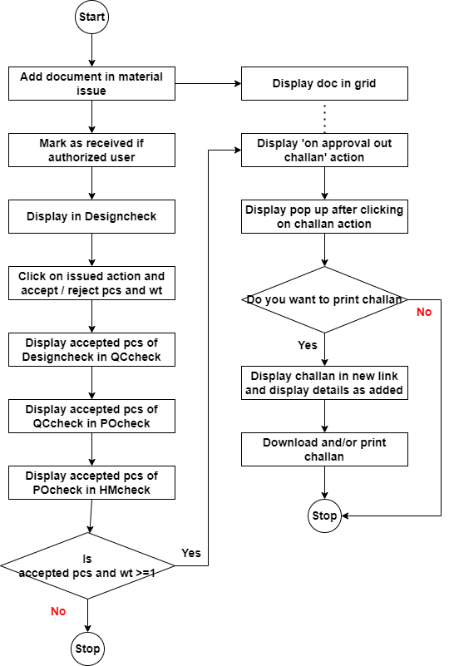

Fig: Flowchart

1. **DEVELOPED SYSTEM**

In earlier system, rate and rate type is not being displayed in any of the checkig stages or material issue or on print. User needs to view rate and rate type for processing documents is better way. Moreoever, we have developed vendor PO system recently where challan number gets generated when users generate the print of WIP pcs. We need field in material issue where our users will mention that generated vendor challan number which will be used for further reference at inventory.

Once user clicks on material issue menu, it will display following fields:

* Add button
* View action
* History action
* Edit action
* Take print action
* Received action
* Edit data action
* Get attachment action
* On approval out challan action
* Doc no.
* Date
* Challan no.
* Net wt (gm)
* Location
* Issued type
* Vendor
* Sub supplier
* Narration
* Received status
* Time difference

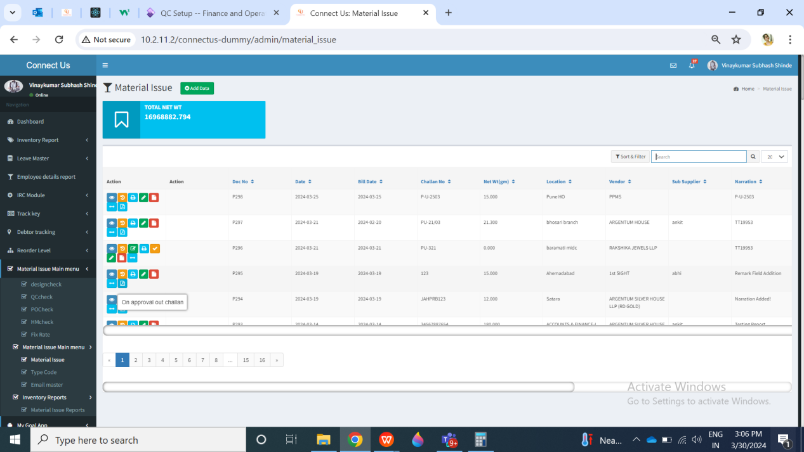

Fig: Material issue -> grid

In Connect us -> material issue main menu -> material issue, once user clicks on add data, it will display following fields:

* Issued date
* Challan no.
* Vendor System challan no.
* Location
* Issued Type
* Vendor
* Sub supplier
* Narration
* Remark
* **Rate type**
* **Rate for 99.50%**
* **Attachment**
* Item detail form:
* Item
* Category
* KT
* Gross wt
* Net wt
* Black bits
* Stone wt
* Stone amt
* Other charges
* Other wt
* Making
* Wastage
* Pcs
* Add to table button
* Reset button
* Table detail
* Total
* Save button
* Save & add more button
* Back button

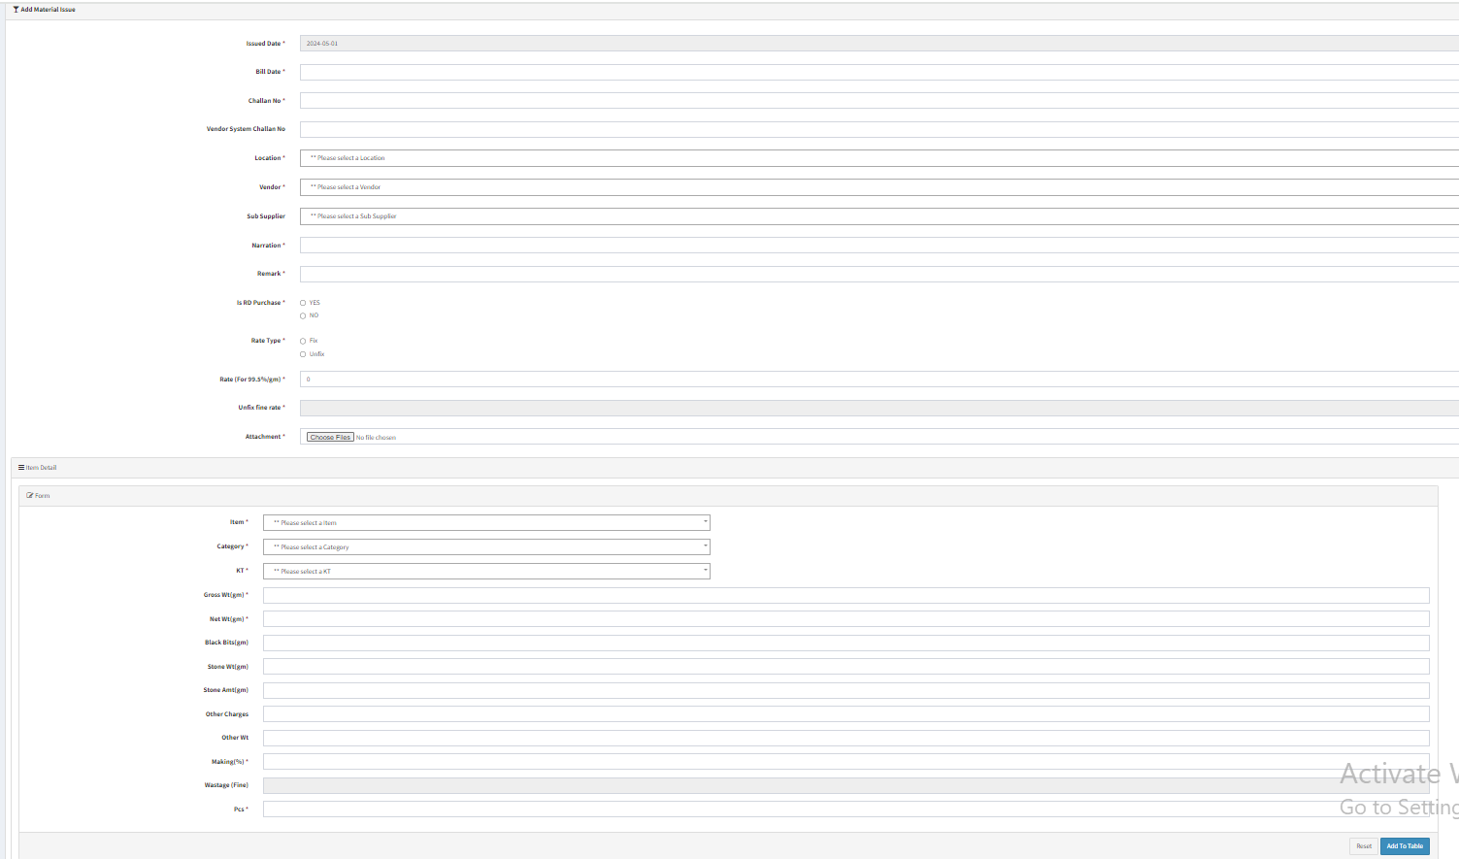

Fig: Material issue -> add

Example:

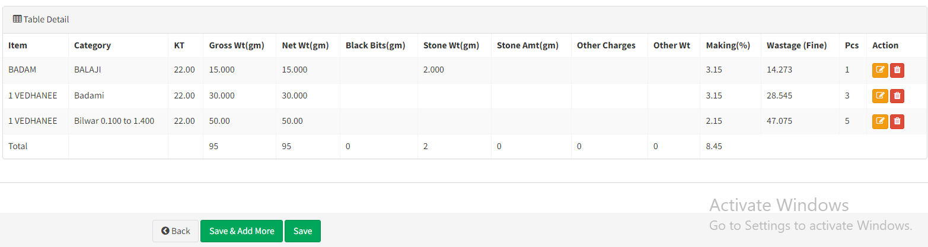

|  |  |  |  |  |
| --- | --- | --- | --- | --- |
| **FIELDS** | **INPUT TYPE** | **MANDATORY/ OPTIONAL** | **EDITABLE** | **DESCRIPTION** |
| Vendor System Challan No. | Text | Optional | Yes | User will enter the challan number generated through vendor PO system. This fiekld is for the reference between raised PO and the received material when user will add it in material issue menu.  Validation: It will accept alphanumeric value. It should not accept space or any special characters.  Min length = 1  Max length = 15 |
| Type of rate | Radio button | Mandatory | Yes | It will display Fix or Unfix. While adding the data in material issue, the user will specify whether the rate for the particular vendor is fixed or not. Only unfix rate type documents will be displayed in fix rate menu.  Validation: It will be single select. Initially, none of the type will be selected. |
| Unfix Rate | Text | Mandatory | yes | Rate which is decided by the vendor for the day during purchase, it will be mentioned here. User will mention the rate of per gram of 99.50% purity.  This field will be disabled once this document has completed HM check process. This field will be editable only till the document hasn’t reached fix rate menu.  Below this text field, we have to display line as ‘per gram rate of 99.50%’.  Validations: In add and both edit actions, it should accept only 4 digits before decimal point and after decimal point. It will accept numbers only. It will accept only one decimal point as a special character.  Min length = 1  Max length = 9 |

Once data is added, then doc number gets generated to it and it will be displayed in grid displaying received action against it to the authorized user.

In Connect us -> material issue main menu -> material issue, once user clicks on edit data, it will display following fields:

* Issued date
* Challan no.
* Vendor System challan no.
* Location
* Issued Type
* Vendor
* Sub supplier
* Narration
* Remark
* **Rate type**
* **Rate for 99.50%**
* **Attachment**
* Item detail form:
* Item
* Category
* KT
* Gross wt
* Net wt
* Black bits
* Stone wt
* Stone amt
* Other charges
* Other wt
* Making
* Wastage
* Pcs
* Add to table button
* Reset button
* Table detail
* Total

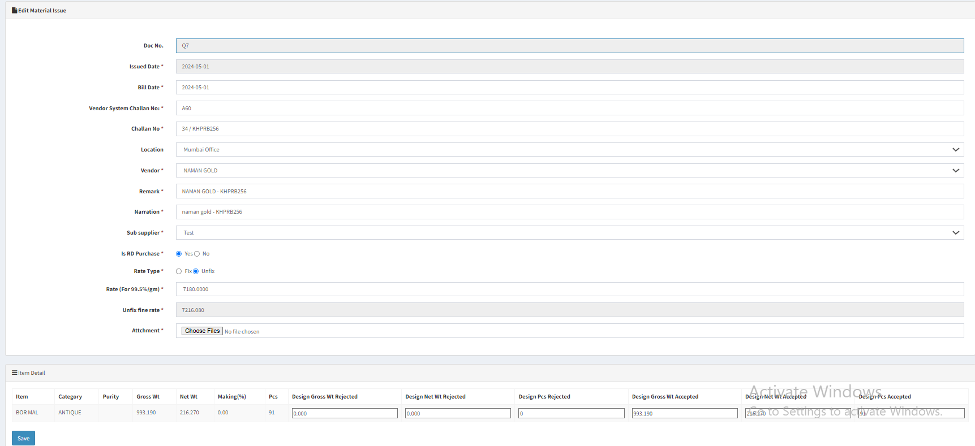

Fig: material issue -> edit

Once user clicks on **view action of material issue**, it will display following fields:

* Issued date
* Challan no.
* Vendor System challan no.
* Location
* Issued Type
* Vendor
* Sub supplier
* Narration
* Remark
* **Rate type**
* **Rate for 99.50%**
* **Attachment**
* Item detail form:
* Item
* Category
* KT
* Gross wt
* Net wt
* Black bits
* Stone wt
* Stone amt
* Other charges
* Other wt
* Making
* Wastage
* Pcs
* Add to table button
* Reset button
* Table detail
* Total

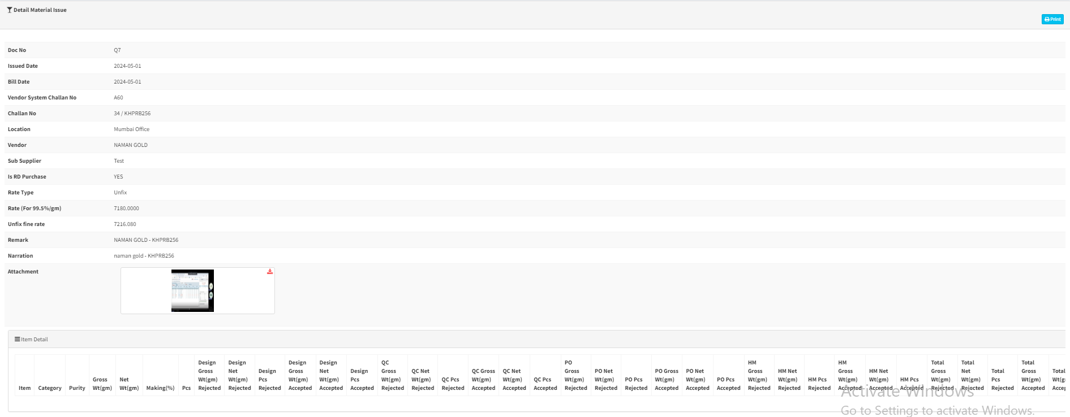

Fig: Material issue -> view action

Once user clicks on **print action of material issue**, it will display following fields on PDF:

* From details
* Address
* Ph. no.
* GST no.
* PAN no.
* To details
* Address
* Ph no.
* GST no.
* PAN no.
* Doc no.
* Date
* Challan no.
* Vendor system challan no.
* Location
* Vendor name
* Address
* GST Number
* Narration
* Rate type
* Rate (for 99.50%)
* Fine rate
* Item details table
* Sr no.
* Item
* Category
* KT
* W/MK
* Pcs
* Gross wt
* BB wt
* Stone wt
* Other wt
* Net wt
* Wastage

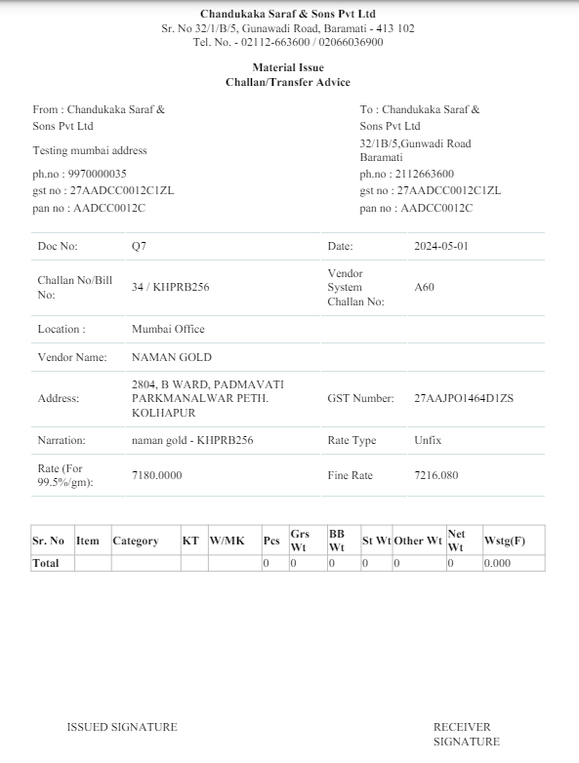

Fig: material issue -> print

|  |  |  |  |
| --- | --- | --- | --- |
| **FIELDS** | **INPUT TYPE** | **MANDATORY/ OPTIONAL** | **DESCRIPTION** |
| From - Address | Text | Mandatory | It will display the address of the location selected against that document while adding / through edit. It will display address of that selected location from branch master. |
| From - Ph. No. | Text | Mandatory | It will display the phone no. of the selected branch from branch master. |
| From - GST No. | Text | Mandatory | It will display the GST no. from cu setting master table. Setting no. 46 for pan no. |
| From - PAN No. | Text | Mandatory | It will display the PAN no. from cu setting master table. Setting no. 67 for GST no. |
| TO - Address | Text | Mandatory |  |
| From - Ph. No. | Text | Mandatory |  |
| TO - GST No. | Text | Mandatory | It will display the GST no. from cu setting master table. Setting no. 46 for pan no. |
| TO - PAN No. | Text | Mandatory | It will display the PAN no. from cu setting master table. Setting no. 67 for GST no. |
| Doc no. | Text | Mandatory | It will display the doc number generated when user submitted & this record got added on grid. |
| Date | Text | Mandatory | It will display the date on which the document was created in material issue. |
| Challan no. | Text | Mandatory | It will display the challan no. Which user entered in add / edit against this document. |
| Vendor system challan no. | Text | - | It will display the vendor system challan no. entered by the user in add/ edit of that document.  It will be blank if user has not entered it.  Validation: It will be alphanumeric value with no special character or no space. |
| Location | Text | Mandatory | It will display the location selected by the user in add /edit for this document. |
| Vendor name | Text | Mandatory | It will display the name of vendor which was selected by the user against that document while add / edit.  It will be displayed as in vendor master.  Validation: It will be read only. It will display updated name on new print if users edits vendor name in vendor master. |
| Vendor Address | Text | Mandatory | It will display the address of vendor as per vendor master which was selected by the user against that document while add / edit.  Validation: It will be read only. It will display updated address on new print if users edits vendor address of that vendor in vendor master. |
| Vendor GST number | Text | Mandatory | It will display the GST number of vendor as per vendor master which was selected by the user against that document while add / edit.  Validation: It will be read only. It will display updated GST on new print if users edits vendor GST of that vendor in vendor master. |
| Narration | Text | Mandatory | It will display the narration mentioned by the user against that document as in add / edit.  Validation: It will be read only. |
| Rate type | Text | Mandatory | It will display rate type as either fix or unfix which is selected by the user for that document as in add / edit. |
| Rate (for 99.50) | Text | Mandatory | It will display rate (for 99.50%) which is mentioned by the user for that document as in add / edit. |
| Fine rate | Text | Mandatory | It will display rate (for 99.50%) which is mentioned by the user for that document as in add / edit. |
| Item details table - sr no. | Text | Mandatory | It will display the Sr. No. for each row in the table. |
| Item details table - item | Text | Mandatory | It will display the list of items in each row which was elected by the user in add. |
| Item details table - category | Text | Mandatory | It will display the list of categories in each row which was elected by the user in add. |
| Item details table - KT | Text | Mandatory | It will display the KT of each item row which was elected by the user in add. |
| Item details table - W/MK | Text | Mandatory | It will display the W/MK of each item row which was elected by the user in add. |
| Item details table - pcs | Text | Mandatory | It will display the pcs of each item row which was elected by the user in add. |
| Item details table - gross wt | Text | Mandatory | It will display the gross wt of each item row which was elected by the user in add. |
| Item details table - BB wt | Text | Mandatory | It will display the BB wt of each item row which was elected by the user in add. |
| Item details table - stone wt | Text | Mandatory | It will display the stone wt of each item row which was elected by the user in add. |
| Item details table - other wt | Text | Mandatory | It will display the other of each item row which was elected by the user in add. |
| Item details table - net wt | Text | Mandatory | It will display the net wt of each item row which was elected by the user in add. |
| Item details table - wastage | Text | Mandatory | It will display the wastage of each item row which was elected by the user in add. |

Once authorized user marks the doc as received, then its received action will be removed whereas this doc will be displayed in design check process menu. In **design check** phase, from Issue data action, user enters the details of accepted and rejected pcs and submits the challan to further process.

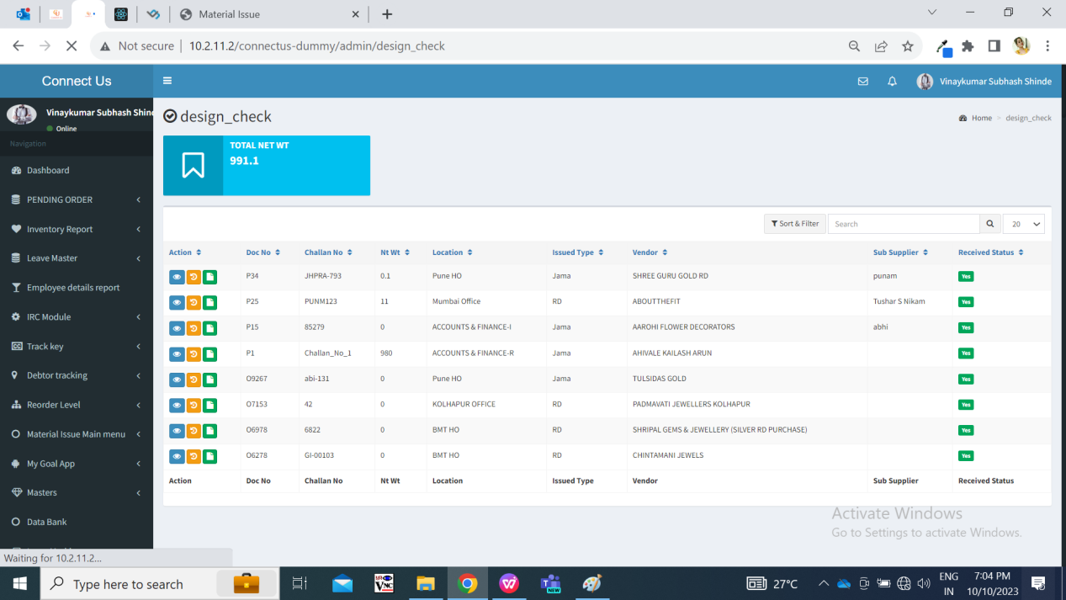

Fig: Design check

Once user clicks on **issued action of design check**, it will display following fields:

* Doc no.
* Date
* Challan no.
* Vendor system challan no.
* Location
* Vendor name
* Sub supplier
* Narration
* Rate type
* Rate for 99.50%
* Fine rate
* Item detail form:
* Item
* Category
* KT
* Gross wt
* Net wt
* Making
* Pcs
* Rejected gross wt
* Rejected net wt
* Rejected pcs
* Accepted gross wt
* Accepted net wt
* Accepted pcs

Once design check is done, the accepted pcs and all details in the document will be forwarded to **QC check** process. The documents received from design check process will be first displayed to QC incharge in QC check menu. Here, QC incharge will first split the document into present employees.

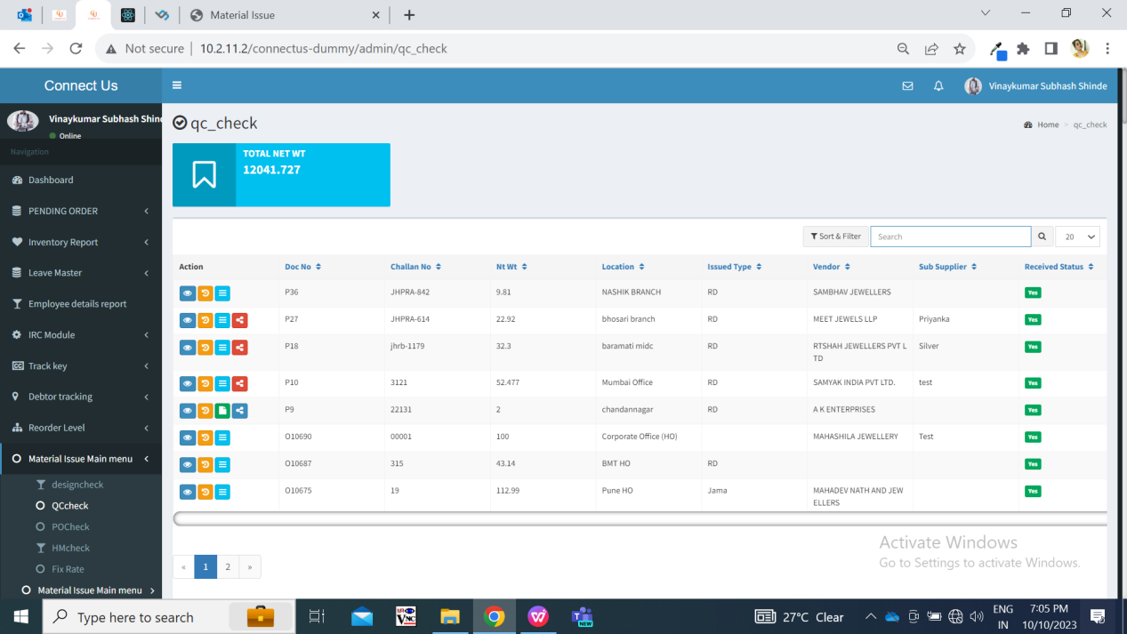

Fig: QC check

Once user clicks on **issued action of Quality check**, it will display following fields:

* Doc no.
* Date
* Challan no.
* Vendor system challan no.
* Location
* Vendor name
* Sub supplier
* Narration
* Rate type
* Rate for 99.50%
* Fine rate
* Item detail form:
* Item
* Category
* KT
* Gross wt
* Net wt
* Making
* Pcs
* Rejected gross wt
* Rejected net wt
* Rejected pcs
* Accepted gross wt
* Accepted net wt
* Accepted pcs

Once all the QC incharge has submitted details of accepted / rejected in QCcheck -> issued action, then total accepted gross wt, total accepted net wt, total accepted pcs will be displayed to **POcheck** process for the respective doc.

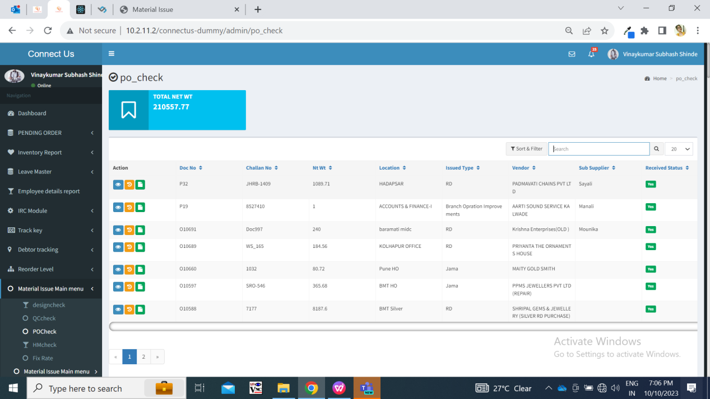

Fig: PO check

Once user clicks on **issued action of PO check**, it will display following fields:

* Doc no.
* Date
* Challan no.
* Vendor system challan no.
* Location
* Vendor name
* Sub supplier
* Narration
* Rate type
* Rate for 99.50%
* Fine rate
* Item detail form:
* Item
* Category
* KT
* Gross wt
* Net wt
* Making
* Pcs
* Rejected gross wt
* Rejected net wt
* Rejected pcs
* Accepted gross wt
* Accepted net wt
* Accepted pcs

Further, the accepted pcs from PO check process are forwarded to **HM check** process. And in generate slip, the total details of rejected and accepted pcs, wt will be displayed.

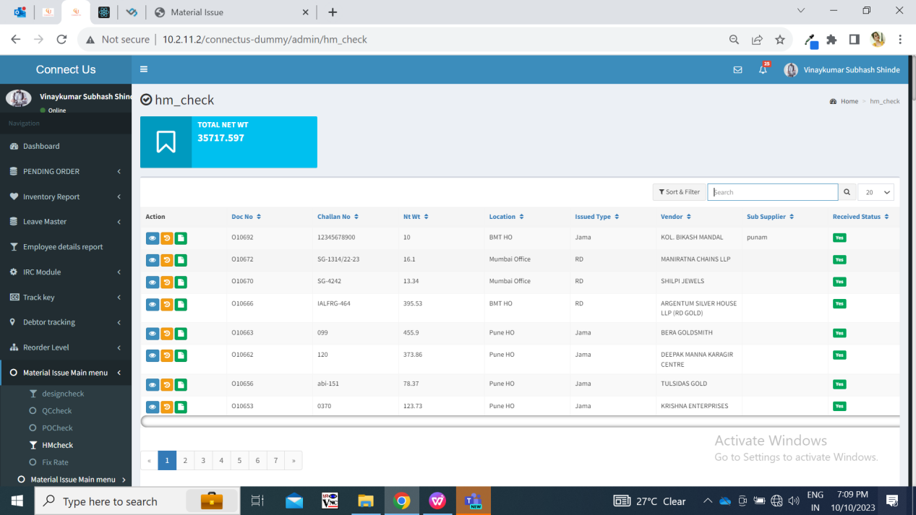

Fig: HM check

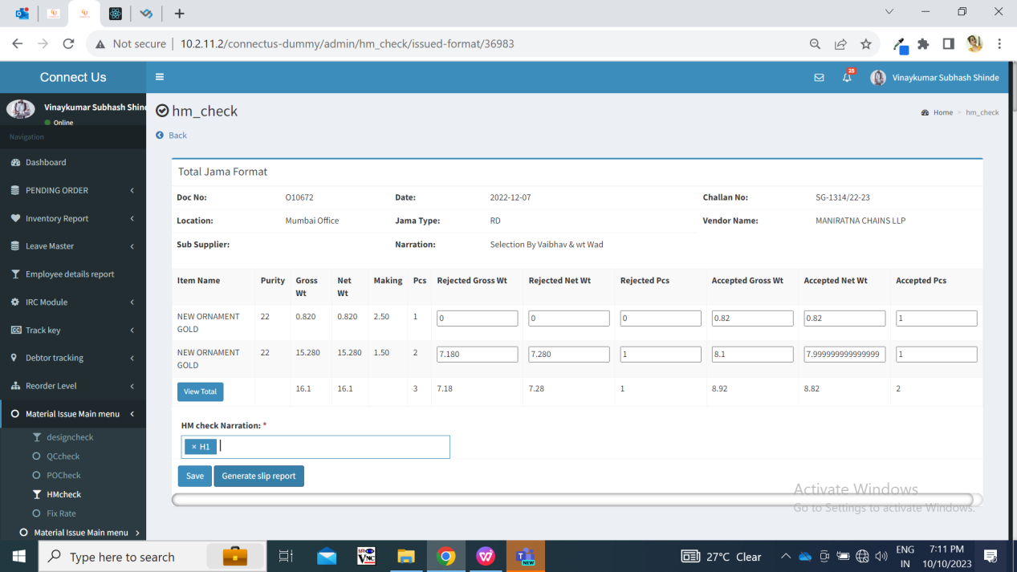

Fig: HM check issued

Once user clicks on **issued action of HM check**, it will display following fields:

* Doc no.
* Date
* Challan no.
* Vendor system challan no.
* Location
* Vendor name
* Sub supplier
* Narration
* Rate type
* Rate for 99.50%
* Fine rate
* Item detail form:
* Item
* Category
* KT
* Gross wt
* Net wt
* Making
* Pcs
* Rejected gross wt
* Rejected net wt
* Rejected pcs
* Accepted gross wt
* Accepted net wt
* Accepted pcs

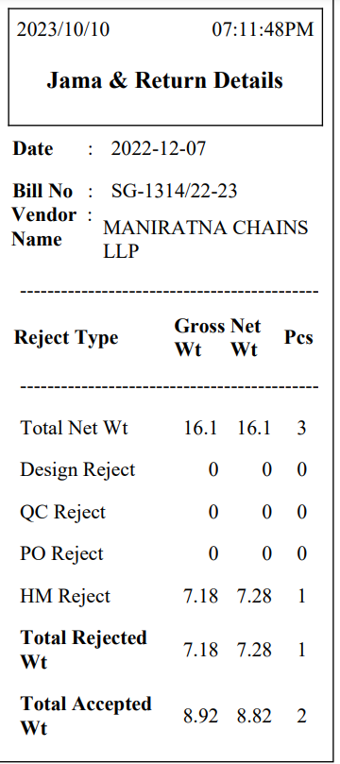

Fig: Receipt after HM check

Once user saves the document from HM check, PDF of jama & return gets displayed. It will have following fields:

* Doc no.
* Date
* Challan no.
* Vendor system challan no.
* Location
* Vendor name
* Vendor address
* Vendor gst number
* Narration
* Rate type
* Rate for 99.50%
* Fine rate
* Item detail form:
* Item
* Category
* KT
* Gross wt
* Net wt
* Making
* Pcs
* Rejected gross wt
* Rejected net wt
* Rejected pcs
* Accepted gross wt
* Accepted net wt
* Accepted pcs
* Total

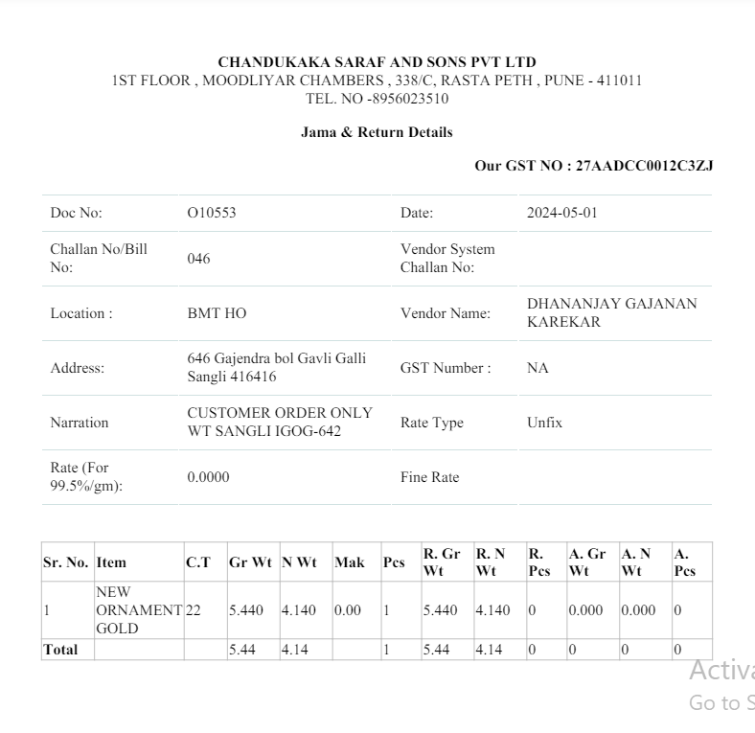

Fig: HM check -> PDF

Whenever pcs are rejected in each checking process, it will be displayed in view action of documents in material issue as well.

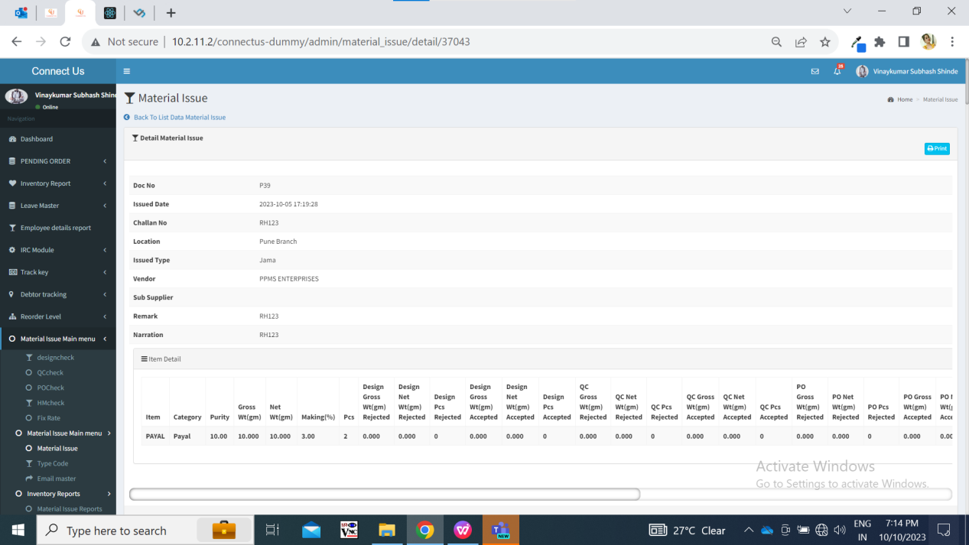

Fig: material issue -> view action

Once the HM check process for the document is completed, then only ‘on approval out challan’ action will be displayed in material issue menu for that document. (This action will not be displayed until all checking processes for that document are completed.) If all pcs are rejected from the document, then ‘on approval out’ action will display all details as 0 in the table.

Once user clicks on ‘on approval out’ action, pop up message will be displayed where user will be able to select ‘from location’. It should display list of active branches from branch master. It will be single select. This selected location and its details will be displayed on challan.

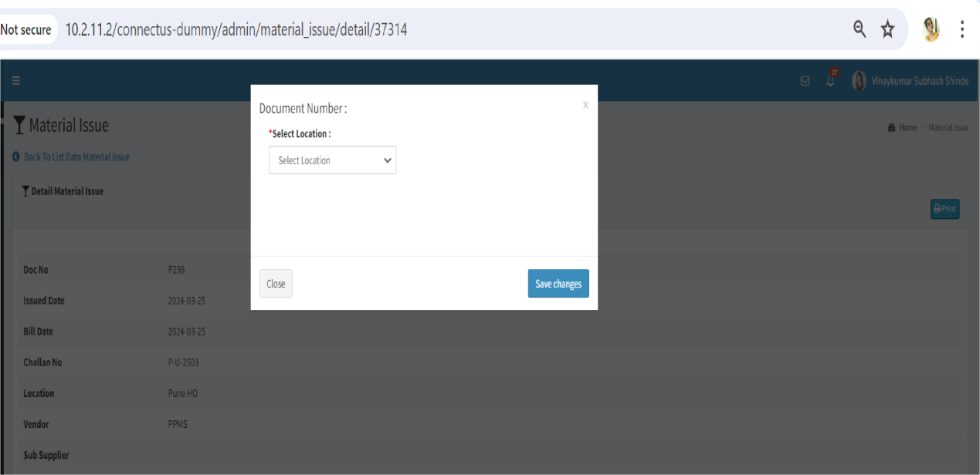

Fig: On approval out -> from location

Once user clicks on confirm button, then challan will be displayed in new tab. It will display following fields:

* From:
* Chandukaka Company name
* Address
* Gst no.
* Phone no.
* Pan no.
* To:
* Vendor Name
* Vendor Address
* Vendor GST no.
* Vendor pan no.
* Vendor phone no.
* Doc No.
* Issued Date
* Challan no. / bill no.
* Narration
* Sr. No.
* Item name
* KT
* W/MK
* Rejected pcs
* Rejected gross wt
* Rejected net wt

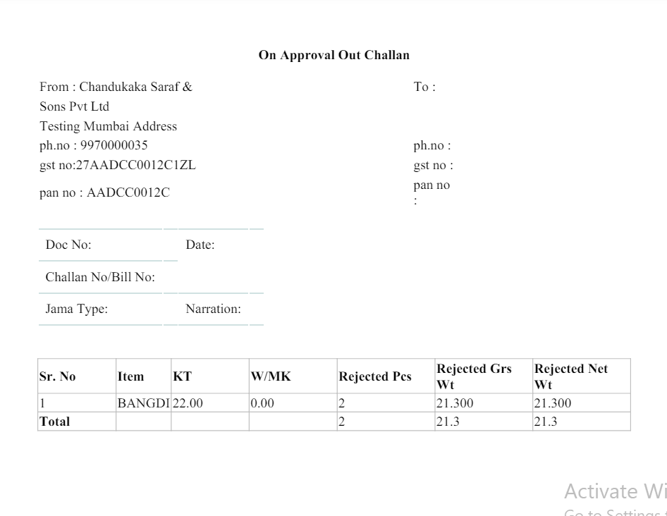

Fig: On approval out challan

|  |  |  |  |
| --- | --- | --- | --- |
| **FIELDS** | **INPUT TYPE** | **MANDATORY/ OPTIONAL** | **DESCRIPTION** |
| From details | Text | Mandatory | It represents the details of the location from which the stock is being dispatched.  It will display company name, gst no., pan no. and ph no. From cu_master_setting table. Whereas, it will display the address from branch master against that selected branch.  Setting number 43 (here 43 is company name), setting no. 45 for address 2, setting no. 46 for pan no. and setting no. 67 for GST no. |
| To details | Text | Mandatory | It will display the vendor details from vendor master.  Vendor will be the one which was selected while adding the document in material issue menu. |
| Doc no. | Text | Mandatory | It will display the doc. No. Which was generated after adding the document in material issue menu. |
| Issued date | Text | Mandatory | It will display the date on which the doc. Number was added in the material issue menu. |
| Challan no. / bill no. | Text | Mandatory | It will display the challan no. Which was mentioned while adding the document. |
| Narration | Text | Mandatory | It will display narration as mentioned while adding the document. |
| Sr. no | Text | Mandatory | It will display the no. of items added in the document. |
| Item name | Text | Mandatory | It will display the names of item added in the document. |
| KT | Text | Mandatory | It will display the KT of each item added in the document. |
| W/MK | Text | Mandatory | It will display the W/MK of each item added in the document. |
| Rejected pcs | Text | Mandatory | It will display the rejected pcs of each item in that document as per rejected pcs in HM check process. |
| Rejected gross wt | Text | Mandatory | It will display the rejected gross wt of each item in that document as per rejected gross wt until HM check process. |
| Rejected net wt | Text | Mandatory | It will display the rejected net wt of each item in that document as per rejected net wt in HM check process. |

User will be able to download and print on approval out challan multiple times.

1. **REFERENCES OF THE USERS**

|  |  |  |  |
| --- | --- | --- | --- |
| **User** | **Name** | **Mail** | **Contact number** |
| **Actual user** | Prashant pise | goldpn@csjewellers.com |  |
| **Ticket created by (if any)** | Manali bhadirage | Manali.bhadirage@techneai.com |  |
| **Assigned business analyst** | Manali bhadirage | Manali.bhadirage@techneai.com |  |
| **Assigned developer** | Jaydeep Patil | Jaydeep.patil@techneai.com |  |
| **Assigned tester** | - | - |  |