14.12.2023

**USER MANUAL HANDOVER**

Connect US 1.0 Bill Checking

Anup Deotale  
anup.deotale@techneai.com

**CONTENTS**

1. VERSION CONTROL 2

2. INTRODUCTION 2

3. SCOPE 2

4. BUSINESS & SYSTEM RULES 2

5. ABBREVIATIONS & TERMS 2

6. GRAPHICAL REPRESENTATION 2

7. DEVELOPED SYSTEM 2

8. TEST DATA AND BUSINESS SCENARIOS 3

1. **VERSION CONTROL**

|  |  |  |  |  |  |  |
| --- | --- | --- | --- | --- | --- | --- |
| **Sr. No.** | **Version no** | **Version Date** | **User Name** | **User department** | **Updated By** | **Ticket ID** |
| **1** | **1.0** | **14/12/2023** |  |  |  |  |
|  |  |  |  |  |  |  |
|  |  |  |  |  |  |  |

1. **INTRODUCTION**The bill checking module is the billing process which is helpful in creating bills, payment details, approval process and the bill payments.
2. **SCOPE**

The scope of the project to create the bill, bills are assigned based on the authority approval process automatically and the bill payments.

1. **BUSINESS & SYSTEM RULES**

* User should be registered in the system and should be logged in.
* System should pop up a message, if any issues in the system is detected.
* All forms should have on field validations. System should display on field errors in case of incorrect inputs.

1. **ABBREVIATIONS & TERMS**

BC - BILL CHECKING

1. **GRAPHICAL REPRESENTATION**



Fig - Bill checking connect us 1.0

1. **DEVELOPED SYSTEM**

Bill Checking system contain following modules in it:

1. BILL CHECKING MASTERS
2. Acme Doc series
3. Vendor master
4. Payment template
5. Bill Type
6. Bill Type mapping user
7. BILL CHECKING TRANSACTION
8. BILL CHECKING TRANSACTION REPORTS
9. BILL PAYMENTS
10. BILL TO BILL REFERENCE REPORT
11. NACH PAYMENT
12. INTERNAL AUDIT QUERY REPORT

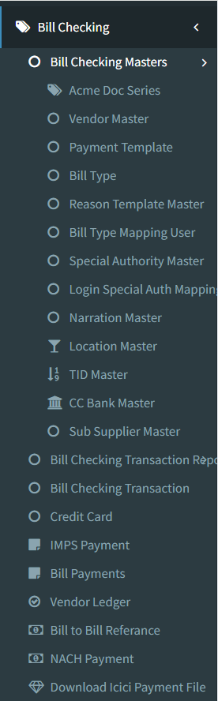

1. **BILL CHECKING MASTERS**
2. **Bill type**

While entering the bill through bill checking transaction -> add form, the entry user will select the type of bill that they are adding in the system like light bill, laptop bill, etc. Those types of bill will be displayed in bill checking transaction -> add and edit form from bill type master.

Bill type master menu has following fields:

* Add button
* Edit button
* History button
* View button
* Company Code
* Bill Type
* Sort Order
* Remark
* Is Active
* Save button
* Save & add more button
* Back button
* Created at
* Created by
* Updated at
* Updated by
* IP address
* User agent

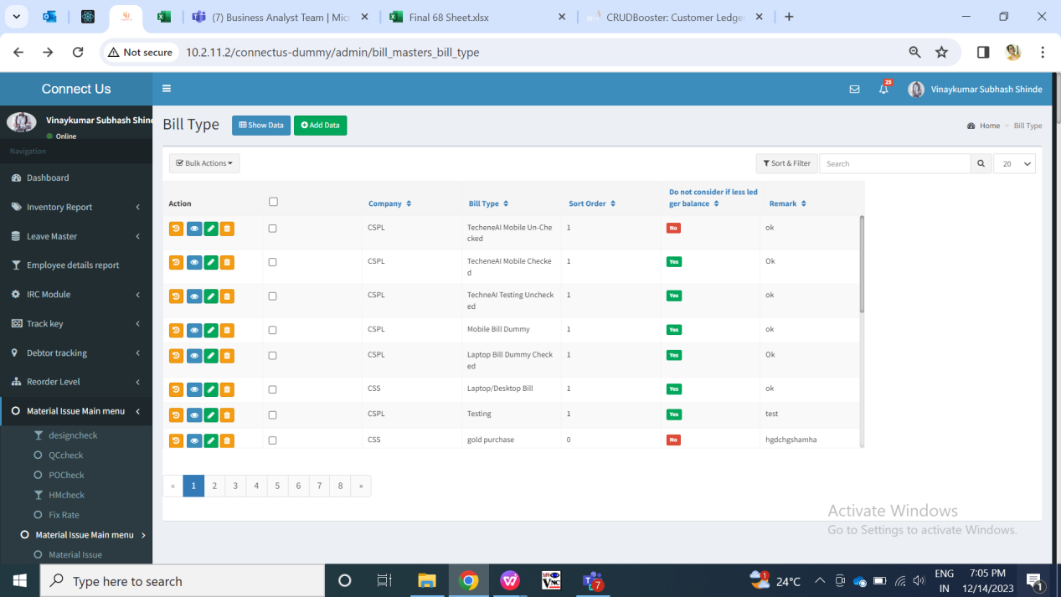

Fig: Bill type master (Grid)

Visibility of fields on pages:

|  |  |  |  |  |
| --- | --- | --- | --- | --- |
| **FIELDS** | **GRID** | **ADD** | **EDIT** | **HISTORY** |
| Add button |  | X | X | X |
| Edit button |  | X | X | X |
| History button |  | X | X | X |
| View button |  | X | X | X |
| Company Code |  |  |  |  |
| Bill Type |  |  |  |  |
| Sort Order |  |  |  |  |
| Remark |  |  |  |  |
| Is Active |  |  |  |  |
| Save button | X |  |  | X |
| Save & add more button | X |  | X | X |
| Back button | X |  |  | X |
| Created at |  | X | X |  |
| Created by |  | X | X |  |
| Updated at |  | X | X |  |
| Updated by |  | X | X |  |
| IP address | X | X | X |  |
| User agent | X | X | X |  |
| Action / operation | X | X | X |  |

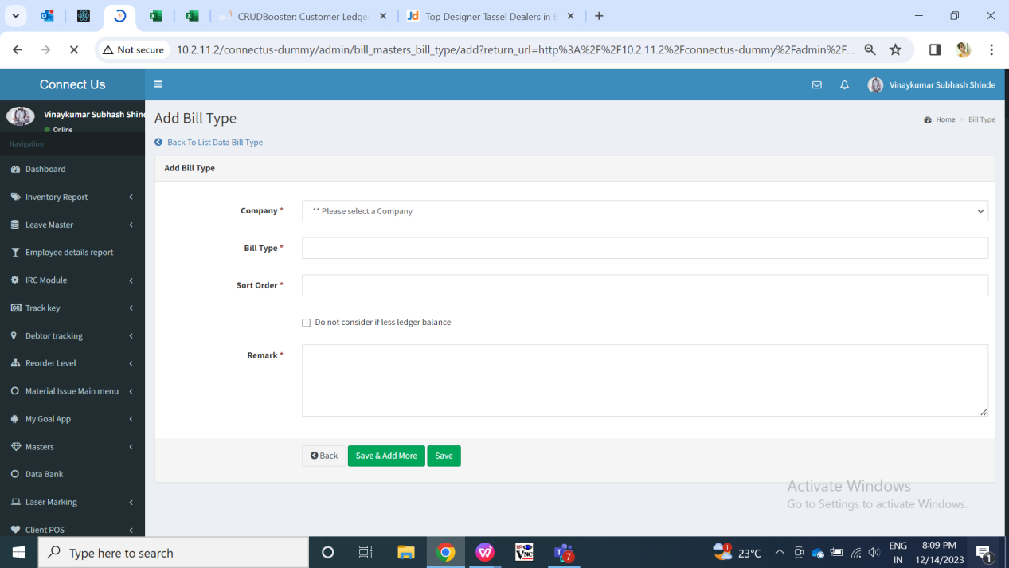

Fig: Bill type master (Add)

|  |  |  |  |  |
| --- | --- | --- | --- | --- |
| **FIELDS** | **INPUT TYPE** | **MANDATORY/ OPTIONAL** | **EDITABLE** | **DESCRIPTION** |
| Company Code | Drop Down menu | Mandatory | Yes | The user will select the company code from the drop down menu.  Validation - It will be a single selection. |
| Bill type | Text | Mandatory | Yes | User will enter name for the Bill Type in this field.  Validation: It should be unique. It should accept characters, special characters, numbers and space.  Min length = 8  Max length = 50 |
| Sort order | Text | Optional | Yes | User will enter the number for the bill type which will be displayed in the bill checking transaction -> add and edit -> bill type field drop-down list.  Validation:  Same number cannot be used again. It should accept only numbers. It should not accept space, characters, special characters.  Min length = 1 digit  Max length = 4 digits |
| Remark | Text | Optional | Yes | User will enter additional notes in this field.  Validation:  It should accept characters, numbers and space. It should accept English / Marathi script.  Min length = 8  Max length = 250 |
| Is active | Radio button | Mandatory | Yes | It will display status as active / inactive. Only the active bills will be displayed in bill checking transaction -> add and edit -> bill type drop-down list.  Validation: It should keep “active” status by default. It will be single select. |
| Save button | Click | - | - | Once user enters valid details in mandatory fields and clicks on save button, bill type should get added. Successful message should be displayed. User should be directed to grid page of bill type where recently added bill type will be displayed at top.  Validation:  Button should be displayed until bill type gets added successfully or until error message is displayed in case of invalid fields. |
| Save & add more | Click | - | - | Once user enters valid details in mandatory fields and clicks on save button, bill type should get added. Successful message should be displayed. Recently added bill type will be displayed at top whereas user will remain on the same page to add another new bill type.  Validation: Button should be displayed until bill type gets added successfully or until error message is displayed in case of invalid fields. |
| Back button | Click | - | - | Once user clicks on back button, user will be directed to grid page and the record will not get added if details are filled any in add form of bill type.  Validation: Once back button is clicked, then it will be disabled until user is redirected to grid page. |
| Created at | Text | - | No | It will display the date and time when the bill type details were added.  Validation: It will be read only. |
| Created by | Text | - | No | It will display the employee name who added the bill type details.  Validation: It will be read only. |
| Updated at | Text | - | - | Once the user edits the bill type details, then it will display the date and time when the bill type details were modified.  Validation: It will be read only. |
| Updated by | Text | - | - | Once the user edits the already created bill type, then it will display the employee name who modified the details.  Validation: It will be read only. |
| IP address | Text | - | No | It specifies the IP address of the system from which user added or edited the bill type.  Validation: It is read only. |
| User agent | Text | - | No | User-Agent is a string of characters sent by HTTP clients (browsers, bots, calendar applications, etc.) for each individual HTTP request to a server.  Thus, in history action we will view the user agent which is nothing but the details of the operating system and browser of user's system who is adding or editing that bill type. It will vary.  Validation: It is read only. |

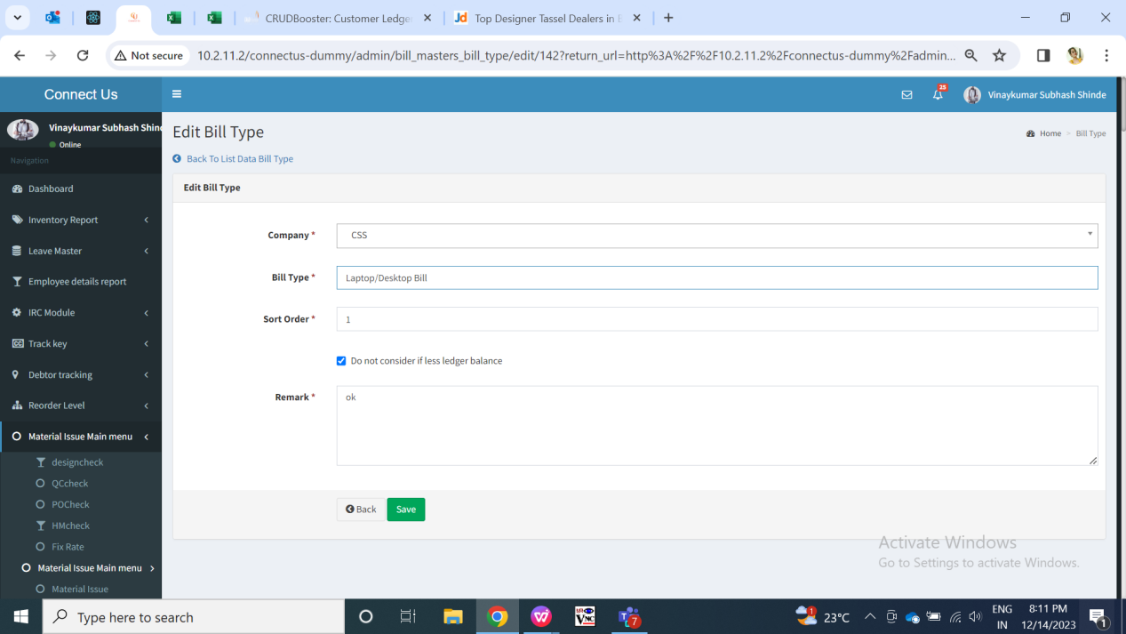

Fig: Bill type master (edit)

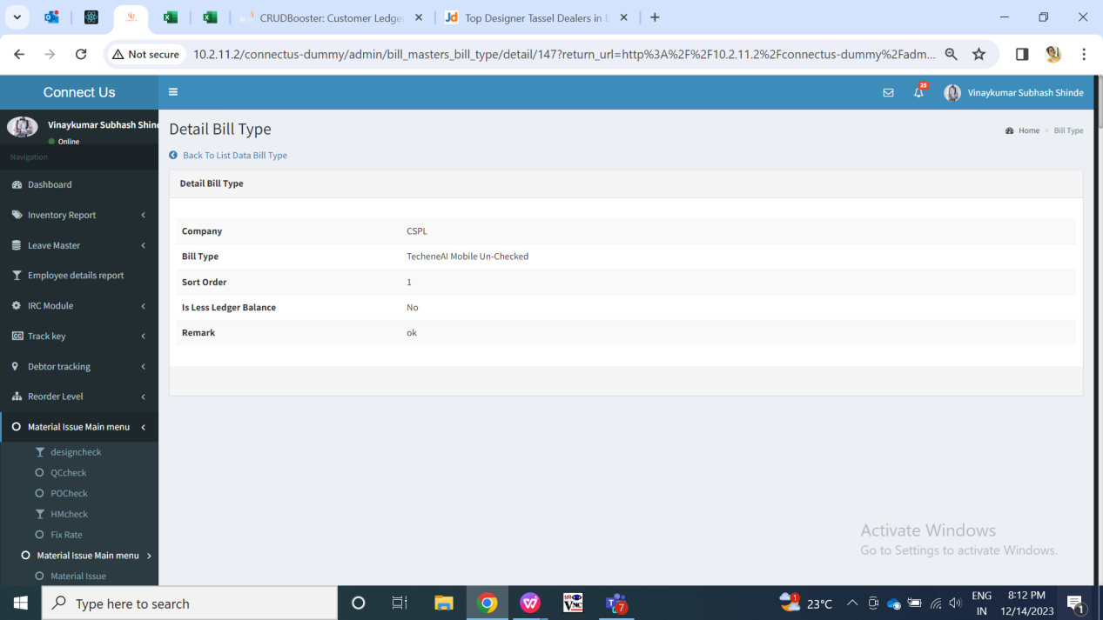

Fig: Bill type master (view)

1. **Bill type mapping user**

Through bill type mapping user, we can map the created bill type with users in the employee master. Thus, users will be able to add the bills for the bill types only which are mapped to them. Once the bill type is mapped with the user, then in bill checking transaction -> add and edit form, the list of ‘assigned to users’ will be displayed as per selected bill type.

Bill type mapping user has following fields:

* Add button
* Edit button
* View button
* Bill type
* User name
* Remark
* Is active
* Save button
* Save & add more button
* Back button

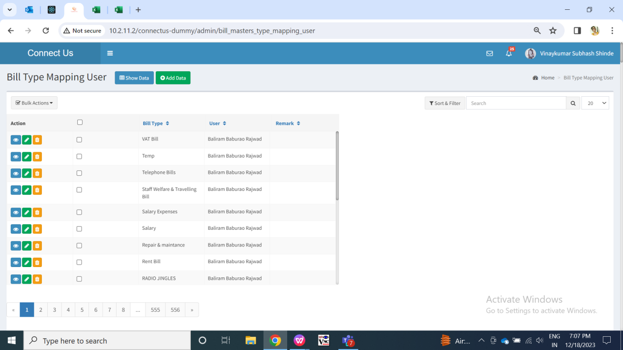

Fig: Bill type mapping user (Grid)

Visibility of fields on pages:

|  |  |  |  |  |
| --- | --- | --- | --- | --- |
| **FIELDS** | **GRID** | **ADD** | **EDIT** | **VIEW** |
| Add button |  | X | X | X |
| Edit button |  | X | X | X |
| View button |  | X | X | X |
| Bill type |  |  |  |  |
| User name |  |  |  |  |
| Remark |  |  |  |  |
| Is active | X |  |  |  |
| Save button | X |  |  | X |
| Save & add more button | X |  | X | X |
| Back button | X |  |  | X |

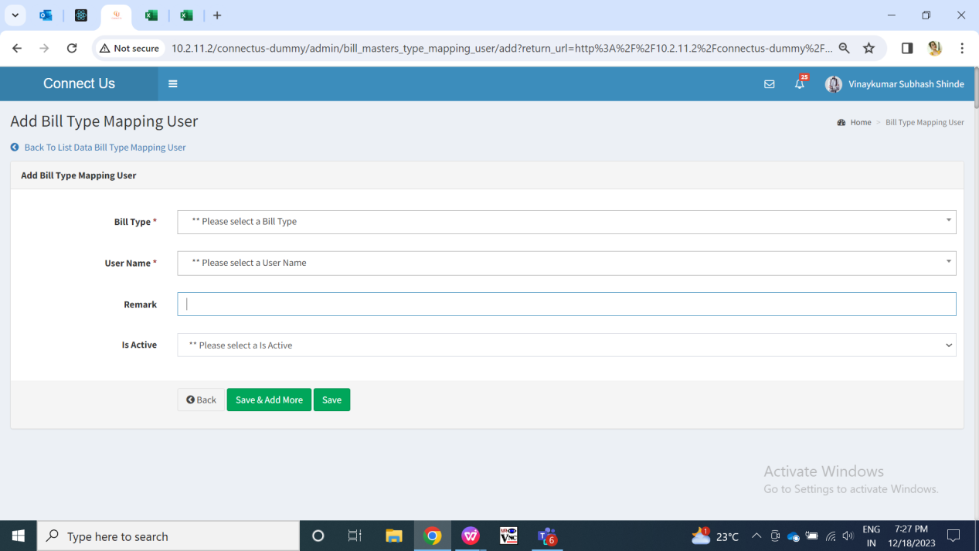

Fig: Bill type mapping user (add)

**Input Table -**

|  |  |  |  |  |
| --- | --- | --- | --- | --- |
| **FIELDS** | **INPUT TYPE** | **MANDATORY/ OPTIONAL** | **EDITABLE** | **DESCRIPTION** |
| Bill type | Drop down | Mandatory | Yes | User will select the bill type against which they have to map assigned to user.  Validation: It will be single select. It will display active bill types in the list from bill type master. |
| User name | Drop down |  |  | User will select the name of the user from the drop down menu to which that bill type is to be mapped. Once the bill type is mapped with the user, then in bill checking transaction -> add and edit form, the list of ‘assigned to users’ will be displayed as per selected bill type.  Same bill type can be mapped to the same user only once. So, user names will be disabled from the drop down list as per bill type selected and already mapped.  Validation: It will be single select. It will display active employees from employee master. |
| Remark | Text | Optional | Yes | User will enter additional notes in this field.  Validation: It should accept characters, numbers and space. It should accept English / Marathi script.  Min length = 3  Max length = 250 |
| Is active | Radio button | Mandatory | Yes | It will display status as active / inactive. If mapping is inactive then the particular bill cannot be assigned to that user through add and edit of bill checking transaction.  If the mapping is active then only the name of the user will be displayed in assigned to user field of bill checking transaction after selecting the particular bill type.  Validation: It should keep “active” status by default. It will be single select. |
| Save button | Click | - | - | Once user enters valid details in mandatory fields and clicks on save button, bill type mapping with the user should get added. Successful message should be displayed. User should be directed to grid page of bill type mapping user master where recently added bill type mapping user record will be displayed at top.  Validation:  Button should be displayed until bill type mapping user gets added successfully or until error message is displayed in case of invalid fields. |
| Save & add more | Click | - | - | Once user enters valid details in mandatory fields and clicks on save button, bill type should get added. Successful message should be displayed. Recently added bill type will be displayed at top whereas user will remain on the same page to add another new bill type.  Validation: Button should be displayed until bill type gets added successfully or until error message is displayed in case of invalid fields. |
| Back button | Click | - | - | Once user clicks on back button, user will be directed to grid page and the record will not get added if details are filled any in add form of bill type.  Validation: Once back button is clicked, then it will be disabled until user is redirected to grid page. |

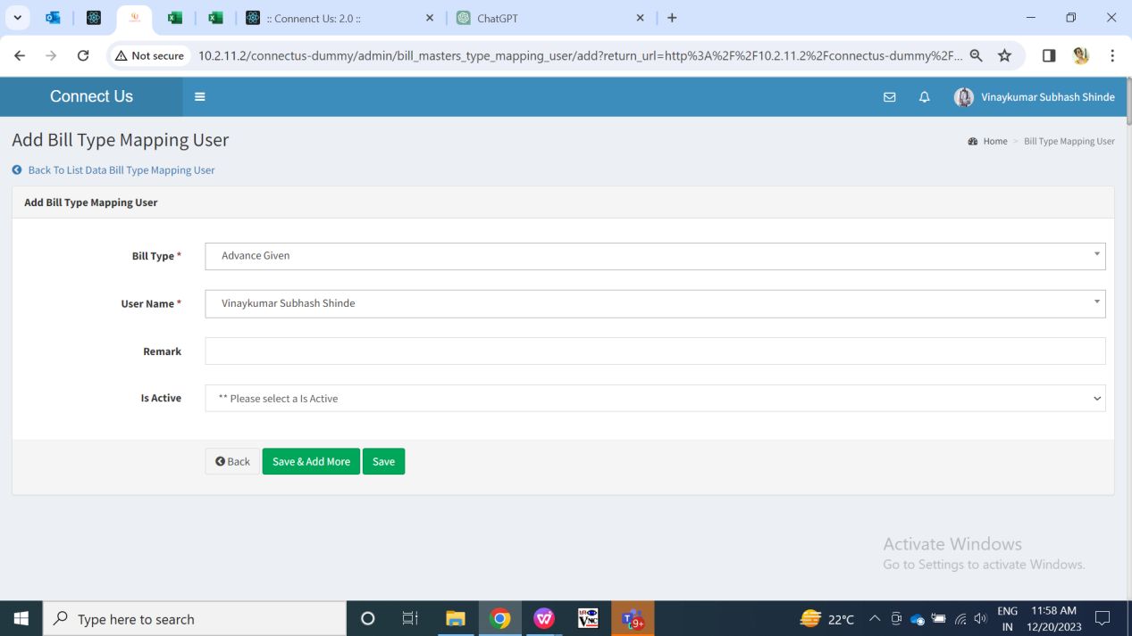

Fig: Bill type mapping user (edit)

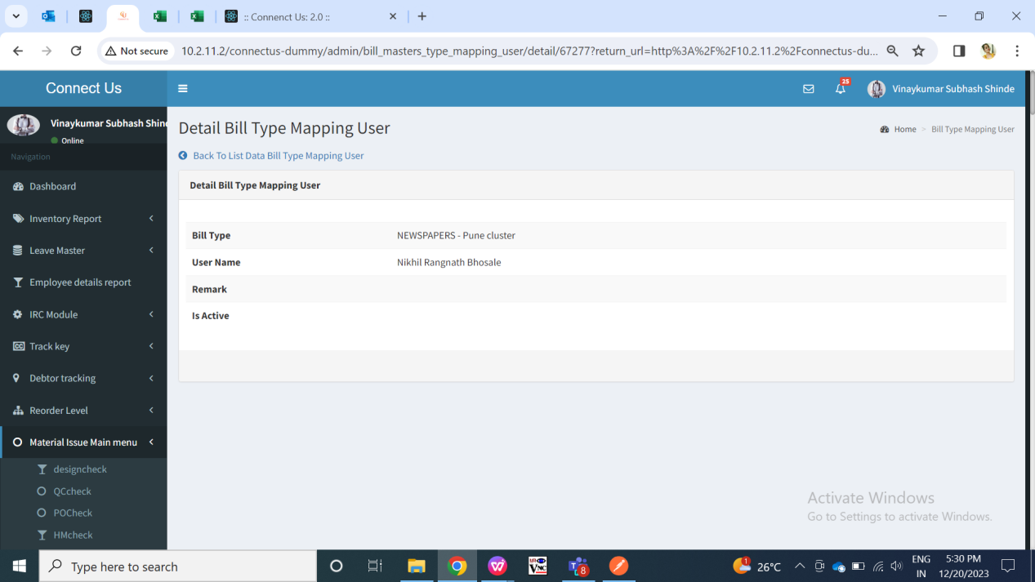

Fig: Bill type mapping user (view)

1. **Payment Template Master**

Whenever a bill for vendor is added through bill checking transaction, its payment date gets displayed as per payment template set against that vendor. This payment template is made in payment template master and then mapped against vendor in vendor master. It has following fields:

* Add button
* View button
* Edit button
* History button
* Company Code
* Template name
* Payment type
* Type of bill
* Min days
* Payment weekly days
* Bill dates
* Remark
* Terms and conditions
* Save button
* Save & add more button
* Back button
* Created at
* Created by
* Updated at
* Updated by

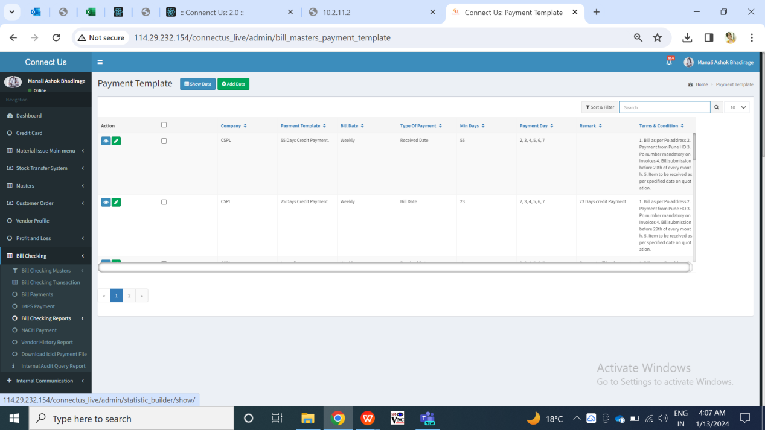

Fig: Payment template master (Grid)

Visibility of fields:

|  |  |  |  |  |
| --- | --- | --- | --- | --- |
| **FIELDS** | **GRID** | **ADD** | **EDIT** | **VIEW** |
| Add button |  | X | X | X |
| Edit button |  | X | X | X |
| View button |  | X | X | X |
| History button |  | X | X | X |
| Company Code |  |  |  |  |
| Template name |  |  |  |  |
| Payment type |  |  |  |  |
| Type of bill |  |  |  |  |
| Min days |  |  |  |  |
| Payment weekly days |  |  |  |  |
| Bill dates |  |  |  |  |
| Remark |  |  |  |  |
| Terms and conditions |  |  |  |  |
| Save button | X |  |  | X |
| Save & add more button | X |  | X | X |
| Back button | X |  |  | X |
| Created at | X | X | X |  |
| Created by | X | X | X |  |
| Updated at | X | X | X |  |
| Updated by | X | X | X |  |

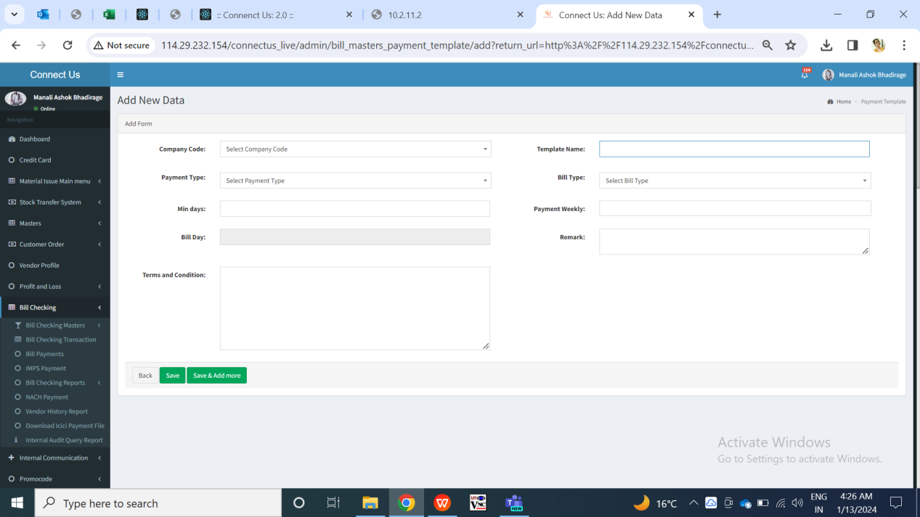

Fig: Payment template master (Add)

**Input Table**

|  |  |  |  |  |
| --- | --- | --- | --- | --- |
| **FIELDS** | **INPUT TYPE** | **MANDATORY/ OPTIONAL** | **EDITABLE** | **DESCRIPTION** |
| Company Code | Drop Down menu | Mandatory | Yes | The user will select the company code from the drop down menu.  Validation - It will be a single selection. |
| Template name | Text | Mandatory | Yes | User will enter name for the template in this field. It will be displayed in vendor master -> payment template field.  Validation:  It should accept characters, special characters, numbers and space.  Template name will be unique.  Min length = 3  Max length =25 |
| Payment type | Drop down | Mandatory | Yes | It consists of drop-down consisting “monthly” and “weekly” in the list.  User will select the payment type I.e. whether that payment should be done weekly or monthly.  If user selects “monthly” from this drop-down, then “Payment weekly days” field will be disabled. If user selects “weekly” from this drop-down, then “Bill Dates” field will be disabled.  Validation: It will be single select. |
| Type of bill | Drop down | Mandatory | Yes | It will display bill date and received date in the list. The payment date will get calculated from the selected type of bill.  Validation: It will be single select. |
| Min days | Text | Mandatory | Yes | User will manually enter the number of minimum days in this field. The entered minimum days count will be calculated from the selected type of bill I.e. bill date or from received day.  Validation:  It should accept only numbers. |
| Payment weekly days | Drop down | Mandatory | Yes | It will be enabled if user selects payment type as weekly. User will select the days on which the payment of that vendor needs to be done after calculating minimum days count from type of bill.  Payment weekly field will display drop-down consisting Sunday, Monday, Tuesday, Wednesday, Thursday, Friday and Saturday in the list.  Validation:  It will be multi select. Selected day will be removed from the drop down list so that user can select another remaining days if needed from the list. |
| Bill Dates | Text | Mandatory | Yes | User will mention the dates of the calender on which the payment date is to be displayed for the vendor after calculating minimum days from type of bill.  If user selects “monthly” from Payment type drop-down, then user will manually enter number in Bill Dates column.  Validation: It should accept numbers only. User can enter multiple dates from the calender 1 to 31 only. It should accept comma only as special character. |
| Remark | Text | Optional | Yes | User will enter additional notes in this field.  Validation: It should accept characters, numbers and space. It should accept English / Marathi script.  Min length = 3  Max length = 250 |
| Terms and condition | Text | Optional | Yes | User will enter the terms for the created template if any.  Validation: It should accept characters, numbers and space. It should accept English / Marathi script.  Min length = 3  Max length = 250 |
| Save button | Click | - | - | Once user enters valid details in mandatory fields and clicks on save button, payment template will get added. Successful message should be displayed. User should be directed to grid page of payment template master where recently added payment template will be displayed at top.  Validation:  Button should be displayed until payment template user gets added successfully or until error message is displayed in case of invalid fields. |
| Save & add more | Click | - | - | Once user enters valid details in mandatory fields and clicks on save button, payment template should get added. Successful message should be displayed. Recently added payment template will be displayed at top whereas user will remain on the same page to add another new bill type.  Validation:  Button should be displayed until payment template gets added successfully or until error message is displayed in case of invalid fields. |
| Back button | Click | - | - | Once user clicks on back button, user will be directed to grid page and the record will not get added if details are filled any in add form of payment template.  Validation:  Once back button is clicked, then it will be disabled until user is redirected to grid page. |
| Created at | Text | - | No | It will display the date and time when the payment template details were added.  Validation: It will be read only. |
| Created by | Text | - | No | It will display the employee name who added the payment template details.  Validation: It will be read only. |
| Updated at | Text | - | - | Once the user edits the bill type details, then it will display the date and time when the payment template details were modified.  Validation: It will be read only. |
| Updated by | Text | - | - | Once the user edits the already created bill type, then it will display the employee name who modified the details.  Validation: It will be read only. |

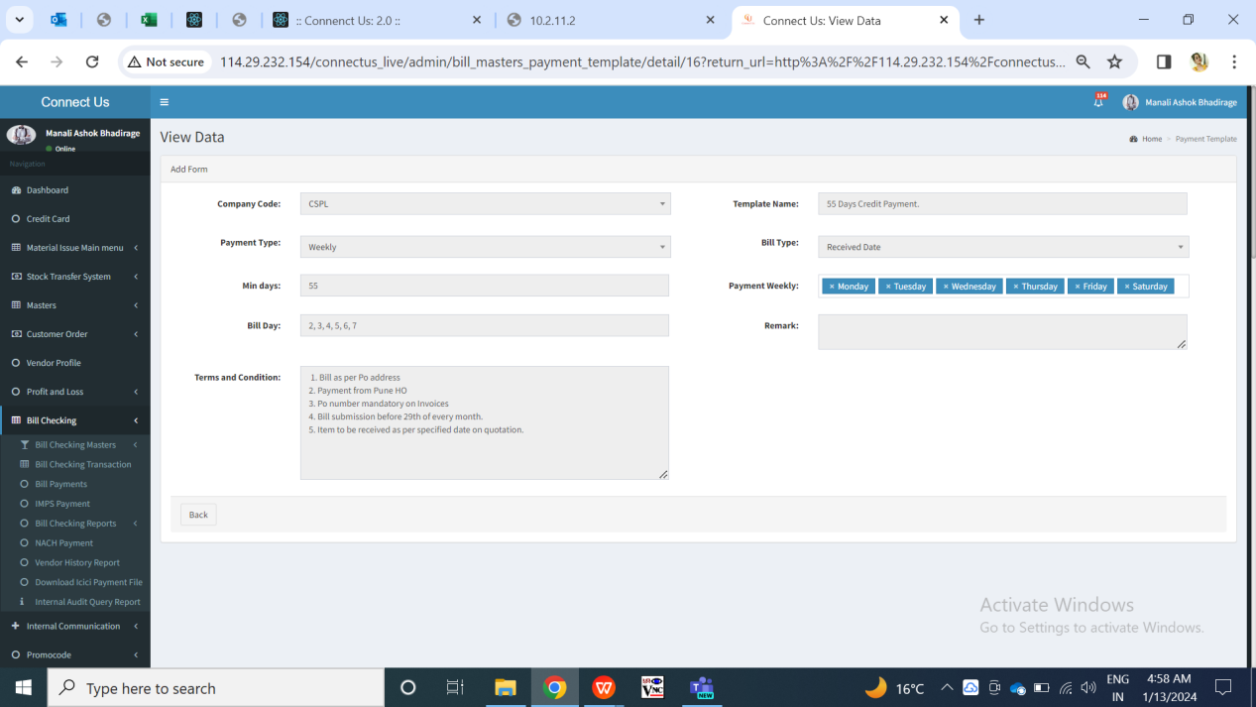

Fig: Payment template master (View)

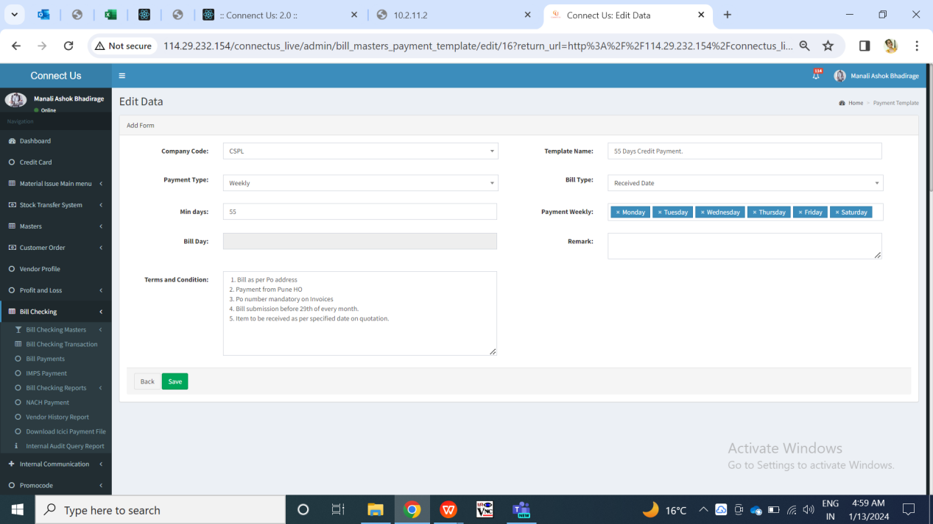

Fig: Payment template master (Edit)

**Vendor Master**

User will add the vendor in vendor master which will get displayed in bill checking transaction while adding the bill. While submitting the bill, entry user selects the vendor for the bill payment is to be done.

Once the user clicks on vendor master the following fields will get displayed.

* Add data button
* Edit button
* View button
* History button
* Export data button
* Vendor ID
* Company Code
* Vendor Name
* Vendor Type
* Address1
* GST Default supplier status
* Remark
* Contact person name
* Contact no.
* Alternate no.
* Landline no.
* Email
* Pan no.
* Referred by
* Department
* Udyog Aadhaar/MSME No.
* Legal status
* Acme account name
* GST no.
* GSTR1
* Consider in payment
* Beneficiary name
* Template
* Attachments
* Save button
* Save & add more button
* Back button

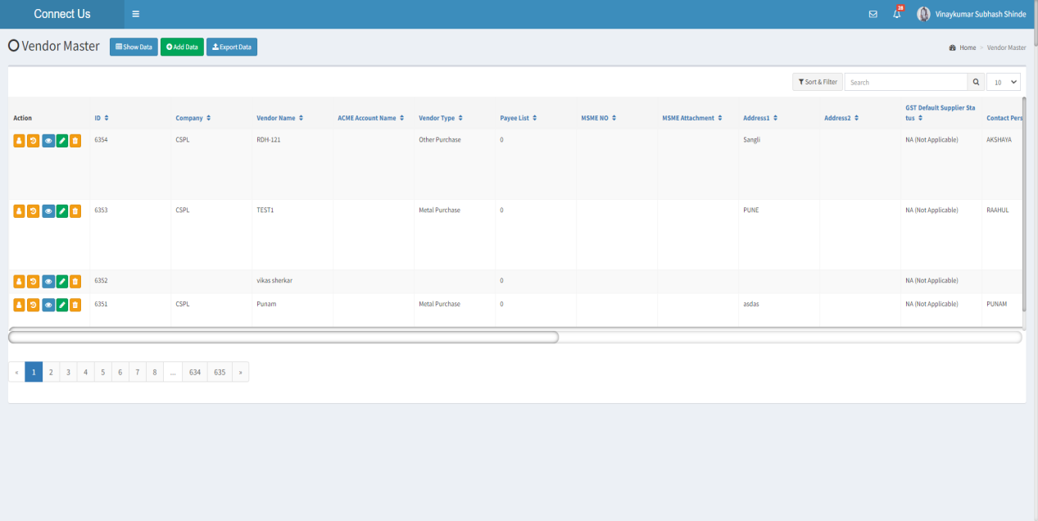

Fig - Vendor Master (Grid View)

Visibility of fields on pages:

|  |  |  |  |  |  |
| --- | --- | --- | --- | --- | --- |
| **FIELDS** | **GRID** | **ADD** | **EDIT** | **HISTORY** | **EXPORT** |
| Add button |  | X | X | X | X |
| Edit button |  | X | X | X | X |
| History button |  | X | X | X | X |
| View button |  | X | X | X | X |
| Export button |  | X | X | X | X |
| ID |  | X | X |  |  |
| Company Code |  |  |  |  |  |
| Vendor Name |  |  |  |  |  |
| Vendor Type |  |  |  |  |  |
| Address |  |  |  |  |  |
| GST Default Supplier Status |  |  |  |  |  |
| Remark | X |  |  |  | X |
| Contact Person |  |  |  |  |  |
| Contact No. |  |  |  |  |  |
| Alternate No. | X |  |  | X |  |
| Landline No. | X |  |  | X |  |
| Email |  |  |  |  |  |
| PAN No. |  |  |  |  |  |
| Referred By |  |  |  |  |  |
| Department |  |  |  |  |  |
| Udyog Aadhaar/MSME No. | X |  |  |  |  |
| Legal status | X |  |  | X |  |
| Acme account name |  |  | X |  |  |
| GST no. |  |  |  |  |  |
| GSTR1 |  |  |  |  |  |
| Consider in payment |  |  |  |  |  |
| Beneficiary name | X |  |  | X |  |
| Template |  |  | X |  |  |
| Attachments |  |  |  |  | X |
| Save button | X |  |  | X | X |
| Save & add more button | X |  | X | X | X |
| Back button | X |  |  | X | X |
| Created By | X | X | X |  | X |
| Created when | X | X | X |  | X |
| Updated By | X | X | X |  | X |
| Updated When | X | X | X |  | X |

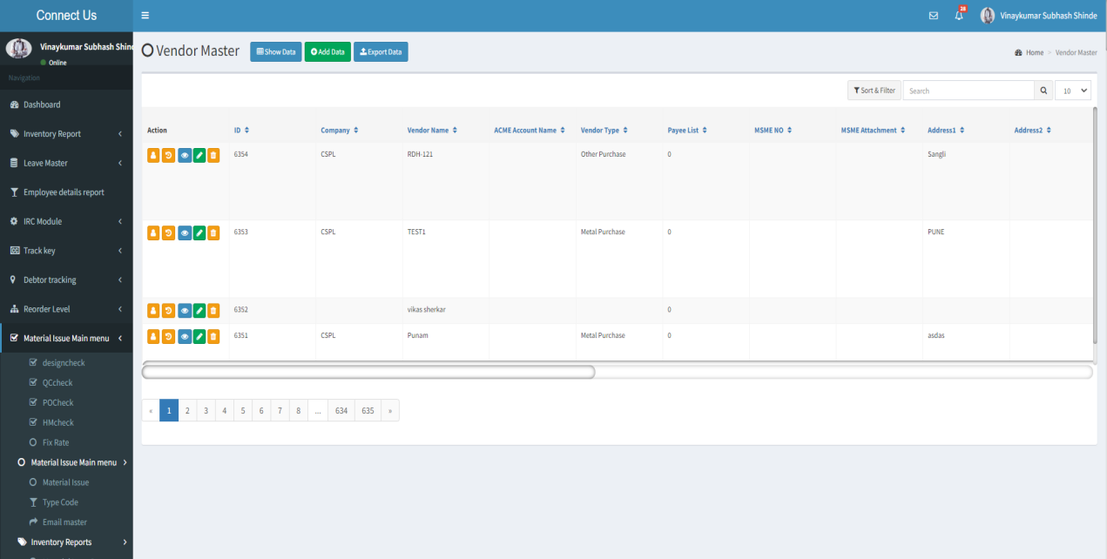

Fig - Vendor Master (Add)

**Input Table**

|  |  |  |  |  |
| --- | --- | --- | --- | --- |
| **FIELDS** | **INPUT TYPE** | **MANDATORY/ OPTIONAL** | **EDITABLE** | **DESCRIPTION** |
| Add Data | Button | - | - | The user will click on the "Add" button to add the vendor to the system. |
| Edit | Button | - | - | Once the user clicks on “Edit” Button then the user will be able to edit the vendor details. |
| View | Button | - | - | Once the user clicks on “View” Button then the user will be able to view the vendor details. |
| History | Button | - | - | Once the user clicks the "History" button, they will be able to view their past history of the vendor details. |
| Export | Button | - | - | The export button to export the data available in the grid view. |
| ID | Auto | - | - | The vendor id is made up of the numbers who will count the number of vendor details. |
| Company Code | Drop Down | Mandatory | Yes | The user will select the company code from the drop down menu.  Validation- it will be a single selection. |
| Vendor Name | Text | Mandatory | Yes | The user will enter the name of the vendor.  Validation-  It must contain alpha-numeric values with spaces.  Maximum length of 50 characters must be accepted. |
| Vendor Type | Drop  Down | Mandatory | Yes | The user will select the type of vendor from the drop down menu.  There are two categories of vendors.   * Metal Purchase * Other Purchase   Validation -  It will be a single select. |
| Address | Text | Mandatory | Yes | The user will enter the vendor's address.  Validation -  It must contain alpha-numeric with special characters and spaces.  Maximum length of 250 characters must be accepted. |
| GST Default Supplier Status | Text | Mandatory | Yes | The user will enter the vendor’s GST default supplier status details.  Validation - By default, NA (Not Applicable) will be mentioned. |
| Remark | Text | Optional | Yes | If the user want to add a specific remarks they will do so.  Validation -  It must contain alpha-numeric with special characters and spaces.  Min length = 3  Max length = 250 |
| Contact Person | Text | Mandatory | Yes | The user will enter the name of the vendor's contact person.  Validation -  It must contain alpha-numeric with spaces.  Maximum length of 50 characters must be accepted. |
| Contact No. | Number | Mandatory | Yes | The user will enter the contact person's number.  Validation -  It must contain only numbers.  It must have only ten digits. |
| Alternate Number | Number | Optional | Yes | The user will enter the contact person's alternate phone number.  Validation -  It must contain only numbers.  It must have only ten digits. |
| Landline  Number | Number | Optional | Yes | The user will enter the contact person's landline number.  Validation-  It must include both a number and a special character.  Specifically, "-".  It must have only ten digits. |
| Email | Text | Mandatory | Yes | The user will enter the vendor’s email address.  Validation-  It must contain alpha-numeric with spaces.  Maximum length of 50 characters must be accepted. |
| PAN No. | Text | Mandatory | Yes | The user will enter the vendor’s PAN number.  Validation -  It must contain alpha-numeric.   * It must contain ten characters long. * The first five characters must be any upper-case alphabet. * The next four-characters must be any number from 0 to 9. |
| Referred By | Drop Down | Mandatory | Yes | The user will select a list of employee names from the drop-down menu who have recommended the vendor.  Validation-  It will be single select. |
| Department | Drop  Down | Mandatory | Yes | The user will select a list of department from the drop-down menu and the list of department will be fetched from the department master. Validation-  It will be single select. |
| Udyog Aadhaar/MSME No. | Text | Optional | Yes | If the vendor has an MSME number, the user will enter it.  It could be the udyog adhar number or the udyam number.  Validation-  **Udyog Aadhaar Number:**  It consist of 12 digits (similar to Aadhaar number).  Avoid accepting twelve consecutive zeros.  **Udyam Number Format:**  First 5 letters, followed by state code (2 digits), city code (2 digits), and a unique 7-digit Udyam Code.  **MSME Registration:**  Each vendor should use a unique MSME number for registration. |
| Legal status | Drop down | Optional | Yes | The user will select the legal status from the drop down menu.  Once the user clicks on drop down menu the following options will be displayed.   * Association of Person(A) * Body of Individuals(B) * Company (C) * HUF (H) * Individual (P) * Local Authority * Partnership Firm * Trust(T)   Validation -  It will be single select. |
| Acme account name | Text | Optional | Yes | The user will enter the vendor's acme account name which will be fetched from the Acme doc series master.  Validation -  The field should display the vendor's name and be editable.  Vendor names and ERP account names might be the same or different.  A maximum of 50 characters must be accepted. |
| GST no. | Text | Mandatory | Yes | The user will enter the vendor's GST number.  Validation-   * Enter a 15-digit GST number. * First 2 digits indicate the state code. * Next 10 digits correspond to the PAN of the person or business entity. * Thirteenth digit is based on the number of registrations under the same PAN. * Fourteenth digit defaults to "Z." * Last digit serves as a check code for error detection. * Each vendor must use a unique GST number for registration. |
| GSTR1 | Drop Down | Optional | Yes | The user will have to select an option from the drop-down menu.  When the user clicks on the GSTR1 drop down menu, the following options will be displayed-   * Month * Quarter   Validation -  It will be a single select. |
| Consider in payment | Drop Down | Mandatory | Yes | The user will have to select an option from the drop-down menu.  When the user clicks on the consider in payment drop down menu, the following options will be displayed-   * Yes * No * Petty Cash   Validation -  It will be single select. |
| Beneficiary name | Text | Mandatory | Yes | The user will enter name of the vendor's bank account.  Validation-  It must contain characters numbers and spaces.  Maximum length of 50 characters must be accepted. |
| Template | Drop down | Optional | Yes | Payment template is set against vendor .  As a result, this field has a drop-down menu that displays a list of active templates from the payment template master.  Validation-  By default, the field will be disabled.  The field will be enabled whenever the user selects "Yes" for the payment consideration option.  It will be single select. |
| Attachments | Image | Optional | Yes | The user will attach a images of the vendor’s PAN card ,bank passbook, Cheque etc.  Validation-  Attachment should only accept single files with the extensions png, jpeg, jpp, and pdf.  Once files are attached, there should be the option to zoom and delete.  Once files are attached, they should be presented as hyperlinks. |
| Save button | Button | - | - | Once details of vendor is added, the user will click on “Save” button and the data will get saved and displayed in the grid once saved. |
| Save & add more button | Button | - | - | Once the vendor details are entered, the user will click the "Save & Add More" option, which will save the data and allow the user to enter additional vendor details. |
| Back button | Button | - | - | Once the user clicks the "back" button, the data will not saved and the user goes back to the grid page. |
| Created When |  |  |  | The date and time when the vendor master is created is displayed.  Validation:  The format will be - YYYY-MM-DD HH:MM:SS |
| Created By |  |  |  | The username who last created the vendor master is displayed. |
| Updated When |  |  |  | The date and time when the vendor master is updated last is displayed.  Validation:  Format - YYYY-MM-DD HH:MM:SS |
| Updated By |  |  |  | The username who last updated the vendor master is displayed. |

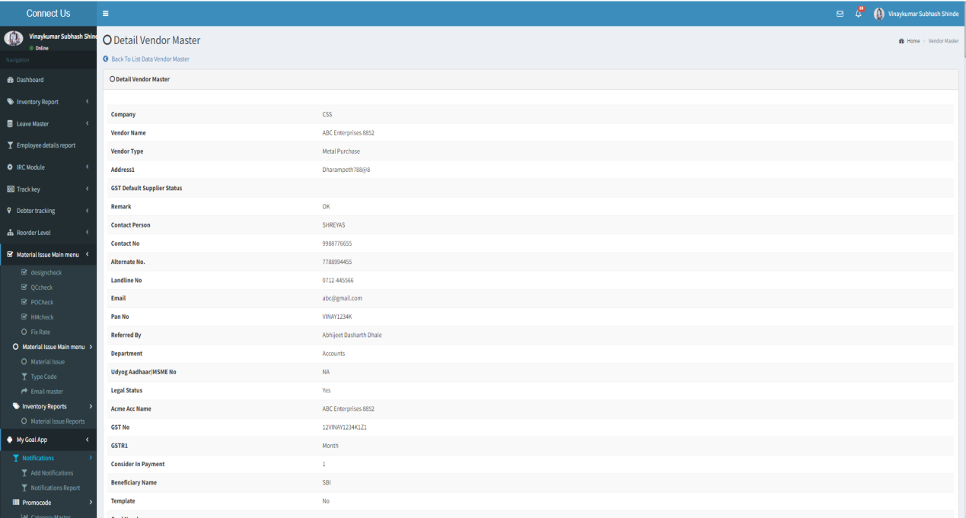

Fig - Vendor Master (View)

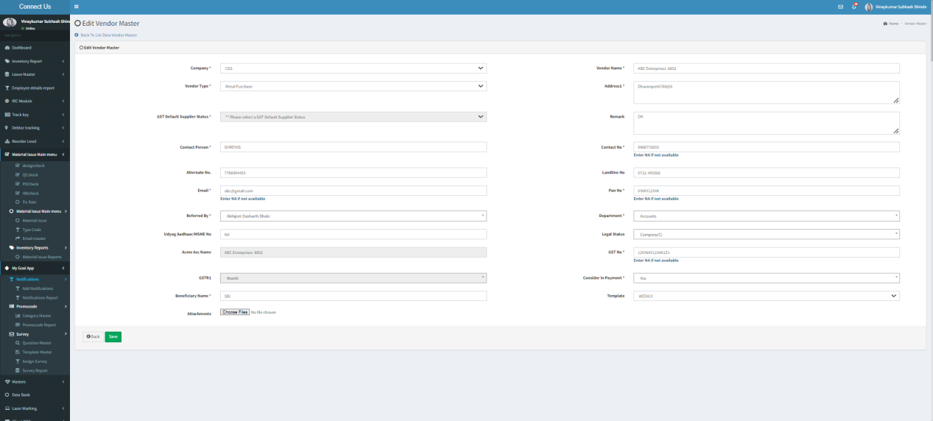

Fig - Vendor Master (Edit)

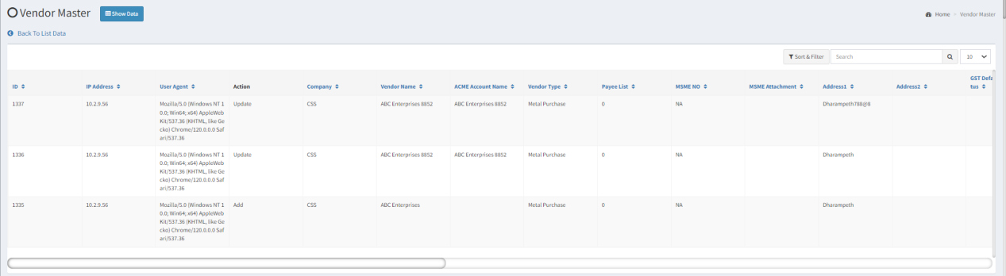

Fig - Vendor Master (History)

**Acme Doc Series**

The Acme Document Number and Series will be entered into the system by the user. Once the user adds the Acme Document Name and Series, it appears in the drop-down menu for the Padm Doc Name in the Bill Checking Transaction -->add and edit form.  
Once the user clicks on acme doc series the following fields will get displayed.

* Add data button
* Export Data
* Bulk Upload Format
* Bulk Upload
* Choose file
* Upload
* Back
* Edit
* View
* History
* Delete
* Document Name
* Doc Series
* Remark
* Is Active Status
* Created By
* Updated By
* Save
* Save & More Button
* Back

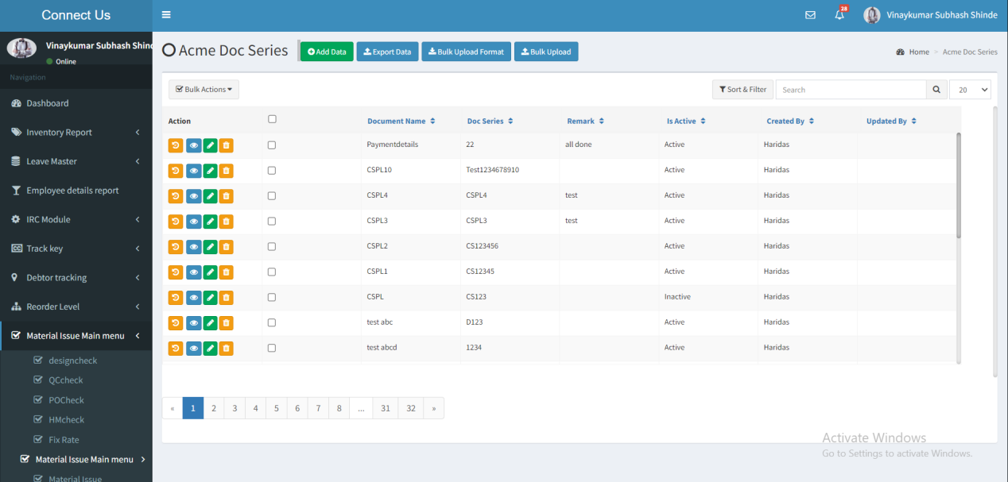

Fig - Acme Doc Series (Grid view)

Visibility of fields on pages:

|  |  |  |  |  |  |
| --- | --- | --- | --- | --- | --- |
| **FIELDS** | **GRID** | **ADD** | **EDIT** | **HISTORY** | **EXPORT** |
| Add button |  | X | X | X | X |
| Edit button |  | X | X | X | X |
| History button |  | X | X | X | X |
| View button |  | X | X | X | X |
| Delete button |  | X | X | X | X |
| Export button |  | X | X | X | X |
| Bulk Upload Format |  |  |  |  | X |
| Bulk Upload |  |  |  |  | X |
| Document Name |  |  |  |  |  |
| Doc Series |  |  |  |  |  |
| Remark |  |  |  |  |  |
| Is Active |  |  |  |  |  |
| Save Button | X |  |  | X | X |
| Save & More Button | X |  | X | X | X |
| Back Button | X |  |  | X | X |
| Created By |  | X | X |  |  |
| Updated By |  | X | X |  |  |

**Input Table**

|  |  |  |  |  |
| --- | --- | --- | --- | --- |
| **FIELDS** | **INPUT TYPE** | **MANDATORY/ OPTIONAL** | **EDITABLE** | **DESCRIPTION** |
| Add Data | Button | - | - | The user will click on the "Add" button to add the acme doc series to the system. |
| Edit | Button | - | - | Once the user clicks on “Edit” Button then the user will be able to edit the acme doc series details. |
| View | Button | - | - | Once the user clicks on “View” Button then the user will be able to view the acme doc series details. |
| History | Button | - | - | Once the user clicks the "History" button, they will be able to view their past history. |
| Export | Button | - | - | The export button to export the data available in the grid view |
| Bulk Upload Format | Button | - | - | The user will click on the bulk upload format to download the file. Once the user clicks on Bulk Upload file button the file will get downloaded with the following fields-   * Document Name * Document Series * Status * Remark   And the user will have to enter the details manually. |
| Bulk Upload | Button | - | - | The user will manually enter details into the downloaded file and then click the "Bulk Upload" button to submit the data to the system.  Once the file is successfully uploaded, the data will be displayed at the top of the grid view. |
| Document Name | Text | Mandatory | Yes | The user will enter the document's name into the system. Once the user adds the Acme Document Name and Series, it appears in the drop-down menu for the Padm Doc Name in the Bill Checking Transaction -->add and edit form.   Validation -  It must contain characters numbers and spaces.  Maximum length of 50 characters must be accepted. |
| Document series | Text | Mandatory | Yes | The user will enter the document's series into the system. After selecting the acme doc name from the drop down the menu the series will get reflected against the document name in Bill Checking Transaction -->add and edit form.  Validation -  It must contain characters numbers and spaces. |
| Remark | Text | Optional | Yes | User will enter additional notes in this field.  Validation: It should accept characters, numbers and space. It should accept English / Marathi script.  Min length = 3  Max length = 250 |
| Is active | Radio button | Mandatory | Yes | It will display status as active / inactive. Only the active status will be displayed.  Validation:  It will be single select. |
| Save button | Click | - | - | Once user enters valid details in mandatory fields and clicks on save button, the data will get added. Successful message should be displayed. User should be directed to grid page where recently added data will be displayed at top. |
| Save & add more | Click | - | - | Once user enters valid details in mandatory fields and clicks on save button, the data should get added. Successful message should be displayed. Recently added data will be displayed at top whereas user will remain on the same page to add another data into the system.  Validation: Button should be displayed until the data gets added successfully or until error message is displayed in case of invalid fields. |
| Back button | Click | - | - | Once user clicks on back button, user will be directed to grid page and the record will not get added.  Validation: Once back button is clicked, then it will be disabled until user is redirected to grid page. |
| Created at | Text | - | No | It will display the date and time when the details were added.  Validation: It will be read only. |
| Created by | Text | - | No | It will display the employee name who added the details.  Validation: It will be read only. |
| Updated at | Text | - | - | Once the user edits the details, then it will display the date and time when the details were modified.  Validation: It will be read only. |
| Updated by | Text | - | - | Once the user edits the details, then it will display the name of the person who modified the details.  Validation: It will be read only. |

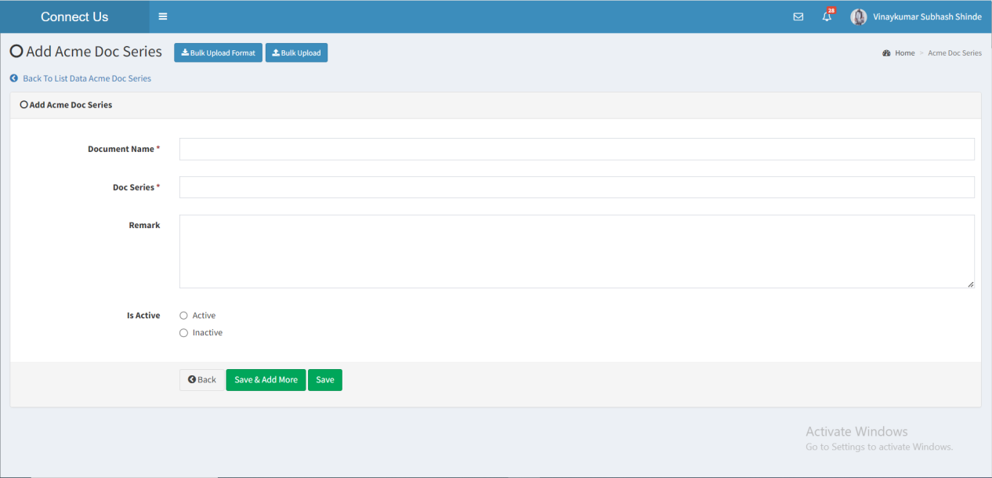

Fig - Acme Doc Series (Add)

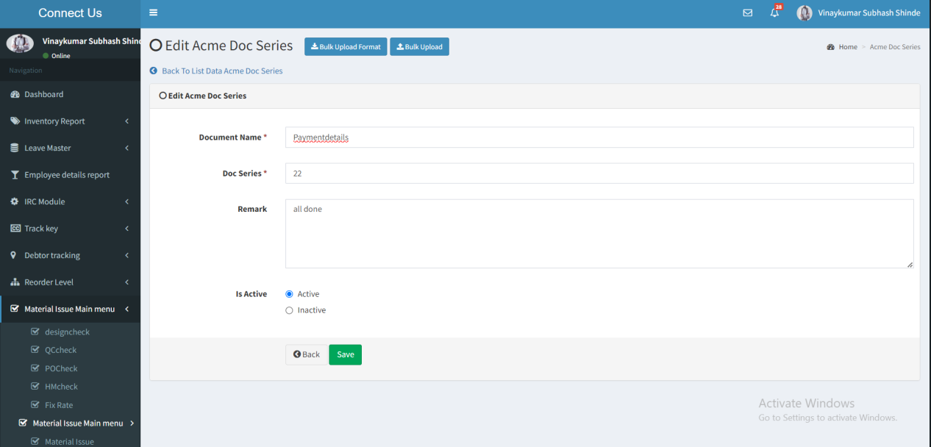

Fig - Acme Doc Series (Edit)

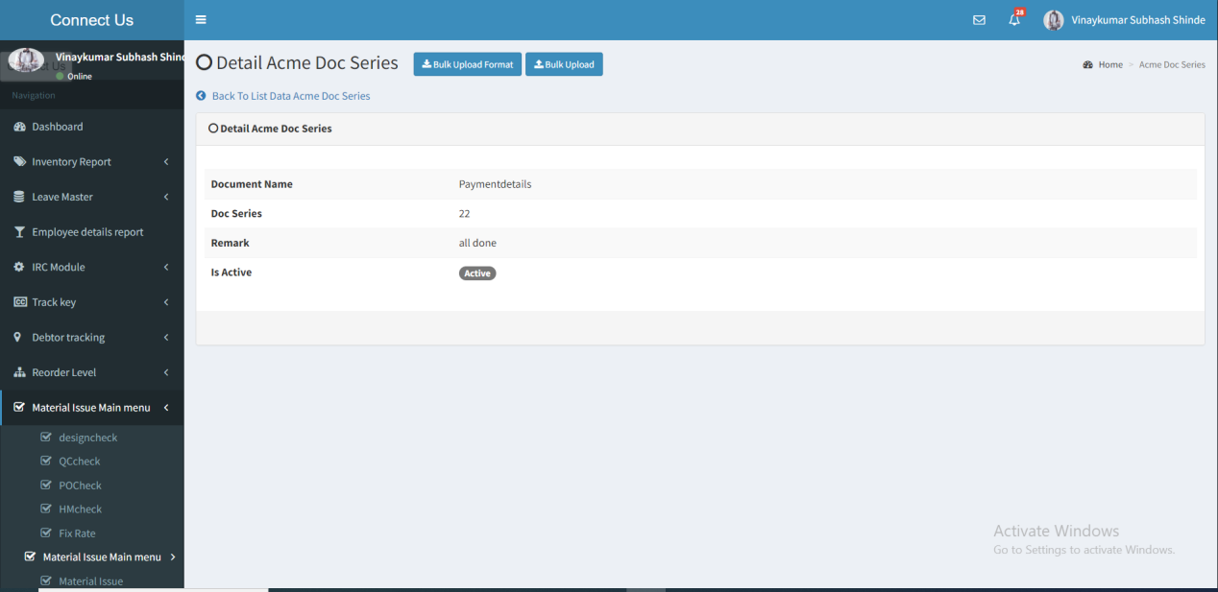

Fig - Acme Doc Series (View)

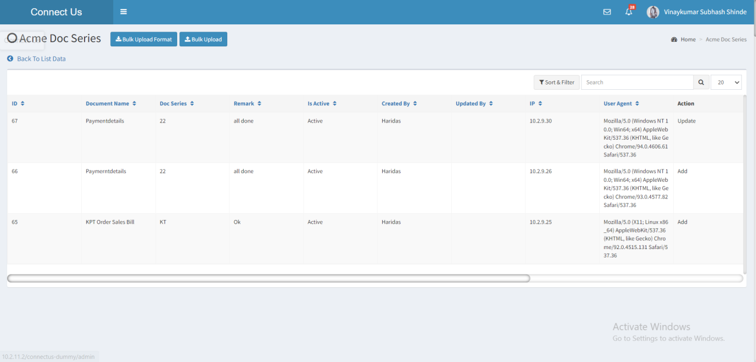

Fig - Acme Doc Series ( History)

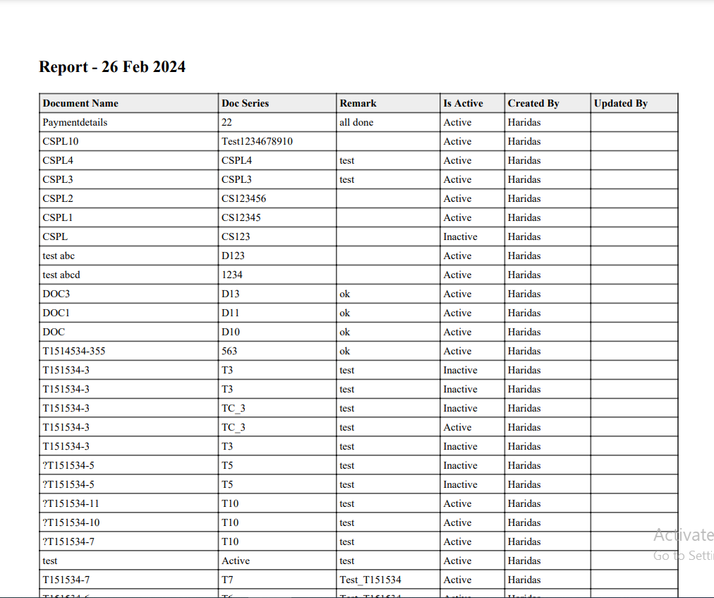

Fig - Acme Doc series ( Export)

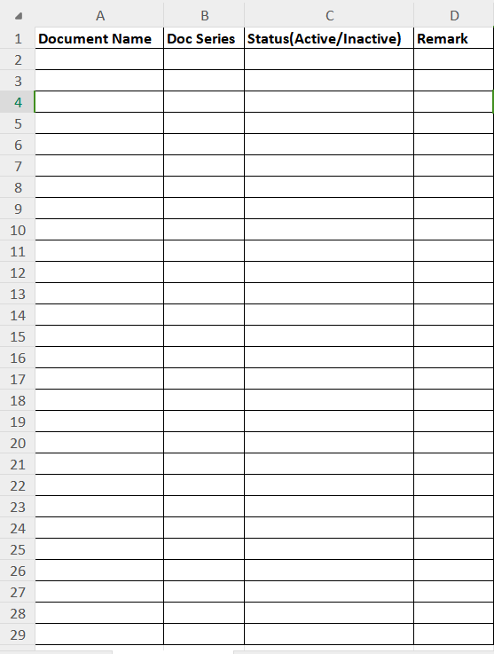

Fig - Acme Doc Series (Bulk Upload)

## BILL CHECKING TRANSACTION

The bill checking module allow the users to view their bills, filters them, download, add, and edit them.

The bill checking transaction modules consist of the following fields-

* Add data
* Filter
* Export
* Action
* Edit data
* View data
* History Data
* Payment history
* Payment details
* Assigned person Data
* Bifurcate Amount
* Bill ID
* PO No
* Acme Doc No
* Acme Doc Date
* Vendor name
* Payment date
* Bill No
* Actual payment date
* Bill amount
* Net amount
* Net amount in words
* Expected Bill Received Date
* Bill status
* Bill type
* Sub Bill type
* Assign from
* Assign to
* Exhibition / Mohtsav
* Amount
* Debit Advance
* Is Original Bill
* Internal Audit
* External Audit
* Bill date
* Received date
* Hold amount
* Actual Paid amount
* Is canceled
* Is initiative
* Is TCS applicable
* Created at
* Created by
* Updated at
* Updated by

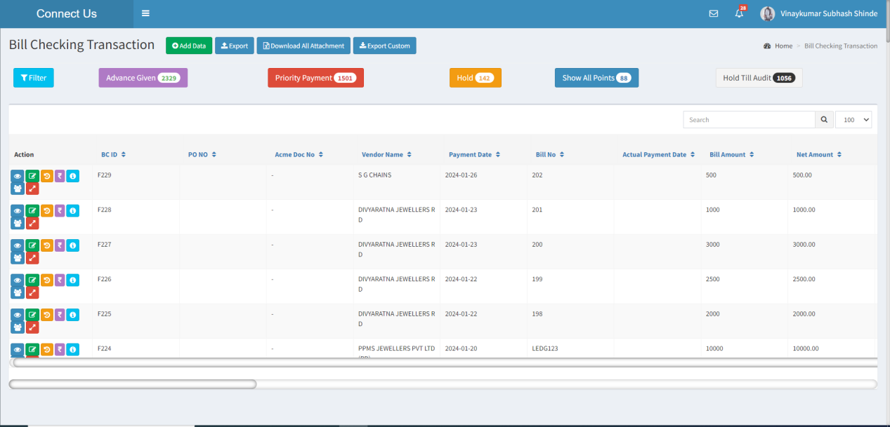

Fig - Bill checking Transaction (Grid View)

Visibility of fields on pages:

|  |  |  |  |  |  |
| --- | --- | --- | --- | --- | --- |
| **FIELDS** | **GRID** | **ADD** | **EDIT** | **HISTORY** | **EXPORT** |
| Add button |  | X | X | X | X |
| Filter |  | X | X | X | X |
| Edit button |  | X | X | X | X |
| History button |  | X | X | X | X |
| View button |  | X | X | X | X |
| Export button |  | X | X | X | X |
| Payment History |  | X | X | X | X |
| Payment Details |  | X | X | X | X |
| Assigned person data |  | X | X | X | X |
| Bifurcate Amount |  | X | X | X | X |
| Bill Type |  |  |  |  |  |
| Sub Bill type |  |  |  |  | X |
| Branch Name | X |  |  | X | X |
| Bill ID |  | X | X |  |  |
| PO No |  |  |  |  |  |
| Acme Doc No | X |  |  |  | X |
| Acme Doc Date |  |  |  |  |  |
| Vendor Name |  |  |  |  |  |
| Payment Date |  | X | X |  |  |
| Bill No |  | X |  |  |  |
| Actual Payment |  | X |  |  |  |
| Bill Amount |  |  |  |  |  |
| Net Amount |  |  |  |  |  |
| Net Amount in words |  |  |  |  |  |
| Is Original bill received |  |  |  |  | X |
| Remark | X |  |  | X |  |
| Padm Doc Name | X |  |  |  |  |
| Internal Audit |  |  |  |  |  |
| External Audit |  |  |  |  |  |
| Authorised by HOD | X |  |  | X | X |
| Authorized By Management | X |  |  | X | X |
| Expected Bill received date |  | X | X |  | X |
| Bill status |  | X | X |  |  |
| Assign From |  | X | X |  | X |
| Assign To |  |  |  |  |  |
| Exhibition/Mohtsav |  |  |  |  |  |
| Debit Advance |  |  |  |  | X |
| Taxable Amount |  |  |  | X | X |
| GST |  |  |  |  | X |
| IGST |  |  |  | X | X |
| Round off |  |  |  |  | X |
| TDS |  |  |  |  | X |
| Internal Audit |  |  |  | X | X |
| External Audit |  |  |  | X | X |
| Bill date |  |  |  |  |  |
| Received date |  |  |  |  |  |
| Ledger Balance |  |  | X | X | X |
| Updated Ledger Balance |  |  | X | X | X |
| Hold Amount |  | X | X |  |  |
| Actual Paid Amount |  | X | X |  |  |
| Is canceled |  | X | X |  | X |
| Is initiative |  |  |  |  | X |
| Is TCS Applicable |  |  |  |  | X |
| Attachments |  |  |  |  | X |
| Created at |  | X | X |  |  |
| Created by |  | X | X |  |  |
| Updated at |  | X | X |  |  |
| Updated by |  | X | X |  |  |

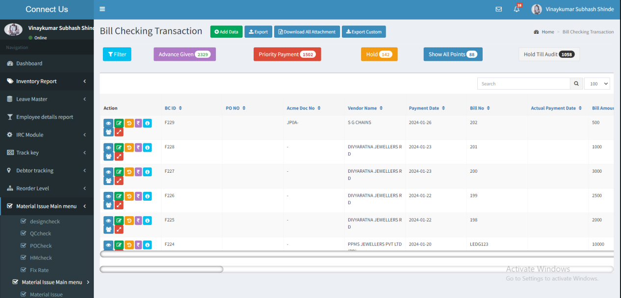

Input table

|  |  |  |  |  |
| --- | --- | --- | --- | --- |
| **Fields** | **Input type** | **Mandatory/ Optional** | **Editable/ No** | **Description** |
| Add data | Button | - | - | The add data button to add the bill into the system. |
| Filter | Button | - | - | The filter button to filter the data based on the data given in the filters. |
| Export | Button | - | - | The export button to export the data available on the grid. |
| Action | - | - | - | The action field consist of the following buttons.   * Edit * View * History * Payment history * Payment details * Assigned person * Cancel |
| Edit data | Button | - | - | The edit data button to edit the data.  The created user can edit the bill until the first approval. The created user can also edit the bill when it is rejected by the assigned person.  The users who are are having the approval authority can also edit the bill.  The users having the special authority can also edit the bill.  The assigned user after the approvals can also edit the bill. |
| View data | Button | - | - | The view data button to view the bill data.  Assigned person can view the bill. |
| History | Button | - | - | The history button to view the history of the bill.  The users having the edit access can view the history of the bill. |
| Payment history | Button | - | - | The payment history of the bill is displayed.  The created user and the assigned user can view the payment history. |
| Payment details | Button | - | - | The changes or to view the payment details.  The assigned user can view and edit the payment details.  The user having the special authority can also view and edit the payment details as per the authority. |
| Assigned person | Button | - | - | The assigned person menu shows the bill assigned to the users hierarchy.  All the user can view the assigned persons menu. |
| Cancel | Button | - | - | The cancel button to cancel the bill.  The user having the special authority can only cancel the bill. |
| Sr no | Auto | Mandatory | - | The serial count of the bill is displayed. |
| Bill ID | Auto | Mandatory | - | The bill ID of the bill is generated automatically and displayed.  Validation:  In filter,   * The bill ID’s are entered. If multiple bill ID’s, comma separated. * Accepts alpha numeric characters. |
| PO No | Text | Optional | Yes | The user will enter the purchase order number for which the bill has been generated.  Validation - It must contain Alphanumeric with special characters. |
| Acme Doc No | Text | Optional | Yes | The Acme doc number will be displayed automatically after the Acme doc name will selected from the drop down menu.  The acme doc name and number will be fetched from the acme doc & series master.  Validation - It must contain Alpha-numeric with special character. |
| Acme Doc Date | Date Calender | Optional | No | When adding a bill to the ERP system, the user will select the acme doc date.  Validation-  The date format will be -YYYY-MM-DD. |
| Vendor name | Drop down | Mandatory | Yes | The vendor name of the bill is selected from the drop down menu. The name of the vendors list are fetched from the vendor master.  Validation:   * Only active vendor’s from the vendor master are fetched. * Single selection   In filters,   * Active and inactive vendors to be fetched from the vendor master. * Multiple selection   Special authority   * The user having the special authority can edit the vendor name. Based on the vendor name selected, the payment date is auto calculated and displayed. |
| Payment date | Auto | Mandatory | No | The payment date of the bill is auto calculated from the payment template master based on the vendor setting. The user can edit the payment date in case of the special authority from the payment details menu.  Validation:  In filter, the from date and to date of the payment date is selected. |
| Bill No | Text | Mandatory | Yes | The vendor bill number is entered or displayed.  Validation:   * Accepts alpha numeric data with special characters up-to 50 characters.   In filter,   * In filter, the bill ID’s are entered. If multiple bill ID’s, comma separated. * Accepts alpha numeric characters. |
| Actual payment date | Auto | Mandatory | No | The actual payment date of the payment is updated when the payment is made against that bill.  Validation:  The last updated payment date is updated. |
| Bill amount | Auto | Mandatory | - | The bill amount of the bill is auto calculated and displayed.  Bill amount = Taxable amount + IGST/ GST + Round off + TCS  Validation:  In filter,   * The from amount and to amount is entered. * Minimum value is “0” and maximum value is “100 crores”. |
| Net amount | Auto | Mandatory | - | The net amount of the bill is auto calculated and displayed.  Net amount = Bill amount – Debit advance – TDS amount. |
| Net Amount in words | Auto | Mandatory | - | The net amount of the bill in word is displayed automatically. |
| Bill status | Auto | Mandatory | - | The bill status of the bill is displayed automatically. The bill status consists of the following.   * Unsolved * Solved * Canceled   Until the approval process and the payment, the bill status will be unsolved from the creation of the bill.  When the payment of the bill is done, the status will be solved.  When the bill is canceled, the status of the changed to canceled.  Validation:  In filters,   * The unsolved, solved and canceled statuses are shown in the drop down. * Multiple selection |
| Bill type | Drop down | Mandatory | No | The bill type of the bill is selected from the drop down. The drop down options are fetched from the bill type master. Based on the bill type selected in the add data, the bill is assigned to the users selected as per the bill type for the approval and the payment.  Validation:   * The active bill types are fetched from the bill type master. * Single selection   In filters,   * The active and inactive bill types are fetched from the bill type master. * Multiple selection |
| Assign from | Auto | Mandatory | - | When the bill is assigned from one person to other, the user, from whom the bill is assigned is displayed.  If the bill is not transferred, then, null is displayed. |
| Assign to | Drop down menu | Mandatory | Yes | The bill, to whom the bill will be assigned to is selected from the drop down. The drop down options are fetched from the user master based on the users assigned in the bill type mapping user.  Validation:   * Based on the bill type selected, the the assigned users to the bill to be displayed in the drop down (only active users in the user master). * Single selection   In filters,   * All the active and inactive users in the user master are fetched. * Multiple selection |
| Exhibition / Mohtsav | Drop down menu | Mandatory | Yes | The user will select the exhibition/ mohtsav from the drop down menu. The list of drop down menu will be fetched from the exhibition master. Master --> General Master --> Exhibition master. |
| Levels of approval | Auto | Mandatory | - | The levels of the approvals required based on the bill amount in the bill type master. Based on the bill amount, the slab is selected and levels of approvals in that slab is displayed. |
| Approved by | Auto | Mandatory | - | The users who approved the bills are displayed. If multiple users, the comma separated users are displayed. |
| Pending approval | Auto | Mandatory | - | The users who’s approvals are pending in that level are displayed. If multiple users, the comma separated users are displayed. |
| Taxable amount | Int | Mandatory | Yes | The taxable amount is entered or displayed.  Validation:   * Accepts positive integers up-to 2 decimals maximum of 100crores. |
| Debit Advance | Int | Optional | Yes | The debit advance if any given is entered or displayed.  Validation:   * Accepts positive integers up-to 2 decimals maximum of 100crores. |
| IGST/ GST | Int | Mandatory | Yes | When the check box is selected, IGST is considered, if not, GST is selected. The IGST/ GST value of the bill is entered or displayed.  Validation:   * Accepts positive integers up-to 2 decimals maximum of 100crores. * By default, the check box is not selected. |
| Round off | Int | Optional | Yes | The round off value of the amount in the bill is entered or displayed.  Validation:   * Accepts both positive and negative integers up-to 2 decimals maximum of 100crores. |
| TCS amount | Int | Optional | Yes | The TCS amount of the bill is entered or displayed.  Validation:   * Accepts positive integers up-to 2 decimals maximum of 100crores. |
| TDS applicable | Check box | Optional | Yes | The TDS applicable check box is selected when the TDS is applicable. If not, the TDS is not applicable. If TDS is applicable, then the following fields are enabled.   * TDS section * TDS constitution * TDS % * TDS amount   Validation:   * By default, the check box is not selected. |
| TCS applicable | Check box | Optional | Yes | The TCS applicable check box is selected when the TCS is applicable. If not, the TCS is not applicable. If the TCS is applicable, then the following field is enabled.   * TCS amount   Validation:   * By default, the check box is not selected. |
| TDS section | Drop down | Optional | Yes | The TDS section field is shown when the TDS applicable is selected. The TDS section is selected from the drop-down. The drop-down consists of the following.   * 194A * 194CB * 194J * I94I * 194H * 194IB   Validation:   * Single selection |
| TDS constitution | Drop down | Optional | Yes | The TDS constitution field is shown when the TDS applicable is selected. The TDS constitution is based on the TDS section selected. The following are the fields displayed automatically and selected when there are multiple options.   * 194A – non-company deductee * 194CB – Company with surcharge and non-company without surcharge * 194J/ 194I – Company with surcharge and non-Company without surcharge * 194H/ 194IB – Blank and disabled   Validation:   * Single selection. |
| TDS% | Auto | Optional | - | The TDS % field is shown when the TDS applicable is selected. The TDS % is calculated based on the TDS constitution.   * 194A – non-company deductee – 10% * 194CB – Company with surcharge – 2% and non-company without surcharge – 1% * 194J/ 194I – Company with surcharge and non-Company without surcharge – 10% * 194H/ 194IB – Blank and disabled – 0% |
| TDS amount | Auto | Optional | - | The TDS amount field is shown when the TDS applicable is selected. The TDS amount is auto calculated based on the TDS %.  TDS amount = taxable amount * TDS% |
| Is original bill | Check box | Optional | Yes | The original bill if required, then the check box is selected. If not, the check box is not selected.  Validation:   * By default, the check box is not selected. |
| Internal audit | Text | Optional | Yes | The internal auditor will provide the remark in the internal audit field.  Validation:   * Accepts alpha-numeric values with special characteristics up-to 2000 characters. |
| External audit | Text | Optional | Yes | The external auditor will provide the remark in the external audit field.  Validation:   * Accepts alpha-numeric values with special characteristics up-to 2000 characters. |
| Bill date | Date picker | Mandatory | Yes | The bill date of the bill is selected from the date picker.  Validation:   * Bill date cannot be the future date and can accept the values of the current financial year. |
| Received date | Date picker | Mandatory | Yes | The received date is default current date is displayed.  Special authority  Users having the special authority - received date can update the received date. |
| Hold amount | Auto | Mandatory | - | The total amount on hold status in the payment details is auto calculated and displayed. |
| Paid amount | Auto | Mandatory | - | The total amount on paid status in the payment details is auto calculated and displayed. |
| Is canceled | - | - | - | The is canceled status is shown on grid with yes and no options. If the bill is canceled, then yes is shown. If not, no is shown.  Validation: In filters,   * The yes or no is selected from the drop down. * Single selection |
| Remark | Text | Optional | Yes | The remark if any is entered or displayed.  Validation:   * Accepts alpha-numeric data with special characters up-to 2000 characters. |
| Remark history | Auto | Mandatory | - | All the remarks added through the remark, internal audit and external audit fields are displayed in the history with the username and date and time in the LIFO order. |
| Upload attachment | File upload | Mandatory | Yes | The attachments are uploaded in the system.  Validation:   * Can accept pdf, jpeg, .png up-to 10 maximum of 2MB.   Special authority   * Users having the special authority - all update bill can update the upload attachment. |
| Authorized by management | Check box | Optional | Yes | The authorized by management is the check box when the management approves that, the management will select the check box.  Validation:   * By default, the check box is not selected.   Special authority   * Users having the special authority - allow edit authorized by management can update the authorized by management check box. |
| Authorized by HOD | Check box | Optional | Yes | The authorized by HOD is the check box when the HOD approves that, the HOD will select the check box.  Validation:   * By default, the check box is not selected.   Special authority   * Users having the special authority - allow edit authorized by HOD can update the authorized by HOD check box. |
| Level approvals | Auto | Mandatory | - | The current level approvals are displayed. |
| Level approved/ rejected by | Auto | Mandatory | - | The users who approved the bill are displayed and the users who rejected the bill are displayed. |
| Approval pending | Auto | Mandatory | - | The approval pending in the current level are displayed. |
| Created by | Auto | Mandatory | - | The username who created the user is displayed. |
| Created at | Auto | Mandatory | - | The date and time when the user is created is displayed.  Validation:  Format - YYYY-MM-DD HH:MM:SS |
| Updated by | Auto | Optional | - | The username who last updated the user is displayed. |
| Updated at | Auto | Optional | - | The date and time when the user is updated last is displayed.  Validation:  Format - YYYY-MM-DD HH:MM:SS |

**Bill Checking Transaction Report -**

**User-wise Id-wise Report**  
The user-wise id-wise report allows users to view the report based on the selected dates and employees, and a list of employee names is fetched from the employee master.

Once the user clicks on User wise Bill Id Report the following fields will get displayed-

* From Date
* To Date
* Employee Name
* Submit
* Reset

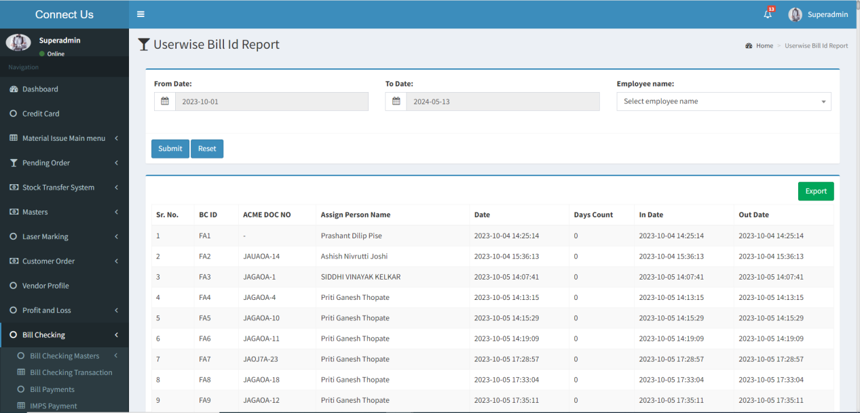

Fig - User-wise Bill Id Report

Visibility of fields on pages:

|  |  |
| --- | --- |
| **FIELDS** | **GRID** |
| From Date |  |
| To Date |  |
| Employee Name |  |
| Submit |  |
| Reset |  |
| Export |  |
| BC ID |  |
| Acme Doc No |  |
| Assign Person Name |  |
| Date |  |
| Days Count |  |
| In Date |  |
| Out Date |  |

**Input table**

|  |  |  |  |  |
| --- | --- | --- | --- | --- |
| **Fields** | **Input type** | **Mandatory/ Optional** | **Editable/ No** | **Description** |
| From Date | Date Calender Picker | Optional | Yes | The starting date for generating the report is selected using the date picker. |
| To Date | Date Calender Picker | Optional | Yes | The ending date for generating the report is selected using the date picker.  Validation: The ending date must be later than the starting date. |
| Employee Name | Drop  Down | Optional | Yes | The user will select the employee name from the drop down menu. The list of the employee name will be fetched from the employee master.  Validation- It will be a single selection. |
| Submit | Button | No- | - | Once the user has selected the appropriate fields, they will click the submit button.  When the user clicks the submit button, the report will be displayed with the selected dates and employee. The report will include the following fields-   * Sr. No * BC ID * Acme Doc No * Assign Person Name * Date * Days Count * In Date * Out Date |
| Reset | Button | - | - | Once the user clicks on the reset button, the fields are reset and the report is cleared. |
| Export | Button | - | - | The export button to export the data available in the grid view. |
| Sr No. |  |  |  | The serial number is made up of the numbers who will count the number of user-wise bill id report details. |
| BC ID | Auto | - | - | The bill ID of the bill is generated automatically and displayed. |
| Acme Doc No | Text | - | - | The acme doc no against the bill is displayed. |
| Assign Person Name | Text | - | - | The assign to person name, which the user selected while adding bills, is displayed. |
| Date | Date Calendar | - | - | The date when the bill was added will be displayed. |
| Days Count | Number | - | - | It will display the number of days the bill has been pending against a specific person. |
| In Date | Date Calendar | - | - | It will display the In date, on which date the bill was assigned to a person. |
| Out Date | Date Calendar | - | - | It will display the Out date, which indicates when the bill was sent to the next a person. |

**Hold and Advance Given Report**The hold and advance given report allows users to view the report based on the selected dates and report type.

Once the user clicks on hold and advance given report the following fields will get displayed-

* From Date
* To Date
* Report Type
* Submit
* Reset
* Export
* Sr No
* BC ID
* BC ID Date
* Vendor Name
* Invoice Number
* Invoice Date
* Padm Doc No
* Padm Doc Date
* Assign To
* Hold By
* Bill Amount
* Payment Status
* Hold Amount
* Days Count
* Payment Date

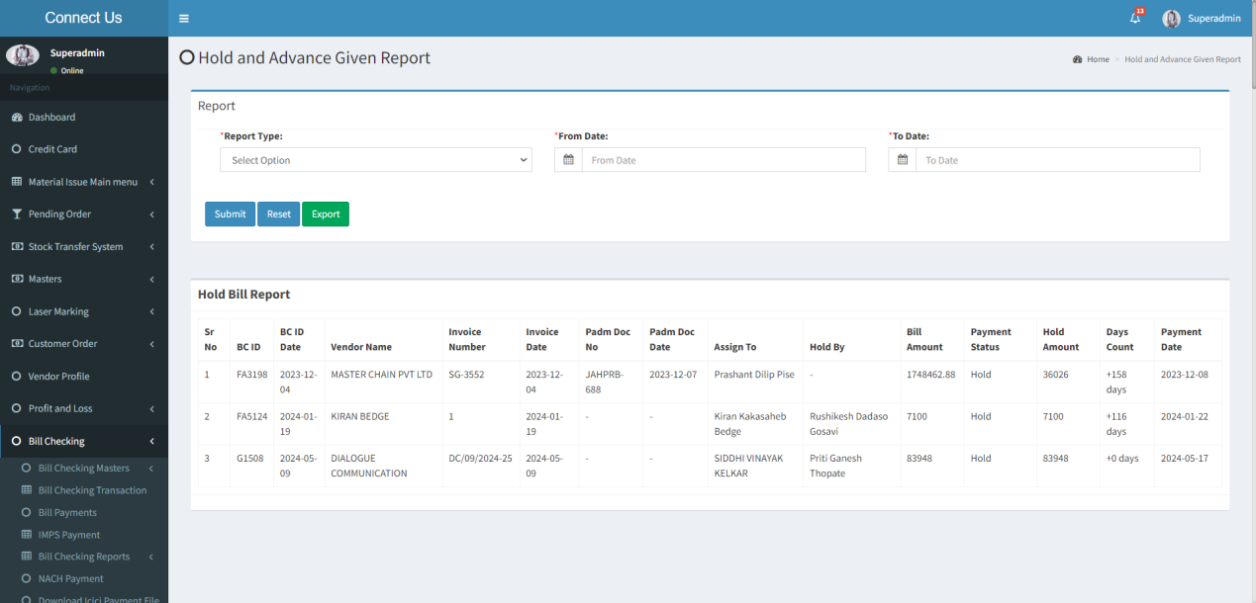

Fig - Hold Bill Report

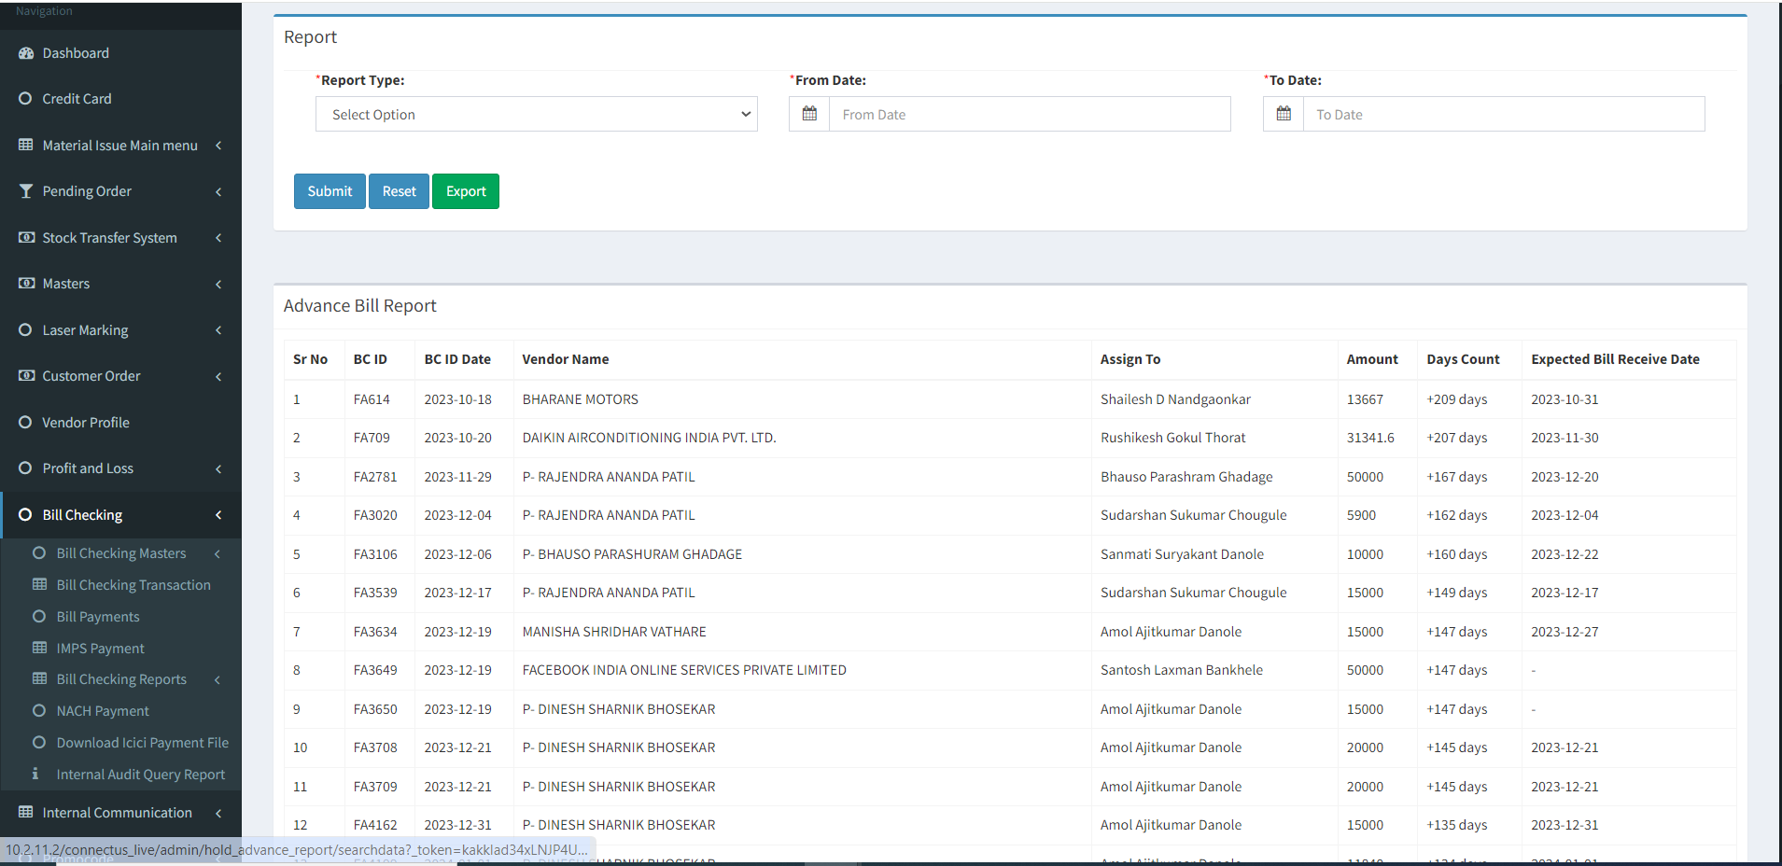

Fig - Advance Bill Report

Visibility of fields on pages:

|  |  |
| --- | --- |
| **FIELDS** | **GRID** |
| From Date |  |
| To Date |  |
| Report Type |  |
| Submit |  |
| Reset |  |
| Export |  |
| BC ID |  |
| BC ID Date |  |
| Vendor Name |  |
| Assign To |  |
| Amount |  |
| Days Count |  |
| Expected Bill Receive Date |  |
| Invoice Number |  |
| Invoice Date |  |
| Padm Doc No |  |
| Padm Doc Date |  |
| Hold By |  |
| Payment status |  |
| Hold Amount |  |
| Payment Date |  |

**Input table**

|  |  |  |  |  |
| --- | --- | --- | --- | --- |
| **Fields** | **Input type** | **Mandatory/ Optional** | **Editable/ No** | **Description** |
| From Date | Date Calender | Mandatory | Yes | The starting date for generating the report is selected using the date picker. |
| To Date | Date Calender | Mandatory | Yes | The ending date for generating the report is selected using the date picker.  Validation: The ending date must be later than the starting date. |
| Report Type | Drop Down | Mandatory | Yes | The user will select the type of report from the drop down menu. The drop down menu has two options -   * Hold Bill Report * Advance Bill Report   Validation - It will be a single selection. |
| Submit | Button | No- | - | Once the user has selected the appropriate fields, they will click the submit button.  When the user clicks the submit button, the report will be displayed with the selected dates and report type. The report will include the following fields-   * Sr. No * BC ID * BC ID Date * Vendor Name * Assign To * Amount * Days Count * Expected Bill Receive date |
| Reset | Button | - | - | Once the user clicks on the reset button, the fields are reset and the report is cleared. |
| Export | Button | - | - | The export button to export the report data available in the grid view. |
| Sr No. |  |  |  | The serial number is made up of the numbers who will count the number of hold and advance given report details. |
| BC ID | Auto | - | - | The bill ID of the bill is generated automatically and displayed. |
| BC ID Date | Text | - | - | The bill ID date of the bill is generated automatically and displayed. |
| Vendor Name | Text | - | - | The name of the vendor against the bill is displayed. |
| Assign To | Text | - | - | The assign to person name, which the user selected while adding bills, is displayed. |
| Amount | Number | - | - | The amount of the bill is displayed. |
| Days Count | Number | - | - | It will display the number of days the bill has been pending against a specific person. |
| Expected bill receive date | Date  Calendar | - | - | The expected bill receive date will get displayed. |
| Invoice Number | Text | - | - | The invoice number of the bill is displayed. |
| Invoice Date | Date Calendar | - | - | The invoice date of the bill is displayed. |
| Padm Doc No | Text | - | - | The padm doc number that the user entered while adding the bill will be displayed. |
| Padm Doc Date | Date Calendar | - | - | The padm doc date, which the user selected while adding bill, will be displayed. |
| Hold By | Text | - | - | The bill held by the employee will be displayed. |
| Payment status | Text | - | - | When the employee puts the bill on hold, the status will be displayed as "Hold". |
| Hold Amount | Number | - | - | The amount that an employee will put on hold will be displayed. |
| Payment Date | Date Calendar | - | - | The payment date of the payment is updated when the payment is made against that bill. |

**Auto Entry Report**The Auto Entry report allows users to view the report based on the selected dates.

Once the user clicks on auto entry report the following fields will get displayed-

* From Date
* To Date
* Search
* Reset
* Export
* Sr. No
* BC ID
* Entry Date
* Vendor Name
* Payment Date
* Release Date
* Actual payment Date
* Amount
* Padm Doc No

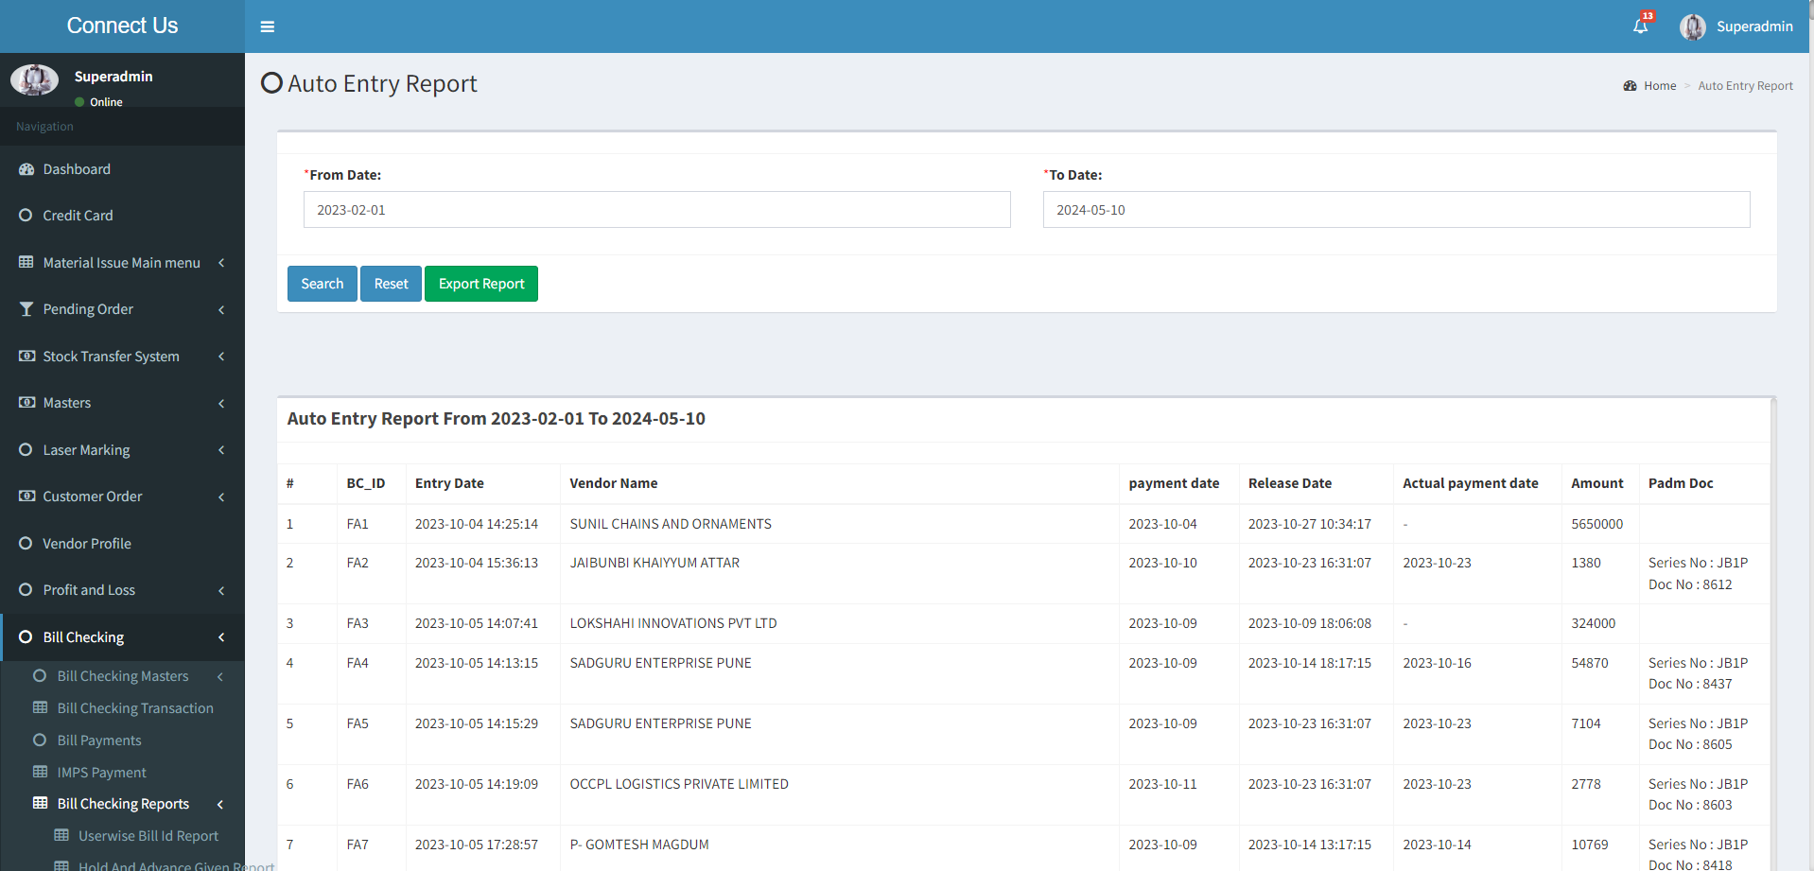

Fig - Auto Entry Report

Visibility of fields on pages:

|  |  |
| --- | --- |
| **FIELDS** | **GRID** |
| From Date |  |
| To Date |  |
| Search |  |
| Reset |  |
| Export |  |
| BC ID |  |
| Entry Date |  |
| Vendor Name |  |
| Payment Date |  |
| Release Date |  |
| Actual Payment Date |  |
| Amount |  |
| Padm Doc No |  |

**Input table**

|  |  |  |  |  |
| --- | --- | --- | --- | --- |
| **Fields** | **Input type** | **Mandatory/ Optional** | **Editable/ No** | **Description** |
| From Date | Date Calender | Mandatory | Yes | The starting date for generating the report is selected using the date picker. |
| To Date | Date Calender | Mandatory | Yes | The ending date for generating the report is selected using the date picker.  Validation: The ending date must be later than the starting date. |
| Search | Button | No- | - | Once the user has selected the date fields, they will click the search button.  When the user clicks the submit button, the report will be displayed with the selected dates. The report will include the following fields-   * Sr. No * BC ID * Entry Date * Vendor Name * Payment Date * Release Date * Actual Payment Date * Amount * Padm Doc |
| Reset | Button | - | - | Once the user clicks on the reset button, the fields are reset and the report is cleared. |
| Export | Button | - | - | The export button to export the report data available in the grid view. |
| Sr No. |  |  |  | The serial number is made up of the numbers who will count the number of auto entry report details. |
| BC ID | Auto | - | - | The bill ID of the bill is generated automatically and displayed. |
| Entry Date | Date and Time | - | - | The date when the bill was entered into the system will be displayed. |
| Vendor Name | Text | - | - | The name of the vendor against the bill is displayed. |
| Payment Date | Date Calendar | - | - | The payment date of the bill is auto calculated from the payment template master based on the vendor setting. |
| Release Date | Date and  time | - | - | The date when the bill was released is displayed. |
| Actual payment date | Date Calendar | - | - | The actual payment date of the payment is displayed when the payment is made against that bill. |
| Amount | Number | - | - | The amount of the bill is displayed. |
| Pad Doc No | Text | - | - | The padm doc number that the user entered while adding the bill will be displayed. |

## BILL PAYMENTS

The bill payments filters the data where the payment to be made. Only the bills, where the status is released is filtered. The following are the fields.

* Download text files
* Auto update payment
* Bill type
* Till date
* Filter
* Action
* Vendor name
* Bill type
* Padm Name
* Padm Balance
* Payment amount
* Trnx.
* Acme No.
* Vendor bill No.
* Bill ID
* Paid
* SBI Amount
* Remark
* Advance ID’s
* Advance Amount
* Beneficiary name
* Bank name
* Branch name
* Account No
* IFSC code
* Card Number
* Reference Number
* Narration

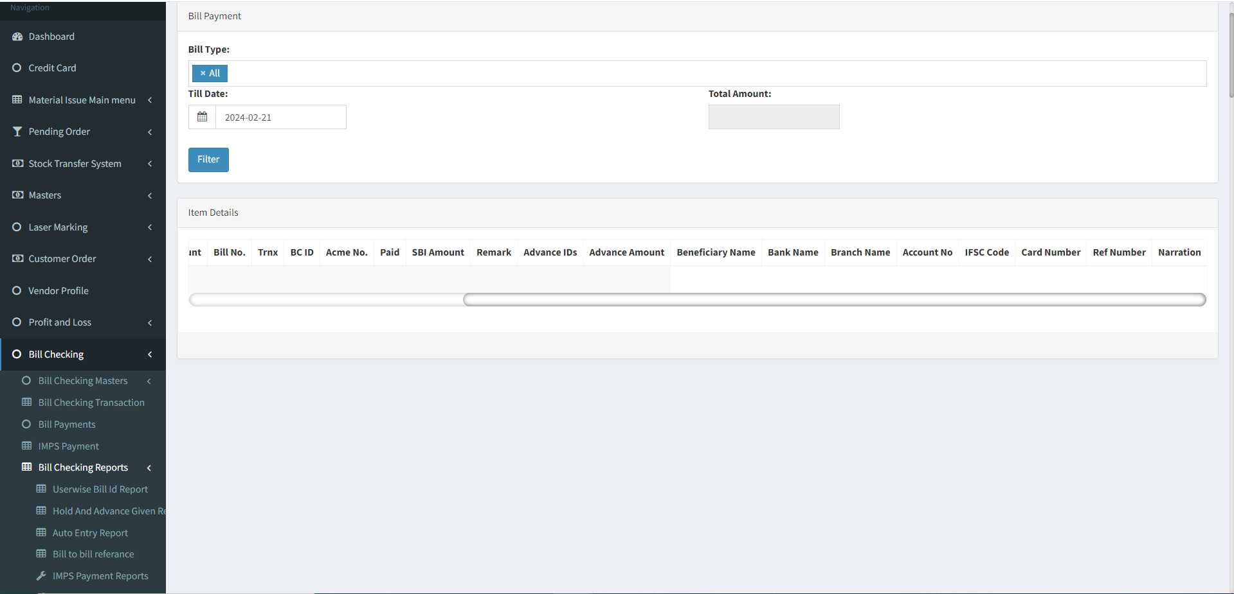

Fig - Bill Payment (Grid View)

The following are the actions.

|  |  |  |
| --- | --- | --- |
| **Fields** | **Grid view** | **View** |
| Download text files | ✓ | x |
| Auto update payment | ✓ | x |
| Bill type | ✓ | x |
| Till date | ✓ | x |
| Filter | ✓ | x |
| Vendor name | ✓ | ✓ |
| Bill type | ✓ | x |
| PADM Name | ✓ | x |
| PADM Balance | ✓ | x |
| Payment amount | ✓ | ✓ |
| Vendor bill No. | ✓ | x |
| Transaction Id | ✓ | x |
| Bill ID | ✓ | ✓ |
| Acme No | ✓ | x |
| Paid | ✓ | x |
| SBI Amount | ✓ | x |
| Remark | ✓ | x |
| Beneficiary name | ✓ | x |
| Bank name | ✓ | x |
| Branch name | ✓ | x |
| Account No | ✓ | x |
| IFSC code | ✓ | x |
| Net payment | x | ✓ |
| Payment status | x | ✓ |
| Advance ID | ✓ | x |
| Advance Amount | ✓ | x |
| Card Number | ✓ | x |
| Reference Number | ✓ | x |
| Taxable Amount | x | ✓ |
| TDS | x | ✓ |
| IGST /GST | x | ✓ |
| Net Payment | x | ✓ |
| Narration | ✓ | x |

**Input table**

|  |  |  |  |  |
| --- | --- | --- | --- | --- |
| **Fields** | **Input type** | **Mandatory/ Optional** | **Editable/ No** | **Description** |
| Download text files | Button | - | - | The download text files button to download the files based on the payment to be made. |
| Auto update payment | Button | - | - | The auto update payment button to update the payment details file generated by the bank portal. |
| Bill type | Drop down | Optional | - | The bill type required for the payment is selected from the drop down. The drop down options are fetched from the bill type master.  Validation:   * Multiple selection * If the user did not select the bill type, then all the bill types to be considered. * All the active bill types are fetched from the bill type master. |
| Till date | Date picker | Mandatory | - | The date till when the data to be fetched is selected from the date picker. |
| Filter | Button | - | - | The filter button to filter the data.  Based on the bill type and till date is entered, the bill payment date before and equal to the date are fetched where the payment status is release. |
| Action | - | - | - | The action field consist of the view button to view the record |
| Vendor name | Auto | - | - | The vendor name of the bill is displayed |
| Bill type | Auto | - | - | The bill type of the bill is displayed. If there are multiple against it, the comma separated values are displayed. |
| Padm Name | Auto | - | - | The Padm Name selected while adding the bill will be displayed. |
| Padm Balance | Auto | - | - | The padm balance amount will be displayed. |
| Payment amount | Auto | - | - | The payment amount of the vendor is displayed. If there are multiple against it, the comma separated values are displayed. |
| Vendor bill No. | Auto | - | - | The vendor bill number is displayed. If there are multiple against it, the comma separated values are displayed. |
| Transaction Id | Auto | - | - | The transaction id number is displayed. If there are multiple against it, the comma separated values are displayed. |
| Bill ID | Auto | - | - | The bill ID is displayed. If there are multiple against it, the comma separated values are displayed. |
| Acme No | Auto | - | - | The Padm number entered against the acme name while adding the bill will be displayed. |
| Paid | Auto | - | - | The paid amount will be displayed. |
| SBI Amount | Auto | - | - | The vendor if having the SBI account, the total amount to be paid to SBI account is displayed. |
| Remark | Auto | - | - | The remark against the payment entry is displayed. If there are multiple against it, the comma separated values are displayed. |
| Advance Id | Auto | - | - | If the advance amount is given to the vendor then the advance amount id will get displayed. |
| Advance Amount | Auto | - | - | If the advance amount is given to the vendor then the advance amount will get displayed. |
| Beneficiary name | Auto | - | - | The beneficiary name of the vendor is displayed. |
| Bank name | Auto | - | - | The bank name of the vendor is displayed. |
| Branch name | Auto | - | - | The bank branch name of the vendor is displayed. |
| Account No | Auto | - | - | The account number of the vendor is displayed. |
| IFSC code | Auto | - | - | The IFSC code of the vendor is displayed. |
| Card Number | Auto | - | - | If the card has been used to make the payment, the card number will be displayed. |
| Reference Number | Auto | - | - | If the card has been used to make the payment, the reference number will be displayed. |
| Narration | Auto | - | - | The narration details of the vendor is displayed. |
| Taxable Amount | Auto | - | - | The total taxable amount of the bill is displayed |
| TDS | Auto | - | - | The TDS amount of the total bill is displayed |
| IGST | Auto | - | - | The IGST amount of the total bill is displayed. |
| GST | Auto | - | - | The GST amount of the total bill is displayed |
| Net payment | Auto | - | - | The total net payment of the total bill is displayed. |
| Payment status | Auto | - | - | The payment status of the record is displayed. |

Fig - Bill Payment (view)

### DOWNLOAD TEXT FILES

The text files are downloaded based on the selection of the vendors. The following are the text files to be downloaded.

* SBI_PAYEE.txt
* RTGS_PAYEE.txt
* NEFT_PAYEE.txt
* PAYEE.txt

|  |  |
| --- | --- |
| FIELDS | DESCRIPTION |
| SBI_PAYEE.txt | The SBI file is downloaded where the vendor is having the SBI bank account. The following is the format for the SBI_PAYEE.txt.  (our account number)#(our IFSC code - last 5 digit)#(payment date)#(total payment)##(unique key)#(SBI unique key)#  Newline  (vendor account no)#(vendor IFSC code - last 5 digit)#(payment date)##(amount to be paid to the vendor)#(unique key)#(SBI unique key)  If multiple vendors, multiple line are added. |
| RTGS_PAYEE.txt | The RTGS file is downloaded where the vendor is non SBI holder and the amount exceeding Rs.2 lakhs. The following is the format for the RTGS_PAYEE.txt.  (our account number)#(our IFSC code - last 5 digit)#(payment date)#(total payment)##(unique key)#(SBI unique key)#RTGS  Newline  (vendor account no)#(vendor IFSC code)#(payment date)##(amount to be paid to the vendor)#(unique key)#(Non SBI RTGS unique key)#RTGS  If multiple vendors, multiple line are added. |
| NEFT_PAYEE.txt | The NEFT file is downloaded where the vendor is non SBI holder and the amount below Rs.2 lakhs. The following is the format for the NEFT_PAYEE.txt.  (our account number)#(our IFSC code - last 5 digit)#(payment date)#(total payment)##(unique key)#(SBI unique key)#NEFT  Newline  (vendor account no)#(vendor IFSC code)#(payment date)##(amount to be paid to the vendor)#(unique key)#(Non SBI NEFT unique key)#NEFT  If multiple vendors, multiple line are added. |
| PAYEE.txt | The payee file is downloaded where the vendors details to be updated. The following is the format for the PAYEE.txt.  (O - in case of non SBI)#A#(vendor name)#(vendor account number)#(vendor IFSC code)#(vendor bank name)#(vendor bank branch)#  new line  (S - in case of SBI)#A#(vendor name)#(vendor account number)#(vendor IFSC code)#(vendor bank name)#(vendor bank branch)#  If multiple vendors, multiple line are added. |

### AUTO UPDATE PAYMENTS

The auto update payment is update the payment date and payment status in the module. When the user clicks on auto update payment, pop up is opened. The pop up consists of the following fields.

* Choose file
* Submit
* Cancel

|  |  |  |  |
| --- | --- | --- | --- |
| **FIELDS** | **INPUT TYPE** | **MANDATORY/ OPTIONAL** | **DESCRIPTION** |
| Choose file | File upload | Optional | The file to upload is attached |
| Upload | Button | Optional | The upload button to upload the file |
| Back | Button | Optional | The back button to close the pop-up |

When the empty file uploaded, then error message is displayed “Something went wrong - Empty file uploaded”.

When the wrong file uploaded, then error message is displayed “Something went wrong - Invalid file type”

**Bill To Bill Reference Report -**

The bill to bill reference report allows users to view the report based on the selected dates, padm doc date & vendor name.

Once the user clicks on bill to bill reference report the following fields will get displayed-

* Vendor Name
* Padm Doc Date
* From Date
* To Date
* Search
* Export Report
* Bill Date
* Invoice No
* Received Date
* PADM Doc Date
* PADM Doc No
* BC ID
* Bill Amount
* TDS
* Net Amount
* Net Payment
* Actual payment date
* Advance Amount
* Advance Payment Date
* Balance Payable
* Reference No
* Payment Days

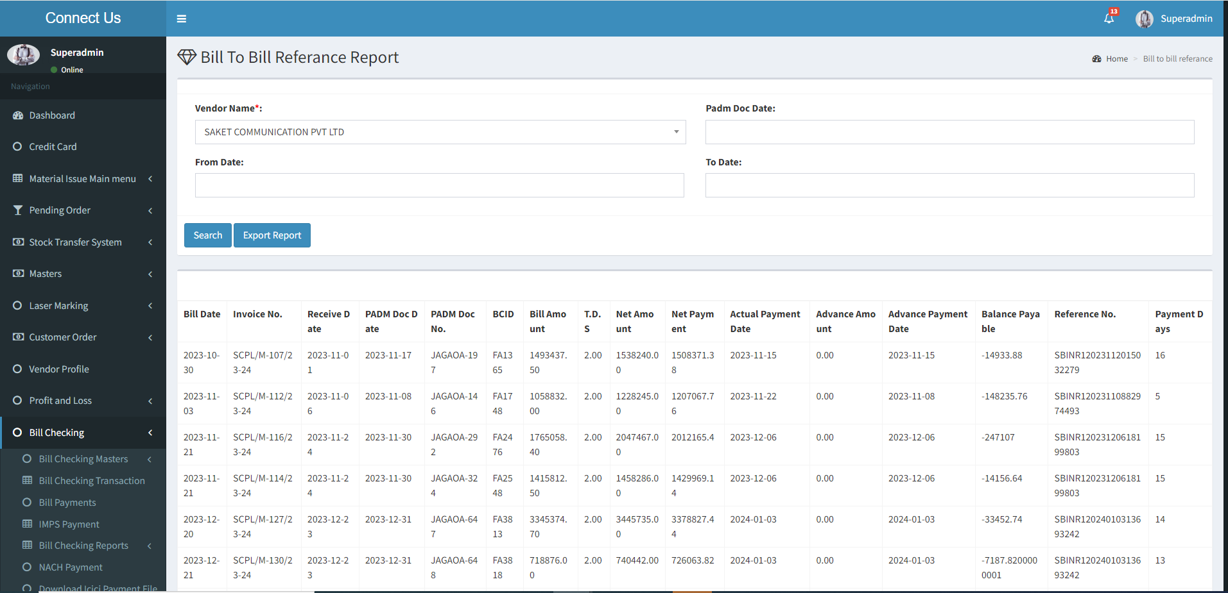

Fig - Bill To Bill Reference Report

Visibility of fields on pages:

|  |  |  |
| --- | --- | --- |
| **FIELDS** | **GRID** | **Export** |
| From Date |  | X |
| To Date |  | X |
| Vendor Name |  | X |
| Search |  | X |
| Export |  | X |
| BC ID Date |  |  |
| Invoice No. |  |  |
| Receive Date |  |  |
| Padm Doc Date |  |  |
| Padm Doc No |  |  |
| BCID |  |  |
| Bill Amount |  |  |
| TDS |  |  |
| Net Amount |  |  |
| Net Payment |  |  |
| Actual Payment Date |  |  |
| Advance Amount |  |  |
| Advance Payment Date |  |  |
| Balance Payable |  |  |
| Reference No. |  |  |
| Payment Days |  |  |

**Input table**

|  |  |  |  |  |
| --- | --- | --- | --- | --- |
| **Fields** | **Input type** | **Mandatory/ Optional** | **Editable/ No** | **Description** |
| Vendor Name | Drop Down | Mandatory | Yes | The user will select the vendor name from the drop down menu. The drop down names will be fetched from the vendor master.  Validation - It will be a single selection.  Only the active vendor name will be displayed. |
| From Date | Date Calender | Optional | Yes | The starting date for generating the report is selected using the date picker. |
| To Date | Date Calender | Optional | Yes | The ending date for generating the report is selected using the date picker.  Validation: The ending date must be later than the starting date. |
| Padm Doc Date | Date Calendar | Optional |  | The user will select the padm doc date for generating the report is selected using the date picker. |
| Search | Button | No- | - | Once the user has selected the fields, they will click the search button.  When the user clicks the submit button, the report will be displayed. The report will include the following fields-   * Bill Date * Invoice No * Receive Date * Padm Doc Date * Padm Doc No. * BCID * Bill Amount * TDS * Net Amount * Net Payment * Actual Payment Date * Advance Amount * Advance Payment Date * Balance Payable * Reference No. * Payment Days |
| Export | Button | - | - | The export button to export the report data available in the grid view. |
| Bill Date | Date Calendar | - | - | The system will display the dates of the calender on which the payment date is to be displayed for the vendor after calculating minimum days from type of bill. |
| Invoice No. | Text | - | - | The invoice number of the bill is displayed. |
| Receive Date | Date Calendar | - | - | The received date is default current date is displayed. |
| PADM Doc Date | Date Calendar | - | - | The padm doc date, which the user selected while adding bill, will be displayed. |
| PADM Doc No. | Text | - | - | The padm doc number that the user selected while adding the bill will be displayed. |
| BCID | Text | - | - | The bill ID of the bill is generated automatically and displayed. |
| Bill Amount | Number | - | - | The bill amount of the bill is auto calculated and displayed.  Bill amount = Taxable amount + IGST/ GST + Round off + TCS |
| T.D.S | Number | - | - | The TDS amount is displayed when the TDS applicable is selected. The TDS amount is auto calculated based on the TDS %. |
| Net Amount | Number | - | - | The net amount of the bill is auto calculated and displayed.  Net amount = Bill amount – Debit advance – TDS amount. |
| Net Payment | Number | - | - | The net payment of the bill is auto calculated and displayed |
| Actual Payment Date | Date Calendar | - | - | The actual payment date of the payment is displayed when the payment is made against that bill. |
| Advance Amount |  |  |  | The debit advance if any given is displayed. |
| Advance Payment Date |  |  |  | The debit advance date is displayed. |
| Balance Payable |  |  |  | The balance payable amount will auto-calculated and displayed. |
| Reference No. |  |  |  | The reference number will get displayed. |
| Payment Days |  |  |  | The total number of payment days will calculated and displayed. |

1. **TEST DATA AND BUSINESS SCENARIOS**

x