Manali Ashok Bhadirage

Manali.bhadirage@techneai.com

26.06.2024

QC - REMOVE COMPLETED DOC FROM GRID

**Functional Requirement Document**

**CONTENTS**

1. TICKET DETAILS 2

2. VERSION CONTROL 2

3. APPROVALS 2

4. ESTIMATION 2

5. INTRODUCTION 3

6. BUSINESS REQUIREMENT 3

7. SCOPE 6

8. BUSINESS & SYSTEM RULES 6

9. ABBREVIATIONS & TERMS 7

10. EXISTING SYSTEM 7

11. GRAPHICAL REPRESENTATION 7

12. PROPOSED SYSTEM 9

13. TEST DATA 60

14. ODUS 51

15. REFERENCES OF THE USERS 61

1. **TICKET DETAILS**

|  |  |
| --- | --- |
| **Ticket ID** | TT21945  TT21895 |
| **Ticket description** | QC Process Multipal line.  Completed items / material should not be displayed in the data grid if checking of that item is completed in that stage. |
| **Created by** | Sanmati Shedbale |
| **Created on** | 19/05/2024 |
| **Priority** | High |

1. **VERSION CONTROL**

|  |  |  |  |  |
| --- | --- | --- | --- | --- |
| **Sr. No** | **Version no** | **Version Date** | **User name** | **User department** |
| **1** | **1.0** | **26/06/2024** | **Sanmati Shedbale** |  |
| **2** | **1.1** | **04/07/2024** |  |  |

1. **APPROVALS**

|  |  |  |
| --- | --- | --- |
| **Field** | **Name of the User** | **Approved date by the user** |
| **Actual User Name Actual User Department Organization Name** | Inventory  CSJ |  |
| **Assigned BA** | Manali Bhadirage |  |
| **Assigned Developer** | Ankita Kirve |  |
| **Assigned Tester** | Saurabh shelke  Gokul Bhoi |  |

1. **ESTIMATION**

|  |  |  |  |  |
| --- | --- | --- | --- | --- |
| **Department name** | **Estimated Time (In hr)** | **Scheduled Date (Starting date)** | **Estimated End date** | **Actual delivery date** |
| **BA** |  |  |  |  |
| **Development** |  |  |  |  |
| **Testing** |  |  |  |  |

1. **INTRODUCTION**

Inventory users raise POs for item configurations against vendors, which must be confirmed by an authorized individual before progressing through the checking stages (design, QC, HM, LM, and PO check). Orders are received in bulk and entered into the provisional parcel receive system. Once a parcel is received, it undergoes checks based on the QC setup for that item. Users can accept or reject pieces, recording rejected quantities, gross weight, net weight, and reasons. Rejected pieces are returned to the vendor, generating a purchase return bill, while accepted pieces proceed to invoicing for the vendor.

1. **BUSINESS REQUIREMENT**

|  |  |  |  |
| --- | --- | --- | --- |
| **Requirement ID** | **Requirement Name** | **Short Description** | **Priority** |
| BR001 | Design check -> data grid | Only pending PR numbers should be displayed in data grid. (Remove issued column from data grid so that user cannot apply that filter and by default only pending PR numbers of that particular stage will be displayed.)  Once completed from DC, those PR numbers should be displayed to further issued checking stage. | High |
| BR002 | Quality check -> data grid | Only pending PR numbers should be displayed in data grid. (Remove issued column from data grid so that user cannot apply that filter and by default only pending PR numbers of that particular stage will be displayed.)  Once completed from QC, those PR numbers should be displayed to further issued checking stage. | High |
| BR003 | HM check -> data grid | Only pending PR numbers should be displayed in data grid. (Remove issued column from data grid so that user cannot apply that filter and by default only pending PR numbers of that particular stage will be displayed.)  Once completed from HM, those PR numbers should be displayed to further issued checking stage. | High |
| BR004 | LM check -> data grid | Only pending PR numbers should be displayed in data grid. (Remove issued column from data grid so that user cannot apply that filter and by default only pending PR numbers of that particular stage will be displayed.)  Once completed from LM, those PR numbers should be displayed to further issued checking stage. | High |
| BR005 | Provisional parcel receive -> provisional parcel register -> DC received date & time | It should display date and time when that PR number was issued to DC stage.  If DC stage was not applicable for that PR number as per QC setup, then date and time should be blank. | Medium |
| BR006 | Provisional parcel receive -> provisional parcel register -> DC issued date & time | It should display date and time when that PR number was issued from DC stage to further stage.  If DC stage was not applicable for that PR number as per QC setup, then date and time should be blank.  If DC stage is not yet done of the received PR number in this stage then, DC issued date & time should be blank. | Medium |
| BR007 | Provisional parcel receive -> provisional parcel register -> QC received date & time | It should display date and time when that PR number was issued to QC stage.  If QC stage was not applicable for that PR number as per QC setup, then date and time should be blank. | Medium |
| BR008 | Provisional parcel receive -> provisional parcel register -> QC issued date & time | It should display date and time when that PR number was issued from QC stage to further stage.  If QC stage was not applicable for that PR number as per QC setup, then date and time should be blank.  If QC stage is not yet done of the received PR number in this stage then, QC issued date & time should be blank. | Medium |
| BR009 | Provisional parcel receive -> provisional parcel register -> HM received date & time | It should display date and time when that PR number was issued to HM stage.  If HM stage was not applicable for that PR number as per QC setup, then date and time should be blank.  If HM stage is not yet done of the received PR number in this stage then, HM issued date & time should be blank. | Medium |
| BR010 | Provisional parcel receive -> provisional parcel register -> QC issued date & time | It should display date and time when that PR number was issued from HM stage to further stage.  If HM stage was not applicable for that PR number as per QC setup, then date and time should be blank. | Medium |
| BR011 | Provisional parcel receive -> provisional parcel register -> HM centre received date & time | It should display date and time when that PR number was issued to HM centre stage.  If PR number was not sent to HM centre, then date and time should be blank. | Medium |
| BR012 | Provisional parcel receive -> provisional parcel register -> HM centre issued date & time | It should display date and time when that PR number was issued from HM centre stage back to HM check.  If PR number was not sent to HM centre, then date and time should be blank. | Medium |
| BR013 | Provisional parcel receive -> provisional parcel register -> PO received date & time | It should display date and time when that PR number was issued to PO stage. | Medium |
| BR014 | Provisional parcel receive -> provisional parcel register -> PO issued date & time | It should display date and time when that PR number was completed from DC stage to further stage. | Medium |
| BR015 | Provisional parcel receive -> parcel receive details -> Add new | User should have provision to add multiple item records of same QC set up in parcel receive details section under same Voucher number. Moreover, user should not be able to add another record of same item - config - purity in same PR number I.e. purity should be different. | High |
| BR016 | Provisional parcel receive -> parcel receive details -> Delete | User should be able to delete the selected one or more records from parcel receive details. | Medium |
| BR017 | DC / QC / HM / LM -> Rejection -> Remark | User should be able to select multiple reasons from the drop-down whereas the selected reason should be displayed in reports in future. | Medium |
| BR018 | DC / QC / HM / LM -> DC details | If any PR has multiple records in it, then all multiple records should be displayed in details section where user will be able to enter the rejection details of selected record only. | High |
| BR019 | Design check / QC check / HM check / LM check -> DC rejection -> add new button and delete button | If any PR has multiple records in it where all pcs and wt is rejected in one of the record and has some wt and pcs in another record, then new button and delete button should be disabled for the record in which all pcs and wt is rejected till that stage. New and delete button should be enabled for the another record. | High |
| BR020 | DC / QC / HM / LM -> complete button | Remove complete button from all checking stages. | Low |
| BR021 | DC / QC / HM / LM -> issue button | Once user clicks on issue button, pop of confirmation should be displayed. Further, once user clicks on OK, user should be able to select the checking user name. | Medium |
| BR022 | Design check / QC check / HM check / LM check -> PO check -> header -> Received date and time | Received date and time should be displayed in all 5 checking stages header table. It will be the date and time when that PR number / voucher number was issued from previous stage to its respective checking stage. | Low |
| BR023 | Design check / QC check / HM check / LM check -> PO check -> header -> Completed date and time | Completed date and time should be displayed in all 5 checking stages header table. It will be the completed date and time when that PR number / voucher number was | Low |
| BR024 | Issue to HM centre | 1. If user is issuing a existing record to HM centre along with another new record of same PR number, then confirmation message should be displayed whether user wants to proceed with already chosen HM centre. If user selects yes, then all further records will be displayed to same HM centre. 2. If user is issuing a existing record to HM centre along with another new record of same PR number, then confirmation message should be displayed whether user wants to proceed with already chosen HM centre. If user selects no, then user will select new HM centre. | High |
| BR025 | PO check -> details & Rejection section | It should display multiple records of PR in details and rejection section along with its details. | Medium |

1. **SCOPE**

**IN SCOPE**: After generating and confirming a PO from all purchase vendors, the PO number is created and becomes in-editable. The user then records the received parcel details using the provisional parcel receive feature, entering vendor info, challan number, warehouse, and item details like configuration, purity, pcs and wt.  
  
Multiple new item configurations can be added under the same Provisional Parcel Receive voucher, maintaining the same QC setup. Upon confirmation, the PR voucher is issued for further checking. In the checking menu, users can view PR details and record any rejected items. Confirming the issue displays a pop-up; selecting "yes" proceeds the PR to the next stage per QC setup.  
  
Further, once user proceed to HM check stage then user can assign the PR voucher number to HM centre or directly check its hallmarking and enter rejected details if any. Once user selects the record which is already issued to HM centre and selects another new record with it from the same PR and issued to HM check, then it should display pop-up message whether you want to continue with same HM centre or not. If user selects ‘no’, then user should be able to select new HM centre for that new record. Later, when user proceed to PO check stage then user will be able to view the PO number mapped against that PR number and enter accepted pcs, accepted gross wt, accepted net wt.

**OUT SCOPE**: Currently, we will be raising PO manually however later PO number will be generated as per PO raised in Connect-Us system. In addition to this, PO number will be same as the challan number through which purchase order details and purchase return order details will be calculated. Once user completes PO check,

Purchase return order which gets generated currently automatically with different PO number for it. Later, purchase return order will not be generated automatically as it will be managed through same raised PO number.

1. **BUSINESS & SYSTEM RULES**

* User should be registered in the system.
* User should be logged in.
* System should display error message for incorrect details if entered.
* Items of same product group only should be added by entry user while raising a PO for more than one item against same PO.
* Items of same product group only should be added by entry user in provisional parcel receive menu for more than one item against same PR voucher no.
* Practically QC process is not followed for MRP items at inventory however it will be done for MRP in system as well where only PO check stage will be yes henceforth after provisional parcel receive.
* Rejection and accepted pcs, gross wt, stone wt, net wt of each PR number at each checking stage should be displayed in reports later on whenever required.
* All validations are applicable for manual process however PO and provisional parcel number will be raised through API from connect-us further on.

1. **ABBREVIATIONS & TERMS**

DC - Design checking

HM - Hallmarking

LM - Laser Marking

MRP -

Pcs - pcs

PR no. - provisional parcel receive number

PO - Purchase Order

QC - Quality check

Wt - Weight

1. **EXISTING SYSTEM**

In existing developed system, user is unable to add multiple item details in the same PR. Hence, user has to create multiple PRs if multiple items are received under same PO against same challan number. This is a time consuming activity for entry users when multiple items are received in one parcel from vendor. Once multiple records are allowed while creating provisional parcel receive, its details will be displayed in details section of all checking stages. Thus, maintaining only one PR number for one received parcel will be feasible for user to maintain in records instead of having multiple PR numbers to maintain against same PO.

Currently all PR numbers are displayed in checking stages even if those are completed. User should be able to view only the pending PR numbers in checking stages. User should be able to have an update about issued date and time & received date of each PR number in its respective stage.

1. **GRAPHICAL REPRESENTATION**

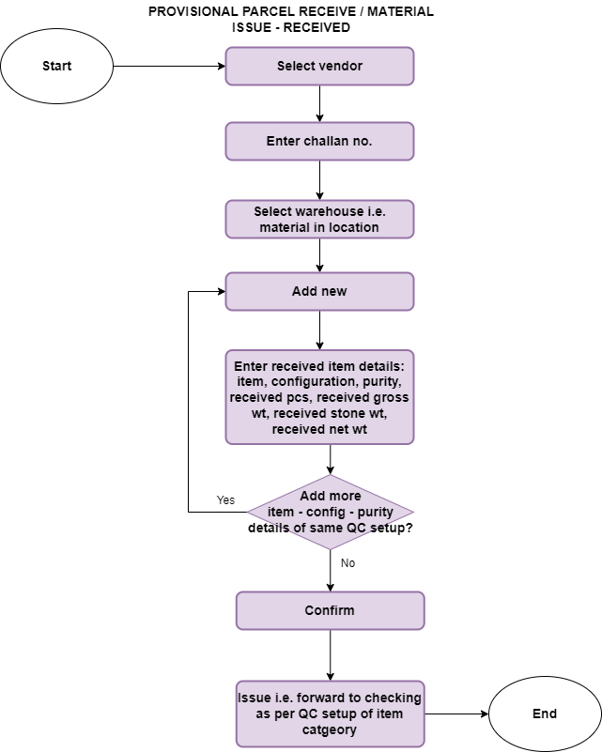

Fig: Process flow diagram -> Provisional parcel receive

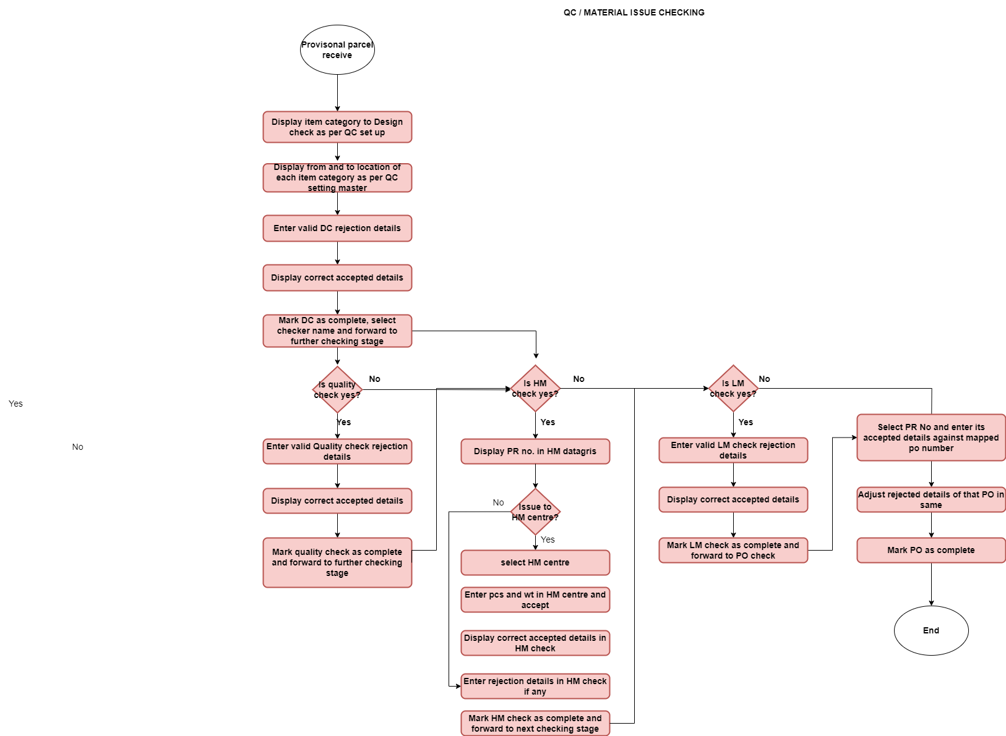

Fig: Process flow diagram -> QC

1. **PROPOSED SYSTEM**

**Step 1: Raise PO and confirm it**

Once user clicks on all purchase orders -> new to raise new PO, user will have to enter following fields:

* Vendor account number
* Vendor name
* Vendor contact no.
* Delivery address
* PO number
* PO type
* Invoice account
* PO rate type
* PO classification
* Sub-smith
* PO order type
* Currency
* Site
* Warehouse
* Accounting date
* Language
* Item
* Configuration
* Purity
* Annexure PO lines
* Item
* Configuration
* Size range
* Wt range
* Exact wt
* Pcs
* Quantity
* Delivery date
* Purity date
* Purchase -> actions -> confirm button

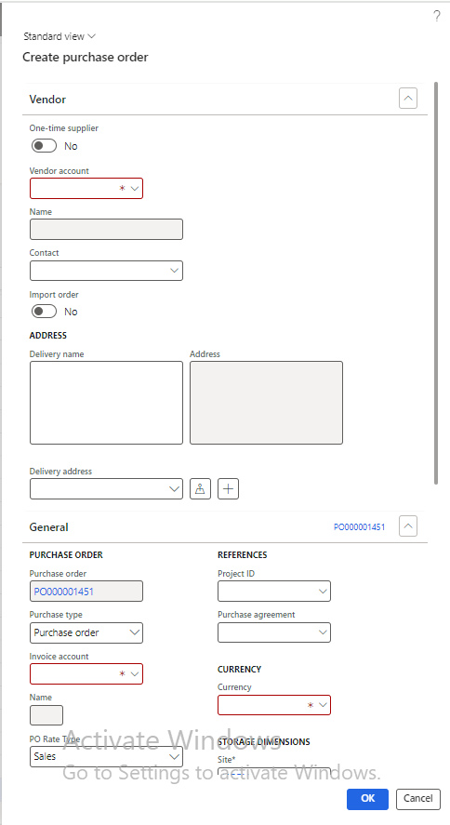

Fig: PO -> Standard details

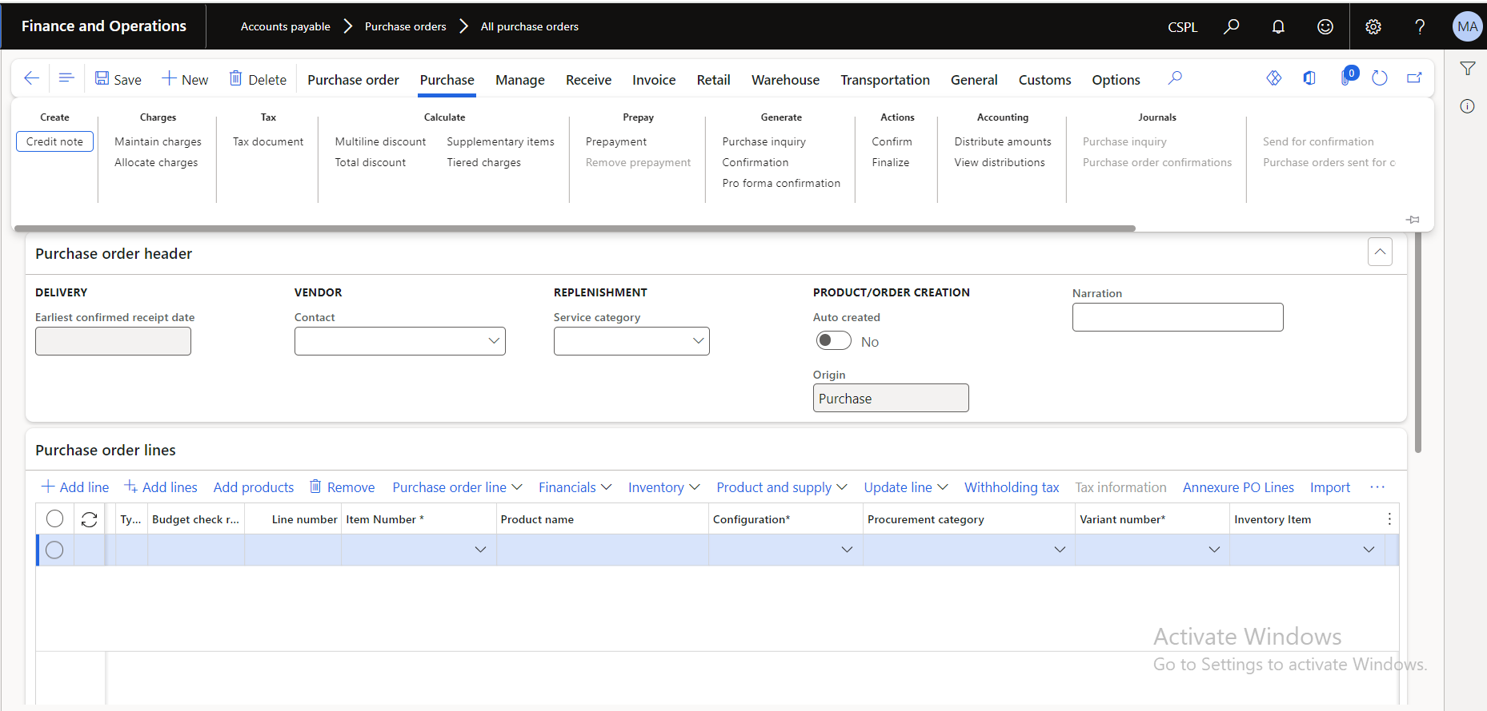

Fig: PO -> lines

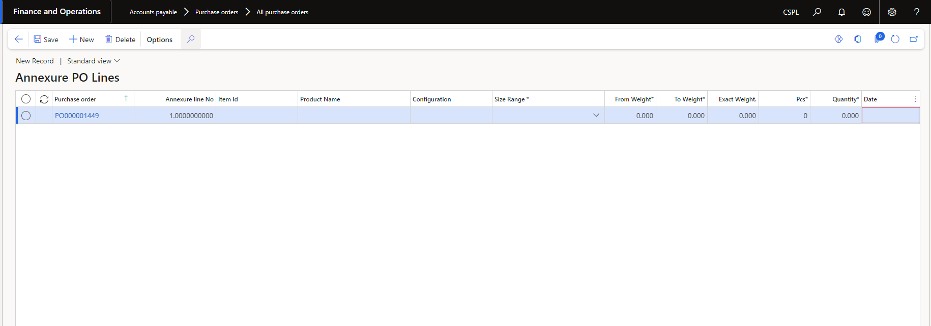

Fig: PO -> Annexure PO lines

**Step 2: QC Setup**

In QC setup module, admin will specify which checking stages should be done for each specific item - configuration. Thus, when any provisional parcel is issued, it will be displayed in the further checking stage as per QC setup against those item - configuration. Once any PR number is issued from one checking stage, it will be displayed to further checking stage as per QC setup. PO check is mandatory stage whereas other checking stages can be set as ‘yes’ as per inventory and business necessity.

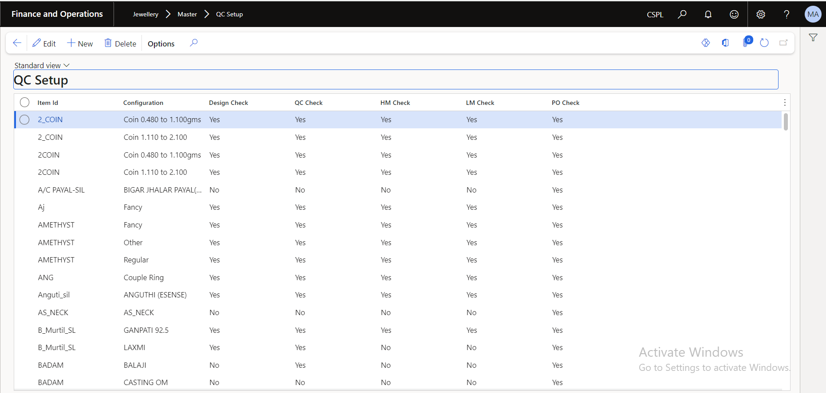

Fig: QC setup

**Step 3: Provisional Parcel Receive**

Once the order is created in connect-us, provisional parcel against that order will get generated automatically in Dsuite with the same data in it. Provisional parcel receive menu will have following fields:

* Save button
* New button
* Confirm button
* Issue button
* Print button

In provisional parcel receive feature, user will enter the details of the vendor, site and the item details which has been received physically from vendor at the inventory. Further user will confirm the added parcel received details and issue it for checking stage I.e. QC process.

It has following columns in data grid to search record:

* Voucher number
* Vendor Code
* Confirm
* Receive date
* Send to DC
* Send to QC
* Send to HM
* Send to LM
* Send to HM centre
* Send to LM
* Send to POC

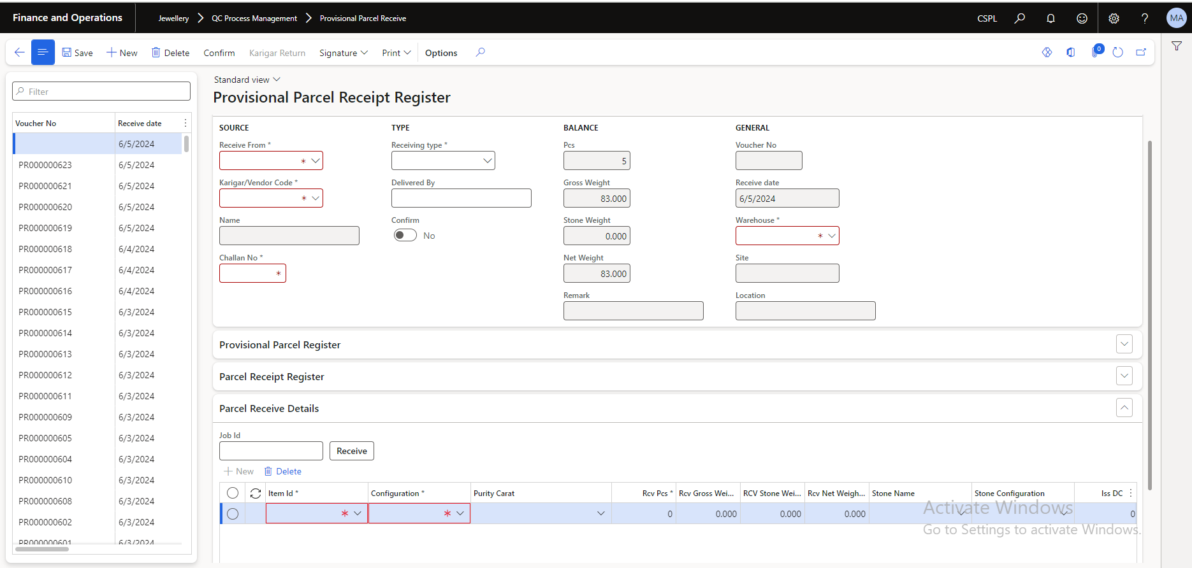

Fig: Provisional Parcel Receive

Once user clicks on new button to add received parcel details, user will enter details in following fields:

|  |  |  |  |
| --- | --- | --- | --- |
| **FIELDS** | **INPUT TYPE** | **FIELD REQ TYPE** | **DESCRIPTION** |
| Receive from | Drop down | Mandatory | User will specify whether the material has been received from Karagir or vendor.  Validation: It will be single select. |
| Vendor / Karagir code | Drop down | Mandatory | User will specify the name from which the material has been received. If user has selected receiving type as Karagir, then it will display the list of Karagir here from all vendors menu as specified in vendor type field. If user has selected receiving type as vendor, then it will display the list of Karagir here from all vendors menu.  Validation: It is single select. |
| Vendor name | Text | Mandatory | From all vendors menu, it will display the name of the vendor as per selected vendor / Karagir code.  Validation: It will be read only. |
| Challan No. | Text | Mandatory | User will enter the challan number as per bill received from the vendor along with the material.  Validation: It will accept alphanumeric value. It will not accept space or special characters.  Min = 1  Max=11 |
| Receiving type | Drop down | Optional | User will select if the parcel has been received by hand or through courier.  Validation: It will be single select. |
| Delivered by | Text | Optional | User will mention the reference name of the person through which the material has been received.  Validation: It should accept space and characters only.  Min = 0  Max = 255 |
| Provisional parcel receipt -> pcs | Text | Mandatory | It will display the total pending pcs which has not been checked yet. Initially it will display the total pcs count in the entire PR once user confirms it. Further, once the checking stage stages are completed, it will update and display the count of the pcs which pending for QC. Here, if any PR has multiple item records in it, then it will display the pending pcs of total items in that PR.  Validation: It will be read only. |
| Provisional parcel receipt -> gross wt | Text | Mandatory | It will display the total pending gross wt which has not been checked yet. Initially it will display the total gross wt count in the entire PR once user confirms it. Further, once the checking stage stages are completed, it will update and display the count of the gross wt which pending for QC. Here, if any PR has multiple item records in it, then it will display the pending gross wt of total items in that PR.  Validation: It will be read only. |
| Provisional parcel receipt -> net wt | Text | Mandatory | It will display the total pending net wt which has not been checked yet. Initially it will display the total net wt count in the entire PR once user confirms it. Further, once the checking stage stages are completed, it will update and display the count of the net wt which pending for QC. Here, if any PR has multiple item records in it, then it will display the pending net wt of total items in that PR.  Validation: It will be read only. |
| Provisional parcel receipt -> stone wt | Text | Mandatory | It will display the total pending stone wt which has not been checked yet. If there are not stone details in PR, then it will display stone wt as 0.00. Whereas, initially it will display the total stone wt count in the entire PR once user confirms it. Further, once the checking stage stages are completed, it will update and display the count of the stone wt which pending for QC. Here, if any PR has multiple item records in it, then it will display the pending stone wt of total items in that PR if any.  Validation: It will be read only. |
| Provisional parcel receipt -> remark | Text | Mandatory | It will display the QC stage which has been completed for that PR for better understanding of user.  Validation: It will be read only. |
| Warehouse | Drop down | Mandatory | User will select the warehouse I.e. inventory office at which the parcel has been received. It will display warehouses list from inventory management -> setup -> warehouses. If any QC setting against selected warehouse is not done, then it will display error message. Warehouse for all the items in the same PR will be one only. User will have to create new PR if warehouse for another item is different.  Validation: It will be single select. |
| Site | Text | Mandatory | As per selected warehouse, it will display the name of site as per inventory management -> setup -> warehouses -> site field against that warehouse.  Validation: It will be read only. |
| Location | Text | Mandatory | It will display the location of selected warehouse as per QC setting master.  Validation: It will be read only. |
| Provisional parcel register -> Design check -> DC warehouse | Text | Mandatory | It will be DC ‘from location’ as per QC setting master.  Validation: It will be read only. |
| Provisional parcel register -> Design check -> DC warehouse name | Text | Mandatory | As per selected warehouse in provisional parcel receipt, it will display the warehouse name from inventory management -> warehsouses.  Validation: It will be read only. |
| Provisional parcel register -> design check -> issued date & time | Text | Mandatory | It will display the date and time when that PR number was issued from DC stage to further stage.  It will be blank until that PR number is not issued to further stage from DC stage. It will be blank of DC check was not require for that PR as per QC setup.  Validation: It will be displayed in format MM/DD/YYYY HH:MM:SS. It will be read only. |
| Provisional parcel register -> design check -> received date & time | Text | Mandatory | It will display the date and time when that PR was received to DC stage after confirming PR number.  It will be blank if DC check isn’t required for that PR number as per QC set up. It will be blank until parcel is not issued to DC stage when it was supposed to.  Validation: It will be displayed in format MM/DD/YYYY HH:MM:SS. It will be read only. |
| Provisional parcel register -> design check -> DC location | Text |  | It will display the location to which parcel is to be sent. It will display DC to location as per QC setting.  Validation: It will be read only. |
| Provisional parcel register -> design check -> send to DC | Click | Mandatory | It will represent whther that PR number was sent to DC stage or not.  Initially, it will be disabled I.e. ‘No’ until user confirms the PR number. It will be enabled I.e. display it as sent to DC -> yes once user clicks on ‘issue to DC’.  Validation: It will be read only. |
| Provisional parcel register -> Quality check -> QC warehouse | Text | Mandatory | It will be QC ‘from location’ as per QC setting master against selected warehouse in provisional parcel receipt -> warehouse.  Validation: It will be read only. |
| Provisional parcel register -> Quality check -> QC warehouse name | Text | Mandatory | As per selected warehouse in provisional parcel receipt, it will display the warehouse name from inventory management -> warehsouses.  Validation: It will be read only. |
| Provisional parcel register -> quality check -> issued date & time | Text | Mandatory | It will display the date and time when that PR number was issued from QC stage to further stage.  It will be blank until that PR number is not issued to further stage from QC stage. It will be blank of QC check was not require for that PR as per QC setup.  Validation: It will be displayed in format MM/DD/YYYY HH:MM:SS. It will be read only. |
| Provisional parcel register -> quality check -> received date & time | Text | Mandatory | It will display the date and time when that PR was received to QC stage after confirming PR number.  It will be blank if QC check isn’t required for that PR number as per QC set up. It will be blank until parcel is not issued to QC stage when it was supposed to.  Validation: It will be displayed in format MM/DD/YYYY HH:MM:SS. It will be read only. |
| Provisional parcel register -> quality check -> QC location | Text |  | It will display the location to which parcel is to be sent. It will display QC to location as per QC setting.  Validation: It will be read only. |
| Provisional parcel register -> quality check -> send to QC | Click | Mandatory | It will represent whether that PR number was sent to QC stage or not.  Initially, it will be disabled I.e. ‘No’ until user confirms the PR number. It will be enabled I.e. display it as sent to QC -> yes once user clicks on ‘issue to QC’.  Validation: It will be read only. |
| Provisional parcel register -> HM check -> HM warehouse | Text | Mandatory | It will be HM ‘from location’ as per QC setting master.  Validation: It will be read only. |
| Provisional parcel register -> HM check -> HM warehouse name | Text | Mandatory | As per selected warehouse in provisional parcel receipt, it will display the warehouse name from inventory management -> warehsouses.  Validation: It will be read only. |
| Provisional parcel register -> HM check -> issued date & time | Text | Mandatory | It will display the date and time when that PR number was issued from HM stage to further stage.  It will be blank until that PR number is not issued to further stage from HM stage. It will be blank of HM check was not require for that PR as per QC setup.  Validation: It will be displayed in format MM/DD/YYYY HH:MM:SS. It will be read only. |
| Provisional parcel register -> HM check -> received date & time | Text | Mandatory | It will display the date and time when that PR was received to HM stage after confirming PR number.  It will be blank if HM check isn’t required for that PR number as per QC set up. It will be blank until parcel is not issued to HM stage when it was supposed to.  Validation: It will be displayed in format MM/DD/YYYY HH:MM:SS. It will be read only. |
| Provisional parcel register -> HM check -> HM location | Text | Mandatory | It will display the location to which parcel is to be sent. It will display HM to location as per QC setting.  Validation: It will be read only. |
| Provisional parcel register -> HM check -> send to HM | Click | Mandatory | It will represent whether that PR number was sent to HM stage or not.  Initially, it will be disabled I.e. ‘No’ until user confirms the PR number. It will be enabled I.e. display it as sent to HM -> yes once user clicks on ‘issue to HM’.  Validation: It will be read only. |
| Provisional parcel register -> HM centre -> HM centre code | Text | Mandatory | It will display the HM centre code to which the items are beeing assigned to. It should display multiple HM centre codes separated by comma if items of that PR are sent to more than one HM centre.  Validation: It will be read only. |
| Provisional parcel register -> HM centre -> HM centre name | Text | Mandatory | It will display the HM centre name to which the items are beeing assigned to. It should display multiple HM centre names separated by comma if items of that PR are sent to more than one HM centre.  Validation: It will be read only. |
| Provisional parcel register -> HM centre -> HM centre issue date & time | Text | Mandatory | It will display the date and time at which the the last item of that PR was received back to HM check.  Validation: It will be read only. |
| Provisional parcel register -> HM centre -> HM centre receive date & time | Text | Mandatory | It will display the first date and time at which the item of that PR number were issued to HM centre.  As we can issue items to hm centre from same PR number multiple times, it should display the first date and time only.  Validation: It will be read only. |
| Provisional parcel register -> HM centre -> send to HM centre | Click |  | It will represent whether that any of the item from that PR number was sent to HM centre or not.  Initially, it will be disabled I.e. ‘No’ until user confirms the PR number. It will be enabled I.e. display it as sent to HM centre -> yes once user clicks on ‘issue to HM centre’ from HM centre stage.  Validation: It will be read only. |
| Provisional parcel register -> LM check -> LM warehouse | Text | Mandatory | It will be LM ‘from location’ as per QC setting master.  Validation: It will be read only. |
| Provisional parcel register -> LM check -> LM warehouse name | Text | Mandatory | As per selected warehouse in provisional parcel receipt, it will display the warehouse name from inventory management -> warehsouses.  Validation: It will be read only. |
| Provisional parcel register -> LM check -> issued date & time | Text | Mandatory | It will display the date and time when that PR number was issued from lM stage to further stage.  It will be blank until that PR number is not issued to further stage from LM stage. It will be blank of LM check was not require for that PR as per QC setup.  Validation: It will be displayed in format MM/DD/YYYY HH:MM:SS. It will be read only. |
| Provisional parcel register -> LM check -> received date & time | Text | Mandatory | It will display the date and time when that PR was received to LM stage after confirming PR number.  It will be blank if LM check isn’t required for that PR number as per QC set up. It will be blank until parcel is not issued to LM stage when it was supposed to.  Validation: It will be displayed in format MM/DD/YYYY HH:MM:SS. It will be read only. |
| Provisional parcel register -> LM check -> LM location | Text | Mandatory | It will display the location to which parcel is to be sent. It will display LM to location as per QC setting.  Validation: It will be read only. |
| Provisional parcel register -> LM check -> send to LM | Click | Mandatory | It will represent whether that PR number was sent to LM stage or not.  Initially, it will be disabled I.e. ‘No’ until user confirms the PR number. It will be enabled I.e. display it as sent to LM -> yes once user clicks on ‘issue to LM’.  Validation: It will be read only. |
| Provisional parcel register -> PO check -> PO warehouse | Text | Mandatory | It will be PO ‘from location’ as per QC setting master.  Validation: It will be read only. |
| Provisional parcel register -> PO check -> PO warehouse name | Text | Mandatory | As per selected warehouse in provisional parcel receipt, it will display the warehouse name from inventory management -> warehsouses.  Validation: It will be read only. |
| Provisional parcel register -> PO check -> issued date & time | Text | Mandatory | It will display the date and time when that PR number was issued from PO stage to further stage.  It will be blank until that PR number is not issued to further stage from PO stage. It will be blank of PO check was not require for that PR as per QC setup.  Validation: It will be displayed in format MM/DD/YYYY HH:MM:SS. It will be read only. |
| Provisional parcel register -> PO check -> received date & time | Text | Mandatory | It will display the date and time when that PR was received to PO stage after confirming PR number.  It will be blank if PO check isn’t required for that PR number as per QC set up. It will be blank until parcel is not issued to PO stage when it was supposed to.  Validation: It will be displayed in format MM/DD/YYYY HH:MM:SS. It will be read only. |
| Provisional parcel register -> PO check -> PO location | Text | Mandatory | It will display the location to which parcel is to be sent. It will display PO to location as per QC setting.  Validation: It will be read only. |
| Provisional parcel register -> PO check -> send to PO | Click | Mandatory | It will represent whether that PR number was sent to PO stage or not.  Initially, it will be disabled I.e. ‘No’ until user confirms the PR number. It will be enabled I.e. display it as sent to PO -> yes once user clicks on ‘issue to PO’.  Validation: It will be read only. |
| Parcel receive details -> New button | Click | - | User can add one or more item details received in by clicking on new button.  Once user clicks on new button and if mandatory fields are not filled from provisional parcel receipt section, then it should display on field error message.  Once user enters mandatory fields and clicks on new button, then a line will appear to enter received item details. When user clicks on new button again after creating one record in it, on field error message should be displayed if user has not filled all mandatory fields in the previously created line whereas second line should not get generated.  Once user enters a record, clicks new button and then changes warehouse then already added record line should not get cleared. Warehouses for all items in same PR should get saved which user selected before clicking confirm button.  If user has added multiple item records in one PR no., then all those added multiple records should be displayed in details section of DC check, QC check, HM check, LM check and PO check.  All the line items record added against same challan number will be displayed in multiple lines in batch registration -> BR lines section.    Fig: Batch registration  Validation: New button should be disabled once 50 item records are added in one particular provisional parcel receipt. Button should be disabled once PR number is confirmed by user. |
| Parcel receive details -> delete button | Click | Optional | User can select the one or more line records and delete it if required.  Validation: Delete button will be disabled if there is number line record. Button should be disabled once PR number is confirmed. |
| Parcel receive details -> item | Drop down | Mandatory | User will select the item from drop-down which has been received at inventory from vendor.  MRP & Forming Item are applicable for QC process henceforth.  Validation: It will be single select. |
| Parcel receive details -> configuration | Drop down | Mandatory | As per selected item, user will select the configuration from drop-down list which are set against that item in released product variants.  Further, item - configuration with same QC setup as already added record should get added. Else, it should display error message as ‘please add item - configuation with same QC setup’.  We are going to perform qc for all items henceforth. In case of mrp and forming only, carat field will be optional and disabled as it doesn't have purity. Moreoever, validation error message of record already exists will be displayed once user selected same mrp item and config in another line.  Validation: It will be single select. |
| Parcel receive details -> purity | Drop down | Mandatory | User will select the purity for the selected item - config.  When user will add another record of same item-configuration after adding one record, then item of same purity should not get added. It should display error message as ‘Item - configuration with same purity already exists’.  Validation: It will be single select. |
| Parcel receive details -> received pcs | Text | Mandatory | User will enter the pcs of that item - configuration - purity received from vendor.  Validation: It will accept numbers only. It should not accept characters or space or special characters. |
| Parcel receive details -> received gross wt | Text | Mandatory | User will mention the total gross wt of that particular item - configuration - purity received from vendor.  Validation: It will accept numbers only and single decimal point as special character. It should not accept characters. It should accept max three digits after and max three digits before decimal point. |
| Parcel receive details -> received stone wt | Text | Mandatory | User will mention the total stone wt in that particular item - configuration - purity received from vendor.  In case of MRP & Forming Stone W, stone name and stone config should be blank and disabled.  Validation: It will accept numbers only and single decimal point as special character. It should not accept characters. It should accept max three digits after and max three digits before decimal point. Stone wt cannot be greater than or equal to gross wt else it will display error message. |
| Parcel receive details -> received net wt | Text | Mandatory | It will auto-calculate and display the net wt of that particular item - configuration - purity. Initially, it will display 0.00 whereas once user enters the gross wt, the same will be displayed as net. In addition to it, if user mentions any stone wt then net wt will be displayed as net wt = gross wt - stone wt.  Validation: It will be read only. |
| Parcel receive details -> stone name | Drop down | Mandatory only if stone wt is entered | User will have to mention stone name if stone wt is entered any. It will display the stone name from released products whose item category is diamond.  Validation: it will be single select. |
| Parcel receive details -> configuration | Drop down | Mandatory only if stone wt is entered | User will have to specify stone configuration if stone wt is entered any. It will display the configuration of selected stone name.  Validation: it will be single select. |
| Issued DC pcs | Text | Mandatory | It will display the total pcs of that item - configuration - purity which are forwarded to DC stage. If any item - configuration doesn’t DC check set in QC set up then it will display 0 pcs here. If any item - configuration has set DC check stage in QC setup then it will display the total pcs of that item - configuration - purity as soon as user confirms the PR.  Validation: it will be read only. |
| Issued DC gross wt | Text | Mandatory | It will display the total gross wt of that item - configuration - purity which are forwarded to DC stage. If any item - configuration doesn’t DC check set in QC set up then it will display 0 gross wt here. If any item - configuration has set DC check stage in QC set up then it will display the total gross wt of that item - configuration - purity as soon as user confirms the PR.  Validation: it will be read only. |
| Issued DC stone wt | Text | Mandatory | It will display the total stone wt of that item - configuration - purity if any which are forwarded to DC stage. If any item - configuration doesn’t DC check set in QC set up then it will display 0 stone wt here. If any item - configuration has set DC check stage in QC set up then it will display the total stone wt of that item - configuration - purity as soon as user confirms the PR.  Validation: it will be read only. |
| Issued DC net wt | Text | Mandatory | It will display the total net wt of that item - configuration - purity if any which are forwarded to DC stage. If any item - configuration doesn’t DC check set in QC set up then it will display 0 stone wt here. If any item - configuration has set DC check stage in QC set up then it will display the total net wt of that item - configuration - purity as soon as user confirms the PR.  Validation: it will be read only. |
| Rejected DC pcs | Text | Mandatory | If user has rejected any pcs in design check stage for that particular item - configuration - purity form its PR then it will display rejected pcs in this field. Initially, it will be 0.00 until DC check of that entire PR number gets completed. It will be 0 if DC check stage is not set in QC setup for that item - configuration.  Validation: It will be read only. |
| Rejected DC gross wt | Text | Mandatory | If user has rejected any gross wt in design check stage for that particular item - configuration - purity form its PR then it will display rejected gross wt in this field. Initially, it will be 0.00 until DC check of that entire PR number gets completed. It will be 0 if DC check stage is not set in QC setup for that item - configuration.  Validation: It will be read only. |
| Rejected DC stone wt | Text | Mandatory | If user has rejected any stone wt in design check stage for that particular item - configuration - purity form its PR then it will display rejected stone wt in this field. Initially, it will be 0.00 until DC check of that entire PR number gets completed. It will be 0 if DC check stage is not set in QC setup for that item - configuration. It will be 0 if there are not stone wt in that PR for that that item - configuration - purity.  Validation: It will be read only. |
| Rejected DC net wt | Text | Mandatory | If user has rejected any net wt in design check stage for that particular item - configuration - purity form its PR then it will display rejected net wt in this field. Initially, it will be 0.00 until DC check of that entire PR number gets completed. It will be 0 if DC check stage is not set in QC setup for that item - configuration.  Validation: It will be read only. |
| Issued QC pcs | Text | Mandatory | It will display the total pcs of that item - configuration - purity which are forwarded to QC stage.  If any item - configuration doesn’t have QC check set in QC setup then it will display 0 pcs here.  If any item - configuration has set QC check stage in QC setup followed by design check stage then it will display the total pcs of that item - configuration - purity as per accepted pcs from design check stage for that item - configuration - purity.  If any item - configuration has set QC check stage in QC setup without design check stage, then it will display directly the total pcs of that item - configuration - purity as in PR once user issues it to QC.  Validation: it will be read only. |
| Issued QC gross wt | Text | Mandatory | It will display the total gross wt of that item - configuration - purity which are forwarded to QC stage.  If any item - configuration doesn’t have QC check set in QC setup then it will display 0 gross wt here.  If any item - configuration has set QC check stage in QC setup followed by design check stage then it will display the total gross wt of that item - configuration - purity as per accepted gross wt from design check stage for that item - configuration - purity.  If any item - configuration has set QC check stage in QC setup without design check stage, then it will display directly the total gross wt of that item - configuration - purity as in PR once user issues it to QC.  Validation: it will be read only. |
| Issued QC stone wt | Text | Mandatory | It will display the total stone wt of that item - configuration - purity which are forwarded to QC stage.  If any item - configuration doesn’t have any stone wt in it, then it will display 0.  If any item - configuration doesn’t have QC check set in QC setup then it will display 0 stone wt here.  If any item - configuration has set QC check stage in QC setup followed by design check stage then it will display the total stone wt of that item - configuration - purity as per accepted stone wt from design check stage for that item - configuration - purity.  If any item - configuration has set QC check stage in QC setup without design check stage, then it will display directly the total stone wt of that item - configuration - purity as in PR once user issues it to QC.  Validation: it will be read only. |
| Issued QC net wt | Text | Mandatory | It will display the total net wt of that item - configuration - purity which are forwarded to QC stage.  If any item - configuration doesn’t have QC check set in QC setup then it will display 0 net wt here.  If any item - configuration has set QC check stage in QC setup followed by design check stage then it will display the total net wt of that item - configuration - purity as per accepted net wt from design check stage for that item - configuration - purity.  If any item - configuration has set QC check stage in QC setup without design check stage, then it will display directly the total net wt of that item - configuration - purity as in PR once user issues it to QC.  Validation: it will be read only. |
| Rejected QC pcs | Text | Mandatory | If user has rejected any pcs in QC check stage for that particular item - configuration - purity form its PR then it will display rejected pcs in this field. Initially, it will be 0.00 until QC check of that entire PR number gets completed. It will be 0 if QC check stage is not set in QC setup for that item - configuration.  Validation: It will be read only. |
| Rejected QC gross wt | Text | Mandatory | If user has rejected any gross wt in QC check stage for that particular item - configuration - purity form its PR then it will display rejected gross wt in this field. Initially, it will be 0.00 until QC check of that entire PR number gets completed. It will be 0 if QC check stage is not set in QC setup for that item - configuration.  Validation: It will be read only. |
| Rejected QC stone wt | Text | Mandatory | If user has rejected any stone wt in QC check stage for that particular item - configuration - purity form its PR then it will display rejected stone wt in this field. Initially, it will be 0.00 until QC check of that entire PR number gets completed. It will be 0 if QC check stage is not set in QC setup for that item - configuration. It will be 0 if there are not stone wt in that PR for that that item - configuration - purity.  Validation: It will be read only. |
| Rejected QC net wt | Text | Mandatory | If user has rejected any net wt in DC check stage for that particular item - configuration - purity form its PR then it will display rejected net wt in this field. Initially, it will be 0.00 until QC check of that entire PR number gets completed. It will be 0 if QC check stage is not set in QC setup for that item - configuration.  Validation: It will be read only. |
| Issued HM pcs | Text | Mandatory | It will display the total pcs of that item - configuration - purity which are forwarded to HM stage.  If any item - configuration doesn’t have HM check set in QC setup then it will display 0 pcs here.  If any item - configuration has set HM check stage in QC setup followed by design check / QC check stage then it will display the total pcs of that item - configuration - purity as per accepted pcs from design check stage for that item - configuration - purity.  If any item - configuration has set HM check stage in QC setup without design check / QC check stage, then it will display directly the total pcs of that item - configuration - purity as in PR once user issues it to HM.  Validation: it will be read only. |
| Issued HM gross wt | Text | Mandatory | It will display the total gross wt of that item - configuration - purity which are forwarded to HM stage.  If any item - configuration doesn’t have HM check set in QC setup then it will display 0 gross wt here.  If any item - configuration has set HM check stage in QC setup followed by design check stage / QC check then it will display the total gross wt of that item - configuration - purity as per accepted gross wt from design check stage / QC check for that item - configuration - purity.  If any item - configuration has set HM check stage in QC setup without design check / QC check stage, then it will display directly the total gross wt of that item - configuration - purity as in PR once user issues it to QC.  Validation: it will be read only. |
| Issued HM stone wt | Text | Mandatory | It will display the total stone wt of that item - configuration - purity which are forwarded to HM stage.  If any item - configuration doesn’t have any stone wt in it, then it will display 0.  If any item - configuration doesn’t have QC check set in QC setup then it will display 0 stone wt here.  If any item - configuration has set HM check stage in QC setup followed by design check stage / QC check then it will display the total stone wt of that item - configuration - purity as per accepted stone wt from design check / QC check stage for that item - configuration - purity.  If any item - configuration has set HM check stage in QC setup without design check / QC check stage, then it will display directly the total stone wt of that item - configuration - purity as in PR once user issues it to HM.  Validation: it will be read only. |
| Issued HM net wt | Text | Mandatory | It will display the total net wt of that item - configuration - purity which are forwarded to HM stage.  If any item - configuration doesn’t have HM check set in QC setup then it will display 0 net wt here.  If any item - configuration has set HM check stage in QC setup followed by design check / QC check stage then it will display the total net wt of that item - configuration - purity as per accepted net wt from design check / QC check stage for that item - configuration - purity.  If any item - configuration has set HM check stage in QC setup without design check / QC check stage, then it will display directly the total net wt of that item - configuration - purity as in PR once user issues it to HM.  Validation: it will be read only. |
| Rejected HM pcs | Text | Mandatory | If user has rejected any pcs in HM check stage for that particular item - configuration - purity form its PR then it will display rejected pcs in this field. Initially, it will be 0.00 until HM check of that entire PR number gets completed. It will be 0 if HM check stage is not set in QC setup for that item - configuration.  Validation: It will be read only. |
| Rejected HM gross wt | Text | Mandatory | If user has rejected any gross wt in HM check stage for that particular item - configuration - purity form its PR then it will display rejected gross wt in this field. Initially, it will be 0.00 until HM check of that entire PR number gets completed. It will be 0 if HM check stage is not set in QC setup for that item - configuration.  Validation: It will be read only. |
| Rejected HM stone wt | Text | Mandatory | If user has rejected any stone wt in HM check stage for that particular item - configuration - purity form its PR then it will display rejected stone wt in this field. Initially, it will be 0.00 until HM check of that entire PR number gets completed. It will be 0 if HM check stage is not set in QC setup for that item - configuration. It will be 0 if there are not stone wt in that PR for that that item - configuration - purity.  Validation: It will be read only. |
| Rejected HM net wt | Text | Mandatory | If user has rejected any net wt in HM check stage for that particular item - configuration - purity form its PR then it will display rejected net wt in this field. Initially, it will be 0.00 until HM check of that entire PR number gets completed. It will be 0 if HM check stage is not set in QC setup for that item - configuration.  Validation: It will be read only. |
| Issued LM pcs | Text | Mandatory | It will display the total pcs of that item - configuration - purity which are forwarded to LM stage.  If any item - configuration doesn’t have Lm check set in QC setup then it will display 0 pcs here.  If any item - configuration has set Lm check stage in QC setup followed by design check / QC check / HM check stage then it will display the total pcs of that item - configuration - purity as per accepted pcs from design check stage / QC check / HM check for that item - configuration - purity.  If any item - configuration has set Lm check stage in QC setup without design check / QC check / HM check stage, then it will display directly the total pcs of that item - configuration - purity as in PR once user issues it to HM.  Validation: it will be read only. |
| Issued LM gross wt | Text | Mandatory | It will display the total gross wt of that item - configuration - purity which are forwarded to Lm stage.  If any item - configuration doesn’t have Lm check set in QC setup then it will display 0 gross wt here.  If any item - configuration has set Lm check stage in QC setup followed by design check stage / QC check / HM check then it will display the total gross wt of that item - configuration - purity as per accepted gross wt from design check stage / QC check / HM check for that item - configuration - purity.  If any item - configuration has set Lm check stage in QC setup without design check / QC check / HM check stage, then it will display directly the total gross wt of that item - configuration - purity as in PR once user issues it to QC.  Validation: it will be read only. |
| Issued LM stone wt | Text | Mandatory | It will display the total stone wt of that item - configuration - purity which are forwarded to Lm stage.  If any item - configuration doesn’t have any stone wt in it, then it will display 0.  If any item - configuration doesn’t have lm check set in QC setup then it will display 0 stone wt here.  If any item - configuration has set lm check stage in QC setup followed by design check stage / QC check / HM check then it will display the total stone wt of that item - configuration - purity as per accepted stone wt from design check stage / QC check / HM check for that item - configuration - purity.  If any item - configuration has set HM check stage in QC setup without design check stage / QC check / HM check, then it will display directly the total stone wt of that item - configuration - purity as in PR once user issues it to HM.  Validation: it will be read only. |
| Issued LM net wt | Text | Mandatory | It will display the total net wt of that item - configuration - purity which are forwarded to HM stage.  If any item - configuration doesn’t have HM check set in QC setup then it will display 0 net wt here.  If any item - configuration has set HM check stage in QC setup followed by design check / QC check stage / HM check then it will display the total net wt of that item - configuration - purity as per accepted net wt from design check / QC check / HM check stage for that item - configuration - purity.  If any item - configuration has set HM check stage in QC setup without design check / QC check / HM check stage, then it will display directly the total net wt of that item - configuration - purity as in PR once user issues it to HM.  Validation: it will be read only. |
| Rejected LM pcs | Text | Mandatory | If user has rejected any pcs in lm check stage for that particular item - configuration - purity form its PR then it will display rejected pcs in this field. Initially, it will be 0.00 until lm check of that entire PR number gets completed. It will be 0 if lm check stage is not set in QC setup for that item - configuration.  Validation: It will be read only. |
| Rejected LM gross wt | Text | Mandatory | If user has rejected any gross wt in lm check stage for that particular item - configuration - purity form its PR then it will display rejected gross wt in this field. Initially, it will be 0.00 until lm check of that entire PR number gets completed. It will be 0 if lm check stage is not set in QC setup for that item - configuration.  Validation: It will be read only. |
| Rejected LM stone wt | Text | Mandatory | If user has rejected any stone wt in lm check stage for that particular item - configuration - purity form its PR then it will display rejected stone wt in this field. Initially, it will be 0.00 until lm check of that entire PR number gets completed. It will be 0 if lm check stage is not set in QC setup for that item - configuration. It will be 0 if there are not stone wt in that PR for that that item - configuration - purity.  Validation: It will be read only. |
| Rejected LM net wt | Text | Mandatory | If user has rejected any net wt in lm check stage for that particular item - configuration - purity form its PR then it will display rejected net wt in this field. Initially, it will be 0.00 until lm check of that entire PR number gets completed. It will be 0 if lm check stage is not set in QC setup for that item - configuration.  Validation: It will be read only. |
| Issued PO pcs | Text | Mandatory | It will display the total pcs of that item - configuration - purity which are forwarded to PO check stage after design check / QC check / HM check / lm check.  It will display 0 initially until user issued it to PO check.  Validation: It will be read only. |
| Issued PO gross wt | Text | Mandatory | It will display the total gross wt of that item - configuration - purity which are forwarded to PO check stage after design check / QC check / HM check / lm check.  If any item - configuration has set PO check stage in QC setup followed by design check stage / QC check / HM check / lm check then it will display the total gross wt of that item - configuration - purity as per accepted gross wt from its previous QC stage for that item - configuration - purity.  If any item - configuration has set po check stage directly after provisional parcel receive I.e. QC setup has only PO check stage set, then it will display directly the total gross wt of that item - configuration - purity as in PR once user issues it to PO.  Validation: it will be read only. |
| Issued PO stone wt | Text | Mandatory | It will display the total stone wt of that item - configuration - purity which are forwarded to PO check stage after design check / QC check / HM check / lm check.  It will display 0 if there is not stone wt in that PR for that item - configuration - purity.  If any item - configuration has set PO check stage in QC setup followed by design check stage / QC check / HM check / lm check then it will display the total stone wt of that item - configuration - purity as per accepted stone wt from its previous QC stage for that item - configuration - purity.  If any item - configuration has set po check stage directly after provisional parcel receive I.e. QC setup has only PO check stage set, then it will display directly the total stone wt of that item - configuration - purity as in PR once user issues it to PO.  Validation: it will be read only. |
| Issued PO net wt | Text | Mandatory | t will display the total net wt of that item - configuration - purity which are forwarded to PO check stage after design check / QC check / HM check / lm check.  If any item - configuration has set PO check stage in QC setup followed by design check stage / QC check / HM check / lm check then it will display the total net wt of that item - configuration - purity as per accepted net wt from its previous QC stage for that item - configuration - purity.  If any item - configuration has set po check stage directly after provisional parcel receive I.e. QC setup has only PO check stage set, then it will display directly the total net wt of that item - configuration - purity as in PR once user issues it to PO.  Validation: it will be read only. |
| Rejected PO pcs | Text | Mandatory | It will display 0.00 as we do not reject any details in PO check.  Validation: it will be read only. |
| Rejected PO gross wt | Text | Mandatory | It will display 0.00 as we do not reject any details in PO check.  Validation: it will be read only. |
| Rejected PO stone wt | Text | Mandatory | It will display 0.00 as we do not reject any details in PO check.  Validation: it will be read only. |
| Rejected PO net wt | Text | Mandatory | It will display 0.00 as we do not reject any details in PO check.  Validation: it will be read only. |

Once user enters the items details in provisional parcel receive section and confirms it, user will not be able to make any changes in generated PR / voucher number Further, user will have to issue that PR to QC stage. It will display only one stage enabled in drop-down as per QC setup. Once user issues that PR, it will be displayed is that checking stage where that PR has been issued to. Once parcel issued to its first stage from provisional parcel receive, all the options in the list of issue will be disabled.

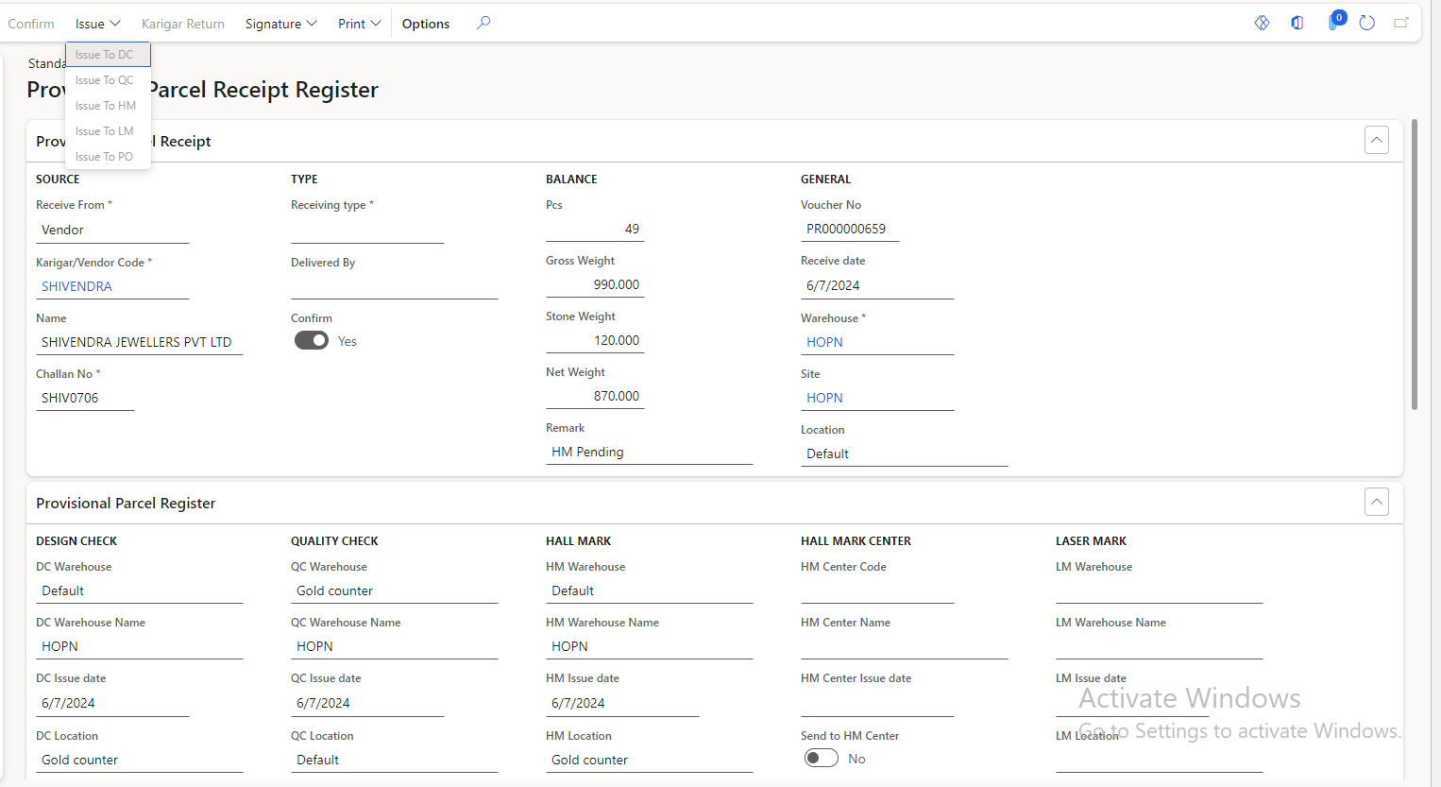

Fig: Provisional parcel receive -> issue

**Step 4: DC check**

Once the PR voucher issued to DC check, it will be displayed in header of DC check page. In DC check, user check the designs of the received items like round shape, square shape, 2 padari, etc. whether they are as expected. It will have following fields:

* Save button
* Issue button
* Print button
* DC Header section
* Voucher no.
* PR no.
* Receive date
* From location
* To location
* DC pass pcs
* DC pass gross wt
* DC pass stone wt
* DC pass net wt
* DC received date & time
* DC issued date & time
* DC user name
* Issued
* DC details section
* Item
* Configuration
* Purity
* Stone name
* Stone configuration
* Received pcs
* Received gross wt
* Received stone wt
* Received net wt
* Rejected DC pcs
* Rejected DC gross wt
* Rejected DC stone wt
* Rejected DC net wt
* DC rejection section
* New button
* Delete button
* Item
* Configuration
* Purity
* Stone name
* Stone configuration
* DC Rejected pcs
* DC Rejected gross wt
* DC Rejected stone wt
* DC rejected net wt
* DC rejection Remark

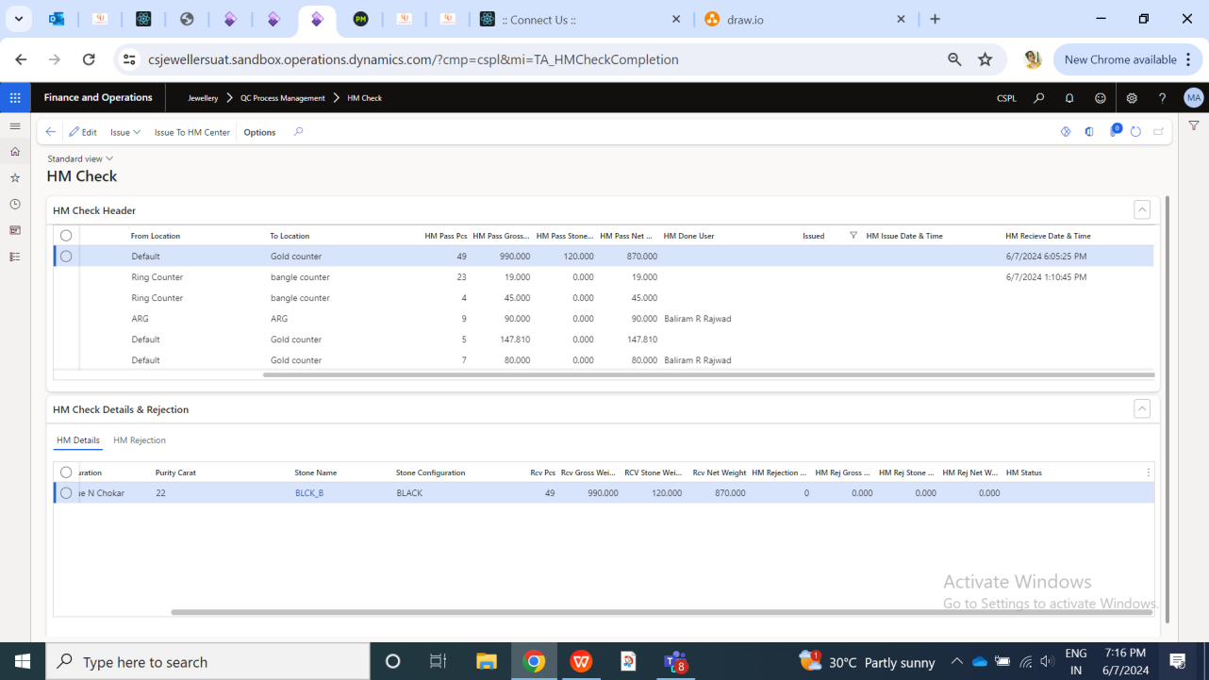

Fig: DC check -> header

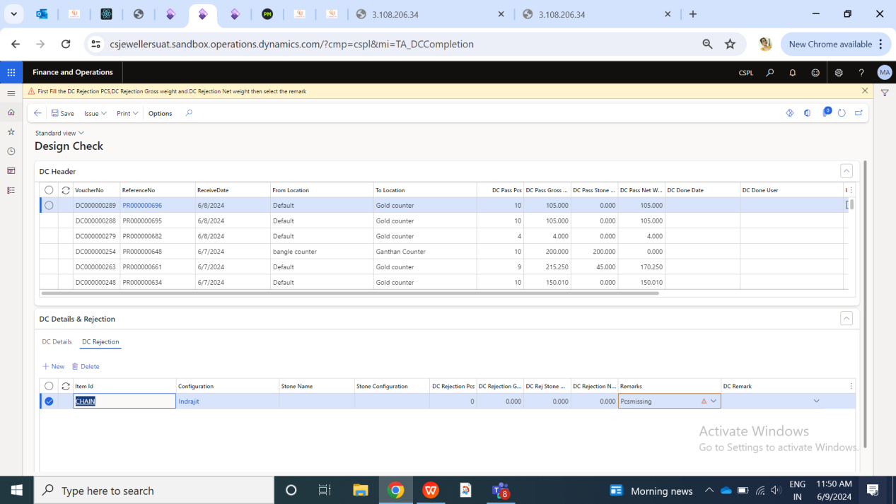

Fig: DC check -> rejection

Here, it will display only the list of PR numbers that are being issued to DC and are pending. The line record of PR number will be removed from data grid of DC check once it is issued to further checking stage.

|  |  |  |  |
| --- | --- | --- | --- |
| **FIELDS** | **INPUT TYPE** | **FIELD REQ TYPE** | **DESCRIPTION** |
| DC header section |  | Mandatory | It will display the list of voucher numbers I.e. PR numbers which have been issued to Dc check stage from provisional parcel receive menu. Recently issued vouchers in DC check should be displayed at top.  DC header has following columns:   * Voucher no. * PR no. * Receive date * From location * To location * DC pass pcs * DC pass gross wt * DC pass stone wt * DC pass net wt * DC user * DC received date and time * DC issued date and time   Initially, it will display the total pcs, total gross wt, total stone wt and total net wt as it is from provisional parcel receive number until user enters rejection details of that PR number in DC rejection section.  As per selected PR number from DC header, it will display the list of one more item records in it under DC details section below. If PR number has multiple item records, then all those records will be displayed in DC details section. |
| DC header -> DC received date and time | Text | Mandatory | For each PR number in header, it should have the date and time when that PR number was issued to DC check stage from provisional parcel receive menu I.e. the date and time when that PR number was received to DC check stage.  Validation: It will be read only. It should be displayed in a format of MM/DD/YYYY HH:MM:SS. |
| DC header-> DC issued date and time | Text | Mandatory | For each PR number in header, it should display the date and time when that voucher number was marked as issue to further checking stage after DC check as per QC setup.  Validation: It will be read only. It should be displayed in a format of MM/DD/YYYY HH:MM:SS. |
| DC details section | Text | Mandatory | It will display the list of one or more item records in DC details as per selected PR number from DC header section. It has following columns:   * Item * Configuration * Purity * Stone name * Stone configuration * Accepted pcs * Accepted gross wt * Accepted stone wt * Accepted net wt * DC rejected pcs * DC rejected gross wt * DC rejected stone wt * DC rejected net wt   User will have to select the line item record firstly and then proceed to it rejection by mentioning in DC rejection section. Once user enters the rejected pcs, Gross wt, stone wt and net wt details of selected item record then its details will get updated in DC details section -> fields namely DC rejected pcs, DC rejected gross wt, DC rejected stone wt, DC rejected net wt of that item record respectively. |
| DC Rejection section | Text | Mandatory | If user wants to enter rejection details, user will select the item line from the DC details section and then user will click on new button of Rejection section. User can add rejection details of each line record by selecting it from details section and specifying its rejection details in rejection section respectively. It has following fields:   * Item * Configuration * Purity * Stone name * Stone configuration * Rejected pcs * Rejected gross wt * Rejected stone wt * Rejected net wt * DC rejection remark |
| DC rejection section -> DC rejection remark | Drop down | Mandatory | User will specify the reason for rejection of item. DC rejection details should be displayed further in reports whenever needed.  Validation: It should be multi-select. Selected option should be removed / disabled from drop-down list. |
| DC issued ation | click |  | Once user enters all the rejection details of each PR number and issues it to further checking stage, the status as DC complete will be displayed against that PR voucher number in provisional parcel receive menu with rejection details accordingly. And total accepted pcs, gross wt, stone wt and net wt from DC will be forwarded to further stage.  If there are number rejection details in the PR number then user will directly select that PR number and click on issue button to proceed further.  Once user clicks on issued action after entering valid rejection details or without any rejection, a pop-up should appear confirming if user wants to proceed with done changes. Once user clicks on yes button, a drop-down will appear to select the DC checking user name. If user selects no, then pop-up should disappear and user will remain on DC check data grid page. Additionally, if user has not enter few mandatory fields or valid details and clicks on issue button, then relevant and specific error message will be displayed.  If any item record is completely rejected however has some accepted details in another item record of that PR voucher no., then it should get issued further to checking from DC.  Once document is issued further from DC stage, its completed date and time should be displayed against that PR voucher number In further checking stage and that voucher number should be removed from data grid of DC check. |

**Step 5: QC check**

Once the PR voucher issued to QC check either after DC check or directly through provisional parcel receive menu, it will be displayed in header of QC check page Here, users check the quality of the received item like if they are broken, its shine, plating, colour, stone inspection, purity, etc. It will have following fields:

* Save button
* Issue button
* Print button
* QC Header section
* Voucher no.
* PR no.
* Receive date
* From location
* To location
* QC pass pcs
* QC pass gross wt
* QC pass stone wt
* QC pass net wt
* QC received date & time
* QC issued date & time
* QC user name
* Issued
* QC details section
* Item
* Configuration
* Purity
* Stone name
* Stone configuration
* Received pcs
* Received gross wt
* Received stone wt
* Received net wt
* Rejected QC pcs
* Rejected QC gross wt
* Rejected QC stone wt
* Rejected QC net wt
* HM status
* QC rejection section
* New button
* Delete button
* Item
* Configuration
* Purity
* Stone name
* Stone configuration
* QC Rejected pcs
* QC Rejected gross wt
* QC Rejected stone wt
* QC rejected net wt
* QC rejection Remark

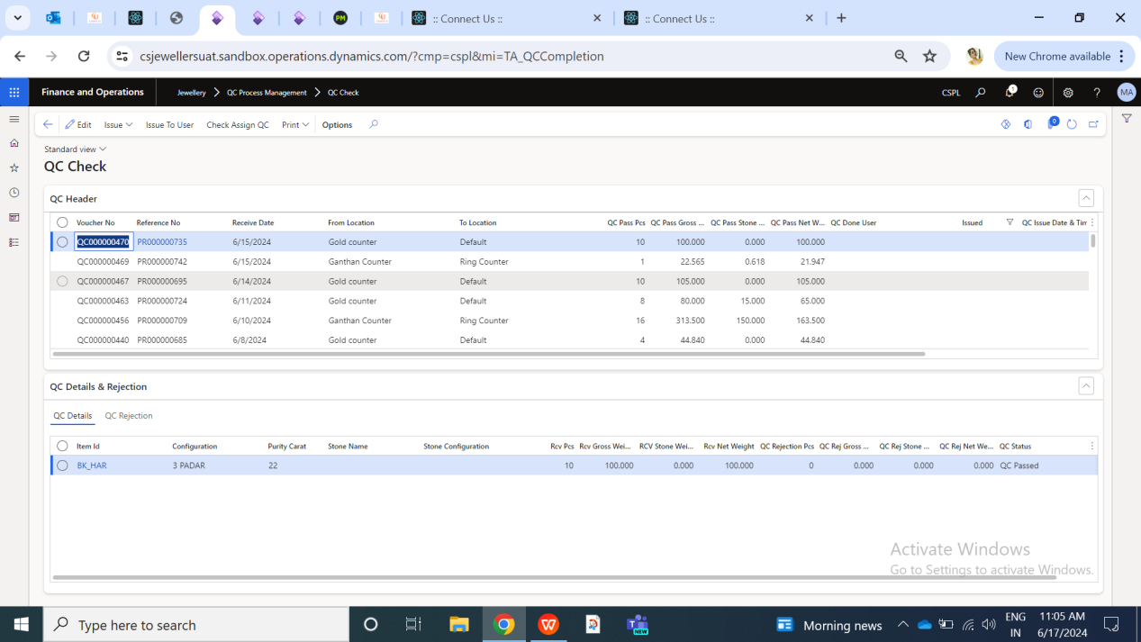

Fig: QC check

Here, it will display only the list of PR numbers that are being issued to QC and are pending. The line record of PR number will be removed from data grid of QC check once it is issued to further checking stage.

|  |  |  |  |
| --- | --- | --- | --- |
| **FIELDS** | **INPUT TYPE** | **FIELD REQ TYPE** | **DESCRIPTION** |
| QC header section |  | Mandatory | It will display the list of voucher numbers I.e. PR numbers which have been issued to QC check stage from provisional parcel receive menu or DC check. Recently issued vouchers in QC check should be displayed at top.  QC header has following columns:   * Voucher no. * PR no. * Receive date * From location * To location * QC pass pcs * QC pass gross wt * QC pass stone wt * QC pass net wt * QC user * QC received date and time * QC issued date and time   Initially, it will display the total pcs, total gross wt, total stone wt and total net wt as it is from provisional parcel receive number until user enters rejection details of that PR number in QC rejection section.  As per selected PR number from QC header, it will display the list of one more item records in it under QC details section below. If PR number has multiple item records, then all those records will be displayed in QC details section. |
| QC header -> QC received date and time | Text | Mandatory | For each PR number in header, it should have the date and time when that PR number was issued to QC check stage from provisional parcel receive menu or DC check I.e. the date and time when that PR number was received to QC check stage.  Validation: It will be read only. It should be displayed in a format of MM/DD/YYYY HH:MM:SS. |
| QC header-> QC issued date and time | Text | Mandatory | For each PR number in header, it should display the date and time when that voucher number was marked as issue to further checking stage after QC check as per QC setup.  Validation: It will be read only. It should be displayed in a format of MM/DD/YYYY HH:MM:SS. |
| QC details section | Text | Mandatory | It will display the list of one or more item records in QC details as per selected PR number from QC header section. It has following columns:   * Item * Configuration * Purity * Stone name * Stone configuration * Accepted pcs * Accepted gross wt * Accepted stone wt * Accepted net wt * QC rejected pcs * QC rejected gross wt * QC rejected stone wt * QC rejected net wt   Here, it will display the total pcs, gross wt, stone wt and gross wt as per provisional parcel receive number if issued directly. Else, it will display the total accepted pcs, gross wt, stone wt and gross wt from DC check stage which are issued to QC stage.  If that PR number has more then one item records out of which one item record has got completed rejected in previous stage, then only another records will be displayed here which are supposed to be checked in QC stage.  User will have to select the line item record firstly and then proceed to it rejection by mentioning in QC rejection section. Once user enters the rejected pcs, Gross wt, stone wt and net wt details of selected item record then its details will get updated in QC details section -> fields namely QC rejected pcs, QC rejected gross wt, QC rejected stone wt, QC rejected net wt of that item record respectively. |
| QC Rejection section | Text | Mandatory | If user wants to enter rejection details, user will select the item line from the QC details section and then user will click on new button of Rejection section. User can add rejection details of each line record by selecting it from details section and specifying its rejection details in rejection section respectively. It has following fields:   * Item * Configuration * Purity * Stone name * Stone configuration * Rejected pcs * Rejected gross wt * Rejected stone wt * Rejected net wt * QC rejection remark |
| QC rejection section -> QC rejection remark | Drop down | Mandatory | User will specify the reason for rejection of item. QC rejection details should be displayed further in reports whenever needed.  Validation: It should be multi-select. Selected option should be removed / disabled from drop-down list. |
| QC issued action | click |  | Once user enters all the rejection details of each PR number and issues it to further checking stage, the status as DC complete will be displayed against that PR voucher number in provisional parcel receive menu with rejection details accordingly. And total accepted pcs, gross wt, stone wt and net wt from QC will be forwarded to further stage.  If there are number rejection details in the PR number then user will direcetly select that PR number and click on issue button to proceed further.  Once user clicks on issued action after entering valid rejection details or without any rejection, a pop-up should appear confirming if user wants to proceed with done changes. Once user clicks on yes button, a drop-down will appear to select the QC checking user name. If user selects no, then pop-up should disappear and user will remain on QC check data grid page. Additionally, if user has not enter few mandatory fields or valid details and clicks on issue button, then relevant and specific error message will be displayed.  If any item record is completely rejected however has some accepted details in another item record of that PR voucher no., then it should get issued further to checking from QC.  Once document is issued further from QC stage, its completed date and time should be displayed against that PR voucher number In further checking stage and that voucher number should be removed from data grid of QC check. |

**Step 6: HM check**

PR voucher numbers from provisional parcel receive number or from previous checking stage will be issued to HM check. Here, users check if the items are hallmarked or not. User will either send the item to hallmarking centre from here for hallmarking or directly check its hallmarking and mark its accepted / rejected details. Users can reject items from hallmarking centre as well. It has following fields:

* Edit button
* Issue button
* Issue to HM centre button
* HM check Header
* Voucher no.
* PR no.
* Receive date
* From location
* To location
* HM pass pcs
* HM pass gross wt
* HM pass stone wt
* HM pass net wt
* HM received date & time
* HM issued date & time
* HM user name
* Issued
* HM details section
* Item
* Configuration
* Purity
* Stone name
* Stone configuration
* Received pcs
* Received gross wt
* Received stone wt
* Received net wt
* Rejected LM pcs
* Rejected LM gross wt
* Rejected LM stone wt
* Rejected LM net wt
* HM rejection section

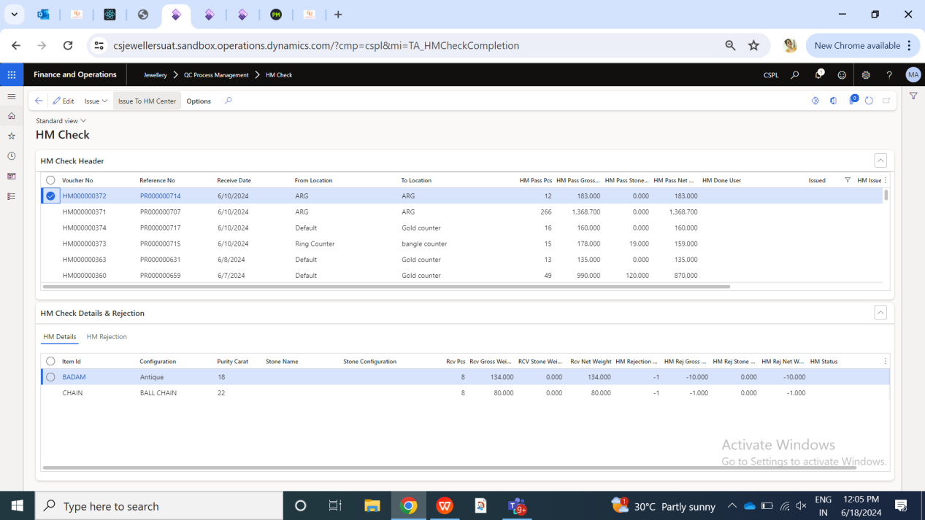

Fig: HM check

Here, it will display only the list of PR numbers that are being issued to HM and are pending. The line record of PR number will be removed from data grid of HM check once it is issued to further checking stage.

As there are two ways in HM check process I.e. by entering rejection details from HM check or passing that PR voucher no. to HM centre. User can reject the pcs and wt at HM centre and then issue it back to HM check.

Initially when user selects the PR number and one of the item record from the details section and clicks on issue to HM centre, an option to select HM centre will appear.

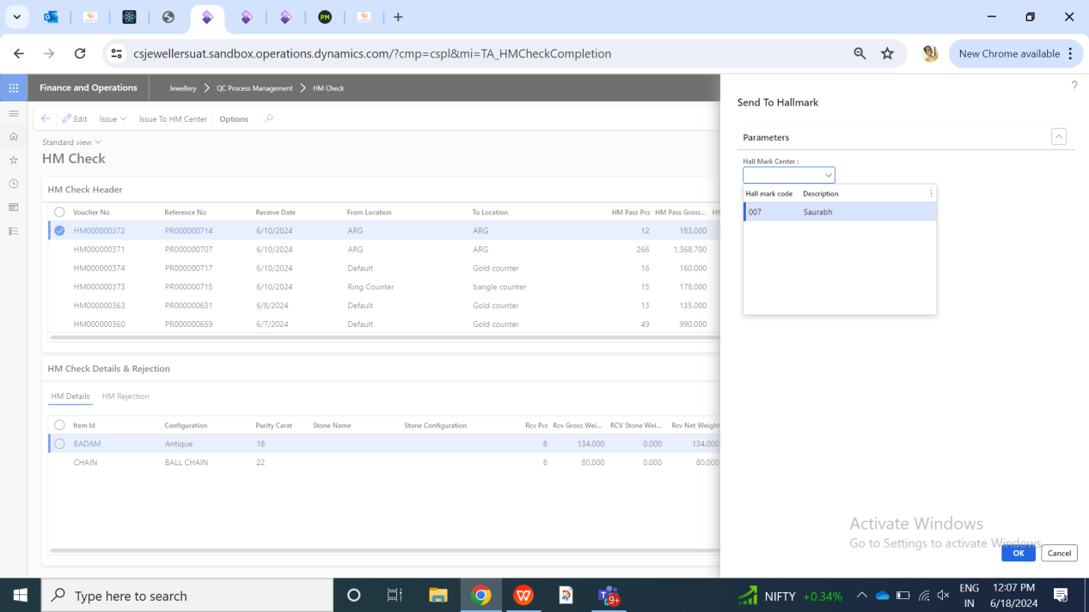

Fig: Issue to HM centre -> select centre

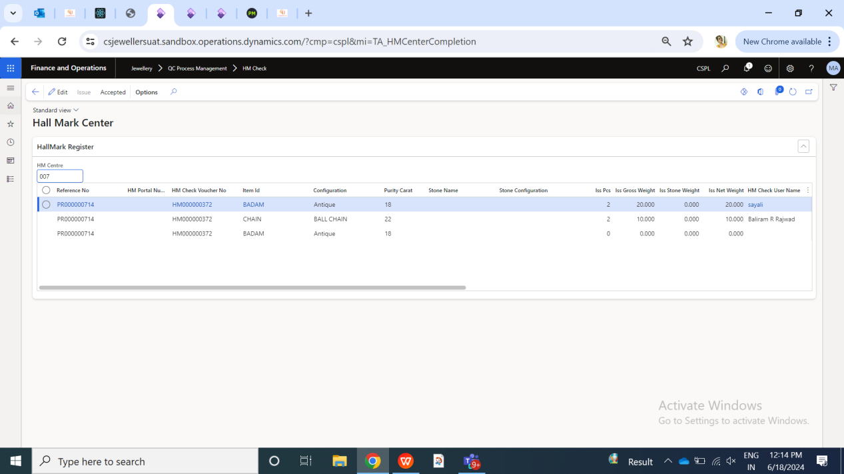

Fig: Issue to HM centre

Once user selects the record which is already partially issued to HM centre and also selects another new record line with it from the same PR and issues it to HM check, then it should display a pop-up message as “do you want to continue with same HM centre?”. On cancel button, user should be able to select new HM centre for that new record where it will display the count of pcs against respective line records which are not issued to HM centre yet out of it I.e count of issue pcs, issue gross wt, issue net wt and issue stone wt. If user selects yes, then all selected records will get assigned to already chosen HM centre in the initial action. Further, PR no. will get issued to further checking stage only when the details are accepted in HM centre and matches.

**Step 7: LM check**

Once the PR voucher issued to LC check either after DC check / QC check / HM check or directly through provisional parcel receive menu, it will be displayed in header of LM check page. Here, users check if the items are laser marked or not. It will have following fields:

* Save button
* Issue button
* Print button
* LM Header section
* Voucher no.
* PR no.
* Receive date
* From location
* To location
* LM pass pcs
* LM pass gross wt
* LM pass stone wt
* LM pass net wt
* LM received date & time
* LM issued date & time
* LM user name
* Issued
* LM details section
* Item
* Configuration
* Purity
* Stone name
* Stone configuration
* Received pcs
* Received gross wt
* Received stone wt
* Received net wt
* Rejected LM pcs
* Rejected LM gross wt
* Rejected LM stone wt
* Rejected LM net wt
* LM rejection section
* New button
* Delete button
* Item
* Configuration
* Purity
* Stone name
* Stone configuration
* LM Rejected pcs
* LM Rejected gross wt
* LM Rejected stone wt
* LM rejected net wt
* LM rejection Remark

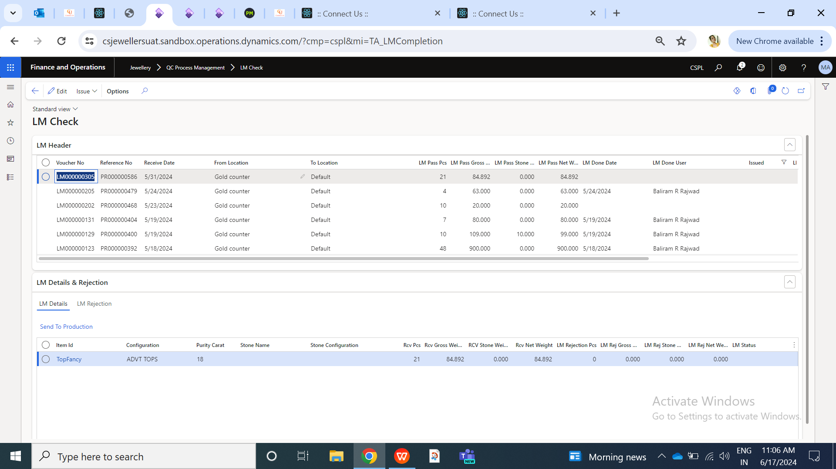

Fig: LM Check

Here, it will display only the list of PR numbers that are being issued to LM and are pending. The line record of PR number will be removed from data grid of LM check once it is issued to further checking stage.

|  |  |  |  |
| --- | --- | --- | --- |
| **FIELDS** | **INPUT TYPE** | **FIELD REQ TYPE** | **DESCRIPTION** |
| LM header section |  | Mandatory | It will display the list of voucher numbers I.e. PR numbers which have been issued to LM check stage from provisional parcel receive menu or DC check / QC check / HM check. Recently issued vouchers in LM check should be displayed at top.  QC header has following columns:   * Voucher no. * PR no. * Receive date * From location * To location * LM pass pcs * LM pass gross wt * LM pass stone wt * LM pass net wt * LM user * LM received date and time * LM issued date and time   Initially, it will display the total pcs, total gross wt, total stone wt and total net wt as it is from provisional parcel receive number until user enters rejection details of that PR number in LM rejection section.  As per selected PR number from LM header, it will display the list of one more item records in it under LM details section below. If PR number has multiple item records, then all those records will be displayed in LM details section. |
| LM header -> LM received date and time | Text | Mandatory | For each PR number in header, it should have the date and time when that PR number was issued to LM check stage from provisional parcel receive menu or DC check I.e. the date and time when that PR number was received to LM check stage.  Validation: It will be read only. It should be displayed in a format of MM/DD/YYYY HH:MM:SS. |
| LM header-> LM issued date and time | Text | Mandatory | For each PR number in header, it should display the date and time when that voucher number was marked as issue to further PO Check after LM check.  Validation: It will be read only. It should be displayed in a format of MM/DD/YYYY HH:MM:SS. |
| LM details section | Text | Mandatory | It will display the list of one or more item records in LM details as per selected PR number from LM header section. It has following columns:   * Item * Configuration * Purity * Stone name * Stone configuration * Accepted pcs * Accepted gross wt * Accepted stone wt * Accepted net wt * LM rejected pcs * LM rejected gross wt * LM rejected stone wt * LM rejected net wt   Here, it will display the total pcs, gross wt, stone wt and gross wt as per provisional parcel receive number if issued directly. Else, it will display the total accepted pcs, gross wt, stone wt and gross wt from DC check stage /QC check / HM check which are issued to LM stage.  If that PR number has more then one item records out of which one item record has got completed rejected in previous stage, then only another records will be displayed here which are supposed to be checked in LM stage.  User will have to select the line item record firstly and then proceed to it rejection by mentioning in LM rejection section. Once user enters the rejected pcs, Gross wt, stone wt and net wt details of selected item record then its details will get updated in LM details section -> fields namely LM rejected pcs, LM rejected gross wt, LM rejected stone wt, LM rejected net wt of that item record respectively. |
| LM Rejection section | Text | Mandatory | If user wants to enter rejection details, user will select the item line from the LM details selection and then user will click on new button of Rejection section. User can add rejection details of each line record by selecting it from details section and specifying its rejection details in rejection section respectively. It has following fields:   * Item * Configuration * Purity * Stone name * Stone configuration * Rejected pcs * Rejected gross wt * Rejected stone wt * Rejected net wt * LM rejection remark |
| LM rejection section -> LM rejection remark | Drop down | Mandatory | User will specify the reason for rejection of item. LM rejection details should be displayed further in reports whenever needed.  Validation: It should be multi-select. Selected option should be removed / disabled from drop-down list. |
| LM issued action | click |  | Once user enters all the rejection details of each PR number and issues it to further checking stage, the status as LM complete will be displayed against that PR voucher number in provisional parcel receive menu with rejection details accordingly. And total accepted pcs, gross wt, stone wt and net wt from LM will be forwarded to further PO check stage.  If there are number rejection details in the PR number then user will directly select that PR number and click on issue button to proceed further.  Once user clicks on issued action after entering valid rejection details or without any rejection, a pop-up should appear confirming if user wants to proceed with done changes. Once user clicks on yes button, a drop-down will appear to select the QC checking user name. If user selects no, then pop-up should disappear and user will remain on LM check data grid page. Additionally, if user has not enter few mandatory fields or valid details and clicks on issue button, then relevant and specific error message will be displayed.  If any item record is completely rejected however has some accepted details in another item record of that PR voucher no., then it should get issued further to checking from LM.  Once document is issued further from LM stage, its completed date and time should be displayed against that PR voucher number In further checking stage and that voucher number should be removed from data grid of LM check. |

**Step 8: PO check**

In PO check stage, user enters the details of the pcs, gross wt, net wt and stone wt which user has to accept against the PO number. Olease note that, user doesn’t reject any pcs or wt in PO check and just enters the details of accepted pcs and wt which are to be mapped against already generated PO. Here, user is selecting the PR number which has specified item - configuration in it and mapping it against the PO number which has that item - config.

It has following fields:

* Edit button
* PO complete button
* Print button
* Purchase return order button
* Challan auto-accept button
* Details button
* PO Header section
* Voucher no.
* PR no.
* Receive date
* From location
* To location
* PO pass pcs
* PO pass gross wt
* PO pass stone wt
* PO pass net wt
* PO received date & time
* PO issued date & time
* PO user name
* Issued
* PO Details section
* Item
* Configuration
* Purity
* Stone name
* Stone configuration
* Received pcs
* Received gross wt
* Received stone wt
* Received net wt
* Rejected PO pcs
* Rejected PO gross wt
* Rejected PO stone wt
* Rejected PO net wt
* PO Rejection section

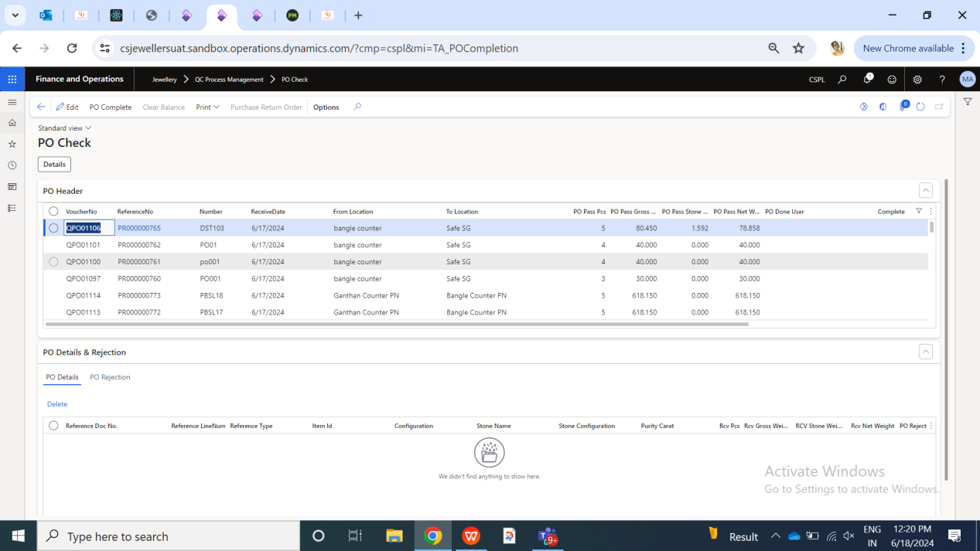

Fig: PO check

Here, it will display the list of PR numbers that are being issued to PO check and are pending, whereas user can view completed PR numbers as well by applying filter.

Once user clicks on detail button, it will have below fields:

* PO Header
* Reference no.
* Item
* Config
* Purity
* Accepted pcs
* Accepted gross wt
* Accepted stone wt
* Accepted net wt
* Rejected pcs
* Rejected gross wt
* Rejected stone wt
* Rejected net wt
* PO Details
* PO no.
* Pending pcs
* Item
* Config
* Purity
* Adjust pcs
* Adjust gross wt
* Adjust stone wt
* Adjust net wt

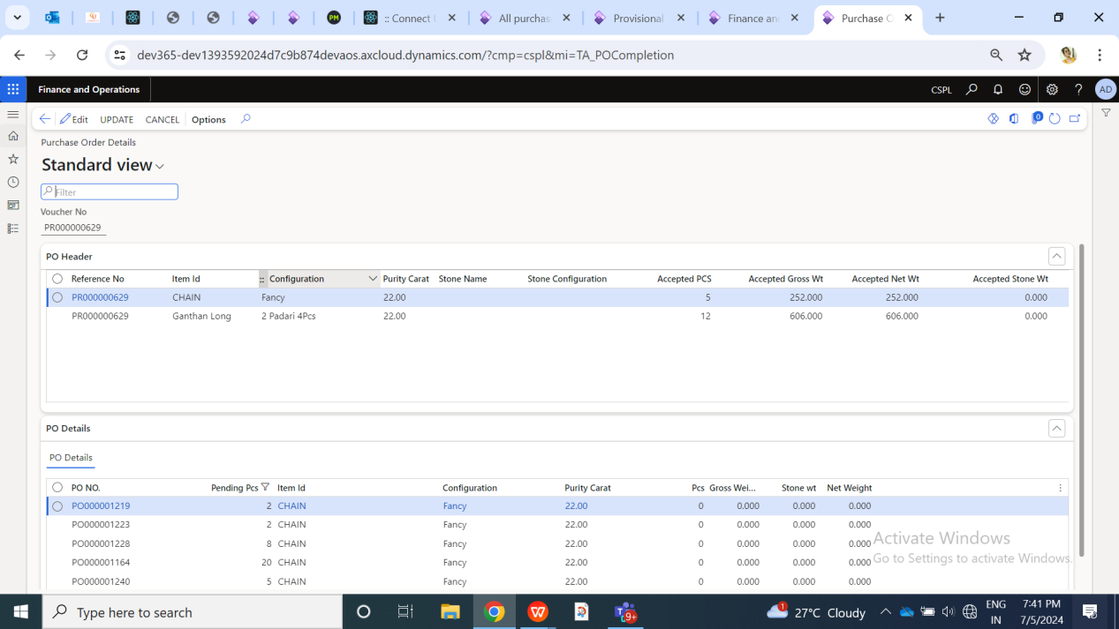

Fig: PO check -> details page

Here, it will display one or more line records of item-config-purity as in that PR number.

|  |  |  |  |
| --- | --- | --- | --- |
| **FIELDS** | **INPUT TYPE** | **FIELD REQ TYPE** | **DESCRIPTION** |
| PO Header -> Reference no. | Text | Mandatory | It will display the PR number which user selected on main page against which user wants to knowck off the wt and pcs now.  Validation: It will be read only. |
| PO Header -> item | Text | Mandatory | It will display the item name as in that PR number.  Validation: It will be read only. |
| PO Header -> config | Text | Mandatory | It will display the config name of that item as in that PR number.  Validation: It will be read only. |
| PO Header -> purity | Text | Mandatory | It will display the purity of that item-config as in that PR number.  Validation: It will be read only. |
| PO Header -> purity | Text | Mandatory | It will display the purity of that item-config as in that PR number.  Validation: It will be read only. |
| PO header -> stone name | Text | Mandatory | It will display the stone name against that item-config-purity which weree entered in that PR while adding.  Validation: It will be read only. |
| PO header -> stone config | Text | Mandatory | It will display the stone config of selected stone name against that item-config-purity which weree entered in that PR while adding.  Validation: It will be read only. |
| PO Header -> accepted pcs | Text | Mandatory | It will display the total accepted pcs of that item-config-purity in that PR which has been accepted till LM check.  Validation: It will be read only |
| PO Header -> accepted gross wt | Text | Mandatory | It will display the total accepted gross wt of that item-config-purity in that PR which has been accepted till LM check.  Validation: It will be read only |
| PO Header -> accepted stone wt | Text | Mandatory | It will display the accepted stone wt of that item-config-purity in that PR which has been accepted till LM check.  Validation: It will be read only |
| PO Header -> accepted net wt | Text | Mandatory | It will display the accepted net wt of that item-config-purity in that PR which has been accepted till LM check. Accepted net wt = accepted gross wt - accepted stone wt.  Validation: It will be read only |
| PO Header -> rejected pcs | Text | Mandatory | It will display the total rejected pcs of that item-config-purity in that PR which has been rejected till LM check.  Accepted pcs and rejeceted pcs will be equal to total pcs on that PR for that item-config-purity line record.  Validation: It will be read only |
| PO Header -> rejected gross wt | Text | Mandatory | It will display the total rejected gross wt of that item-config-purity in that PR which has been rejected till LM check.  Accepted gross wt and rejeceted gross wt will be equal to total gross wt on that PR for that item-config-purity line record.  Validation: It will be read only |
| PO Header -> rejected stone wt | Text | Mandatory | It will display the total rejected stone wt of that item-config-purity in that PR which has been rejected till LM check.  Accepted stone wt and rejeceted stone wt will be equal to total stne wt on that PR for that item-config-purity line record.  Validation: It will be read only |
| PO Header -> rejected net wt | Text | Mandatory | It will display the total rejected net wt of that item-config-purity in that PR which has been rejected till LM check.  Accepted net wt and rejeceted net wt will be equal to total net wt on that PR for that item-config-purity line record.  Rejected net wt = rejected gross wt - rejected stone wt.  Validation: It will be read only |
| Adjust PO -> PO number | Text | Mandatory | It will display the list of PO numbers having pending pcs for selected item-config-purity as per PR in it.  In case of multiple record in Provisional record if PO is generated for 1st record & another Item does not have any PO then none of the PO will be displayed in po check page against that item-config-purity line. User will not be able to update po check for that PR number until all the line records are adjusted.  Validation: It will be read only. |
| Adjust PO -> pending pcs | Text | Mandatory | It will display the count of pending pcs of that PO number which are to be knocked off yet.  Each time when user enters some valid pcs and marks PO as complete against that PR, then these pcs wil get reduced where pending pcs = Total PO order pcs - knocked off pcs till current date for that item-config-purity.  Validation: It will be read only. |
| Adjust PO -> pending gross wt | Text | Mandatory | It will display the count of pending pcs of that PO number which are to be knocked off yet.  Each time when user enters some valid pcs and marks PO as complete against that PR, then these pcs wil get reduced where pending pcs = Total PO order pcs - knocked off pcs till current date for that item-config-purity.  Validation: It will be read only. |
| Adjust PO -> pending stone wt | Text | Mandatory |  |
| Adjust PO -> pending net wt | Text | Mandatory |  |
| Adjust PO -> accepted pcs | Text | Mandatory |  |
| Adjust PO -> accepted gross wt | Text | Mandatory |  |
| Adjust PO -> accepted stone wt | Text | Mandatory |  |
| Adjust PO -> accepted net wt | Text | Mandatory |  |

PO Number Details will have following columns for each selected record from details section: PO number

* pending pc
* pending gross
* pending net
* accepted pcs
* accepted gross
* accepted net

It will display all PO numbers as per selected item-config-purity and its respective pending pcs, gross and net. Further, user will manually edit and enter accepted pcs, accepted gross and accepted net. The total of accepted pcs, accepted gross and accepted net in PO details section should match count of accept pcs, accept gross and accept net in above details section. Else, it should display validation error message.

Once user clicks on update button, accepted pcs, accepted gross, accepted net should get updated and displayed on PO check header page. Further, PR no. will get completed only when accepted details matches with the mapped PO no.

1. **TEST DATA & SCENARIOS**
2. **ODUS (Open Discussion Unhanded scenarios)**

|  |  |  |  |  |
| --- | --- | --- | --- | --- |
| **Sr. No.** | **Topic** | **Priority** | **Remark** | **Status** |
| 1 | If we remove the record from data grid of checking stage, how will user view the status of its PR number. | Medium | User view status from Provisional parcel receive and later on through reports. | Close |
| 2 |  |  |  |  |
| 3 |  |  |  |  |

1. **REFERENCES OF THE USERS**

|  |  |  |  |
| --- | --- | --- | --- |
| **User** | **Name** | **Mail** | **Contact number** |
| **Actual user** |  |  |  |
| **Ticket created by (if any)** | Sanmati Shedbale | Sanmati.shedbale@techneai.com |  |
| **Assigned business analyst** | Sanmati Shedbale  Manali Bhadirage | [Sanmati.shedbale@techneai.com](mailto:Sanmati.shedbale@techneai.com)  Manali.bhadirage@techneai.com |  |
| **Assigned developer** | Ankita Kirve  Rutuja Deshmukh | Ankita.kirve@techneai.com |  |
| **Assigned tester** | Saurabh Shelke  Gokul Bhoi  Vaishnavi khandwe | Saurabh.shelke@techneai.com  Gokul.bhoi@techneai.com |  |