**D365 Infrastructure Handbook**

~Acxiom Consulting Pvt Ltd

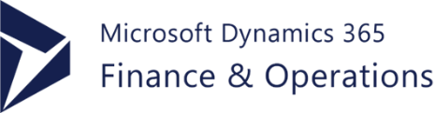

Table of Contents

Microsoft D365 Finance and Operations architecture 5

5

Subscription 6

Licenses 6

Tenant 6

Azure Active Directory (AAD) 6

Microsoft 365 admin center 6

Microsoft Dynamics Lifecycle Services (LCS) 6

Finance and operations apps 6

Microsoft Azure DevOps 6

Development and administration for finance and operations apps 7

Administrator experience and Lifecycle Services 7

Developer experience 7

Intelligence 7

Mobile apps 8

Data management and data entities 8

Office integration 8

Develop and customize 8

General Data Protection Regulation 8

Environment Planning 9

Environment purpose 9

Environment topology 9

Environment tier 9

Environment Types: 9

Environment purpose 9

Environment topology 9

Environment tier 9

Additional environments: 10

System Requirement for Users: 11

Supported Operating System: 11

Network Requirement: 11

Supported web browsers: 12

BYOD (Bring Your Own Database): 12

Tenant and Data Management: 13

Data Integration 13

Recurring integrations: 13

Database movement operations 15

Manage third-party models and runtime packages by using source control 15

Admin Access to D365 Management: 15

The Dynamics 365 admin can: 15

Monitoring & Diagnostic: 16

Health monitoring 16

Model Versioning 17

Service Level Agreement (SLA): 17

Servers Roles: 18

Azure Data Lake: 18

MS Power platform Integration with F&O: 18

Logic Apps 19

Azure Active Directory Features: 20

Document Printing Overview 21

Life Cycle Services 21

Project migration manager: 21

Subscription estimator: 22

Configure Lifecycle Services (LCS) security: 22

Asset Library: 23

Validate a package in Lifecycle Services 23

Mobile platform resources 23

D-365 On-Boarding & Prerequisite 23

D365 Subscription Activation: 24

DPOR (Digital Partner of Record Group): 24

Azure DevOps Setup: 24

LCS (Lifecycle Service) Sign up: 24

D365 Sandbox Environment 25

Regression suite automation tool (RSAT) 25

D365 Development & Build Server 25

DEPLOYMENT 26

Cloud Deployment: 26

On-premises Deployment: 26

Deploy Custom Code: 26

Deploy Custom Help: 27

Azure API Service & Management 27

Service protection API limits 29

Throttling prioritization: 29

Application Connector: 29

Azure Functions 29

Azure Power Platform 30

Logic Apps in Dynamics 365 F&O File Based Data Integration 30

D365 Additional Components 31

1. Dynamics 365 31

Dynamics 365 is available in two editions: 31

2. Common Data Model 31

3. Microsoft PowerApps 31

4. Microsoft Flow 31

5. Office 365 31

6. Power BI 32

7. Azure IoT Suite 32

8. AppSource and third-party applications 32

9. Azure Machine Learning 32

10. Microsoft Azure 32

Modern Data warehouse D365 F&O 32

Modern POS 33

Mobile mPOS 33

Telemetry D365 34

Environment-level telemetry: 34

App/extension-level telemetry: 34

CDS in D365 F&O 34

RSSU in D365 Retail 35

Client POS hardware requirement for D365 Retail 35

Printer 35

Scanner 36

MSR 36

Cash drawer 36

Line display 36

Signature capture 36

Scale 36

PIN pad 36

Secondary display 36

Payment device 37

System Requirement for D365 F&O On-Premises requirements. 37

Network requirement: 37

Network response time: 37

LAN environment: 37

WAN environment: 38

Internet connectivity requirement: 38

Telemetry data transfer: 38

Domain requirement: 38

Hardware Requirement: 38

Supported MS Office: 38

D365 production outage button 39

Azure to Azure Disaster recovery 39

Architectural components 39

Azure Conditional Access Deployment for D365 41

Responsible AI 42

Responsible AI FAQs for the Microsoft Dynamics 365 finance and operations platform 42

Overview of Copilot capabilities in finance and operations apps: 42

Installing the Copilot application in your finance and operations apps environment: 43

# Microsoft D365 Finance and Operations architecture

Dynamics 365 for Finance and Operations is a cloud-based Enterprise Resource Planning (ERP) system. It's designed for large or diversified companies to automate and manage their global operations.

The finance and operations application cloud architecture includes all the elements that are common to all Microsoft cloud offerings. It can be deployed to Azure, and the production environment is fully managed by Microsoft.

# 

D365 Finance and Operations can be deployed to Azure. The minimum system requirements for cloud deployments are:

2 GB of RAM (4 GB of RAM are recommended)

1.6 GHz peak CPU speed per core (Two cores are the minimum)

15 GB of free space

The cloud architecture consists of these conceptual areas:

Subscription – A subscription to finance and operations apps gives you an online cloud environment (or multiple environments) and experience.

Licenses – Customers must purchase subscription licenses (SLs) for their organization, or for their affiliates' employees and on-site agents, vendors, or contractors who directly or indirectly access finance and operations apps. These apps are licensed through Microsoft Volume Licensing and the Microsoft Cloud Solution Provider (CSP) program.

Tenant – In Microsoft Azure Active Directory (AAD), a tenant represents an organization. It's a dedicated instance of the AAD service that an organization receives and owns when it creates a relationship with Microsoft.

Azure Active Directory (AAD) – AAD is the multi-tenant, cloud-based directory and identity management service from Microsoft that combines core directory services, application access management, and identity protection in a single solution.

Microsoft 365 admin center – Microsoft 365 admin center is the subscription management portal that Microsoft 365 provides for administrators. It's used to provide management functions for users (AAD) and subscriptions. As part of these management functions, it provides information about service health.

Microsoft Dynamics Lifecycle Services (LCS) – LCS is a collaboration portal that provides an environment and a set of regularly updated services that can help you manage the application lifecycle of your implementations.

Finance and operations apps – finance and operations apps are deployed through LCS. Various topologies are available: development/test/build, acceptance test, performance test, and high-availability production.

Microsoft Azure DevOps – Azure DevOps is used primarily for code version control, development, and to deploy a build environment. Azure DevOps is also used to track support incidents, such as work items in Azure DevOps that are submitted to Microsoft through Cloud-powered support, and to integrate the Business process modeler (BPM) library hierarchy into your Azure DevOps project as a hierarchy of work items. Azure DevOps is also used during code upgrade.

For more information, [Click Here.](https://learn.microsoft.com/en-us/dynamics365/fin-ops-core/dev-itpro/organization-administration/architecture-overview?context=%2Fdynamics365%2Fcontext%2Fcommerce)

# Development and administration for finance and operations apps

Development and administration for finance and operations apps includes:

## Administrator experience and Lifecycle Services

Finance, Supply Chain Management, and Commerce are cloud-hosted. As an IT professional, you can use Dynamics Lifecycle Services (LCS) to monitor and tune your environments, deploy features, and stay up to date with recent hotfixes. Within your deployment, you can configure security, and manage when processes run. You can also use LCS when you are called on to support business intelligence and reporting, mobile apps, Office, and other integrations.

## Developer experience

The developer experience is based on modern tooling using Visual Studio and .NET components.

The development tools are decoupled from any running environment, which means that you develop against local, XML-based files, not the online database.

For more information, see [Develop and customize home page](https://learn.microsoft.com/en-us/dynamics365/fin-ops-core/dev-itpro/dev-tools/developer-home-page).

## Intelligence

Finance and operations provides five distinct reporting experiences. Specialized tools are provided to meet the complex and diverse reporting needs of various functions throughout the organization.

* Operational views – Designed to address the specific needs of a given business persona.
* Business documents – Static documents used to capture and exchange processed business data.
* Analytical tools and visualizations – Personalized presentations of logical calculations that allow the user to explore their data.
* Electronic reporting – Tool used to configure formats for electronic documents.
* Financial reporting – Designed to provide in-depth accounting management tools based on standard views of financial activities across legal entities.

## Mobile apps

The finance and operations mobile app empowers your organization to mobilize its business processes. After your IT admin enables the mobile workspaces feature for your organization, users can sign in to the app and immediately begin to run business processes from their mobile devices.

## Data management and data entities

Data from finance and operations can easily be integrated with Microsoft and non-Microsoft data sources using Dataverse, Power Apps, and Power BI. For more information, see [Data entities overview](https://learn.microsoft.com/en-us/dynamics365/fin-ops-core/dev-itpro/data-entities/data-entities).

## Office integration

The Microsoft Office integration capabilities provide users with a productive environment that helps them get the job done by using Office products. For more information, see [Office integration overview](https://learn.microsoft.com/en-us/dynamics365/fin-ops-core/dev-itpro/office-integration/office-integration).

For more information, [Click Here.](https://learn.microsoft.com/en-us/dynamics365/fin-ops-core/dev-itpro/lifecycle-services/report-production-outage)

# Develop and customize

The finance and operations apps enable the entire enterprise resource planning (ERP) application suite as a cloud-based solution, for both public and private clouds, as well as on-premises. The apps leverage the speed, simplicity, and cost-effectiveness of working in the cloud, while building on the latest technology from Microsoft.

For more information, [Click Here.](https://learn.microsoft.com/en-us/dynamics365/fin-ops-core/dev-itpro/dev-tools/developer-home-page)

# General Data Protection Regulation

The privacy laws and regulations of the European Union set a new global standard for privacy rights, security, and compliance for the citizens and residents of the European Union (EU). Privacy governs the handling and use of personal data of EU citizens and residents. Enforcement begins May 25, 2018, and there are significant consequences for non-compliance. For more information about the regulation, see the European Union site.

EU citizens have specific data subject rights (DSRs) that let them perform the following actions:

* View their personal data.
* Correct errors in their personal data.
* Erase their personal data.
* Object to processing of their personal data.
* Export their personal data.

For more information, [Click Here.](https://learn.microsoft.com/en-us/dynamics365/fin-ops-core/dev-itpro/privacy/privacy-guide)

# Environment Planning

To begin, here are a few important concepts:

Environment purpose – The reasons why the environment exists. Examples include development, system testing, user acceptance testing (UAT), and operations.

Environment topology – The composition of the environment and the purpose. Examples include Develop and Build and Test for Tier-1 environments.

Environment tier – The type or category of the environment. Examples include Tier-1 environments and Tier-2 environments.

## Environment Types:

To begin, here are a few important concepts:

Environment purpose – The reasons why the environment exists. Examples include development, system testing, user acceptance testing (UAT), and operations.

Environment topology – The composition of the environment and the purpose. Examples include Develop and Build and Test for Tier-1 environments.

Environment tier – The type or category of the environment. Examples include Tier-1 environments and Tier-2 environments.

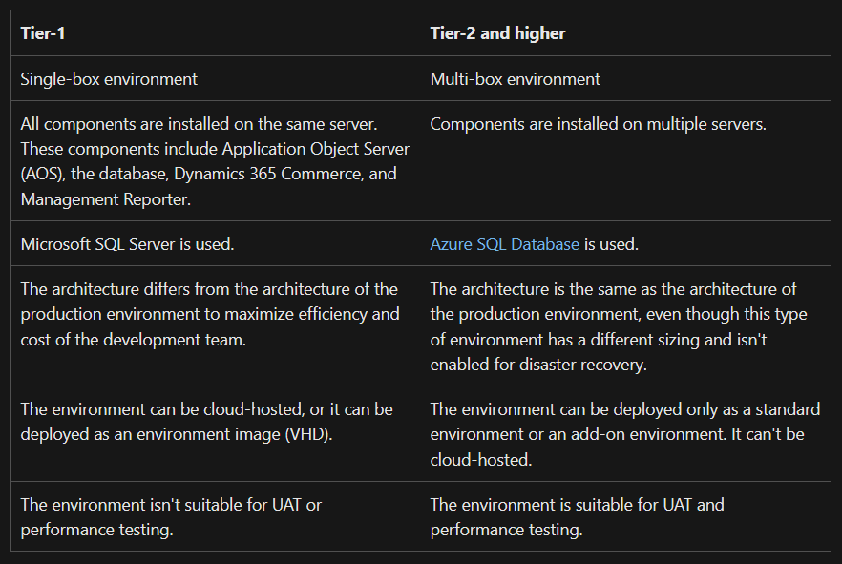

The following illustrations shows the environment planning process:

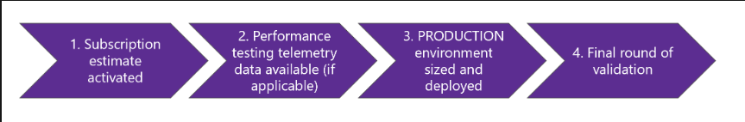

## Additional environments:

Additional environments can be purchased as add-ons, or they can be deployed as cloud-hosted environments. The following illustration shows a sample overview of standard and additional environments, based on the complexity of the implementation.

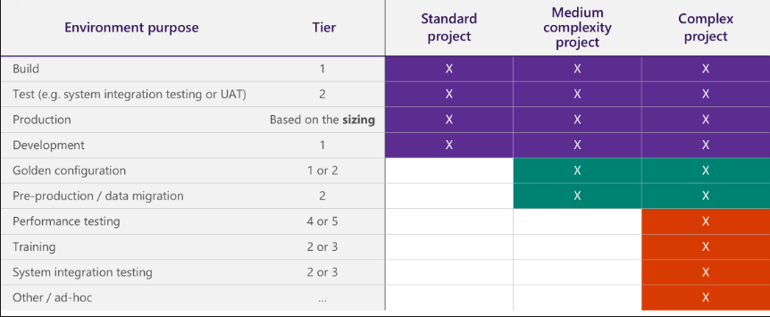

## System Requirement for Users:

### Supported Operating System:

* Windows 7 Professional, Enterprise, and Ultimate editions.

Note: Windows 7 is supported only if Internet Explorer 11 is manually installed on the system.

* Windows 8.1 Update 1 Professional, Enterprise, and Embedded editions.
* Windows 10 Pro, Enterprise, and Enterprise LTSB editions.
* Windows Server 2012 R2 and Windows Server 2016.

Supported Microsoft Office applications:

The following Microsoft Office applications are supported in cloud:

* To run the Microsoft Excel and Word add-ins, you must have Microsoft Office 2016 for Windows installed. For more information about version requirements, see [Troubleshoot the Office integration](https://docs.microsoft.com/en-us/dynamics365/fin-ops-core/dev-itpro/office-integration/office-integration-troubleshooting).
* To view documents that are generated by the Export to Excel or Export to Word functionality, you must have Microsoft Office 2007 or later installed.

### Network Requirement:

Finance + Operations is designed for networks that have a latency of 250–300 milliseconds (ms) or less. This latency is the latency from a browser client to the datacenter that hosts Finance + Operations.

Bandwidth requirements depend on your scenario. Typical scenarios require a bandwidth of more than 50 KBps between the browser and the server. However, we recommend higher bandwidth for scenarios that have high payload requirements, such as scenarios that involve workspaces or extensive customization. The specific amount of bandwidth depends on use.

Deployments where AOS and the Microsoft SQL Server database are in different datacenters aren't supported. AOS and the SQL Server database must be co-located.

## Supported web browsers:

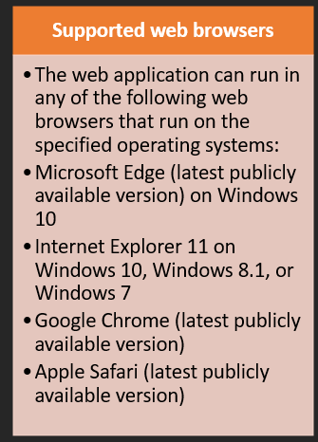

For more information, [Click Here.](https://docs.microsoft.com/en-us/dynamics365/fin-ops-core/fin-ops/imp-lifecycle/environment-planning)

## BYOD (Bring Your Own Database):

The BYOD feature lets administrators configure their own database, and then export one or more data entities that are available in the application into the database. (Currently, more than 1,700 data entities are available.) Specifically, this feature lets you complete these tasks:

* Define one or more SQL databases that you can export entity data into.
* Export either all the records (*full push*) or only the records that have changed or been deleted (*incremental push*).
* Use the rich scheduling capabilities of the batch framework to enable periodic exports.
* Access the entity database by using Transact-SQL (T-SQL), and even extend the database by adding more tables.

For more information, [Click Here.](https://learn.microsoft.com/en-us/dynamics365/fin-ops-core/dev-itpro/analytics/export-entities-to-your-own-database)

## Tenant and Data Management:

[Master Data Management System (MDMS)](https://docs.it.integro.pl/en-us/mdms/index.html) is an app that allows corporate groups to ensure data consistency across the whole organization by setting up sets of data within a Dynamics 365 Business Central tenant/company and replicating them to another tenant/company.

With MDMS, you can create or assign a master company where all master data is maintained, select the receiving companies within the group and select the data to be replicated (synchronized). You can replicate data that is stored in standard Business Central tables, or in other apps and extensions. Below are the most common examples of the data replicated by groups of companies:

* Items
* G/L accounts
* Customers
* Vendors
* Dictionaries
* Dimensions
* Posting Groups
* User roles

Users are allowed to set up any number of Receivers - the target companies to which data will be replicated. The structure of data to be replicated is set up as Data Sets. The user can set up which fields should be included in a data set. In the replication process, data sets are linked to a selected Receiver. Replication can be either Full or Incremental.

For more information, [Click Here](https://appsource.microsoft.com/en-cy/product/dynamics-365-business-central/pubid.it_integro%7Caid.bc_mdms_001%7Cpappid.3c107f88-c5c8-4ec0-b40f-c321a596c29c?tab=overview).

# Data Integration

Data integration can be used when data needs to be available in other systems so that it can be used and manipulated. For example, clients may use ERP solutions like Oracle or SAP, and data from these systems can be integrated into Microsoft Dynamics 365

## Recurring integrations:

Recurring integration does the following things:

* It builds on data entities and the Data management framework.
* It enables the exchange of documents or files between finance and operations and any third-party application or service.
* It supports several document formats, source mapping, Extensible Stylesheet Language Transformations (XSLT), and filters.

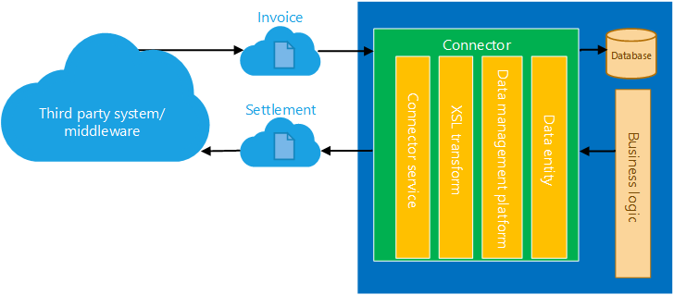

* It uses secure REST application programming interfaces (APIs) and authorization mechanisms to receive data from, and send data back to, integration systems.

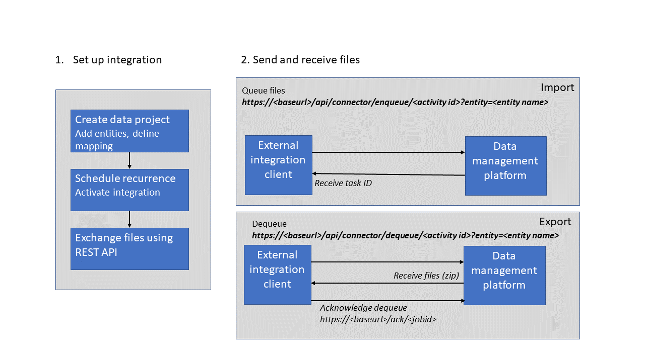

For more information, [Click Here.](Microsoft%20D365%20Finance%20and%20Operations%20architecture%20-%20Copy.docx)

# Database movement operations

Database movement operations are a suite of self-service actions that can be used as part of Data Application Lifecycle Management (also referred to as DataALM). These actions provide structured processes for common implementation scenarios such as golden configuration promotion, debugging/diagnostics, destructive testing, and general refresh for training purposes.

For more information, [Click Here.](https://learn.microsoft.com/en-us/dynamics365/fin-ops-core/dev-itpro/database/dbmovement-operations)

# Manage third-party models and runtime packages by using source control

Customers that work with solutions from third parties might receive different solution artifacts to use in their solution. Typically, these artifacts are distributed as code (in the form of models) or binaries (in the form of deployable packages). In some cases, third parties might provide some parts of their solution as code and other parts as a binary.

For more information, [Click Here.](https://learn.microsoft.com/en-us/dynamics365/fin-ops-core/dev-itpro/dev-tools/manage-runtime-packages)

## Admin Access to D365 Management:

### The Dynamics 365 admin can:

* Sign in to and manage multiple environments. If an environment uses a security group, a service admin would need to be added to the security group in order to manage that environment. Not assigning to an in place security group essentially locks these admins out of any admin management.
* Perform admin functions in Microsoft Power Platform because they have the System Administrator role.

## Monitoring & Diagnostic:

To have a successful onboarding experience to the cloud service, you must know the health of your environments at all times. You must also be able to troubleshoot any health issues that occur. Microsoft Dynamics Lifecycle Services (LCS), which is the administration center, contains a collection of monitoring and diagnostics tools that can help to ensure that you have an accurate view of the environments that you manage.

Health monitoring – In addition to availability checks, some basic health checks must be performed. These health checks span various components, such as Application Object Server (AOS), Batch Framework, Data Management Framework, Microsoft Azure SQL, and Management Reporter. These checks are done based on multiple data sources, such as the telemetry that is collected from the environments, checks that are done by a watchdog service that continuously monitors the environment, and CPU counters and other system-level counters that the environment emits. Some health checks are self-healing and are mitigated immediately. However, other health checks are reported to the Microsoft Service Engineering team for investigation.

The telemetry data that is the basis of the Monitoring and diagnostics portal in LCS has three primary use cases: monitoring, diagnostics, and analytics.

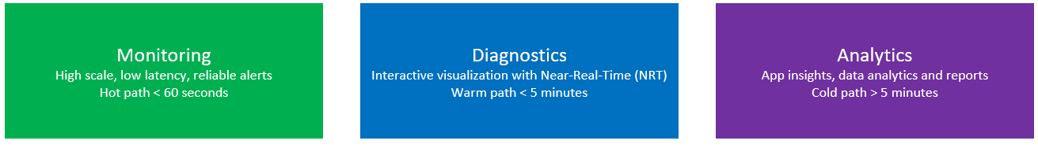

In business operations software, you should always know whether your environment is up and running, so that it can perform business operations. You should also be able to easily view the health of the environment through LCS.

When a user reports an issue, you can use various tools in LCS for troubleshooting. The rich set of telemetry data helps you build a storyboard view that shows what that user and other users were doing when the issue was reported.

Analytics is another critical use case for the telemetry data that is collected. Currently, only Microsoft can perform analytics, so that it can gauge and understand feature usage and performance through Microsoft Power BI.

For more information, [Click Here.](https://learn.microsoft.com/en-us/dynamics365/fin-ops-core/dev-itpro/lifecycle-services/monitoring-diagnostics)

# Model Versioning

As code is updated, the build is used to produce new packages that can be deployed to environments. Microsoft Azure DevOps tracks the changes that have been included in each build since the previous build. When the version number of the build is included in the models that are produced, it provides end-to-end traceability of the code changes that are available in a specific environment. You can find the build number and then review the changes that are included in that build in Azure DevOps. For customers and partners that use builds on different branches, or that use different build definitions for nightly builds, gated check-in builds, or deployment builds, each build can have a different versioning scheme. This approach helps differentiate the model metadata in the deployable packages and tie them back to their originating build definition.

For more information, [Click Here.](https://learn.microsoft.com/en-us/dynamics365/fin-ops-core/dev-itpro/dev-tools/version-models-build)

## Service Level Agreement (SLA):

With service-level agreements (SLAs) configured in Customer Service Hub, you can use out-of-the-box actions in Microsoft Power Automate.

Define work hours, and pause and resume SLAs at the SLA KPI level and SLA item level, which help track SLA items for different work hours based on priority and criteria. The pause settings at SLA KPI level or SLA item level give you added flexibility to define pause conditions at a more granular level.

In a case lifecycle, multiple SLA KPIs can be triggered at different start points. The following illustration depicts how you can define an overall resolution time, and also specify SLA KPIs at different start points.

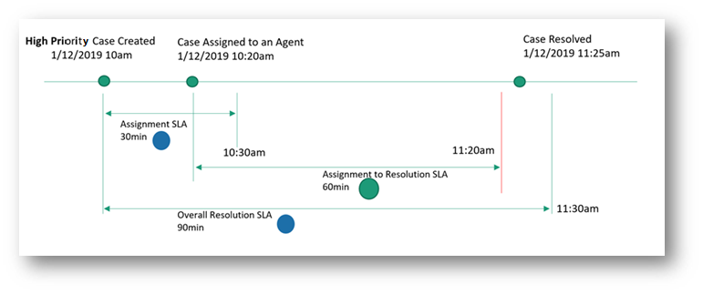

For more information, [Click Here.](https://learn.microsoft.com/en-us/dynamics365/customer-service/administer/define-service-level-agreements?tabs=customerserviceadmincenter)

## Servers Roles:

With Dynamics 365 Server, you can install specific server functionality, components, and services on different computers. These components and services correspond to specific server roles. For example, customers who have larger user bases can install the Front End Server role on two or more servers that run Internet Information Services (IIS) to increase throughput performance for users. Or, a Full Server role can be installed on one computer and Microsoft Dynamics 365 Reporting Extensions on another. If a server role is missing, Deployment Manager displays a message in the **Messages** area.

For more information, [Click Here.](https://learn.microsoft.com/en-us/dynamics365/customerengagement/on-premises/deploy/microsoft-dynamics-365-server-roles?view=op-9-1)

## Azure Data Lake:

Azure Data Lake includes all the capabilities required to make it easy for developers, data scientists, and analysts to store data of any size, shape, and speed, and do all types of processing and analytics across platforms and languages. It removes the complexities of ingesting and storing all of your data while making it faster to get up and running with batch, streaming, and interactive analytics. Azure Data Lake works with existing IT investments for identity, management, and security for simplified data management and governance. It also integrates seamlessly with operational stores and data warehouses so you can extend current data applications. We’ve drawn on the experience of working with enterprise customers and running some of the largest scale processing and analytics in the world for Microsoft businesses like Office 365, Xbox Live, Azure, Windows, Bing, and Skype. Azure Data Lake solves many of the productivity and scalability challenges that prevent you from maximizing the value of your data assets with a service that’s ready to meet your current and future business needs.

For more information. [Click Here.](https://learn.microsoft.com/en-us/azure/data-lake-analytics/data-lake-analytics-overview)

## MS Power platform Integration with F&O:

Power Platform Integration is a feature in Microsoft Dynamics Lifecycle Services that allows administrators to link their finance and operations environments with Microsoft Power Platform–based environments.

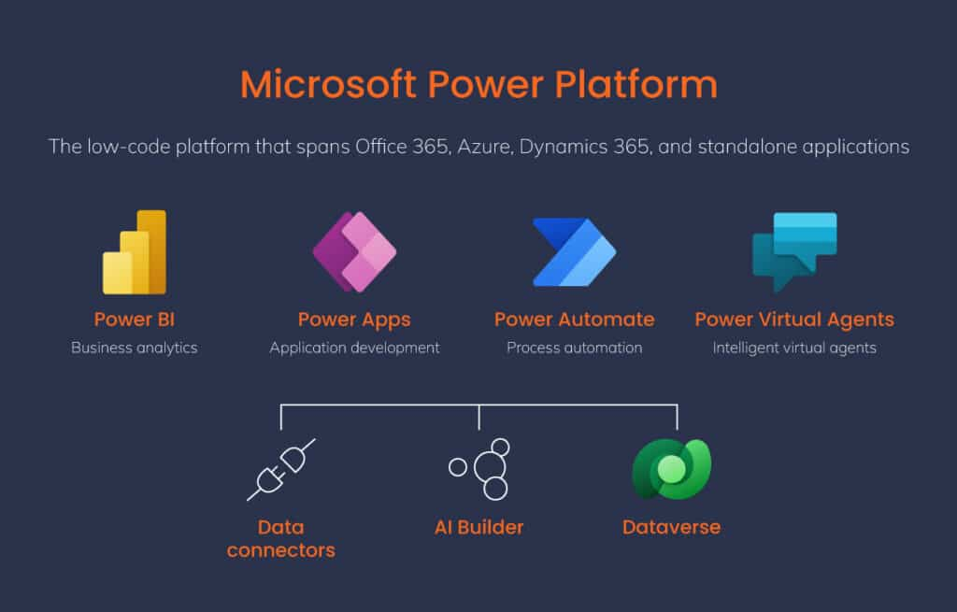

Integrating Dynamics 365 F&O with Power Platform can enable users with low/no code applications, real-time data dashboards, and automated processes.

Here are some steps for integrating Microsoft D365 F&O and Power Platform:

* Define business processes and outcomes
* Choose an integration approach
* Run the data integration project manually from the Power Platform admin center
* Verify that the data syncs correctly to Dynamics 365 for Finance and Operations
* Monitor the status using the Execution history tab.

For more information, [Click Here.](https://learn.microsoft.com/en-us/dynamics365/fin-ops-core/dev-itpro/power-platform/overview)

## Logic Apps

Azure Logic Apps is a cloud platform where you can create and run automated workflows with little to no code. By using the visual designer and selecting from prebuilt operations, you can quickly build a workflow that integrates and manages your apps, data, services, and systems.

Azure Logic Apps simplifies the way that you connect legacy, modern, and cutting-edge systems across cloud, on premises, and hybrid environments and provides low-code-no-code tools for you to develop highly scalable integration solutions for your enterprise and business-to-business (B2B) scenarios.

This list describes just a few example tasks, business processes, and workloads that you can automate using Azure Logic Apps:

* Schedule and send email notifications using Office 365 when a specific event happens, for example, a new file is uploaded.
* Route and process customer orders across on-premises systems and cloud services.
* Move uploaded files from an SFTP or FTP server to Azure Storage.
* Monitor tweets, analyse the sentiment, and create alerts or tasks for items that need review.

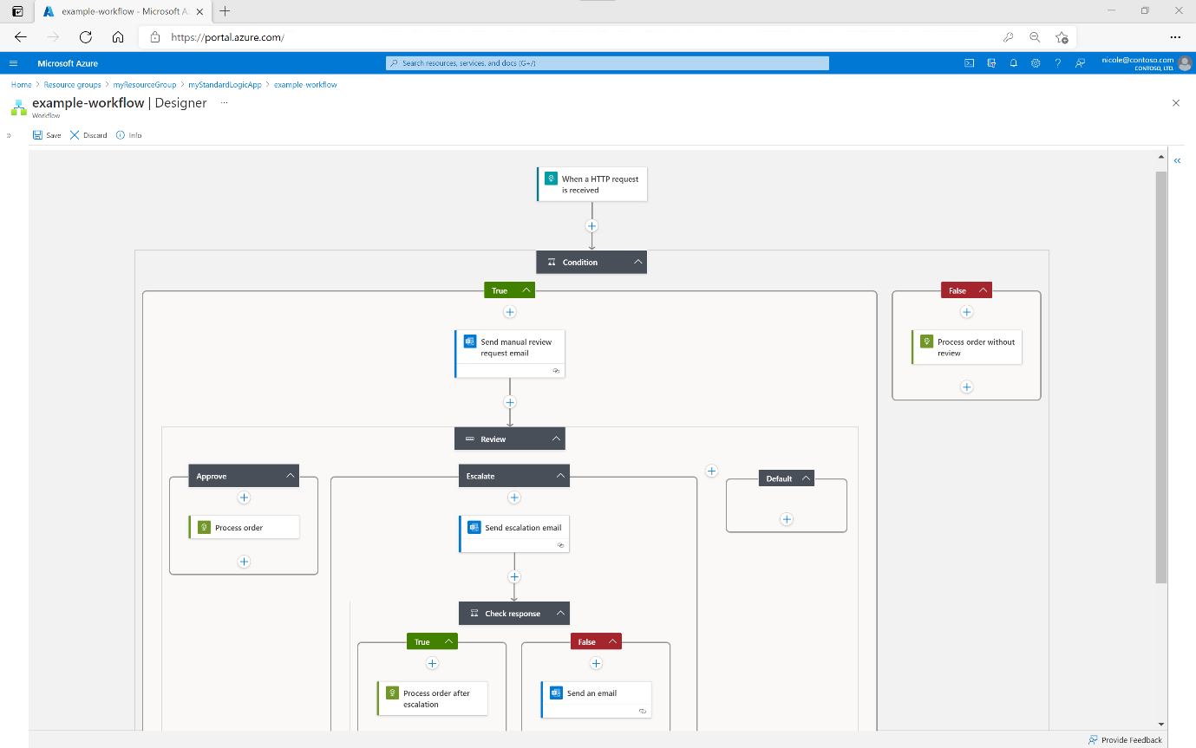

For more information, [Click Here.](https://learn.microsoft.com/en-us/azure/logic-apps/logic-apps-overview)

## Azure Active Directory Features:

All employees in an organization need access to some [Azure services](https://www.simplilearn.com/tutorials/azure-tutorial/what-is-azure) to perform their tasks. They can access services like [SQL database](https://www.simplilearn.com/tutorials/sql-tutorial/what-is-sql), [machine learning](https://www.simplilearn.com/tutorials/machine-learning-tutorial/what-is-machine-learning), or Azure container services when the administrator assigns them separate user id and password for each service. Employees, as well as administrators, often find it hard to manage multiple user logins at the same time. It creates more of a hassle for administrators working in an organization that involves more than 1000 employees.

This is where Azure Active Directory (AD) comes into the picture. With Azure AD, the administrators can handle multiple user logins without any issue. Administrators need to assign a single username and password to access all the services they want.

For more information, [Click Here.](https://www.simplilearn.com/tutorials/azure-tutorial/azure-active-directory)

## Document Printing Overview

The ability to print transactions and reports is a simple but critical aspect of user experience and productivity. Regardless of industry vertical, a common business expectation is to have a hosted ERP application configured in the Cloud.

As transactions are being performed, they need to be reported, shared, and printed between stakeholders and decision makers. Users trying to print documents on network devices from hosted applications often face challenges such as print drivers that might incompatible or not available on their device. In some cases, the user's device might not be connected or able to connect to the corporate network due to infrastructure constraints.

In Microsoft Dynamics 365 for Finance and Operations, you can seamlessly print documents from a local or network-connected printer device as long as it provides integrated services supporting an HTML5 client and uses hosted client applications with Microsoft Office 365 services. This makes it easy to generate, store, and distribute documents.

For more information, [Click Here.](https://microsoft-business-applications.hcltech.com/dynamics-365-finance-operations/printing-from-dynamics-365-for-finance-and-operations/)

# Life Cycle Services

## Project migration manager:

The Microsoft Dynamics Lifecycle Services Project migration manager lets you move your project data from one geography (or geo) to another geography that Lifecycle Services supports.

For more information, [Click Here.](https://learn.microsoft.com/en-us/dynamics365/fin-ops-core/dev-itpro/lifecycle-services/project-migration-manager)

## Subscription estimator:

Subscription estimator is a tool that is available in Microsoft Dynamics Lifecycle Services (LCS). Microsoft uses this tool to estimate the initial size of the production environment that must be provisioned for a customer. Before customers can request deployment of a production environment, they must estimate their peak workloads in terms of transaction counts and then upload that information to LCS. By using the details of user licenses and transaction counts to infer subscription requirements, the Subscription estimator tool helps ensure that the provisioned environment meets the customer's business requirements.

For more information, [Click Here.](https://learn.microsoft.com/en-us/dynamics365/fin-ops-core/dev-itpro/lifecycle-services/subscription-estimator)

## Configure Lifecycle Services (LCS) security:

Security in Microsoft Dynamics Lifecycle Services (LCS) is controlled at both the organization level and the project level. Not all members of an organization have access to all projects. Additionally, the members of a project might not all be members of the same organization.

Currently, users can sign in by using the Microsoft Azure Active Directory (Azure AD) credentials that they created in the Microsoft 365 portal when they signed up. Users who are administrators for their organization in Azure AD will be administrators in Lifecycle Services (LCS).

Project-level access to LCS is by invitation. You can invite members of your organization to be project owners and team members. Additionally, you can invite users who aren't part of your organization, and who don't have accounts in Azure AD to be team members.

For more information, [Click Here.](https://learn.microsoft.com/en-us/dynamics365/fin-ops-core/dev-itpro/lifecycle-services/configure-lcs-security)

## Asset Library:

The Asset library is a storage location for the various assets that are associated with a tenant in Microsoft Dynamics 365 Lifecycle Services. Two types of Asset library are available in Lifecycle Services: the Shared asset library and the project-level Asset library.

For more information, [Click Here.](https://learn.microsoft.com/en-us/dynamics365/fin-ops-core/dev-itpro/lifecycle-services/asset-library)

# Validate a package in Lifecycle Services

A new Validate packages feature has been introduced in Lifecycle Services. This feature lets customers validate an environment package before they schedule it or apply it to an environment. The validation can detect issues such as:

* Failure to create a new index due to duplicate values.
* Failure to deploy an enum value because it already exists.

For more information, [Click Here.](https://learn.microsoft.com/en-us/dynamics365/fin-ops-core/dev-itpro/deployment/validate-pack)

# Mobile platform resources

By using mobile apps, you can reuse business logic and modelling. Mobile apps enable rich offline and mobile interactions, and provide an easy-to-use designer experience. Developers can create simplified forms in Microsoft Visual Studio and then design mobile apps that expose this functionality. The mobile platform makes it easy to change the forms and mobile app definitions to include customizations that are made to your cloud app.

For more information, [Click Here.](https://learn.microsoft.com/en-us/dynamics365/fin-ops-core/dev-itpro/mobile-apps/platform/mobile-platform-home-page)

# D-365 On-Boarding & Prerequisite

Project onboarding is a self-paced, wizard-driven onboarding experience that guides project users in Microsoft Dynamics Lifecycle Services (LCS) through the process of setting up the key configuration components for a new implementation project for Dynamic 365 Finance, Dynamics 365 Supply Chain Management, or Dynamic 365 Retail. This wizard can also be accessed during and after the implementation and can be used to update the information as required.

Microsoft relies on the information that you provide. You must provide the most current and accurate data as you complete Project onboarding. After you complete Project onboarding, you can deploy environments and continue with the project implementation

## D365 Subscription Activation:

After your organization has purchased a subscription to Finance and Operations, D365 subscription must be activated on your organization's Azure Active Directory (Azure AD) tenant by your Tenant Administrator.

## DPOR (Digital Partner of Record Group):

Digital Partner of Records (DPOR) automates how partners are attached as partner of record for the subscriptions they are actively managing for customer of Microsoft Office 365.

## Azure DevOps Setup:

Azure DevOps is a Software as a service (SaaS) platform from Microsoft that provides an end-to-end DevOps toolchain for developing and deploying software.

## LCS (Lifecycle Service) Sign up:

Project onboarding is a self-paced, wizard-driven onboarding experience that guides project users in Microsoft Dynamics Lifecycle Services (LCS) through the process of setting up the key configuration components for a new implementation project for Dynamic 365 Finance & Operations. This wizard can also be accessed during and after the implementation, and can be used to update the information as required.

Microsoft relies on the information that you provide. You must provide the most current and accurate data as you complete Project onboarding. After you complete Project onboarding, you can deploy environments and continue with the project implementation.

Each step in Project onboarding is designed to give you guidance about the project implementation or to gather information about the project context. By providing accurate information in the wizard, you help Microsoft understand your implementation plan, so that it can provide appropriate guidance.

For more information, [Click Here.](https://learn.microsoft.com/en-us/dynamics365/fin-ops-core/dev-itpro/lifecycle-services/project-onboarding)

# D365 Sandbox Environment

In Dynamics 365 Business Central, a sandbox is an environment totally isolated from a production instance, where you can develop, test, run demos, and play with the service, without affecting the real production data.

For more information, [Click Here.](https://learn.microsoft.com/en-us/dynamics365/business-central/dev-itpro/developer/devenv-sandbox-overview)

# Regression suite automation tool (RSAT)

The Regression suite automation tool (RSAT) significantly reduces the time and cost of user acceptance testing (UAT) of finance and operations apps. UAT is typically required before you take a Microsoft application update, or before you apply custom code and configurations to your production environment. RSAT lets functional power users record business tasks by using Task recorder and then convert the recordings into a suite of automated tests, without having to write source code.

For more information, [Click Here.](https://learn.microsoft.com/en-us/dynamics365/fin-ops-core/dev-itpro/perf-test/rsat/rsat-overview)

# D365 Development & Build Server

A D365 build server is a virtual machine that is used to create builds. It is a one-box Dynamics 365 for Operations virtual machine that is typically used with demo data.

A D365 developer is responsible for:

* Designing and coding application modules
* Developing ERP according to functional specifications
* Developing test scripts to ensure applications meet quality standards
* Troubleshooting errors and issues for functional clients

For more information, [Click Here.](https://learn.microsoft.com/en-us/dynamics365/fin-ops-core/dev-itpro/dev-tools/access-instances)

# DEPLOYMENT

A deployment and release strategy describes how the Enterprise is going to deploy the application and release to their end users. The strategy chosen is based on business objectives, risk propensity, budget, resources, and time availability, and its complexity varies depending on each implementation's unique scenarios.

## Cloud Deployment:

Working with Microsoft to deploy finance and operations apps in the cloud requires that you understand the environment and subscription that you're deploying to, who can perform which tasks, and the data and customizations that you need to manage.

For more information, [Click Here.](https://learn.microsoft.com/en-us/dynamics365/fin-ops-core/dev-itpro/deployment/cloud-deployment-overview)

## On-premises Deployment:

Microsoft Dynamics 365 Finance + Operations (on-premises) supports running business processes in customer data centers. With this deployment option, application servers and the Microsoft SQL Server database will run in the customer’s data center. Customers and partners will utilize Microsoft Dynamics Lifecycle Services (LCS) to manage their on-premises deployments.

For more information, [Click Here.](https://learn.microsoft.com/en-us/dynamics365/fin-ops-core/dev-itpro/deployment/on-premises-deployment-landing-page)

## Deploy Custom Code:

In order to deploy your code and customizations to a runtime environment (demo, sandbox, or production), you must create deployable packages of your solution or implementation. Deployable packages can be created by using Visual Studio dev tools or by using the build automation process that is available on build environments. These deployable packages are referred to as Application Deployable Packages or AOT Deployable Packages. The following image shows an overview of the process. After a deployable package is created, it must be uploaded to the Lifecycle Services (LCS) project's asset library.

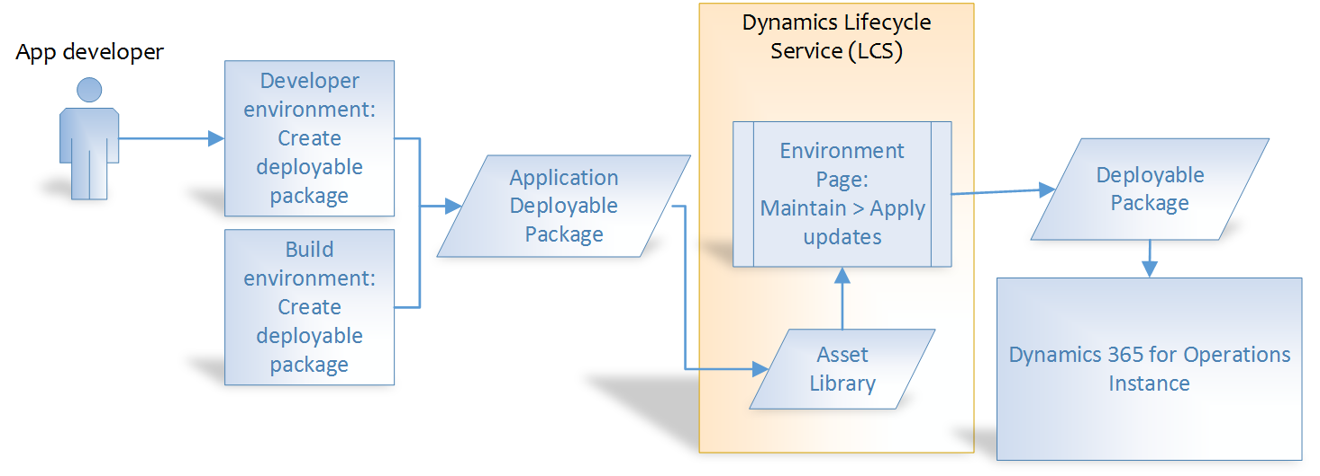

For more information, [Click Here.](https://learn.microsoft.com/en-us/dynamics365/fin-ops-core/dev-itpro/deployment/create-apply-deployable-package)

## Deploy Custom Help:

Finance and operations apps are often customized and extended to fit an organization's needs. If your solution is based on Microsoft Dynamics 365 Finance, Dynamics 365 Supply Chain Management, or Dynamics 365 Commerce, you can connect solution-specific and customer-specific Help content to the Help pane in the finance and operations client.

For more information, [Click Here.](https://learn.microsoft.com/en-us/dynamics365/fin-ops-core/dev-itpro/help/custom-help-overview)

# Azure API Service & Management

APIs enable digital experiences, simplify application integration, underpin new digital products, and make data and services reusable and universally accessible. With the proliferation and increasing dependency on APIs, organizations need to manage them as first-class assets throughout their lifecycle.

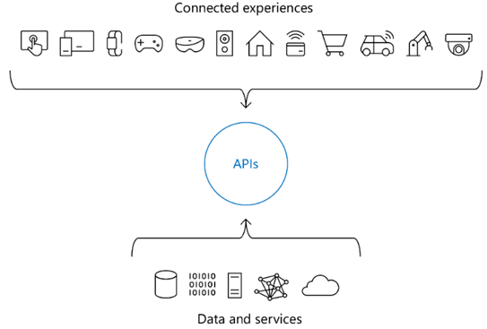

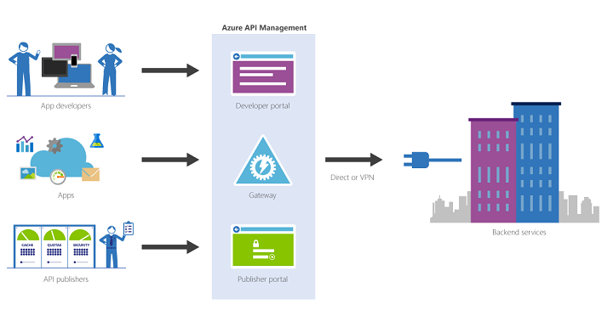Azure API Management (APIM) is a Microsoft cloud-based solution that helps businesses manage and secure their APIs. It's a platform-as-a-service (PaaS) that supports the entire API lifecycle.

APIM works like a proxy and is located in the upper layer of backend services. It creates consistent, modern API gateways for existing backend services.

APIM provides tools and services for:

* Creating, publishing, and managing APIs
* Enforcing security
* Scaling
* Monitoring API usage

For more information, [Click Here.](https://learn.microsoft.com/en-us/azure/api-management/api-management-key-concepts)

# Service protection API limits

To ensure consistent availability and performance of the finance and operations apps service, Microsoft applies limits to the way that the service APIs are used. These limits are designed to protect the service when client applications make extraordinary demands on server resources. Sudden bursts of high incoming API traffic or concurrent long-running requests against the server can exhaust server resources, and can cause outages or have other impacts on the availability and performance of the service.

## Throttling prioritization:

Resource-based limits for service protection application programming interfaces (APIs) work together with the user-based limits for service protection APIs as protective settings that help prevent the over-utilization of resources. In this way, they help preserve the system's responsiveness and ensure consistent availability and performance for environments that run finance and operations apps. The resource-based limits will throttle service requests when the aggregate consumption of web server resources reaches levels that threaten service performance and availability.

For more information, [Click Here.](https://learn.microsoft.com/en-us/dynamics365/fin-ops-core/dev-itpro/data-entities/priority-based-throttling)

# Application Connector:

The application connector allows Microsoft Power Automate, Power Apps, Data Integrator, and Logic Apps to integrate with finance and operations. An external application can use the available trigger and actions to integrate with them.

For more information, [Click Here.](https://learn.microsoft.com/en-us/dynamics365/fin-ops-core/dev-itpro/data-entities/fin-ops-connector)

# Azure Functions

Azure Functions is a cloud service available on-demand that provides all the continually updated infrastructure and resources needed to run your applications. You focus on the code that matters most to you, in the most productive language for you, and Functions handles the rest. Functions provides serverless compute for Azure. You can use Functions to build web APIs, respond to database changes, process IoT streams, manage message queues, and more.

For more information, [Click Here.](https://learn.microsoft.com/en-us/azure/azure-functions/)

# Azure Power Platform

The ‘Power Platform’ is a collective term for three Microsoft products: Power BI, PowerApps and Power Automate (previously known as Flow). They provide the means to help people easily manipulate, surface, automate and analyse data and can be used with Office 365 and Dynamics 365 (as well as other third-party apps and other Microsoft services). The Power Platform is possible thanks to the Common Data Service (or CDS), which is essentially the underlying data platform that provides a unified and simplified data schema so that applications and services can inter-operate.

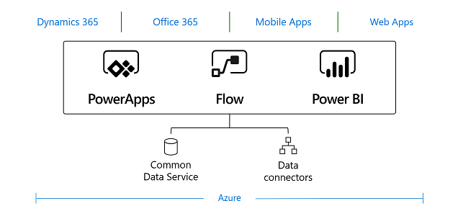

For more information, [Click Here.](https://azure.microsoft.com/en-in/products/power-platform)

# Logic Apps in Dynamics 365 F&O File Based Data Integration

In the “old days” (read before the cloud), integrating systems with solutions like Dynamics 365 would have happened via a middleware such as Microsoft BizTalk Server, on-premise. With a solution like Microsoft Azure Logic Apps, it is now possible to integrate Dynamics 365 directly with Salesforce from the cloud.

Microsoft Azure Logic Apps is a cloud service that Microsoft provides and recommends if you want to integrate Microsoft Dynamics 365 with other applications. Microsoft Azure Logic Apps is a consumption-based billing service so you will need an Azure subscription in order to build and run logic apps.

For more information, [Click Here.](https://www.encorebusiness.com/blog/logic-apps-in-dynamics-365-fo-file-based-data-integrations/)

# D365 Additional Components

Here is a list of the Additional Components in D365:

## 1. Dynamics 365

Microsoft with Dynamics 365 and other products covers all of your business’s needs. Dynamics 365 is the only business information system that has the ERP and CRM agenda all in one. ERP is an application for running the organizational and business processes, while CRM connects all business partners and assists with running a wide range of business activities.

### Dynamics 365 is available in two editions:

* The Small Business edition for smaller companies
* The Enterprise edition for medium and large organizations.

## 2. Common Data Model

The Common Date Model functions as a uniform framework for the entire environment. CDM is a common database for all entities (e.g. Customer Orders, Invoices, Customer List, Vendors, Products, etc.) thanks to which users can easily import and use data in all applications in the same format (CRM, ERP, mobile and web applications, etc.)

## 3. Microsoft PowerApps

PowerApps allow users to create new applications in a visual design environment and connect them to the common data model. This simple solution allows users to quickly design applications without knowing how to program. For more complex applications users can use the Microsoft Azure platform.

## 4. Microsoft Flow

With Microsoft Flow you can connect different applications and services together, for example, you can use it to send notifications, synchronize files, collect data, store email attachments on SharePoint, etc. Just like in PowerApps, there are a wide range of templates that can be used. Among the applications that are most often connected through Flow are Facebook, SharePoint, OneDrive, Twitter, Dropbox, Instagram, RSS, Yammer and YouTube.

## 5. Office 365

The number one office suite available as a cloud service. The biggest new feature of the Business Edition Dynamics 365 is the possibility to integrate Outlook with data from the information system. According to the addressee, the system can automatically bring up all documents related to the correspondent such as previous invoices, orders and offers. Thanks to this feature, users can save a lot of time switching between applications.

## 6. Power BI

The Business Intelligence tool allows users to transform a wide range of business data into straightforward visualizations. Producing reports and interactive analyses along with dashboard overviews can all be done in a matter of minutes. Multiple templates are available to use.

## 7. Azure IoT Suite

With the Azure IoT Suite you can connect, monitor and analyze previously unused data and integrate it into one business system. It is typically used to predict maintenance or to remotely monitor other systems connected to the network – the Internet of Things. Connecting and monitoring millions of devices in the Azure IoT Suite on any platform – Linux and Windows – is not a problem.

## 8. AppSource and third-party applications

Dynamics 365 allows for the easy connection of applications from Microsoft partners (including Blue Dynamic s.r.o.). These apps can easily be purchased through the AppSource portal, which is the central market place for all Dynamics 365 customers. Applications are classified according to categories and the business field, and all are available in trial mode for testing without payment.

## 9. Azure Machine Learning

Powerful analyses are part of the Cortana Intelligence Suite. Full cloud services which allow for the simple creation, deployment and sharing of predictive analytic solutions. Azure ML offers technical machine learning that meets the demands of both ordinary and challenging complex tasks.

Data sets are needed to perform analyses (which can be purchased), though ideally these sets can be obtained from the internet of things and utilize real data, online, directly from the field. Its use is practically unlimited.

## 10. Microsoft Azure

Microsoft Azure is a cloud computing platform that includes a wide range of IT services. It is used to create, host and scale web applications through Microsoft’s data centers. Among Azure’s products are SQL databases, data storage, cloud services, back up, Machine Learning, virtualization tools and many others.

# Modern Data warehouse D365 F&O

A data warehouse (DWH) is a storage location that organizations use to electronically store data retrieved from organizational activities. This data is accessed and made available for ad-hoc searches and reporting. The creation and use of a data warehouse is what data warehousing is all about. Data in data warehouses have a different arrangement from data in the operating environment. Individual data is brought together to facilitate reporting for day-to-day operations and analysis. The system then determines trends over time and produces plans based on that information.

For more information, [Click Here.](https://learn.microsoft.com/en-us/azure/architecture/example-scenario/data/small-medium-data-warehouse)

# Modern POS

Users of Modern Point of Sale (POS) can perform various tasks on supported laptops, tablets, and phones. These tasks include processing sales transactions, viewing customer orders, managing daily operations and inventory, and viewing role-based reports. Both MPOS and Cloud POS are available in Microsoft Dynamics 365 Commerce. The Cloud POS is a hosted version of the POS app. Both the POS clients don't perform business functions or data processing. All business functions are provided by Commerce Scale Unit. Modern POS and Cloud POS clients can communicate with Commerce Scale Units. Modern POS client can also communicate with peripheral devices, such as cash drawers, credit card readers, and printers, by using Hardware Station. Hardware Station must be deployed in your store, and all Modern POS clients can connect to the same Hardware Station.

# Mobile mPOS

A mobile POS is a smartphone, tablet, or dedicated wireless device that performs the functions of a cash register or electronic point of sale terminal (ePOS). Mobile point-of-sale technology has moved the point of sale from a brick-and-mortar location to wherever you need to complete a sale.

Here are some benefits of an mPOS system:

* Ease of use
* Reduced setup costs
* Improved customer service
* Integrations

Microsoft Dynamics 365 for Retail offers two types of POS experiences:

Cloud POS (cPOS): A browser-based POS that can be used on mobile devices

Modern POS (MPOS): A POS app for PCs, tablets, and phones

**MPOS allows sales staff to:**

* Process sales transactions and customer orders
* Perform clienteling activities
* Perform daily operations and inventory management
* View role-based reports

For more information, [Click Here.](https://learn.microsoft.com/en-us/dynamics365/commerce/dev-itpro/retail-modern-pos-device-activation)

# Telemetry D365

Monitoring and telemetry in D365FO by using Azure Application Insights helps developers and admins triage and resolve application issues in near-real time.

Telemetry can be enabled on two different levels:

## Environment-level telemetry:

Telemetry can be enabled for a Business Central online environment or on-premises Business Central Server instance. When enabled on the environment, telemetry is emitted to a single Azure Application Insights resource for gathering data on operations that happen on the environment.

## App/extension-level telemetry:

With the Business Central 2020 release wave 2 and later, telemetry can also be enabled on a per-extension basis. Enabling telemetry is done by setting an Azure Application Insights connection string in the app's manifest (app.json file). At runtime, certain events related to the app/extension are emitted to the Azure Application Insights resource. This feature targets publishers of per-tenant extensions or Microsoft AppSource apps. It gives extension publishers insight into usage of their apps/extensions and also allows them to find errors and performance issues before partners and customers report them.

For more information, [Click Here.](https://learn.microsoft.com/en-us/dynamics365/fin-ops-core/dev-itpro/sysadmin/monitoring-and-telemetry-appinsights)

# CDS in D365 F&O

Common Data Service for Apps is a platform that allows users to quickly integrate programs, build new custom applications, and create automated workflows.

The CDS for Apps is built on the Common Data Model. Initially rolled out in early 2016 as part the introduction of Microsoft PowerApps, the Common Data Model is the foundation on which all current and future Common Data Services are built and operated.

With the case of legacy business apps, a program’s data is often siloed within that app, and sharing information between software platforms can be difficult, often impossible, without extensive customization.

That’s where the Common Data Model comes in, and why it was needed. Microsoft created the Common Data Model to act as a secure database, where business information can not only be stored, but standardized, allowing information to be unified across a number of apps.

“The Common Data Service allows data to be managed and stored securely between applications. Data in the CDS is stored within a set of standard and custom entities or fields, which can be effortlessly synchronized across multiple applications that are being developed.”

For more information, [Click Here.](https://learn.microsoft.com/en-us/business-applications-release-notes/april19/dynamics365-finance-operations/integration-dual-write)

# RSSU in D365 Retail

In the October 2018 release, Microsoft launched the concept of Retail Cloud Scale Unit (RCSU) to increase cloud scalability for customers consuming retail work-loads on the D365 platform.  
The Retail Store Scale Unit (RSSU) which was already available in D365 Retail is different from the newly released RCSU functionality. It is “on-premises” box physically located within the store which allows retailers with intermittent internet (and hence cloud) connectivity issues to still execute cross terminal transactions and shift operations when they lose connectivity to the back office. It contains a retail server, a channel database, CDX Asynch client and the IIS website to enable cloud POS features.

For more information, [Click Here.](https://synergy-software.com/blog/2018/11/27/retail-cloud-scale-unit-dynamics-365-finance-and-operations-october-18-release/)

# Client POS hardware requirement for D365 Retail

## Printer

Printers include traditional POS receipt printers and full-page printers. The POS function in the Printer is supported through Object linking and embedding for Retail POS (OPOS) and Microsoft Windows driver interfaces. It allows use of two printers simultaneously. The capability is supported in the case of scenarios that involve cash-and-carry customer receipts are printed on receipt printers, whereas in the case of customer orders, that have to offer more information, a full-page printer is normally used.

## Scanner

Up to two bar code scanners can be used at the same time. The use of scanner is manly used in situations when there are large or heavy items to be scanned. For standard-sized items, the use of a fixed embedded scanner is more suitable.

## MSR

Magnetic stripe reader (MSR) is mainly set up using OPOS drivers. If you want to use a stand-alone MSR for electronic funds transfer (EFT) payment transactions, the MSR must be managed by a payment connector. Stand-alone MSRs can be used for customer loyalty entry, employee sign-in, and gift card entry, independently of the payment connector.

## Cash drawer

One hardware profile can support up to two cash drawers, allowing two active shifts to be supported simultaneously. If the cash drawer is being used by multiple POS devices, only one cash drawer can be used per hardware profile. The connection with cash drawers is connected with the computer through USB, network or a receipt printer via an RJ12 interface. It can also be connected via Bluetooth.

## Line display

Line displays are important in terms of showcasing products, transaction balances, along with other useful information involved in customer transaction. One line display can be connected to the computer via USB by using OPOS drivers.

## Signature capture

Signature capture devices are connected using OPOS drivers of a computer via USB. Upon configuring the signature capture, the customer can sign on the device. Once signature is provided, it is shown to the cashier for payment for acceptance.

## Scale

These are connected to the system with USB using OPOS drivers. When a marked product is added to a transaction, the POS registers the mark present on the product from the scale, it is added as a product, and the quantity is used with the help of the scale provided.

## PIN pad

Personal identification number (PIN) pads are supported through OPOS, but they must be managed via a payment connector.

## Secondary display

Upon configuring secondary display, the number 2 Windows display is used to for basic information. The secondary display is used to support independent software vendor (ISV) extension, because when used as a customized feature, the secondary display does not configure properly and displays limited information as well.

## Payment device

Payment device support is implemented through the payment connector. With the help of payment devices a variety of functions can be executed that other device classes provide. For example, a payment device can provide multi-function in the form of MSR/card reader function, line display, signature capture device, or PIN pad. Support for payment devices is implemented independently of the stand-alone device support that is provided for other devices that are included in the hardware profile.

For more information, [Click Here.](https://dynamics.folio3.com/2018/06/01/dynamics-for-retail-hardware-peripherals-requirements-setup/)

# System Requirement for D365 F&O On-Premises requirements.

## Network requirement:

Dynamics 365 Finance + Operations (on-premises) can work on networks that use Internet Protocol Version 4 (IPv4) or Internet Protocol Version 6 (IPv6). Consider the network environment when you plan your system, and use the following guidelines:

## Network response time:

The following table lists the minimum network requirements for the connection between the web browser and Application Object Server (AOS), and for the connection between AOS and the database in an on-premises system:

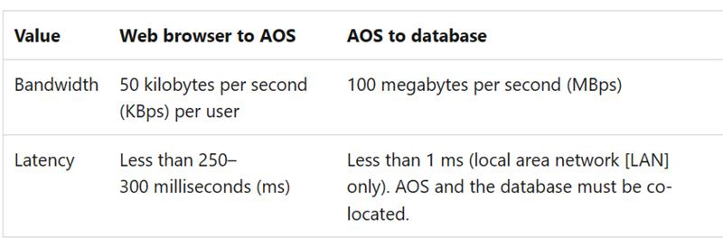

## LAN environment:

In LAN environments, Microsoft Remote Desktop in Microsoft Windows Server isn't required in order to connect to Finance + Operations. However, Remote Desktop might be required for servicing operations on the virtual machines (VMs) that make up the server deployments.

## WAN environment:

In wide area network (WAN) environments, Remote Desktop in Windows Server isn't required in order to connect to Finance + Operations.

## Internet connectivity requirement:

Finance + Operations doesn't require internet connectivity from user workstations. However, some features won't be available if there is no internet connectivity.

## Telemetry data transfer:

Most telemetry data is stored locally and can be accessed by using Event Viewer in Microsoft Windows. A small subset of telemetry events is transferred to the Microsoft telemetry pipeline in the cloud for diagnostics. Customer data and user-identifiable data aren't part of the telemetry data that is sent to Microsoft. VM names are sent to Microsoft to help with environment management and diagnostics from the LCS portal.

## Domain requirement:

Consider the following domain requirements when you install Finance + Operations:

VMs that host Finance + Operations components must belong to an Active Directory domain. Active Directory Domain Services (AD DS) must be configured in native mode.

VMs that run Finance + Operations components must have access to each other. This access is configured in AD DS.

The domain controller must be Microsoft Windows Server 2012 R2 or later, and the domain functional level must be 2012 R2 or more.

## Hardware Requirement:

This section describes the hardware that is required in order to run Finance + Operations.

The actual hardware requirements vary, based on the system configuration, the data composition, and the features that you decide to use. Here are some of the factors that can affect the choice of appropriate hardware:

* The number of transactions per hour
* The number of concurrent users

## Supported MS Office:

The following Microsoft Office applications are supported in on-premises deployments:

* To run the Microsoft Excel and Microsoft Word add-ins, you must have Microsoft Office 2016 for Windows (or newer) installed. For more information about version requirements, see [Troubleshoot the Office integration](https://learn.microsoft.com/en-us/dynamics365/fin-ops-core/dev-itpro/office-integration/office-integration-troubleshooting).
* To view documents that are generated by the Export to Excel or Export to Word functionality, you must have Microsoft Office 2007 or later installed.

For more information, [Click Here.](https://learn.microsoft.com/en-us/dynamics365/fin-ops-core/dev-itpro/get-started/system-requirements-on-prem)

# D365 production outage button

Production outage: Lifecycle Services (LCS) has a feature called **Report production outage**. This feature is available to all customers who have purchased one or more Dynamics 365 finance and operations apps and have implementation projects with a production environment deployed in LCS. This feature provides a quick and effective channel to escalate issues to Microsoft Support in the event that the services in a production environment are degraded or become unavailable.

Following mutually inclusive conditions, a production outage can be defined as one or more system-wide issues on a live production environment that impact multiple users and prevent your business from performing daily operations.

For more information, [Click Here.](https://learn.microsoft.com/en-us/dynamics365/fin-ops-core/dev-itpro/lifecycle-services/report-production-outage)

# Azure to Azure Disaster recovery

With disaster recovery set up, Azure VMs continuously replicate to a different target region. If an outage occurs, you can fail over VMs to the secondary region, and access them from there. When everything's running normally again, you can fail back and continue working in the primary location.

## **Architectural components**

The components involved in disaster recovery for Azure VMs are summarized in the following table.

| **Component** | **Requirements** |
| --- | --- |
| **VMs in source region** | One of more Azure VMs in a [supported source region](https://learn.microsoft.com/en-us/azure/site-recovery/azure-to-azure-support-matrix#region-support).  VMs can be running any [supported operating system](https://learn.microsoft.com/en-us/azure/site-recovery/azure-to-azure-support-matrix#replicated-machine-operating-systems). |
| **Source VM storage** | Azure VMs can be managed, or have non-managed disks spread across storage accounts.  [Learn about](https://learn.microsoft.com/en-us/azure/site-recovery/azure-to-azure-support-matrix#replicated-machines---storage) supported Azure storage. |
| **Source VM networks** | VMs can be located in one or more subnets in a virtual network (VNet) in the source region. [Learn more](https://learn.microsoft.com/en-us/azure/site-recovery/azure-to-azure-support-matrix#replicated-machines---networking) about networking requirements. |
| **Cache storage account** | You need a cache storage account in the source network. During replication, VM changes are stored in the cache before being sent to target storage. Cache storage accounts must be Standard.  Using a cache ensures minimal impact on production applications that are running on a VM.  [Learn more](https://learn.microsoft.com/en-us/azure/site-recovery/azure-to-azure-support-matrix#cache-storage) about cache storage requirements. |
| **Target resources** | Target resources are used during replication, and when a failover occurs. Site Recovery can set up target resource by default, or you can create/customize them.  In the target region, check that you're able to create VMs, and that your subscription has enough resources to support VM sizes that will be needed in the target region. |

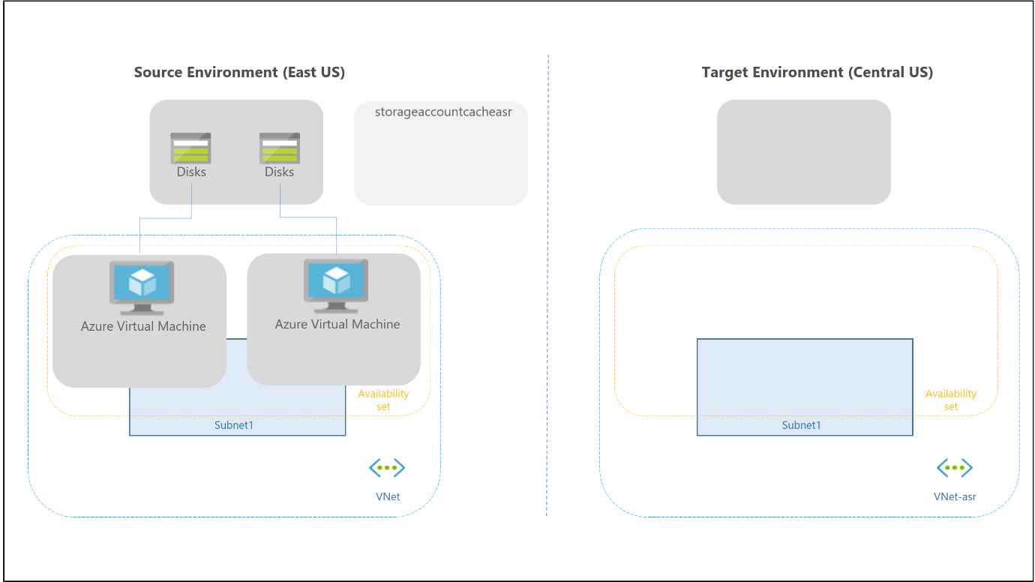

For more information, [Click Here.](https://learn.microsoft.com/en-us/azure/site-recovery/azure-to-azure-architecture)

# Azure Conditional Access Deployment for D365

Microsoft Dynamics 365 for Finance and Operations could be protected by using [Microsoft Azure Conditional Access](https://www.microsoft.com/en-us/cloud-platform/conditional-access) instead of just configuring a specific IP range whitelist within the Microsoft Dynamics 365 environment. Utilizing Microsoft Conditional Access would provide a more modern workplace approach for accessing Microsoft Dynamics 365, which was the solution the customers were hoping to achieving with the new ERP provided from the Microsoft Azure Cloud.

For more information, [Click Here.](https://learn.microsoft.com/en-us/entra/identity/conditional-access/plan-conditional-access)

# Responsible AI

## Responsible AI FAQs for the Microsoft Dynamics 365 finance and operations platform:

An AI system includes not only the technology but also the people who use it, the people who are affected by it, and the environment where it's deployed. Microsoft's Responsible AI FAQs are intended to help you understand how AI technology works, the choices that system owners and users can make that influence system performance and behavior, and the importance of thinking about the whole system, including the technology, the people, and the environment.

For more information, [Click Here.](https://learn.microsoft.com/en-us/dynamics365/fin-ops-core/dev-itpro/responsible-ai/responsible-ai-overview)

## Overview of Copilot capabilities in finance and operations apps:

Copilot gives users access to AI capabilities that augment the application experiences and functionality of finance and operations apps.

Copilot brings a growing set of skills that help users complete various tasks. It can appear in many different user experiences. Here are some examples:

* **Sidecar** – Copilot sits alongside the application as a *sidecar* and provides conversational support to the user. The sidecar is the primary Copilot interface in finance and operations apps. It provides a natural language chat experience that helps users work with application functionality and data.
* **Embedded** – These Copilot features add intelligent capabilities to the application itself. In this way, they bring AI to the center of the application experience.
* **Outside** – External agents help orchestrate across different apps and tasks. For example, users can use Copilot to ask questions about finance and operations data.

For more information, [Click Here.](https://learn.microsoft.com/en-us/dynamics365/fin-ops-core/fin-ops/copilot/copilot-for-finance-operations)

## Installing the Copilot application in your finance and operations apps environment:

One of the essential steps in enabling Copilot capabilities in finance and operations apps is installing the Copilot application in your F&O apps environment.

Follow these steps to install the Copilot application in your finance and operations apps environment.

1. Open the [Copilot in Microsoft Dynamics 365 Supply Chain Management](https://aka.ms/dynamicsfnocopilot_scmaiapp) page in the Microsoft commercial marketplace.
2. Select **Get it now**.
3. The deployment process opens [Power Platform admin center](https://admin.powerplatform.microsoft.com/). Select the Dataverse environment that's connected to your finance and operations apps environment to install the Copilot application.
4. You can follow the status of the installation by opening the detail view of the environment. In the Resources field, select Dynamics 365 apps. During installation, the status of the Copilot application is Installing. After installation is completed, the status changes to Installed. If an error occurs, the status changes to Failed. In this case, you can find details about the error in the Notifications field.

For more information, [Click Here.](https://learn.microsoft.com/en-us/dynamics365/fin-ops-core/dev-itpro/copilot/enable-copilot#step-4-install-the-copilot-application-in-your-finance-and-operations-apps-environment)