26.04.2023

**Handover Document**

**CONTENTS**

1. VERSION CONTROL 2

2. INTRODUCTION 2

3. SCOPE 2

4. BUSINESS & SYSTEM RULES 2

5. ABBREVIATIONS & TERMS 2

6. GRAPHICAL REPRESENTATION 2

7. DEVELOPED SYSTEM 2

1. **VERSION CONTROL**

|  |  |  |  |  |  |  |
| --- | --- | --- | --- | --- | --- | --- |
| **Sr. No** | **Version no** | **Version Date** | **User name** | **User department** | **Updated By** | **Ticket ID** |
| 1. | 1.1 | 27/5/2024 | Sanika Dewoolkar | IT Implementation | Sanika Dewoolkar | TT8878 |

1. **INTRODUCTION**

This system outlines the candidate interview process, salary negotiation cycle, sending job offer to the candidate and related masters required for the process flow.

The job application submitted by candidate via QR Code is fetched in the system.

Users can view, edit the candidate details through Candidate details menu. Entry user can manually add the candidate to the interview process as well.

HR can set the interview steps count for the combination of Department, designation, experience level and add the interviewer details against every step.

HR can reject the candidate and stop the interview process at any point in this system. If the candidate has surpassed all the interview steps then salary negotiation and approval process with Senior HR can be done through this system.

Once the salary is confirmed, Joining form can be sent to the candidate through this system.

1. **SCOPE**

The scope of this project is to develop the Employee Joining process for CSPL. This process will include steps like Candidate filling the job application form, Application form shortlisting, Interview panel selection from interview master, interview scheduling- rescheduling, follow up of candidate, Interview process, sending invites for interview to the interview panel and candidates, Interview process, shortlisting of candidate, Salary negotiation and generating and sending offer to candidate.

1. **BUSINESS & SYSTEM RULES**

* User will be registered in the system.
* User will be logged in.
* System should display error message for incorrect details if entered.
* System should pop up a message, if any issues in the system is detected.
* All forms should have on field validations. System should display on field errors in case of incorrect inputs.

1. **GRAPHICAL REPRESENTATION**

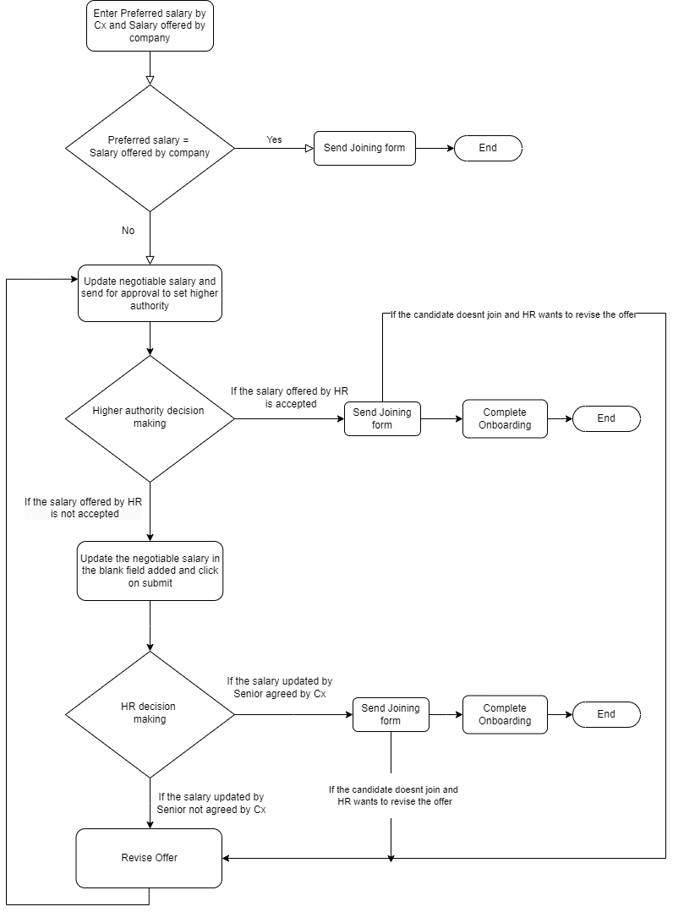

Diag: Negotiation Cycle

1. **DEVELOPED SYSTEM** 
   1. **MASTERS:**

* Branch Master
* Source Master
* Remark Master
* Interview Master
* Salary Master
* **BRANCH MASTER:**

Feature Overview:

Branch master helps entry user to add branch name I.e. Location in the system.

Below are the fields in the master:

* Sr no
* Search
* Reset
* Export
* Add
* Action
* Branch name
* Remark
* Active
* Deactive
* Save
* Cancel
* Update
* Created at
* Updated at
* Created by
* Updated by

Field Description:

|  |  |  |  |
| --- | --- | --- | --- |
| **FIELD** | **INPUT TYPE** | **MANDATORY/OPTIONAL** | **DESCRIPTION** |
| Sr No | - | - | To display the serial number |
| Search | Text | - | User will be able to search the record by data present at grid view  Validation: The search can accept alpha-numeric with special characters as well. |
| Reset | Button | - | To reset the search tab |
| Export | Button | - | To export the data in branch master  Once the user clicks on the export button, excel file with the data in grid view will be downloaded in the system. |
| Add Branch | Button | - | To add branch in the branch master  Once the user clicks on ‘Add’ button, pop up will be displayed to add data. |
| Branch name | Text | Mandatory | User will be able to enter branch name.  Validation: Should accept alpha numeric and special characters up to 100. |
| Status - Active, Deactive | Radio Button | - | By default the status of branch will be active, if the user updates the status as deactive, the record should not be displayed in the location dropdown. |
| Remark | Text | Optional | To enter the necessary remark.  Validation: Remark field should accept 1000 alpha numeric, special characters. |
| Action | Button | - | To edit the record, Once the user clicks on action button, pop up to edit the data will be displayed. |
| Save | Button | - | To save the record.  Precondition:   * User must have filled all the mandatory details before clicking on the save button. Else, error will be thrown “Please fill all the mandatory details!”   Post Condition:   * Once the user clicks on the save button, pop up will be displayed with confirmation message as “Do you want to save this record?” along with Yes, No button. * If the user clicks on “Yes” data will be saved and reflected in the grid view. At the same time, user will be redirected to the grid view. * In case, user clicks on “No” the user will be redirected to the Previous pop up. |
| Update | Button | - | To update the edited record.  Precondition:  Users must have filled in all the mandatory details before clicking on the update button. Else, error will be thrown “Please fill all the mandatory details!”  Post Condition:   * Once the user clicks on the Update button, pop up will be displayed with confirmation message as “Do you want to update this record?” along with Yes, No button. * If the user clicks on “Yes” data will be updated and reflected in the grid view. At the same time, user will be redirected to the grid view. * In case, user clicks on “No” the user will be redirected to the Previous pop up. |
| Cancel | Button | - | To cancel the input records.  Post Condition:   * User will be redirected to the grid page * The data should not be saved. |
| Created at | - | - | The date and time when the branch is created will be displayed.  Validation: Format - YYYY-MM-DD HH:MM:S |
| Created by | - | - | The username who created the branch will be displayed. |
| Updated at | - | - | The date and time when the branch is updated last will be displayed.  Validation: Format - YYYY-MM-DD HH:MM:SS |
| Updated by | - | - | The username who last updated the branch name will be displayed. |

The masters consist of following actions:

|  |  |  |  |  |
| --- | --- | --- | --- | --- |
| **FIELD** | **GRID** | **ADD** | **EDIT** | **EXPORT** |
| Sr No | ✓ | x | x | ✓ |
| Search | ✓ | x | x | x |
| Reset | ✓ | x | x | x |
| Export | ✓ | x | x | x |
| Add Branch | ✓ | x | x | x |
| Branch name | ✓ | ✓ | ✓ | ✓ |
| Status - Active, Deactive | ✓ | x | ✓ | ✓ |
| Remark | ✓ | ✓ | ✓ | ✓ |
| Action | ✓ | x | x | x |
| Save | x | ✓ | x | x |
| Update | x | x | ✓ | x |
| Cancel | x | ✓ | ✓ | x |
| Created at | ✓ | x | x | ✓ |
| Created by | ✓ | x | x | ✓ |
| Updated at | ✓ | x | x | ✓ |
| Updated by | ✓ | x | x | ✓ |

Grid View:

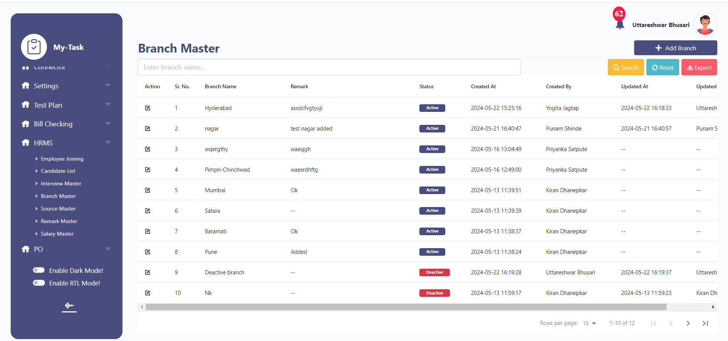

Add:

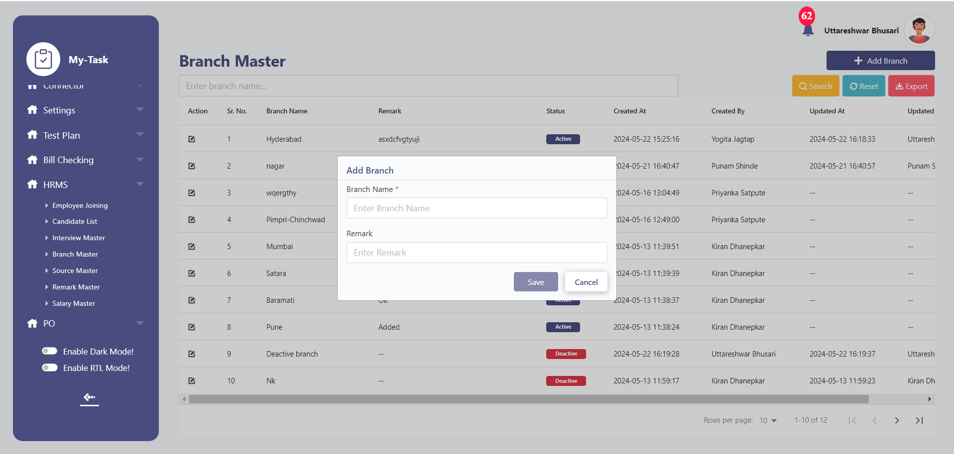

Edit:

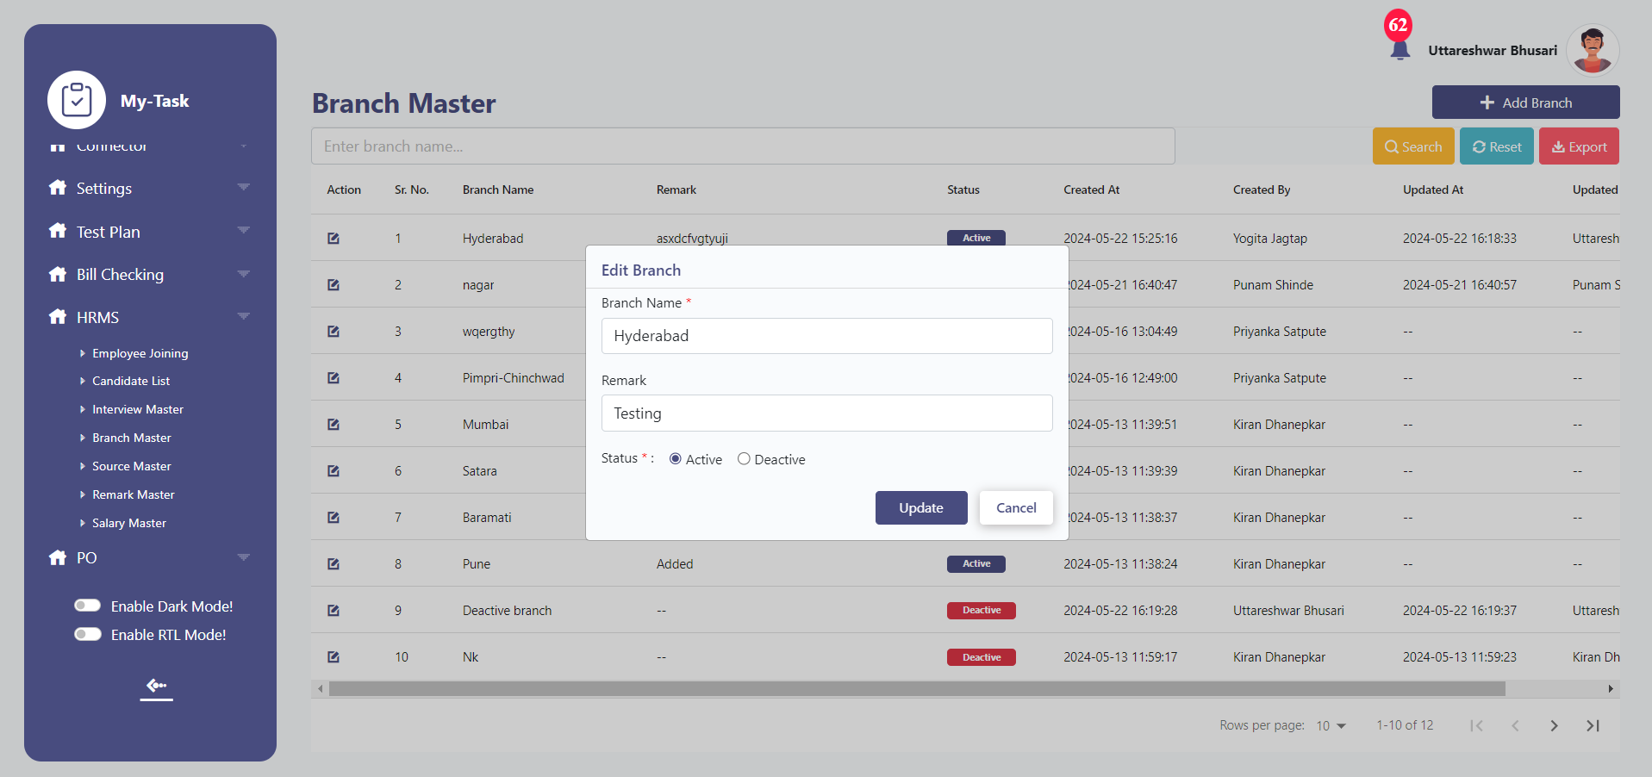

* **SOURCE MASTER**

Feature Overview:

Source master helps entry user to add Source of the application in the system. Source refers to the platform through which candidate has got to know about job opening/ the platform through which the candidate has scanned the QR code.

Below are the fields in the master:

* Sr no
* Search
* Reset
* Export
* Add
* Action
* Source name
* Remark
* Active
* Deactive
* Save
* Cancel
* Update
* Created at
* Updated at
* Created by
* Updated by

Field Description:

|  |  |  |  |
| --- | --- | --- | --- |
| **FIELD** | **INPUT TYPE** | **MANDATORY/OPTIONAL** | **DESCRIPTION** |
| Sr No | - | - | To display the serial number |
| Search | Text | - | User will be able to search the record by data present at grid view  Validation: The search can accept alpha-numeric with special characters as well. |
| Reset | Button | - | To reset the search tab |
| Export | Button | - | To export the data in source master  Once the user clicks on the export button, excel file with the data in grid view will be downloaded in the system. |
| Add Source | Button | - | To add source in the source master  Once the user clicks on ‘Add’ button, pop up will be displayed to add data. |
| Source name | Text | Mandatory | Users will be able to enter the source name.  Eg, Naukri, Linkedin, Walk in, Reference  Validation:   1. Should accept alpha numeric and special characters up to 100. |
| Status - Active, Deactive | Radio Button | - | By default, the status of source name will be active, if the user updates the status as deactive, the record should not be displayed in the Source dropdown. |
| Remark | Text | Optional | To enter the necessary remark.  Validation: Remark field should accept 1000 alpha numeric, special characters. |
| Action | Button | - | To edit the record, Once the user clicks on action button, pop up to edit the data will be displayed. |
| Save | Button | - | To save the record.  Precondition:   * User must have filled all the mandatory details before clicking on the save button. Else, error will be thrown “Please fill all the mandatory details!”   Post Condition:   * Once the user clicks on the save button, pop up will be displayed with confirmation message as “Do you want to save this record?” along with Yes, No button. * If the user clicks on “Yes” data will be saved and reflected in the grid view. At the same time, user will be redirected to the grid view. * In case, user clicks on “No” the user will be redirected to the Previous pop up. |
| Update | Button | - | To update the edited record.  Precondition:  User must have filled all the mandatory details before clicking on the update button. Else, error will be thrown “Please fill all the mandatory details!”  Post Condition:   * Once the user clicks on the Update button, pop up will be displayed with confirmation message as “Do you want to update this record?” along with Yes, No button. * If the user clicks on “Yes” data will be updated and reflected in the grid view. At the same time, user will be redirected to the grid view. * In case, user clicks on “No” the user will be redirected to the Previous pop up. |
| Cancel | Button | - | To cancel the input records.  Post Condition:   * User will be redirected to the grid page * The data should not be saved. |
| Created at | - | - | The date and time when the source is created will be displayed.  Validation: Format - YYYY-MM-DD HH:MM:S |
| Created by | - | - | The username who created the source will be displayed. |
| Updated at | - | - | The date and time when the source is updated last will be displayed.  Validation: Format - YYYY-MM-DD HH:MM:SS |
| Updated by | - | - | The username who last updated the source name will be displayed. |

The masters consist of following actions:

|  |  |  |  |  |
| --- | --- | --- | --- | --- |
| **FIELD** | **GRID** | **ADD** | **EDIT** | **EXPORT** |
| Sr No | ✓ | x | x | ✓ |
| Search | ✓ | x | x | x |
| Reset | ✓ | x | x | x |
| Export | ✓ | x | x | x |
| Add Source | ✓ | x | x | x |
| Source name | ✓ | ✓ | ✓ | ✓ |
| Status - Active, Deactive | ✓ | x | ✓ | ✓ |
| Remark | ✓ | ✓ | ✓ | ✓ |
| Action | ✓ | x | x | x |
| Save | x | ✓ | x | x |
| Update | x | x | ✓ | x |
| Cancel | x | ✓ | ✓ | x |
| Created at | ✓ | x | x | ✓ |
| Created by | ✓ | x | x | ✓ |
| Updated at | ✓ | x | x | ✓ |
| Updated by | ✓ | x | x | ✓ |

Grid View:

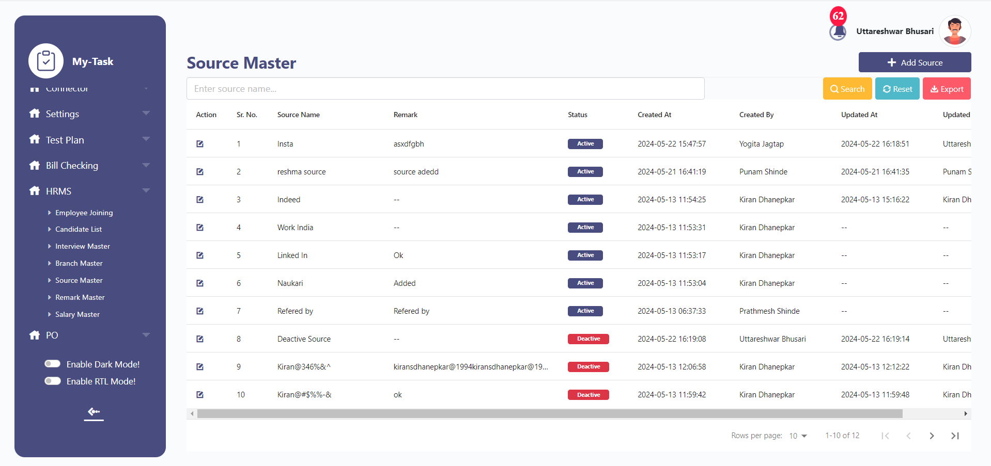

Add:

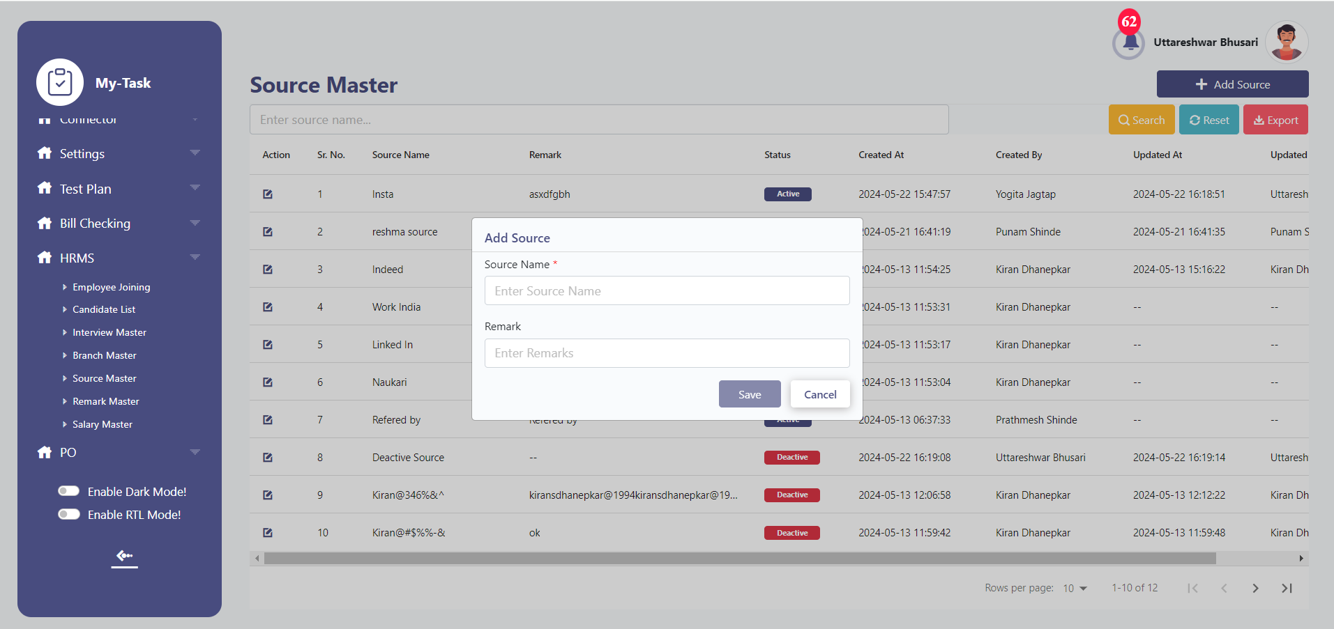

Edit:

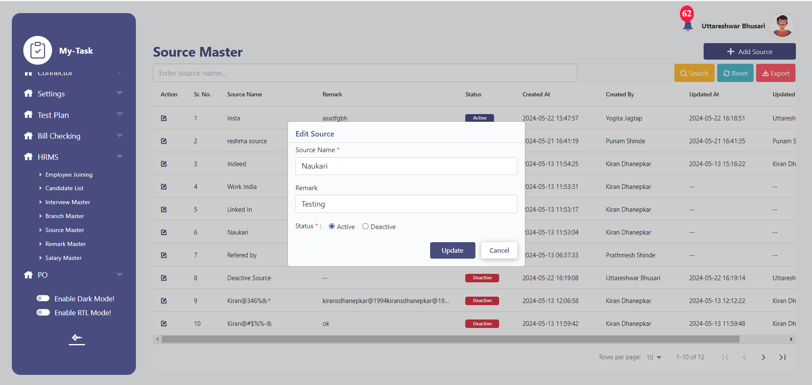

* **REMARK MASTER:**

Feature Overview:

Remark master helps entry user to add Remark in the remark dropdown while proceeding or rejecting the candidate.

Eg, If the employer wants to Reject the candidate, employer will be able to select the reason for rejection through remark field dropdown.

This dropdown values will be fetched from the remark master.

Below are the fields in the master:

* Sr no
* Search
* Reset
* Export
* Add
* Action
* Type
* Remark Description
* Supporting Remark
* Active
* Deactive
* Save
* Cancel
* Update
* Created at
* Updated at
* Created by
* Updated by

Field Description:

|  |  |  |  |
| --- | --- | --- | --- |
| **FIELD** | **INPUT TYPE** | **MANDATORY/OPTIONAL** | **DESCRIPTION** |
| Sr No | - | - | To display the serial number |
| Search | Text | - | User will be able to search the record by data present at grid view  Validation: The search can accept alpha-numeric with special characters as well. |
| Reset | Button | - | To reset the search tab |
| Export | Button | - | To export the data in remark master  Once the user clicks on the export button, excel file with the data in grid view will be downloaded in the system. |
| Add Remark | Button | - | To add remark in the Remark master  Once the user clicks on ‘Add’ button, pop up will be displayed to add data. |
| Remark Description | Text | Mandatory | User will be able to enter Remark description in this field.  Validation: Should accept alpha numeric and special characters up to 1000. |
| Status - Active, Deactive | Radio Button | - | By default the status of remark added will be active, if the user updates the status as deactive, the record should not be displayed in the Remark dropdown. |
| Supporting Remark | Text | Optional | To enter the necessary supporting details(Remark)  Validation: Remark field should accept 1000 alpha numeric, special characters. |
| Action | Button | - | To edit the record, Once the user clicks on action button, pop up to edit the data will be displayed. |
| Save | Button | - | To save the record.  Precondition:   * 1.User must have filled all the mandatory details before clicking on the save button. Else, error will be thrown “Please fill all the mandatory details!”   Post Condition:   * Once the user clicks on the save button, pop up will be displayed with confirmation message as “Do you want to save this record?” along with Yes, No button. * If the user clicks on “Yes” data will be saved and reflected in the grid view. At the same time, user will be redirected to the grid view. * In case, user clicks on “No” the user will be redirected to the Previous pop up. |
| Update | Button | - | To update the edited record.  Precondition:  User must have filled all the mandatory details before clicking on the update button. Else, error will be thrown “Please fill all the mandatory details!”  Post Condition:   * Once the user clicks on the Update button, pop up will be displayed with confirmation message as “Do you want to update this record?” along with Yes, No button. * If the user clicks on “Yes” data will be updated and reflected in the grid view. At the same time, user will be redirected to the grid view. * In case, user clicks on “No” the user will be redirected to the Previous pop up. |
| Cancel | Button | - | To cancel the input records.  Post Condition:   * User will be redirected to the grid page * The data should not be saved. |
| Created at | - | - | The date and time when the record is created will be displayed.  Validation: Format - YYYY-MM-DD HH:MM:S |
| Created by | - | - | The username who created the record will be displayed. |
| Updated at | - | - | The date and time when the record is updated last will be displayed.  Validation: Format - YYYY-MM-DD HH:MM:SS |
| Updated by | - | - | The username who last updated the record will be displayed. |

The masters consist of following actions:

|  |  |  |  |  |
| --- | --- | --- | --- | --- |
| **FIELD** | **GRID** | **ADD** | **EDIT** | **EXPORT** |
| Sr No | ✓ | x | x | ✓ |
| Search | ✓ | x | x | x |
| Reset | ✓ | x | x | x |
| Export | ✓ | x | x | x |
| Add Remark | ✓ | x | x | x |
| Remark Description | ✓ | ✓ | ✓ | ✓ |
| Status - Active, Deactive | ✓ | x | ✓ | ✓ |
| Supporting Remark | ✓ | ✓ | ✓ | ✓ |
| Action | ✓ | x | x | x |
| Save | x | ✓ | x | x |
| Update | x | x | ✓ | x |
| Cancel | x | ✓ | ✓ | x |
| Created at | ✓ | x | x | ✓ |
| Created by | ✓ | x | x | ✓ |
| Updated at | ✓ | x | x | ✓ |
| Updated by | ✓ | x | x | ✓ |

* **INTERVIEW MASTER:**

Feature Overview:

The Interview Master assists users in adding details for each step or round of an interview. Typically, interviews are conducted in various stages such as Technical Interview, HR Interview, etc. This tool helps in determining the specifics of each interview round, such as the number of rounds/steps based on the specific job title, department, and level of experience. Additionally, users can select the interviewers for each round/step by providing details like their designation, name, and email address.

**The first step of application shortlisting and last step of Offer generation and onboarding will be fixed in this process. Users should not be able to add/edit these steps.**

Eg, If the user selects the department, designation, and experience level, steps such as IT Implementation, BA, with 2 years of experience, 3 steps respectively, the BA position will entail 3 rounds of interviews. For each step of the interview, the user can set a title, for example, "Technical Interview Round". Furthermore, by inputting the designation, name, and email of the interviewer in the Interviewer details section, the user can designate who will conduct each round/step of the interview.

Below are the fields in the master:

* Sr no
* Search
* Reset
* Export
* Add Steps
* Action
* Department
* Designation
* Experience level
* Steps Count
* Step Title
* Designation
* Name
* Email
* Remark
* Active
* Deactive
* Save
* Cancel
* Update
* Created at
* Updated at
* Created by
* Updated by

Field Description:

|  |  |  |  |
| --- | --- | --- | --- |
| **FIELD** | **INPUT TYPE** | **MANDATORY/OPTIONAL** | **DESCRIPTION** |
| Sr No | - | - | To display the serial number |
| Search | Text | - | User will be able to search the record by data present at grid view  Validation: The search can accept alpha-numeric with special characters as well. |
| Reset | Button | - | To reset the search tab |
| Export | Button | - | To export the data in Interview master  Once the user clicks on the export button, excel file will be downloaded in the system. |
| Add Steps | Button | - | To add step details in the interview master  Once the user clicks on ‘Add’ button, pop up will be displayed to add data. |
| Department | Dropdown | Mandatory | Add Interview Steps>>Opening Details>>  User will be able to select the department for which the job opening is available.  The values in this dropdown will be fetched from the department master.  Validation:   1. Single selection. 2. Only Active values will be fetched. |
| Designation | Dropdown | Mandatory | Add Interview Steps>>Opening Details>>  User will be able to select the designation for which the job opening is available.  The values in this dropdown will be fetched from the designation master.  Validation:   1. Single selection. 2. Only Active values will be fetched. |
| Experience level | Dropdown | Mandatory | Add Interview Steps>>Opening Details>>  User will be able to select the experience level for which the job opening is available.  The dropdown will have below values:   * Fresher * 0-1 years of experience * 1-3 years of experience * 3-5 years of experience * 5+ years of experience   Validation: Single selection. |
| Steps Count | Dropdown | Mandatory | User will be able to select the count of interview steps/round.  Post Condition:   * Once the user selects the step count, number of rows = Step count will be added in the pop up, to assign interviewer to each step. * Eg, if user adds step count as 3, 3 rows of interviewer details will be added as shown below:     Validation:  Min step will be 1  Max will be 7 |
| Step Title | Text | Mandatory | To give title to each step/round of interview. Eg, Technical Interview, HR interview.  Validation:  This field will accept alpha numeric special characters up to 50 |
| Designation | Dropdown | Mandatory | Interviewer Details>>  User will be able to select the designation of interviewer. The values of this dropdown will be fetched from the designation master.  Validation:   1. Only Active values will be fetched. 2. Single selection |
| Name | Dropdown | Mandatory | Users will be able to select the interviewer's name from the dropdown. These values will be fetched from User master.  Pre-Condition:  User must have selected the designation before clicking on this field. If user clicks on the Name field without inputting designation, error message with red colour below name will be displayed as “Please select designation first.” |
| Email | - | Mandatory | This field will be auto fetched after the user selects the Name of interviewer. The email assigned to that interviewer/ user in user master will be displayed.  This field will be read-only.  Precondition:  The user must have selected the Name field before clicking on this field. If user clicks on the email without selecting Name, error message with red colour below email will be displayed as “Please select Name first.” |
| Status - Active, Deactive | Radio Button | - | By default, the status of record will be active, if the user deactivates the template of interview steps then for that specific opening the added details should not be fetched. |
| Remark | Text | Optional | To enter the necessary remark.  Validation: Remark field should accept 1000 alpha numeric, special characters. |
| Action – View, History | Button | - | Edit button- To edit the record, Once the user clicks on action button, pop up to edit the data will be displayed.  View Button – To view the record, Once the user clicks on view button, pop up with added records will be displayed. |
| Save | Button | - | To save the record.  Precondition:   * The user must have filled in all the mandatory details before clicking on the save button. Else, error will be thrown “Please fill all the mandatory details!”   Post Condition:   * Once the user clicks on the save button, pop up will be displayed with confirmation message as “Do you want to save this record?” along with Yes, No button. * If the user clicks on “Yes” data will be saved and reflected in the grid view. At the same time, user will be redirected to the grid view. * In case, user clicks on “No” the user will be redirected to the Previous pop up. |
| Update | Button | - | To update the edited record.  Precondition:  Users must have filled in all the mandatory details before clicking on the update button. Else, error will be thrown “Please fill all the mandatory details!”  Post Condition:   * Once the user clicks on the Update button, pop up will be displayed with confirmation message as “Do you want to update this record?” along with Yes, No button. * If the user clicks on “Yes” data will be updated and reflected in the grid view. At the same time, user will be redirected to the grid view. * In case, user clicks on “No” the user will be redirected to the Previous pop up. |
| Cancel | Button | - | To cancel the input records.  Post Condition:   * User will be redirected to the grid page * The data should not be saved. |
| Created at | - | - | The date and time when the record is created will be displayed.  Validation: Format - YYYY-MM-DD HH:MM:S |
| Created by | - | - | The username who created the record will be displayed. |
| Updated at | - | - | The date and time when the record is updated last will be displayed.  Validation: Format - YYYY-MM-DD HH:MM:SS |
| Updated by | - | - | The username who last updated the record will be displayed. |

The masters consist of following actions:

|  |  |  |  |  |
| --- | --- | --- | --- | --- |
| **FIELD** | **GRID** | **ADD** | **EDIT** | **EXPORT** |
| Sr No | ✓ | x | x | ✓ |
| Search | ✓ | x | x | x |
| Reset | ✓ | x | x | x |
| Export | ✓ | x | x | x |
| Add Steps | ✓ | x | x | x |
| Department | x | ✓ | ✓ | ✓ |
| Designation | x | ✓ | ✓ | ✓ |
| Experience level | x | ✓ | ✓ | ✓ |
| Steps Count | ✓ | ✓ | ✓ | ✓ |
| Step Title | x | ✓ | ✓ | ✓ |
| Designation | x | ✓ | ✓ | ✓ |
| Name | x | ✓ | ✓ | ✓ |
| Email | x | ✓ | ✓ | ✓ |
| Status - Active, Deactive | ✓ | x | ✓ | ✓ |
| Remark | x | ✓ | ✓ | ✓ |
| Action | ✓ | x | x | x |
| Save | x | ✓ | x | x |
| Update | x | x | ✓ | x |
| Cancel | x | ✓ | ✓ | x |
| Created at | ✓ | x | x | ✓ |
| Created by | ✓ | x | x | ✓ |
| Updated at | ✓ | x | x | ✓ |

Grid View:

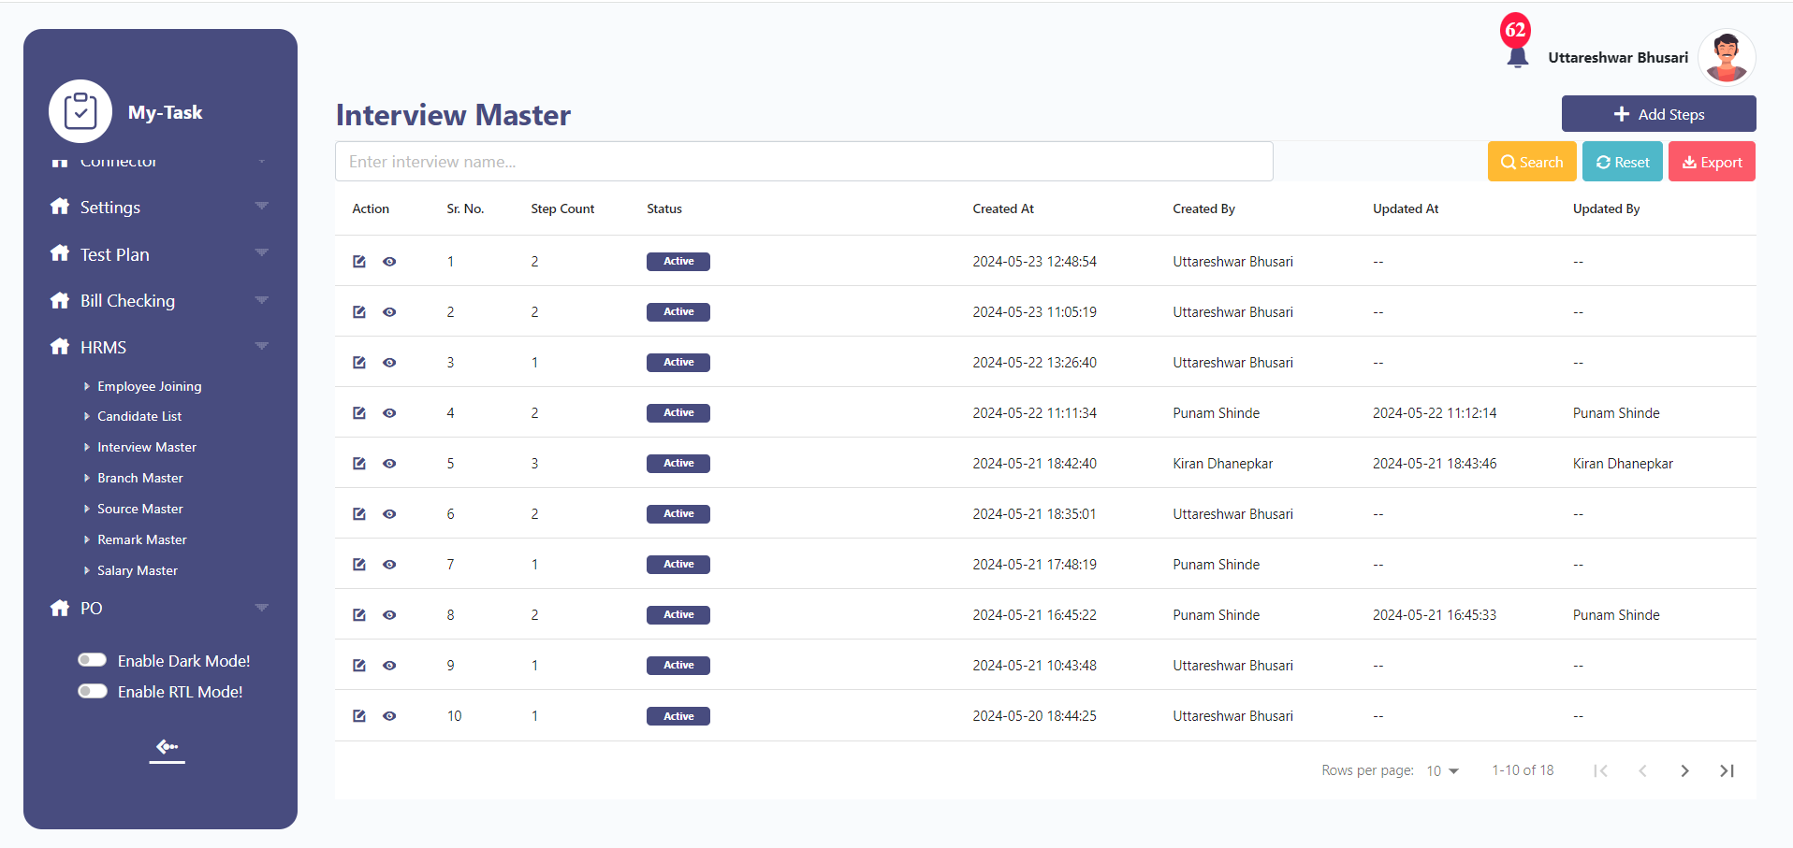

Add:

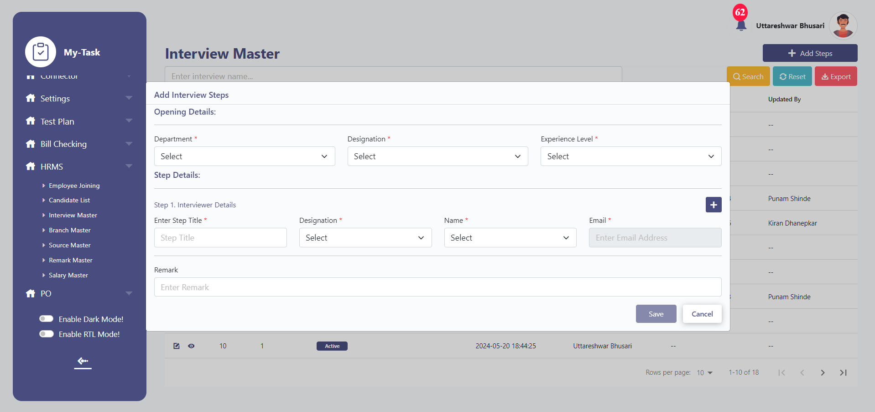

Edit:

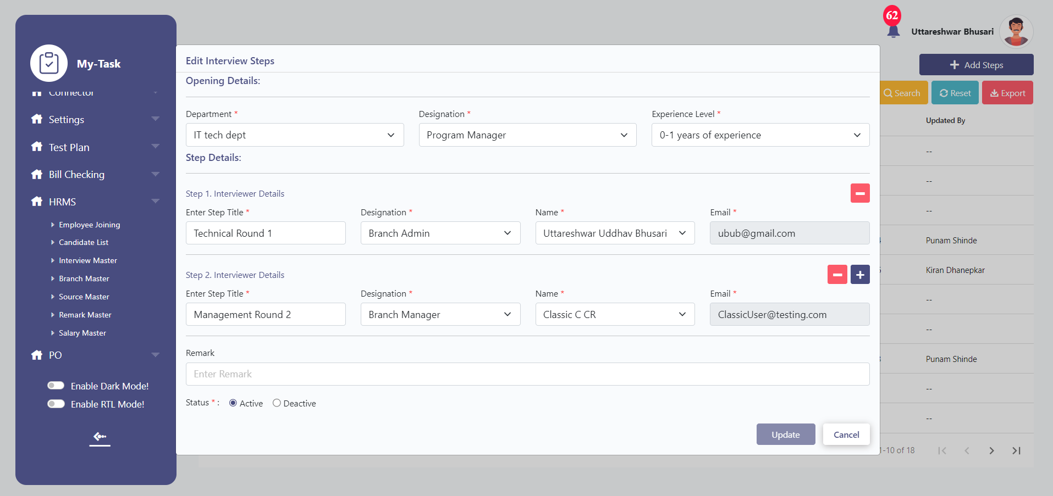

* **SALARY MASTER**

Feature Overview:

Salary master allows user to add salary for different designation, experience level and locations.

Below are the fields in the master:

* Sr no
* Search
* Reset
* Export
* Add Salary
* Action
* Department
* Designation
* Location
* Experience level
* Salary (Net)
* Remark
* Active
* Deactive
* Save
* Cancel
* Update
* Created at
* Updated at
* Created by
* Updated by

Field Description:

|  |  |  |  |
| --- | --- | --- | --- |
| **FIELD** | **INPUT TYPE** | **MANDATORY/OPTIONAL** | **DESCRIPTION** |
| Sr No | - | - | To display the serial number |
| Search | Text | - | Users will be able to search the record.  Validation: The search can accept alpha-numeric with special characters as well. |
| Reset | Button | - | To reset the search tab |
| Export | Button | - | To export the data in branch master  Once the user clicks on the export button, excel file with the data in grid view will be downloaded in the system. |
| Add Salary | Button | - | To add branch in the branch master  Once the user clicks on ‘Add’ button, pop up will be displayed to add data. |
| Department | Dropdown | Mandatory | User will be able to select the department from the dropdown.  The values in this dropdown will be fetched from the department master.  Validation:  Single selection.  Only Active values will be fetched. |
| Designation | Dropdown | Mandatory | User will be able to select the designation from the dropdown.  The values in this drop-down will be fetched from the designation master.  Validation:  Single selection.  Only Active values will be fetched. |
| Experience Level | Dropdown | Mandatory | Add Interview Steps>>Opening Details>>  User will be able to select the experience level for which the job opening is available.  The dropdown will have below values:   * Fresher * 0-1 years of experience * 1-3 years of experience * 3-5 years of experience * 5+ years of experience   Validation: Single selection. |
| Location | Dropdown | Mandatory | This dropdown values will be fetched from the Branch master.  Validation:  Multi- selection  Only active values will be fetched. |
| Salary(Net) | Text | Mandatory | User will be able to set the salary against the selected department>>designation>>experience level and location.  Validation:  It should accept numbers only. |
| Status - Active, Deactive | Radio Button | - | By default the status of record will be active, if the user updates the status as deactive, the salary updated against the department>>designation>>experience level and location will be deactivated. |
| Remark | Text | Optional | To enter the necessary remark.  Validation: Remark field should accept 1000 alpha numeric, special characters. |
| Action | Button | - | To edit the record, Once the user clicks on action button, pop up to edit the data will be displayed. |
| Save | Button | - | To save the record.  Precondition:   * User must have filled all the mandatory details before clicking on the save button. Else, error will be thrown “Please fill all the mandatory details!”   Post Condition:   * Once the user clicks on the save button, pop up will be displayed with confirmation message as “Do you want to save this record?” along with Yes, No button. * If the user clicks on “Yes” data will be saved and reflected in the grid view. At the same time, user will be redirected to the grid view. * In case, user clicks on “No” the user will be redirected to the Previous pop up. |
| Update | Button | - | To update the edited record.  Precondition:  User must have filled all the mandatory details before clicking on the update button. Else, error will be thrown “Please fill all the mandatory details!”  Post Condition:   * Once the user clicks on the Update button, pop up will be displayed with confirmation message as “Do you want to update this record?” along with Yes, No button. * If the user clicks on “Yes” data will be updated and reflected in the grid view. At the same time, user will be redirected to the grid view. * In case, user clicks on “No” the user will be redirected to the Previous pop up. |
| Cancel | Button | - | To cancel the input records.  Post Condition:   1. User will be redirected to the grid page 2. The data should not be saved. |
| Created at | - | - | The date and time when the record is created will be displayed.  Validation: Format - YYYY-MM-DD HH:MM:S |
| Created by | - | - | The username who created the record will be displayed. |
| Updated at | - | - | The date and time when the record is updated last will be displayed.  Validation: Format - YYYY-MM-DD HH:MM:SS |
| Updated by | - | - | The username who last updated the record will be displayed. |

The masters consist of following actions:

|  |  |  |  |  |
| --- | --- | --- | --- | --- |
| **FIELD** | **GRID** | **ADD** | **EDIT** | **EXPORT** |
| Sr No | ✓ | x | x | ✓ |
| Search | ✓ | x | x | x |
| Reset | ✓ | x | x | x |
| Export | ✓ | x | x | x |
| Add Salary | ✓ | x | x | x |
| Department | ✓ | ✓ | ✓ | ✓ |
| Designation | ✓ | ✓ | ✓ | ✓ |
| Experience Level | ✓ | ✓ | ✓ | ✓ |
| Location | ✓ | ✓ | ✓ | ✓ |
| Salary(Net) | ✓ | ✓ | ✓ | ✓ |
| Status - Active, Deactive | ✓ | x | ✓ | ✓ |
| Remark | x | ✓ | ✓ | ✓ |
| Action | ✓ | x | x | x |
| Save | x | ✓ | x | x |
| Update | x | x | ✓ | x |
| Cancel | x | ✓ | ✓ | x |
| Created at | ✓ | x | x | ✓ |
| Created by | ✓ | x | x | ✓ |
| Updated at | ✓ | x | x | ✓ |
| Updated by | ✓ | x | x | ✓ |

Grid View:

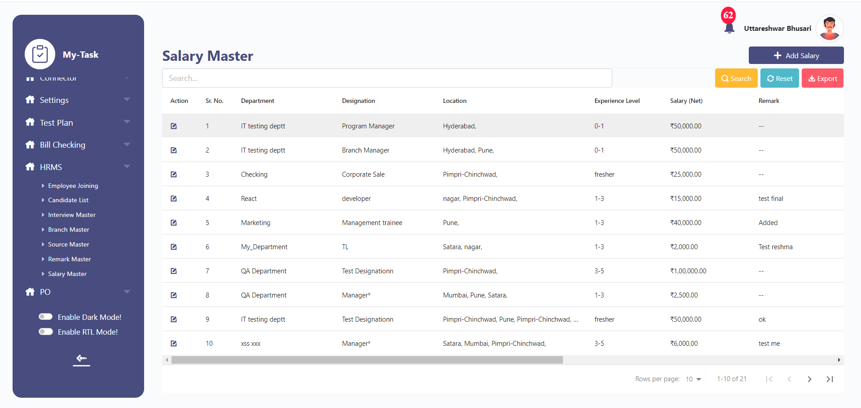

Add:

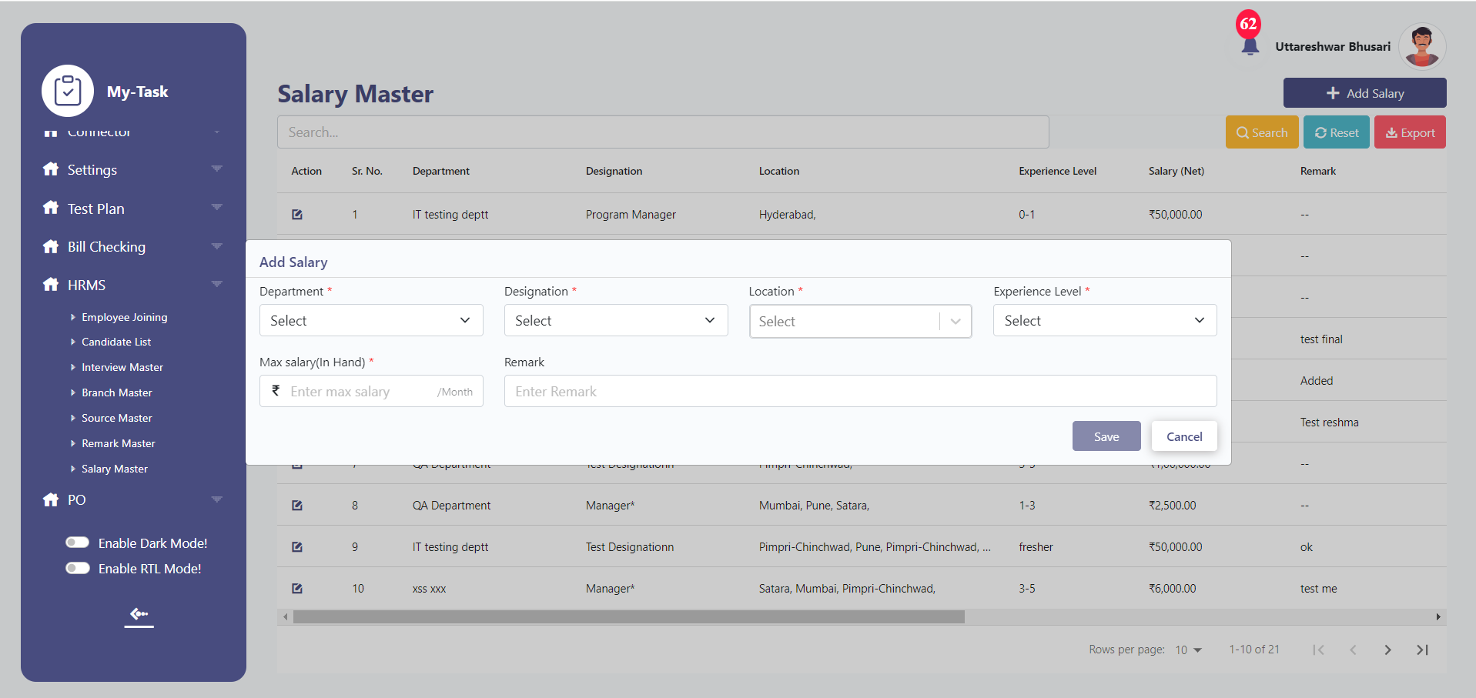

Edit:

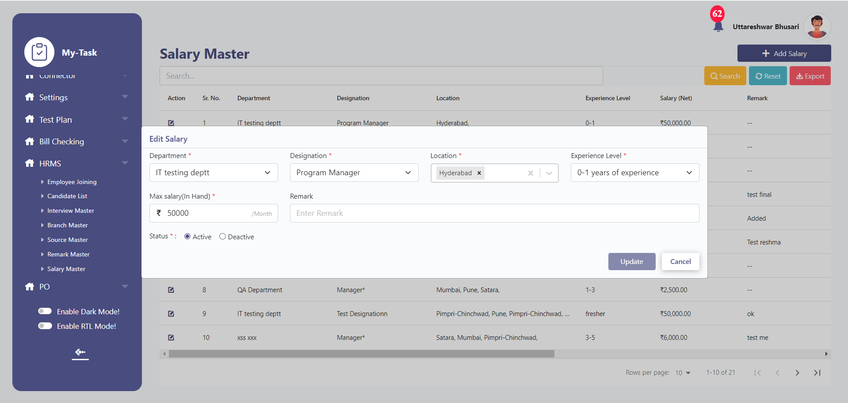

* 1. **JOB APPLICATION FORM:**

This is the first step of Employee joining process, where the candidate submits the required details in the job application form. The details submitted by candidate will be fetched in the system.

Step 1: Scan QR Code

Candidate will be able to fill the job application form by scanning QR code available at different sources.

Once the candidate scans the QR Code, the application form will be displayed.

The Job Application form will have below fields:

* Source
* Full Name
* Date of Birth
* Preferred Role
* Preferred Location
* Phone Number
* Email
* Current years of work experience
* Current monthly salary(Net)
* Expected salary(Net)
* Notice period
* Upload Resume
* Apply Now
* Verify OTP
* Resend

Fields Description:

|  |  |  |  |
| --- | --- | --- | --- |
| **FIELDS** | **INPUT TYPE** | **MANDATORY/OPTIONAL** | **DESCRIPTION** |
| Source | Dropdown | Mandatory | The source dropdown will be fetched from the source master.  If the candidate scans the QR code and redirects to the application form, the source will be auto filled and read-only.  Validation:  Single selection only. |
| Referee Name | Text | Mandatory | Pre Condition:  If the source is selected as Reference, this field will be populated.  Validation:   1. It should accept characters and space only. 2. Maximum length of input field will be 50 characters.   This field shouldn’t be case sensitive. |
| Full Name | Text | Mandatory | Candidate will be able to enter the First name and last name.  Validation:   * It should accept characters and space only. * Maximum length of input field will be 50 characters. * This field shouldn’t be case sensitive. |
| Date of Birth | Calendar picker | Mandatory | Candidate will be able to select his/her date of birth from the calendar.    Future dates will be disabled. |
| Preferred Role | Dropdown | Mandatory | Candidate will be able to select the preferred role from dropdown. The dropdown values will be fetched from the Role master.  Validation:  Multiple Selection will be allowed. |
| Preferred Location | Dropdown | Mandatory | Candidate will be able to select the preferred location from dropdown. The dropdown values will be fetched from the branch master.  Validation:  Multiple Selection will be allowed. |
| Phone Number | Text | Mandatory | * Only numbers will be accepted. * Maximum 10 digits will be accepted. * It will be unique. * Consecutive ten zeros or consecutive ten ones shouldn’t be accepted as a number. |
| Email | Text | Optional | * This field should accept “ @ - . “ only as special characters. * In case of invalid format, it should display on field error message as “Invalid email address”. * It shouldn’t accept space anywhere. * It will be unique. * Maximum length of input field will be 50 characters. |
| Current years of work experience | Dropdown | Mandatory | The dropdown will be hard coded.  It should have below values:   * Fresher * 0-1 years of experience * 1-3 years of experience * 3-5 years of experience * 5+ years of experience |
| Current monthly salary(Net) | Text | Optional | Candidate will be able to add currently monthly salary  Validation:  It should accept numbers only. |
| Expected Monthly salary (Net) | Text | Optional | Candidate will be able to add expected monthly salary  Validation:  It should accept numbers only. |
| Notice period (In days) | Text | Optional | Candidate will be able to enter the notice period.  Validation:  It should accept numbers only. |
| Upload Resume | Upload | Mandatory | It should accept only one attachment of maximum 2MB size with jpeg, jpg, png, pdf, docx extensions only. |
| Apply Now | Button | - | Candidate will be able to submit the application by clicking on this field.  Pre- Condition:  Before clicking on this field, all the mandatory fields will be filled in.  Post Condition:   1. Once the candidate clicks on this field, it will be redirected to mobile number authentication page. 2. On clicking the Apply now button, candidate should receive 4 digit OTP on the registered mobile. |
| Verify OTP | Button | - | Pre Condition:   1. Candidate should have input the received code. If the code is not entered, the verify otp button will be disabled.   Post Condition:   1. Upon clicking on the verify otp button, if the code is correct, success message will be displayed as -   “Profile has been submitted successfully!  Our team will review your application and contact you shortly.  Your Application ID is: ------”     1. If the code is incorrect, ‘’Please enter correct otp” will be displayed with the input otp highlighted as red 2. If the authentication is done, Application ID will be generated and sent on contact number and email ID(If the email id is entered) |
| Application ID | - | - | Upon verifying the registered contact number, the Application ID will be generated.  Validation:   * This application ID will be numeric. * It will be unique |
| Resend | Button | - | OTP will be sent on the registered mobile number. |

* **MANUAL ENTRY OF JOB APPLICATION FORM:**

Other than Candidate, HR will be able to add candidate details in the system by manually filling in the Job application form.

Below fields will be present in the form:

* Add data
* Source
* Full Name
* Date of Birth
* Preferred Role
* Preferred Location
* Phone Number
* Email
* Current years of work experience
* Current monthly salary(Net)
* Expected salary(Net)
* Notice period
* Upload Resume
* Apply Now
* Verify OTP
* Resend

Fields Description:

|  |  |  |  |
| --- | --- | --- | --- |
| **FIELDS** | **INPUT TYPE** | **MANDATORY/OPTIONAL** | **DESCRIPTION** |
| Add Data | Button | - | To add candidate details.  Once the users click on this field, pop up will be opened. |
| Source | Dropdown | Mandatory | Entry user will be able to add source manually, the dropdown values will be fetched from the source master.  Validation:  Single selection only. |
| Referee Name | Text | Mandatory | Pre-Condition:  If the source is selected as Reference, this field will be populated.  Validation:   * It should accept characters and space only. * Maximum length of input field will be 50 characters. * This field shouldn’t be case sensitive. |
| Full Name | Text | Mandatory | Users will be able to enter the First name and last name.  Validation:   * It should accept characters and space only. * The maximum length of input field will be 50 characters. * This field shouldn’t be case sensitive. |
| Date of Birth | Calendar picker | Mandatory | Candidate’s date of birth will be selected from the calendar.    Future dates will be disabled. |
| Preferred Role | Dropdown | Mandatory | Entry users will be able to select the preferred role of candidate from dropdown. The dropdown values will be fetched from the Role master.  Validation:  Multiple Selection will be allowed. |
| Preferred Location | Dropdown | Mandatory | Entry users will be able to select the preferred location of candidate from dropdown. The dropdown values will be fetched from the branch master.  Validation:  Multiple Selection will be allowed. |
| Phone Number | Text | Mandatory | * Only numbers will be accepted. * Maximum 10 digits will be accepted. * It will be unique. * Consecutive ten zeros or consecutive ten ones shouldn’t be accepted as a number. |
| Email | Text | Optional | * This field should accept “ @ - . “ only as special characters. * In case of invalid format, it should display on field error message as “Invalid email address”. * It shouldn’t accept space anywhere. * It will be unique. * Maximum length of input field will be 50 characters. |
| Current years of work experience | Dropdown | Mandatory | The dropdown will be hard coded.  It should have below values:   * Fresher * 0-1 years of experience * 1-3 years of experience * 3-5 years of experience * 5+ years of experience |
| Current monthly salary(Net) | Text | Optional | Entry users will be able to add the current monthly salary of the candidate.  Validation:  It should accept numbers only. |
| Expected Monthly salary (Net) | Text | Optional | Entry users will be able to add the expected monthly salary of the candidate  Validation:  It should accept numbers only. |
| Notice period (In days) | Text | Optional | Entry users will be able to enter the notice period of candidates.  Validation:  It should accept numbers only. |
| Upload Resume | Upload | Mandatory | It should accept only one attachment of maximum 2MB size with jpeg, jpg, png, pdf, docx extensions only. |
| Apply Now | Button | - | Users will be able to submit the application by clicking on this field.  Pre- Condition:  Before clicking on this field, all the mandatory fields will be filled in.  Post Condition:   * Once the users click on this field, it will be redirected to mobile number authentication page. * On clicking the Apply now button, candidate should receive 4 digit OTP on the registered mobile. |
| Verify OTP | Button | - | Pre-Condition:   * Users will be able to input the received code. If the code is not entered, the verify otp button will be disabled.   Post Condition:   * Upon clicking on the verify otp button, if the code is correct, success message will be displayed as - * “Profile has been submitted successfully! Application ID is : ------” * If the code is incorrect, ‘’Please enter correct otp” will be displayed with the input otp highlighted as red * If the authentication is done, Application ID will be generated and sent on contact number and email ID(If the email id is entered) |
| Application ID | - | - | Upon verifying the registered contact number, the Application ID will be generated.  This application ID will be numeric. |
| Resend | Button | - | OTP will be sent on the registered mobile number. |

Once the candidate submits the job application, the details of the candidate will be fetched in the employee joining system.

The employer will be able to view the candidate details and perform further hiring procedures through this system.

* **CANDIDATE LIST:**

Once the Job application form is submitted, the entry of candidate details will be displayed in the grid view.

**If the candidate has applied for multiple positions rows = position applied will be added. Eg, if the candidate has applied for 2 positions, 2 entries will be added in the grid view, with different positions applied.**

Below details will be displayed in grid:

* Sr no
* Search
* Reset
* Export
* Add Data
* Action
* Candidate name
* Applied Position
* Date of application
* Status of application
* Source

|  |  |  |  |
| --- | --- | --- | --- |
| **FIELDS** | **INPUT TYPE** | **MANDATORY/ OPTIONAL** | **DESCRIPTION** |
| Sr No | - | **-** | To display the serial number. |
| Search | Text | **-** | Users will be able to search for the record.  Validation: The search can accept alpha-numeric with special characters as well. |
| Reset | Button | **-** | To reset the search tab |
| Export | Button | **-** | To export the data of candidate's application.  Once the user clicks on the export button, an excel file will be downloaded in the system. |
| Action | Button | **-** | To view the employee joining procedure.  Once the user clicks on the view button, it will be redirected to the employee joining procedure screen. |
| Application ID | Text | **-** | Users will be able to view the application ID of candidate which is generated after submission of application form by candidate and the HR in the system. |
| Candidate name | **-** | **-** | It will be fetched from the job application form submitted by the users. |
| Applied position | **-** | **-** | It will be fetched from the job application form submitted by the users.  If the candidate has applied for multiple positions, new rows with each position will be added. |
| Date of application | **-** | **-** | Date of job application form submission will be displayed. |
| Status | **-** | **-** | Status of employee joining will be displayed.   * **Applied –** If the users have submitted the application form and no action has been taken on the record then the status of application will be ‘Applied’. * **In Process -** If the candidate is a part of hiring process and not yet on board then the status will be ‘In process’. * **Offer sent -** If the interviewer submits the application of candidate for approval and the candidate is on boarded, then the status will be displayed as ‘selected’ * **Reject -** If the employee is rejected at any point of step of hiring procedure, then the status will be displayed as ‘Rejected’. |
| Source | **-** | **-** | It will be fetched from the source entered in the job application form. |

* **EMPLOYEE JOINING SYSTEM:**

By clicking on the action button at Candidate List page, user will be redirected to the Interview Process tab.

This screen consists of 5 Tabs as below:

* Candidate List
* Interview process
* Follow up
* Remak history
* Interview Schedule History

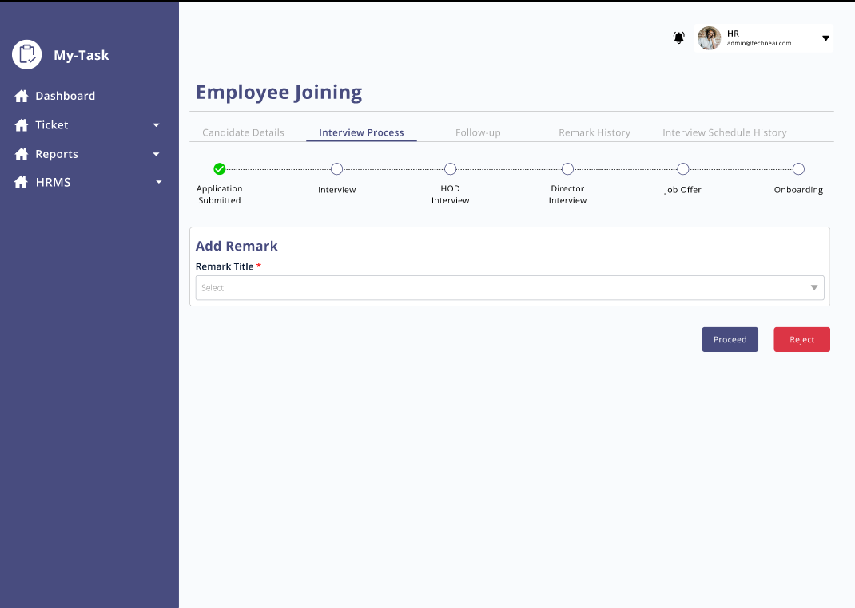

* **CANDIDATE DETAILS:**

The details submitted in the job application form filled in by Candidate and by HR through system will be reflected in this section along with application ID. The application ID field will be readable only.

HR will be **able to edit the fields below** by clicking on the edit button. Upon clicking on the edit button, the update and cancel button will be displayed.

The edited details history will be maintained on the same page.

|  |  |  |
| --- | --- | --- |
| **FIELDS** | **EDITABLE (Readable only)** | **INCLUDE IN HISTORY COLUMN** |
| Source | No | No |
| Referee Name | No | No |
| Full Name | No | Yes |
| Date of Birth | No | No |
| Preferred Role | No | Yes |
| Preferred Location | No | Yes |
| Phone Number | No | No |
| Email | No | No |
| Current years of work experience | Yes | Yes |
| Current monthly salary (Net) | Yes | Yes |
| Expected Monthly salary (Net) | Yes | Yes |
| Notice period (In days) | Yes | Yes |
| Upload Resume | Yes | No |

* **INTERVIEW PROCESS:**

In this tab, the journey from application submission to onboarding is captured.

Step 1: Application Submission

By default, when the user clicks on the action button and visits this tab, the application submission step will be completed.

HR will now decide whether to go ahead with this application or not.

To proceed or reject the candidate after reviewing the application, HR must submit the remark from the drop down which will be fetched from the remark master and then click on the proceed/reject button.

If the required remark is not present in the drop-down, ‘other’ will be selected, once the user selects ‘Other’ ‘specify other’ text box will be displayed.

The remark input will be saved in the Remark history tab.

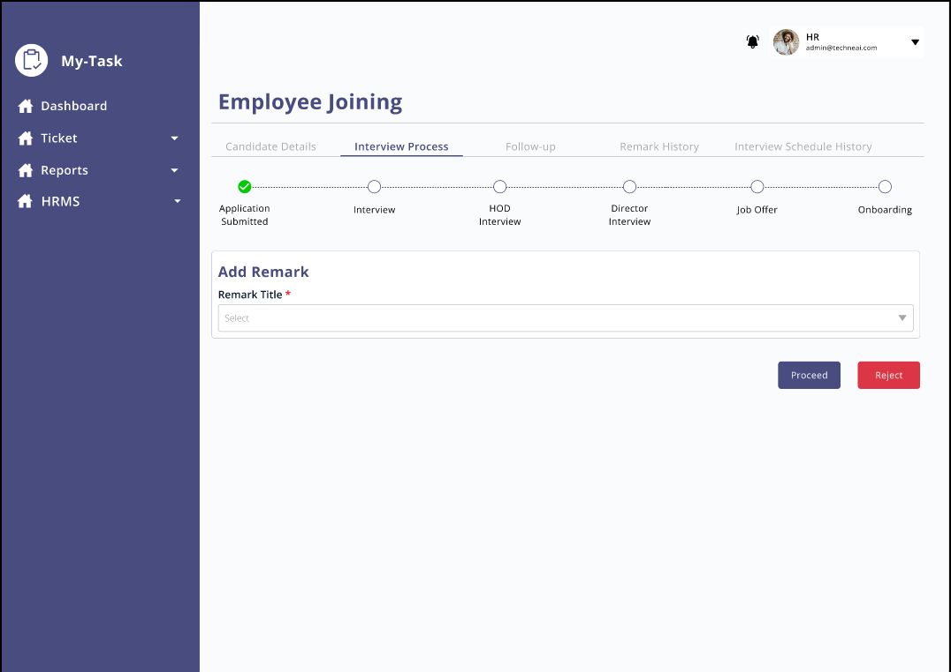

Img: Screen after clicking on action button at candidate details page

**Proceed:**

If the user decides to proceed ahead with the candidate and clicks on proceed button, user will be able to view ‘Schedule Interview’ button.

* **Schedule Interview:**

Users will be able to schedule an interview by clicking on date and time. Successful message pop up will be displayed on screen after the user has scheduled the interview.

Post Condition:

1. Once the interview is scheduled, the record will be visible in the interview schedule history tab
2. Once the user schedules the interview, Candidate and the interviewer will receive email and WhatsApp with the details of interview.
3. User will be able to view ‘Reschedule’ and ‘Send interview link/location’ buttons on the screen

* **Reschedule Interview:**

Users will be able to reschedule the interview by clicking on date and time. Once the user reschedules the interview, the reschedule history will be maintained in the interview schedule history tab.

* Proceed:

Once the user clicks on proceed button after the schedule button appears on the screen, it specifies that the candidate has cleared the interview, and the system will move ahead with the next round of interview/joining process.

* **Reject:**

If the user clicks on the reject button, the application journey will be aborted at that point.

Pre-Condition: User must specify the reason of rejection by inputting the remark which will be fetched from the remark master.

Validation: Employer should not be able to go to next menu.

* The cycle after the processing of candidate will be repeated for the steps count mentioned in the interview master.

Eg, If the user has specified 4 steps in the interview master for a specific designation. The process of Schedule Interview>> Reschedule (In case of rescheduling interview)>> Send interview link/location)>> updating remark will go on for 4 times with condition applied the candidate has successfully passed the interview round. If the candidate gets rejected in any step the process will be halted at that point.

* **GENERATE OFFER:**

Feature Overview:

* Once the candidate passes all the interview rounds, the user will be able to send joining form to the candidate.
* Once the entry user enters the role, location, relevant experience, experience level, max salary, preferred salary the system will display the max salary which can be offered by company as per settings in the salary master.
* If the preferred salary conveyed by the candidate and the salary set by company matches or the candidate agrees to the negotiation done by user, user will proceed to the employee joining form. In case the candidate does not agree to the negotiation, the user will update the salary and submit it for approval to the higher authority.
* The higher authority will receive the details input and can either directly send a joining form to the candidate or enter the salary which can be delivered and submit it.
* Upon receiving the negotiated updated salary from higher authority HR can revise the offer and the cycle will be repeated or reject, send joining form to the candidate
* HR and Senior HR can send joining form to the candidate at any time or reject the candidate.
* Salary negotiation history will be maintained on the same screen as by HR and higher authority.
* On sending the joining form to the candidate, HR professionals still have the option to reject the candidate and abort the process.
* Once the HR clicks on the ‘send joining form’ button, ‘Complete Onboarding’ button will be displayed which indicates the onboarding process has been completed.
* In case, if the candidate does not wish to join after sending joining form, then:

Scenario 1: HR will reject the candidate

Scenario 2: If the candidate is not joining because it has a better offer and the HR wants to match that offer then, HR will be able to revise the offer and again the negotiation cycle will be repeated. Once the negotiation is decided, HR will click on the send joining form where the updated details will be sent to the candidate in joining form and complete the onboarding. In this case, the process will be reverted from Onboarding to Job offer in the system.



FIELD DESCRIPTION:

|  |  |  |  |
| --- | --- | --- | --- |
| FIELD | INPUT TYPE | MANDATORY/OPTIONAL | DESCRIPTION |
| Role | Dropdown | Mandatory | Will be fetched from role master.  Validation:  Single selection |
| Location | Dropdown | Mandatory | Will be fetched from the branch master  Validation: Single selection |
| Relevant Experience | Text | Mandatory | HR will enter the relevant experience.  Validation: It should accept only numbers and ‘.’ symbol  Note will be mentioned below the field with below text  Note: Accepts only numbers and ‘.’ Eg, Enter experience of 2 years 3 months as 2.3, 7 months experience at 0.7 |
| Experience level | Dropdown | Mandatory | It will be dropdown with below values: |
| Current Salary | Text | Mandatory | Pre-Condition:  If the experience is selected as Fresher then this field should not be populated.  Validation:  Should accept numbers only |
| Preferred salary | Text | Mandatory | Validation:  Should accept numbers only. |
| Max Salary (In hand) | Dropdown | Mandatory | The data in this dropdown will be fetched from the salary master. |
| Negotiable salary | Text | Mandatory | The salary set in the system will be auto populated once the role and location is selected.  Validation:  Field shoule be editable  Should accept numbers only. |
| Submit for approval | Button | - | Once the user clicks on submit for approval, the request to review add updated negotiable salary will be sent to set higher authority. |
| Send Joining form | Button | - | Once the user clicks on this button, candidate should receive then joining form on email and WhatsApp. |
| Revise Offer | Button | - | If the users want to revise the offer and wants to repeat the negotiation cycle, then the user can click on the revise offer button.  Post Condition:   1. A back button will be displayed in case the user doesn't want to go ahead with the revise offer option. 2. Negotiated salary input field will be displayed to input the updated salary. |
| Complete Onboarding | Button | - | To complete the employee joining process. Once the HR clicks on this button, the employee joining process will be completed. It implies the candidate has accepted the offer and joining with the company. |

* **SALARY NEGOTIATION ACTIVITY:**

The salary negotiation history will be maintained in this section:

Below fields will be displayed in this section:

* Sr No
* Salary
* Negotiated salary
* Created at
* Created by
* Updated at
* Updated by

Eg, If the first salary input by HR is 25k on 2nd November, and is sent for approval to senior HR and it gets updated to 24k on 3rd November then:

|  |  |  |  |  |  |  |
| --- | --- | --- | --- | --- | --- | --- |
| Sr No | Salary | Negotiated Salary | Created at | Created by | Updated at | Updated by |
| 1 | 25000 | - | 2/11/2023 | HR |  |  |
| 2 | - | 24000 |  | Senior HR | 2/11/2023 | Senior HR |

* **JOINING FORM:**

Once the salary negotiation is done, the user will be able to send a Joining letter to the candidate from the system. Once the user proceeds to send the joining form, the candidate should receive the on boarding message and email on the registered mobile number.

* 1. **ONBOARDING**

Once the candidate receives the job offer and the candidate accepts the offer, on boarding process will end.

In case, after sending the joining form candidate does not want to join, user can still reject the candidate and close the process.

**ADDITIONAL FEATURE:**

* Upon clicking on Proceed, reject the step will be marked with green ticket, red ticket respectively.

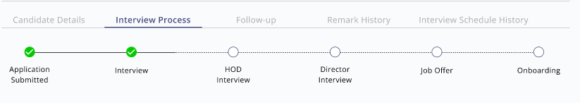

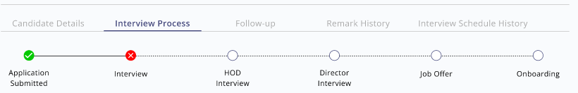

* **FOLLOW UP:**

Feature Overview:

In this tab, users can add follow up details discussed with the candidate in this section.

Users can add text, next follow up date and time, attachment. These details added will get saved and users can view the history of follow up details on the same page.

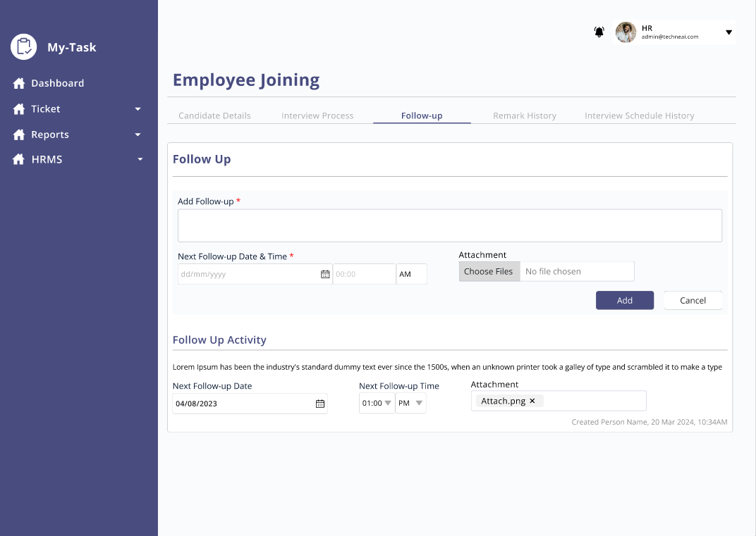

This tab contains below fields:

* Add Follow up
* Next Follow up date and time
* Attachment
* Add
* Cancel
* Follow up activity

Field Description:

|  |  |  |  |
| --- | --- | --- | --- |
| FIELD | INPUT TYPE | MANDATORY/OPTIONAL | DESCRIPTION |
| Add follow up | Text | Mandatory | To add follow-up details.  Validation: Should accept alpha numeric, special characters up to 1000 |
| Next Follow up date and time | Date and time | Mandatory | User will be able to add date and time of next follow up to be taken of candidate up to be ta |
| Attachment | All formats | Optional | Users will be able to add attachment if any.  Validation:  Single file selection.  File format: Jpg, jpeg, pdf, docx, csv |
| Add | Button | - | To add follow up details.  Once the user clicks on the button, follow up details will be saved, and the history will be reflected on the same page.  The data will be cleared from the text box, next follow up date and time, attachment. |
| Cancel | Button | - | Once the user clicks on the cancel button, data will be cleared, and the details should not be saved. |
| Follow up activity | - | - | The history of follow up added will be visible in this section.  Along with all the details added, below details will be visible:   * Created by- Username of the person who has added the record. * Date and time- date and time the follow up was added |

**REMARK HISTORY TAB**

Once the user adds the remark on every step of interview, the history will be saved in this section automatically.

Along with remark, the username of the person who has posted the remark, date and time the remark was added will be displayed.

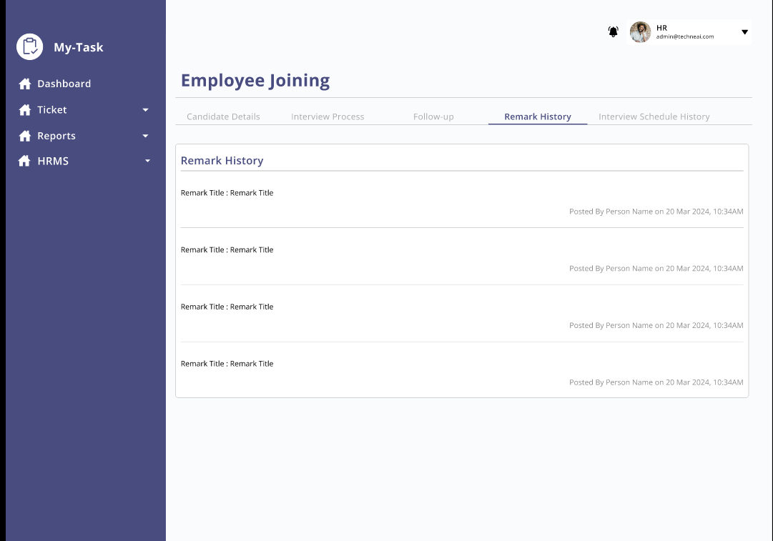

* **INTERVIEW SCHEDULE HISTORY TAB**

The history of the interview schedule will be displayed in this tab.

Below fields will be present in this tab:

* Sr No
* Status
* Schedule time and date
* Created at
* Created by
* Updated at
* Updated by

|  |  |  |  |
| --- | --- | --- | --- |
| **FIELD** | **INPUT TYPE** | **MANDATORY** | **DESCRIPTION** |
| Sr No | - | - | To display the serial number |
| Status | - | - | If the interview scheduled for the first time then the status will be Schedule and if the interview is rescheduled the status will be rescheduled. |
| Created at | - | - | The date and time of the interview scheduled will be displayed. |
| Created by | - | - | The username of the interview scheduler will be displayed |
| Updated at | - | - | The rescheduled interview date and time will be displayed |
| Updated by | - | - | The username of the interview re scheduler will be displayed. |