26.10.2024

[Promotional Gift Card]

Harshali rananaware

Harshali.rananaware@techneai.com

**Handover Document**

**CONTENTS**

1. TICKET DETAILS 2

2. INTRODUCTION 2

3. BUSINESS REQUIREMENT 2

4. SCOPE 2

5. BUSINESS & SYSTEM RULES 2

6. ABBREVIATIONS & TERMS 3

7. EXISTING SYSTEM 3

8. GRAPHICAL REPRESENTATION 3

9. DEVELOPED SYSTEM 3

10. REFERENCES OF THE USERS 3

1. **TICKET DETAILS**

|  |  |
| --- | --- |
| **Ticket ID** | TT22455 |
| **Ticket description** | Gift Voucher |
| **Created by** | Harshali Rananaware |
| **Created on** | 06/07/2024 |
| **Priority** | High |

1. **INTRODUCTION**

To issue a promotional gift card.

1. **BUSINESS REQUIREMENT**

|  |  |  |  |
| --- | --- | --- | --- |
| **Requirement ID** | **Requirement Name** | **Short Description** | **Priority** |
| BR001 | Sales Order | Want a provision to generate a auto sales order for a promotional gift card. |  |
| BR002 | Status Update | Want to add status against gift card. |  |

1. **SCOPE**

Gift card status should be issue.

Gift card sales order.

Gift card inventory effect.

1. **BUSINESS & SYSTEM RULES**

* User should be registered in the system.
* User should be logged in.
* System should display error message for incorrect details if entered.
* System should pop up a message, if any issues in the system is detected.
* All forms should have on field validations. System should display on field errors in case of incorrect inputs.
* Posting check for all document.
* Accounting check for all document.
* Inventory check for all document.
* Calculation should be as per regular invoice.

1. **ABBREVIATIONS & TERMS**

GC - Gift Card

1. **EXISTING SYSTEM**

There is no existing system.

1. **DEVELOPED SYSTEM**

## Input table

|  |  |  |  |
| --- | --- | --- | --- |
| **FIELDS** | **INPUT TYPE** | **MANDATORY/ OPTIONAL** | **DESCRIPTION** |
| Customer Name | Drop-down | Mandatory | * Data fetch from Accounts receivable -> Customers -> All customers. * Only Single customer should be select. |
| Item Number | Drop-down | Mandatory | * Data fetch from Product information management   -> Products -> Released products where item category - gift voucher.   * Only Single item should be select. |
| Location | Drop-down | Mandatory | * Data fetch from Inventory management -> Setup -> Inventory breakdown -> Inventory locations. * Only Single location should be select. |
| Gift Card No | Text | Mandatory | * This is text field we can enter a gift card number. * If wrong gift card is added then show the pop up message. * Only selected item gift card is accepted. * Alphanumeric data will accept here. |
| Scan Count | Text | Mandatory | * This field accept number only. |
| Scan | Button | Mandatory | * Click on this button then all gift card will show below. * Example Gift card No - GC001 and scan Count - 5 and GC002 is already issue then GC should not be scan. * Issue GC should not be scan. * Redeem GC should not be scan. |
| Edit | Button | Optional | * Click on this button then we can add the data. |
| New | Button | Optional | * Click on this button then one row is added. |
| Delete | Button | Optional | * Select the line and delete. * Single and multiple line should be delete. |
| Post | Button | Optional | * Click on this button then below GC is post. * After posting sales order is generate and data is show “Accounts receivable -> Orders -> All sales orders” this menu. * Sales order is generate Accounts receivable -> Orders -> All sales orders sales order against invoice -> Invoice -> voucher accounting effect is zero. * After posting GC status is update as issue. GC status is show in this “Jewellery -> Gift Card Scheme -> Gift Card Transaction” menu. * Inventory should be impact. Check on the “Inventory management -> Enquiries and reports -> On-hand list”. |

## **Gift card entry**

**Jewellery -> Gift Card Scheme -> Promotional Gift card**

For Promotional Gift card click on this menu.

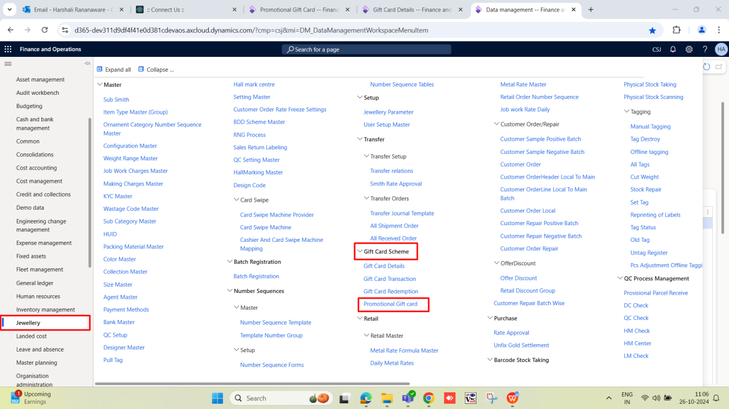

Click On “Edit” button.

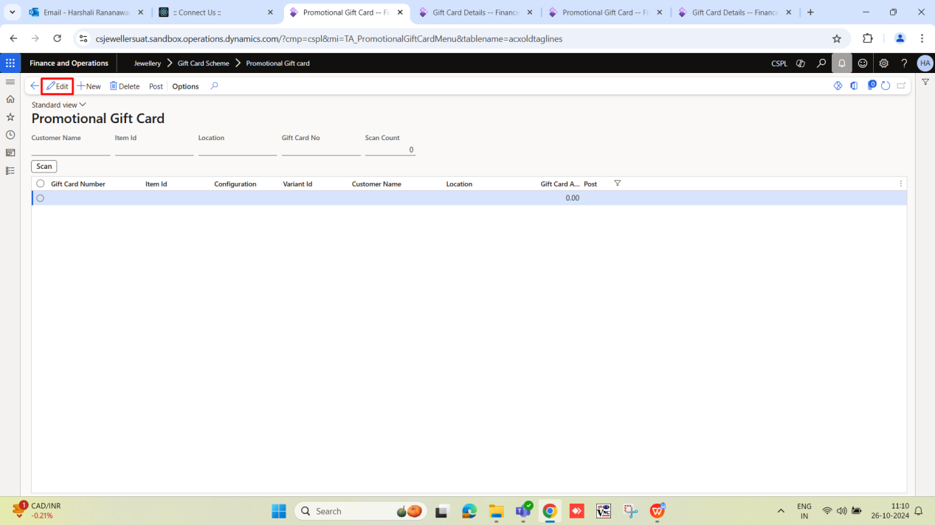

Add customer name , item ID ,location ,Gift card No and Scan count.

After that click on “scan” button.

Then gift card details show below.

Then Click on “Post” button.

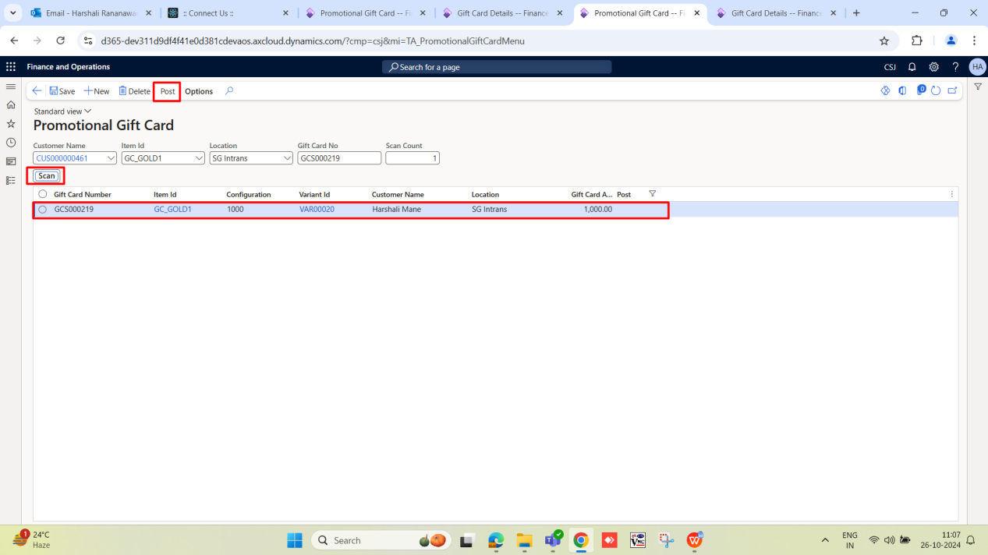

After click on “Post” button sales order generate and print format show.

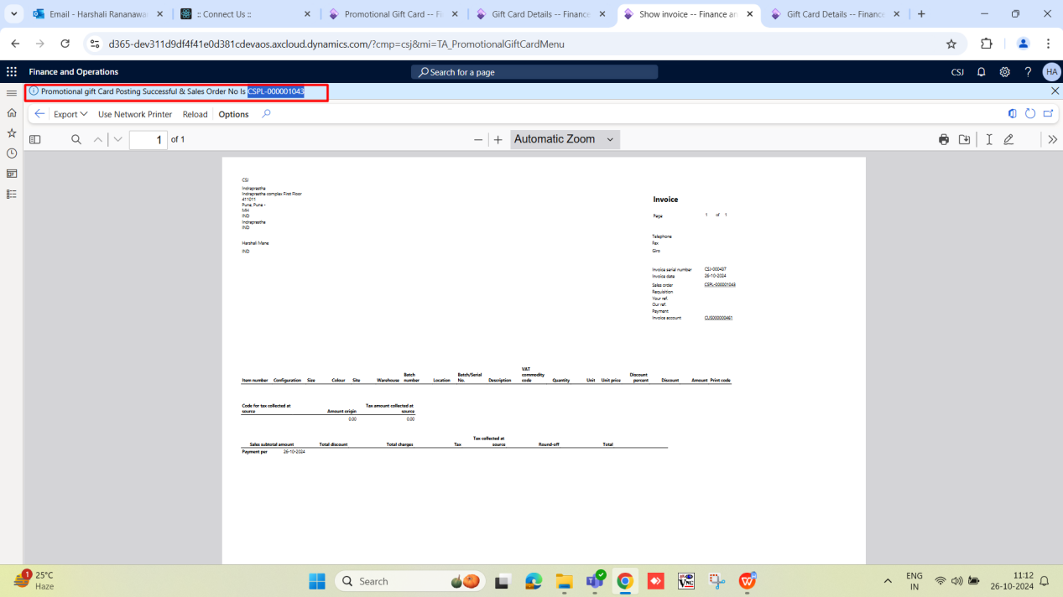

## Sales Order

For Sales Order show below menu. Accounts receivable - >Orders -> All sales orders

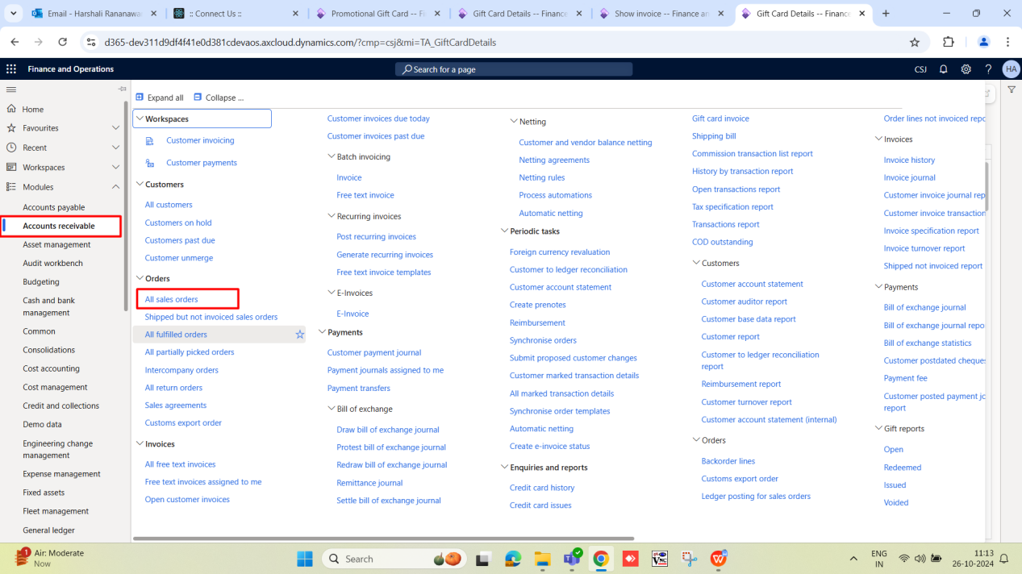

Sales Order generate in zero amount.

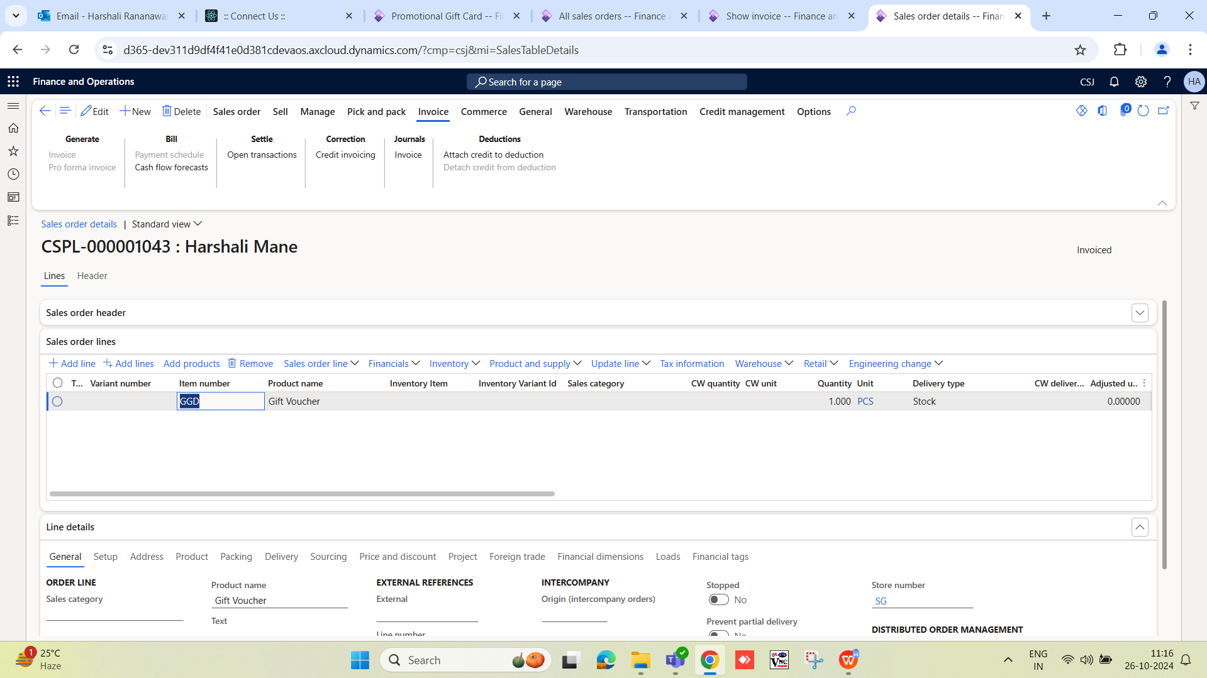

Below are the fields of sales order.

|  |  |  |  |
| --- | --- | --- | --- |
| **Sr. No** | **Field** | **Value** | **Description** |
| Sales Order Header | | |  |
|  | Name | Sayali B V | Customer name show here. |
|  | Delivery address | Sayali B V | Customer address show here. |
|  | Address | 42  Rasta peth Pune  Pune - 411011  MH  IND | Customer address show here. |
|  | Requested ship date | 03-07-2024 | Today's date should be reflected “Requested ship date” |
|  | Requested receipt date | 03-07-2024 | Today's date should be reflected “Requested receipt date” |
| Sales Order Line | | |  |
|  | Item Number | GGC | “Jewellery -> Setup -> Jewellery Parameter” Gift card product item should be reflect here. |
|  | Variant number | VAR001648 | Item against Variant number must be show here. |
|  | Product Name | GIFTCARD | Product Name must be show here. |
|  | Quantity | 1 | Quantity show 1. |
|  | Delivery type | Stock |  |
|  | Unit Price | 0 | Unit price show zero. |
|  | Net amount | 0 | Net amount show zero. |
|  | Assessable value | 0 | Assessable value show zero. |
| Line Details - General | | |  |
|  | Product Name | GIFTCARD | Product Name must be show here. |
|  | Store Number | HOPN | Store name show here. |
| Line Details - Setup | | |  |
|  | Created date and time | 07-08-2024 15:52:14 | Created date and time show. |
| Line Details - Address | | |  |
|  | Name | Sayali B V | Customer name show here. |
|  | Delivery address | Sayali B V | Customer address show here. |
|  | Address | 42  Rasta peth Pune  Pune - 411011  MH  IND | Customer address show here. |
| Line Details - Product | | |  |
|  | Configuration | VAR001648 | Item against Variant number must be show here. |
|  | Site | HOPN | As per location site should be reflect here. |
|  | Warehouse | HOPN | As per location warehouse should be reflect here. |
|  | Location | Default | Selected location show here. |
|  | Batch Number | GC0001 | Gift card number should be reflected. |

## Gift card status

After sales order generate Gift card status is issue and check this “Jewellery -> Gift Card Scheme -> Gift Card Transaction” menu.

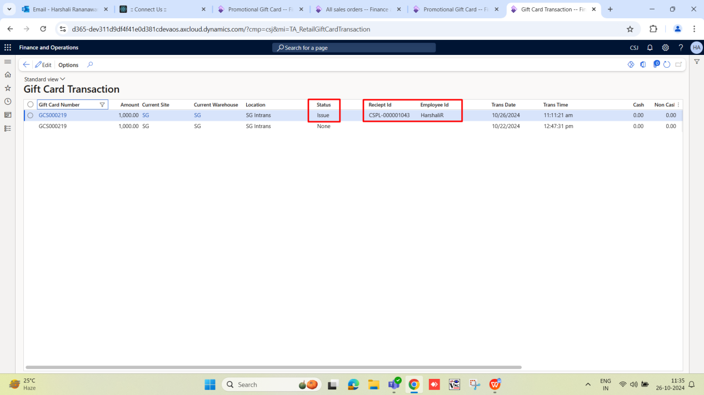

## Inventory

Inventory impact check on this “Finance and Operations -> Inventory management -> Enquiries and reports -> On-hand list” menu.

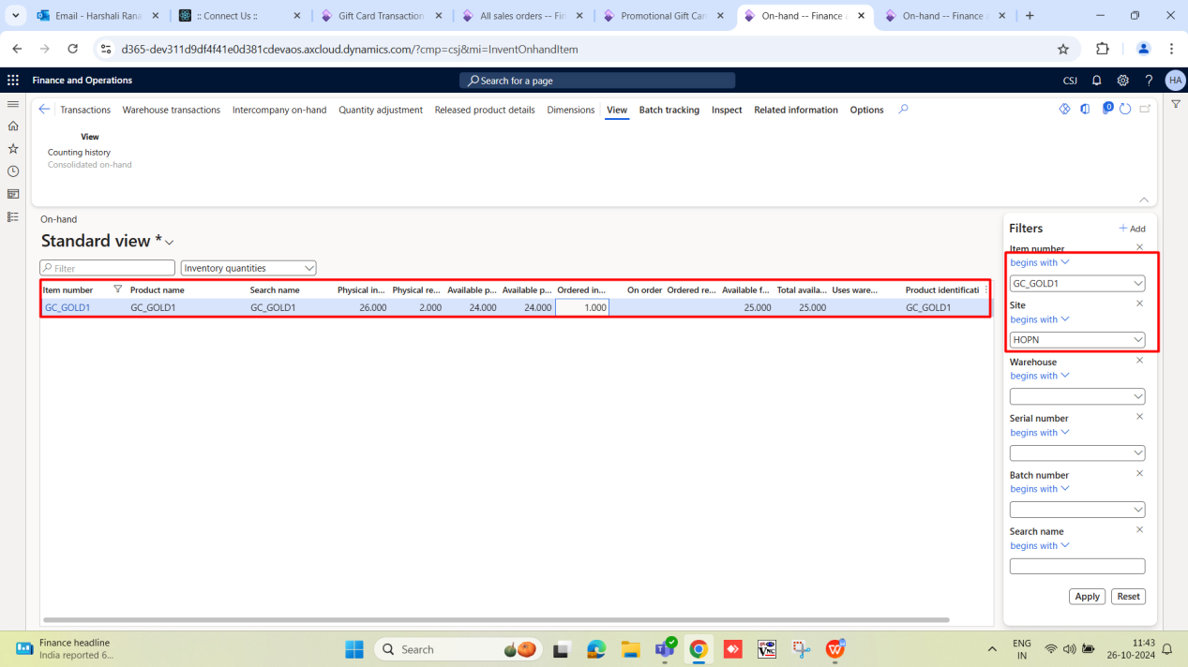

## Jewellery -> Gift Card Scheme -> Gift Card Transaction

Want to add below status against gift card.

|  |  |  |
| --- | --- | --- |
| **Sr. No** | **Field** | **Description** |
|  | Generated | Gift card is generated (Menu name - Jewellery -> Gift Card Scheme - > Gift Card Details) then status of the gift card should be “Generated”. |
|  | Issue | Gift card sales to customer then status should be “Issue”. |
|  | Redeem | Gift card use in the invoice then status should be “Redeem”. |
|  | Expiry | Gift card “Expiry Date” is tomorrow then status is “Expired”. |

|  |  |  |
| --- | --- | --- |
| **Sr. No** | **D field** | **Our** |
|  | None | Generated |
|  | Issue | Issue |
|  | Redeem | Redeem |
|  | AddTo |  |
|  | Refund |  |
|  | Adjust |  |
|  | MCRVoid |  |
|  | Close | Expiry |
|  | ManualUnlock |  |
|  | OfflineUnlock |  |
|  | Voidissue | Cancel |
|  | CashOut |  |

1. **REFERENCES OF THE USERS**

|  |  |  |  |
| --- | --- | --- | --- |
| **User** | **Name** | **Mail** | **Contact number** |
| **Actual user** | Pritam Metha. | pritam.metha@techneai.com |  |
| **Ticket created by (if any)** | Harshali Rananware. | harshali.rananaware@techneai.com |  |
| **Assigned business analyst** | Harshali Rananware. | harshali.rananaware@techneai.com |  |
| **Assigned developer** | Ankita Kirve. | ankita.kirve@techneai.com |  |
| **Assigned tester** |  |  |  |