#### Gift Card Sales Bill

|  |  |  |  |
| --- | --- | --- | --- |
| **Sr. No** | **Field** | **Description** | **Value** |
| **Header** | | | |
|  | Customer Name/Mobile No | Customer name is select from POS. | Harshali Ajay Rananaware. |
|  | Store | From cash registry location will show. | Pune |
|  | Net amount | Net amount will show. |  |
| **Customer name click** | | | |
|  | Customer name | Selected customer name is show. |  |
|  | Mobile number | Customer mobile number is show. |  |
|  | Address | Customer address is show. |  |
|  | X | Click on ”X’ this then show the main page. |  |
| **Add Data** | | | |
|  | Quantity | User can add quantity. | 3 |
|  | Starting Number | User can enter the starting number. | GC001 |
|  | > | Quantity is added and click on “>” this button then quantity field is disable. |  |
|  | Gift card name | As per “starting number” gift card name will be ”Jewellery -> Setup -> Jewellery Parameter” retail tab “gift card item against set the item show in this field. This is non editable field. | GC_Gold |
|  | Gift Card Category | As per “starting number” gift card category will show. This is non editable field. | 5000 |
|  | Ending number | As per “starting number” and “quantity” ending number will show. This is non editable field. | GC003 |
|  | Rate | As per Gift card rate will be display. | 5000 |
|  | Amount | Rate * quantity | 15000 |
|  | GV Validity date | As per gift card expiry date will be show. Expiry date is set against the item and jewellery parameter. Item against not set then consider jeweller paramtere against. | 25 Aug 24 |
|  | Save | Click on “save” then line will be show.as per gift card the gift card line will show. |  |
|  | Cancel | Click on “Cancel” then data should not be save. |  |
|  | X | Click on “X”then data should not be save. |  |
|  | Remark | User can add any remark in the field. |  |
| **Go To payment** | | | |
|  | Cash | This payment mode accept cash. |  |
|  | UPI | This payment mode accept online. |  |
|  | Card | This payment mode accept card. |  |
|  | Advance | This payment mode accept advance urd, customer order, blanket advance and sales return advance. |  |
|  | Credit | This payment mode we can put payment as credit as per authority. |  |

Check Posting for the sales bill.

#### First Page

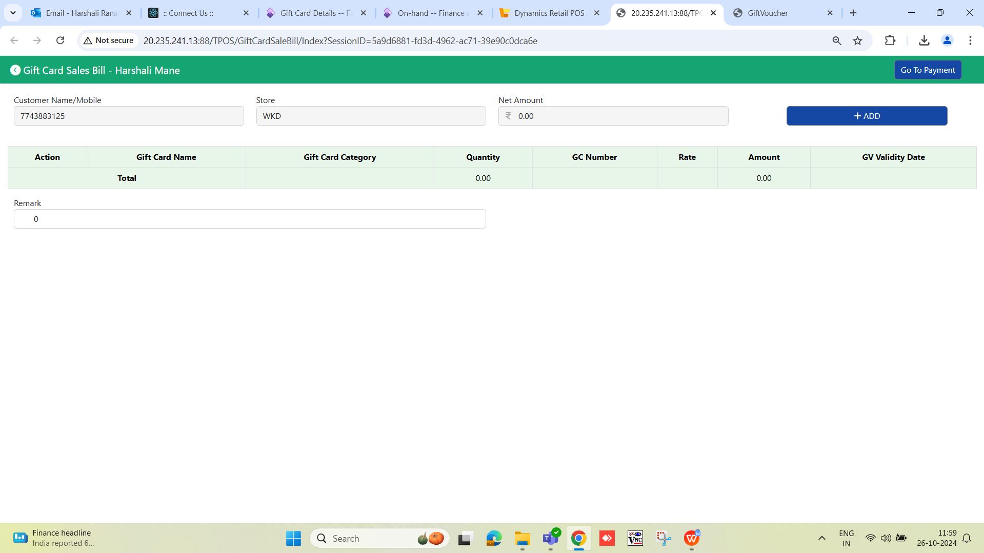

#### Add Data Page

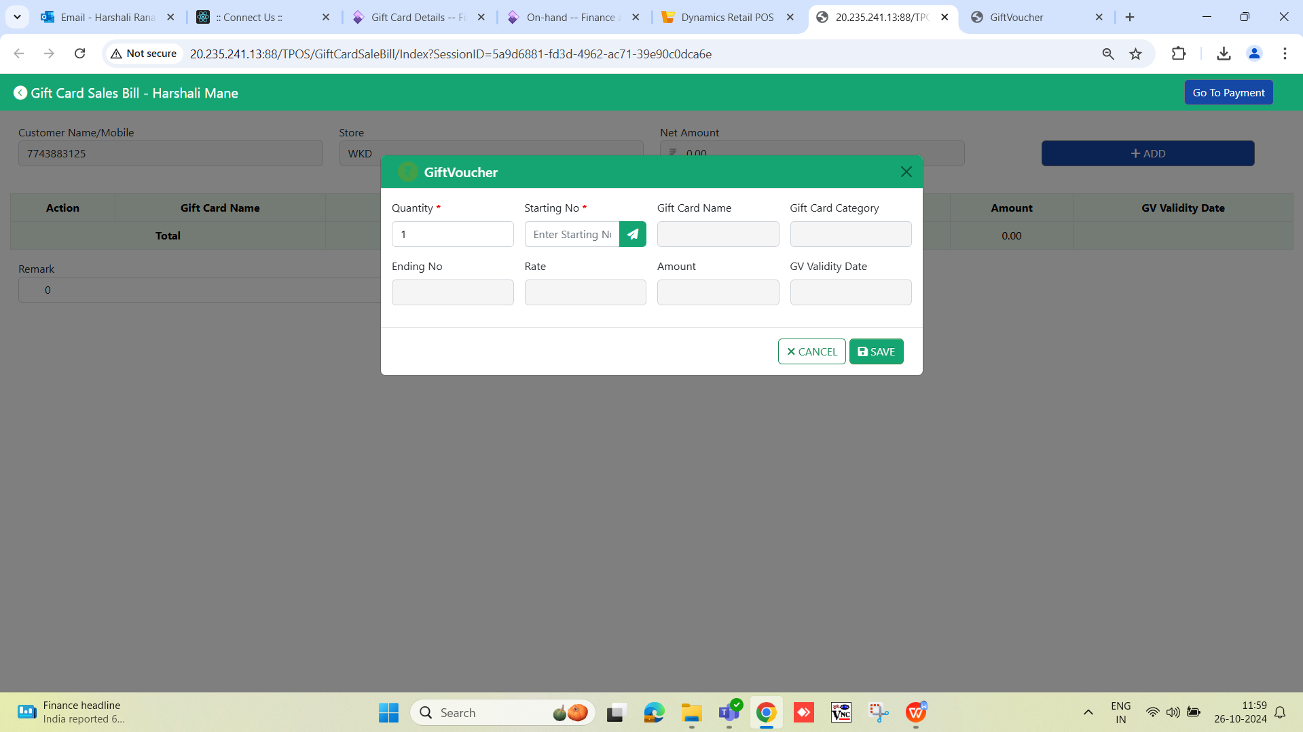

#### Notification

We can enter the quantity 3 and starting number is GC001 and GC002 is already issued then click on save button then show the pop up **“gift Card number: GC002 is already issued.”**

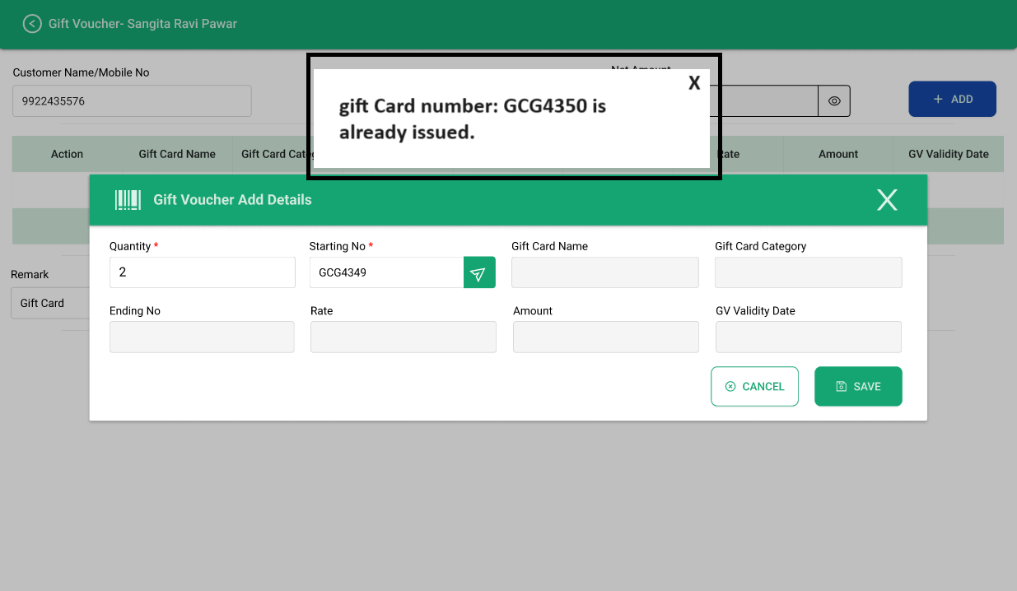

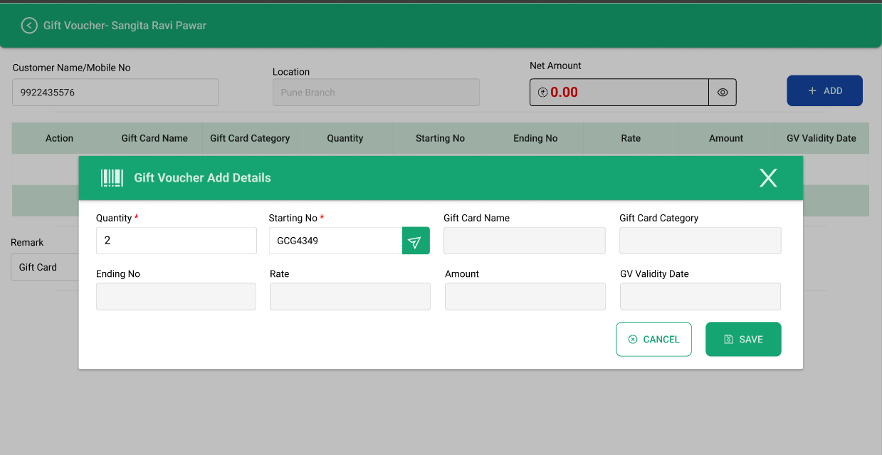

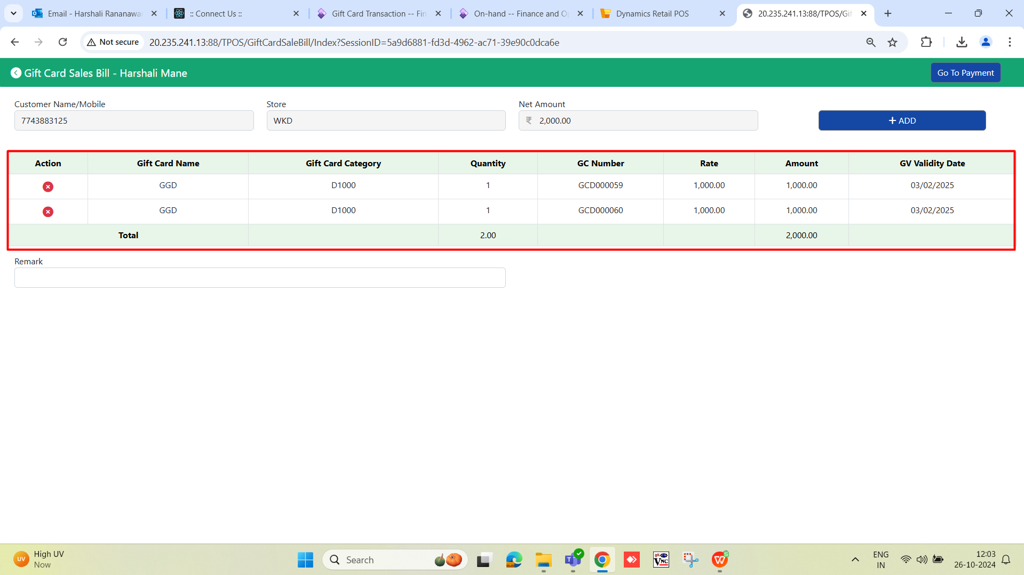

#### Payment Page

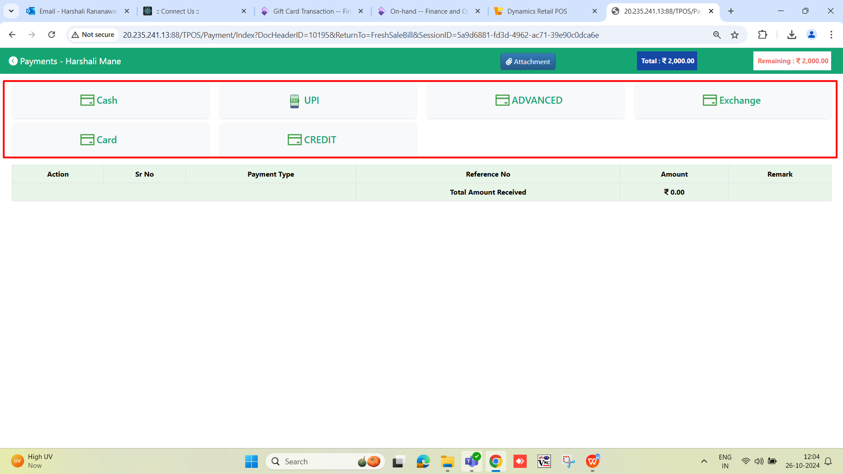

#### Signature

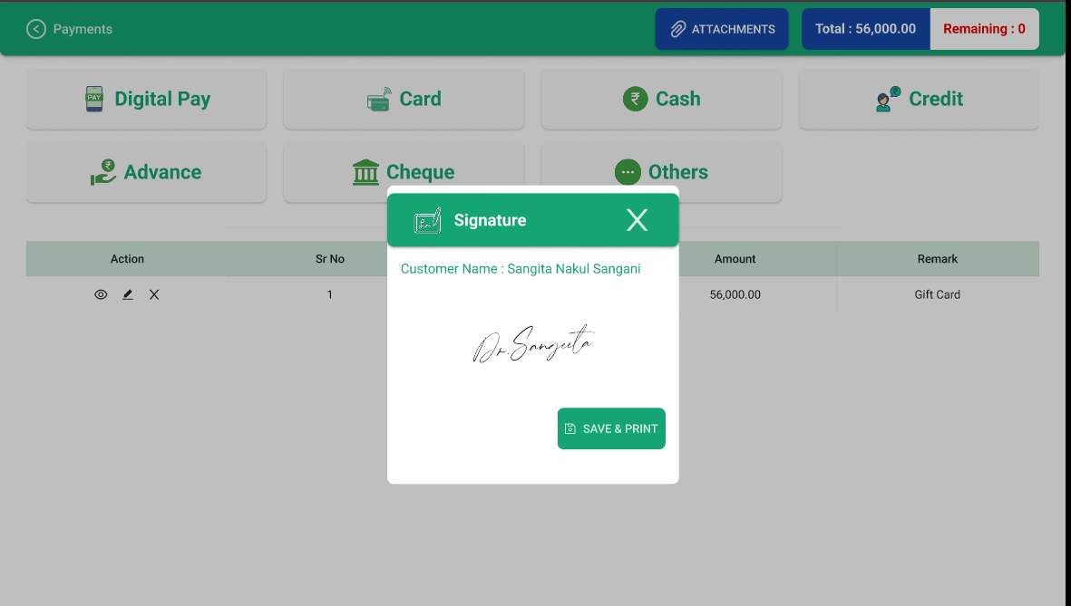

#### Print Preview

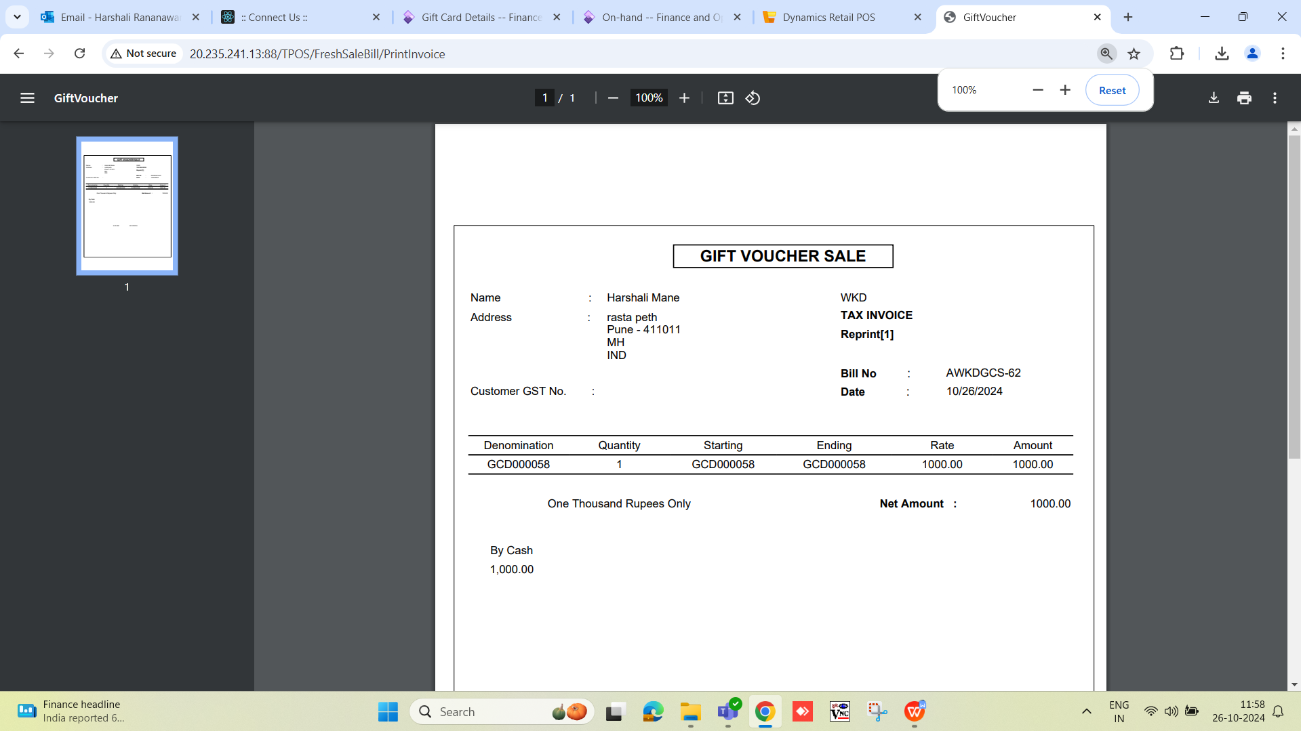

#### Inventory effect

GC number - GCD000058

