26.10.2024

[Gift Card Simulation ]

Harshali Rananaware

Harshali.rananaware@techneai.com

**Functional Requirement Document**

**CONTENTS**

1. TICKET DETAILS 2

2. VERSION CONTROL 2

3. APPROVALS 2

4. ESTIMATION 2

5. INTRODUCTION 3

6. BUSINESS REQUIREMENT 3

7. SCOPE 3

8. BUSINESS & SYSTEM RULES 3

9. ABBREVIATIONS & TERMS 3

10. EXISTING SYSTEM 3

11. GRAPHICAL REPRESENTATION 3

12. PROPOSED SYSTEM 3

13. TEST DATA 4

14. ODUS 4

15. REFERENCES OF THE USERS 5

1. **TICKET DETAILS**

|  |  |
| --- | --- |
| **Ticket ID** | TT26458 |
| **Ticket description** | Gift card simulation |
| **Created by** | Harshali Rananaware |
| **Created on** | 19/10/2024 |
| **Priority** | Very high |

1. **VERSION CONTROL**

|  |  |  |  |  |
| --- | --- | --- | --- | --- |
| **Sr. No** | **Version no** | **Version Date** | **User name** | **User department** |
| **1** | **1** | **26/10/2024** | **Harshali Rananaware** | **BA** |

1. **APPROVALS**

|  |  |  |
| --- | --- | --- |
| **Field** | **Name of the User** | **Approved date by the user** |
| **Actual User Name Actual User Department Organization Name** | Pritam Mehta  BA  Techneai |  |
| **Assigned BA** | Harshali Rananaware |  |
| **Assigned Developer** |  |  |
| **Assigned Tester** |  |  |

1. **ESTIMATION**

|  |  |  |  |  |
| --- | --- | --- | --- | --- |
| **Department name** | **Estimated Time (In hr)** | **Scheduled Date (Starting date)** | **Estimated date** | **Actual delivery date** |
| **BA** |  |  |  |  |
| **Development** |  |  |  |  |
| **Testing** |  |  |  |  |

1. **INTRODUCTION**

Gift card redemption time full gift card amount should be redeem.

1. **BUSINESS REQUIREMENT**

|  |  |  |  |
| --- | --- | --- | --- |
| **Requirement ID** | **Requirement Name** | **Short Description** | **Priority** |
| BR001 | Invoice | Gift card against set the multiple redemption type then full amount should be redeem. |  |
| BR002 | Payment mode | ON POS payment mode show the bifurcation. |  |

1. **SCOPE**

### 1. ****Executive Summary****

The purpose of this document is to outline the business requirements for enhancing the gift card redemption process to allow customers to redeem multiple gift cards in a manner that maximizes their benefits. The proposed enhancement will ensure that customers receive the highest possible value first from their gift cards same as Scheme redemption process

### ****Proposed Solution****

Implement a new redemption criteria that prioritizes the value of gift cards during the redemption process. The solution will include the following features:

* **Multiple Gift Card Redemption:** Allow customers to redeem more than one gift card in a single transaction.
* **Value Optimization:** Establish a redemption sequence where customers redeem gift cards in an order that maximizes their total value first.
* **User Interface Adjustments:** Update the user interface to display the total available balance from all gift cards before redemption and provide a clear breakdown of values being redeemed.

The system correctly prioritizes gift card redemptions based on the defined criteria.

1. **BUSINESS & SYSTEM RULES**

* User should be registered in the system.
* User should be logged in.
* System should display error message for incorrect details if entered.
* System should pop up a message, if any issues in the system is detected.
* All forms should have on field validations. System should display on field errors in case of incorrect inputs.
* Posting check for all document.
* Accounting check for all document.
* Inventory check for all document.
* Calculation should be as per regular invoice.

1. **ABBREVIATIONS & TERMS**

POS - POINT OF SALES

GC- GIFT CARD

1. **EXISTING SYSTEM**

In Existing system GC redeem condition is apply on first tag only.

1. **PROPOSED SYSTEM**

|  |  |  |  |  |  |  |  |  |
| --- | --- | --- | --- | --- | --- | --- | --- | --- |
| **Sr. No.** | **Gift card item** | **Gift card number** | **Gift card amount** | **Invoice number** | **Item** | **Discount Amount** | **priority** | **UTILIZATION** |
| 1 | GC_Gold | GCG001 | 5000 | ASGFSB-1 | GOLD | 200 | 3 | 0 |
| 1 |  |  |  | ASGFSB-1 | SILVER | 4000 | 1 | 4000 |
| 1 |  |  |  | ASGFSB-1 | DIAMOND | 1000 | 2 | 1000 |
|  |  |  |  |  |  |  |  |  |
| 2 | GC_Gold | GCG001 | 1000 | ASGFSB-2 | GOLD | 200 | 2 | 200 |
| 2 |  |  |  | ASGFSB-2 | SILVER | 300 | 1 | 300 |
| 2 |  |  |  | ASGFSB-2 | DIAMOND | 100 | 3 | 100 |
|  |  |  |  |  |  |  |  |  |
| 3 | GC_Gold | GCG001 | 4000 | ASGFSB-3 | GOLD | 4500 | 1 | 4000 |
| 3 |  |  |  | ASGFSB-3 | SILVER | 300 | 2 | 0 |

## Below document check the gift card redemption

* Invoice
* Customer Order
* Scheme instalment
* Scheme invoice

## **Step** -

* POS login
* Click on invoice.
* Scan tag.
* Click on save &create invoice.
* Click on “Gift card”.
* Add gift card number and save.

## BR002 - POS FLOW

Click on “Gift voucher sales bill” button.

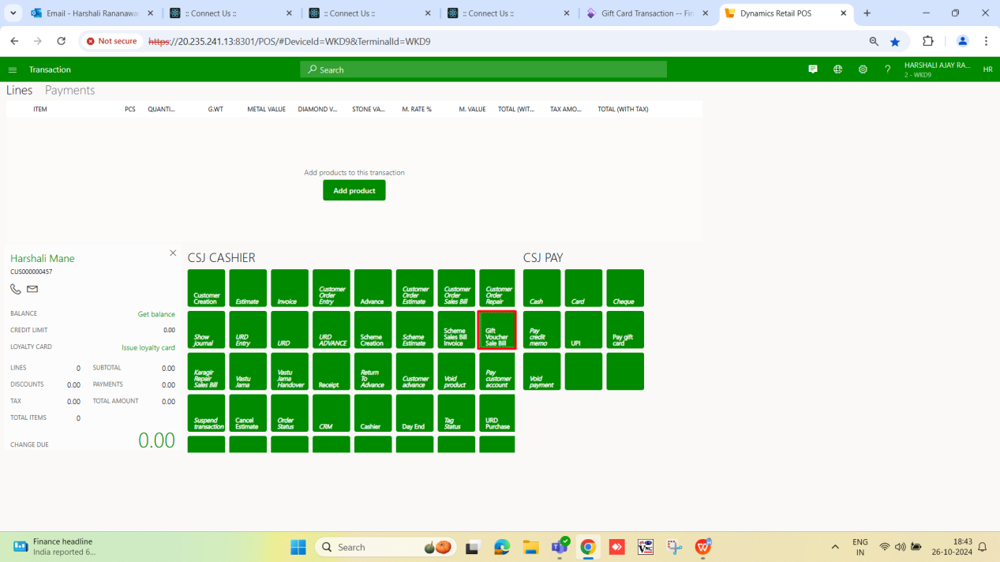

Scan tag and click on “save & create invoice”.

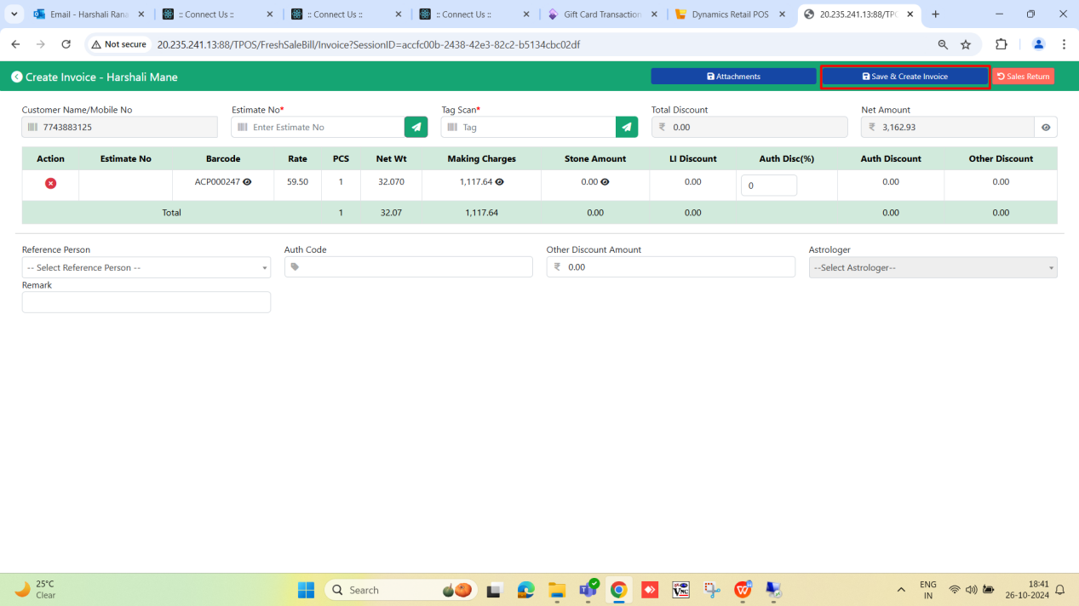

After click open Payment page. Click on “Gift Card” and redeem gift card.

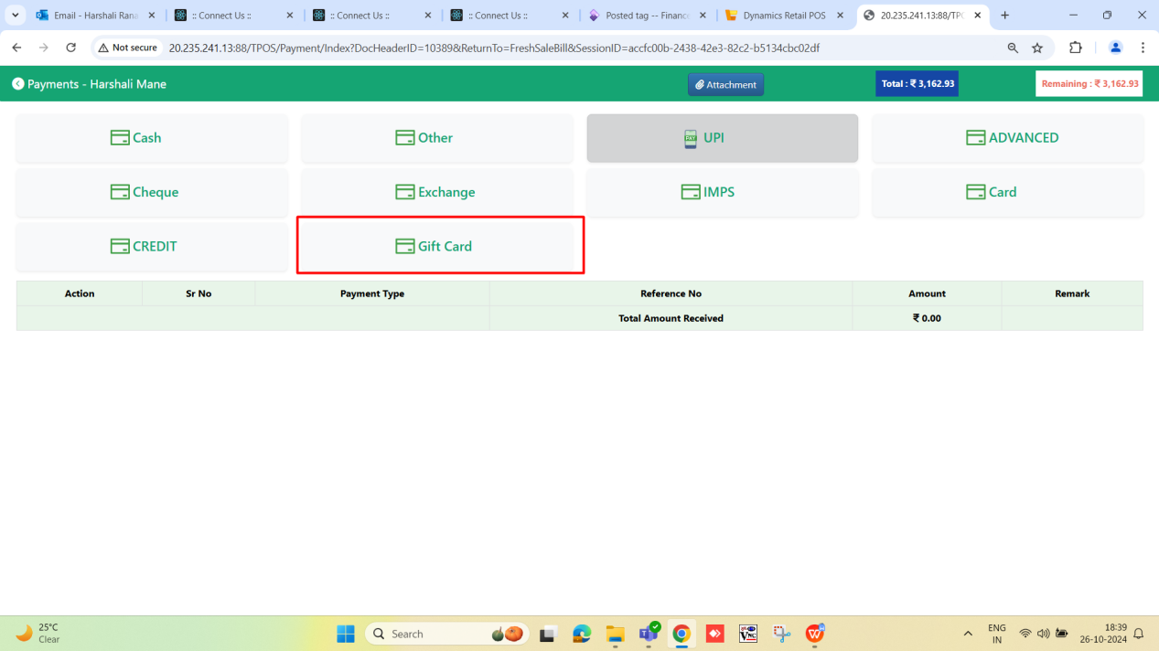

Enter a gift card details and click on “Confirm” button.

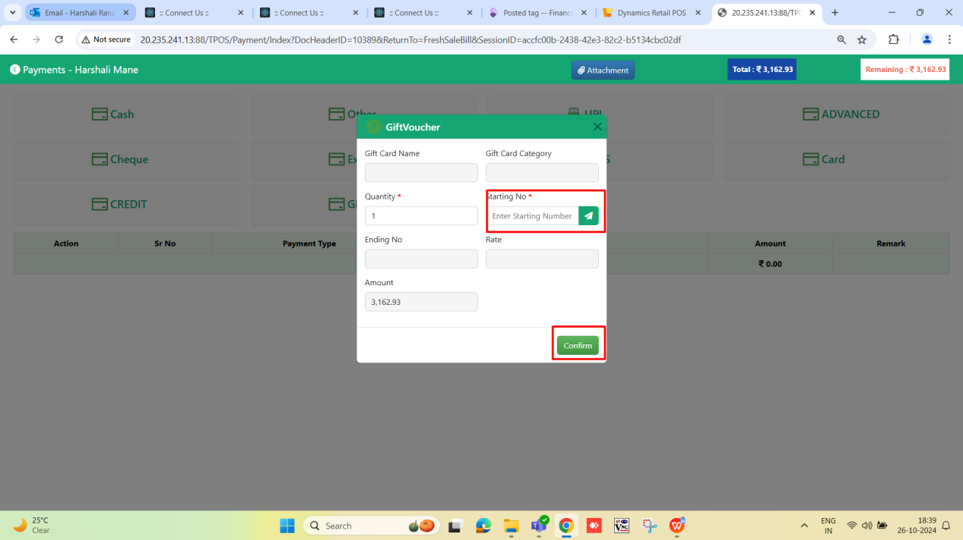

Gift card line will be add.

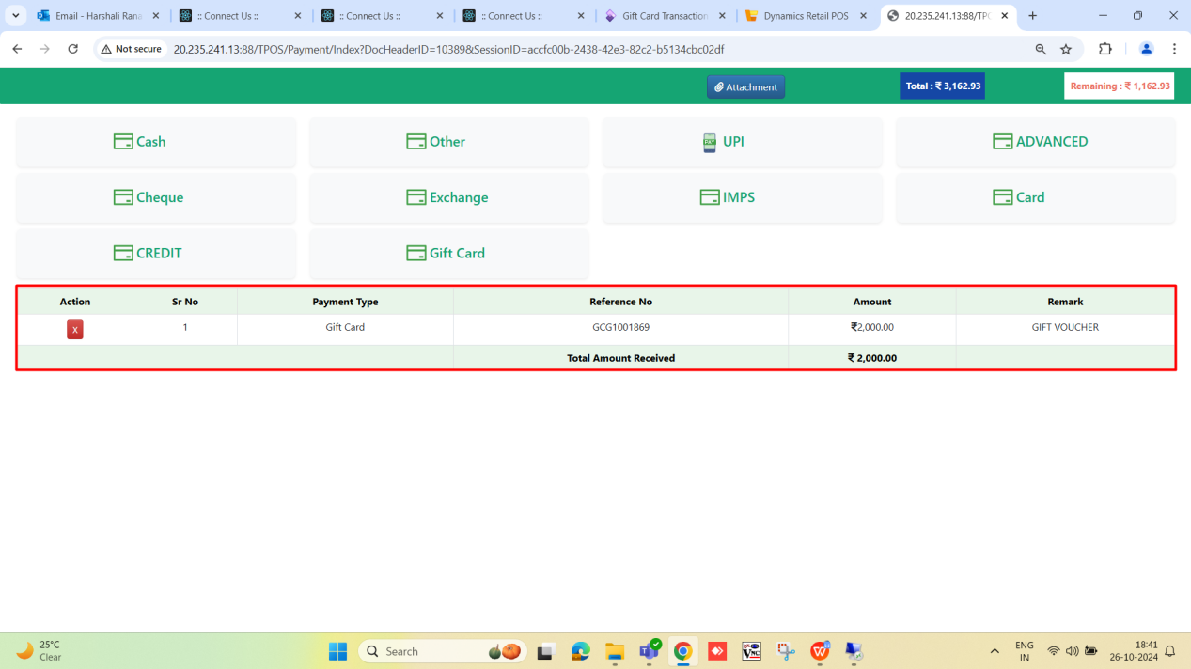

Payment mode

ON POS click on eye button the show the below format.

|  |  |  |  |  |  |  |  |  |
| --- | --- | --- | --- | --- | --- | --- | --- | --- |
| **Sr. No.** | **Gift card number** | **Gift card amount** | **Tag** | **Item Name** | **Discount type** | **Discount Percentage** | **Discount applicable amount** | **Discount amount** |
| 1 | GCG0001 | 10000 | SANG0020241 | SIL ANG | AMOUNT | 50 | 5000 | 5000 |
| 2 | GCG0001 | 10000 | ANG0020241 | ANGTHI | MAKING | 50 | 5000 | 2500 |
| 3 | GCG0001 | 10000 | DRI0020241 | D. RING | STONE | 20 | 600 | 120 |
| 2 | GCD002 | 5000 | ANG0020242 | ANGTHI | AMOUNT | 50 | 5000 | 2500 |

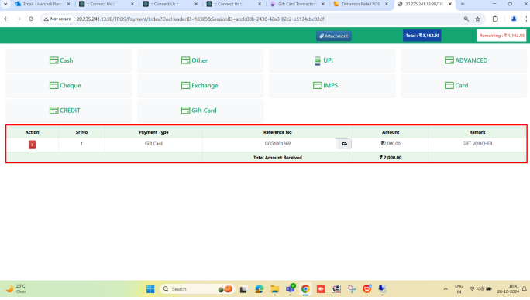

1. **ODUS ( Open Discussed Unhanded scenarios )**

|  |  |  |  |  |
| --- | --- | --- | --- | --- |
| **Sr. No.** | **Topic** | **Priority**  **(High / medium / low)** | **Remark** | **Status**  **(Open/**  **Closed)** |
| 1 | On POS view is required or not | High |  | Open |

1. **REFERENCES OF THE USERS**

|  |  |  |  |
| --- | --- | --- | --- |
| **User** | **Name** | **Mail** | **Contact number** |
| **Actual user** | Pritam Metha | pritam.metha@techneai.com |  |
| **Ticket created by (if any)** | Harshali Rananaware. | harshali.rananaware@techneai.com |  |
| **Assigned business analyst** | Harshali Rananaware. | harshali.rananaware@techneai.com |  |
| **Assigned developer** |  |  |  |
| **Assigned tester** |  |  |  |