#### ****Objective:****

The purpose of this document is to outline the structure and functionality of a new menu for confirming bulk customer orders and customer order repairs. The menu will only display open orders. A "Confirm All" button will allow the user to confirm all orders at once, but if there are any issues with an order, it will not be confirmed and will remain visible on the same page.

#### Menu

Jewellery -> Retail -> Customer Order/Repair -> Customer Order Confirmation

#### "Confirm All" Button

Once all open orders (for both customer and repairs) are listed, there will be a **“Confirm All”** button at the top of the page.

##### Functionality

* Clicking **“Confirm All”** will attempt to confirm all open customer orders and customer repair order.
* If **no issues** are found with any of the orders (both customer and repairs), the system will mark them as **“recorded”** and update their status accordingly.
* If **any issue** is found with any of the orders (either cstomer or repair), that order will **not be confirmed** and will remain on the list with the status still as "Open".

#### Process

Go to the link click on “Jewellery -> Retail -> Customer Order/Repair -> Customer Order Confirmation”.

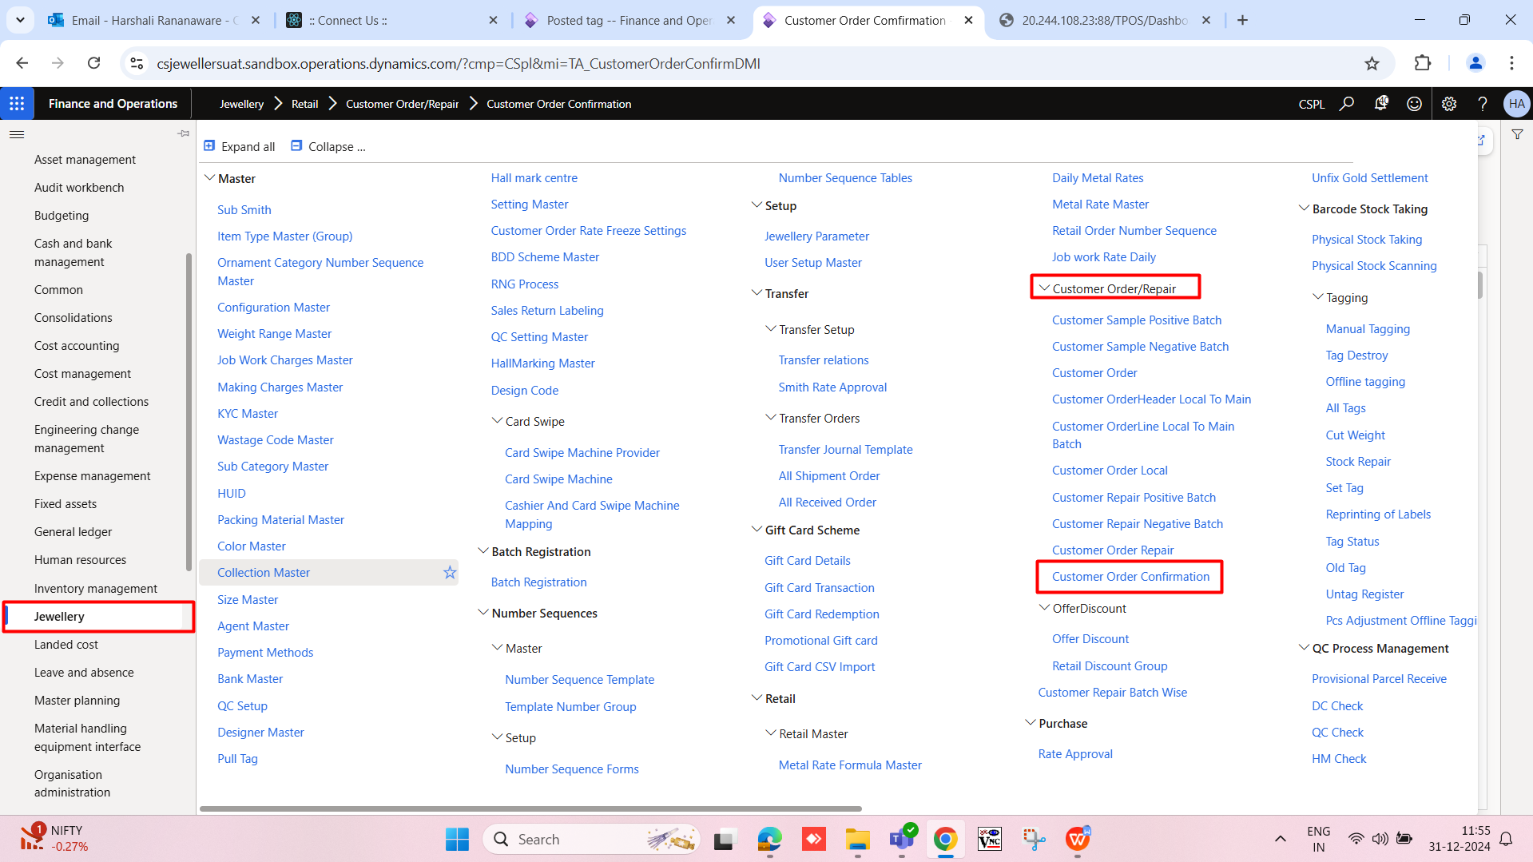

After clicking open this menu. Click on “Confirm all” button”.

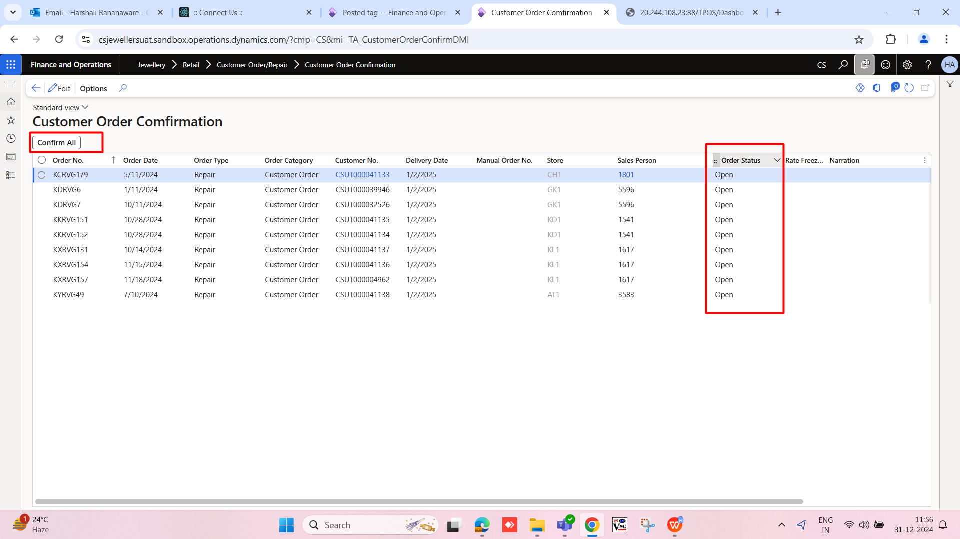

Issue in order this order show here.

