18.12.2024

Sanika Dewoolkar

Sanika.dewoolkar@techneai.com

**Functional Requirement Document**

KKJPL - PENDING ORDER

**CONTENTS**

1. TICKET DETAILS 2

2. VERSION CONTROL 2

3. APPROVALS 2

4. ESTIMATION 2

5. INTRODUCTION 3

6. BUSINESS REQUIREMENT 3

7. SCOPE 3

8. BUSINESS & SYSTEM RULES 3

9. ABBREVIATIONS & TERMS 3

10. EXISTING SYSTEM 3

11. GRAPHICAL REPRESENTATION 3

12. PROPOSED SYSTEM 3

13. TEST DATA 4

14. ODUS 4

15. REFERENCES OF THE USERS 5

1. **TICKET DETAILS**

|  |  |
| --- | --- |
| **Ticket ID** | TT26405 |
| **Ticket description** | Kothari - Pending Order |
| **Created by** | Sanika Dewoolkar |
| **Created on** | 18-10-2024 |
| **Priority** | High |

1. **VERSION CONTROL**

|  |  |  |  |  |
| --- | --- | --- | --- | --- |
| **Sr. No** | **Version no** | **Version Date** | **User name** | **User department** |
| **1.** | **1.1** | **18-12-2024** | **Sanika Dewoolkar** | **IT Implementation** |

1. **APPROVALS**

|  |  |  |
| --- | --- | --- |
| **Field** | **Name of the User** | **Approved date by the user** |
| **Actual User Name Actual User Department Organization Name** | Karan Kothari  KKJPL |  |
| **Assigned BA** | Sanika Dewoolkar |  |
| **Assigned Developer** |  |  |
| **Assigned Tester** |  |  |

1. **ESTIMATION**

|  |  |  |  |  |
| --- | --- | --- | --- | --- |
| **Department name** | **Estimated Time (In hr)** | **Scheduled Date (Starting date)** | **Estimated date** | **Actual delivery date** |
| **BA** |  |  |  |  |
| **Development** |  |  |  |  |
| **Testing** |  |  |  |  |
|  |  |  |  |  |

1. **INTRODUCTION**

Through Pending Order Bulk Upload menu, user can upload the bulk order .csv file in system mentioning the order details, for which unique PO number is generated.

The order of one particular SCM is divided and given to one or more karagirs. So, order number is generated for each Karagir. This is called as purchase order. Further, out of total pcs in one order given to Karagir is again divided as per delivery dates.

Example: Angathi- Fancy - 2.760-3.759 - 0 has total requirement of 40 pcs. Then this order of 40 pcs is divided and given to multiple karagirs. Like, 12 pcs order is given to Karagir A (PO1), 18 pcs order is given to Karagir B (PO2) and 10 pcs order is given to Karagir C (PO3). Further, PO1 of 12pcs can be sub-divided as per delivery date. Delivery date for 5 pcs can be set 18/05/2023 and delivery date for 7 pcs can be set 21/05/2023.

Users can view the order and generate challan for the same. Through PO Challan history, users can download the challan.

Users can cancel the ordered pcs through PO Bulk Order Upload File> View action.

Even after generating challan, the pcs can be rejected by user through PO Challan History> View action. The details of the same will be maintained in detail table.

1. **BUSINESS REQUIREMENT**

|  |  |  |  |
| --- | --- | --- | --- |
| **Requirement ID** | **Requirement Name** | **Short Description** | **Priority** |
| BR001 | Upload bulk file of new order | User will upload an excel file with details as order date, Karagir, item, category, size range, weight range, new order, Dia Pcs, Dia Wt, Stone Wt, Design No, Metal Color. | High |
| BR002 | Bulk upload - Grid | Once excel file is uploaded with valid details, record will be displayed in grid with PO no. to it. | Medium |
| BR003 | Bulk upload - view | It should display the details which were inserted displaying the total order details which were inserted in file, count of canceled items. | High |
| BR004 | Bulk upload - cancel action | User will be able to cancel the items of that order by specifying reason from the drop-down list through remark master. | High |
|  | Authority based actions | Uploading excel bulk file will be based on authority.  Canceling order pcs action will be based on authority. | High |
| BR005 | Vendor pending order | Inventory team will be able to view orders given to vendors with details of total pending quantity of each order number. | High |
| BR006 | Vendor pending order -> Challan | Once user enters the new delivery count and submits, Challan should get generated. | High |
| BR007 | Padm vendor mapping | We have multiple vendors created with different names in vendor master as per ornament. However, it is only one vendor in Padm. Thus through vendor mapping, user will select vendor name from drop-down and mention all its possible names. | High |
|  | PO Challan History | User will be able to bulk temporary/permanent reject the pcs from PO Challan history view action | High |

1. **SCOPE**

Using the PO Bulk File Order Upload menu, users can upload an Excel file containing order details to be provided to the vendor. Upon successful upload of a file with valid data, an order number will be generated, and the record will be displayed in the grid. Detailed information for each order can be viewed through the view action, and users have the option to cancel or reject specific units from the given order.

Another part of this includes Vendor Pending order. When bulk upload order is uploaded then given orders will be displayed in this menu. Users can view the orders, enter the quantity which vendor is delivering, generate Challan for it.

Through PO Challan History, users can download challan in the system, additionally, through view action, users have the option to temporary or permanent reject specific units from the given order.

The scope of the ticket is to deliver PO Bulk menu, Vendor PO Mapping, Vendor Pending Order and PO Challan History to KKJPL.

In this menus, additional fields like Dia Pcs, Dia Wt, Stone Wt, Design No, Metal Color have been added in PO Bulk upload file and fields like Order date, karagir Wt range, Knock off wt range, karagir size range have been made optional. This additional fields will be reflected in the Vendor pending order grid, challan history view and PO bulk upload view action.

1. **BUSINESS & SYSTEM RULES**

* User should be registered in the system.
* User should be logged in.
* System should display error message for incorrect details if entered.
* System should pop up a message, if any issues in the system is detected.
* All forms should have on field validations. System should display on field errors in case of incorrect inputs.

1. **ABBREVIATIONS & TERMS**

PO - Pending Order

SCM code- item, category, weight range, size range, purity range

Wt - weight

Qty - quantity

DNC - do not consider

Dia- Diamond

1. **PROPOSED SYSTEM**

In Connect us, we have to create pending order as main menu which will have bulk upload, vendor PO and Challan history modules in it.

**Step 1. PO BULK FILE UPLOAD**

Through pending order the user will upload the Excel file containing the details of orders given for Karagirs as per the SCM code. It will have following fields:

* Download bulk format
* Upload bulk file
* View action
* History action
* PO date
* PO no.
* Karagir
* Total order pcs
* Created at
* Created by
* Updated at
* Updated by

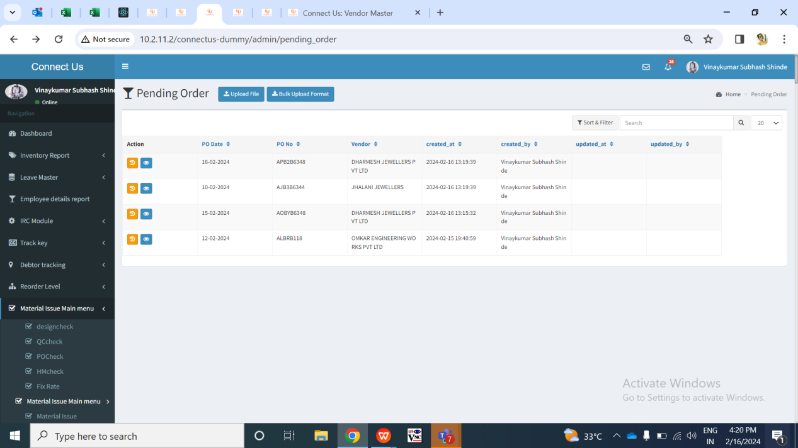

Fig: PO Bulk upload menu -> grid

User will have to first download the bulk format file. Once user clicks on bulk upload format, excel file will get downloaded which will have following columns:

* Delivery date
* Order date
* Karagir
* Item
* Category
* Size range
* Weight range
* Exact wt
* Purity range
* New order
* Karagir weight range
* Knockoff weight range
* Karagir size range
* Dia Pcs
* Dia Wt
* Stone Wt
* Design No
* Metal Color

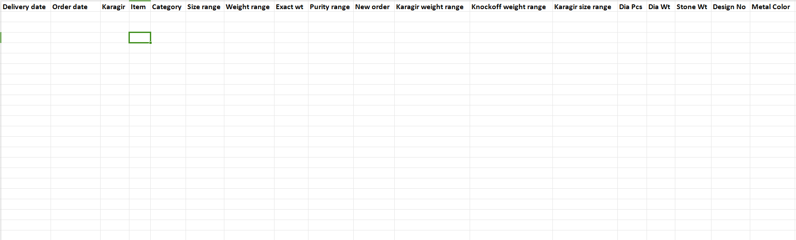

Fig: PO Bulk upload menu -> Download bulk format

|  |  |  |  |  |
| --- | --- | --- | --- | --- |
| **FIELDS** | **INPUT TYPE** | **MANDATORY/ OPTIONAL** | **EDITABLE** | **DESCRIPTION** |
| Delivery Date | Text | Yes | No | User will enter the delivery date on which the order is expected to be delivered by the vendor at inventory.  Validation: Delivery date and order date can be same.  Delivery date will be greater than or equal to Order date.  Its format in excel file will be MM/DD/YYYY or DD-first three letters of month-YY. Its format will be as ‘Date’ in excel and not text. |
| Order date | Text | Optional | No | User will enter the date on which the order is given to the vendor for that SCM code.  Validations: Delivery date should and order date can be same. Its format in excel file will be MM/DD/YYYY or DD-first three letters of month-YY. Its format will be as ‘Date’ in excel and not text.  If the order date is not entered by user then system should auto fill the order date as current date. |
| Karagir | Text | Mandatory | No | User will enter the name of the vendor to whom this order is given. Vendor name will be first added in Padm vendor mapping as well.  Validation: It will accept exact name from connect us -> bill checking -> vendor master which are active only. |
| Item | Text | Mandatory | No | User will mention item name from the SCM master gold. |
| Category | Text | Mandatory | No | User will mention category name from the SCM master gold for that item. |
| Exact wt | Text | Mandatory | No | User will mention the exact wt of the item - category which will be between mentioned weight range only. |
| Weight range | Text | Mandatory | No | User will mention weight range from the SCM master gold for that item -category. |
| Size range | Text | Mandatory | No | User will mention size range from the SCM master gold for that item -category. |
| Purity range | Text | Mandatory | No | User will mention purity range from the SCM master gold for that item - category. As SCM code is combination of item-category-weight range - size range - purity rnage, if user enters any of these values and there is not SCM code then it will display error for that record. |
| New order | Text | Mandatory | No | User will mention the pcs count for which are to be ordered from the vendor for that SCM code. |
| Karagir wt range | Text | Optional | No | User will enter the Karagir wt range that that means weight range as per karagir’s record.  Validation: Karagir wt range can be different from weight range column but Karagir wt range has to be between or equal to mentioned weight range only.  If this field is blank, then the karagir weight range should be considered same as weight range entered in .csv excel file. |
| Knockoff wt range | Text | Optional | No | User will mention the weight range against which we have to map the pcs with net wt field of labeling file once uploaded.  Validation: Knockoff wt range can be different from weight range column but knock off wt range has to be between or equal to mentioned weight range only.  If this field is blank, then the karagir weight range should be considered same as weight range entered in .csv excel file. |
| Karagir size range | Text | Optional | No | User will enter the Karagir size range for that item - category.  Validation: Karagir size wt range can be different from SCM size range column but karagir size range has to be between or equal to mentioned SCM size range only.  If this field is blank, then the karagir size range should be considered same as size range entered in .csv excel file. |
| Diamond Pcs | Text | Mandatory | No | User will enter the diamond pcs for that item.  This field will be just for information. While knocking off of the pcs, this field will not be considered. |
| Diamond Wt | Text | Mandatory | No | User will enter the diamond wt for that item.  This field will be just for information. While knocking off of the pcs, this field will not be considered. |
| Stone Wt | Text | Optional | No | User will enter the stone wt for that item.  This field will be just for information. While knocking off of the pcs, this field will not be considered. |
| Design No | Text | Mandatory | No | User will enter the Design No for that SCM Code.  This field will be just for information. While knocking off of the pcs, this field will not be considered. |
| Metal Color | Text | Optional | No | User will enter the Metal color for that item.  This field will be just for information. While knocking off of the pcs, this field will not be considered. |

Fig: PO Bulk Upload file

Once user uploads the bulk order file through upload button and clicks on submit button, submit button will be disabled until successful or error message gets displayed.

In case any of the data in uploaded bulk file is incorrect, error will be displayed. User can download the error file in which error message will be displayed against each incorrect record. None of the data will get uploaded if any single data is invalid in bulk file. Duplicate record of entire same same cannot be added. Bulk will upload data only if it has all correct details in it.

Once file is uploaded, then the collated data will be displayed as per Order date, order no and Karagir name in the grid.

Additionally, through ‘send email’ action button against every record, users can send email to the vendor on their registered email id of the pending order keeping following emails in CC:

[Cc : karan@kkjpl.com arjun@kkjpl.com pradeep@kkjpl.com ushab@kkjpl.com order.dia@kkjpl.com order.gold@kkjpl.com order.sil@kkjpl.com](http://3.108.206.34/TechTicket/Ticket)

The email will have below format:

|  |
| --- |
| Subject Line: Purchase Order (PO number)  Attachment: (Excel file with below table field)  Hello (vendor name)  Please find the specifications of the order below.    Please fill this order as soon as possible.  In case of any queries, please contact us at:  Email:  Contact No: 9326677109 / 9834163394  Thank You  Regards,  Order Dept.  KKJPL |

The record of that uploaded file I.e. that upload activity only will be displayed in grid whereas will be removed when user explores to another menu. PO Bulk upload menu will have following columns on grid:

* PO date
* Delivery date
* Order number
* Vendor name
* Total Order pcs
* Created at
* Created by
* Updated at
* Updated by

|  |  |  |  |  |
| --- | --- | --- | --- | --- |
| **FIELDS** | **INPUT TYPE** | **MANDATORY/ OPTIONAL** | **EDITABLE** | **DESCRIPTION** |
| PO Date | Text | Mandatory | No | It will display the order date when the excel file was uploaded in the system.  Validation: It will be displayed in MM/DD/YYYY format. |
| Delivery date | Text | Mandatory | No | It will display the delivery date of that order from the bulk file.  Validation: It will be displayed in MM/DD/YYYY format. |
| Order number | text | Mandatory | no | Once bulk file is uploaded, order no. will be generated by the system.   * First letter for financial year code (A for 2023-24 and there onwards) * Second character stands for order date (A to Z for dates 1 to 26 and then numbers 1 to 5 for dates from 27 to 31) * Third character stands for order date -> month ( A to L means from jan to dec) * Fourth character stands for delivery date (A to Z for dates 1 to 26 and then numbers 1 to 5 for dates from 27 to 31) * Fifth character stands for delivery date -> month ( A to L means from jan to dec) * Sixth onwards will be vendor code from database |
| Vendor name | Text | Mandatory | No | It will display the Karagir name which was mentioned in the uploaded bulk file for that record. |
| Total order pcs | Text | Mandatory | No | It will display the count of total pcs under that order once user uploads the bulk upload file. |
| Created by | Text | Mandatory | No | It will display the name of the employee who created this record by uploading the bulk file. |
| Created at | Text | Mandatory | No | It will display the date and time on which the record was created in the grid by uploading bulk file. |
| Updated by | Text | Mandatory | No | It will display the employee name once user updates the record either by canceling the pcs of that order through view and by uploading new order under it. |
| Updated at | Text | Mandatory | No | It will display the date and time on which the record was updated by uploading bulk file. |

For each new order, if SCM code and Karagir name is same, then the new order pcs will get added in the same existing order if delivery date is not different.

Once data is uploaded, successful message will be displayed and data will be displayed in the grid for one time. If user re-uploads new data, then newly uploaded data will be displayed in grid and previous one will not be displayed. If user visits on another menu, then the grid data of PO bulk upload will be removed as it is one time activity.

As header includes PO order number, PO date and vendor number, view action will display order details of each SCM code in that order. Through **view action** of each PO, details of that order will be displayed as below:

* PO date
* PO no.
* Vendor name
* PO Order details Table
* Item
* Category
* Weight range
* Size range
* Purity range
* Dia Pcs
* Dia Wt
* Stone Wt
* Design No
* Metal Color
* Delivery Date
* Total Order
* Accepted Quantity
* Canceled quantity
* Permanent reject qty
* Temporary reject qty
* Canceled pcs count
* Cancel action
* Table of canceled details

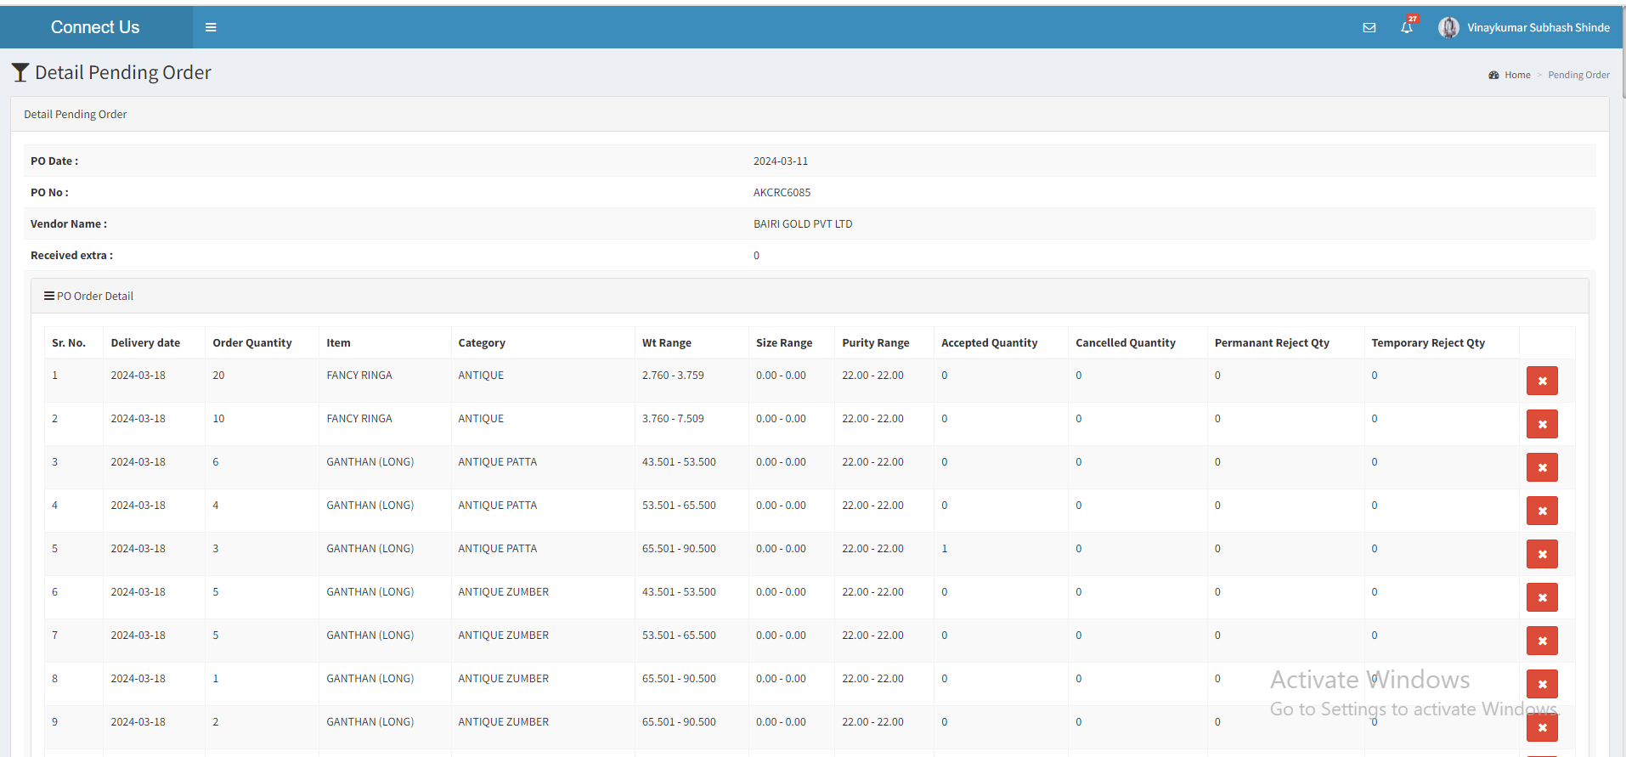

Fig: PO Bulk upload file menu -> view action

|  |  |  |  |  |
| --- | --- | --- | --- | --- |
| **FIELD** | **INPUT TYPE** | **MANDATORY** | **EDITABLE** | **DESCRIPTION** |
| PO Date | Text | Yes | No | It will display the order date of that order which will as same as in grid as per uploaded bulk order file. |
| PO number | Text | Yes | No | It will display the order number for that record as same as in grid. |
| Vendor name | Text | Yes | No | It will display the Karagir name of that order as per grid and uploaded bulk order file. |
| PO Order details table | Text | Yes | No | It will display the order details of each SCM code under that order. It will display following columns and details as per uploaded order file in each row:   * Item * Category * Weight range * Size range * Purity range * Delivery Date * Total Order * Accepted Quantity * Canceled quantity * Canceled pcs count * Cancel action |
| Delivery Date | Text | Yes | No | It will display the delivery date of the order given to vendor for that particular SCM code(item-category-size range-weight range-purity range). It will displayed as per uploaded bulk order file.  Validation; Its format will be MM/DD/YYYY. |
| Count of total pcs ordered | Text | Yes | No | It will display the count of total pcs of order that has been given to Karagir for that SCM code and delivery date. It will be displayed as per uploaded bulk order excel file. |
| Canceled pcs | Text | Yes | No | It will display the total pcs of order that have been canceled by the authorized user through cancel action. |
| Permanent reject qty | Text | Yes | No | It will display the count of pcs against that row which user rejected through po challan history -> view -> reject. |
| Temporary reject qty | Text | Yes | No | It will display the count of pcs against that row which user rejected through po challan history -> view -> reject temporary. |
| Cancel action button | Click | - | - | This button will be provided based on authority.  Through cancel action, authorized user can cancel the entire order or few pcs from the order that has already been given to vendor. Once authorized user clicks on cancel button, it will display below fields:   * Cancel pcs count * Cancel reason * Confirm button       Cancel count will be text field where user will mention the number of pcs that has to be canceled.  Cancel reason - Reasons on drop-down list of ‘cancellation reason’ will be specified from daily stock remark master-> active reasons. It will be mandatory and single select.  Once user clicks on submit button, dialogue box will be displayed as “Are you sure you want to cancel?” Once user clicks yes, then the count of canceled pcs will be displayed in ‘canceled pcs’ field.  Canceled pcs count should get deducted from the total pcs orders. User can cancel the item pcs out of total order pcs only. |
| Table of canceled details | Text | - | No | It will display details of canceled pcs in table having following columns:   * Delivery date * Order quantity * Canceled quantity * Reason * Canceled by * Canceled date and time |

**Step 2. Padm Vendor Mapping**

As there are multiple vendor names in vendor master for the same vendor name. We need to map the different vendor names with Padm vendor name.

Padm Vendor mapping will have following fields:

* Add button
* View button
* Edit button
* Vendor name I.e. company name
* Padm vendor name I.e. ledger name
* Is active
* Remark
* Created at
* Created by
* Updated at
* Updated by

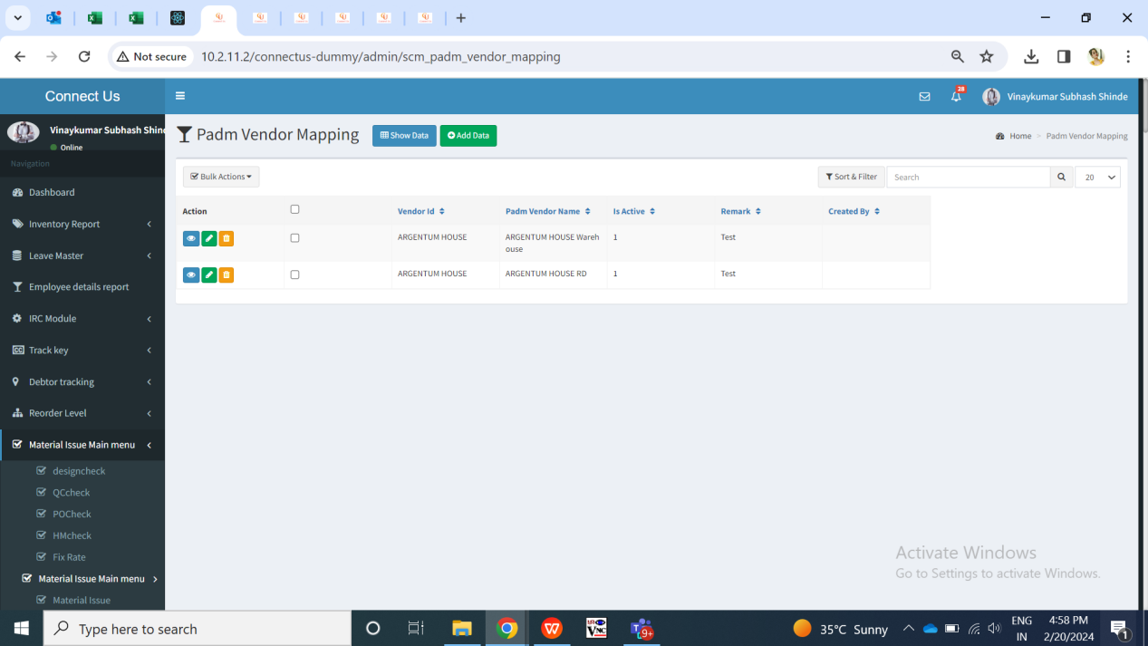

Fig: Padm vendor mapping -> grid

|  |  |  |  |  |
| --- | --- | --- | --- | --- |
| **FIELD** | **INPUT TYPE** | **MANDATORY** | **EDITABLE** | **DESCRIPTION** |
| Vendor name | Drop down | Yes | Yes | User will select the vendor against which the Padm name is to be mentioned which will get checked when labeling file is uploaded. It will display the list of vendors from bill checking -> vendor master.    Validation: It will be single select. |
| Padm vendor name | Text | Yes | Yes | User will mention the Padm names for that vendor here.  Validation: It has to be unique for same vendor I.e company name else it should display error message as ‘record already exists’.  Min length = 3  Max length = 50 |
| Is active | Radio button | Yes | Yes | If the user selects it as active, then it will consider and map the order correctly with the Padm vendor name mentioned. If this is inactive, then labeling file will display error when user will upload the data of inactive Padm vendor name.  Validation: it will be single select. Default value will be yes. |
| Remark | Text | Optional | Yes | User will mention the additional comments here if required.  Validation: It will accept characters, numbers, space and special characters.  Min length = 0  Max length = 250 |
| Save | Click | - | - | Once user enters data in mandatory fields and clicks on save button, Padm vendor name will get saved for that vendor. |

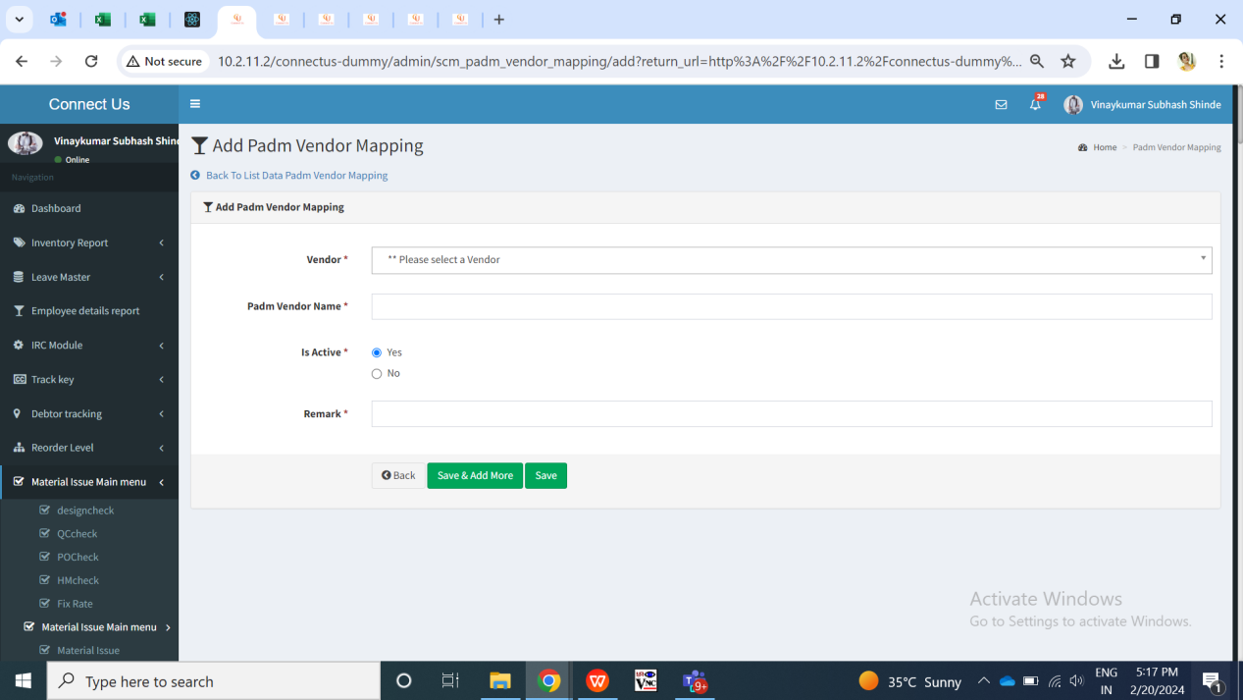

Fig: Padm vendor name menu -> Add

View action of Padm vendor mapping menu will have following fields:

* Vendor name
* Padm vendor name
* Is active
* Remark
* Created at
* Created by
* Updated at
* Updated by

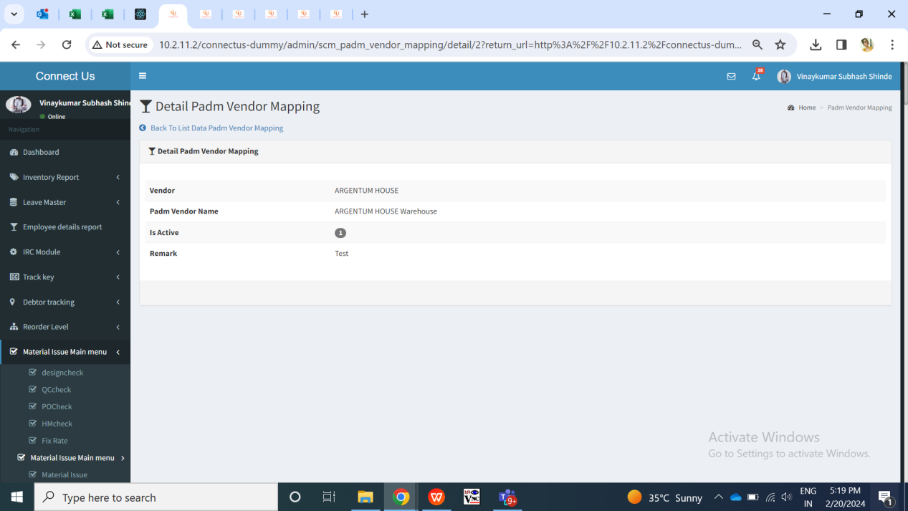

Fig: Padm vendor mapping -> view action

**Step 3. VENDOR PENDING ORDER**

Through this menu, users can log into the system and view the total orders and its quantities vendor have received from the them. Jeweller can also enter the quantity of each order which they want to get delivered and thus generate Challan for it.

Orders of recent delivery date will be displayed on top. Once user logs in and clicks on Vendor Challan Generation, it will display following fields:

* Select Vendor
* Search bar
* Export button
* Order details
* Select check box
* Sr. No.
* PO number
* Delivery Date
* Item
* Category
* Wt range
* Karagir Size range
* Exact Wt
* Purity range
* Dia Pcs
* Dia Wt
* Stone Wt
* Design No
* Metal Color
* New Delivery
* Balance quantity
* Copy Balance Qty
* Submit button

In grid view, it will display the list of orders given by the jeweller to the selected vendor. It will display the order number and its SCM code details along with total pcs which are to be delivered to jeweller by the vendor.

|  |  |  |  |
| --- | --- | --- | --- |
| **FIELDS** | **INPUT TYPE** | **MANDATORY/ OPTIONAL** | **DESCRIPTION** |
| Select Vendor | Dropdown | Mandatory | Jeweller can select the vendor name from dropdown.  The dropdown list of vendors will be fetched from connect us -> bill checking -> vendor master which are active only.  The selected vendor's details will be displayed in grid view.  Below fields will be displayed :   * Select check box * Sr. No. * PO number * Delivery Date * Item * Category * Wt range * Karagir size range * Exact Wt * Purity range * New Delivery * Balance quantity |
| Search bar | text | Optional | Vendor can search the order by PO number, delivery date, item, category, wt range, size range, purity range, balance qty.  Once vendor enters any details, it will display the exact match records in the grid.  Validation: By default search field will be blank and will display all orders in the grid.  Min length = 0  Max length = 100 |
| Export button | Click | - | Vendor can download the orders details which are available in grid I.e. the orders given to that vendor.  Once vendor clicks on export button, csv file will get downloaded which will have following columns displaying the data as in grid:   * Sr. No. * Po no. * Delivery date * Item * Category * Karagir wt range * Karagir size range * Purity range * Delivery qty * Exact Wt   Validation: It will be disabled until exported file gets downloaded. |
| Check box | Check box | Mandatory | The check box to select the records.  Validation: Multiple selection |
| Select all | Check box | Optional | The select all option to select all the records with the single tick.  When the user selects the select box, all the check boxes gets selected.  If the user unselects the select all, all the check boxes gets unselected.  If the user filters the data and clicks on select all, the filtered data will be selected. |
| PO Number | Text | Mandatory | It will display the order number given to the vendor by the jeweller when they uploaded the bulk order file from their end through PO bulk upload menu.  Validation: It will be read only. |
| Delivery Date | Text | Mandatory | It will display the delivery date of that order for that particular SCM code mentioned by the jeweller in uploaded bulk order file through their own end.  Records for which the delivery date has passed, those orders will be displayed in red colour in grid.  Validation: It will be read only. |
| Item | Text | Mandatory | It will display the item name of that order number as uploaded by the jeweller from their own end through bulk order upload menu. If there are multiple different items under that order number, then it will display all those items in each row with order number as same against it.  Validation: It will be read only. |
| Category | Text | Mandatory | It will display the category name of that order number and item as uploaded by the jeweller from their own end through bulk order upload menu. If there are multiple different items under that order number, then it will display all those categories in each row with same order number against it.  Validation: It will be read only. |
| weight range | Text | Mandatory | It will display the Karagir weight range of that order number and SCM which was mentioned by the jeweller while uploading the bulk order file from their end.  Validation: It will be read only. |
| Karagir size range | Text | Mandatory | It will display the Karagir size range of that order number and SCM which was mentioned by the jeweller while uploading the bulk order file from their end.  Validation: It will be read only. |
| Purity range | Text | Mandatory | It will display the purity range of that order number and SCM which was mentioned by the jeweller while uploading the bulk order file from their end.  Validation: It will be read only. |
| Diamond Pcs | Text | Mandatory | It will display the Diamond Pcs of that order number and SCM which was mentioned by the jeweller while uploading the bulk order file from their end.  Validation: It will be read only. |
| Diamond Wt | Text | Mandatory | It will display the Diamond Wt of that order number and SCM which was mentioned by the jeweller while uploading the bulk order file from their end.  Validation: It will be read only. |
| Stone Wt | Text | Mandatory | It will display the Stone Wt of that order number and SCM which was mentioned by the jeweller while uploading the bulk order file from their end.  Validation: It will be read only. |
| Design No | Text | Mandatory | It will display the Design No of that order number and SCM which was mentioned by the jeweller while uploading the bulk order file from their end.  Validation: It will be read only. |
| Metal Color | Text | Mandatory | It will display the Metal Color of that order number and SCM which was mentioned by the jeweller while uploading the bulk order file from their end.  Validation: It will be read only. |
| Deliver new | Text | Mandatory | Vendor will enter the pcs of that particular order which vendor is delivering to the jeweller. This is WIP qty for which challan is being generated.  Once user enters deliver new qty for rows and clicks on submit button, Challan will get generated displaying order details.  Validation: Default value will be 0. It should accept digits only. It will not be more than Balance qty. |
| Balance qty | Text | Mandatory | It will display the total qty of that order and SCM which is pending and to be delivered by the vendor to jeweller.  Balance qty = Total order qty - wip - wip without challan - cancelled + temporary reject (open)  Order details will be removed from the grid once balance qty = 0.  Validation: It will be read only. |
| Copy Balance Qty | Button | - | User can copy the balance qty value to delivery qty field by clicking on this button.  The copied values will be editable.  Pre- Condition -  Users needs to compulsorily select the records by clicking on the checkbox before clicking on this button.  Once the user selects the record by clicking on checkbox and and clicks on copy, the balance qty should get copied in the delivery qty field.  The functionality should work after filtering the data by using search filter as well. |
| Submit | Click | - | User will enter the deliver new qty and click on submit button to generate Challan.  Upon clicking on submit button, confirmation pop up will be displayed with “Are you sure you want to submit the form?”  Once the user clicks on Yes button, delivery qty will be submitted and challan will be generated. The generated challan will be reflected in PO Challan history at vendor’s login as well as Jewellers login.  If the user clicks on ‘No’ button, the record will not be submitted.  If user enters incorrect delivery new qty then relevant error message will be displayed after clicking on submit button.  Challan will get generated in new tab. Challan will display following fields:   * Jeweller Name * Challan No. * Challan Date * Vendor Name * Order details table for which Challan is being generated: * Sr. No. * PO Date * Delivery Date * Item * Category * Karagir Wt range * Karagir size range * Size range * Purity range * Delivery Qty   Once Challan is generated for the delivery new qty, then those delivery qty will be deducted from the balance qty of that order from grid. Once Challan is generated for delivery new qty = balance qty, then that record will be removed from the grid.  Validation: Button will be disabled once clicked until Challan is generated or error message is displayed in case of incorrect inputs. |

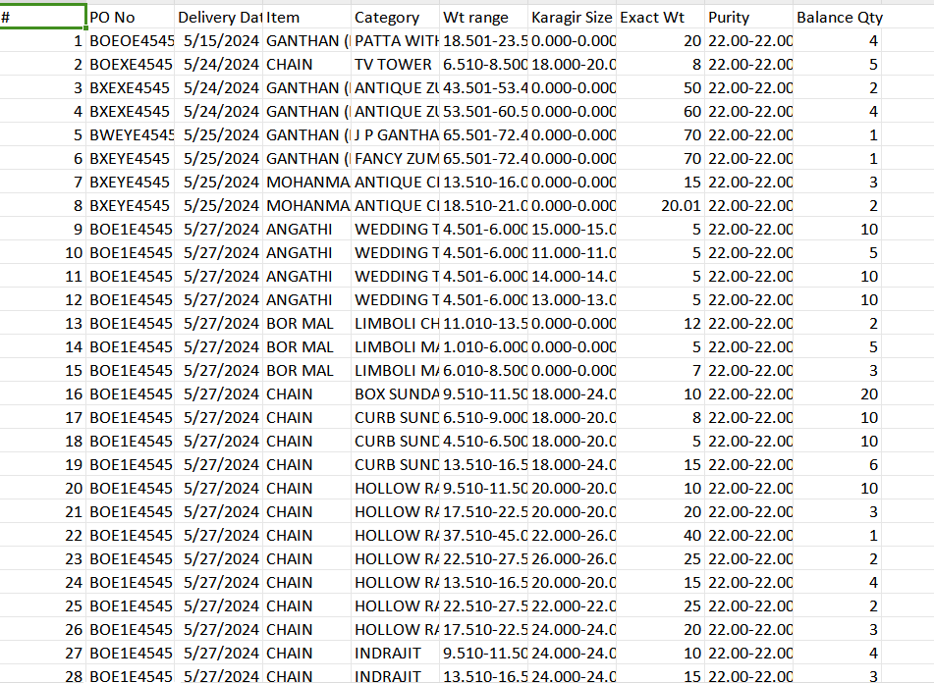

Fig: Vendor PO -> export grid

(Yet to be confirmed by end user)

Fig: Vendor Challan

**STEP NO 4: PO Challan History**

It will display the details of all Challan generated by each vendor and user can download the generated Challan. It will have following fields:

* Search Filter for Pending order Qty
* Filter : From date, to date, Vendor, PO Number
* Search bar
* Export
* Sr. No.
* Download action
* View action
* Vendor name
* Challan no.
* Total delivery qty
* Total Label Qty
* Created at

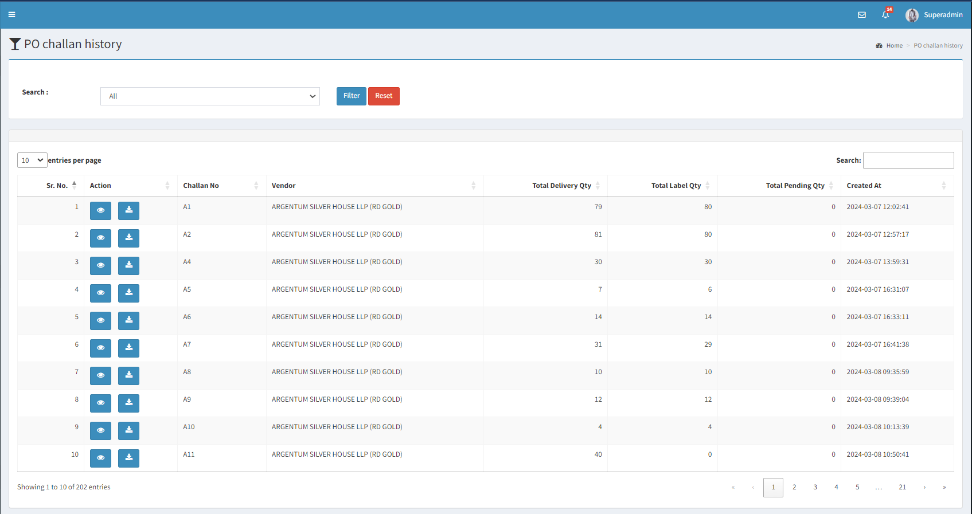

Fig: PO challan History -> data grid

|  |  |  |  |
| --- | --- | --- | --- |
| **FIELDS** | **INPUT TYPE** | **MANDATORY/ OPTIONAL** | **DESCRIPTION** |
| Search Filter for pending order Qty | Drop-down | Optional | By default, the records with Pending Qty> 0, will be displayed in the grid view.  User can view records with pending qty as 0 by clicking on ‘all’ in search filter.  This field will not be visible for vendor logins i.e. vendor purchase system privilege. Vendors will be able to view only records with Pending Qty>0 |
| Vendor name filter | Dropdown | Optional | User will be able to filter the challan by vendor names.  The dropdown will be fetched from Vendor master.  Post- Condition:  Once the user filters data by selecting vendor, the challan against that vendor will be displayed. |
| From Date | Calender picker | Optional | User will select the challan creation date from which the challan details are to be displayed.  Validation: It will be single select. Future dates will be disabled. |
| To date | Calender picker | Optional | User will select the challan creation date till which the challan details are to be displayed.  Validation: It will be single select. Future dates will be disabled. Dates before ‘to date’ will be disabled. |
| PO Number | Text | Optional | Users will be able to filter challan by selecting the PO number. |
| Export | Click | Optional | User will be able to export the data present in grid in excel.  Below fields will be displayed in export file:   * Sr No * Challan no * Challan date * Supplier name * PO number * PO date * PO Delivery date * Item * Category * Wt Range * Karagir size range * Purity * Delivery Qty * Total Delivery Qty * Created by * Created at   If the user filters the data and clicks on export, only filtered data will be populated in the export file. |
| Search bar | Text | Optional | Vendor can search by Challan number, created at and vendor name.  Once vendor enters any details, it will display the exact match records in the grid.  Validation: By default search field will be blank and will display all orders in the grid.  Min length = 0  Max length = 150 |
| Sr. no. | Text | Mandatory | It will display Sr. No. For the challans in the list in descending order. Recently generated challan will be display at the top.  Validation: it will be read only. |
| Download action | Click | - | User can download the generated challan again through here.  One challan can be downloaded anytime multiple times. Once user clicks on download button, PDF file will get downloaded with challan - challan no. as name of the file.  Validation: Once clicked, download button will be disabled until pdf file gets downloaded. |
| Excel Download | Click | - | User can download the generated challan again through here.  One challan can be downloaded anytime multiple times. Once user clicks on download button, excel file will get downloaded with challan - challan no. as name of the file.  Below fields will be displayed in excel file:   * Sr No * Challan no * Challan date * Supplier name * PO number * PO date * PO Delivery date * Item * Category * Wt Range * Size range * Purity * Dia Pcs * Dia Wt * Stone Wt * Design No * Metal Color * Delivery Qty * Created by * Created at |
| View action | click | - | Through view action, user can view the item details for which challan is generated. User can reject the pcs for which challan is generated which means pcs which are in WIP.    Fig: PO challan history -> view |
| Challan no | Text | - | It will display the challan number generated after submitting the delivery qty. |
| Vendor name | Text | - | It will display the varied vendor names.  Validation: It will be read only. |
| Total delivery qty | Text | Mandatory | It will display the total pcs which were mentioned while generating that challan I.e. it will display the total of delivery qty as in challan.  Validation: It will be read only. |
| Total Label Qty | Text | Mandatory | It will display the total labelled Qty against that challan.  Validation: It will be readonly. |
| Created at | Text | Mandatory | It will display the date and time when the challan was generated by the vendor.  The records will be displayed in ascending order, I.e. the old challan generated will be displayed at top and new ones will be displayed at botton.  Validation: It will display in format DD/MM/YYYY HH:MM:SS. It will be read only. |

View action will not be displayed to vendor purchase system privilege. Once user clicks on view action of PO challan history menu, it will have following fields:

* Challan No.
* Vendor name
* Challan generated date
* Challan created by
* Item details table
* Check box
* Sr. No.
* PO Date
* PO no.
* Item
* Category
* Wt range
* Exact wt
* Size range
* Purity range
* Dia Pcs
* Dia Wt
* Stone Wt
* Design No
* Metal Color
* Delivery Qty
* Permanent reject qty
* Temporary reject qty
* Reject button
* Bulk reject
* Copy balance Qty
* Bulk Reject Order
* Total
* Cancel details table
* Select all check box
* Checkbox
* Permanent Reject
* Temporary reject
* Sr. No.
* PO Date
* PO no.
* Item
* Category
* Wt range
* Exact wt
* Size range
* Purity range
* Dia Pcs
* Dia Wt
* Stone Wt
* Design No
* Metal Color
* Permanent reject qty
* Temporary reject qty (open)
* Reason
* Rejected by

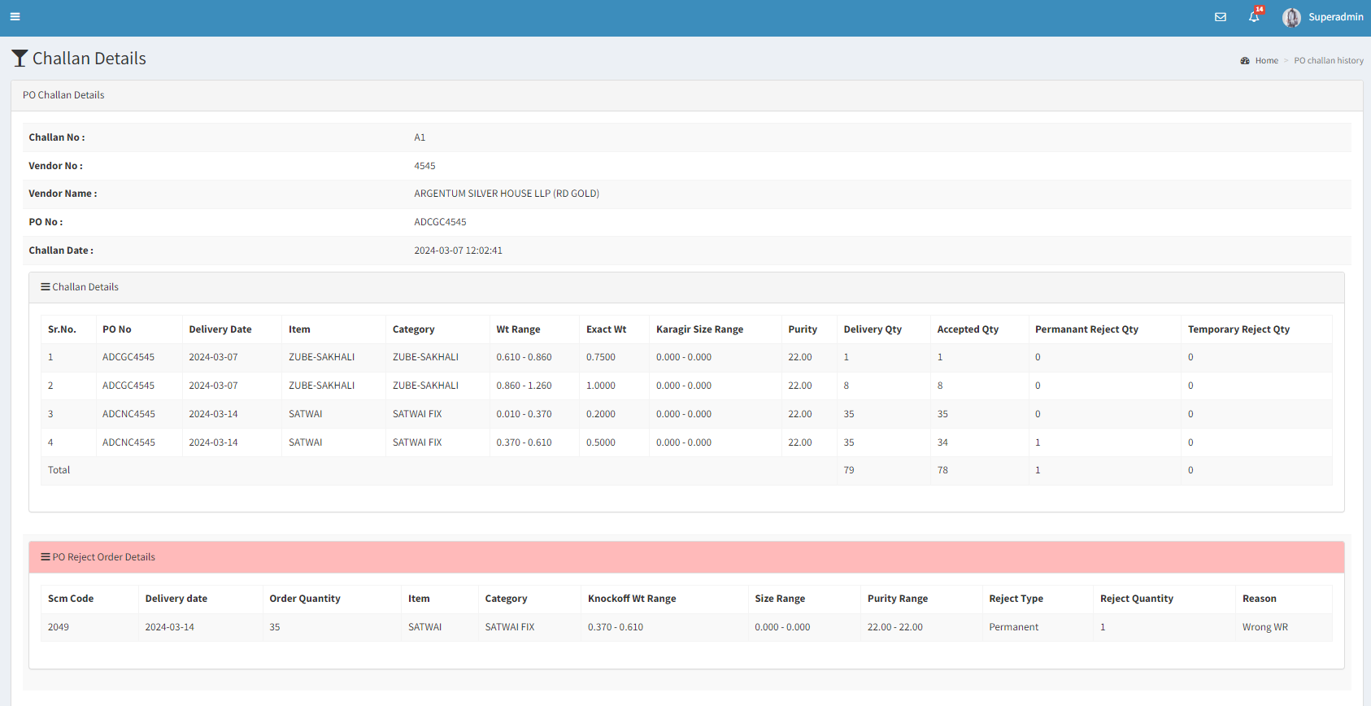

Fig: PO challan history -> view

|  |  |  |  |
| --- | --- | --- | --- |
| **FIELDS** | **INOUT TYPE** | **MANDATORY/ OPTIONAL** | **DESCRIPTION** |
| Check box | Check box | Mandatory | The check box to select the records.  Validation: Multiple selection |
| Select all | Check box | Optional | The select all option to select all the records with the single tick.  When the user selects the select box, all the check boxes gets selected.  If the user unselects the select all, all the check boxes gets unselected. |
| Challan No. | Text | Mandatory | It will display the challan no. Which vendor generated.  Validation: It will be read only. |
| Vendor name | Text | Mandatory | It will display the vendor name who generated the challan.  Validation: It will be read only. |
| Challan generated Date | Text | Mandatory | It will display the date on which that challan was generated by vendor.  Validation: It will be read only. |
| Challan created by | Text | Mandatory | It will display the challan creator username.  Validation: It will be read only. |
| Item details table - Sr. No. | Text | Mandatory | It will display the list of item details in the row along with sr.no. generated under that challan.  Validation: It will be read only. |
| Item details table - PO date | Text | Mandatory | It will display the order date of that item detail in a row as per challan.  Validation: It will be read only. |
| Item details table - PO No. | Text | Mandatory | It will display the order number of that item detail in a a row as per challan.  Validation: It will be read only. |
| Item details table - Item | Text | Mandatory | It will display the item name in a a row as per challan.  Validation: It will be read only. |
| Item details table - category | Text | Mandatory | It will display the category name in a a row as per challan for which the order was given to vendor from user where further user has created challan for it.  Validation: It will be read only. |
| Item details table - wt range | Text | Mandatory | It will display the Karagir wt in a a row for that item details as per challan.  Validation: It will be read only. |
| Item details table - exact wt | Text | Mandatory | It will display the exact wt in a a row as per challan for which the order was given to vendor from user where further user has created challan for it.  Validation: It will be read only. |
| Item details table - size range | Text | Mandatory | It will display the size range in a a row as per challan for which the order was given to vendor from user where further user has created challan for it.  Validation: It will be read only. |
| Item details table - purity range | Text | Mandatory | It will display the purity range in a a row as per challan for which the order was given to vendor from user where further user has created challan for it.  Validation: It will be read only. |
| Item details table - Dia Pcs | Text | Mandatory | It will display the purity range in a a row as per challan for which the order was given to vendor from user where further user has created challan for it.  Validation: It will be read only. |
| Item details table - Dia Wt | Text | Mandatory | It will display the purity range in a a row as per challan for which the order was given to vendor from user where further user has created challan for it.  Validation: It will be read only. |
| Item details table - Stone Wt | Text | Mandatory | It will display the purity range in a a row as per challan for which the order was given to vendor from user where further user has created challan for it.  Validation: It will be read only. |
| Item details table - Design No | Text | Mandatory | It will display the purity range in a a row as per challan for which the order was given to vendor from user where further user has created challan for it.  Validation: It will be read only. |
| Item details table - Metal Color | Text | Mandatory | It will display the purity range in a a row as per challan for which the order was given to vendor from user where further user has created challan for it.  Validation: It will be read only. |
| Item details table - delivery qty | Text | Mandatory | It will display the delivery qty of that which vendor entered while generating the challan.  Validation: It will be read only. |
| Item details table - permanent reject qty | Text | Mandatory | It will display the total permanent rejected qty of that row which user has entered while rejecting.  Validation: It will be read only. It will be less than (total delivery qty + temporary reject qty). |
| Item details table - temporary reject qty | Text | Mandatory | It will display the total temporary rejected qty of that row which user has entered while rejecting.  Validation: It will be read only. It will be less than (total delivery qty + permanent reject qty). |
| Copy Balance Qty | Button | - | User can copy the balance qty value to delivery qty field by clicking on this button.  The copied values will be editable.  Pre- Condition -  Users needs to compulsorily select the records by clicking on the checkbox before clicking on this button.  Once the user selects the record by clicking on checkbox and and clicks on copy, the balance qty should get copied in the delivery qty field. |
| Bulk Reject | Click | Optional | If user wants to bulk reject the pcs from the total of generated challan, then user will click on the reject button. It will display following fields:   * Reject type : It will dropdown displaying following fields - Temporary reject, Permanent reject * Reason * Submit button * Back button   Here the reject qty will be total delivery qty. |
| Reject button | Click | Optional | If user wants to reject the pcs from the total of generated challan, then user will click on the reject button of that row. It will display following fields:   * Reject qty * Reject type * Reason * Remark * Submit button * Back button |
| Reason | Dropdown | Mandatory | It will be dropdown where user needs to select reason for rejection.  This dropdown will be fetched from the Daily Stock Module> Remark master |
| Remark | Text | Optional | User will be able to add additional remark against the reason for rejection.  Validation:  It will accept 250 alpha numeric special characters. |
| Total | Text | Mandatory | It will display the total Delivery Qty, Accepted Qty, Permanent Reject Qty, Temporary Reject Qty. |
| Reject details table | Text | - | Once user has rejected few pcs then its details will be displayed in the reject table details. It will display following fields:   * Delivery date * Order qty * Item * Category * Size range * Purity range * Wt range * Dia Pcs * Dia Wt * Stone Wt * Design No * Metal Color * Reject type * Reject qty * Reason * Rejected date & time * Rejected by - The username who rejected the pcs will be displayed. |
| Challan Status> Jama Doc Count | Text | Mandatory | It will display jama doc number count against one challan number. |
| Challan Status>Labeling file Upload Qty | Text | Mandatory | It will display number of times the labelling file is uploaded against the specific challan number |
| Challan Status>Challan Qty | Text | Mandatory | It will display delivered Qty/ number pcs for which chllan is generated. |
| Challan Status>Upload Qty | Text | Mandatory | The pcs count uploaded in labeling file against the challan number.  It will display the number of rows and not the sum of pcs. |
| Challan Status>Pending Qty | Text | Mandatory | It will display balance Qty against the pending order. |
| Challan Status>Knock off Qty | Text | Mandatory | Knockoff pcs i.e. accepted pcs have got mapped with order by uploading labeling file against the jama doc number. |
| Challan Status>Knock Off against another PO | Text | Mandatory | The knock off against another PO Qty |
| Challan Status>Extra (without DNC) | Text | Mandatory | It will display Extra Qty without DNC (White coloured records) fetched from PO Adjust Report. |
| Challan Status>DNC Extra | Text | Mandatory | It will display records which are extra and DNC. |
| Challan Status>Rejected | Text | Mandatory | It will display return to vendor qty fetched from PO Adjust Report. |

1. **REFERENCES OF THE USERS**

|  |  |  |  |
| --- | --- | --- | --- |
| **User** | **Name** | **Mail** | **Contact number** |
| **Actual user** | Karan Kothari | karan@kkjpl.com |  |
| **Ticket created by (if any)** | Sanika Dewoolkar | Sanika.dewoolkar@techneai.com |  |
| **Assigned business analyst** | Sanika Dewoolkar | Sanika.dewoolkar@techneai.com |  |
| **Assigned developer** | Jayant Kadam | [Jayant.kadam@techneai.com](mailto:Jayant.kadam@techneai.com) |  |
| **Assigned tester** | Amreen Shaikh | Amreen.shaikh@techneai.com |  |