26.04.2023

[SUB SCM MASTER - SILVER]

Sanika Dewoolkar

Sanika.dewoolkar@techneai.com

**Handover Document**

**CONTENTS**

1. TICKET DETAILS 2

2. INTRODUCTION 2

3. BUSINESS REQUIREMENT 2

4. SCOPE 2

5. BUSINESS & SYSTEM RULES 2

6. ABBREVIATIONS & TERMS 3

7. EXISTING SYSTEM 3

8. GRAPHICAL REPRESENTATION 3

9. DEVELOPED SYSTEM 3

10. REFERENCES OF THE USERS 3

1. **TICKET DETAILS**

|  |  |
| --- | --- |
| **Ticket ID** | TT22721 |
| **Ticket description** | Connect us madhe pending order silver ha option create karun dene. same as gold pending order user Bharat R ID 1052 |
| **Created by** | Bharat Raynade |
| **Created on** | 18/06/2024 |
| **Priority** | Medium |

1. **INTRODUCTION**

The Sub SCM Master is a structured framework designed to provide detailed bifurcation and classification of inventory items under a Main SCM Code. This master table helps the inventory and procurement teams in decision-making by assigning specific weightage and priority to each Sub SCM Code.

User can Prioritize orders based on the assigned Priority. Additionally, Allocate importance to specific Sub SCM Codes using the Weightage value. Furthermore, Ensure balanced inventory placement and prevent duplication or mismanagement.

1. **BUSINESS REQUIREMENT**

|  |  |  |  |
| --- | --- | --- | --- |
| **Requirement ID** | **Requirement Name** | **Short Description** | **Priority** |
| BR001 | Switcher | User can switch SCM Master Silver menu to SCM Master gold or vice versa through same screen. This switcher will be authority based. | High |
| BR002 | Upload bulk file of new order | User will upload an excel file with details as Item, Category, Size range ,Weight range, Knock off Wt Range, Karagir Wt Range, Karagir size range, Exact wt, Priority, Weightage | High |
| BR003 | Bulk upload - Grid | Once excel file is uploaded with valid details, record will be displayed in grid. | Medium |
| BR004 | Bulk upload - view | It will display the details which were inserted in the uploaded excel file | High |
| BR005 | Remove SCM Master Silver | Remove SCM Master Silver menu which already exists in Connect Us | Medium |
| BR006 | Special Authority Master | Need to add special authority for SCM/Sub SCM Master Gold and SCM/Sub SCM Master Silver | Medium |
| BR007 | Login Special Authority Mapping | Map logins with the special authority so defined users can access the menu. | Medium |

1. **SCOPE**

Once user downloads bulk format from sub- scm master, user will enter the details of item, category, wt range, size range, exact wt, knock off wt range, karagir size range, karagir wt range, priority and weightage. Once user uploads the bulk file having all correct details, the data will be displayed in grid view. However, it will display error file when user enters incorrect details in the bulk format file.

1. **BUSINESS & SYSTEM RULES**

* Users need to have login based authority to access this menu.
* User should be registered in the system.
* User should be logged in.
* System should display error message for incorrect details if entered.
* System will pop up a message, if any issues in the system is detected.
* All forms will have on field validations. System will display on field errors in case of incorrect inputs.

1. **ABBREVIATIONS & TERMS**

Main SCM code - item, category, wt range, size range, purity range

Wt - weight

KT - karat

1. **DEVELOPED SYSTEM**

**Switcher:**

Once the user goes in SCM Master menu, by default no data will be displayed in grid view.

Through SCM Master Gold or SCM Master Silver radio button, user can switch into the respective menus and the data will be displayed in grid view for that SCM Master.

This switcher will be authority based, which means,Eg, if the user has authority to only access SCM Master Gold, user will only view SCM Master gold radio button. By default, this radio button will be selected. Same for silver.

If the user has authority to both menus then, upon login, user needs to select the radio button of which the menu is to be accessed.

**Main SCM Code:**

-Represents the primary classification of an item.

-A combination of key parameters like Item, Category, Size Range, Weight Range, Purity, and Exact Weight.

**Sub SCM Code:**

-A further subdivision of the Main SCM Code for granular management.

-It factors in additional attributes such as:

Knockoff Weight Range

Karagir Weight Range

Karagir Size Range

The unique combination of these attributes ensures precise tracking of inventory variants.

1. **SUB - SCM MASTER SILVER**

Once user clicks on Sub -SCM master menu, it will display following fields:

* Bulk format
* Upload file
* Export data
* View button
* ID
* Item
* Category
* Knock off Wt Range
* Karagir Wt Range
* Karagir size range
* Priority
* Weightage
* Exact wt
* Created at
* Created by

Once user downloads bulk format, it will have following columns:

* Item
* Category
* Size range
* Weight range
* Knock off Wt Range
* Karagir Wt Range
* Karagir size range
* Exact wt
* Priority
* Weightage

Once user fills the data in above columns and uploads the file, the weightage and priority against every record will be set and displayed in grid view. However, in case user enters incorrect data and uploads the file through upload file button, then error message will be displayed along with error file. Error file will specify the invalid details of the record.

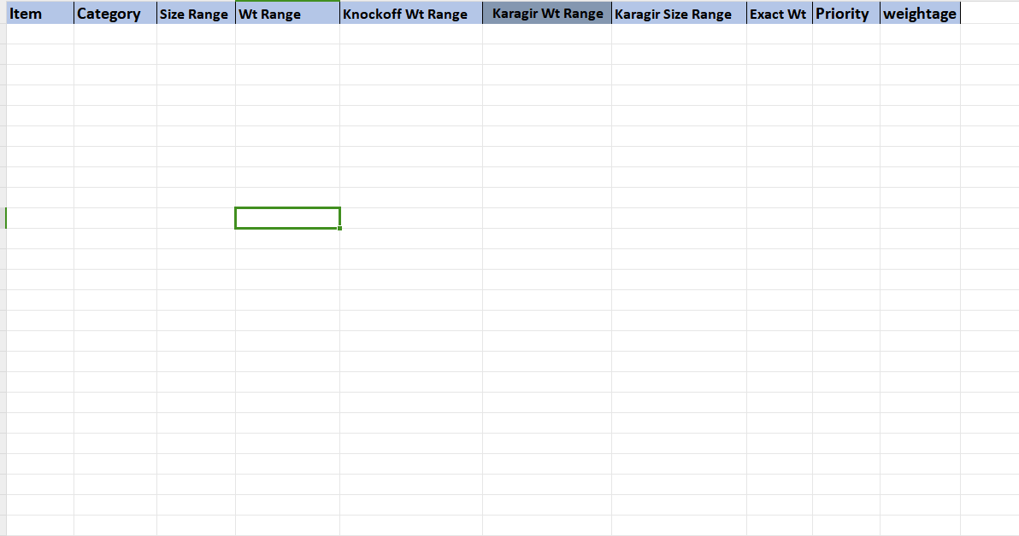

Fig: Downloaded Bulk format

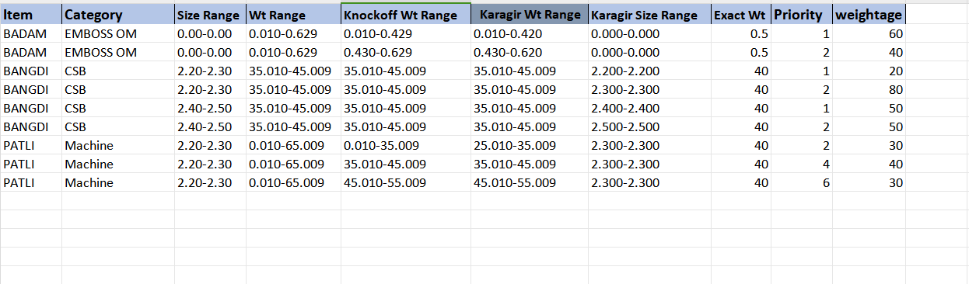

Fig: Sub -SCM Master -> Bulk upload file

|  |  |  |  |  |
| --- | --- | --- | --- | --- |
| **FIELDS** | **INPUT TYPE** | **MANDATORY/ OPTIONAL** | **EDITABLE** | **DESCRIPTION** |
| Item | Text | Mandatory | Editable in bulk file only | User will mention the name of the item for which the priority and weightage is to be set.  Validation: It will accept alphanumeric value. It will accept - and / only as special character. It will accept space.  Min length = 3 Max length = 50 |
| Category | Text | Mandatory | Editable in bulk file only | User will mention the name of the category name of the item for which the priority and weightage is to be set.  Validation: It will accept alphanumeric value. It will accept - and / only as special character. It will accept space.  Min length = 3 Max length = 50 |
| Size Range | Text | Mandatory | Editable in bulk file only | User will enter the from size and to size of the mentioned item - category.  In case user enters overlapping size range from the existing Sub- SCM code, then it will display error for that record in bulk file.  Each time when user enters record, then it will check it SCM code. And, if entered size range of bulk upload file gets overlapped with its existing SCM code entry, then it will display error file and that record will not get added as new SCM code in master or grid. Example: If user already enters BANGDI - CSB - size range 2-4, weight range 10.000-15.000, then it will get added initially. However If user enters another SCM code as BANGDI - CSB - size range 3-5, weight range 10.000-15.000 then it will not get added as size is overlapping.  Validation: It will accept one hyphen only. It will accept numbers only. It accept only max two numbers after decimal point. It will consider number and its number with 00 after decimal point as same (I.e. 1 and 1.00 are same). |
| Weight range | Text | Mandatory | Editable in bulk file only | User will enter the from weight and to weight of the entered item - category.  In case, user enters overlapping weight range of existing SCM code, then it will display error file and that record will not get added in SCM master grid. Example: If user already enters BANGDI - CSB - size range 2-4, weight range 10.000-15.000, then it will get added initially. However If user enters another SCM code as BANGDI - CSB - size range 2-4, weight range 10.000-13.000 then it will not get added as weight is overlapping.  Validation: It will accept one hyphen only. It will accept numbers only. It accept only max three numbers after decimal point. It will consider number & its number with 00 after decimal point as same (I.e. 14 and 14.00 are same). |
| Knock off Wt Range | Text | Mandatory | Editable in bulk file only | User will enter the from weight and to weight of the entered item - category.  In case, user enters overlapping weight range of existing SCM code, then it will display error file and that record will not get added in SCM master grid. Example: If user already enters BANGDI - CSB - size range 2-4, weight range 10.000-15.000, then it will get added initially. However If user enters another SCM code as BANGDI - CSB - size range 2-4, weight range 10.000-13.000 then it will not get added as weight is overlapping.  Validation: It will accept one hyphen only. It will accept numbers only. It accept only max three numbers after decimal point. It will consider number & its number with 00 after decimal point as same (I.e. 14 and 14.00 are same). |
| Karagir Wt Range | Text | Mandatory | Editable in bulk file only | User will enter the from weight and to weight of the entered item - category.  In case, user enters overlapping weight range of existing SCM code, then it will display error file and that record will not get added in SCM master grid. Example: If user already enters BANGDI - CSB - size range 2-4, weight range 10.000-15.000, then it will get added initially. However If user enters another SCM code as BANGDI - CSB - size range 2-4, weight range 10.000-13.000 then it will not get added as weight is overlapping.  Validation: It will accept one hyphen only. It will accept numbers only. It accept only max three numbers after decimal point. It will consider number & its number with 00 after decimal point as same (I.e. 14 and 14.00 are same). |
| Karagir size range | Text | Mandatory | Editable in bulk file only | User will enter the from size and to size of the mentioned item - category.  In case user enters overlapping size range from the existing Sub- SCM code, then it will display error for that record in bulk file.  Each time when user enters record, then it will check it SCM code. And, if entered size range of bulk upload file gets overlapped with its existing SCM code entry, then it will display error file and that record will not get added as new SCM code in master or grid. Example: If user already enters BANGDI - CSB - size range 2-4, weight range 10.000-15.000, then it will get added initially. However If user enters another SCM code as BANGDI - CSB - size range 3-5, weight range 10.000-15.000 then it will not get added as size is overlapping.  Validation: It will accept one hyphen only. It will accept numbers only. It accept only max two numbers after decimal point. It will consider number and its number with 00 after decimal point as same (I.e. 1 and 1.00 are same). |
| Exact wt | Text | Mandatory | Editable in bulk file only | User will enter the exact wright of the item - category.  Validation - It will be between the entered weight range. It will accept numbers only. It will accept decimal point only as special character. It will accept only one decimal point. It accept max three digits after decimal point. |
| Weightage | Text | Mandatory | Editable in bulk file only | Weightage indicates the  the relative importance of a Sub SCM Code for decision-making regarding inventory and order placement.  It will be percentage value.  The total weightage of all Sub SCM Codes under a single Main SCM Code must sum to 100%.  Example:   |  |  |  | | --- | --- | --- | | Main SCM Code | SCM Sub Code | Weightage | | 276 | 355 | 60 | | 276 | 356 | 40 |   Total weightage = 100%  Validation:  Range: Weightage must be a positive value greater than 0 and expressed as a percentage (e.g., 60, 40).  Numeric Only: Only numeric values are allowed (no special characters or text).  **In case of missing weightage :** i.e. weightage field is blank then system will throw error as "Weightage cannot be blank."  **Total Weightage Invalid:** I.e. if Total ≠ 100% then system will throw error as “"Total Weightage must equal 100%. Current: [Y]%."  **Invalid Weightage Value:** i.e. Weightage ≤ 0 or non-numeric then system will throw error as "Weightage must be a positive numeric value." |
| Priority | Text | Priority | Editable in bulk file only | Defines the order of importance for a Sub SCM Code when determining inventory placement priorities.  A lower number indicates higher priority.  Validation:   * Priority values must be unique within a single Main SCM Code. Duplicate priorities are not allowed. * Value Range: Priority must be a positive integer starting from 1. The value 0 is not allowed. * Sequential Assignment: Priorities must be assigned logically (e.g., 1, 2, 3, ...). Skipping numbers is not allowed.   **In case of Missing Priority :** I.e. Priority field is blank then system will throw error as “Priority cannot be blank."  **Duplicate Priority:**   1. e. Duplicate priority detected then system will throw error as "Duplicate Priority [Y] found." against the row.   **Invalid Priority Value:**  I.e Priority = 0, negative, or non-numeric then system will throw error as "Priority must be a positive integer value." |

Once user clicks on view action of SCM master record, it will display following fields:

* ID
* Item
* Category
* Knock off Wt Range
* Karagir Wt Range
* Karagir size range
* Priority
* Weightage
* Exact wt
* Created at
* Created by

|  |  |  |  |  |
| --- | --- | --- | --- | --- |
| **FIELDS** | **INPUT TYPE** | **MANDATORY/ OPTIONAL** | **EDITABLE** | **DESCRIPTION** |
| Created at | Text | Mandatory | No | It will display the date and time when the Sub SCM code was created by the user that means added in grid through bulk upload file. |

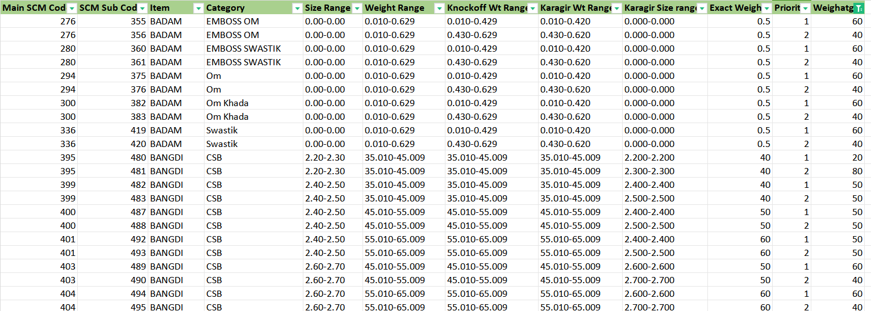

Img: Reference data for understanding

**SPECIAL AUTHORITY MASTER** (MASTERS> GENERAL MASTERS)

Add below special authority for SCM Master / SCM Sub Master Access to users:

* SCM/Sub SCM Master Gold Access
* SCM/Sub SCM Master Silver Access

Through this special authority users can access SCM/Sub SCM Master Gold and Silver.

**LOGIN SPECIAL AUTHORITY MAPPING**(MASTERS> GENERAL MASTERS)

Only users mapped with the special authority will be able to view the SCM/Sub SCM Master Gold and Silver.

1. **REFERENCES OF THE USERS**

|  |  |  |  |
| --- | --- | --- | --- |
| **User** | **Name** | **Mail** | **Contact number** |
| **Actual user** | Bharat Raynade | sinventorypn@csjewellers.com |  |
| **Ticket created by (if any)** | Bharat Raynade | sinventorypn@csjewellers.com |  |
| **Assigned business analyst** | Sanika Dewoolkar | Sanika.dewoolkar@techneai.com |  |
| **Assigned developer** | Jayant Kadam | Sanika.dewoolkar@techneai.com |  |
| **Assigned tester** | - |  |  |