# 1 Gift card amt show zero.

Jewellery -> batch jobs -> Gift card run this job then scheme gift card is generated and scheme against show this gift card no. But currently if gift card is generated then scheme total amount not show in the gift card.

Scheme entry no - JARGDP-819 against GC000014769 this gift card is generated but the amount of gift card is zero. But scheme against 65,000 amount is present.

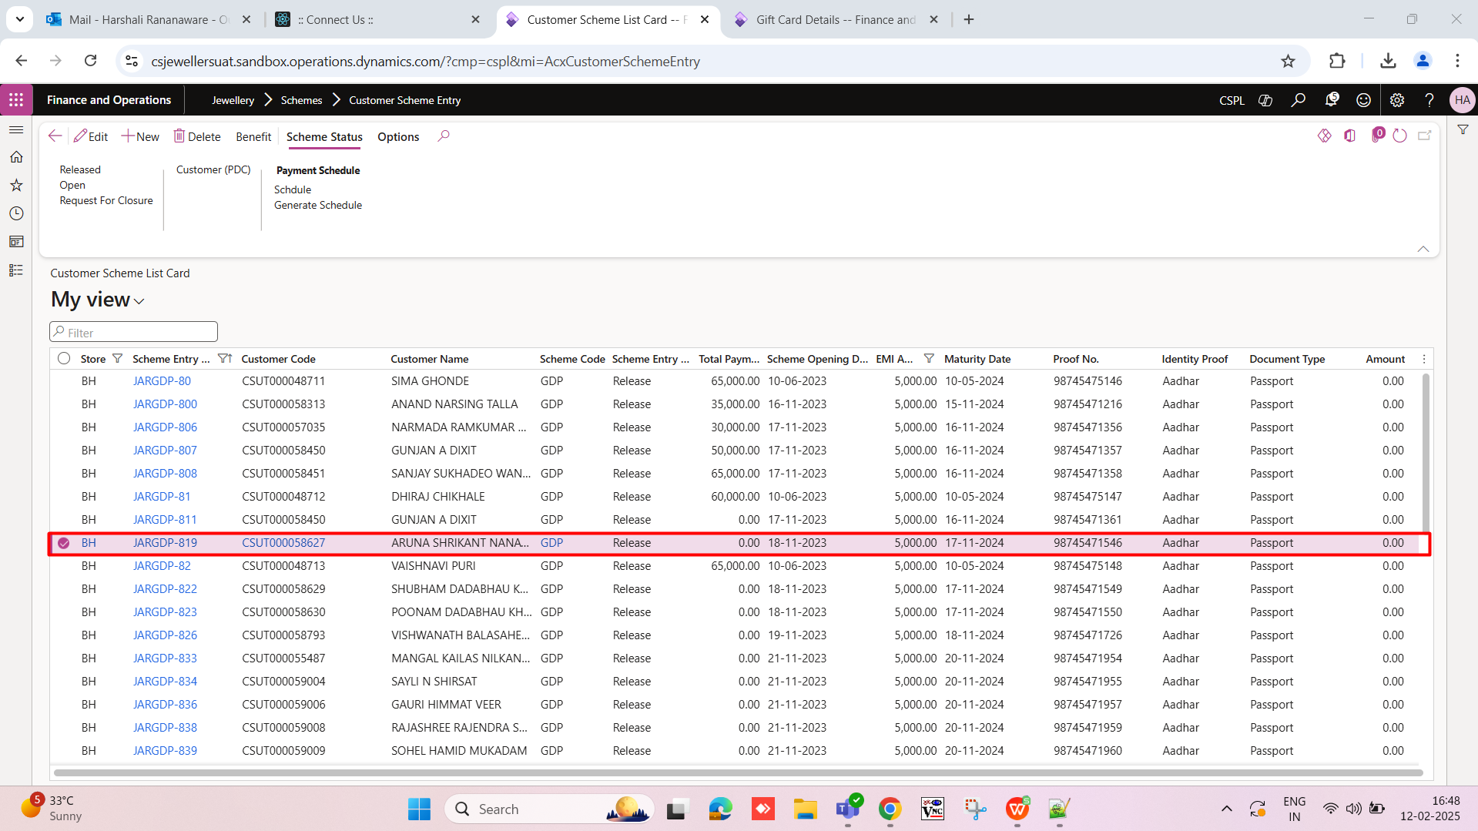

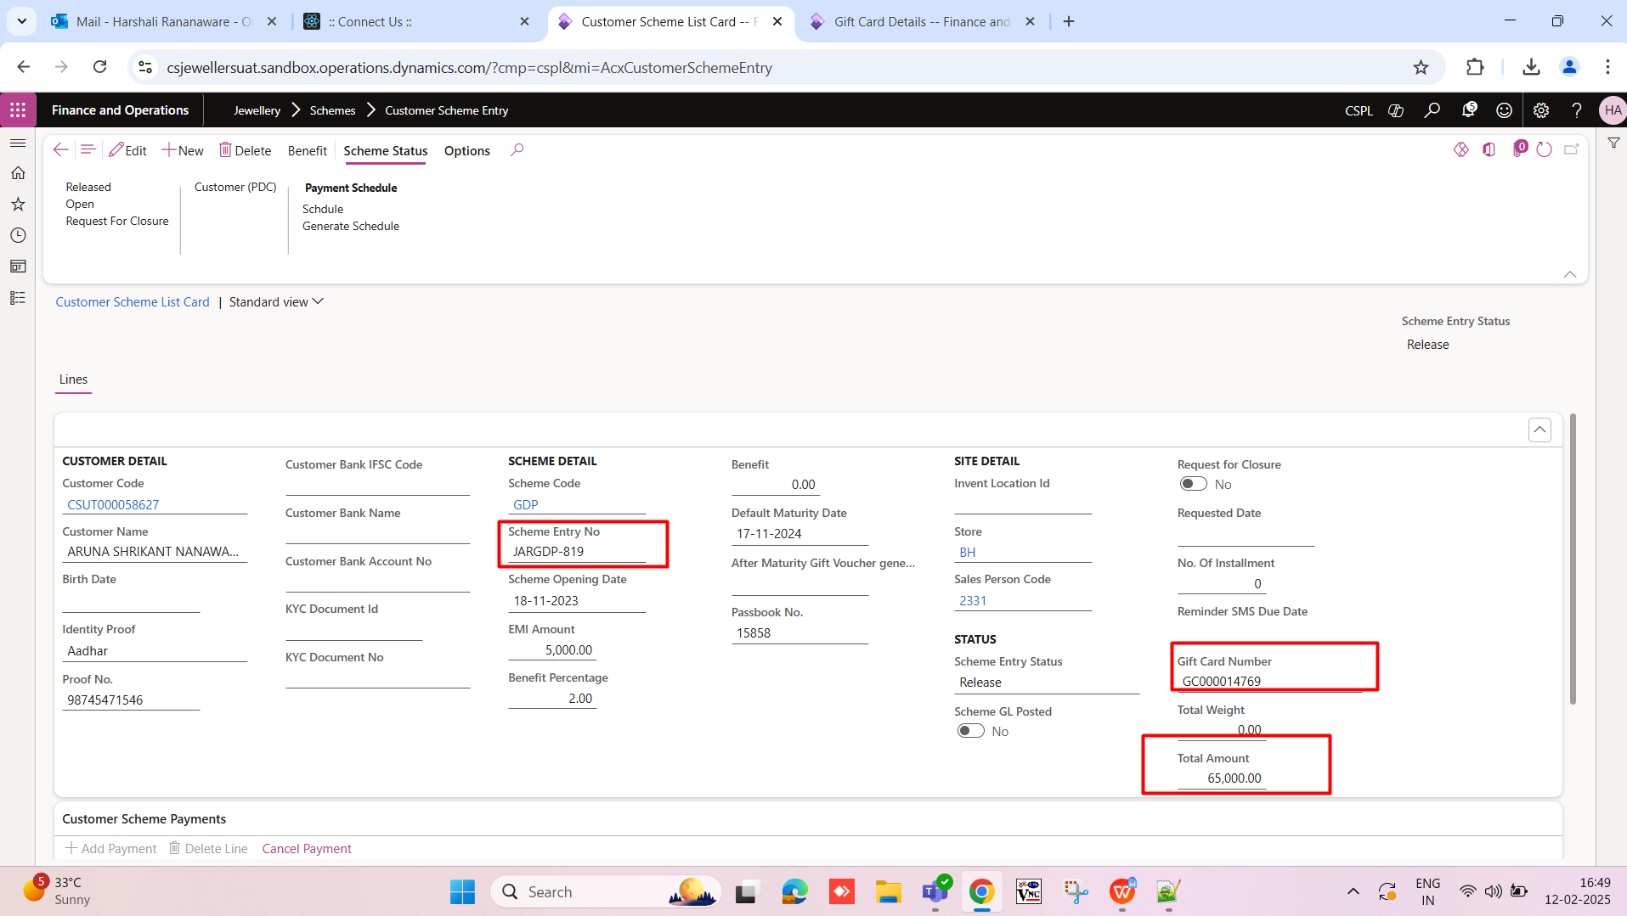

Jewellery -> Gift Card Scheme -> Gift Card Details

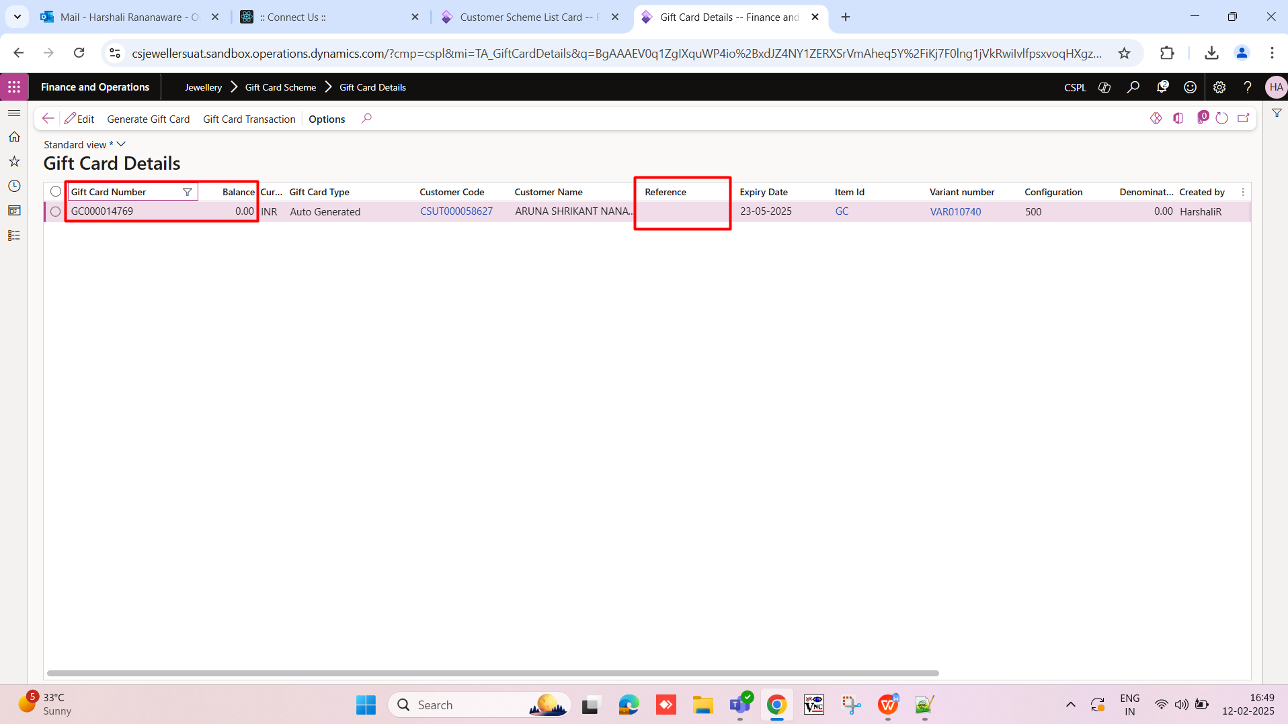

# 2 Remove menu

Remove the menu Jewellery -> batch jobs -> Generate Gift card

# 3 Gift card against want to scheme entry no show.

Jewellery -> Gift Card Scheme -> Gift Card Details if gift card is auto generated from “Jewellery -> batch jobs -> Gift card “ this menu then in the gift card “Reference” field show the Scheme number.

**Example** - Scheme entry no - JARGDP-819 against Gift card GC000014769generated . then gift card menu reference field show the Scheme entry no - JARGDP-819.