TT29506-

PO- Delete Requisition and Export Button in Sub SCM Master

26.04.2023

Sanika Dewoolkar

Sanika.dewoolkar@techneai.com

**Handover Document**

**CONTENTS**

1. TICKET DETAILS 2

2. INTRODUCTION 2

3. BUSINESS REQUIREMENT 2

4. SCOPE 2

5. BUSINESS & SYSTEM RULES 2

6. ABBREVIATIONS & TERMS 3

7. EXISTING SYSTEM 3

8. GRAPHICAL REPRESENTATION 3

9. DEVELOPED SYSTEM 3

10. REFERENCES OF THE USERS 3

1. **TICKET DETAILS**

|  |  |
| --- | --- |
| **Ticket ID** | TT29506 |
| **Ticket description** | Tech Ticket> PO> Create a menu where users can delete the requisition records by filtering the item and category. Also in Connect Us> Sub SCM Master> Export functionality where records can be downloaded in the system by selecting item, category. |
| **Created by** | Sanika Dewoolkar |
| **Created on** | 22-01-2025 |
| **Priority** | High |

1. **INTRODUCTION**

In the ticketing system, users currently create and upload requisition files through the **Pending Order > Generate Requisition** menu using the Upload File button. While preparing these files, they rely on data from the **Requisition PO Report** (Reorder Level Report). However, since the report only includes records with a final requirement greater than 0, it becomes challenging to generate requisitions for records with a requirement of 0.

To solve this, we will add an **Export** button under **Connect Us > SCM Master > Sub SCM Master.** This button will export all Sub SCM records in a format compatible with the PO Generate Requisition file. Users can then use this file to upload data directly, even for records with a 0 requirement.

Additionally, a new menu will be created in the ticketing system to allow users to delete previously uploaded requisition records.

1. **BUSINESS REQUIREMENT**

Enter details of the ticket requirement.

|  |  |  |  |
| --- | --- | --- | --- |
| **Requirement ID** | **Requirement Name** | **Short Description** | **Priority** |
| BR001 | Connect Us> Sub SCM Master> Export Button | Add Export button in SUB SCM Master Gold and Silver. | High |
| BR002 | Ticketing System> Delete Requisition Menu | Create menu in ticketing system under PO to delete the requisition records. | High |

1. **SCOPE**

Scope of the ticket is to add export button in Sub SCM Master Gold and Silver. Where users can select Item(Optional), Category(Optional) and export the records in the defined format.

Additionally, user will be able to delete the requisition records through ticketing system Delete Requisition menu under PO Menu.

1. **BUSINESS & SYSTEM RULES**

* User will be registered in the system.
* User will be logged in.
* System will display error message for incorrect details if entered.
* System will pop up a message, if any issues in the system is detected.
* All forms will have on field validations. System will display on field errors in case of incorrect inputs.

1. **ABBREVIATIONS & TERMS**

PO- Pending Order

SCM- Item, Category, Weight range, Size range, Purity range

1. **GRAPHICAL REPRESENTATION**

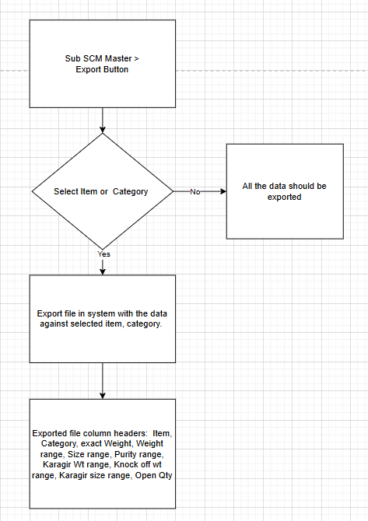

Fig: Sub SCM Master> Export

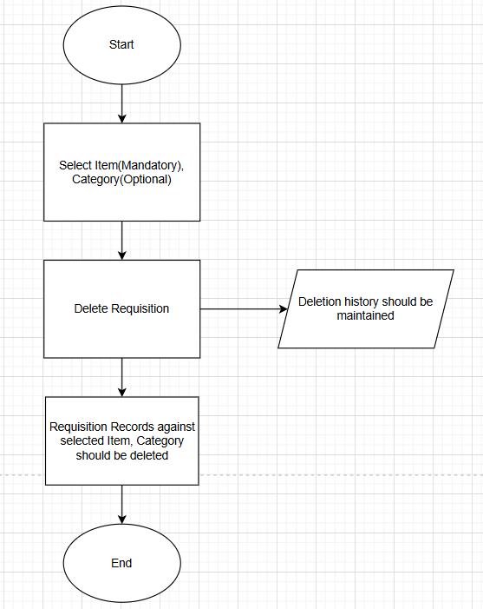

Fig: Delete Rquisition

1. **DEVELOPED SYSTEM**

## SUB SCM MASTER:

In Sub SCM Master Gold and Silver, Export button will be added.

Upon clicking on Export button, pop up will be opened and below fields will be displayed:

* Item
* Category
* Submit
* Cancel

**Input table**

|  |  |  |  |
| --- | --- | --- | --- |
| **FIELDS** | **INPUT TYPE** | **MANDATORY/ OPTIONAL** | **DESCRIPTION** |
| Item | Dropdown | Optional | All the records in the drop down will be fetched from the Sub SCM Master.  Validation:   * Multi-Selection |
| Category | Dropdown | Optional | All the records in the drop down will be fetched from the Sub SCM Master.  Validation:  Multi-Selection |
| Submit | Button | - | Upon clicking on Submit button:   * If the Item is selected, and category is not selected then all the categories against the selected item will be exported * If only category is selected then records with selected category will be exported * If both Item, Category is not selected then all the data will be exported in the system.   The file name of the exported data will be:  PO Requisition- Date.csv |
| Cancel | Button | - | Upon clicking on cancel button user will be redirected to the previous screen and the data if selected will be cleared. |

**The exported file will only have records where weightage > 0 and DNC = N**

The exported file will contain below column headers:

* Item
* Category
* Exact Weight
* Weight range
* Size range
* Purity range
* Karagir Wt range
* Knock off wt range
* Karagir size range
* Open Qty

The open Qty will be blank in the exported file.

## DELETE REQUISITION DATA (TICKETING SYSTEM> PO)

Once the user clicks on this menu, below fields will be displayed on the screen:

* Item
* Category

|  |  |  |  |
| --- | --- | --- | --- |
| **FIELDS** | **INPUT TYPE** | **MANDATORY/ OPTIONAL** | **DESCRIPTION** |
| Item | Dropdown | Mandatory | Dropdown values of the items will be fetched from the generate requisition menu uploaded file data.  Precondition:  By default, no value will be selected.  Validation:  Multi- selection  Unique records will be displayed. |
| Category | Dropdown | Optional | Drop-down values of the category will be fetched from the generate requisition menu uploaded file data.  Precondition:   * By default, no value will be selected. * Item will be selected first.   Validation:   * Multi- selection * Category against the item selected will only be reflected in the drop down. |
| Delete Requisition | Button | - | User will be able to delete the requisition record upon clicking on this button.  Once the user clicks on this button, pop will be opened with Remark input field and submit, Close button.  User will enter the remark and upon clicking on submit button the record will be deleted.  The delete button will be disabled until the record is successfully deleted in case of slow network.  Success message in system notification will be displayed on the screen in green colour.  If the user clicks on Cancel, then user will be redirected to the grid view without deleting the record.  Pre- Condition:  Before clicking on this button, Item will be selected. If the user tries to click on Delete button without selecting the Item, error will be displayed as: “Please select Item”  Post- Condition:   * The record will be deleted from the generate requisition menu and the in generate PO menu upon selecting the Item and Category. * Upon deleting the record, the deletion history will be maintained in the grid view. |
| Remark | Text | Mandatory | When the user clicks on Delete button, the text box for the remark is displayed. The remark will be applicable to all the records which are to be deleted.  Validation: Accepts alpha-numeric data with special characters up-to 1000 characters. |
| Submit | Button | - | If the user clicks on submit button, delete action will be executed. |
| Close | Button | - | By clicking on this button, user will be redirected to the previous screen. |

Action Screens:

|  |  |
| --- | --- |
| **FIELD** | **GRID VIEW** |
| Item(Dropdown) | ✓ |
| Category(Dropdown) | ✓ |
| Delete History | ✓ |
| Delete Requisition | ✓ |
| Sr No | ✓ |
| Item | ✓ |
| Category | ✓ |
| Exact Wt | ✓ |
| Weight Range | ✓ |
| Size range | ✓ |
| Purity range | ✓ |
| Karagir Wt Range | ✓ |
| Knock Off Wt Range | ✓ |
| Karagir Size Range | ✓ |
| Created at | ✓ |
| Created by | ✓ |
| Deleted by | ✓ |
| Deleted at | ✓ |

1. **REFERENCES OF THE USERS**

|  |  |  |  |
| --- | --- | --- | --- |
| **User** | **Name** | **Mail** | **Contact number** |
| **Actual user** | Priyanka Pawar | Gold.inventory@techneai.com |  |
| **Ticket created by (if any)** | Sanika Dewoolkar | Sanika.dewoolkar@techneai.com |  |
| **Assigned business analyst** | Sanika Dewoolkar | Sanika.dewoolkar@techneai.com |  |
| **Assigned developer** | Asmita M  Jaydeep Patil  Yogita J | [Asmita.margaje@techneai.com](mailto:Asmita.margaje@techneai.com)  [Jaydeep.patil@techneai.com](mailto:Jaydeep.patil@techneai.com)  Yogita.jagtap@techhneai.com |  |