#### D365 Jewellery -> Receipt -> Receipt Type Master

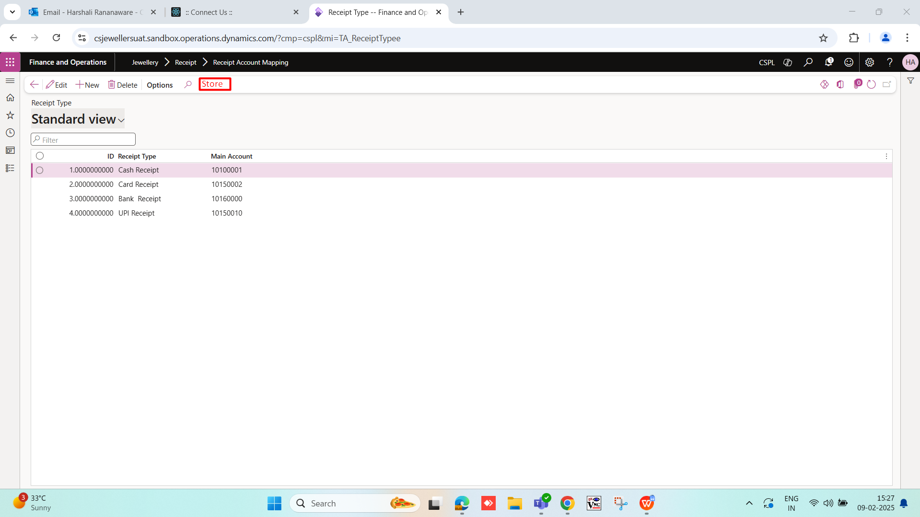

Jewellery -> Receipt -> Receipt Type Master want to add one button “store”. Click on this button then open a form. We can add store name and main account. In the main account we can add multiple account number.

|  |  |  |  |  |
| --- | --- | --- | --- | --- |
| **Sr. No** | **Field** | **Data type** | **Manadtory** | **Description** |
|  | Store | Drop-down | Yes | * We can add store name here. * Store select one or all. * If select all then set to the all store. * If one then set one by one. * Same store name should not be add again. * Store name fetch from ”Retail and Commerce -> Channels -> Stores -> All stores” |
|  | Main account | Drop-down | Yes | * Data fetch from “General ledger -> Chart of accounts -> Accounts -> Main accounts”. * we can select one or more account. |
|  | Active | Check box | Yes | * If yes then active want by default active. * If no disable. |

#### POS

**Receipt** - If we set the multiple account for the all receipt type then we want the select main account type option on POS.store wise account show on POS.

