# process scheme for closure

Go to Jewellery > Schemes > Customer Scheme Entry.

In the list, find and select the desired record.

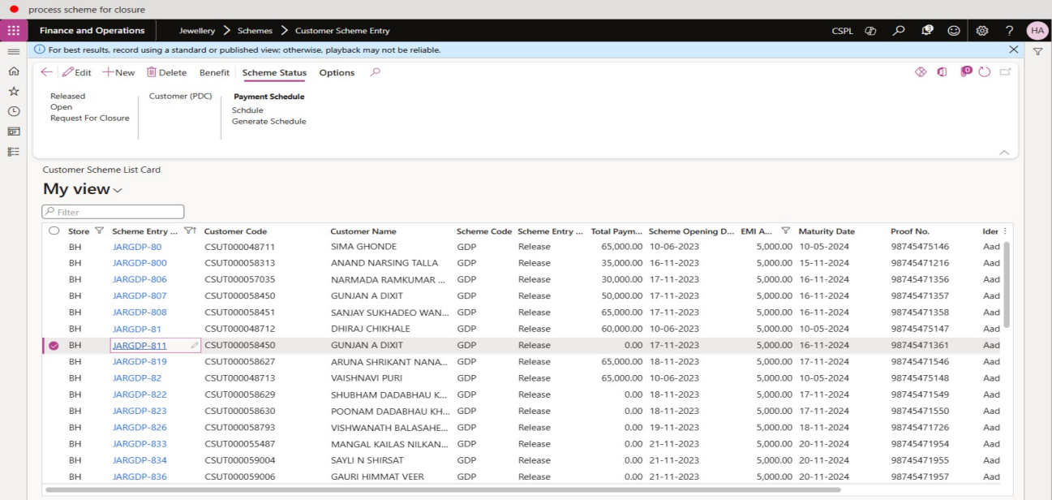

Click on “Request For Closure”.

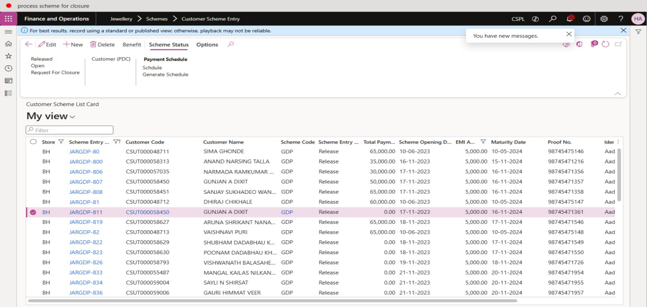

Click OK.

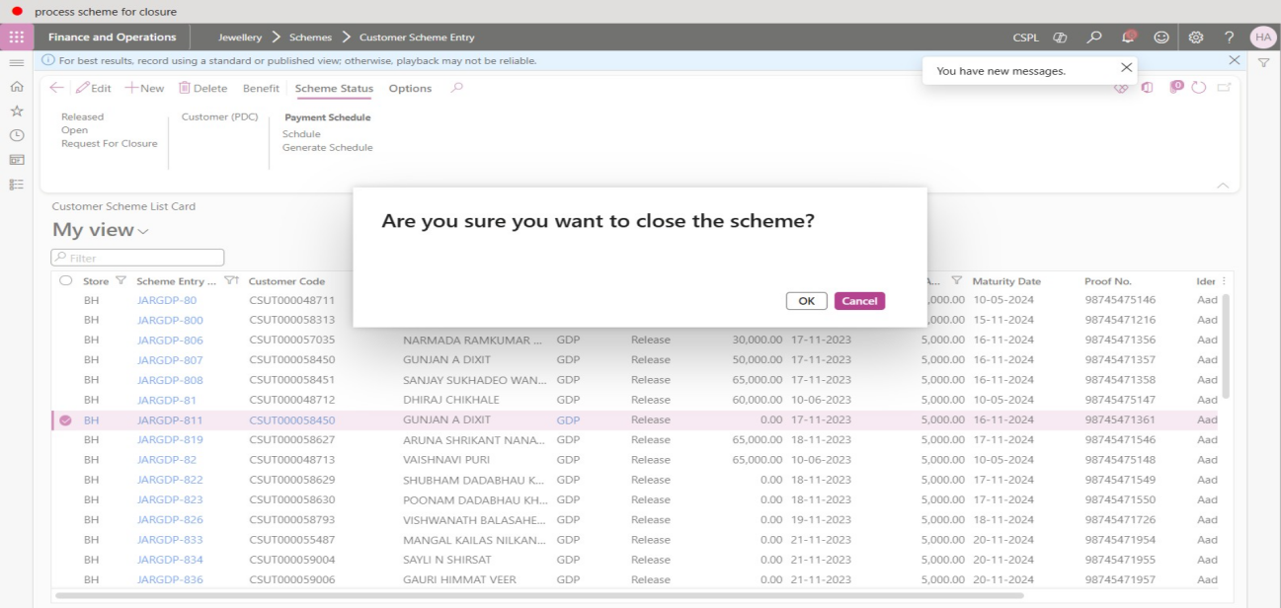

In the list, click the link in the selected row. Selected row “request for Closure - is yes”.

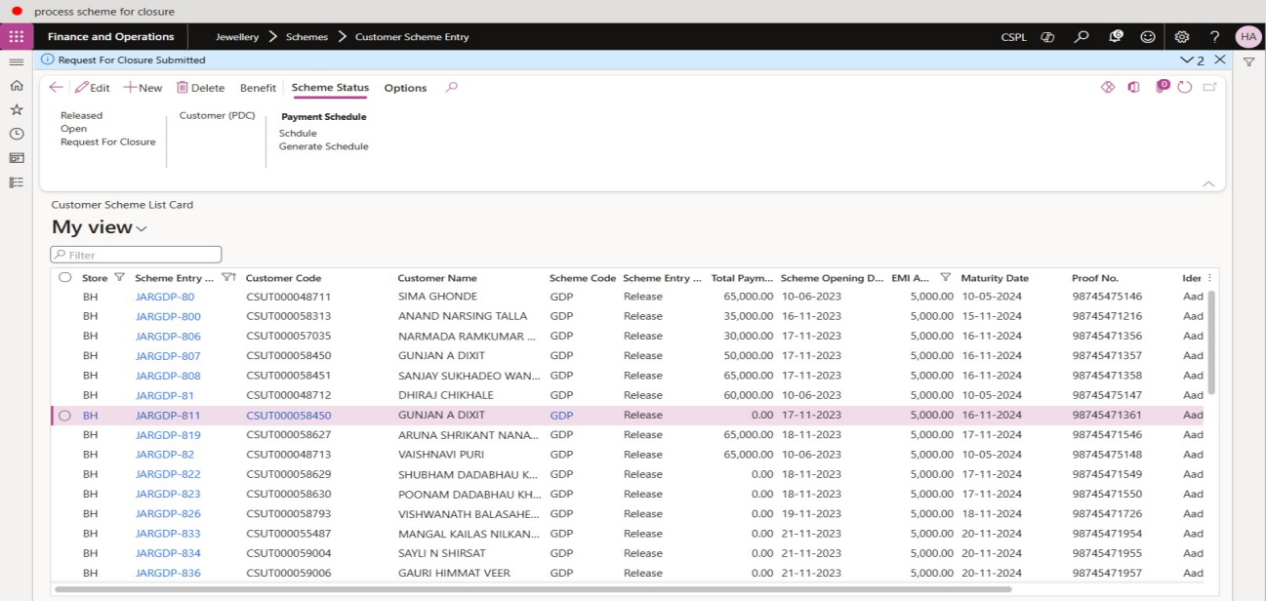

Close the page.

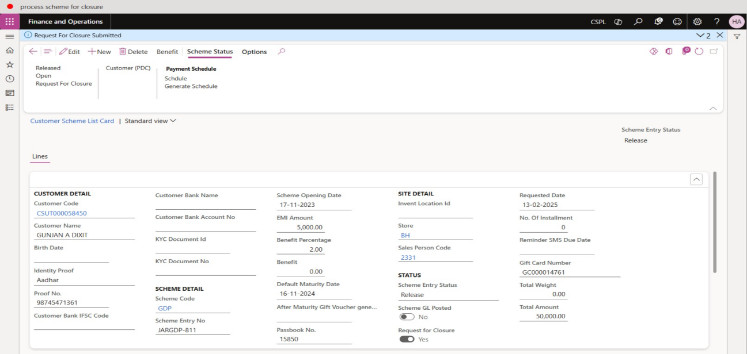

Go to Jewellery > Schemes > Periodic > Process Scheme For Closure. Run this process then scheme against “Request For Closure” is yes then this account advance is generated and scheme entry status - close.

Click OK.

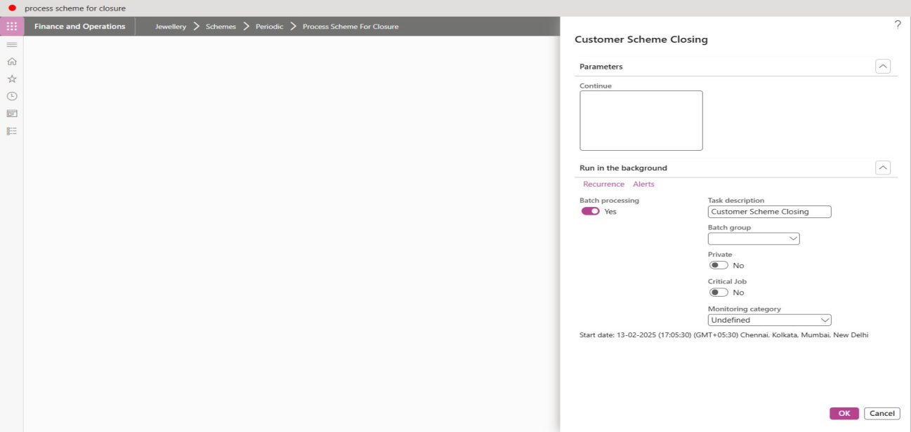

Go to System administration > Enquiries > Batch jobs.

Open Job description column filter.

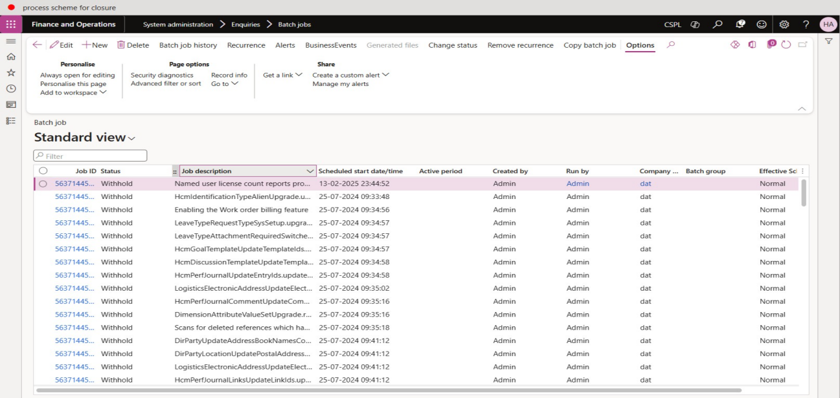

Enter a filter value of "customer s" on the "Job description" field using the "contains" filter operator.

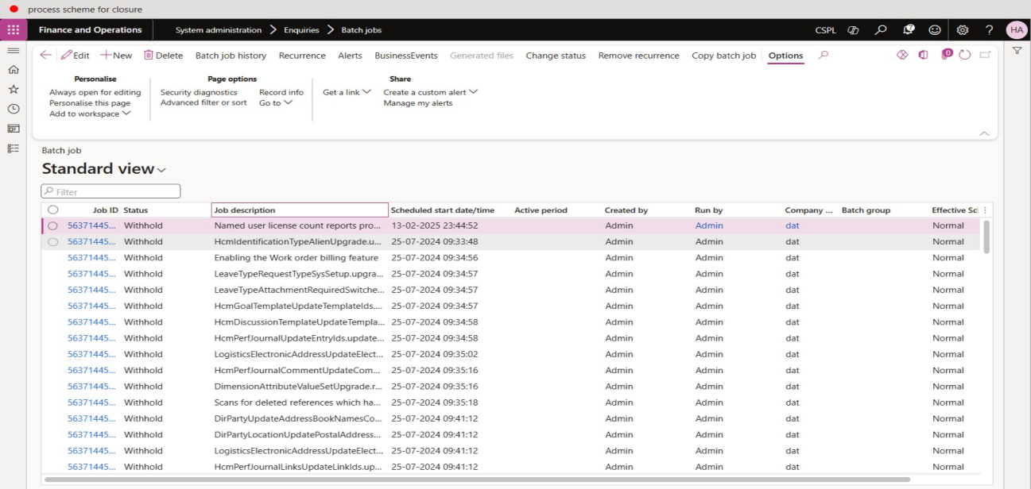

Close the page.

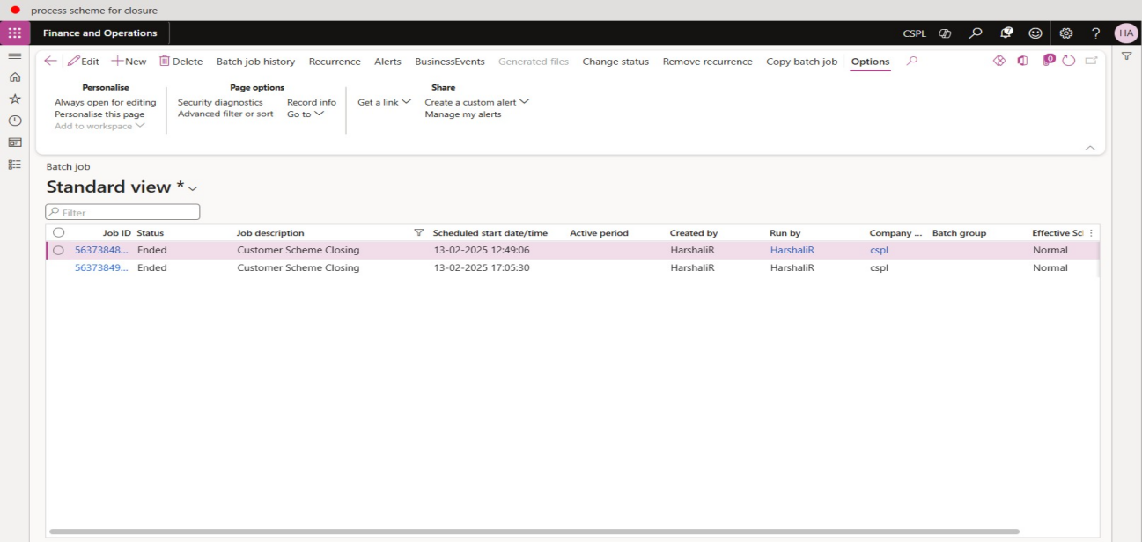

Go to Jewellery > Schemes > Customer Scheme Entry.

In the list, find and select the desired record.

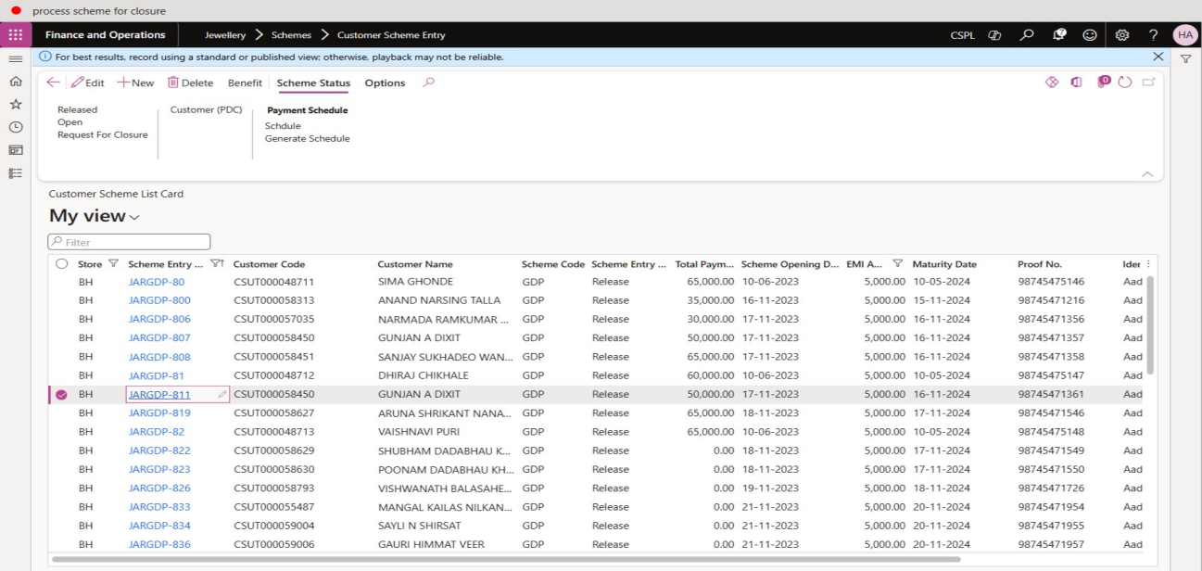

Jewellery -> Schemes -> Customer Advance

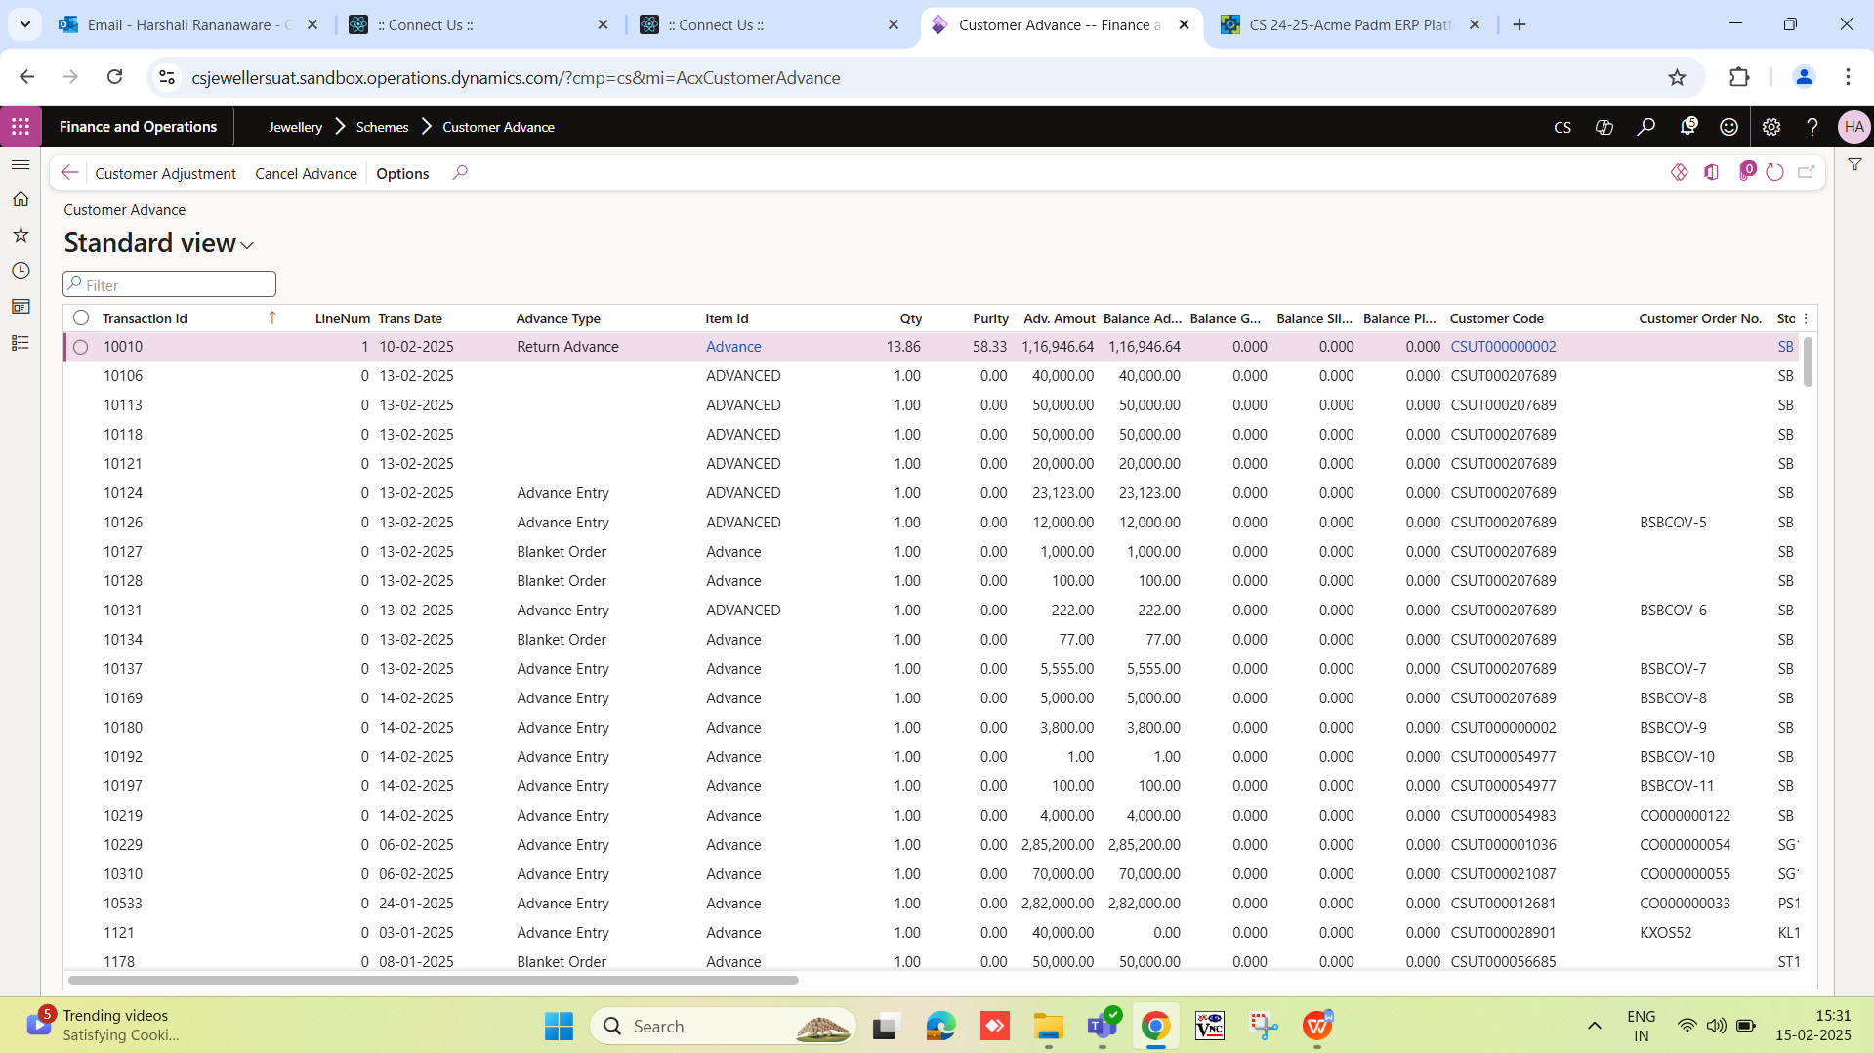

# Bug

Go to Jewellery > Schemes > Periodic > Process Scheme For Closure. Run this process then scheme against “Request For Closure” is yes then this account advance is generated and scheme entry status - close. This is not work.