**CURRICULAM VITAE**

**BAVISKAR YOGESH SOMNATH** 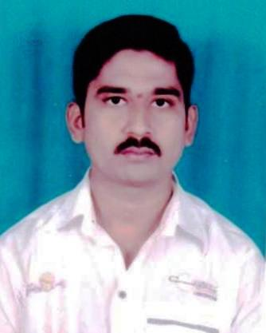

[yogbaviskar@gmail.com](mailto:yogbaviskar@gmail.com) [ysbaviskar@ymail.com](mailto:ysbaviskar@ymail.com)

**Contact no. 9960827039, 7387257222 .**

**OBJECTIVE**

To obtain knowledge of Corporate Sector with whole efforts and prudent skills to achieve self & organization goal. Seeking to accomplish and perform with objective effectively and efficiently.

**EDUCATIONAL QUALIFICATION**

|  |  |  |  |  |
| --- | --- | --- | --- | --- |
| **EDUCATION** | **YEAR** | **COLLEGE/SCHOOL** | **UNIVERSITY** | **%TAGE** |
| **B.COM** | 2009 | YESHWANTRAO CHAVAN COLLEGE SILLOD | DR.B.A.M.U. AURANGABAD | **63.13%** |
| **H.S.C.** | 2006 | YESHWANTRAO CHAVAN COLLEGE SILLOD | AURANGABAD DIV. BOARD | **69%** |
| **S.S.C** | 2004 | SHIVAJI VIDYALAYA SAWALADBARA, TQ.SOYGAON,DIST.AURANGABAD | AURANGABAD DIV. BOARD | **74%** |
| **MS-CIT** | 2008 | OM COMPUTER BHARADI | AURANGABAD | **84%** |

**COMPUTERPROFICIENCY**

**Well Known Abt Internet And Ms-Office.**

* ***WORK EXPERIENCE***
* Company Name - SHRIRAM CITY UNION FINANCE LTD
* Position Title - Gold Loan Officer
* From - 07/09/2012 To Present.
* ***sJOB PROFILE***
* I handle the File’s Of Gold Loan, Persnal Loan, Business Loan(SME) & Property Loan.

**Core Competences:**

**1 Smart Worker**

**2 Good Communication**

**3 Discipline**

**Hobbies & Interest:**

**Listening Songs, Playing Cricket, Riding Bikes.**

**PERSONAL DETAILS**

* **Date of Birth :- 27**Oct 1987.
* **Nationality :-** Indian.
* **Gender** **:-** Male.
* **Marital Status :-** married.
* **Permanent Address:-** At Post: Tulja Bhavani Nagar,

Bharadi, Tq. Sillod, Dist:Aurangabad-431113

* **Languages Known: -** English, Hindi, and Marathi.

**Signature**

**Place : Sillod**

**Date :** / / 2013 s **Yogesh S Baviskar**