**RESUME**

|  |  |  |
| --- | --- | --- |
| **MURALI S AMBEKAR** | |  |
|  | | |
| **Mobile No: (+91) 8618781307** | **muraliambekar74@gmail.com** | |

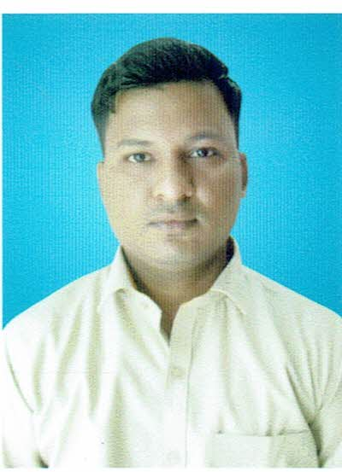

H.No 25

Somanath Galli,

Raibag,

Belagavi,

Pin-591317

**Career Objective:**

To work in an organization that provides me with an opportunity to grow and learn, and help me to achieve my personal as well as organizational goals.

**Academic Qualifications:**

|  |  |  |  |  |
| --- | --- | --- | --- | --- |
| Class | Institute | **University** | **Year** | Aggregate |
| B.Com | Govt. First Grade College, Raibag | Rani Channamma University,Belgaum | 2017 | 70 % |
| P.U.C.(Commerce) | R V Comp PU College, Raibag | Department Of Pre University Education, Bangalore | 2014 | 72 % |
| S.S.L.C | Raibag Vidyalaya, Raibag | Karnataka Secondary Education Examination Board | 2012 | 50.56 % | |

**PROFESSIONAL CERTIFICATION:**

* Advance Diploma In Application & Accounting Course(DCA) In IIMS, Raibag.

**EXPERIENCE:**

* 10 Years Experience in Gold Salesman.

**SKILLS:**

* Point Of Sales Knowledge
* Product and Service Sales
* Exceptional Customer Service
* Good Communication
* Good analytical skill positive attitude

**PERSONAL PROFILE:**

Name : Murali Ambekar

Father Name : Sharad Ambekar

Date of Birth : 06/08/1995

Gender : Male

Marital Status : Unmarried

Languages Known : Kannada, English, Hindi & Marathi.

Nationality : Indian

**Declaration:**

I hereby declare that the information furnished above is correct to best of my knowledge.

 Place: Raibag Signature

Date:                                                                                           **( Murali Ambekar )**