**Curriculum Vital**

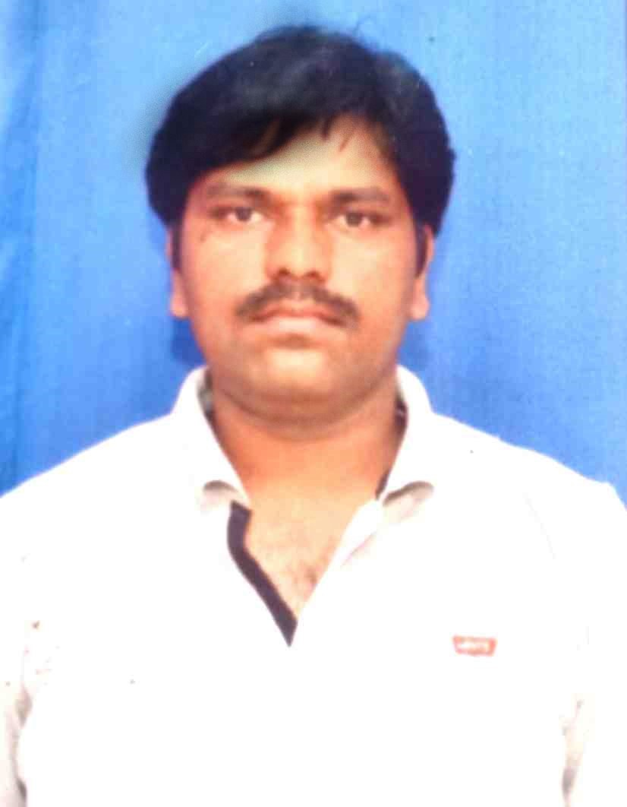

**Photo**

|  |
| --- |
| **YOGESH VIJAY NAIKNAWARE.**  **At Post:-Anjangaon (Khe), Tal:-Madha, Dist:-Solapur, 413214.**  **Mob- 7219529474/9022450533. E-mail: ynaik370@gmail.com**  **Career Objective:-**  Seeking a position for Executive/Administrator/IT Assistant/Clerical in a growth oriented IT Company/College/Bank etc, that allows me to, showcase my potential and experience for the advancement of the organization. Looking forward to, an opportunity to, serve the organization to the best of their interest by providing all the dedication and hard work to achieve the result.  **Career Summary:-**  **Field fresh foods pvt Ltd-:**   * **Baby corn, Chilli, Beans Sweet corn Import - Exports Agriculture Company.** * Online collecting sowing & Harvest Data of all crops. * Responsible for updating and uploading farmer data in the Crop in software. * Collecting online farmer data throw email on weekly basis from Maharashtra, AP & Punjab State. * Operating different types of crop in keys like sowing data upload, harvest data upload, made harvest details etc. * Updating the expenses bills of employee in the system. * Create PO & MIGO number throw SAP system. * Creating phyto Application certificate. * Filing documentation of hard copy farmers harvest data.   **Gogad Logistics (Mahindra & Mahindra Spare Parts Pvt Ltd**) -:   * Creating PCS & GRN NO throw SAP T-code. * Checking part receipt Invoice papers in SAP. * Counting one by one part at location by the time of Annual Inventory. * Uploading parts photo in SAP. * Unloading the vehicles by worker after creating PCS no. after received all material, create GRN no for the customer’s bill payment. * Handling annual Material Management Inventory**.**   **Pravin Masalewale Pvt Ltd (Su'hana) -:**   * Count and Send daily first shift, 2nd shift and 3rd shift manpower report to Sr. HR Manager for production requirements. * Co-ordinate with client in recruitment process, prepare for Offer letter, Appointment Letter, Salary breakup. * Provide support & co-ordinate in conducting Annual Appraisals of the employees. * Provide data such OT, Attendance, PL of the employees for monthly Salary process. * Payroll was done in excel format after upload and download through Salarium software. * To co-ordinate with Bank for Salary opening account. * Provide data for statutory Compliances such as, ESIC, PF gratuity & other reports required at different job locations. * Maintain personal files & data of the employees. * Provide data for group Medical insurance/Personal Accident Policy etc. * Conducting exit interviews, exit formalities. * Experience in handling discipline cases, preparation of various reports, in case of accident/major injury of the employees. * Check daily how much manpower required to all production. * Check and update daily attendance card of 400 workers through Punching watch timer machine. * Then update day to day attendance of present workers in Attendance register note book for tally. * Make monthly payments of workers through Salairum Software in system. * Make PF UAN account no of new join client in Contract EPFO account. * Check PF passbook & update KYC details of the employees.   **Nutan Maharashtra Institute of Engineering & Technology Talegaon Dabhade Pune.**  **\* Check windows system Updatation after 15 days.**  **\* Installation old New College’s Software for practical work and exam.**  **\* Formatting required Computer as per its Conditions.**  **\* Check Network connection, all cables wires, Keyboard, Mouse are properly working or not.**  **\* Handling and do proper lab setup for practical exam. And filled ext & Int. examiner, lab assistant, peon documentation form of SPPU PR/OR/TW exam.**  **\* Replaced old Computer as per required system conditions.**  **\* Working Administrative office work as per required need.**  **\* Update & Maintain lab inward outward Dead stock register of components. And issue these components to SE, TE & BE students for Project work.**  **\* Do Prelims Exam Internal Supervision duty as well as End Sem SPPU internal scoud duty as per college norms.**  **\* Help to faculty for make SE,TE & BE result analysis, Lab verify documentation, Scanning internship letter & Certificate as well as prepare the labs components, color poster and project documents to decorate the labs all this work done in the institute for NBA accreditation & Committee Visit.**  **\***  **Computer Skills:-**   * Experience working on Windows95/98/2000/NT/XP * Good knowledge of MS office suit that includes Excel, Power Point, File management. * Well versed with the use of publisher. * Good typing skill of 25 -30 wpm. * Basic knowledge of Tally Prime   **Professional Experience:-**   1. **FIELD FRESH FOODS PVT LTD - PUNE,**   **From 1stFeb 2013 to 24thJune 2015. [Exp - 2.6 Year's]**  **Data Base Analysis / Entry Operator.**   1. **Mahindra Business Spare Parts (Mahindra Logistics) – Vadgaon Maval Pune,**   **From 27th Sep 2016 to 14th June 2017. [Exp - 10 Months]**  **SAP Data Entry Executive.**   1. **Pravin Masalewale Pvt Ltd. - Hadapsar,Pune**   **From 1st Dec 19 - 10th Jan 21. [Exp - 1 Year's]**  **As HR Assistant.**   1. **Currently Working in NMIET Talegaon as a Lab Assistant. [4th Nov-22 – Till date]**   **Educational Qualification:-**   * **BCA degree passed with (53.10℅) through Savitribai Phule University of Pune.**   **From Dr.Purandare Jr & Sr Arts & Commerce College Lonavla, Pune,**  **in 2011.**   * **HSC passed (50℅) through Maharashtra Board Pune,**   **From Sri.V.S.S Jr. Arts, Commerce & Science College Wagholi, Pune,**  **in 2007.**   * **SSC passed (58.40℅) through Maharashtra Board Pune,**   **From Sri Khiloba Madhymik Vidyalay Anjangaon (Khe ), Madha , Solapur,**  **in 2005.**  **Key Skills and Strengths:-**   * Able to perform independently * Hard working and result oriented * Good in making friends * Good eye to minute details * Excellent professionalism and Self- motivation * Good organizational skills   **Personal Details:-**  **Date of Birth: - 27th, August 1989.**  **Languages Known: -** English, Hindi & Marathi.  **Nationality: -** Indian.  **Gender: -** Male.  **Married/Un-married**:- Married.  **Hobbies** - Running, playing Cricket, singing & listing old and new song and reading news paper.  **Place: - Anjangaon (Khe) Madha Solapur.**  **Date: -**    **Signature**  **(Yogesh Vijay Naiknaware).** |
|  |
|  |
|  |
|  |
|  |