**RESUME**

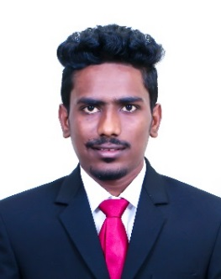

**Gomatesh Keshme**

**Mobile No :** +918880076520

**Email Id :** [gomatesh_keshme@klsimer.edu](mailto:gomatesh_keshme@klsimer.edu)

**Career Objective**

To work for an organization which will enable to use my skill to achieve the organizational goals.

**Education**

|  |  |  |  |  |
| --- | --- | --- | --- | --- |
| **Year** | **Degree** | **Institute** | **Specialization** | **Percentage** |
| 2016-2018 | MBA | KLS IMER  Belagavi | Marketing | 60%  ( 1st year) |
| 2013-2016 | B.com | Shivanand College  Kagwad | Commerce | 64% |
| 2011-2013 | PUC | Shivanand College  Kagwad | Commerce | 64% |
| 2010-2011 | SSLC | Vidyasagar High School  Kagwad | - | 83% |

**Project Details**

**MBA Summer Internship Project**

**Topic :** A Study on customer loyalty and satisfaction towards Royal Enfield bikes.

**Company :** Rohan Motors (Vijayapura)

**MBA Organizational Study**

**Objective :** Study on managerial etiquettes

**Company :** Delta Ecohuts Resorts

**Workshops/Certifications**

* Received certification of participation for 2 days program on Digital Marketing by Carpe Diem 2k17-18, IIM Calcutta Event.
* Currently perusing IIMBx MOOC on Predictive Analytics.
* Pursuing Certificate in Supply Chain Management by Confederation of Indian Industry.
* Certificate of Merit for competing English Proficiency from KLS IMER, Belagavi.

**Personal Details**

**Date of Birth :** 07th February 1995

**Nationality :** Indian

**Gender :** Male

**Permanent Address :** 440, Near Ram mandir, KAGWAD 591223

**Languages :** English, Hindi, Marathi and Kannada

Date :

Place : Belagavi **GOMATESH KESHME**