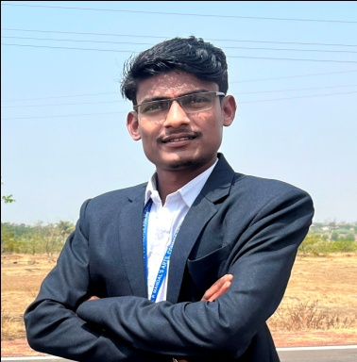

**CHETAN R JADHAV**

Work with maximum potential in a challenging and dynamic environment, with an opportunity of working with diverse group of people and enhancing my professional skills with learning and experience for career growth.

images (1).jpeg **EDUCATION**

jadhavchetan701@gmail.com

**M.COM**

+916361260440 Percentage: (final year)

 SPM’s ARTS & COMMERCE College Raibag,Dist-Belagavi, karnataka

A/P-Chinchali,Tq- Raibag, Dist- Belagavi. **B.COM**

State- Karnataka. INDIA (591217) Percentage:74.10%

SPM’s ARTS & COMMERCE College Raibag,Dist-Belagavi

**SKILLS**  karnataka

Team management **PUC**

Problem solving skills Percentage:79%

Interpersonal skills EXCELLENT IND.PU College Chinchali,Tq-Raibag,Dist-

Leadership skills Belagavi. (2014-2016) (Karnataka).

**SSLC(10th)**

**LANGUAGE**  Percentage:80.48%

English SRI MAHAKALI COMP JUNIOR College Chinchali Tq-Raibag

*Limited working proficiency* Dist-Belagavi.(2013-2014) (Karnataka).

Kannada **STRENGTH**

*Native or bilingual proficiency* Good learner

Hindi Hard-worker

*Limited working proficiency* Egar to learn new things.

Marathi **CERTIFICATES**

*Limited working proficiency* various awards in various competitions & paper presentation.

**PROFESSIONAL TRAINING**

* Completed 3 months course on “Data Entry Operator” from KEONICS Yuva.com centre.

**AREA OF INTEREST**

* Financial management

**PERSONAL DETAILS**

Father’s name : Ramakrishna B Jadhav.

Mother’s name : Mahadevi R Jadhav.

DOB : 04th OCT 1998

Marital status : Unmarried

Nationality : Indian