27 Jan 2023

http://15.207.120.175/TechTicketDummy/Dashboard
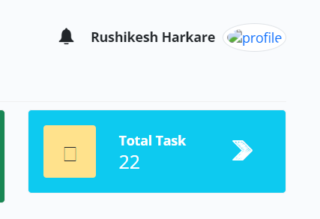

- Profile is not displayed.

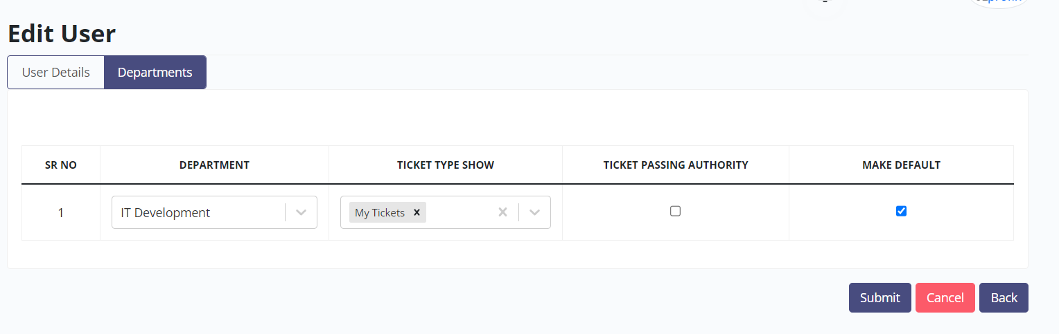
- While editing the user, unable to add the department as “+” icon not there. It is expected Beside ‘Make Default’ there should be provision to add the department.

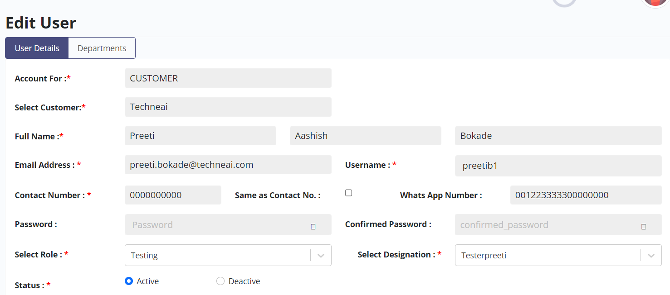
- Contact number accepting as all 10 digit as ‘0’. it is expected as only accept 1to 9 digit and zero can be accepted at last digit.

- WhatsApp Number : Editable and allows user to enter more than 10 digits. It is accepting all ten digits as ‘0’. Expected result - it should accept 10 digits - 1 to 9 digit and zero can be accepted at last digit.

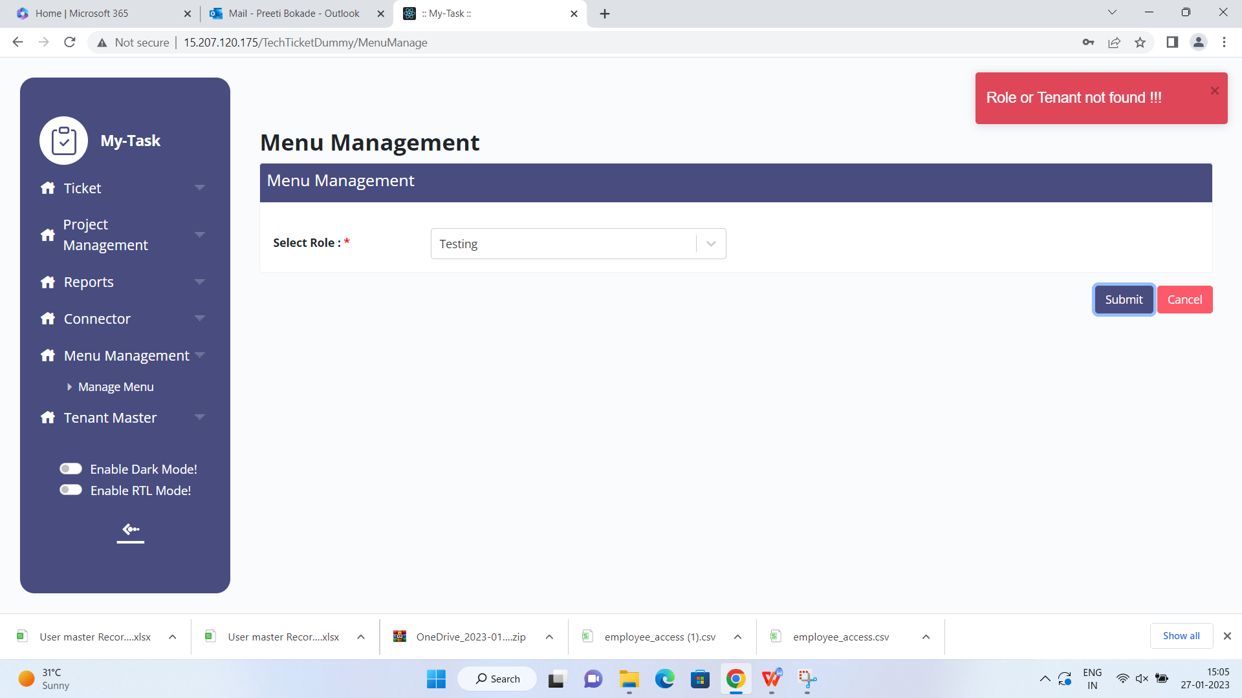

- In menu management system upon click on Submit button , user get ire-relevant error “ Role or Tenant not found”.

Steps followed
search the Role as “ Testing” and click on Submit button.
Select all menu and click on update button .
Again click on submit button .

6.

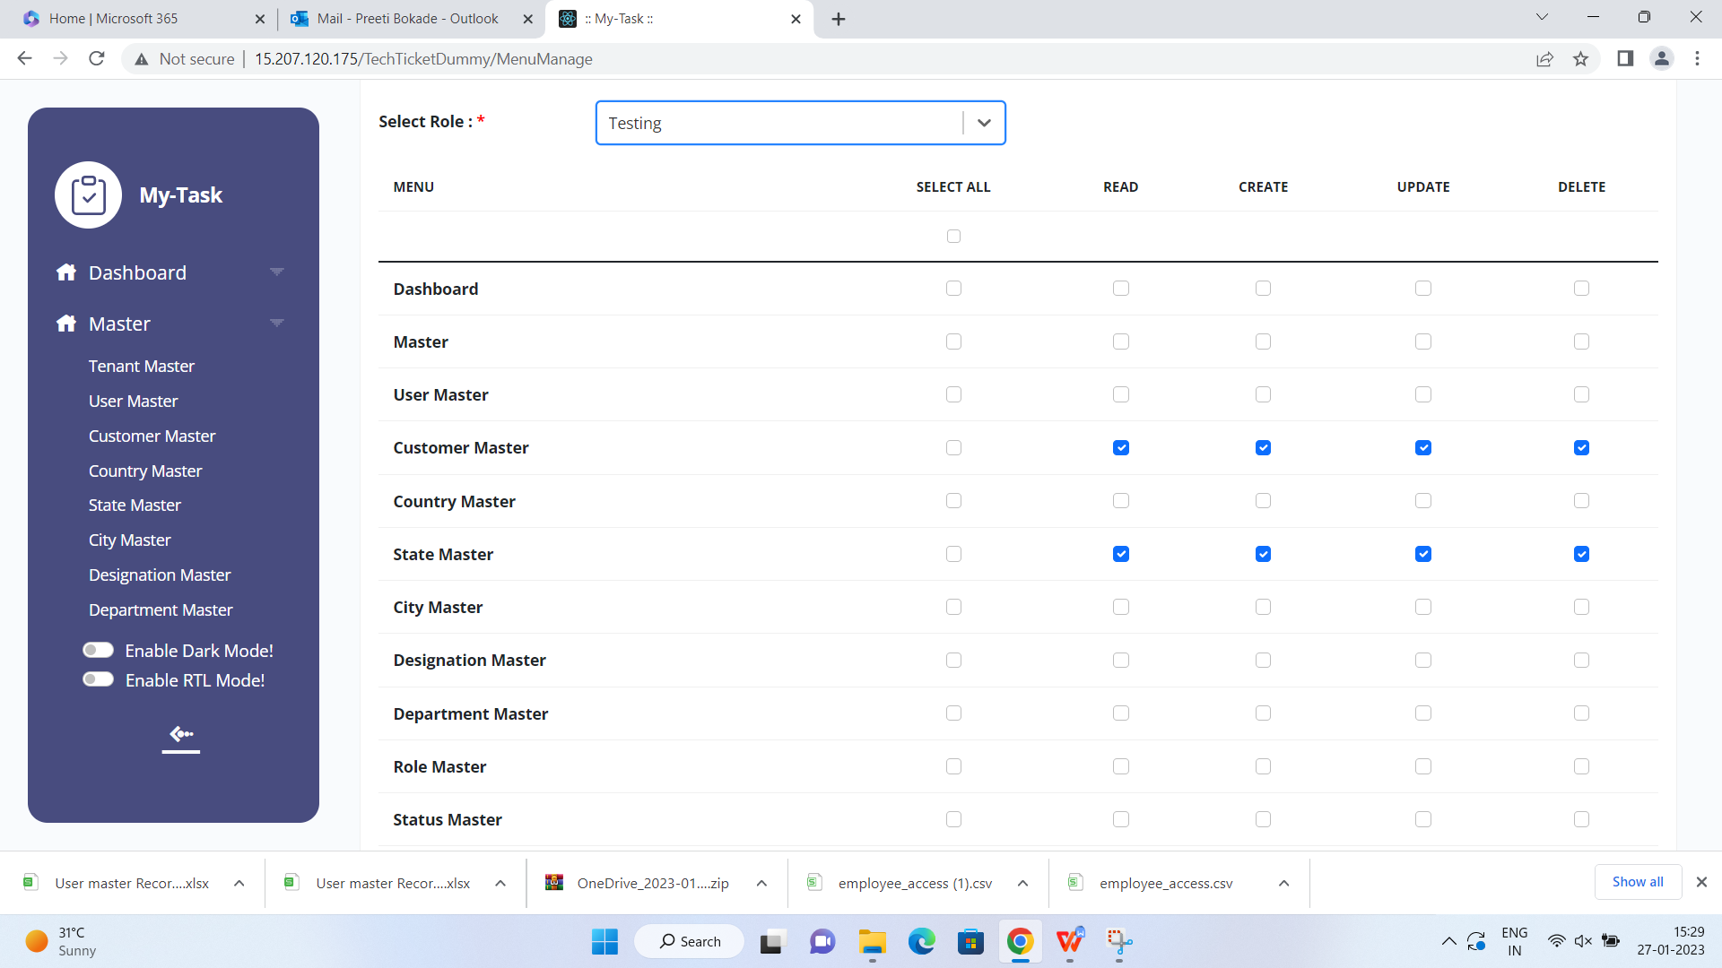

System is allowing to select child master (sub module ) however parent master ( module ) is not selected. It is expected if parent master is not selected then system should not allow to select child master .

- In case of user logged in and the user has all masters & menu access , if somebody revoke the access , still user allowed to see the masters . it is expected that user should not allow to view the masters.

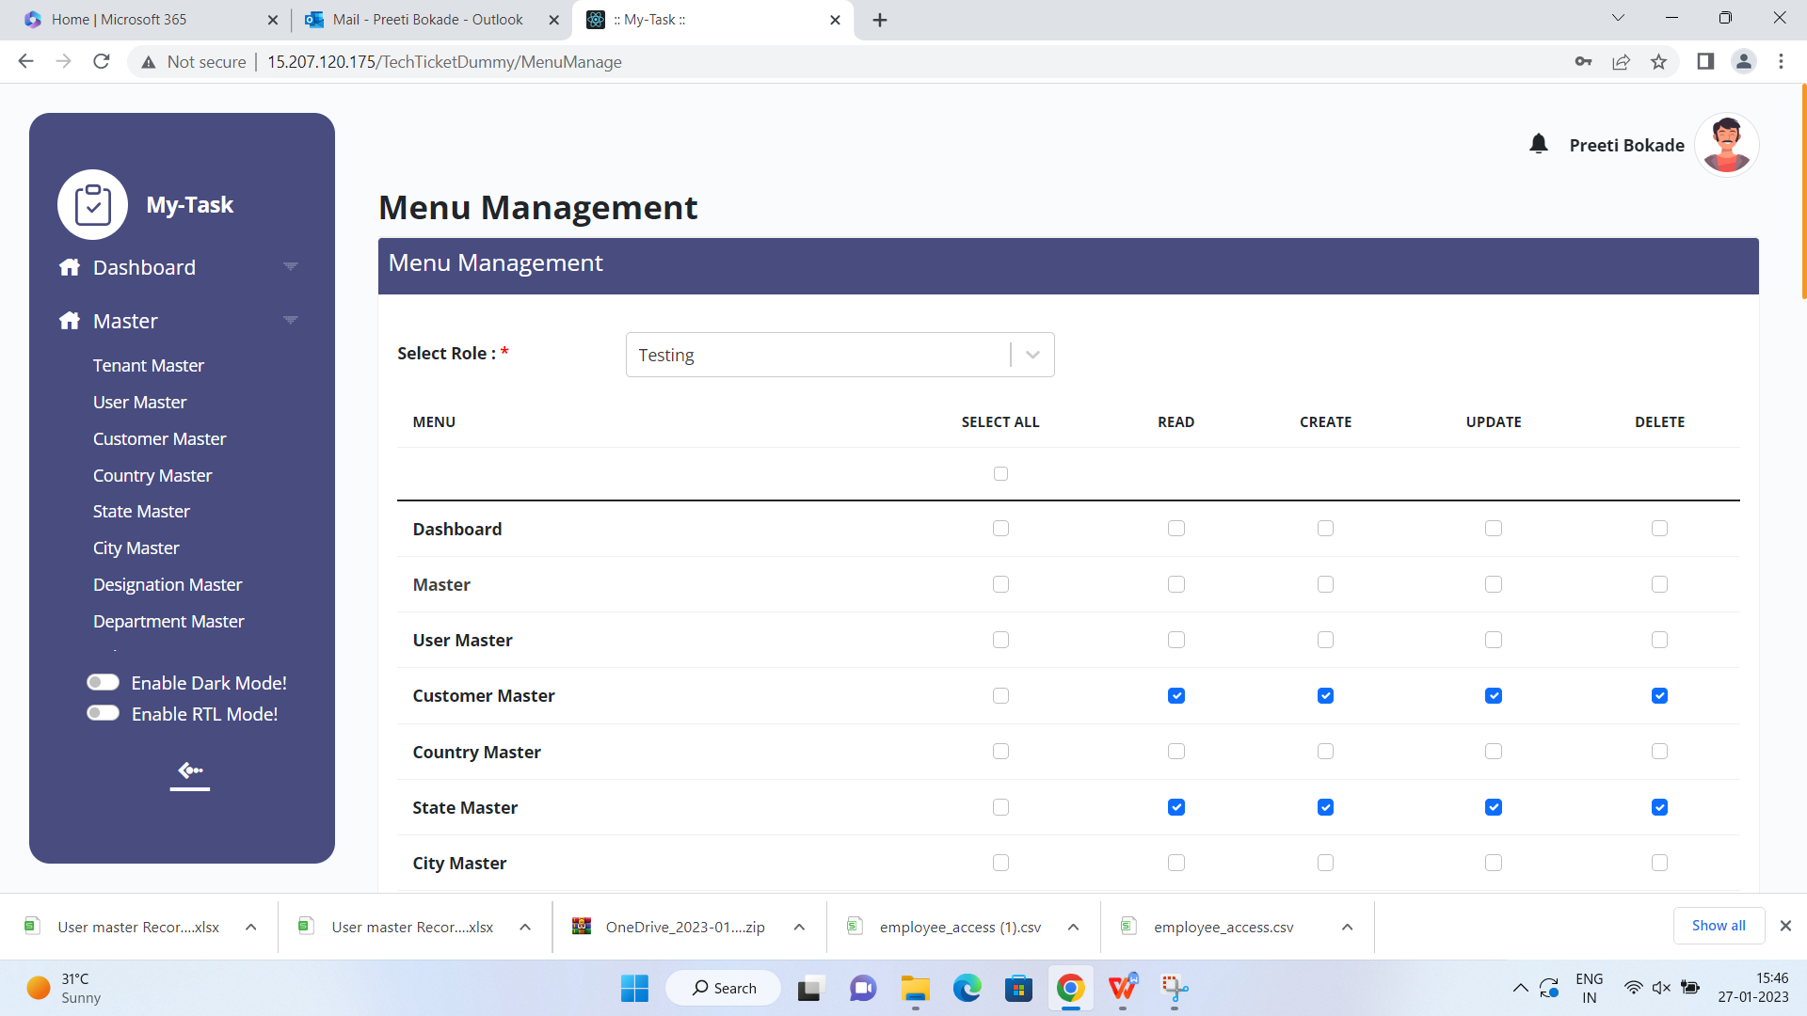

7.
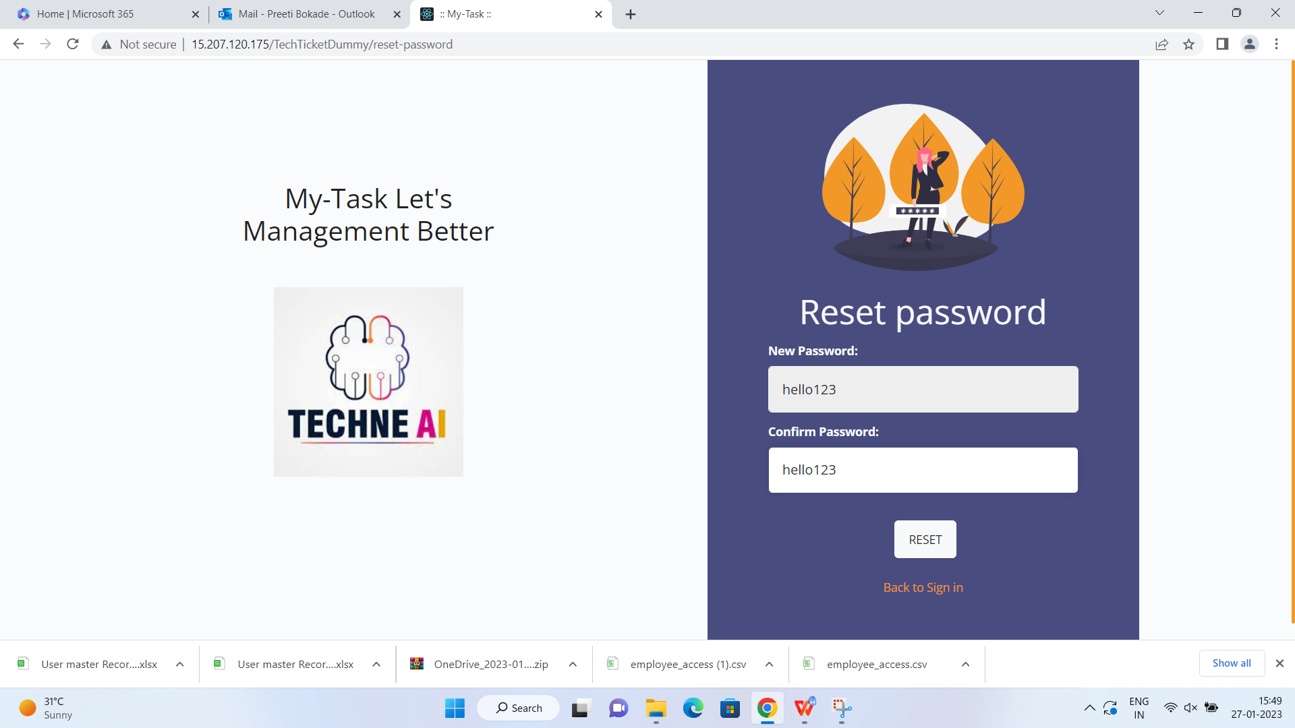

On reset password screen , New Password & Confirm password field values are displayed. It should be masked and provide the provision to user to view by clicking “eye icon” if user wish.

8.

I have created 2 users with same email id hence while resetting the pwd system has changed the password of last login user and allowed to login with changed password . However for 2nd user ( having the same email id ) does not allowed to login with neither with changed password nor with old password. Please look into this on priority.

- 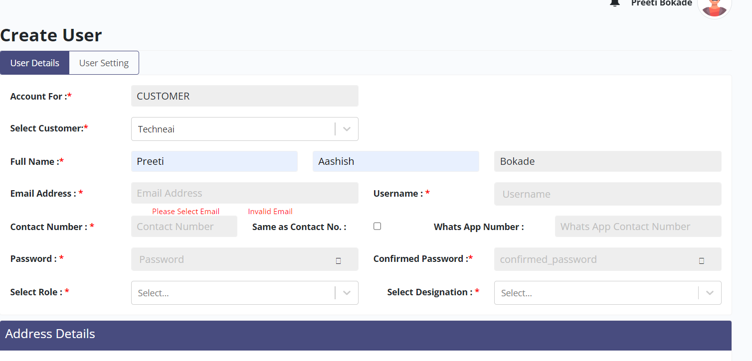
User getting instruction and error simultaneously for one field. It is expected that user get error once the focus goes to other field.

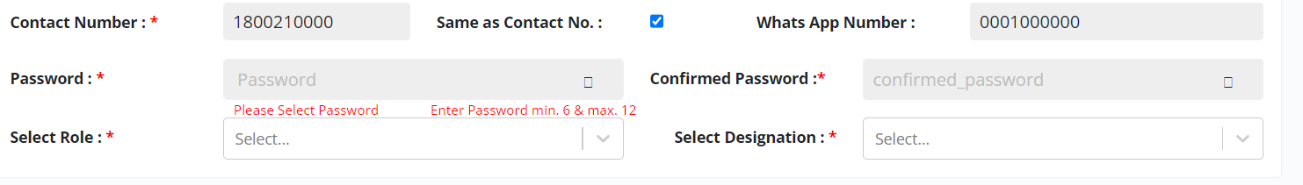
- Same issue observed for password field as well.

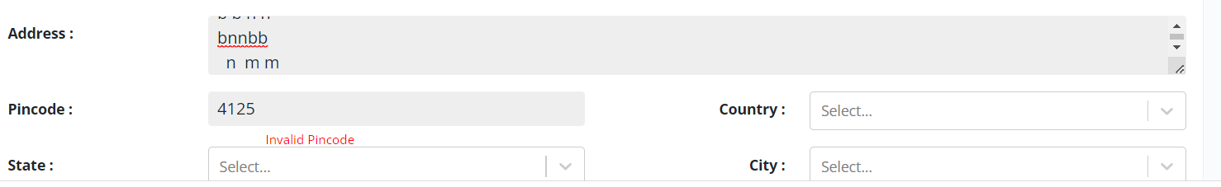

- For Pincode: user has not yet finished the pincode entry and system throwing error. Let user to finish the pincode then system throwing error seems to be meaningful.
- Address field accepting unlimited characters , lets system to allow

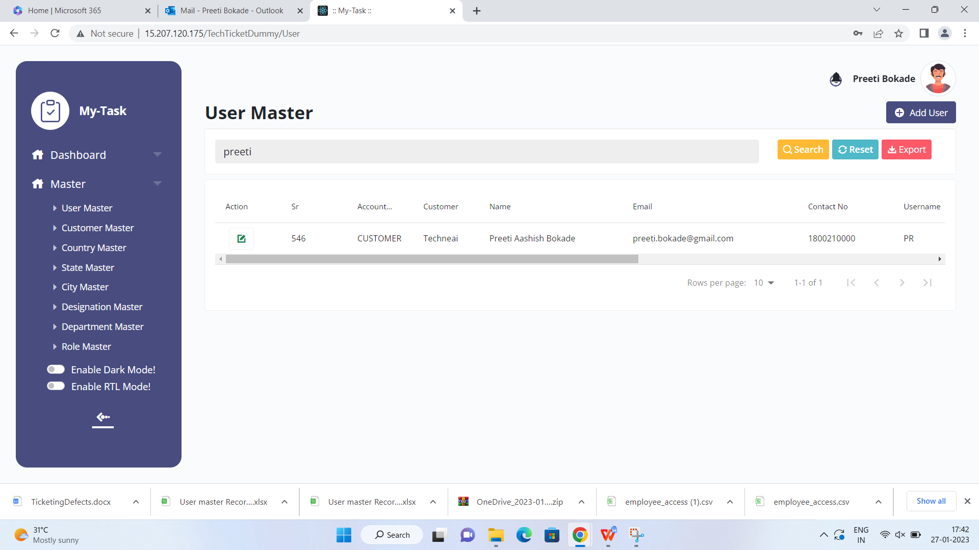
- It has been observed that while creating the 3 user with same name ,the latest user is only displayed in grid view expected all users get displayed .

