Proposed System:

* Creation of dynamic form, feedback escalation.
* Creation of query type based on branch and priority.
* Mapping of user for the query type
* New setting “Feedback query” syncing
* New setting “Escalated feedback setting” module and mapping
* Changes in feedback and escalation.
* New module “Escalated Feedback” and raising the ticket.

Step 1

Addition of dynamic form - “Feedback Escalation Form”

Ticketing system >> Masters >> Dynamic form master >> Add dynamic form

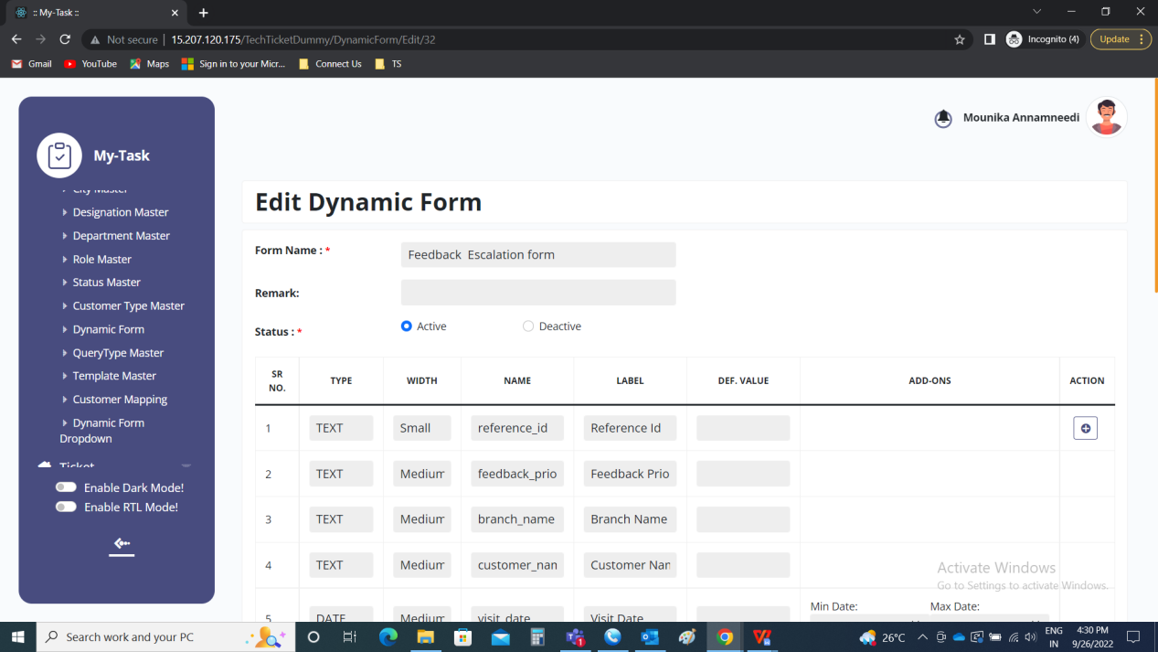

Dynamic Form Master >> Add form

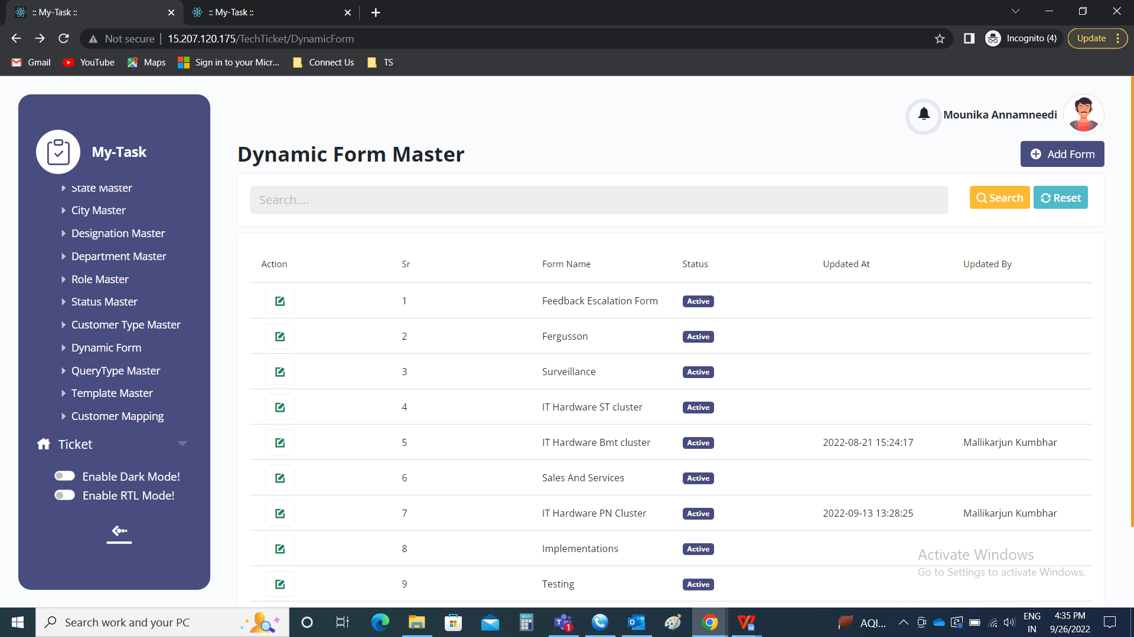

Add Form:

Following are the fields to be filled.

* Form Name
* Type
* Label
* Def value
* Add ons
* Action
* Submit
* Cancel
* View form

|  |  |  |  |
| --- | --- | --- | --- |
| **FIELDS** | **INPUT TYPE** | **MANDATORY/ OPTIONAL** | **DESCRIPTION** |
| Form name | Text | Mandatory | The form name is mentioned |
| Type | Drop down | Mandatory | The type of field is selected from drop down. The following are the fields in the drop down.   * Text - for small texts * Text area - for paragraphs * Number - for numbers * Date - for calender * Date Time - for both date and time * Time - for time * Select - drop down selection from the drop down masters * Select master - drop down selection from the available masters |
| Label | Text | Optional | The label name if any is to be entered |
| Def value | Text | Optional | The def value refers to default value. The default value is used when we require any default value in that field. |
| Add ons | Date & Time | Optional | The add ons are viewed when the user selects the date or time. Date - for minimum and maximum date  Time - for minimum and maximum time |
| Action | Button | Optional | The action button to add one more field or to delete any row. |
| Submit | Button | Optional | The submit form is used to submit the form. |
| Cancel | Button | Optional | The cancel button is used to cancel the form. |
| View form | Button | Optional | The view form button is used to preview the form. When the form is edited, the when we click on “view form”, the form is previewed. To hide it again, “hide form” is selected, so that the form is hidden. |

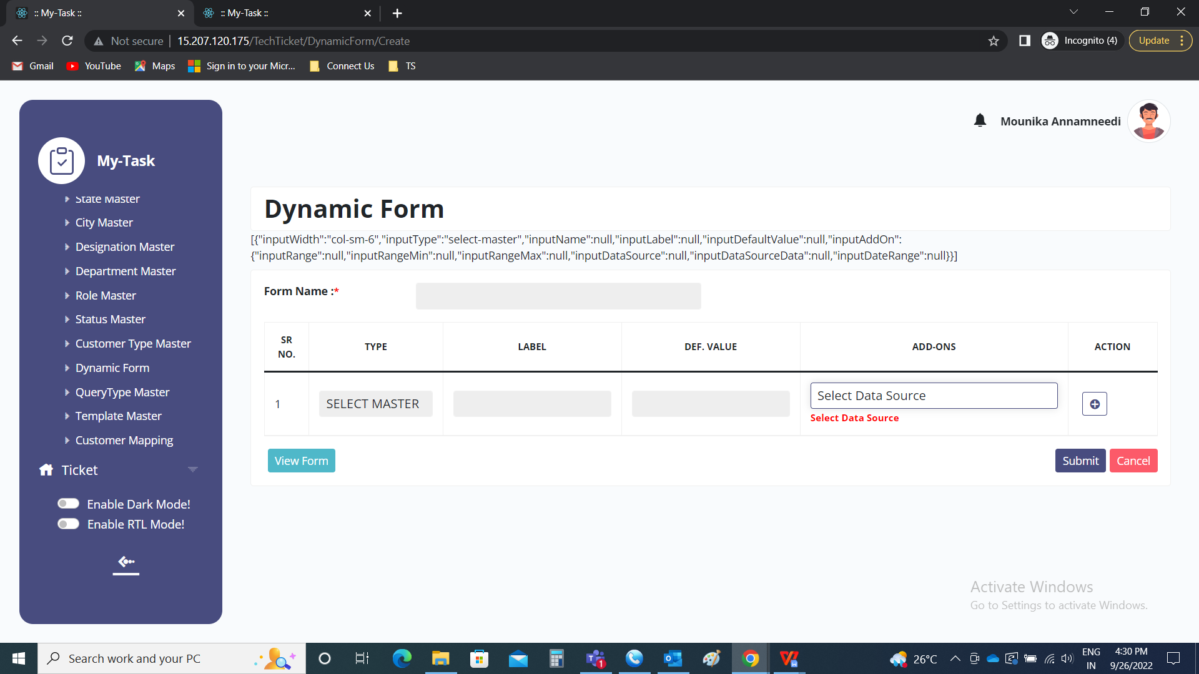

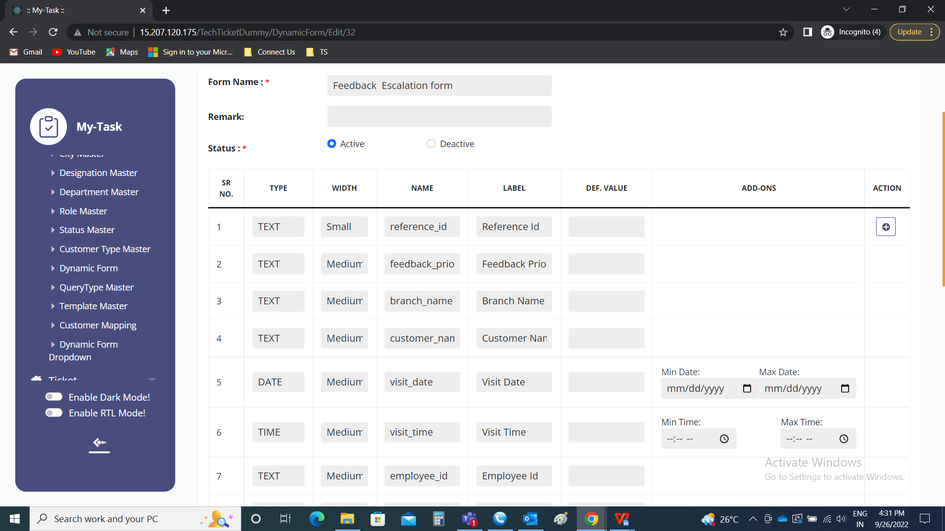

The feedback escalation form consists of the following.

|  |
| --- |
| Reference ID |
| Feedback Priority |
| Branch Name |
| Customer Name |
| Visit Date |
| Visit Time |
| Employee Id |
| Employee Name |
| Counter Name |
| Metal |
| Ornament |
| Calling Date |
| First call |
| Call status |
| Reason |
| Next Visit |
| Scheme Informed |
| EMI Informed |
| Service |
| Customer Feedback |

|  |  |  |
| --- | --- | --- |
| **Field** | **Type** | **Description** |
| Reference ID | - | The reference ID is automatically generated from the feedback (connect us >> report >> feedback) module |
| Feedback Priority | Drop down | The feedback priority is fetched from the escalated feedback (connect us >> escalated feedback) module. The feedback priority drop down consists of the following.   * Low * Medium * High * Very high |
| Branch Name | Drop down | The branch of the entry user is selected. The drop down options are mentioned below. |
| Customer Name | Text | The name of the customer is entered which is fetched from the feedback (connect us >> report >> feedback) |
| Visit Date | Calender | The visit date of the customer to the shop is entered which is fetched from the feedback (connect us >> report >> feedback) |
| Visit Time | Time | The time at which customer visited the shop is entered which is fetched from the feedback (connect us >> report >> feedback) |
| Employee Id | Text | The employee ID of the employee who assisted the customer is entered |
| Employee Name | Drop down | The employee who assisted the customer is selected which is fetched from the feedback (connect us >> report >> feedback). The drop down options are fetched from employee master as per employee name user master. |
| Counter Name | Drop down | The counter to which the customer arrived is entered which is fetched from the feedback (connect us >> report >> feedback). The drop down options of counter name is mentioned below. |
| Metal | Drop down | The metal for which the customer visited is selected which is fetched from the feedback (connect us >> report >> feedback). The drop down options of metal is mentioned below. |
| Ornament | Drop down | The ornament for which the customer visited is selected which is fetched from the feedback (connect us >> report >> feedback). The drop down options of ornament is mentioned below. |
| Calling Date | Calender | The actual calling date to the customer is selected which is fetched from the feedback (connect us >> report >> feedback). |
| First call | Calender | The first call on when the employee called the customer is entered which is fetched from the feedback (connect us >> report >> feedback). |
| Call status | Drop down | The call status is selected from the drop down list which is fetched from the feedback (connect us >> report >> feedback). The drop down options of call status are   * Feedback * No feedback |
| Reason | Text | The reason if any is mentioned which is fetched from the feedback (connect us >> report >> feedback). |
| Next Visit | Drop down | The next visit of the customer is selected from the drop down list which is fetched from the feedback (connect us >> report >> feedback). The drop down options of counter name is mentioned below. |
| Scheme Informed | Check box | Whether the scheme informed to customer is selected from the check box list which is fetched from the feedback (connect us >> report >> feedback).  If yes, yes to be selected.  If no, no to be selected. |
| EMI Informed | Check box | Whether the EMI informed to customer is selected from the check box list which is fetched from the feedback (connect us >> report >> feedback).  If yes, yes to be selected.  If no, no to be selected. |
| Service | Check box | Status of the service liked by the customer or not is selected from the check box which is fetched from the feedback (connect us >> report >> feedback).  If liked, like is selected.  If no, not like is selected. |
| Customer Feedback | Text | The customer feedback if any is mentioned which is fetched from the feedback (connect us >> report >> feedback). |

Drop down options

|  |  |  |  |  |
| --- | --- | --- | --- | --- |
| **Branch master** | **Counter Name** | **Metal** | **Ornament** | **Next visit** |
| Baramati | Cash Counter | Gold | Utensils | Purchase From Another |
| Baramati midc | Delivery Counter | Silver | Pooja Items | Visit to Our Website |
| Akluj | Diamond Counter | Diamond | Murti | Sales Person will Contact them |
| Pune | Tops Counter | Stone | Payal | Next Month |
| Chandan nagar | Vedhnee Counter | Mrp | Sakhali | Next Week |
| Hadapsar | Chain Counter | Forming | Jodvi | Cancelled |
| Kothrud | Angathi Counter | Platinium | Challa | Visit to our other branch |
| Satara road | Necklace Counter | Other | Mekhala | Not Confirm |
| Chinchwad | Bangdi Counter |  | Devache Tak |  |
| Sangamner | Ganthan Counter |  | Rakhi |  |
| Bhosari | Silver Counter |  | Kadali |  |
| Ahemadnagar | Forming Counter |  | Apata pan |  |
| Nashik | URD Counter |  | Kalas Vel |  |
| Satara | Smith Counter |  | Modak |  |
| Sangli |  |  | Durva |  |
| Karad |  |  | Pratima |  |
| Kolhapur |  |  | Satwai |  |
| Athani |  |  | Bichave |  |
|  |  |  | Vale |  |
|  |  |  | Paan |  |
|  |  |  | Palna |  |
|  |  |  | Katree |  |
|  |  |  | Mukhavata |  |
|  |  |  | Khulkhula |  |
|  |  |  | Karadoda |  |
|  |  |  | Swastik |  |
|  |  |  | Kamarpatta |  |
|  |  |  | Supari |  |
|  |  |  | Devache Paat |  |
|  |  |  | Saadi Pin |  |
|  |  |  | Swarovski |  |
|  |  |  | Black Beeds |  |
|  |  |  | Oxide Jewellery |  |
|  |  |  | Tode |  |
|  |  |  | Janava |  |
|  |  |  | Other |  |
|  |  |  | Ganthan |  |
|  |  |  | Angathi |  |
|  |  |  | Tops |  |
|  |  |  | Chamaki |  |
|  |  |  | Necklace |  |
|  |  |  | Rani Har |  |
|  |  |  | Mohanmal |  |
|  |  |  | Laxmi Har |  |
|  |  |  | Bangdi |  |
|  |  |  | Bajuband |  |
|  |  |  | Bindi |  |
|  |  |  | Thushi |  |
|  |  |  | Chain |  |
|  |  |  | Kada |  |
|  |  |  | Pendent |  |
|  |  |  | Nath |  |
|  |  |  | Vel |  |
|  |  |  | Kolhapuri Saj |  |
|  |  |  | Bracelet |  |
|  |  |  | Pohe Har |  |
|  |  |  | Coin |  |
|  |  |  | Vedhanee |  |
|  |  |  | Dorla |  |
|  |  |  | Mani |  |
|  |  |  | Padak |  |
|  |  |  | Dal Tik |  |
|  |  |  | Tashiv Mani mal |  |
|  |  |  | Kap |  |
|  |  |  | Badam |  |
|  |  |  | Patli |  |
|  |  |  | Bor Mal |  |
|  |  |  | Goth |  |
|  |  |  | Kanthi Mal |  |
|  |  |  | Bakuli Har |  |
|  |  |  | Manchali |  |
|  |  |  | Watch |  |
|  |  |  | Putali Har |  |
|  |  |  | Wedding Set |  |
|  |  |  | Zumka |  |
|  |  |  | Bali |  |
|  |  |  | Dul |  |
|  |  |  | Bugadi |  |
|  |  |  | S Phasa |  |
|  |  |  | Shahi Har |  |
|  |  |  | Choker |  |
|  |  |  | Diamond |  |
|  |  |  | Yellow Sapphire |  |
|  |  |  | Emerald |  |
|  |  |  | Ruby |  |
|  |  |  | Blue Sapphire |  |
|  |  |  | Quartz |  |
|  |  |  | Cats Eye |  |
|  |  |  | Pearl |  |
|  |  |  | Coral |  |
|  |  |  | Gomed |  |
|  |  |  | Zircon |  |
|  |  |  | Amethyst |  |
|  |  |  | Alexandrite |  |
|  |  |  | Sun Stone |  |
|  |  |  | Hemetite |  |
|  |  |  | Firoza |  |
|  |  |  | Topaz |  |
|  |  |  | Opal |  |
|  |  |  | Tiger's Eye |  |
|  |  |  | Moonstone |  |
|  |  |  | Tourmaline |  |
|  |  |  | Alexandar |  |
|  |  |  | Lapis |  |
|  |  |  | Rudraksha Mala |  |
|  |  |  | Tanmani |  |
|  |  |  | Chinchpeti |  |
|  |  |  | Mala |  |

Step 2

Creation of query type based on branch and priority

Ticketing System >> Masters >> Query Type Master >> Add query type

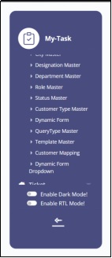

Query Type Master >> Add query type

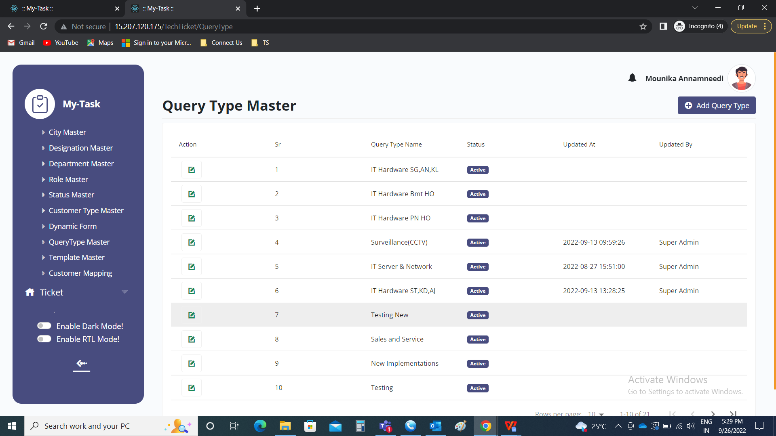

Add query type

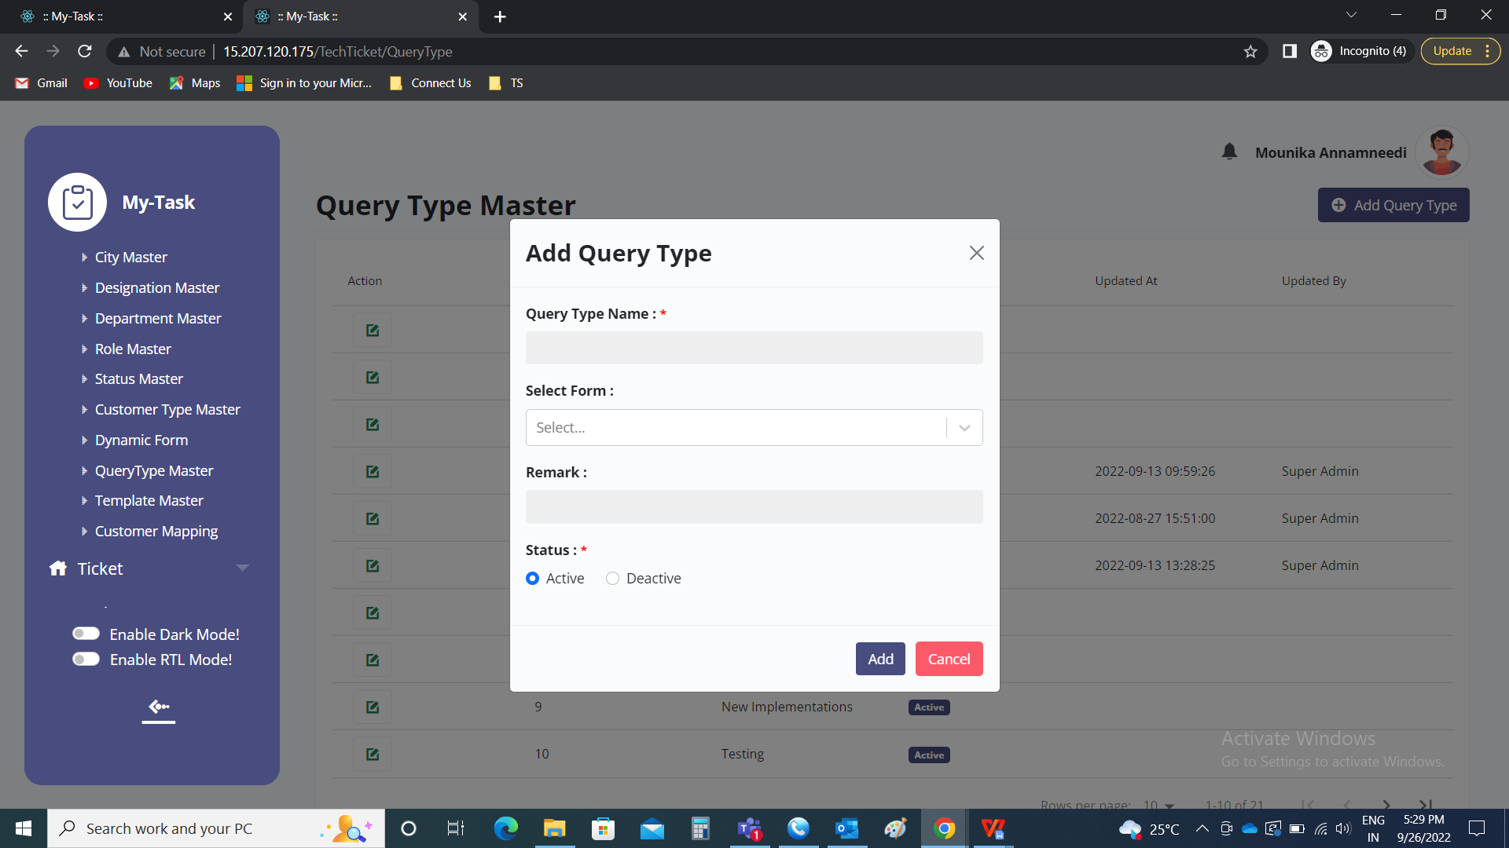

Following are the fields

* Query type name
* Select form
* Remark
* Status
* Add
* Cancel

|  |  |  |  |
| --- | --- | --- | --- |
| **FIELDS** | **INPUT TYPE** | **MANDATORY/ OPTIONAL** | **DESCRIPTION** |
| Query type name | Text | Mandatory | The query type name name is entered. |
| Select form | Drop down | Mandatory | The type of form required is selected. The data is fetched from dynamic form master. |
| Remark | Text | optional | The remark if any is mentioned |
| Select status | Radio button | Mandatory | The radio button consists of active and de-active.  Active is selected if the query type name is active or else de-active is selected. |
| Add | Button | Optional | To create the query type name |
| cancel | Button | Optional | To navigate to the query type name master page |

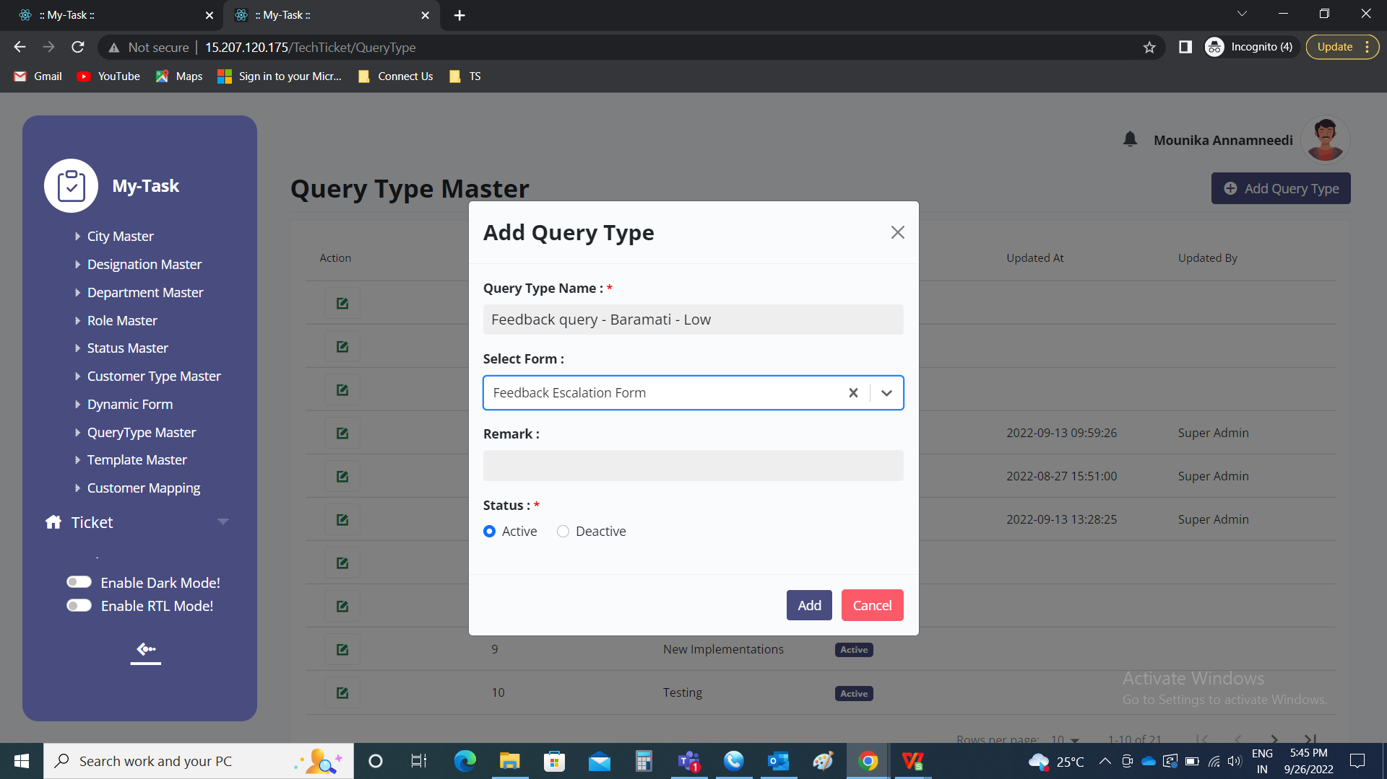

The following are the query types based on priority and branch.

|  |  |  |
| --- | --- | --- |
| **Priority** | **Branch** | **Point Assign To** |
| Low | Baramati | Rohit Awade |
| Low | Baramati Midc | Rahul Ghorpade |
| Low | Akluj | Deepak Chavan |
| Low | Pune | Pravin Gaikwad |
| Low | Chandan Nagar | Arun Mahadik |
| Low | Hadapsar | Onkar Tiwari |
| Low | Kothrud | Shivraj Kanse |
| Low | Satara Road | Sandesh Pandit |
| Low | Chinchwad | Hemant Gandale |
| Low | Sangamner | Deepak Datir |
| Low | Bhosari | Swapnil Ghorpade |
| Low | Ahemadnagar | Milind Sharma |
| Low | Nashik | Prashant Jagtap |
| Low | Satara | Rupali Kadam |
| Low | Sangli | Amol Danole |
| Low | Karad | Yashpal Ghate |
| Low | Kolhapur | Suhas Patil |
| Low | Athani | Deepak Raynade |
| Medium | Baramati | Deepak Wabale |
| Medium | Baramati Midc |
| Medium | Akluj |
| Medium | Pune | Sameer Dabhade |
| Medium | Chandan Nagar |
| Medium | Hadapsar |
| Medium | Kothrud |
| Medium | Satara Road |
| Medium | Chinchwad | Avinash Javanjal |
| Medium | Sangamner |
| Medium | Bhosari |
| Medium | Ahemadnagar |
| Medium | Nashik |
| Medium | Satara | Rupesh Sharma |
| Medium | Sangli |
| Medium | Karad |
| Medium | Kolhapur |
| Medium | Athani |
| High | All Branches | Amrutha Gaikwad |
| Very High | All Branches | Mayuresh |

Step 3

Mapping of user for the query type

Ticketing system >> Masters >> Customer mapping >> Create mapping setting



Customer mapping >> Create mapping setting

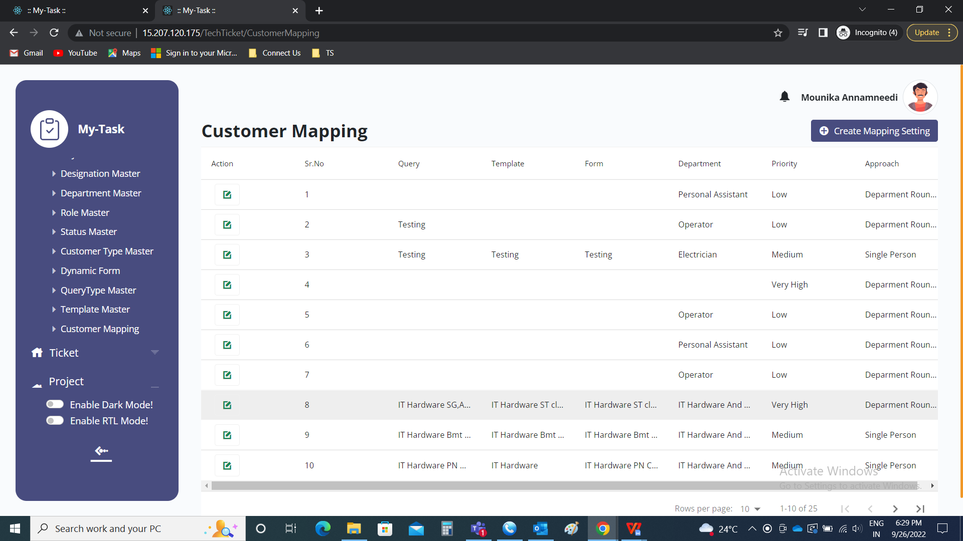

Create mapping setting

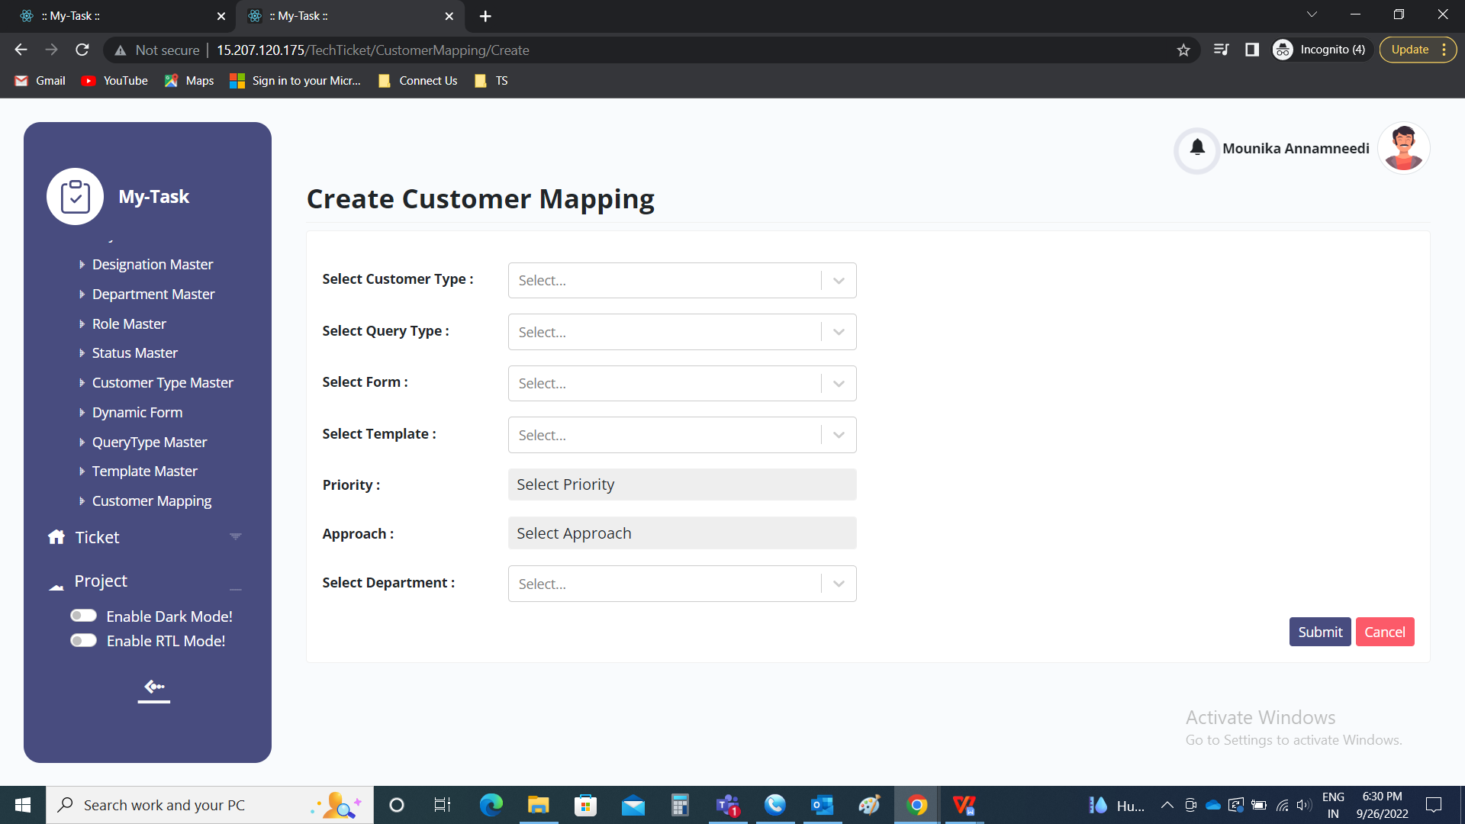

Following are the fields in create mapping setting

* Select customer type
* Select query type
* Select template
* Select priority
* Select approach
* Select department
* Submit
* Cancel

|  |  |  |  |
| --- | --- | --- | --- |
| **FIELDS** | **INPUT TYPE** | **MANDATORY/ OPTIONAL** | **DESCRIPTION** |
| Select customer type | Drop down | Mandatory | The customer type is selected from the drop down list. The drop down options are fetched from customer type master. |
| Select query type | Drop down | Mandatory | The query type is selected from the drop down list. The drop down options are fetched from query type master. |
| Select template | Drop down | Mandatory | The template is selected from the drop down list. The drop down options are fetched from template master. |
| Select priority | Drop down | Mandatory | The priority is selected from the drop down list. The drop down option consists of the following.   * Low * Medium * High * Very high |
| Select approach | Drop down | Mandatory | The approach is selected from the drop down list. The drop down option consists of the following.   * Department wise round robin * User having less tickets * Single person * Ratio wise   Department wise round robin refers to where the tickets are distributed among the departments in the round wise equally.  User having less tickets refers to where, in a department, where there are less tickets, the tickets are assigned to those persons accordingly.  Single person refers to where the few tickets based on the above factors, selected to specific person.  Ratio wise refers to where the tickets are distributed in ratio wise in the departments. |
| Select department | Drop down | Mandatory | The department is selected from the drop down list. The drop down options are fetched from department master. |
| Submit | Button | Optional | To submit the data and to add the entry. |
| Cancel | Button | Optional | To cancel the data |

Here, we are using single person approach. So, the following is the process for the single approach.

Single person:

Single person refers to where the few tickets based on the above factors, selected to specific person. When the user selects the single person, then automatically, extra field will be displayed in which the user to be selected.

* Select user

|  |  |  |  |
| --- | --- | --- | --- |
| **FIELDS** | **INPUT TYPE** | **MANDATORY/ OPTIONAL** | **DESCRIPTION** |
| Select user | Drop down | Mandatory | The user to be selected from the drop down list. The drop down options are fetched from the user master. The users are fetched against the department. |

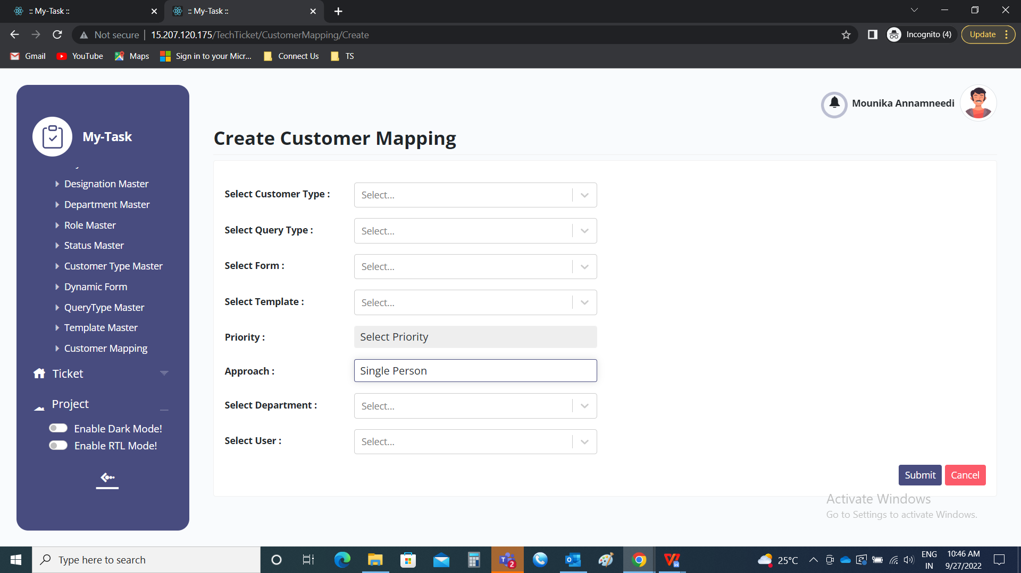

The users list given above are mapped with the query type and the customer.

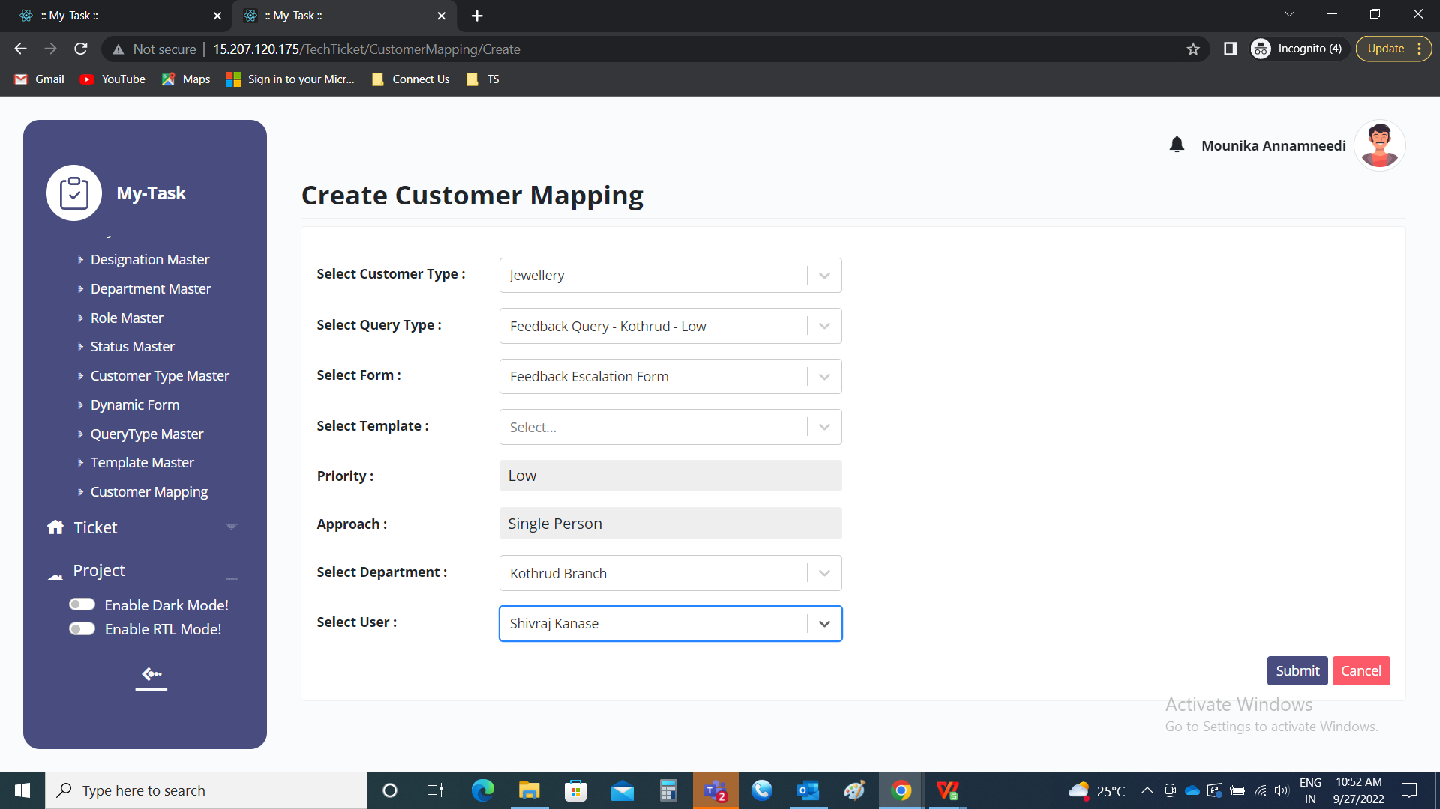

Step 4

New setting “ Escalated Feedback query” syncing

Connect Us >> Escalated Feedback Query

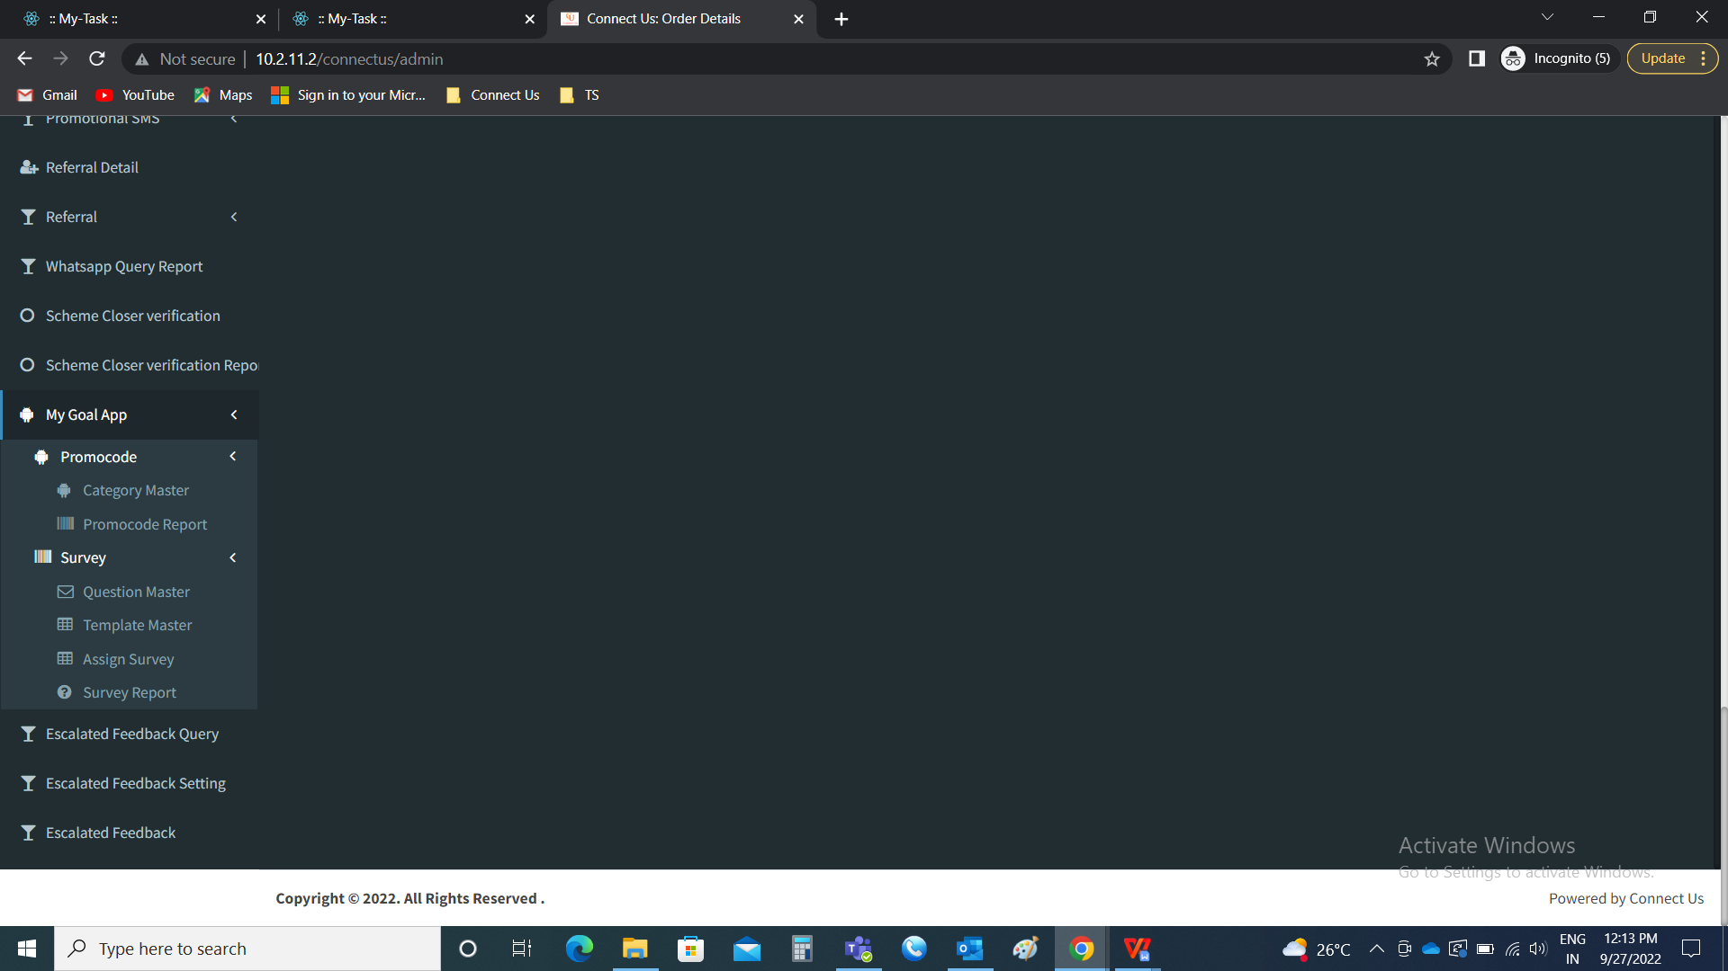

Creation of new module, “Escalated Feedback Query”

The escalated feedback query is used to sync the query type settings in ticketing system to connect us. The following are the fields in the escalated feedback query.

* Sync data
* Query name
* Priority
* Is active
* Synced at

|  |  |
| --- | --- |
| Field | Description |
| Sync data | The sync data button is used to sync the data of the query type in ticketing system in connect us |
| Query name | The query name in the ticketing system is displayed in the connect us when it is synced |
| Priority | The priority of the query type in customer mapping is displayed |
| Is active | The is active is displayed when the query type is in active |
| Synced at | The synced at is displayed, when the query type is last synced |

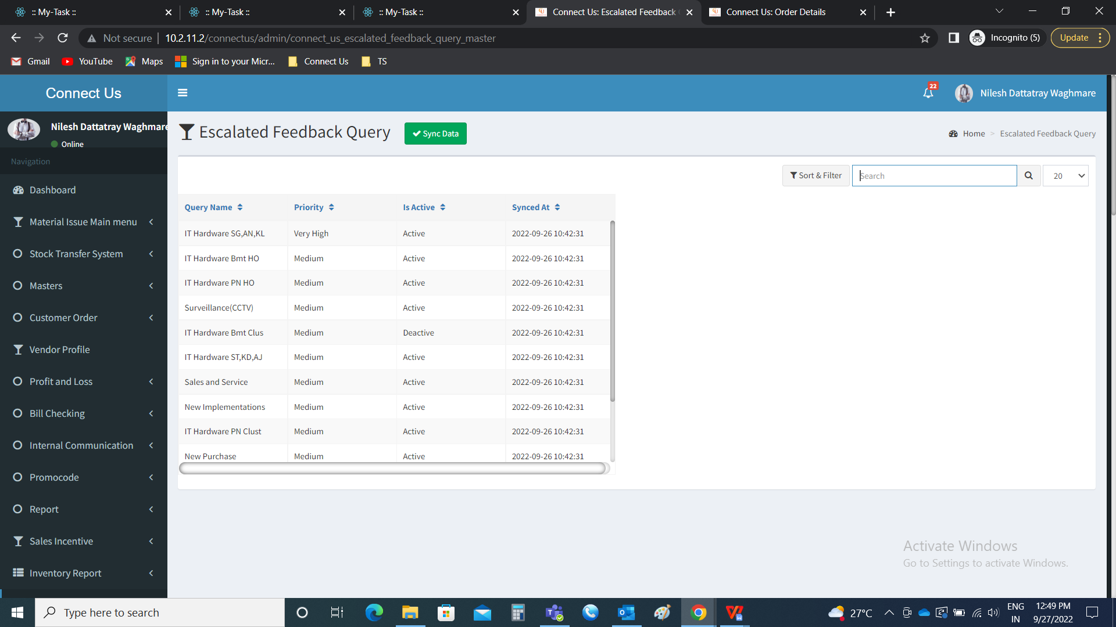

Step 5

New setting “Escalated feedback setting” module and mapping

Connect Us >> Escalated Feedback setting



Escalated feedback setting

The escalated feedback setting is used to map the query type with the branch. The following are the fields in the escalated feedback setting.

* Show data
* Add data
* Action
* Branch ID
* Query type ID
* Priority
* Is active
* Remark
* Created by
* Created at

|  |  |
| --- | --- |
| Field | Description |
| Show data | Show data button is used to show the data |
| Add data | The add data button is used to add the data in the module |
| Action | The action button consists of two button to add, edit and delete the data |
| Branch ID | The branch ID mentioned is displayed |
| Query type ID | The query type ID mentioned is displayed |
| Priority | The priority set against the query type in customer mapping is displayed |
| Is active | The active and in active status of the query type is displayed |
| Remark | The remark mentioned if any is displayed |
| Created by | The created person name is displayed |
| Created at | The date and time at the time of creation is displayed |
| Updated by | The updated person name is displayed |
| Updated at | The date and time at the time of updation is displayed |

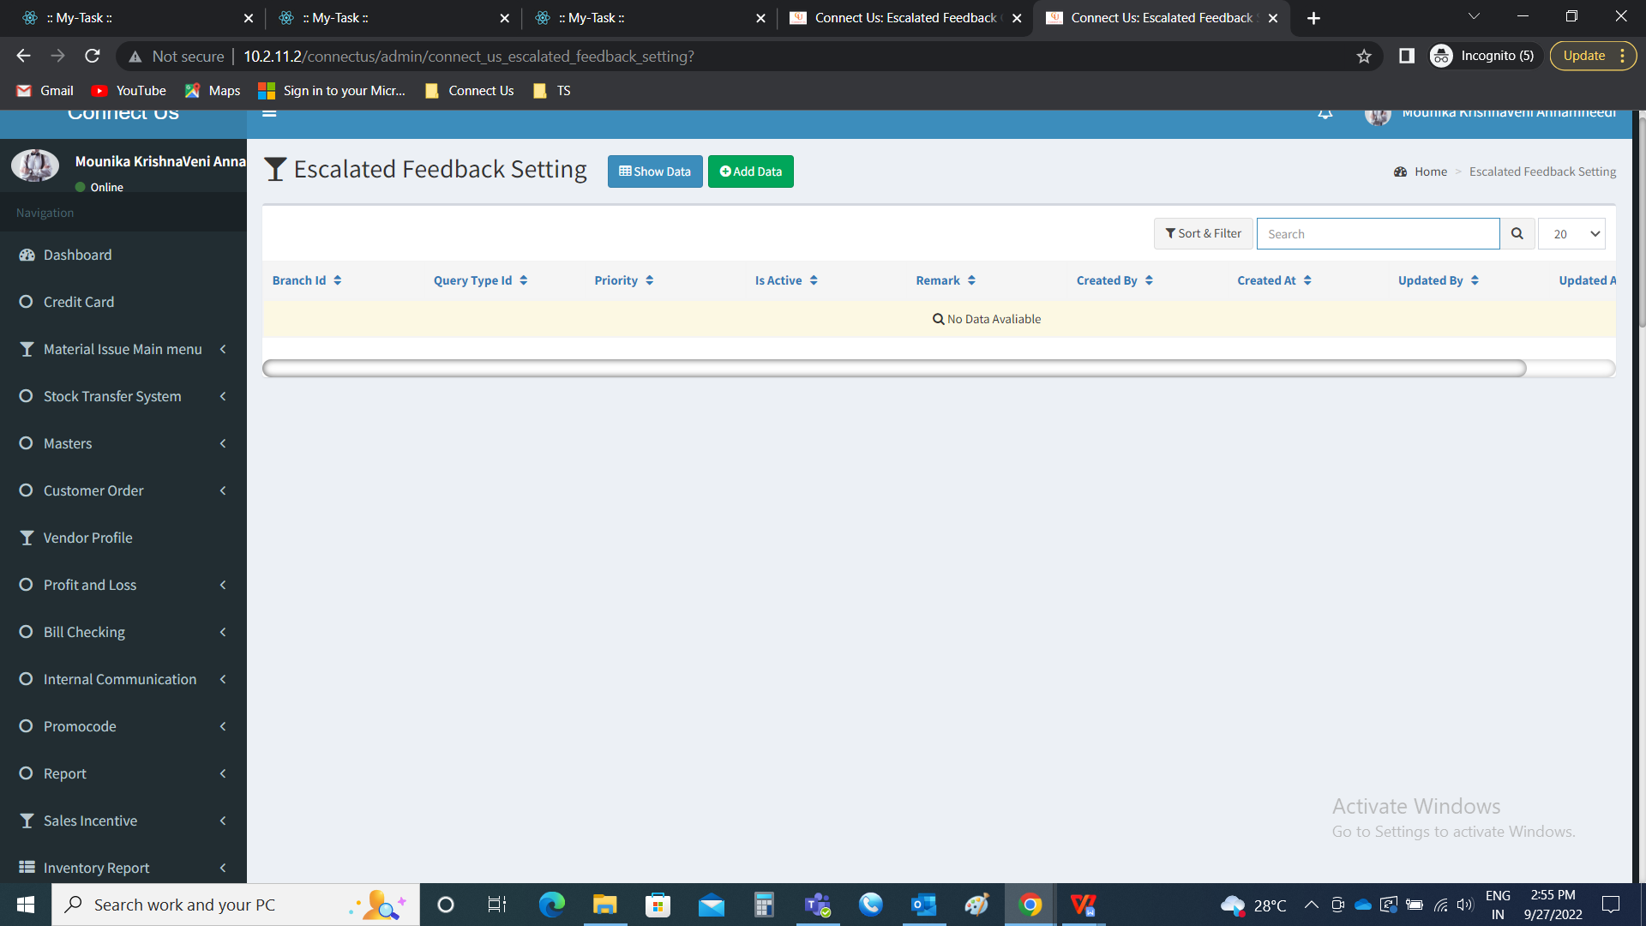

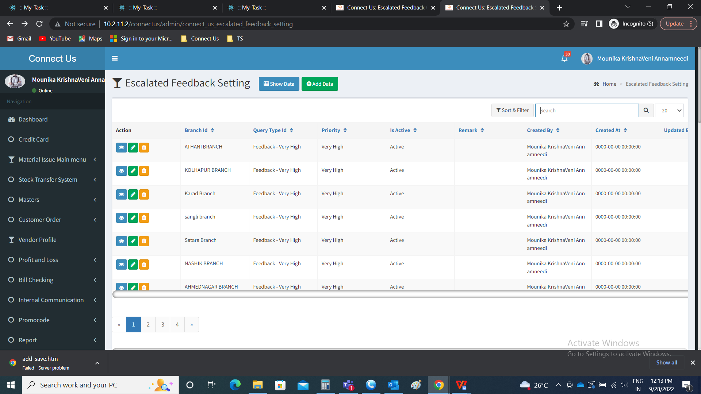

Show data

The show data button is used to show the data.

Add data

The add data button is used to add the data in the escalated feedback setting module. The add data consists of the following fields.

* Branch ID
* Query type ID
* Is active
* Remark
* Back
* Save and add more
* Save

|  |  |  |  |
| --- | --- | --- | --- |
| **Field** | **Type** | **Mandatory/ optional** | **Description** |
| Branch ID | Drop down | Mandatory | The branch ID to be mapped is selected from the drop down. The drop down options are fetched from the branch master (Connect Us >> Masters >> General Masters >> Branch Master). |
| Query type ID | Drop down | Mandatory | The query type Id to be mapped is selected from the drop down. The drop down options are fetched from the query types synced (Connect us >> Escalated queries). |
| Is active | Radio button | Mandatory | The is active consists of 2 buttons.   * Active * Deactive   Active is when the escalated feedback setting is active. If not, deactive is selected. |
| Remark | Text | Optional | The remark if required is entered |
| Back | Button | Optional | The back button to navigate to back page |
| Save and add more | Button | Optional | The save & add more button to save the existing and add the another one in the setting |
| Save | Button | Optional | The save button to save the data |

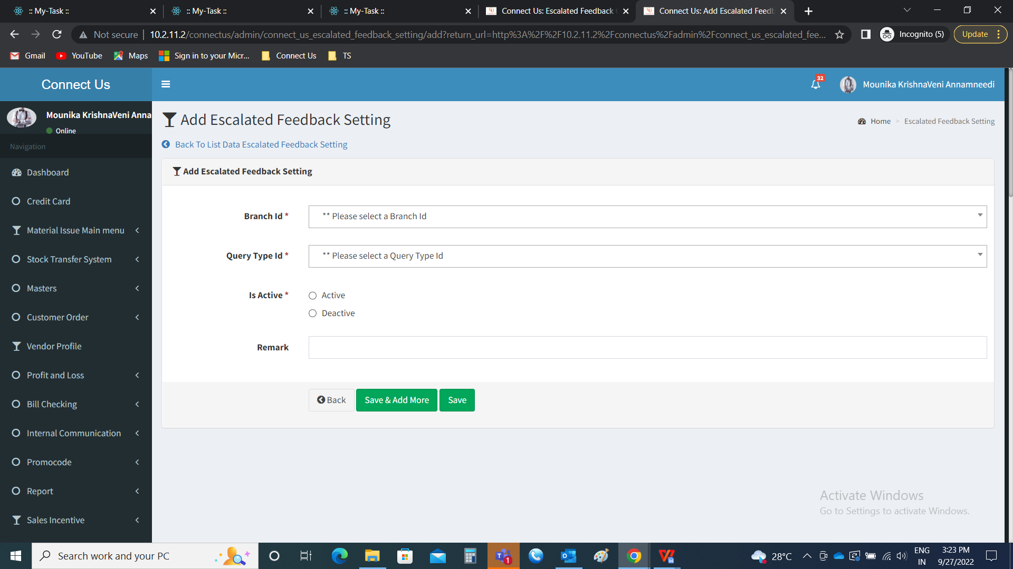

Now, the query type mapped in the customer mapping is to be mapped with the branch which is mentioned above.



View data:

The view data is used to view the data. The following are the fields in view data.

* Branch ID
* Query type ID
* Is active
* Remark

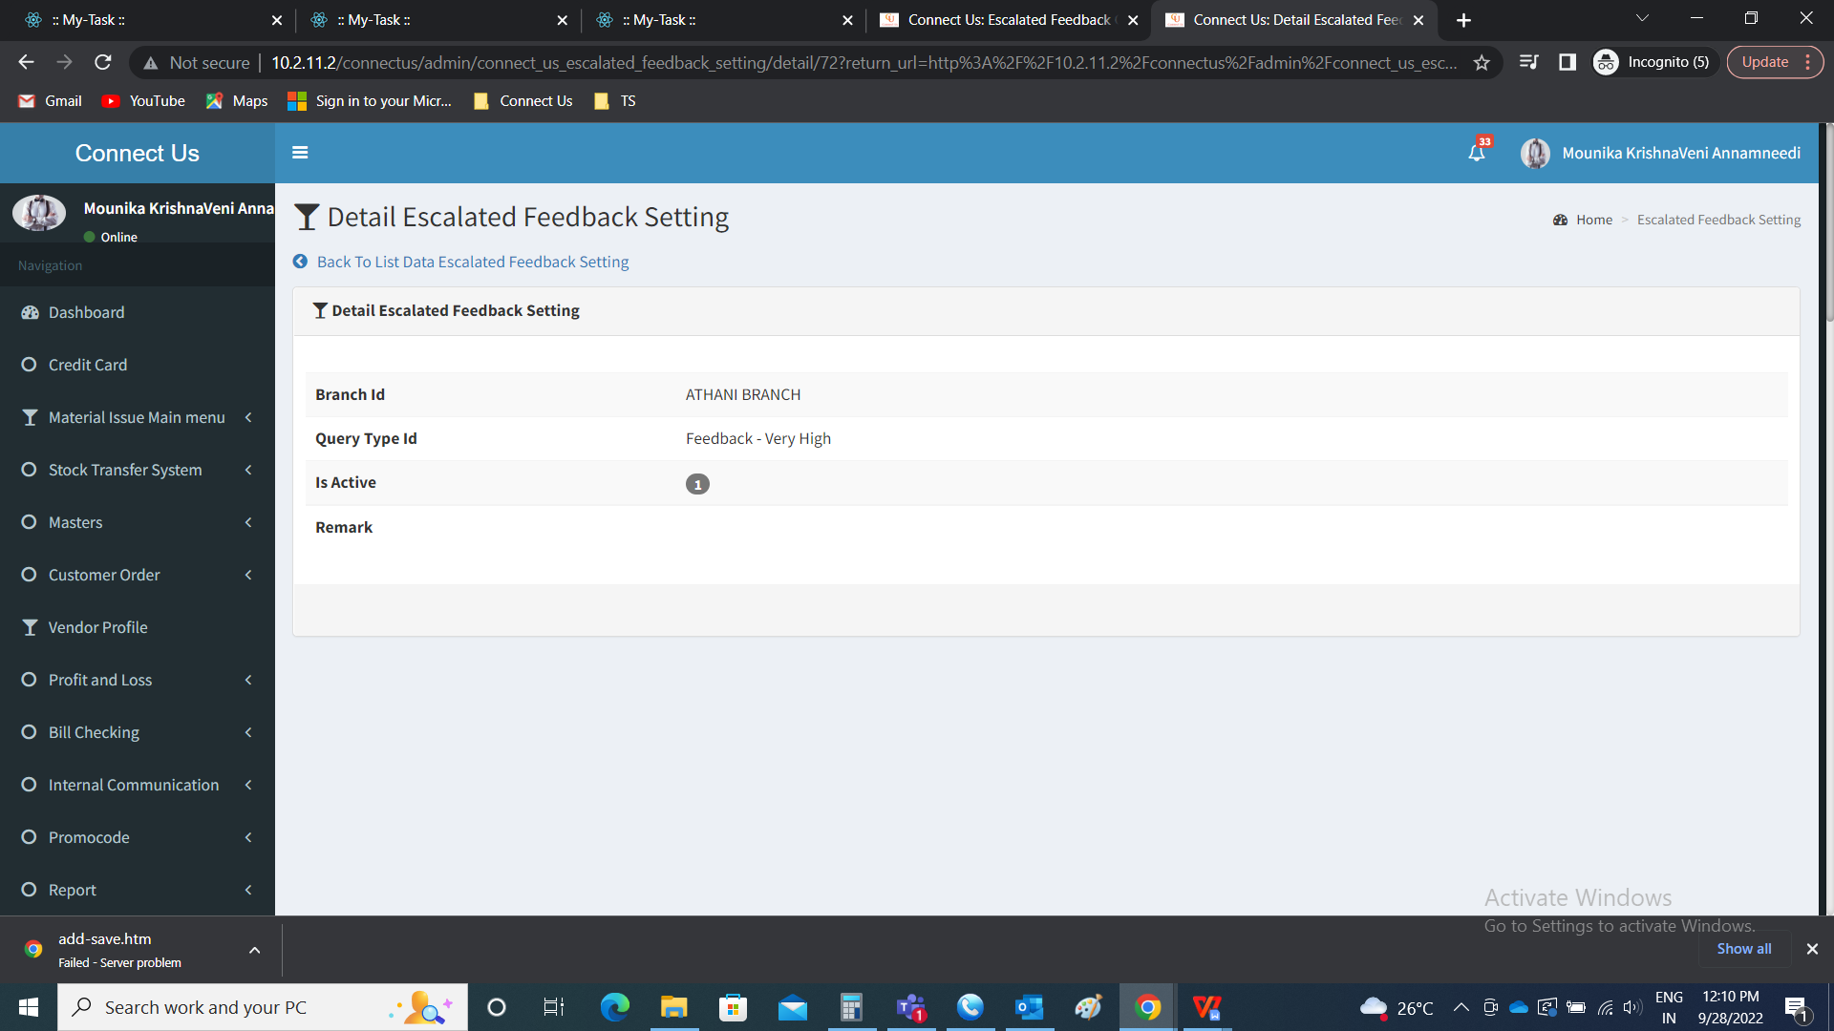

Edit data:

The edit data button is used to edit the following. The following are the fields that can be edited.

* Branch ID
* Query type ID
* Is active
* Remark

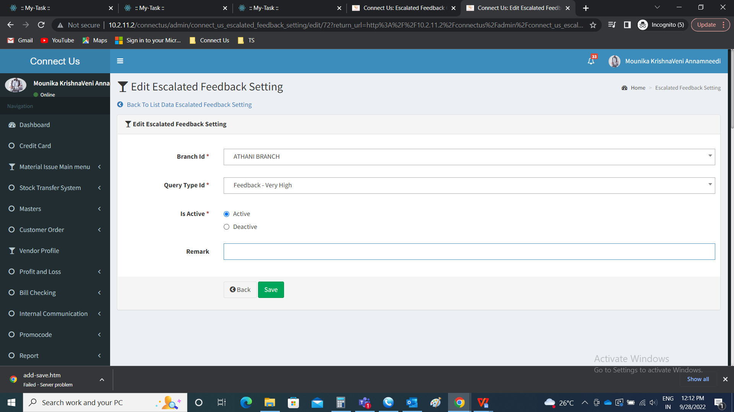

Delete data:

The delete data button is used to delete the record.

Step 6

Changes in feedback and escalation.

Connect Us >> Report >> Feedback

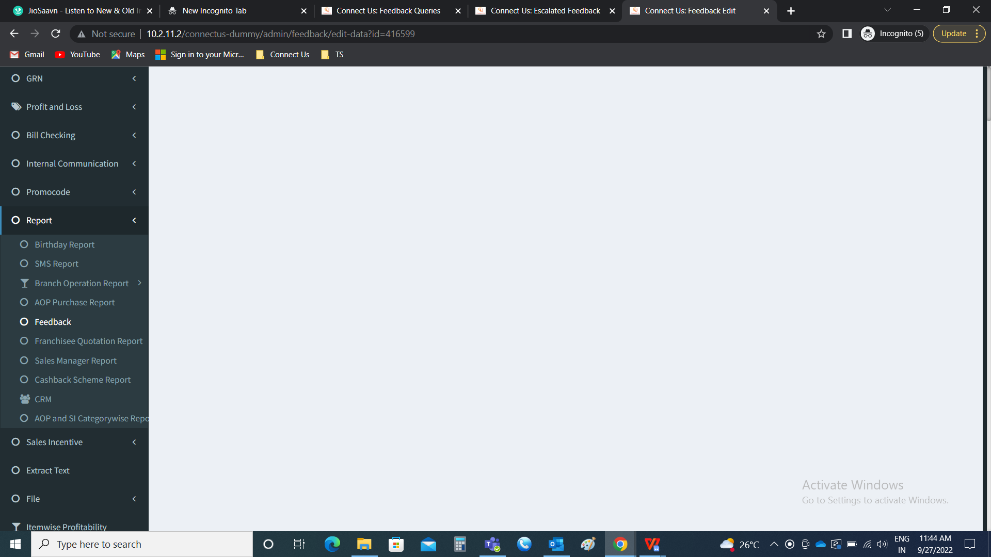

Feedback menu

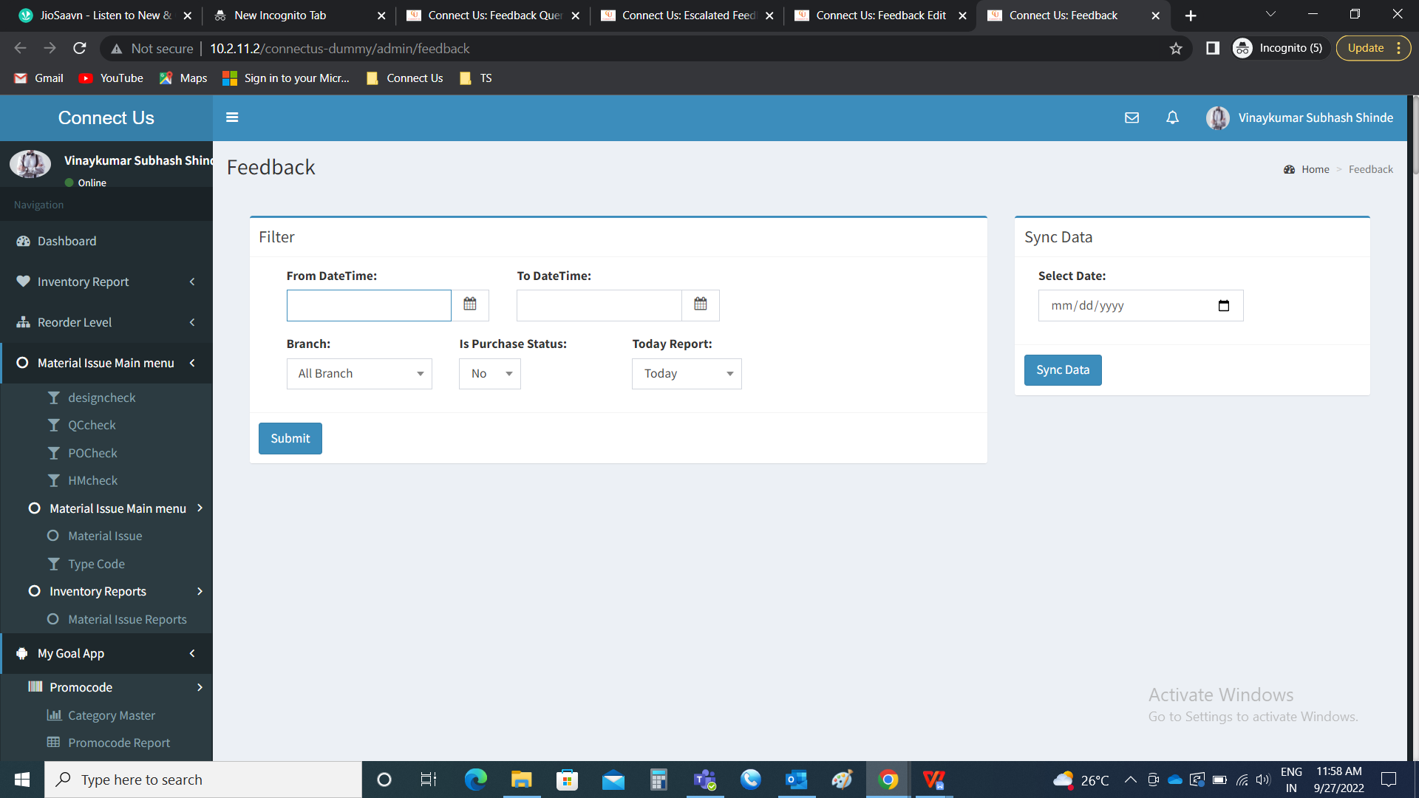

The basic details to be filled to generate the report such as.

* From date time
* To date time
* Branch
* Is purchase status
* Today report

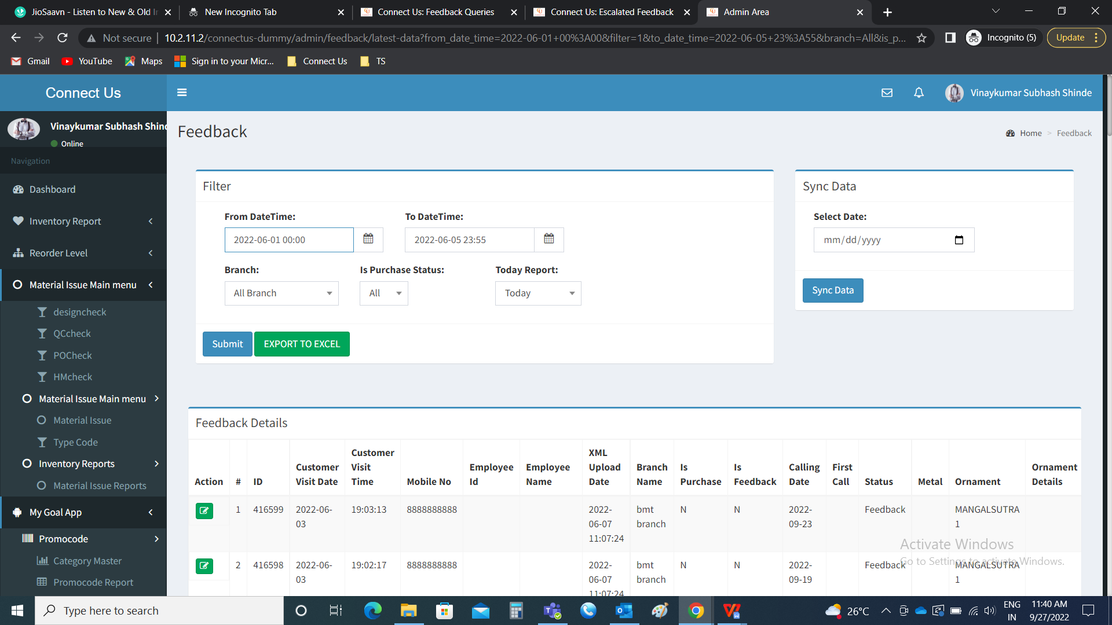

The toll free department edits the details and update the data

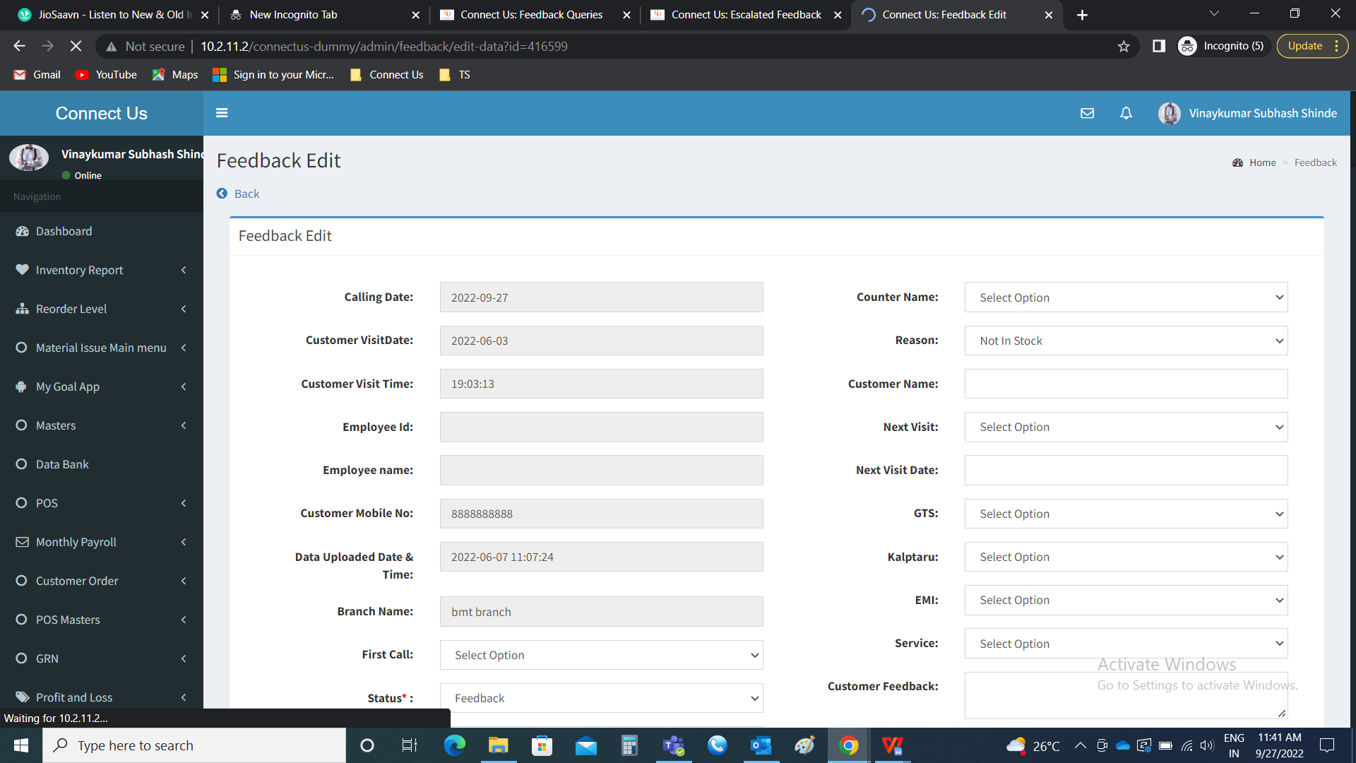

In Feedback >> edit, new field is added

* Need to escalate

|  |  |  |
| --- | --- | --- |
| **Field** | **Type** | **Description** |
| Need to escalate | Drop down | The need to escalate field is used to escalate the feedback or not. The dropdown consists of two options such as   * Yes * No   Yes - to escalate the feedback report  No - for not escalating the feedback report  By default, no is selected, if the user wants to escalate, then “yes” is selected. |

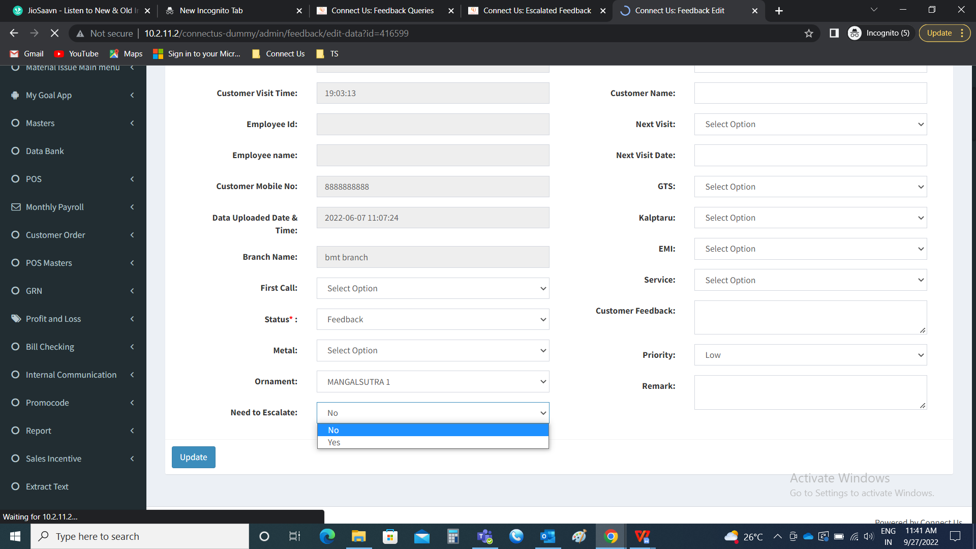

The priority field consists of the following

* Low
* Medium
* High
* Very high

By default, low is selected, according to the priority of the point, the priority is selected.

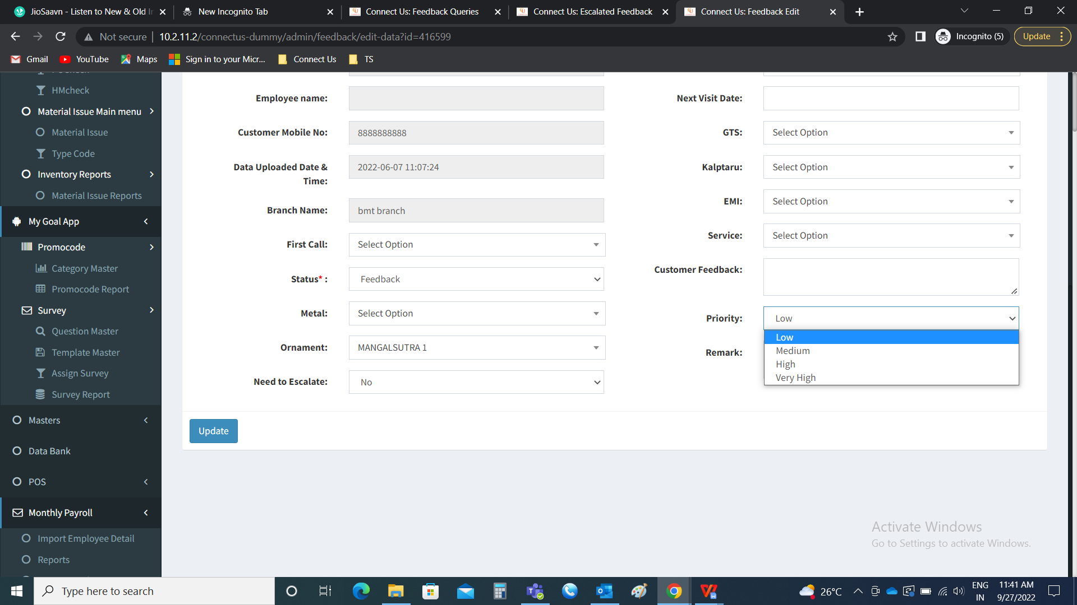

When the user selects “yes” in feedback - need to escalate, then the record is shown in the escalated feedback (Connect us >> escalated feedback).

Step 7

New module “Escalated Feedback” and raising the ticket.

Connect Us >> Escalated Feedback



Escalated Feedback

The escalated feedback module is used to raise the tickets in the ticketing system based escalated feedback setting made in the connect us (Connect us >> escalated feedback setting). The records which are escalated in feedback module (Connect us >> Report >> Feedback) are shown in escalated feedback. The escalated feedback module consists of the following fields.

* Raise ticket
* Check box
* ID
* Ticket ID
* Priority
* Branch ID
* Customer name
* Visit date
* Visit time
* Salesman name
* Counter name
* Metal
* Ornament
* Calling date
* First call
* Call status
* Reason
* Next visit
* Scheme informed
* EMI informed
* Service
* Customer Feedback

|  |  |
| --- | --- |
| Field | Description |
| Raise ticket | The raise ticket button to used to raise the tickets in the ticketing system what all records are selected |
| Check box | The check box to select the records. The multiple records and all records can be selected. |
| ID | The reference ID of the record in feedback module (Connect us >> Report >> Feedback) is displayed |
| Ticket ID | The ticket ID in the ticketing system is displayed when the ticket is raised |
| Priority | The priority in the feedback module (Connect us >> Report >> Feedback) is synced and displayed. The priority can be edited if required. |
| Branch ID | The branch ID in the feedback module (Connect us >> Report >> Feedback) is synced and displayed |
| Customer name | The customer name in the feedback module (Connect us >> Report >> Feedback) is synced and displayed |
| Visit date | The visit date in the feedback module (Connect us >> Report >> Feedback) is synced and displayed |
| Visit time | The visit time in the feedback module (Connect us >> Report >> Feedback) is synced and displayed |
| Salesman name | The salesman name in the feedback module (Connect us >> Report >> Feedback) is synced and displayed |
| Counter name | The counter name in the feedback module (Connect us >> Report >> Feedback) is synced and displayed |
| Metal | The metal in the feedback module (Connect us >> Report >> Feedback) is synced and displayed |
| Ornament | The ornament in the feedback module (Connect us >> Report >> Feedback) is synced and displayed |
| Calling date | The calling date in the feedback module (Connect us >> Report >> Feedback) is synced and displayed |
| First call | The first call in the feedback module (Connect us >> Report >> Feedback) is synced and displayed |
| Call status | The call status in the feedback module (Connect us >> Report >> Feedback) is synced and displayed |
| Reason | The reason in the feedback module (Connect us >> Report >> Feedback) is synced and displayed |
| Next visit | The next visit in the feedback module (Connect us >> Report >> Feedback) is synced and displayed |
| Scheme informed | The scheme informed in the feedback module (Connect us >> Report >> Feedback) is synced and displayed |
| EMI informed | The EMI informed in the feedback module (Connect us >> Report >> Feedback) is synced and displayed |
| Service | The service in the feedback module (Connect us >> Report >> Feedback) is synced and displayed |
| Customer Feedback | The customer feedback in the feedback module (Connect us >> Report >> Feedback) is synced and displayed |

Once, the record is raised as the ticket, the ticket ID is displayed and get disabled in the module.

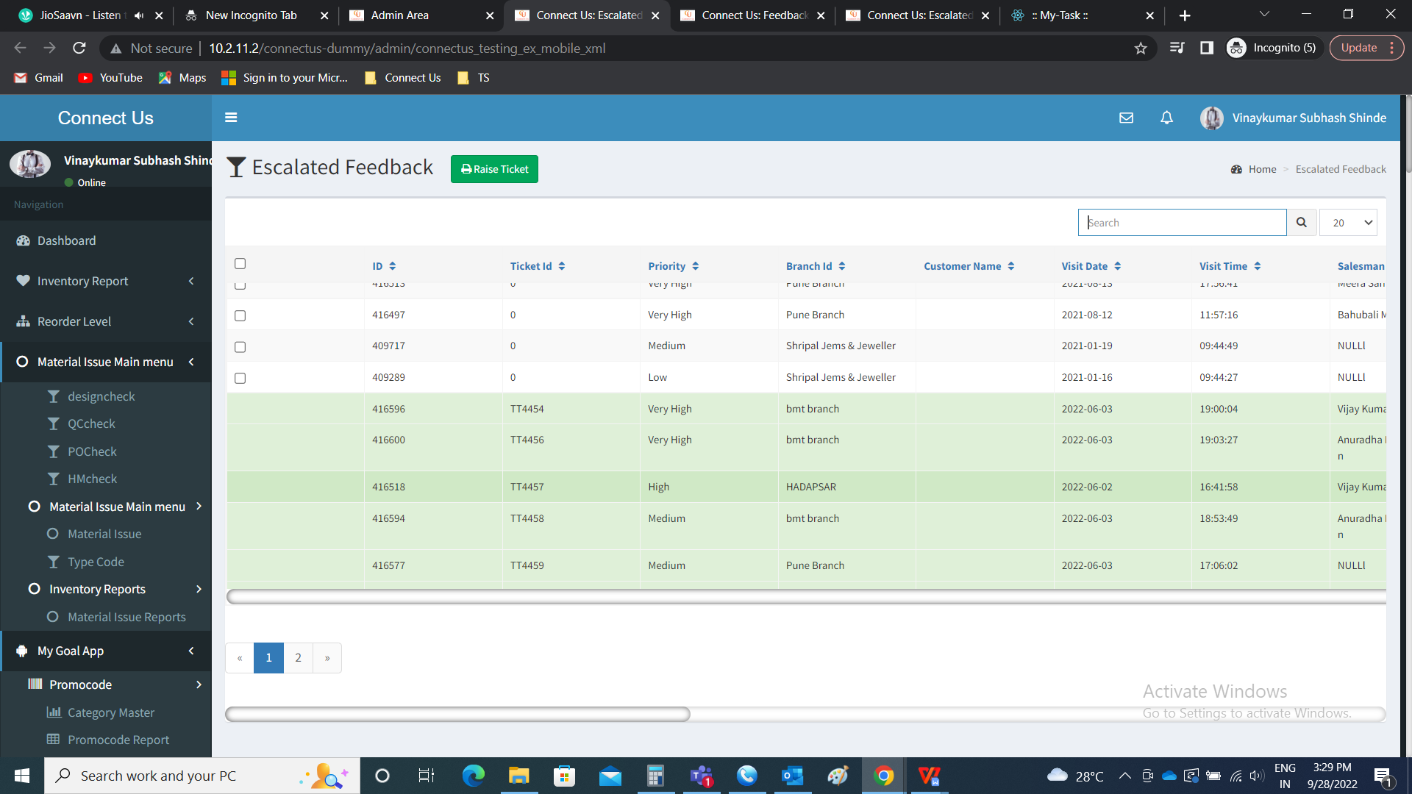

When any escalation raised and when the mapping is not done, then the tickets will be raised for which the mapping is done and active and for the remaining error file is displayed with the success and failed count.

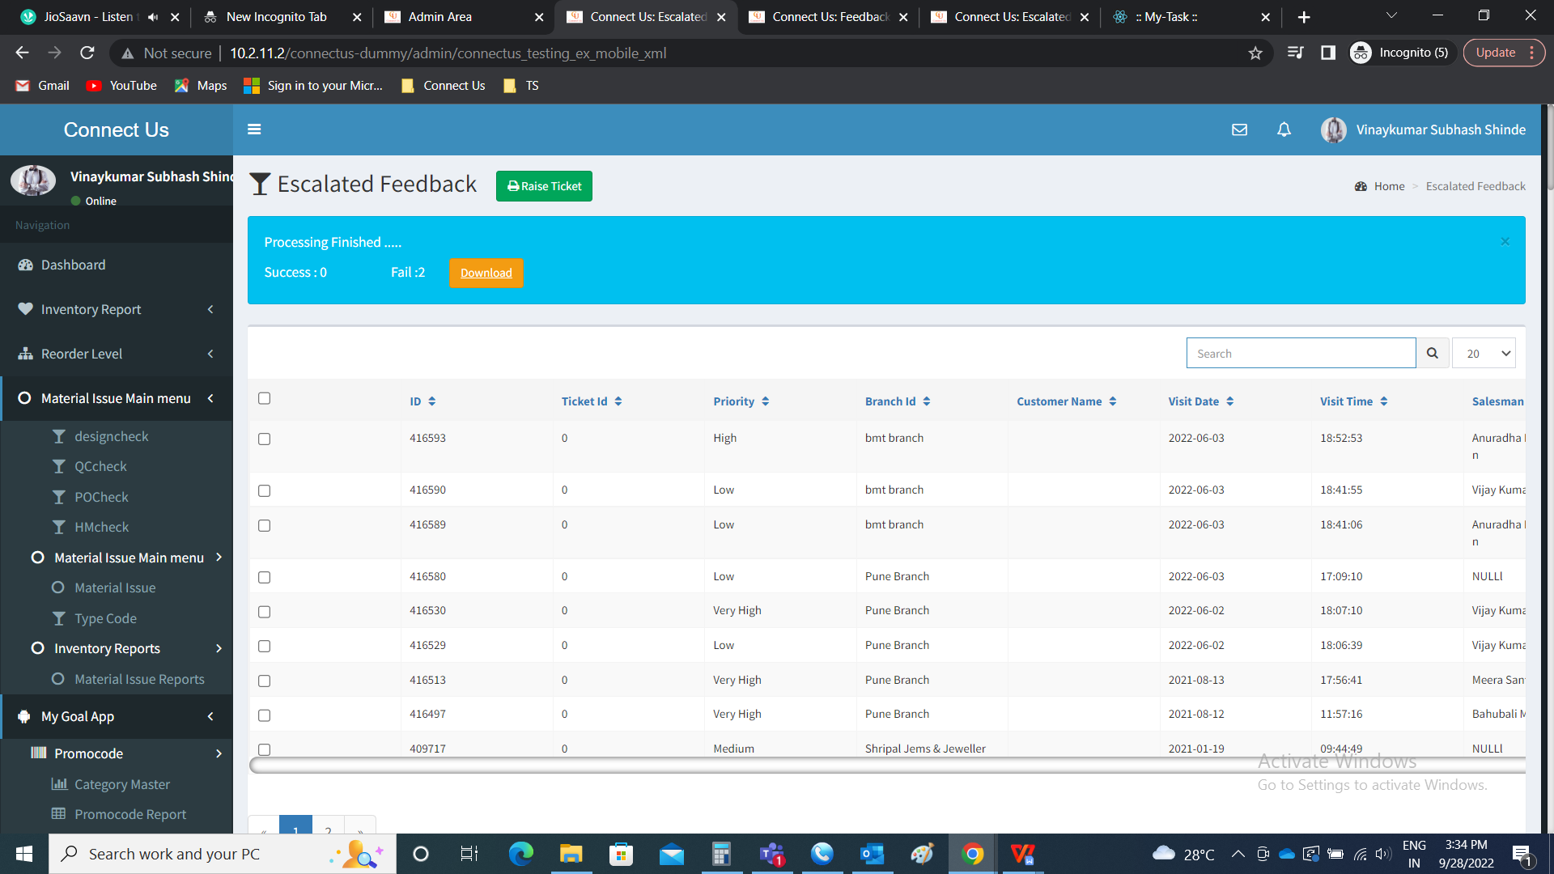

The downloaded file consists of the following fields

* ID
* Priority
* Branch ID
* Customer name
* Visit date
* Visit time
* Salesman name
* Counter name
* Metal
* Ornament
* Calling date
* First call
* Call status
* Reason
* Next visit
* Scheme informed
* EMI informed
* Service
* Customer Feedback
* Exception

|  |  |
| --- | --- |
| Field | Description |
| ID | The reference ID of the record in feedback module (Connect us >> Report >> Feedback) is displayed |
| Priority | The priority in the feedback module (Connect us >> Report >> Feedback) is synced and displayed. |
| Branch ID | The branch ID in the feedback module (Connect us >> Report >> Feedback) is synced and displayed |
| Customer name | The customer name in the feedback module (Connect us >> Report >> Feedback) is synced and displayed |
| Visit date | The visit date in the feedback module (Connect us >> Report >> Feedback) is synced and displayed |
| Visit time | The visit time in the feedback module (Connect us >> Report >> Feedback) is synced and displayed |
| Salesman name | The salesman name in the feedback module (Connect us >> Report >> Feedback) is synced and displayed |
| Counter name | The counter name in the feedback module (Connect us >> Report >> Feedback) is synced and displayed |
| Metal | The metal in the feedback module (Connect us >> Report >> Feedback) is synced and displayed |
| Ornament | The ornament in the feedback module (Connect us >> Report >> Feedback) is synced and displayed |
| Calling date | The calling date in the feedback module (Connect us >> Report >> Feedback) is synced and displayed |
| First call | The first call in the feedback module (Connect us >> Report >> Feedback) is synced and displayed |
| Call status | The call status in the feedback module (Connect us >> Report >> Feedback) is synced and displayed |
| Reason | The reason in the feedback module (Connect us >> Report >> Feedback) is synced and displayed |
| Next visit | The next visit in the feedback module (Connect us >> Report >> Feedback) is synced and displayed |
| Scheme informed | The scheme informed in the feedback module (Connect us >> Report >> Feedback) is synced and displayed |
| EMI informed | The EMI informed in the feedback module (Connect us >> Report >> Feedback) is synced and displayed |
| Service | The service in the feedback module (Connect us >> Report >> Feedback) is synced and displayed |
| Customer Feedback | The customer feedback in the feedback module (Connect us >> Report >> Feedback) is synced and displayed |
| Exception | The exception consists of the reason, why the ticket is not created |

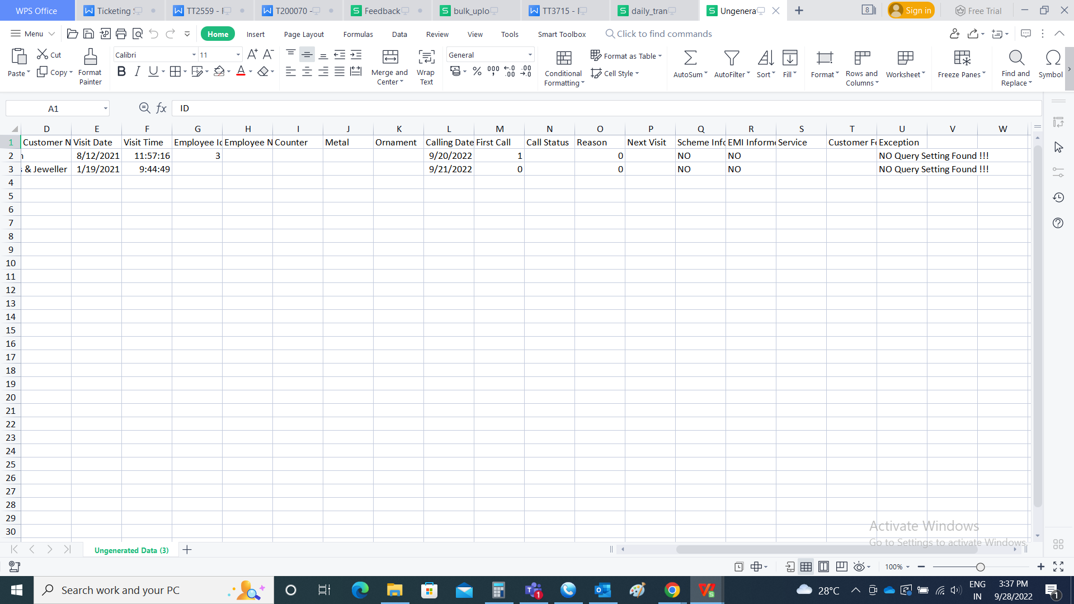

Ticketing system for reference.

The tickets are raised in the ticketing system. The entry user will be the person who raised the tickets in connect us in escalated feedback. The assigned person will be the person who is set against the query type in customer mapping. The assigned person can edit the ticket if required.

The tickets are directly passed to the respective persons when raised.

The tickets requires confirmation at the time of solving the ticket.

View ticket:

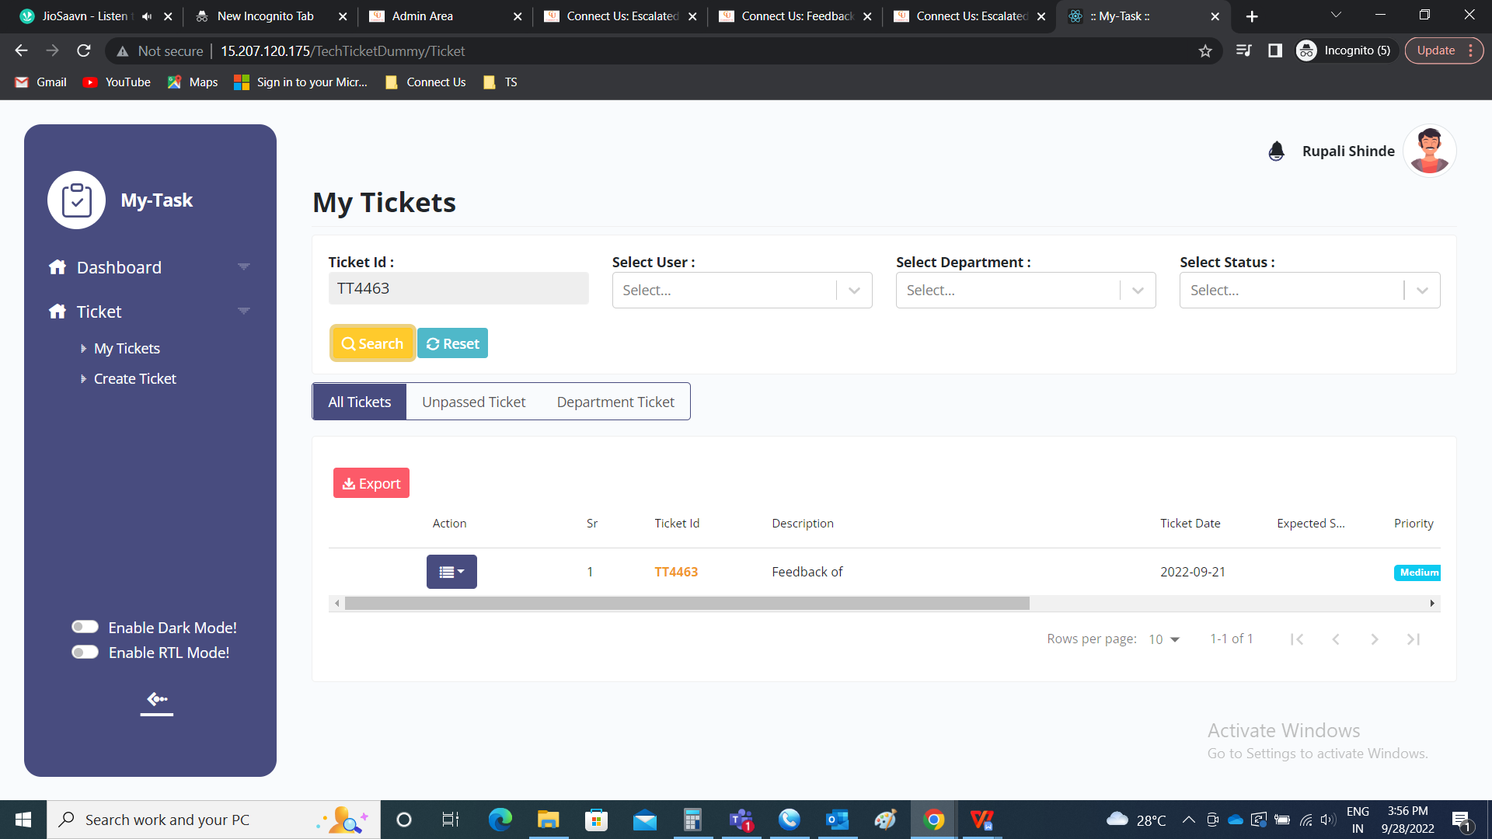

Ticket view

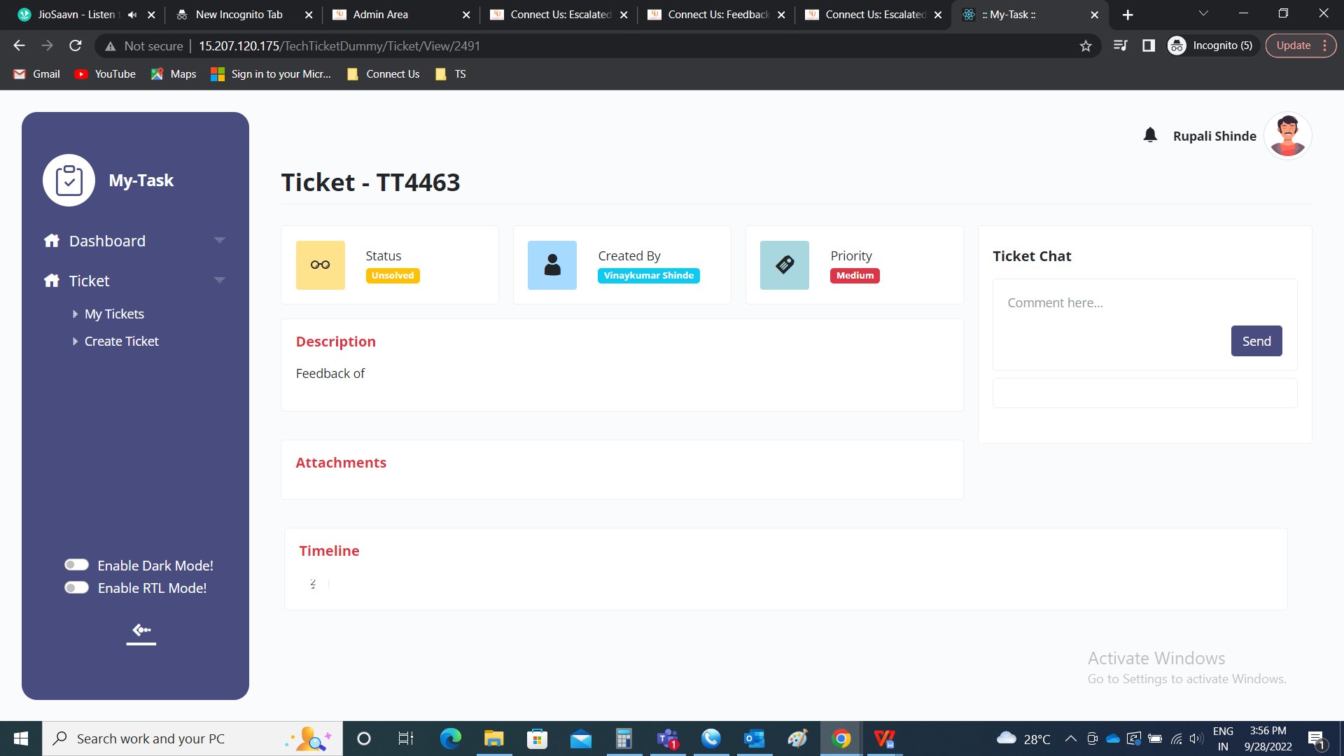

Ticket edit

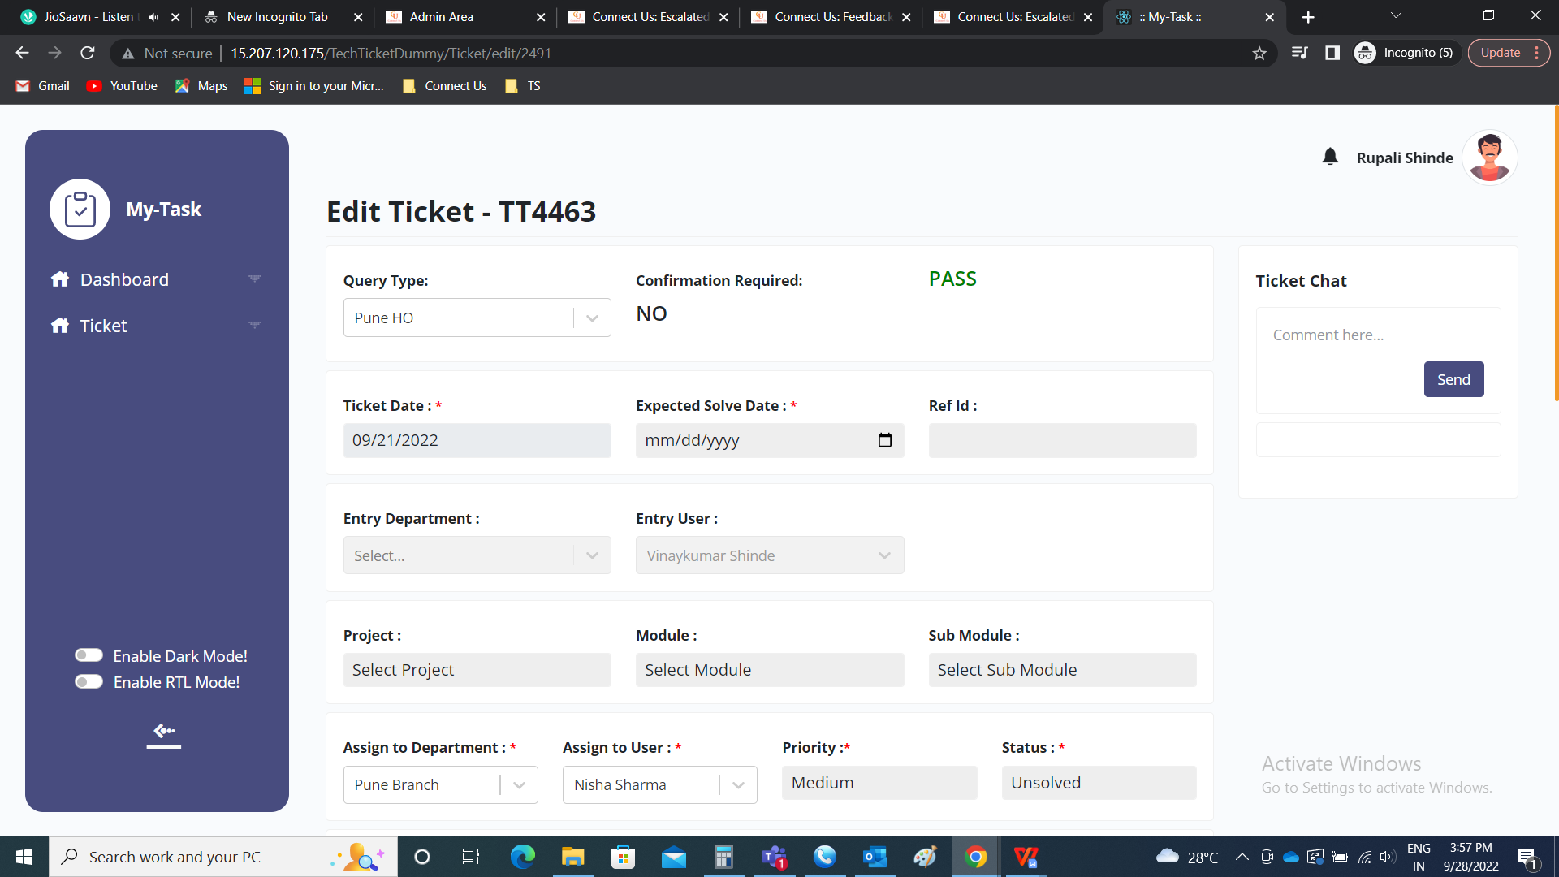

All the fields are displayed according to the dynamic form created.

