**STATE MASTER**

The state master consists of all the state details which helps in the easy access of the data. The following are the fields in state master.

* Search
* Reset
* Add state
* Sr
* State
* Country
* Status
* Updated by
* Updated at
* Action

|  |  |
| --- | --- |
| Field | Description |
| Search bar | To search the fields |
| Reset Button | To refresh the search bar |
| Add State button | To add a new state in the master |
| Sr | The serial count is displayed |
| State | The list of states is displayed |
| Country | The countries in which the state is thereis diaplayed |
| Status | Whether the state is active or not is displayed |
| Updated by | Last updated by is mentioned |
| Updated at | The time on which it is updated last is displayed |
| Action | The action field consists of the edit button to edit the existing state |

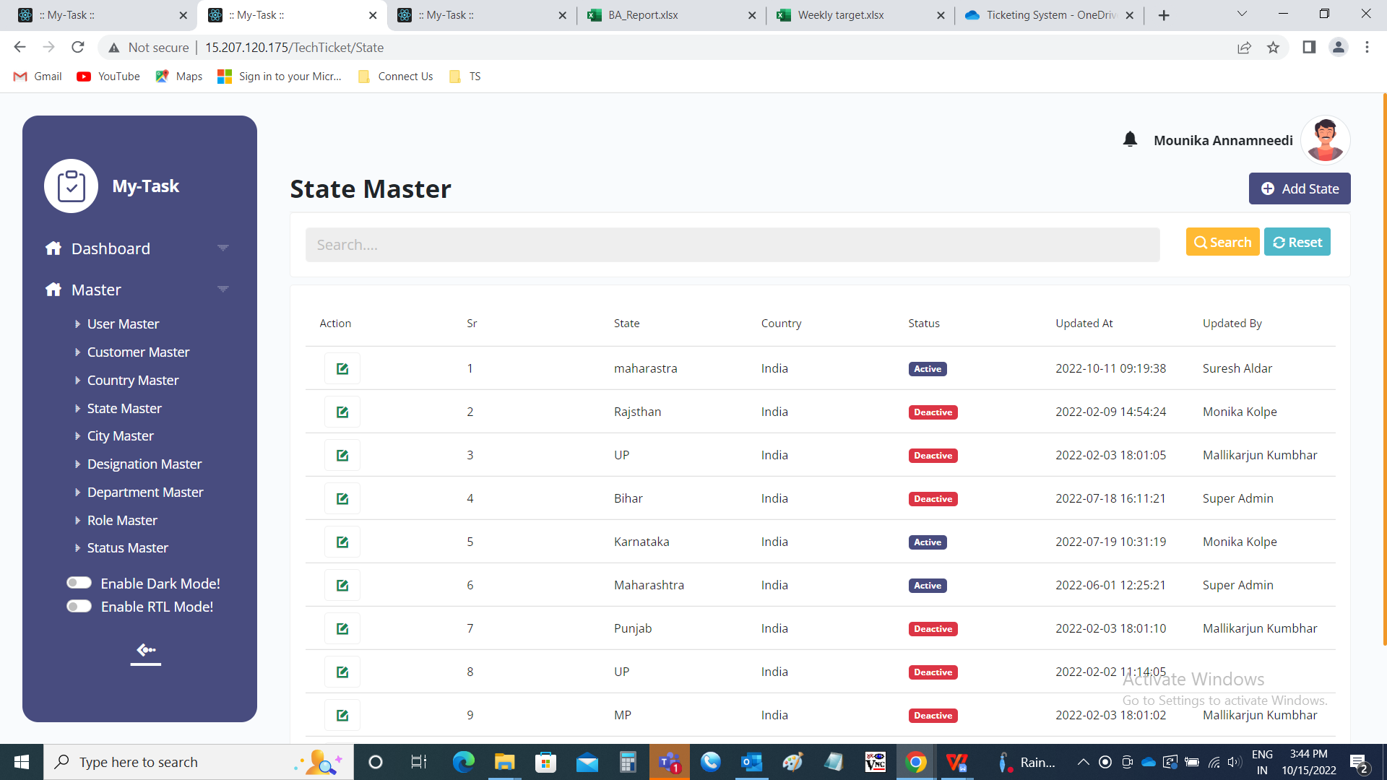

Add data:

The add page consists of the following fields.

* Country
* State
* Remark
* Status
* Add
* Cancel

|  |  |  |  |
| --- | --- | --- | --- |
| **FIELDS** | **INPUT TYPE** | **MANDATORY/ OPTIONAL** | **DESCRIPTION** |
| Country | Drop down | Mandatory | The country to which the state is belonged is selected. The country is selcted from the drop down options. The drop doen options are fetched from the country master (in Ticketing system >> Masters >> Country Master). |
| State | Text | Mandatory | The state name is entered |
| Remark | Text | optional | The remark if any is mentioned |
| Select status | Radio button | Mandatory | The radio button consists of active and de-active. By default, active is selected. Active is selected if the state is active or else deactive is selected. |
| Add | Button | Optional | To create the state in the master |
| cancel | Button | Optional | To navigate to the state master main page |

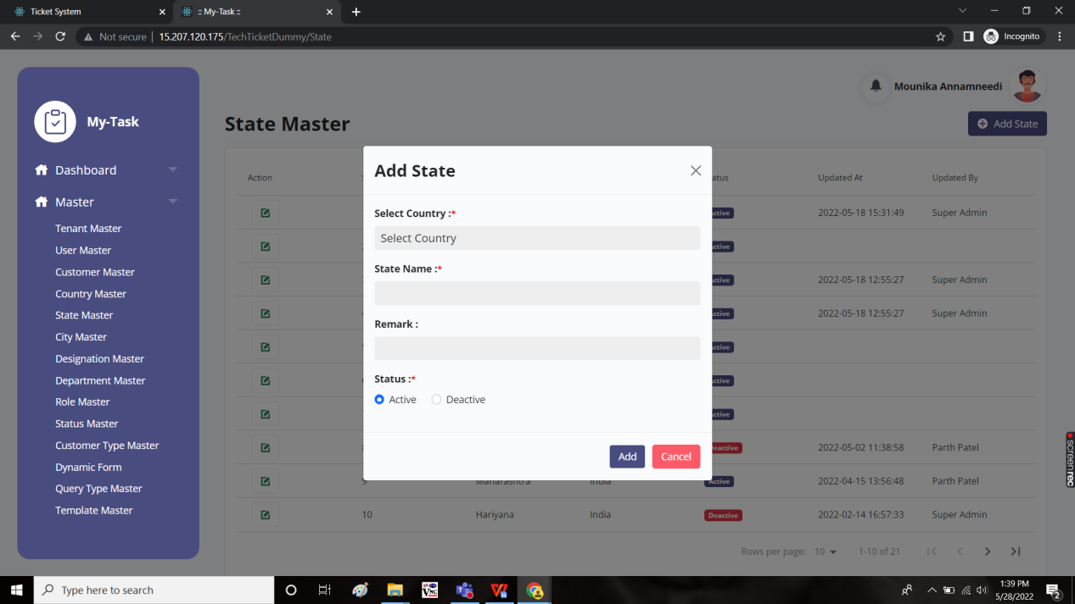

Edit page:

The edit page consists of the following and all fields can be edited if required.

* Country
* State
* Remark
* Status
* Update
* Cancel

