**STATUS MASTER**

The status master consists of all the terminologies used related to status of the ticket in the organization which helps in easy access of the data. The following are the fields in status master.

* Search
* Reset
* Add Status
* Sr
* Status name
* Status
* Updated by
* Updated at
* Action

|  |  |
| --- | --- |
| Field | Description |
| Search bar | To search the fields |
| Reset Button | To refresh the search bar |
| Add Status button | To add a new status name in the master |
| Sr | The serial count is displayed |
| Status name | The list of status name are displayed |
| Status | Whether the status name is active or not is displayed |
| Updated by | Last updated by is mentioned |
| Updated at | The time on which it is updated last is displayed |
| Action | The action field consists of the edit button to edit the existing status name |

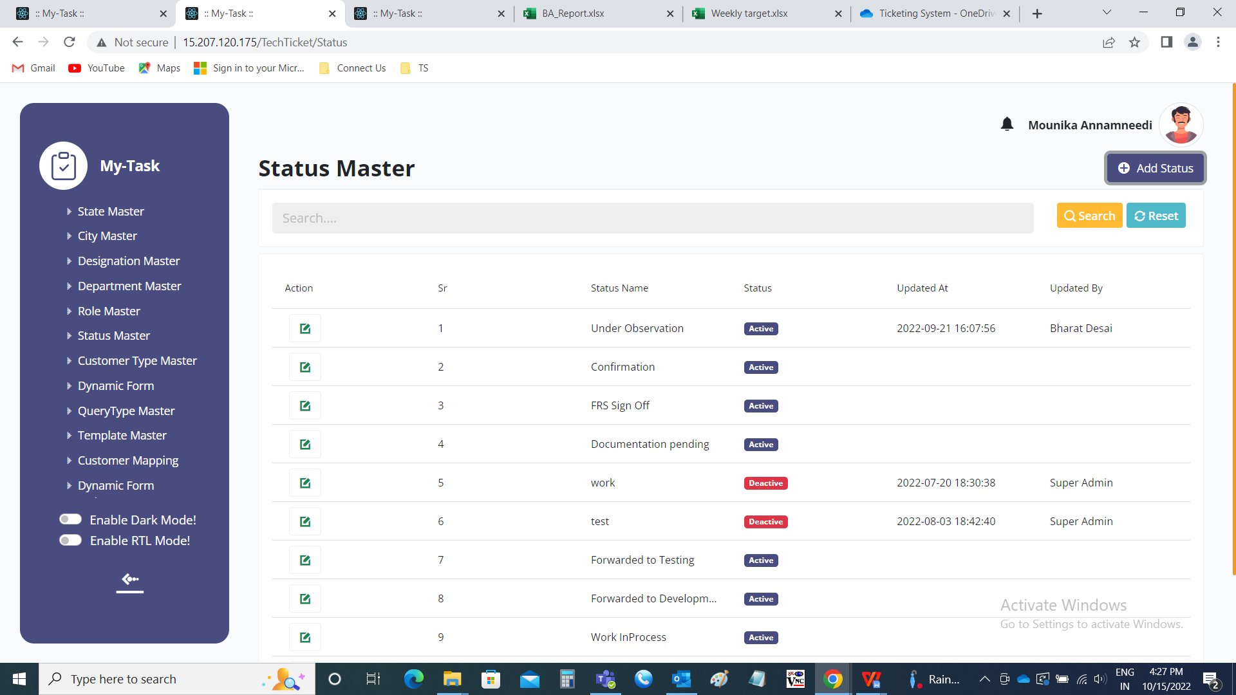

Add data:

The add page consists of the following fields.

* Status name
* Remark
* Status
* Add
* Cancel

|  |  |  |  |
| --- | --- | --- | --- |
| **FIELDS** | **INPUT TYPE** | **MANDATORY/ OPTIONAL** | **DESCRIPTION** |
| Status name | Text | Mandatory | The status name name is entered. |
| Remark | Text | optional | The remark if any is mentioned |
| Select status | Radio button | Mandatory | The radio button consists of active and de-active. By default, active is selected.  Active is selected if the status name is active or else deactive is selected. |
| Add | Button | Optional | To create the status name |
| cancel | Button | Optional | To navigate to the status name master main page |

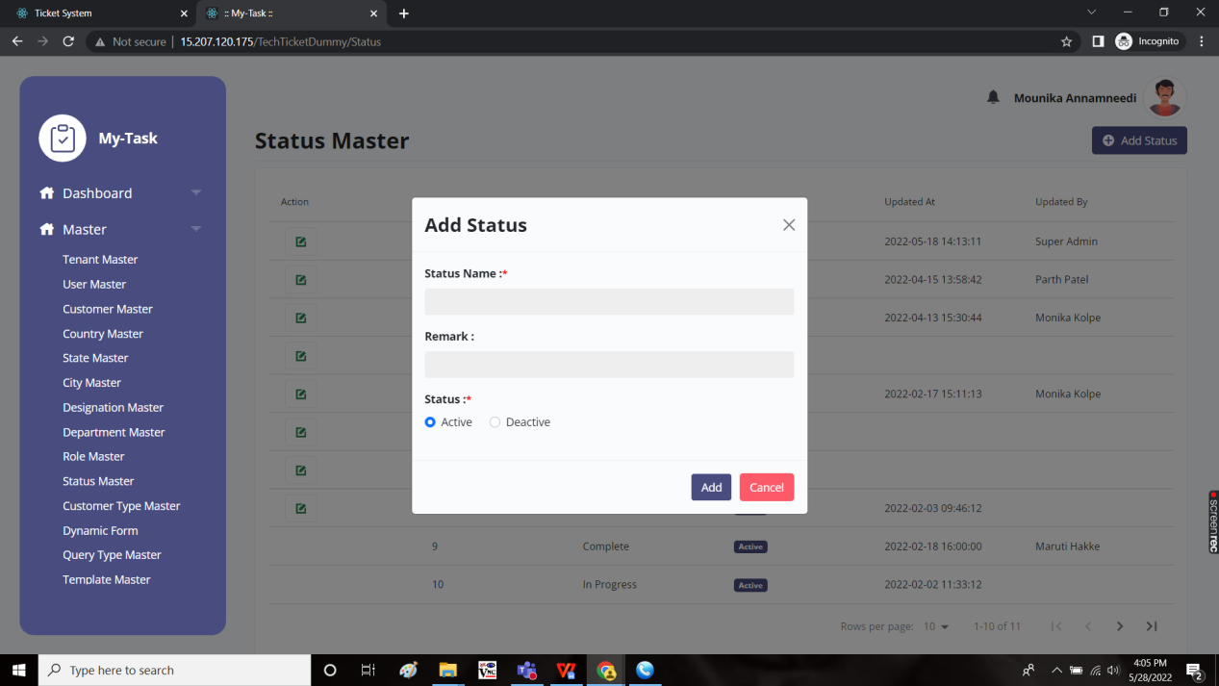

Edit page:

The edit page consists of the following and all fields can be edited if required.

* Status name
* Remark
* Status
* Update
* Cancel

