|  |  |
| --- | --- |
| **Ticket ID** | T200883 |

**Business requirement**

The user needs the report in a printed form on slip, so that it can be used as a hard copy and report to the higher management accordingly in HM check in material issue main menu.

**Existing system**

In the existing system, the report can be viewed but cannot be printed on slip.

**Proposed system**

* Creation of the new button generate slip report.
* Report format.

**Step-1**

In Connect US -> Material Issue Main Menu -> HM check

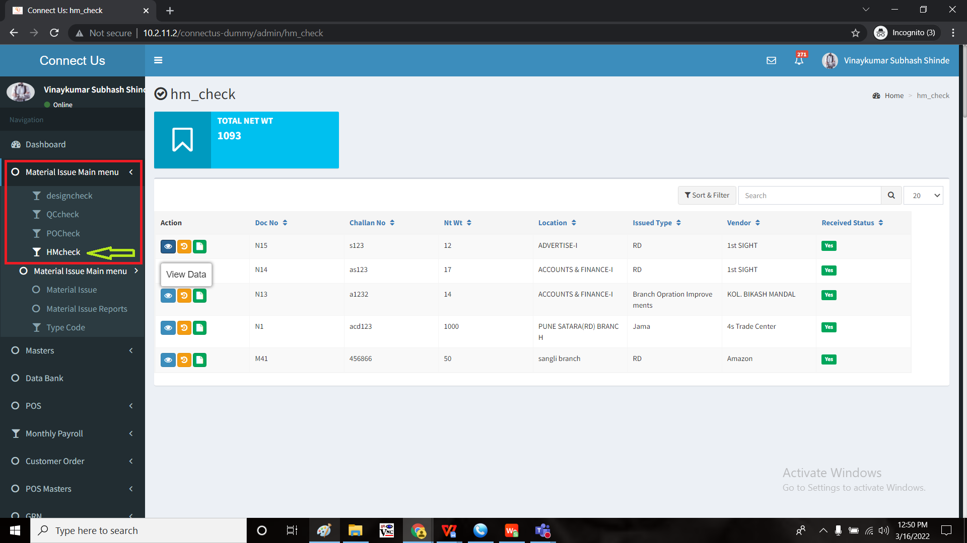

In issued format

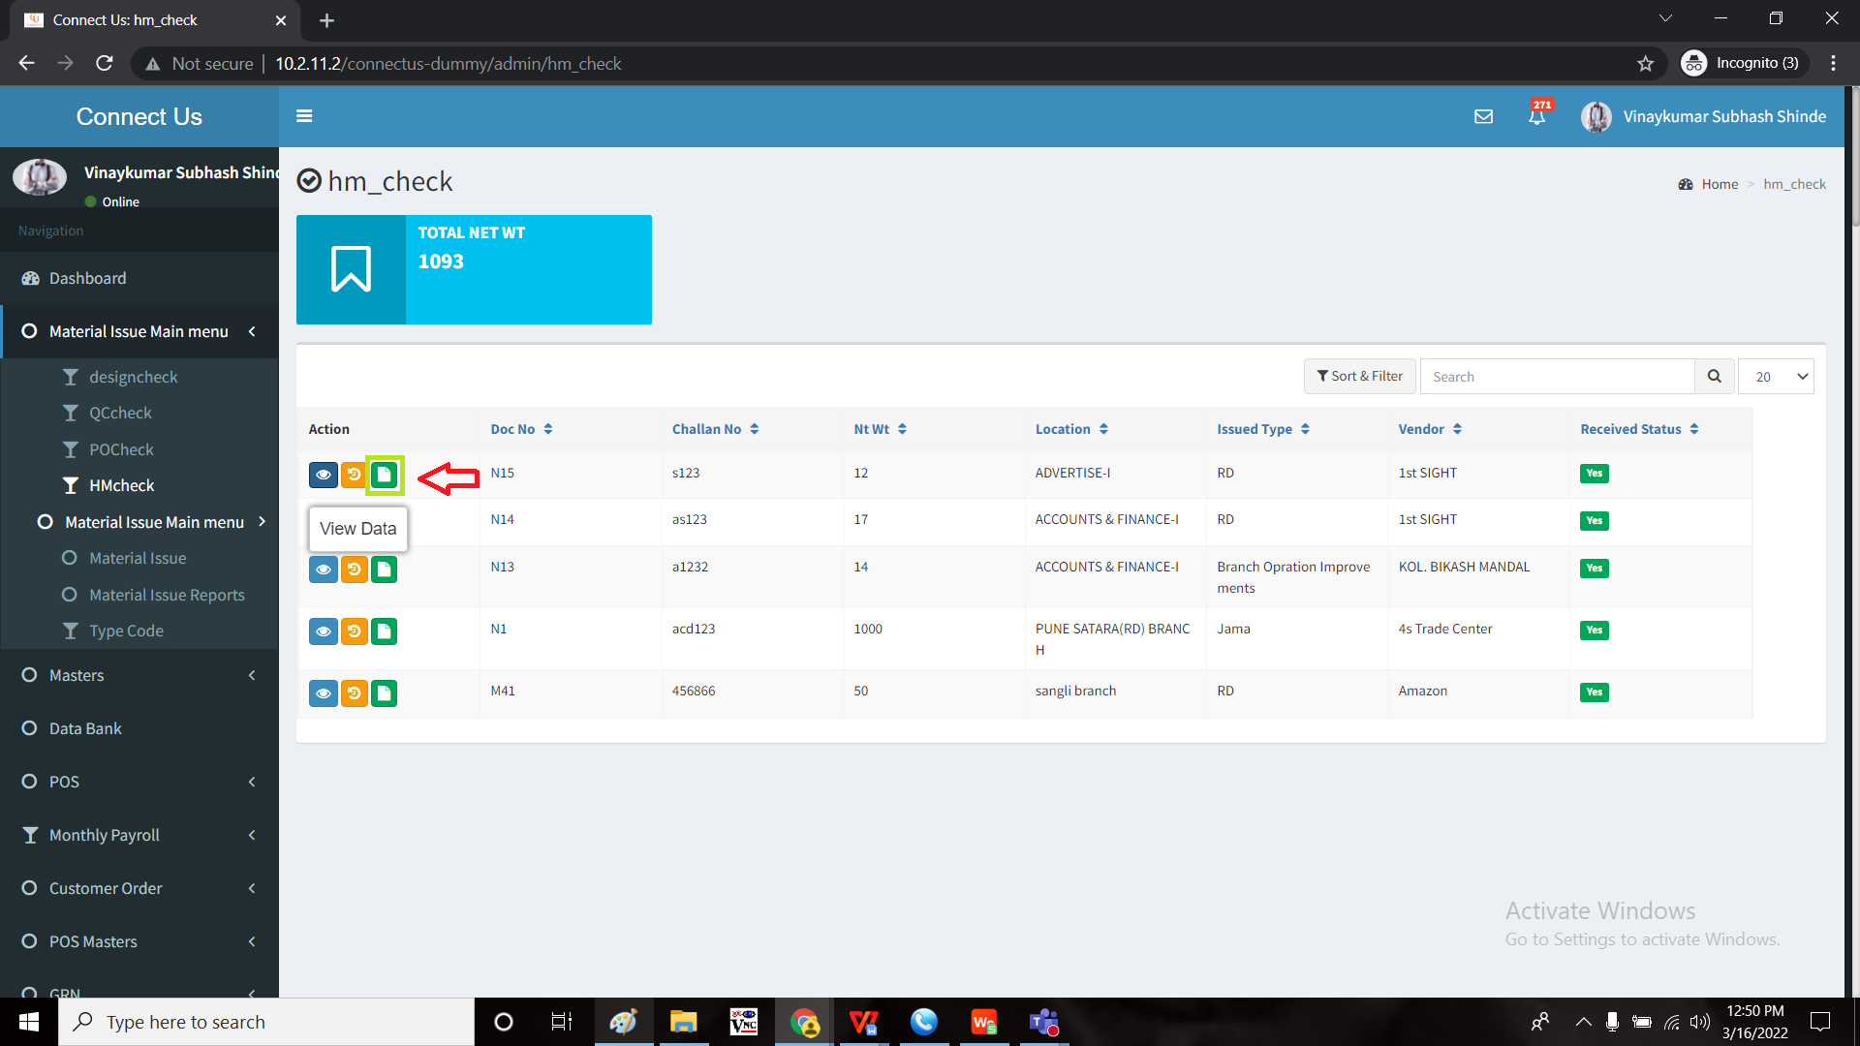

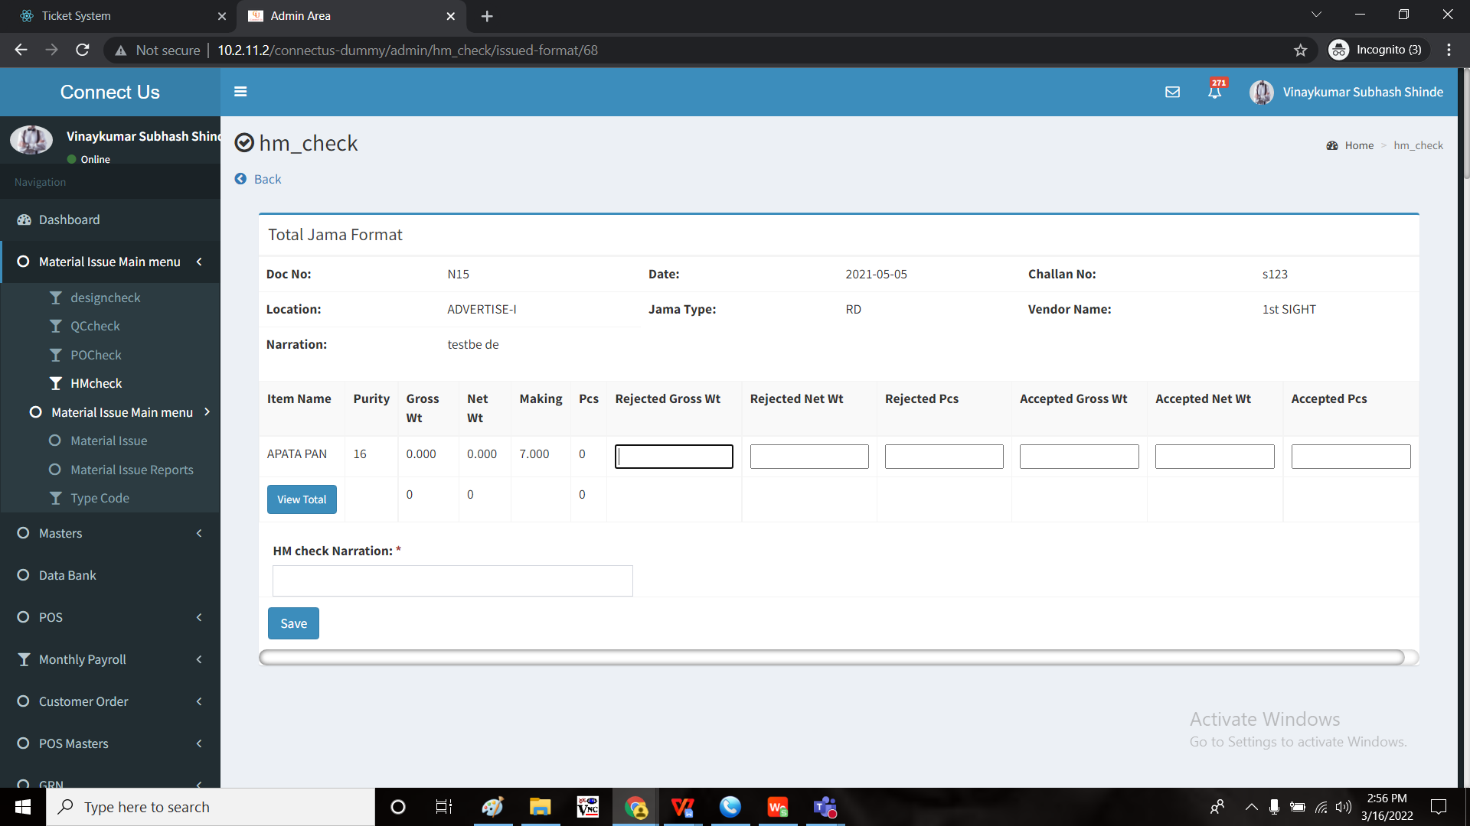

Creation of new button “Generate slip print” beside save button.

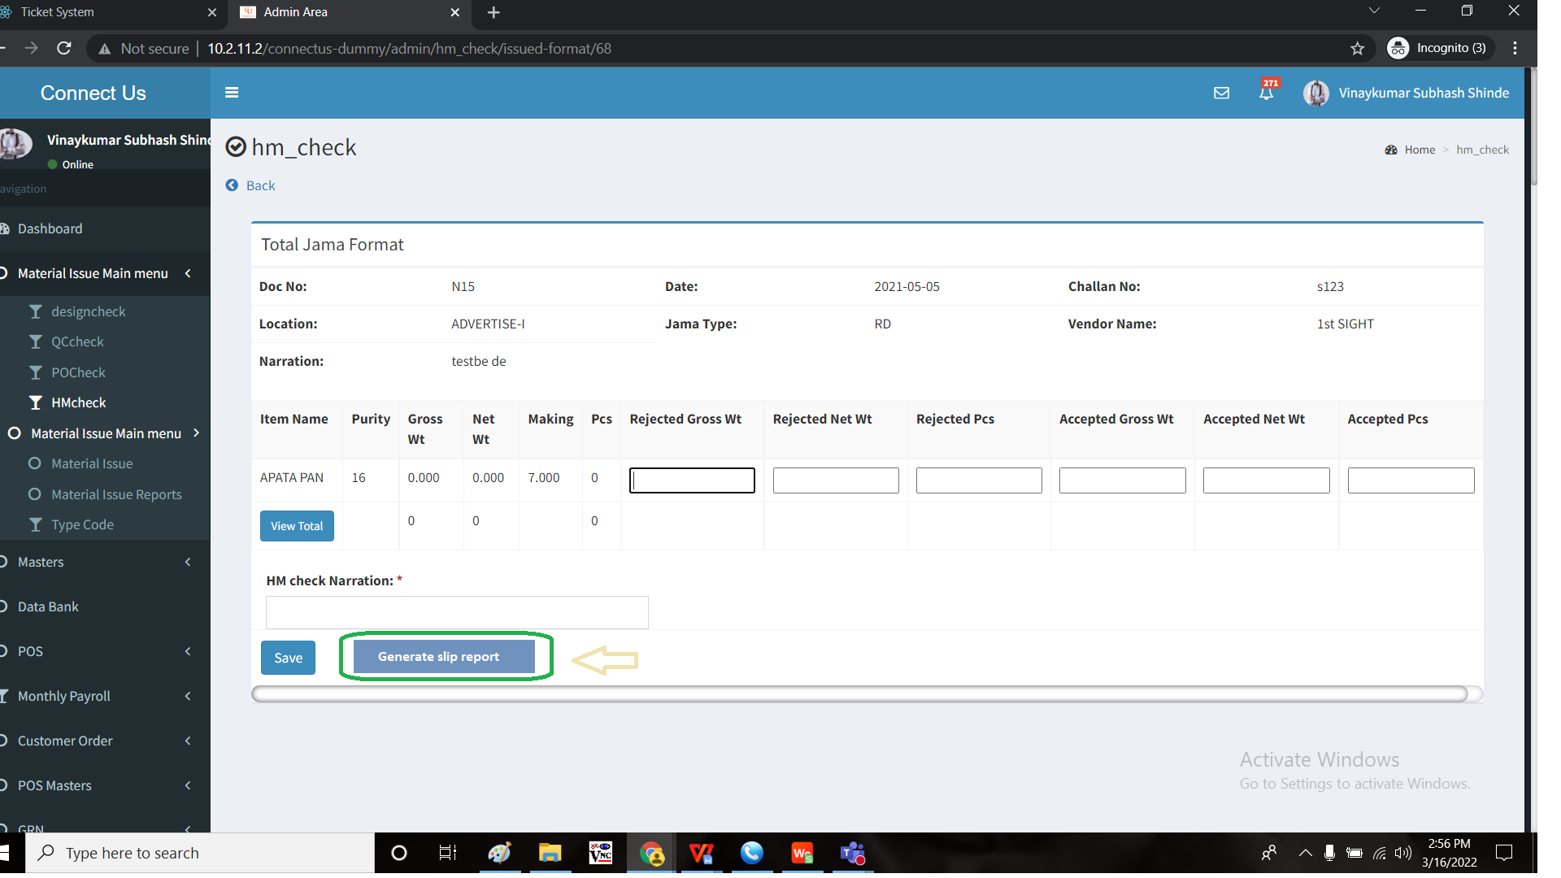

In issued format page, the user gives the details of the rejected gross weight, rejected net weight, rejected pieces, accepted gross weight, accepted net weight, accepted pieces and HM check narration.

When the user clicks the “Generate slip report”, the data to be saved automatically and following report to be generated on the slip.

|  |  |  |  |  |
| --- | --- | --- | --- | --- |
| 5/3/2022 |  | 12:15 PM | |  |
|  |  |  |  |  |
| **Jama & Return Details** | | | |  |
|  |  |  |  |  |
| Date : 3/5/2022 | Bill No. : | 1346/2021-22 | |  |
|  |  |  |  |  |
| Vendor Name | Lotus Jewellery Creation | |  |  |
|  |  |  |  |  |
| Reject Type | Gross Wt | Net Wt | Pcs |  |
| Total Net Wt | 100 | 95 | 15 |  |
| Design Reject | 10 | 9 | 3 |  |
| QC Reject | 5 | 4.5 | 2 |  |
| PO Reject | 5 | 4.5 | 1 |  |
| HM Reject | 0 | 0 | 0 |  |
| Total Rejected Wt | 20.00 | 18.000 | 6 |  |
| Total Accepted Wt | 80.00 | 77.00 | 9 |  |

The reports consists of the following data

* Date
* Bill no
* Vendor name
* Reject type - total net weight, design reject, QC reject, PO reject, HM reject and total accepted weight.
* Columns of reject gross weight, reject net weight and reject pieces.

The design reject, QC reject, PO reject data is fetched from the menus under the material issue wise menu - design reject, QC reject and PO reject.

The HM details consists of the data added in those fields.

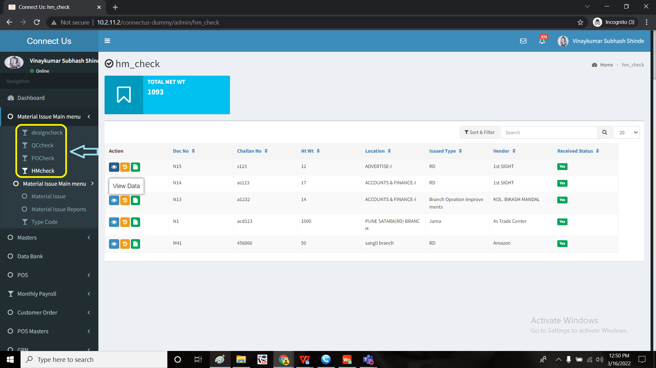

**OUTPUT:**

Generate slip report button:

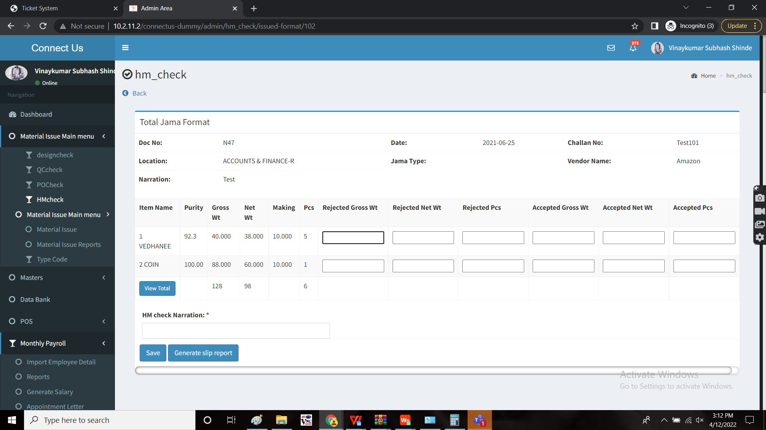

**Report:**

